Case 1:- Adding the URL in the DB.
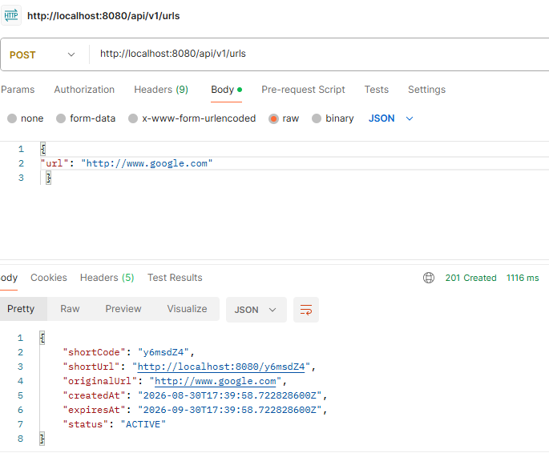

Case 2:- Fetching the URL using short code
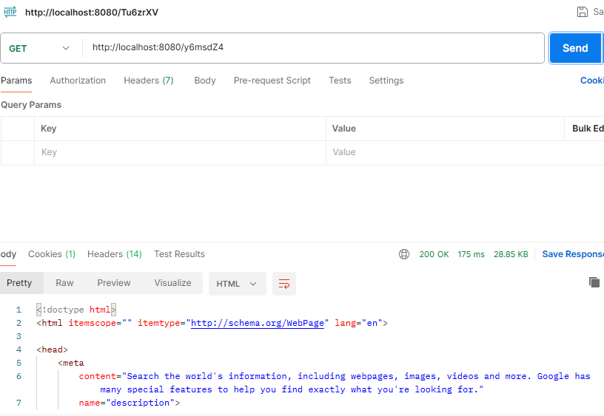

Case 3:- Fetching the URL using invalid short code
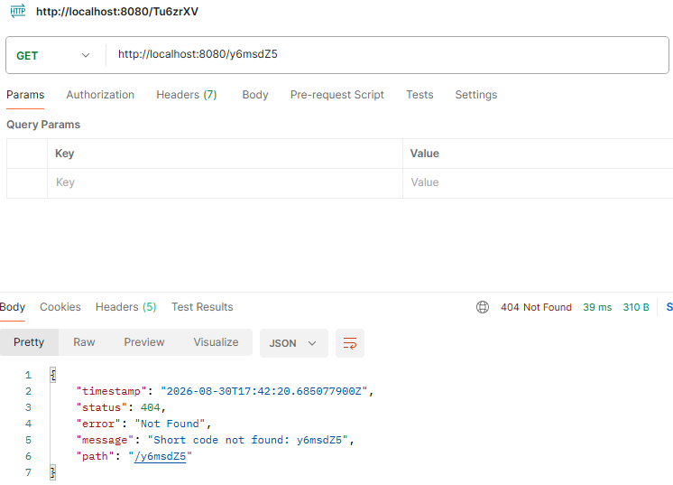
Case 4:- Analytical Reporting
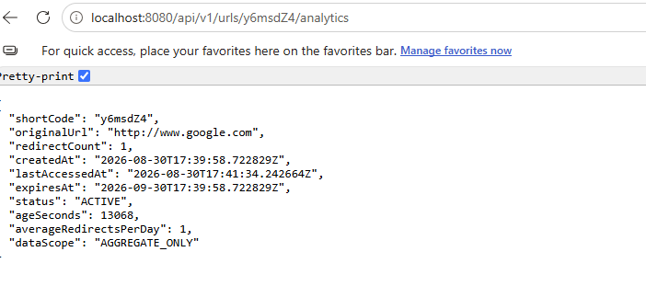

Case 5:- Execution of Assessment Scenario’s
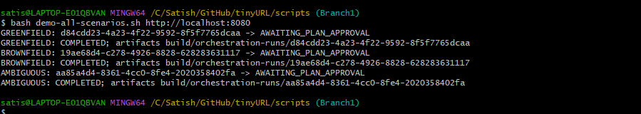
Case 6:- Output of Assessment Scenario
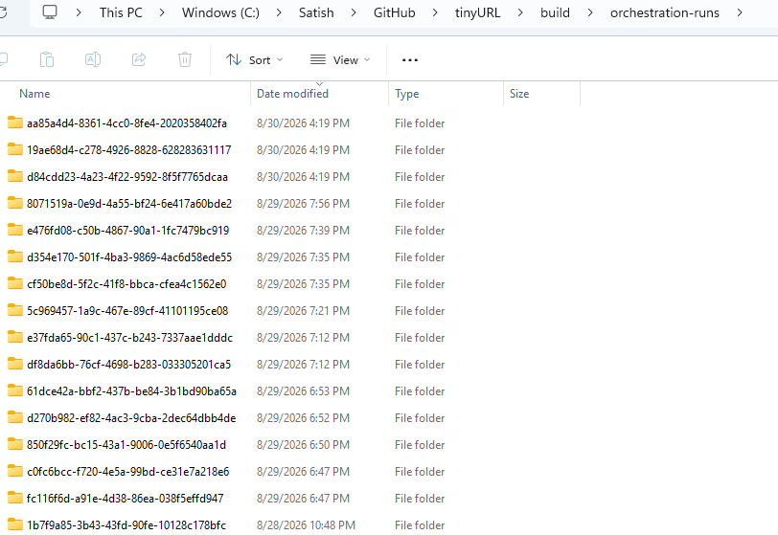

Case 7:- Greenfield Scenario Output
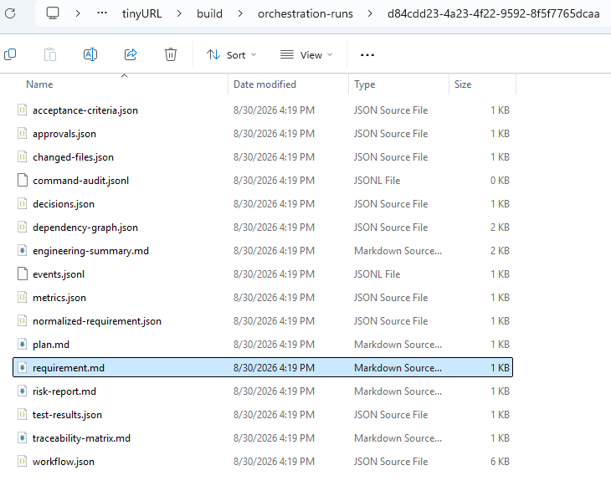

Case 8:- Brownfield Scenario Output
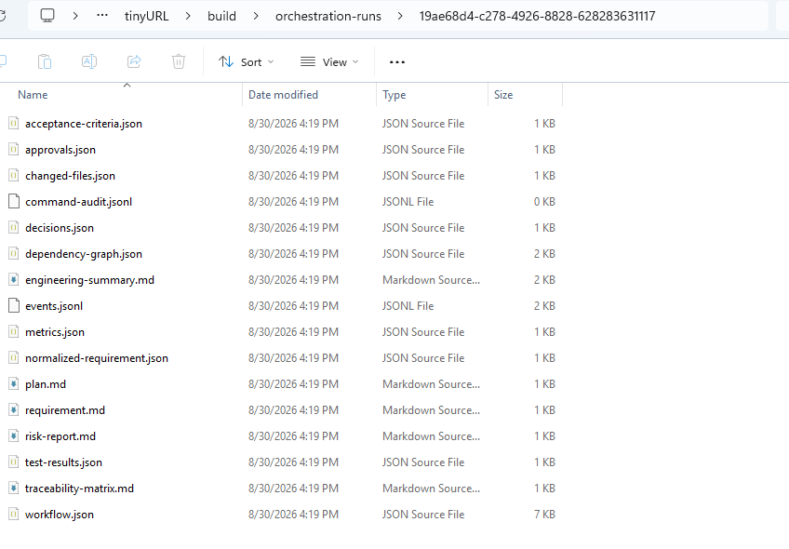

Case 9:- Ambiguous Scenario Output
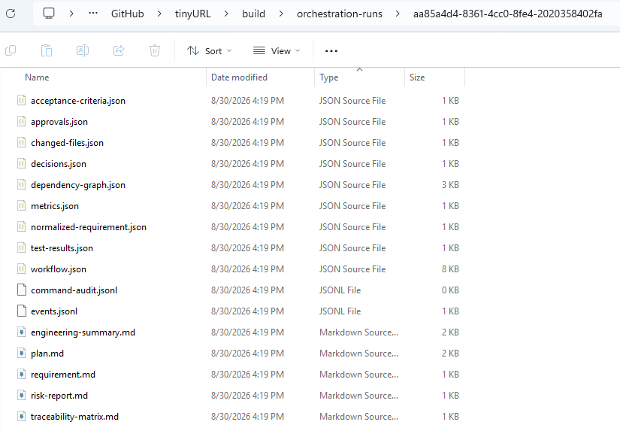

Case10:- API for Artifacts 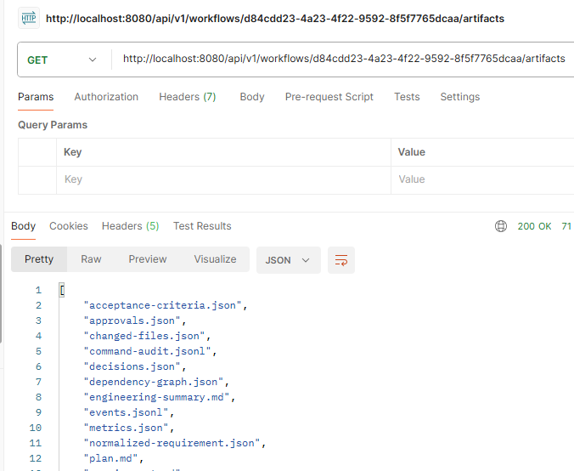

Case11:- API for command execution