**DSM_STATISTICS3_Assignment18.1**

Blood glucose levels for obese patients have a mean of 100 with a standard deviation of 15. A researcher thinks that a diet high in raw cornstarch will have a positive effect on blood glucose levels. A sample of 36 patients who have tried the raw cornstarch diet have a mean glucose level of 108. Test the hypothesis that the raw cornstarch had an effect or not.

**Solution:-**Follow the above discussed steps to test this hypothesis:

Step-1: State the hypotheses. The population mean is 100.

H0: μ= 100  
H1: μ > 100

Step-2: Set up the significance level. It is not given in the problem so let’s assume it as 5% (0.05).

Step-3: Compute the random chance probability using z score and z-table.

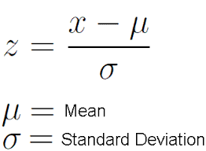  
For this set of data: z= (108-100) / (15/√36)=3.20

look at the probability by looking at z- table and p-value associated with 3.20 is 0.9993 i.e. probability of having value less than 108 is 0.9993 and more than or equals to 108 is (1-0.9993)=0.0007.

Step-4: It is less than 0.05 so we will reject the Null hypothesis i.e. there is raw cornstarch effect.

**Note:** Setting significance level can also be done using z-value known as critical value. Find out the z- value of 5% probability and it is 1.65 (positive or negative, in any direction). Now we can compare calculated z-value with critical value to make a decision.