DSM_Statistics4_Assignment19.1

Problem Statement 1:

Is gender independent of education level? A random sample of 395 people were

surveyed and each person was asked to report the highest education level they

obtained. The data that resulted from the survey is summarized in the following table:

   High School  Bachelors Masters  Ph.d. Total

Female  60  54 46  41 201

Male  40  44 53  57 194

Total  100  98 99  98 395

Question: Are gender and education level dependent at 5% level of significance? In

other words, given the data collected above, is there a relationship between the gender

of an individual and the level of education that they have obtained?

**Solution:**

### This can be solved with Chi-Square Test of Independence

**Null Hypothesis**: The two categorical variables are independent.

**Alternative Hypothesis**: The two categorical variables are dependent.

The chi-square test statistic is calculated by using the formula:

 χ2=∑(O−E)2 / E

where O represents the observed frequency. E is the expected frequency under the null hypothesis and computed by:

 E=row total × column total / sample size

We will compare the value of the test statistic to the critical value of χ2α with degree of freedom = (r - 1) (c - 1) and reject the null hypothesis if χ2 > χ2α.

Here's the table of expected counts:

   High School  Bachelors Masters  Ph.d. Total

Female  50.886  49.868 50.377  49.868 201

Male  49.114  48.132 48.623  48.132 194

Total  100  98 99 98 395

So, working this out, χ2=(60−50.886)2/50.886+⋯+(57−48.132)2/48.132=8.006χ2=(60−50.886)2/50.886+⋯+(57−48.132)2/48.132=8.006

The critical value of χ2 with 3 degree of freedom is 7.815. Since 8.006 > 7.815, therefore we reject the null hypothesis and conclude that the education level depends on gender at a 5% level of significance.

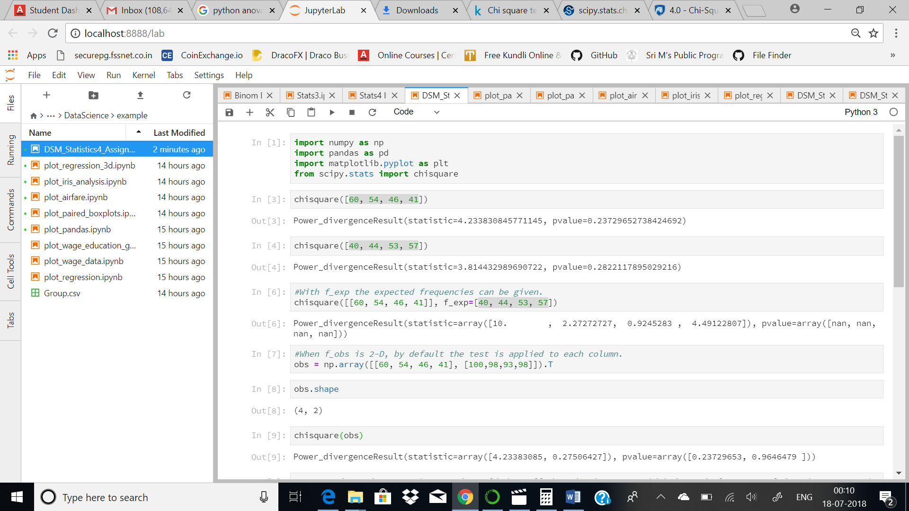

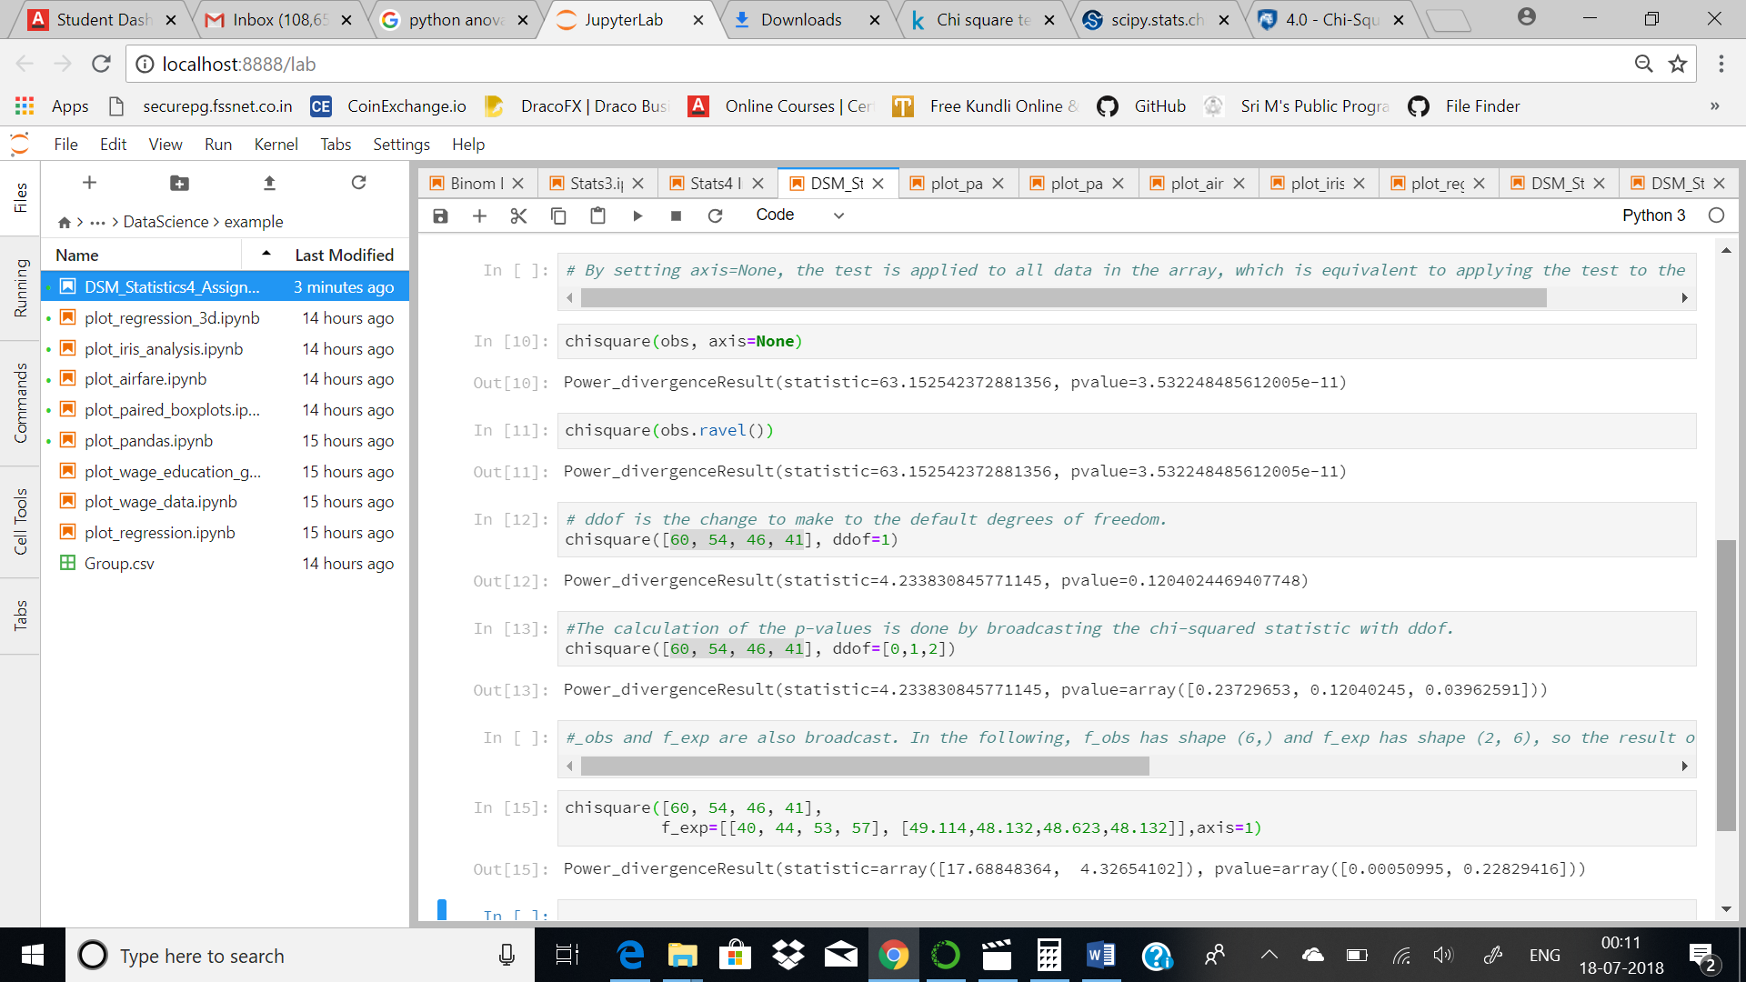

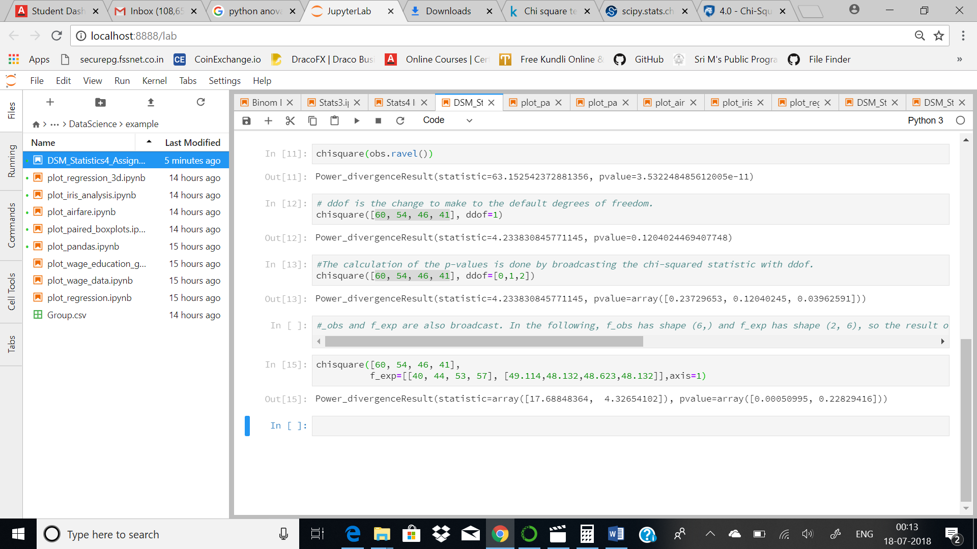

therefore we reject the null hypothesis and conclude that the education level depends on gender at a 5% level of significance.