**DSM_Statistics4_Assignment19.3**

**Problem Statement 1:**

**Calculate F Test for given 10, 20, 30, 40, 50 and 5,10,15, 20, 25.**

**For 10, 20, 30, 40, 50:**

**Solution: Explanation-**

F Test is generally defined as ratio of the variances of the given two set of values. First [calculate standard deviation](http://ncalculators.com/statistics/mean-standard-deviation-calculator.htm) and variation of the given set of values. The formula used to calculate SD is,   
**Standard Deviation Formula**   
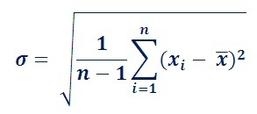   
The standard deviation is represented by the symbol ᵟ and variance is square of the standard deviation.   
The formula used to calculate F Test is,   
**F Test Formula**   
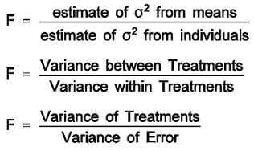   
  
**Calculate Variance of first set**   
  
**Calculate Variance of second set**   
  
**To calculate F Test**   
F Test = (variance of 10, 20,30,40,50) / (variance of 5, 10, 15, 20, 25)   
= 200/50  
= 4.   
  
The F Test value is 4.   
  
