
School of Computing
Department of Artificial Intelligence and Machine Learning
DATA ANALYSIS ESSENTIALS
CORNERSTONE PROJECT
SALES DATA
ANALYSIS
Submitted in partial fulfilment of the requirements for the award of the
B.Tech. degree in Artificial Intelligence and Machine Learning
SUBMITTED BY
V.JASWANTH 25B11AI424
G.SATISH 25B11AI367
D.PRADEEP 25B11AI255
N.BADARINADH 25B11AI802
PROJECT GUIDE
Bh. Sai Venkata Ganesh
Assistant Professor, Department of AIML
ADITYA UNIVERSITY, SURAMPALEM
Academic Year 2026 – 2027

School of Computing
Department of Artificial Intelligence and Machine Learning
DATA ANALYSIS ESSENTIALS
CERTIFICATE
This is to certify that the Cornerstone project work entitled “SALES DATA ANALYSIS” is submitted by

V.JASWANTH 25B11AI424
G.SATISH 25B11AI367
D.PRADEEP 25B11AI255
N.BADARINADH 25B11AI802

in partial fulfilment of the requirements for the award of the B.Tech. degree in Artificial Intelligence and Machine Learning during the academic year 2026–2027.

Project Guide  Bh. Sai Venkata Ganesh  Assistant Professor  Department of AIML | Head of the Department  Dr. K. Naga Bhargavi, Ph.D  Associate Professor & HOD  Department of AIML
DECLARATION
We hereby declare that the project entitled “SALES DATA ANALYSIS” is our original work and is submitted to ADITYA UNIVERSITY, Surampalem, in partial fulfilment of the requirements for the award of the B.Tech. degree in Artificial Intelligence and Machine Learning.
We further declare that this project work has not been submitted, either in full or in part, for the award of any degree or diploma in this or any other institution. We also confirm that this work has been carried out with academic honesty and complies with the Institutional Academic Integrity and AI Usage Policy.

Place: Surampalem
Date: ____ / ____ / 2026
V.JASWANTH 25B11AI424
G.SATISH 25B11AI367
D.PRADEEP 25B11AI255
N.BADARINADH 25B11AI802
ACKNOWLEDGEMENT
It is with immense pleasure that we express our sincere gratitude to our Cornerstone Project Guide, Bh. Sai Venkata Ganesh, Assistant Professor, who has guided us throughout the project. His valuable support, encouragement and guidance have greatly contributed to the successful completion of this work.
We would like to thank our Deputy Heads of the Department, Dr. Bollu Manikyala Rao, Assistant Professor and Dr. Dasari Veeraswamy, Assistant Professor, Department of AIML, for their support and valuable suggestions.
Our deepest thanks to our Head of the Department, Dr. K. Naga Bhargavi, Associate Professor & HOD, for her inspiration and for providing all the necessary facilities and resources required for this project.
We also extend our sincere thanks to Dr. M.V. Rajesh, Associate Dean, School of Computing, for his encouragement and support during our project.
We would like to express our sincere gratitude to Dr. G. Suresh, Registrar; Dr. A. Ramesh, Pro Vice-Chancellor (Engineering & Sciences); Dr. S. Rama Sree, Pro Vice-Chancellor (Academics); Dr. M.B. Srinivas, Vice-Chancellor; and Dr. M. Sreenivasa Reddy, Deputy Pro Chancellor and Management, Aditya University, for providing excellent infrastructure and state-of-the-art laboratories.
Finally, we would like to thank the faculty members, lab technicians, non-teaching staff and our friends who have directly or indirectly supported us in completing this Cornerstone project successfully.
ABSTRACT
Businesses record what they sell every day, yet reading those records line by line rarely shows which products and regions bring in the money. Sales Data Analysis builds a Python workflow that creates a sales dataset of 10 products with their units sold, price and region, calculates the total sales of each product, saves the data as a CSV file and summarises the patterns it contains.
The dataset has 10 records and 5 columns and no missing values, so no cleaning was needed. Statistical analysis with NumPy and Pandas showed total sales of 70,100, an average of 7,010 and a median of 4,200 per product, with an average of 30.7 units sold. Four visualisations, a histogram, a bar chart, a scatter plot and a pie chart, revealed that Laptop and Mobile earn 20,000 each, which is 57.1 % of all sales, that the North and South regions together generate 82.0 % of sales, and that the products sold in the largest numbers, Mouse and Keyboard, earn the least.
Finally, a rule-based sales-performance module was built in Python. It reads a product name, the units sold and the price at run time, calculates the total sales and reports HIGH when the total is 10,000 or more and LOW otherwise. The project demonstrates the full analytics journey from data creation to a simple decision rule and offers a foundation for larger sales dashboards.
TABLE OF CONTENTS
1 Title Page i
2 Certificate ii
3 Declaration iii
4 Acknowledgement iv
5 Abstract v
6 Table of Contents vi
7 List of Figures viii
8 List of Tables ix
Chapter 1 Introduction 1
1.1 Introduction to the Project 1
1.2 Problem Statement 1
1.3 Objectives of the Project 1
1.4 Scope of the Project 2
Chapter 2 Dataset Description and Understanding 3
2.1 Dataset Source 3
2.2 Dataset Description 4
2.3 Features / Attributes 4
2.4 Target Variable 4
2.5 Dataset Statistics / Initial Exploration 5
2.6 Data Quality Assessment 6
2.7 Ethical Use and Licence of the Data 7
Chapter 3 Data Preprocessing 8
3.1 Data Collection / Loading 8
3.2 Handling Missing Values 8
3.3 Handling Duplicate / Inconsistent Data 8
3.4 Feature Scaling 9
3.5 Standardization 9
3.6 Label Encoding 9
3.7 One-Hot Encoding 9
3.8 Other Project-Specific Preprocessing 9
Chapter 4 System Design and Methodology 10
4.1 Proposed Methodology 10
4.2 System Workflow / Architecture 10
4.3 Flowchart 11
4.4 Tools and Technologies Used 12
4.5 Algorithm / Prediction Logic Used 13
Chapter 5 Implementation 14
5.1 Development Environment 14
5.2 Dataset Creation and Loading 14
5.3 Data Inspection Implementation 14
5.4 Statistical and Exploratory Data Analysis (EDA) 14
5.5 Prediction Module Implementation 15
5.6 Important Code Explanation 15
Chapter 6 Data Visualization and Results 16
6.1 Histogram 16
6.2 Bar Chart 17
6.3 Scatter Plot 17
6.4 Pie Chart 18
6.5 Interpretation of Visualizations 19
Chapter 7 Prediction Module and Analysis of Results 21
7.1 Prediction Rules 21
7.2 Sample Predictions 21
7.3 Result Interpretation 21
7.4 Discussion 22
Chapter 8 Output Screenshots 23
8.1 Input / Dataset Screenshots 23
8.2 Preprocessing Outputs 24
8.3 Statistical Analysis Outputs 24
8.4 Prediction / Analysis Outputs 26
Chapter 9 Conclusion and Future Enhancements 27
9.1 Conclusion 27
9.2 Limitations 27
9.3 Future Enhancements 27
References 29
Appendix – Source Code 30
LIST OF FIGURES
Figure 2.1 Steps to create and load the sales dataset 3
Figure 4.1 Layered architecture of the Sales Data Analysis system 11
Figure 4.2 Flowchart of the project workflow 12
Figure 6.1 Units Sold Distribution 16
Figure 6.2 Total Sales by Product 17
Figure 6.3 Price vs Units Sold 18
Figure 6.4 Sales Percentage by Region 19
Figure 8.1 Preview of the dataset file sales_data.csv 23
Figure 8.2 Output of Steps 1 to 4: file created and dataset displayed 23
Figure 8.3 Dataset information: shape, columns, data types and missing values 24
Figure 8.4 Output of the NumPy analysis 24
Figure 8.5 Output of the Pandas analysis 25
Figure 8.6 Prediction output for the input Laptop, 25, 800 (HIGH) 26
Figure 8.7 Prediction output for the input Mouse, 60, 20 (LOW) 26
LIST OF TABLES
Table 2.1 Attributes of the sales dataset 4
Table 2.2 Sales performance label of the dataset products (threshold 10,000) 5
Table 2.3 Descriptive statistics of numerical attributes (df.describe()) 5
Table 2.4 Commands used for the initial exploration 6
Table 2.5 Data quality assessment of the dataset 6
Table 3.1 Missing values in each column 8
Table 3.2 Dataset condition before saving and after reloading from CSV 9
Table 4.1 Hardware requirements 12
Table 4.2 Software requirements and libraries 13
Table 5.1 Key code elements and their purpose 15
Table 6.1 Number of products in each bin of the histogram (UnitsSold) 16
Table 6.2 Total sales by region 19
Table 6.3 Products ranked by total sales 20
Table 7.1 Sample predictions from the sales-performance module 21

CHAPTER 1
INTRODUCTION

1.1 Introduction to the Project
Every business records what it sells: which products move, in what quantity, at what price and in which region. Reading those records line by line is slow and rarely shows where the money is really coming from. Data analysis turns the same records into totals, averages and charts that a manager can read in a minute.
Sales Data Analysis is a Python-based data analytics project developed as the Cornerstone project of the Data Analysis Essentials course. It builds a sales dataset of 10 products with their units sold, unit price and sales region, calculates the total sales of every product, stores the data as a CSV file and then studies it with NumPy, Pandas and Matplotlib. The project ends with a small sales-performance module that takes a product name, units sold and price at run time and reports whether the sales are HIGH or LOW.
The project is end-to-end. It follows the stages of any real data-analysis assignment: data creation, storage, loading, inspection, statistical analysis, visualisation and a simple decision rule. Every stage is supported by code, the output produced by that code, and a written explanation.

1.2 Problem Statement
Sales figures kept as plain lists or spreadsheets make it hard to answer basic questions quickly: Which products earn the most? Which region contributes the largest share of revenue? Do cheaper products sell in larger numbers? Is a given sale large enough to be called a good result? Manual calculation is slow, error-prone and gives no picture of the overall pattern.
The problem addressed by this project is therefore to organise product-wise sales data, calculate the total sales, summarise it with statistical measures, present it through clear charts and provide a basic rule that classifies the sales performance of a product as HIGH or LOW.

1.3 Objectives of the Project
- To create a sales dataset with Product, UnitsSold, Price and Region and to derive the TotalSales of every product.
- To save the dataset as a CSV file and read it back with Pandas.
- To inspect the dataset: shape, column names, data types and missing values.
- To calculate the average, maximum, minimum, median and standard deviation using NumPy.
- To use Pandas for summary statistics, product counts, region-wise counts and region-wise total sales.
- To present the data with a histogram, bar chart, scatter plot and pie chart.
- To build a simple sales-performance check that labels a sale as HIGH or LOW from the units sold and the price entered by the user.

1.4 Scope of the Project
The project covers the complete analysis pipeline on a single, fixed dataset of 10 records and 5 attributes. Its scope includes dataset creation, CSV storage, data inspection, statistical analysis with NumPy and Pandas, four types of visualisation and one rule-based sales-performance check with run-time input.
The following are outside the scope of this work: very large or real-time sales data, date-wise trend or forecasting models, deployment as a web application and a trained machine-learning model. These are discussed as future enhancements in Chapter 9.

CHAPTER 2
DATASET DESCRIPTION AND UNDERSTANDING

2.1 Dataset Source
Unlike projects that download a ready-made file, this project creates its own dataset inside the program. The sales records are typed into a Python dictionary, converted into a Pandas DataFrame and written to a file named sales_data.csv. The same file is then read back and used for every later stage. The records are sample values prepared for learning and are not taken from any real company.

2.1.1 Step-by-Step Process Followed to Obtain the Dataset
The steps below describe how the dataset file is produced and made ready for analysis. They are summarised in Figure 2.1.
- Create the data. A Python dictionary is written with four keys: Product, UnitsSold, Price and Region. Each key holds a list of 10 values, one per product.
- Build the DataFrame. pd.DataFrame(data) converts the dictionary into a table with 10 rows and 4 columns.
- Derive TotalSales. A fifth column is calculated with df["TotalSales"] = df["UnitsSold"] * df["Price"].
- Save as CSV. df.to_csv("sales_data.csv", index=False) writes the table to a file without the row-number column, and the message "sales_data.csv created successfully." is printed.
- Read the CSV file. pd.read_csv("sales_data.csv") loads the saved file into a new DataFrame, so every later step works on the data stored in the file.
- Begin inspection and analysis. The structure of the data is printed and the analysis of Chapters 3 to 7 is carried out.
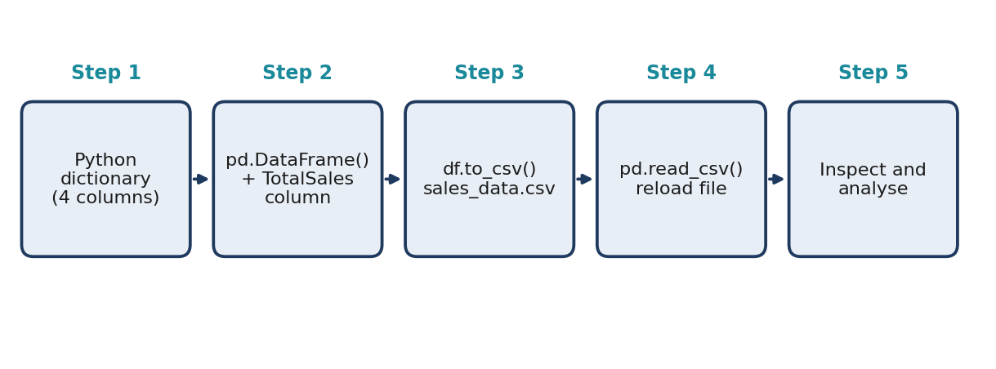
Figure 2.1: Steps to create and load the sales dataset

2.1.2 Files Used in the Project
- Python program (.py or notebook): contains the complete code listed in the Appendix.
- sales_data.csv: the dataset file created by the program, with 10 rows and 5 columns and no missing values. It is the input of the analysis stages.

2.2 Dataset Description
Each row of the dataset represents one product and each column represents one property of that product: its name, the number of units sold, the unit price, the sales region and the total sales amount. The dataset has 10 rows and 5 columns.

2.2.1 Characteristics of the Dataset
- Format: comma-separated values file (.csv), created by the program itself.
- Size: 10 product records and 5 attributes.
- Type of data: three numerical attributes (UnitsSold, Price, TotalSales) and two categorical attributes (Product, Region).
- Missing data: none. Every column has 0 missing values.
- Use in this project: descriptive statistics, visualisation and a simple sales-performance check.

2.3 Features / Attributes
Table 2.1 lists every attribute of the dataset with its data type and the values observed in the data. The prices in the code carry no currency symbol, so they are treated as plain currency units.
Table 2.1: Attributes of the sales dataset
S.No | Attribute | Type | Description and observed range
1 | Product | Categorical | Name of the product (10 different products, Laptop to Headphones)
2 | UnitsSold | Numerical | Number of units sold (12 to 60)
3 | Price | Numerical | Price of one unit (20 to 800)
4 | Region | Categorical | Sales region: North, South, East or West
5 | TotalSales | Numerical (derived) | UnitsSold × Price (1,200 to 20,000)

2.3.1 Categorical and Numerical Attributes
Categorical attributes such as Product and Region are used to name, count and group the records. Numerical attributes such as UnitsSold, Price and TotalSales are used to calculate means, medians, standard deviations and totals, and to draw the charts of Chapter 6.

2.4 Target Variable
This project does not train a classification model, so there is no stored target column. The key measure is TotalSales, which tells how much each product earned. The sales-performance module of Chapter 7 turns this measure into a label: a total of 10,000 or more is HIGH and anything lower is LOW.
Applying the same threshold to the 10 products of the dataset, only Laptop (20,000) and Mobile (20,000) reach HIGH, as shown in Table 2.2. Eight of the ten products are LOW, so a few products carry most of the revenue.
Table 2.2: Sales performance label of the dataset products (threshold 10,000)
Label | Meaning | Products | Percentage
HIGH | TotalSales ≥ 10,000 | 2 (Laptop, Mobile) | 20 %
LOW | TotalSales < 10,000 | 8 (the remaining products) | 80 %
Total |  | 10 | 100 %

2.5 Dataset Statistics / Initial Exploration
The first inspection of the dataset gives these facts: it has 10 rows and 5 columns, there are no missing values, three columns are numerical and two are text. Total sales of all products add up to 70,100, the average sales per product is 7,010 and the median is 4,200. Table 2.3 summarises the numerical attributes exactly as printed by df.describe().
Table 2.3: Descriptive statistics of numerical attributes (df.describe())
Attribute | Mean | Std. Dev. | Min | 25 % | Median | 75 % | Max
UnitsSold | 30.70 | 15.64 | 12 | 19.00 | 27.50 | 38.75 | 60
Price | 289.00 | 263.67 | 20 | 85.00 | 225.00 | 450.00 | 800
TotalSales | 7,010.00 | 7,079.93 | 1,200 | 2,850.00 | 4,200.00 | 6,775.00 | 20,000

Two observations deserve attention. First, the mean TotalSales (7,010) is much larger than the median (4,200), which tells us that a few large values pull the average upwards; the two top products earn 20,000 each. Second, the standard deviation of TotalSales (7,079.93) is almost as large as its mean, so product earnings differ widely.

2.5.1 Commands Used for Initial Exploration
The initial inspection of the dataset was carried out with the following commands (Step 5 of the code). Table 2.4 explains what each command tells us.
print("\nShape :", df.shape)
print(df.columns)
print(df.dtypes)
print(df.isnull().sum())

Table 2.4: Commands used for the initial exploration
Command | What it tells us
df.shape | Number of rows and columns (10 and 5)
df.columns | Names of the five columns
df.dtypes | Data type of each column (object for text, int64 for numbers)
df.isnull().sum() | Number of missing values in each column (0 in every column)
df.describe() | Count, mean, standard deviation, minimum, quartiles and maximum of the numerical columns

2.5.2 Observations from the Initial Exploration
- The dataset has three numerical columns, so means, medians and totals can be calculated.
- All text columns (Product and Region) are stored as the object data type; the numerical columns are stored as int64.
- There are no missing values, so no cleaning step is required.
- Every product name appears exactly once, so each row describes a different product.

2.6 Data Quality Assessment
Before a dataset is used, its quality must be judged. The dataset was assessed with five common data-quality dimensions, summarised in Table 2.5.
Table 2.5: Data quality assessment of the dataset
Dimension | How it was checked | Finding
Completeness | df.isnull().sum() | No missing values in any of the 5 columns
Uniqueness | df["Product"].value_counts() | Every product occurs once, so no repeated product rows
Consistency | df.dtypes and the values printed | Numbers are stored as int64 and text as object; Region contains only North, South, East and West
Validity | Comparing TotalSales with UnitsSold × Price | TotalSales is calculated by the program, so it always matches the other two columns
Timeliness | Looking for a date column | Not applicable: the dataset has no date field

The checks show that the dataset is complete and consistent. Its limitation is size: with only 10 records, the findings describe this sample and should not be generalised to a whole business.

2.7 Ethical Use and Licence of the Data
The dataset is created by the program itself from sample values. It contains no names, addresses or other personal details of customers, and it is not copied from any company record, so no external licence applies. The data is used only for academic learning, and the results are described as patterns in the sample data and not as a statement about any real business.

CHAPTER 3
DATA PREPROCESSING

3.1 Data Collection / Loading
The dataset is first created as a Python dictionary and converted into a DataFrame. It is then saved with to_csv and loaded back with read_csv. After loading, the DataFrame is printed in full and its shape, column names, data types and missing values are displayed. This inspection records the starting condition of the data.
df = pd.read_csv("sales_data.csv")
print("Sales Dataset\n")
print(df)

3.2 Handling Missing Values
The check df.isnull().sum() returned 0 for every column, as shown in Table 3.1. The dataset therefore has no missing values, and neither median imputation nor mode imputation nor deletion of rows was necessary.
Table 3.1: Missing values in each column
Column | Type | Missing values | Action needed
Product | Categorical | 0 | None
UnitsSold | Numerical | 0 | None
Price | Numerical | 0 | None
Region | Categorical | 0 | None
TotalSales | Numerical | 0 | None

3.3 Handling Duplicate / Inconsistent Data
The program does not contain a separate duplicate-row command. However, the output of df["Product"].value_counts() shows a count of 1 for each of the 10 products, so no product is repeated and no record needs to be removed. The dataset remains at 10 rows.
For consistency, the data types were compared with the expected types: UnitsSold, Price and TotalSales are integers and Product and Region are text. The Region column holds only the four expected values. No inconsistent entries were found. Table 3.2 compares the dataset before and after saving it to the CSV file and reading it back.
Table 3.2: Dataset condition before saving and after reloading from CSV
Check | Before (DataFrame) | After (read_csv)
Rows | 10 | 10
Columns | 5 | 5
Missing values | 0 | 0
Total of TotalSales | 70,100 | 70,100

3.4 Feature Scaling
The numerical attributes lie on different scales: Price goes up to 800, UnitsSold up to 60 and TotalSales up to 20,000. Feature scaling was not applied. The project reports totals, averages and charts in the original units, so that each value can be read directly as a number of units or an amount of sales, and no distance-based model is used that would need scaled inputs.

3.5 Standardization
Standardisation, which converts every feature to a mean of 0 and a standard deviation of 1, was not applied either. All attributes are kept in their original units, so the threshold of 10,000 used by the sales-performance rule and the totals reported in Chapter 6 can be compared directly with the data.

3.6 Label Encoding
Label encoding was not applied. Product and Region remain as text in the dataset. They are used only to name and group records, and the performance result is displayed as the words HIGH and LOW, so no numeric conversion of any text column is needed.

3.7 One-Hot Encoding
One-hot encoding was not applied. The Region column could be expanded into four yes/no columns if a machine-learning model were trained later, but the present project uses groupby and value_counts directly on the text values.

3.8 Other Project-Specific Preprocessing
- Derived column: TotalSales is created by multiplying UnitsSold by Price before the data is saved.
- CSV round trip: the DataFrame is saved with index=False so that no extra index column is stored, and it is read back with read_csv before the analysis starts.
- Type conversion of run-time input: the units sold and the price entered by the user are converted with int() before the total is calculated.
- NumPy arrays: the UnitsSold and TotalSales columns are converted to NumPy arrays with .values for the statistical calculations.

CHAPTER 4
SYSTEM DESIGN AND METHODOLOGY

4.1 Proposed Methodology
The proposed system replaces manual sales calculation with an automated Python pipeline. The methodology is organised into six modules that follow one another, each producing a verifiable output:
- Dataset creation: import the libraries, create the sales dictionary and the DataFrame, calculate TotalSales and save sales_data.csv.
- Data loading and exploration: read the CSV file and check shape, column names, data types and missing values.
- Statistical analysis with NumPy: average, maximum, minimum, median and standard deviation of units sold, and average, maximum and minimum of total sales.
- Analysis with Pandas: describe(), product counts, region-wise counts and region-wise total sales.
- Visualisation: draw a histogram, a bar chart, a scatter plot and a pie chart.
- Sales-performance check: read a product name, units sold and price, calculate the total and print HIGH or LOW.

4.2 System Workflow / Architecture
Figure 4.1 shows the layered architecture of the system. Data moves from the input layer through loading, analysis and visualisation into the prediction layer, and finally to the output layer where results, charts and the performance message are produced.
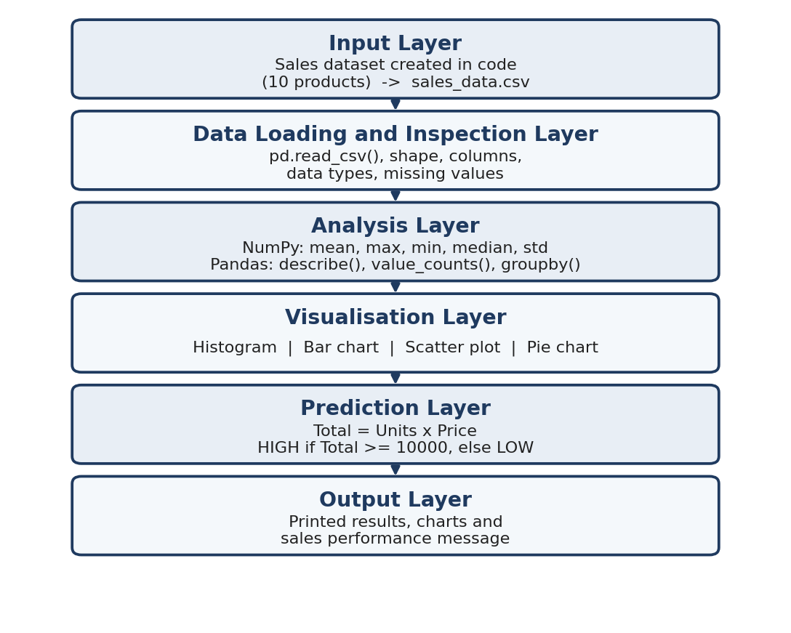
Figure 4.1: Layered architecture of the Sales Data Analysis system

4.3 Flowchart
The flowchart in Figure 4.2 gives the step-by-step control flow of the program, including the decision taken on the total sales entered by the user.
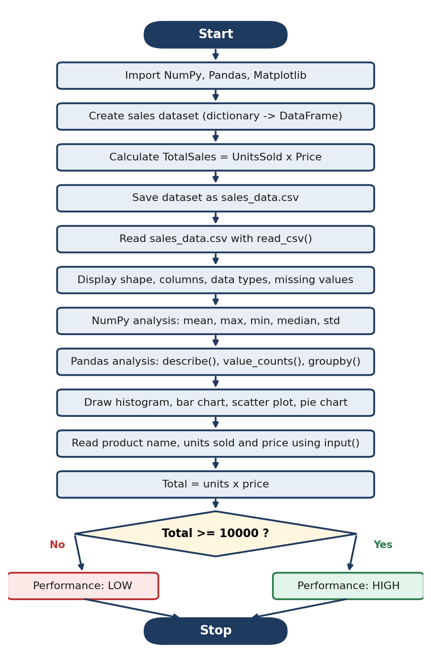
Figure 4.2: Flowchart of the project workflow

4.4 Tools and Technologies Used
The hardware and software requirements of the project are modest, because the dataset has only 10 records.
Table 4.1: Hardware requirements
Component | Requirement
Processor | Intel Core i3 or above
RAM | Minimum 4 GB
Storage | 20 GB
Input devices | Keyboard and mouse
Output device | Monitor

Table 4.2: Software requirements and libraries
Category | Tool / Library | Purpose
Operating system | Windows / Linux | Platform to run the Python environment
Language | Python 3 | Implementation of the whole pipeline
Environment | Google Colab / Jupyter Notebook / IDE | Running the code and viewing the printed output and charts
Data handling | Pandas, NumPy | Creating the DataFrame, CSV input and output, statistics
Visualisation | Matplotlib | Histogram, bar chart, scatter plot and pie chart
Decision logic | Python if-else | HIGH or LOW sales-performance decision

4.5 Algorithm / Prediction Logic Used
The prediction step uses a simple rule rather than a trained machine-learning model. It multiplies the units sold by the price to get the total sales of the entered product and compares that total with a fixed threshold of 10,000. The threshold is a manually chosen example and has not been optimised or validated on other data.
- Read the product name, the number of units sold and the price from the user with input().
- Convert the units and the price to integers with int().
- Calculate total = units * price.
- If total >= 10000, print "Sales Performance : HIGH".
- Otherwise, print "Sales Performance : LOW".
- Print "Project Completed Successfully." and stop.

CHAPTER 5
IMPLEMENTATION

5.1 Development Environment
The project is implemented in Python 3 using the libraries NumPy, Pandas and Matplotlib. The code can be run in Google Colab, a Jupyter Notebook or any Python IDE, because it needs no files other than the sales_data.csv that it creates for itself. The complete listing is given in the Appendix, and the code is organised in twelve numbered steps.

5.2 Dataset Creation and Loading
The sales data is stored in a dictionary and converted into a DataFrame. TotalSales is calculated, the table is saved as a CSV file and then read back:
df = pd.DataFrame(data)
df["TotalSales"] = df["UnitsSold"] * df["Price"]
df.to_csv("sales_data.csv", index=False)
df = pd.read_csv("sales_data.csv")

5.3 Data Inspection Implementation
The structure of the dataset is printed with four commands: df.shape, df.columns, df.dtypes and df.isnull().sum(). Because the data is created inside the program, no cleaning step follows; the missing-value count of 0 in every column confirms that the data is ready for analysis.

5.4 Statistical and Exploratory Data Analysis (EDA)
The NumPy analysis converts the UnitsSold and TotalSales columns to arrays and applies the NumPy functions. The Pandas analysis then prints the summary table, the product counts, the region counts and the region-wise total sales:
units = df["UnitsSold"].values
sales = df["TotalSales"].values
print("Average Units Sold :", np.mean(units))
print("Median Units Sold :", np.median(units))
print("Standard Deviation :", np.std(units))
print(df.describe())
print(df.groupby("Region")["TotalSales"].sum())

Four charts are then drawn with Matplotlib. A sample of the code for the bar chart is shown below; the other charts follow the same structure.
plt.figure(figsize=(8,4))
plt.bar(df["Product"], df["TotalSales"])
plt.title("Total Sales by Product")
plt.xlabel("Product")
plt.ylabel("Total Sales")
plt.xticks(rotation=45)
plt.show()

5.5 Prediction Module Implementation
The prediction module asks the user for three values, converts the numbers to integers, calculates the total and prints the performance label:
product = input("Enter Product Name : ")
units = int(input("Enter Units Sold : "))
price = int(input("Enter Price : "))

total = units * price
print("\nTotal Sales = ", total)

if total >= 10000:
print("Sales Performance : HIGH")
else:
print("Sales Performance : LOW")

5.6 Important Code Explanation
Table 5.1: Key code elements and their purpose
Code element | Purpose
pd.DataFrame(data) | Converts the dictionary into a table of 10 rows and 4 columns
df["UnitsSold"] * df["Price"] | Calculates the TotalSales column for every product
df.to_csv(..., index=False) | Saves the dataset as sales_data.csv without the row index
pd.read_csv() | Reads the saved CSV file back into a DataFrame
df.shape / df.dtypes / df.isnull().sum() | Show the size, data types and missing values of the dataset
np.mean / np.max / np.min / np.median / np.std | NumPy statistics of units sold and of total sales
df.describe() | Summary statistics of the numerical columns
value_counts() | Counts how many records each product and each region has
groupby("Region")["TotalSales"].sum() | Adds up the total sales of each region
plt.hist / plt.bar / plt.scatter / .plot(kind="pie") | Draw the histogram, bar chart, scatter plot and pie chart
input() and int() | Read the product, units and price entered by the user and convert the numbers
if total >= 10000 | Decides between HIGH and LOW sales performance

One small point about the code: the variable units first holds the NumPy array of units sold (Step 6) and is later reused for the number typed by the user (Step 12). This causes no problem because the NumPy analysis is completed before the variable is reassigned. The entered product name is read but is not used in the calculation; it only identifies the sale to the person running the program.

CHAPTER 6
DATA VISUALIZATION AND RESULTS
This chapter presents the four visualisations produced by the code, together with an interpretation of what each one shows. Every chart is drawn from the 10-record dataset stored in sales_data.csv.

6.1 Histogram
The histogram uses 5 bins to show how the units sold are distributed across the 10 products.
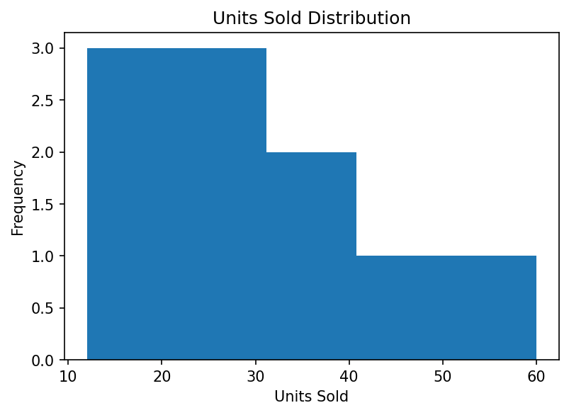
Figure 6.1: Units Sold Distribution
Interpretation: units sold range from 12 to 60, with a mean of 30.7 and a median of 27.5. The five bins contain 3, 3, 2, 1 and 1 products (Table 6.1). Six of the ten products sold fewer than 31.2 units, while only Mouse (60) and Keyboard (50) sold more than 40 units. The distribution therefore leans towards lower sales volumes with a short tail of high-volume products.
Table 6.1: Number of products in each bin of the histogram (UnitsSold)
Bin (units sold) | Products | Count
12.0 to 21.6 | Camera (12), Printer (15), Tablet (18) | 3
21.6 to 31.2 | Monitor (22), Laptop (25), Speaker (30) | 3
31.2 to 40.8 | Headphones (35), Mobile (40) | 2
40.8 to 50.4 | Keyboard (50) | 1
50.4 to 60.0 | Mouse (60) | 1

6.2 Bar Chart
The bar chart compares the total sales of the ten products.
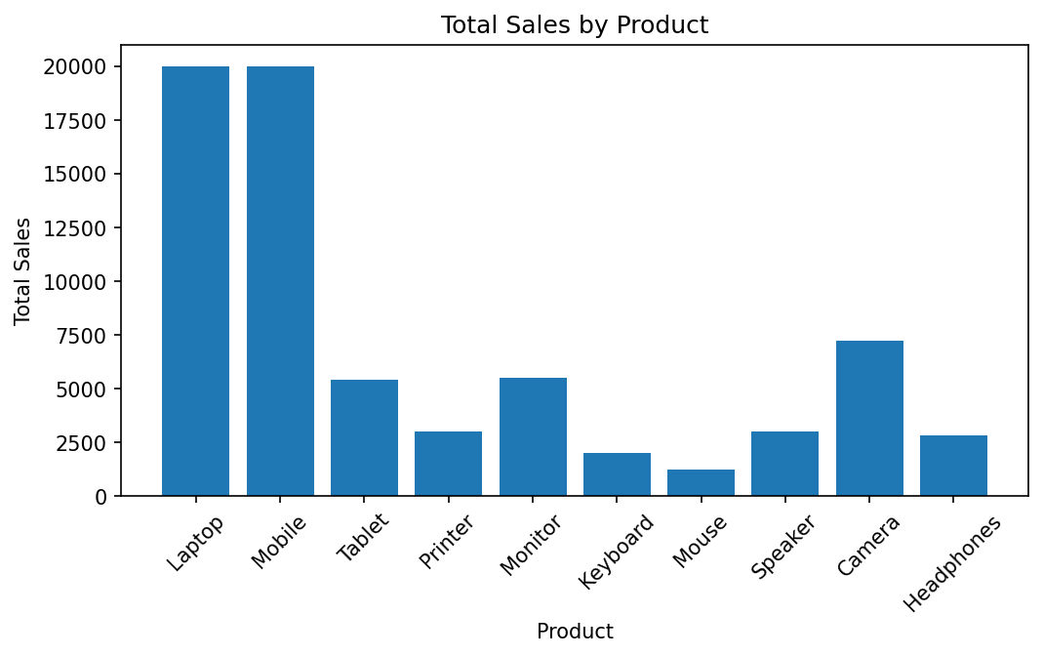
Figure 6.2: Total Sales by Product
Interpretation: Laptop and Mobile both reach 20,000 and stand far above the others. Camera follows at 7,200, then Monitor (5,500) and Tablet (5,400). Mouse has the lowest total sales (1,200), although it sold the most units. Total sales is therefore driven much more by price per unit than by the number of units sold.

6.3 Scatter Plot
The scatter plot places each product by its price (x-axis) and units sold (y-axis).
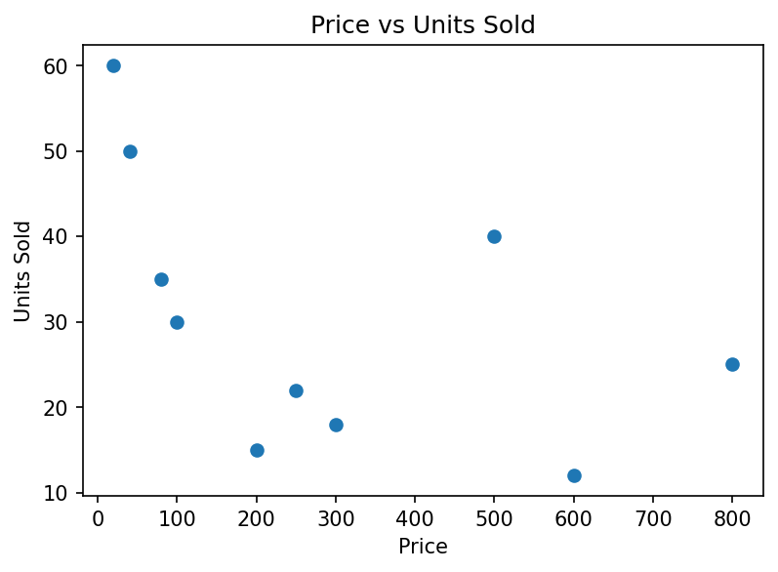
Figure 6.3: Price vs Units Sold
Interpretation: the points slope downwards from the top left to the bottom right. The four cheapest products (Mouse 20, Keyboard 40, Headphones 80 and Speaker 100) all sold 30 or more units, whereas Camera at price 600 sold only 12 and Laptop at price 800 sold 25. The correlation coefficient between price and units sold, calculated from the same data, is about -0.50, a moderate negative relationship. Mobile (price 500, 40 units) is the clearest exception. With only 10 points, the pattern is a tendency in this sample and not proof that price alone decides demand.

6.4 Pie Chart
The pie chart expresses the total sales of each region as a percentage of the overall total of 70,100.
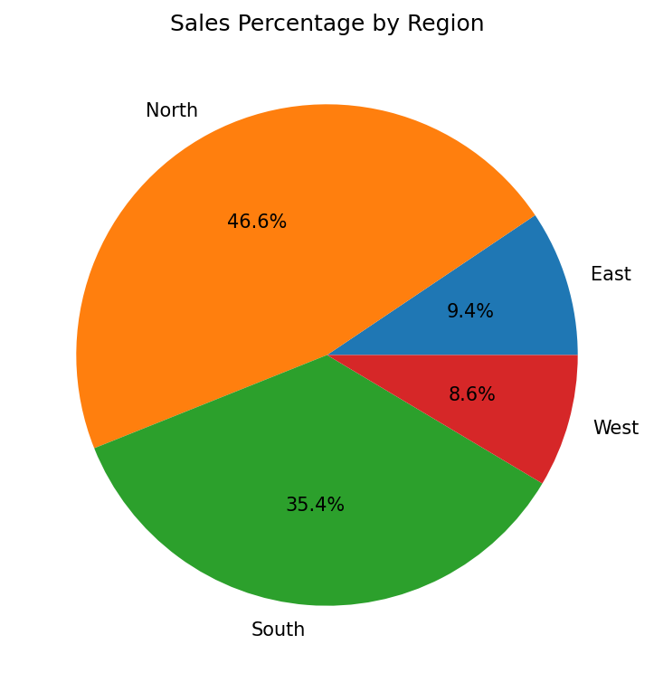
Figure 6.4: Sales Percentage by Region
Interpretation: North contributes 46.6 % of the sales and South 35.4 %, together 82.0 % of the total. East (9.4 %) and West (8.6 %) share the remaining 18.0 %. North leads because it holds both Laptop (20,000) and Camera (7,200), and South is second mainly because of Mobile (20,000).

6.5 Interpretation of Visualizations
To go beyond what the charts show visually, the region totals and the product ranking were tabulated. Table 6.2 gives the total sales by region, exactly as printed by the groupby command, together with each region's share. Table 6.3 ranks the products by total sales.
Table 6.2: Total sales by region
Region | Products | Total sales | Share of total
East | 2 | 6,600 | 9.4 %
North | 3 | 32,700 | 46.6 %
South | 3 | 24,800 | 35.4 %
West | 2 | 6,000 | 8.6 %
All regions | 10 | 70,100 | 100.0 %

Table 6.3: Products ranked by total sales
Rank | Product | Region | Units sold | Price | Total sales | Share
1 | Laptop | North | 25 | 800 | 20,000 | 28.5 %
2 | Mobile | South | 40 | 500 | 20,000 | 28.5 %
3 | Camera | North | 12 | 600 | 7,200 | 10.3 %
4 | Monitor | North | 22 | 250 | 5,500 | 7.8 %
5 | Tablet | East | 18 | 300 | 5,400 | 7.7 %
6 | Printer | West | 15 | 200 | 3,000 | 4.3 %
7 | Speaker | West | 30 | 100 | 3,000 | 4.3 %
8 | Headphones | South | 35 | 80 | 2,800 | 4.0 %
9 | Keyboard | South | 50 | 40 | 2,000 | 2.9 %
10 | Mouse | East | 60 | 20 | 1,200 | 1.7 %

The combined evidence from the charts and tables leads to the following descriptive findings. They describe this sample dataset and do not prove why customers buy:
- Revenue is concentrated: Laptop and Mobile together earn 40,000 of 70,100, which is 57.1 % of all sales, from only two of the ten products.
- Volume is not revenue: Mouse (60 units) and Keyboard (50 units) sold the most units but earned only 1,200 and 2,000, the two lowest totals.
- Price drives revenue: the five products priced 250 or more (Laptop, Mobile, Camera, Monitor and Tablet) hold the top five revenue ranks, while the five products priced 200 or less fill the bottom five.
- Two regions dominate: North and South together generate 82.0 % of total sales.
- Average hides the spread: the mean total sales per product is 7,010, but the median is 4,200, because two products earn almost three times the average.

CHAPTER 7
PREDICTION MODULE AND ANALYSIS OF RESULTS

7.1 Prediction Rules
The prediction module is a rule-based check. It takes the details of one sale and returns a performance label. It does not learn from the dataset; it applies a single rule:
- Inputs: product name (text), units sold (integer) and price (integer), entered by the user at run time.
- Calculation: total = units * price.
- Rule (HIGH): if total >= 10000, the output is "Sales Performance : HIGH".
- Default (LOW): if the total is below 10,000, the output is "Sales Performance : LOW".

7.2 Sample Predictions
The code was executed twice with different inputs; both results are shown in Chapter 8. Table 7.1 lists those two runs and four further inputs. Each further result follows directly from the rule in Section 7.1, and rows 5 and 6 show the boundary: a total of exactly 10,000 is HIGH because the condition uses "greater than or equal to".
Table 7.1: Sample predictions from the sales-performance module
S.No | Product | Units | Price | Total sales | Performance | Source
1 | Laptop | 25 | 800 | 20,000 | HIGH | Executed (Figure 8.6)
2 | Mouse | 60 | 20 | 1,200 | LOW | Executed (Figure 8.7)
3 | Mobile | 40 | 500 | 20,000 | HIGH | By the rule
4 | Printer | 15 | 200 | 3,000 | LOW | By the rule
5 | Monitor | 50 | 200 | 10,000 | HIGH | By the rule (boundary)
6 | Tablet | 33 | 300 | 9,900 | LOW | By the rule (just below)

7.3 Result Interpretation
The module is deterministic: the same units and price always give the same answer, and the answer can be traced to one comparison, which makes it easy to explain. In the first run, Laptop with 25 units at 800 gives a total of 20,000, which is above the threshold and is reported as HIGH. In the second run, Mouse with 60 units at 20 gives only 1,200 and is reported as LOW, even though 60 units is the highest volume in the dataset. This matches the finding of Chapter 6 that revenue depends on price as much as on volume.
The module is a demonstration only: it is a classification rule on a single sale and not a forecast of future sales, and no accuracy measure applies to it.

7.4 Discussion
The rule should be read with a few cautions. First, the threshold of 10,000 was chosen by hand and is not derived from the data; with it, only 2 of the 10 dataset products would be called HIGH. Second, the same threshold is applied to every product, so a low-priced product such as Mouse can never reach HIGH unless it sells 500 or more units. Third, the product name is not checked against the dataset, and int() rejects decimal input such as 12.5 with an error. Finally, both the rule and the analysis of Chapter 6 reflect a sample of only 10 records and should be used as a learning demonstration rather than a business decision tool.

CHAPTER 8
OUTPUT SCREENSHOTS
This chapter records the outputs produced by executing the project code on the dataset. The text panels in this chapter were generated by running the code of the Appendix and capturing everything it printed, and the four charts of Chapter 6 are the figures saved from the same run. They are not screenshots of a live Google Colab session. If your institution requires notebook screenshots, capture them after running the final code in your own environment.

8.1 Input / Dataset Screenshots
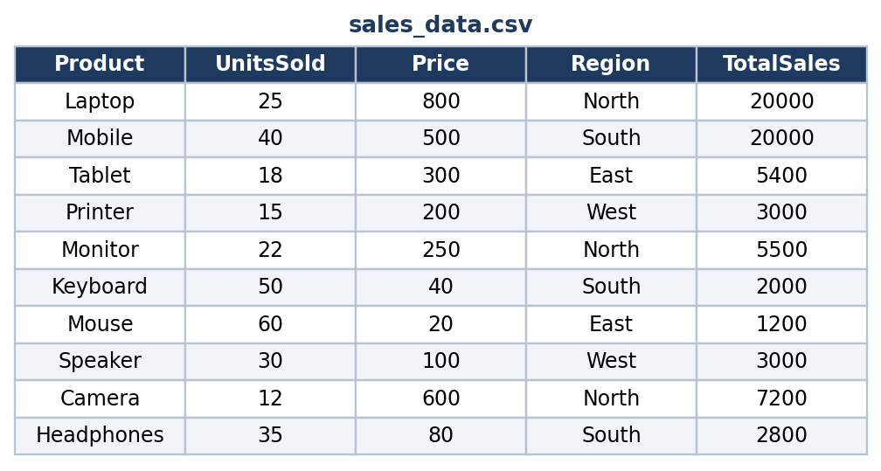
Figure 8.1: Preview of the dataset file sales_data.csv
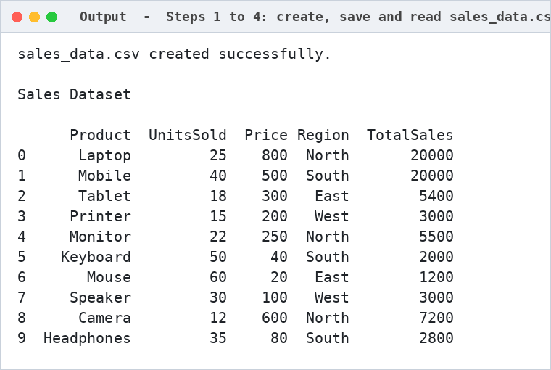
Figure 8.2: Output of Steps 1 to 4: file created and dataset displayed

8.2 Preprocessing Outputs
Figure 8.3 shows the printed dataset information: shape, columns, data types and missing values.
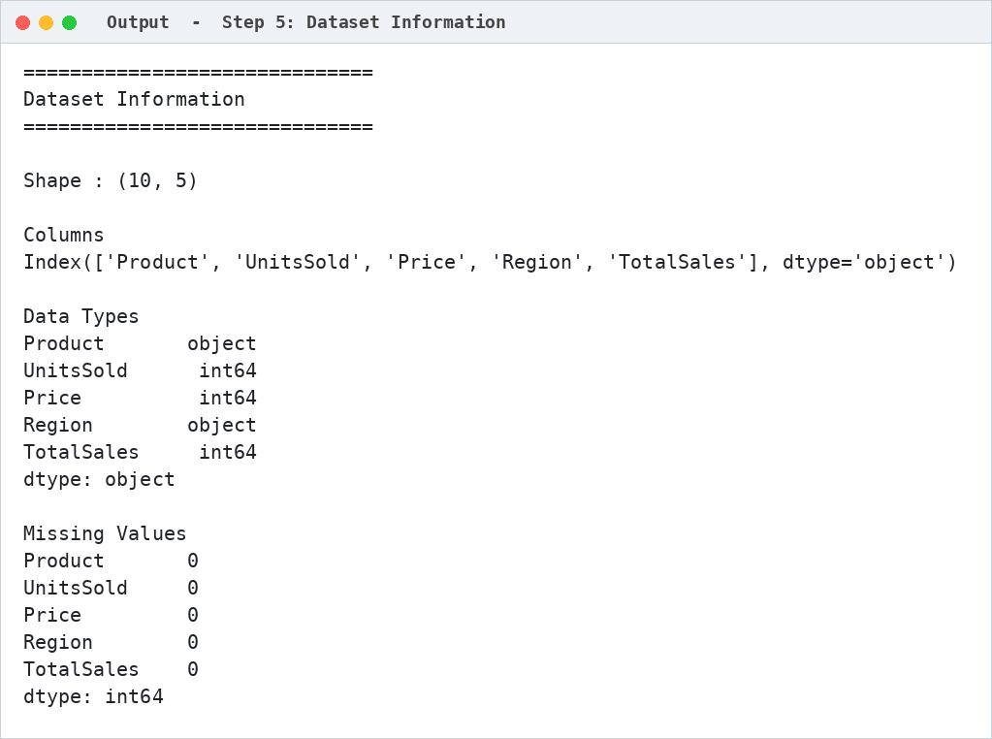
Figure 8.3: Dataset information: shape, columns, data types and missing values

8.3 Statistical Analysis Outputs
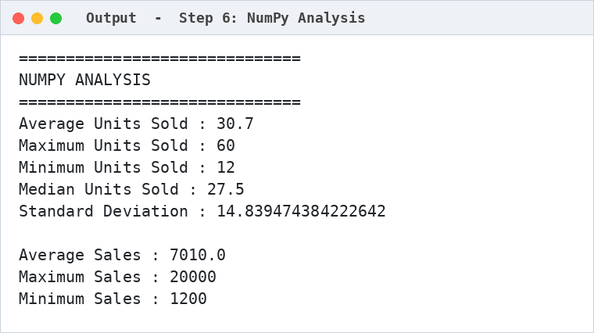
Figure 8.4: Output of the NumPy analysis
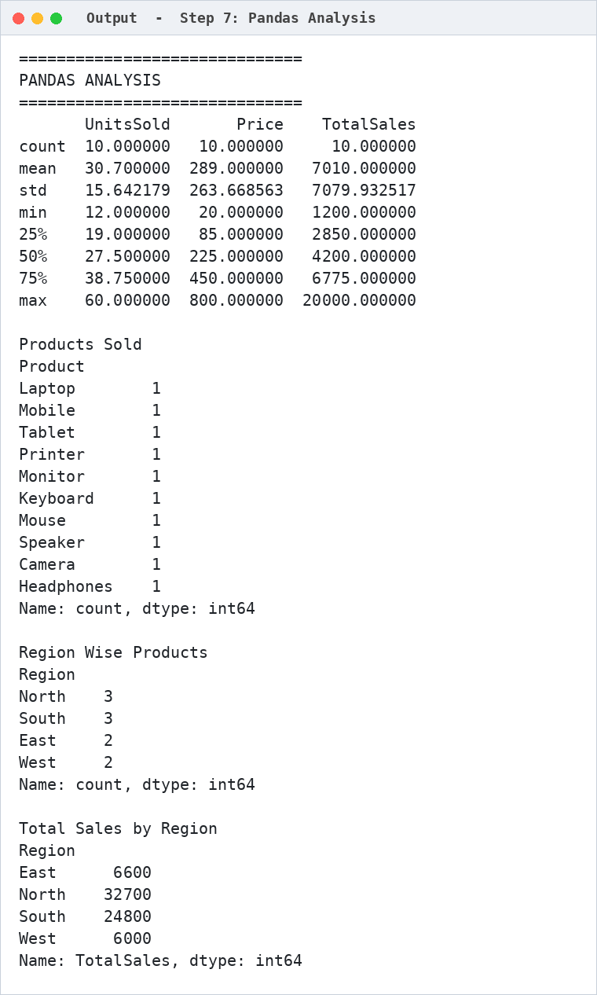
Figure 8.5: Output of the Pandas analysis
The four charts produced by the code (Figures 6.1 to 6.4) are shown in Chapter 6.
A note on the two standard deviations: NumPy's np.std divides by n and gives 14.84 for units sold, while Pandas' describe() divides by n - 1 and gives 15.64. Both are correct; they use the population and the sample formula respectively.

8.4 Prediction / Analysis Outputs
Figure 8.6 shows a run of the prediction module with the inputs Laptop, 25 units and a price of 800, and Figure 8.7 a run with Mouse, 60 units and a price of 20.
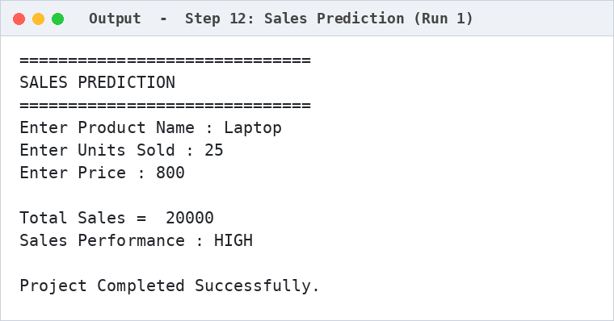
Figure 8.6: Prediction output for the input Laptop, 25, 800 (HIGH)
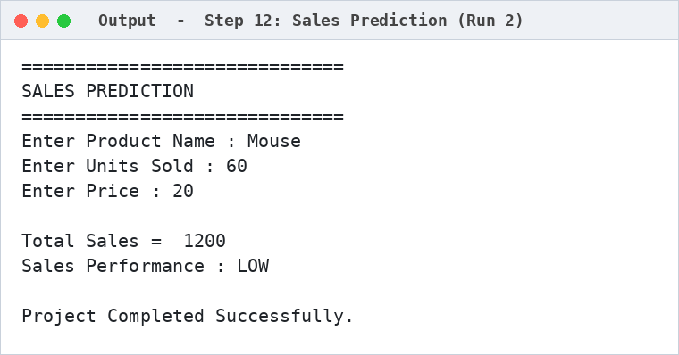
Figure 8.7: Prediction output for the input Mouse, 60, 20 (LOW)

CHAPTER 9
CONCLUSION AND FUTURE ENHANCEMENTS

9.1 Conclusion
This project demonstrated a complete data-analysis pipeline for sales data, from creating a dataset and saving it as a CSV file, through inspection and statistical analysis with NumPy and Pandas, to visualisation and a simple rule-based performance check. The dataset of 10 products and 5 attributes had no missing values. Total sales amounted to 70,100, with an average of 7,010 and a median of 4,200 per product.
The analysis showed that revenue is concentrated: Laptop and Mobile contribute 20,000 each, 57.1 % of all sales. The North region (46.6 %) and the South region (35.4 %) produce 82.0 % of the sales. Products that sell in large numbers, such as Mouse and Keyboard, bring in the least revenue, and price and units sold show a moderate negative relationship (about -0.50) in this sample.
A rule-based sales-performance module was then implemented. It multiplies the units sold by the price entered at run time and returns HIGH when the total is 10,000 or more and LOW otherwise. The project therefore achieved its objectives of building, analysing and visualising the sales data and providing a basic performance check.

9.2 Limitations
- The dataset is small: only 10 records, one record per product, and it was typed into the program and not collected from a real business.
- The data has no date column, so monthly trends, seasonality and growth cannot be studied.
- The performance rule uses a single fixed threshold of 10,000 for every product and is not learned from the data.
- The product name entered by the user is not used in the calculation or checked against the dataset, and decimal inputs for units or price are not accepted.
- The module classifies a sale as HIGH or LOW; it does not forecast future sales.
- The program runs in the notebook or console and has no graphical user interface.

9.3 Future Enhancements
- Use a larger real sales dataset with a date column, study monthly and yearly trends with line charts, and forecast future sales with a regression model (for example, linear regression in scikit-learn).
- Add input validation, accept decimal values and look the product up in the dataset.
- Set the HIGH/LOW threshold from the data (for example, from the median or a percentile) instead of a fixed number.
- Include more features such as customer segment, discount and cost, so that profit can be analysed as well as revenue.
- Build an interactive dashboard (for example, with Streamlit) so that a manager can filter by region and product.

REFERENCES
[1] W. McKinney, "Data Structures for Statistical Computing in Python," in Proceedings of the 9th Python in Science Conference, 2010, pp. 56–61.
[2] C. R. Harris et al., "Array programming with NumPy," Nature, vol. 585, pp. 357–362, 2020.
[3] J. D. Hunter, "Matplotlib: A 2D Graphics Environment," Computing in Science & Engineering, vol. 9, no. 3, pp. 90–95, 2007.
[4] Pandas Development Team, "pandas documentation," https://pandas.pydata.org/docs/
[5] NumPy Developers, "NumPy documentation," https://numpy.org/doc/
[6] Matplotlib Development Team, "Matplotlib documentation," https://matplotlib.org/stable/
[7] Google, "Colaboratory: Frequently asked questions," https://research.google.com/colaboratory/faq.html

APPENDIX – SOURCE CODE
The complete source code of the project is given below. It creates the dataset, saves and reads sales_data.csv, performs the NumPy and Pandas analysis, draws the four charts and runs the sales-performance check.
import numpy as np
import pandas as pd
import matplotlib.pyplot as plt

# ---------------------------------------
# Step 1 : Create Sales Dataset
# ---------------------------------------

data = {
"Product": ["Laptop", "Mobile", "Tablet", "Printer", "Monitor",
"Keyboard", "Mouse", "Speaker", "Camera", "Headphones"],

"UnitsSold": [25, 40, 18, 15, 22,
50, 60, 30, 12, 35],

"Price": [800, 500, 300, 200, 250,
40, 20, 100, 600, 80],

"Region": ["North", "South", "East", "West", "North",
"South", "East", "West", "North", "South"]
}

df = pd.DataFrame(data)

# ---------------------------------------
# Step 2 : Calculate Total Sales
# ---------------------------------------

df["TotalSales"] = df["UnitsSold"] * df["Price"]

# ---------------------------------------
# Step 3 : Save Dataset as CSV
# ---------------------------------------

df.to_csv("sales_data.csv", index=False)

print("sales_data.csv created successfully.\n")

# ---------------------------------------
# Step 4 : Read CSV File
# ---------------------------------------

df = pd.read_csv("sales_data.csv")

print("Sales Dataset\n")
print(df)

# ---------------------------------------
# Step 5 : Dataset Information
# ---------------------------------------

print("\n==============================")
print("Dataset Information")
print("==============================")

print("\nShape :", df.shape)

print("\nColumns")
print(df.columns)

print("\nData Types")
print(df.dtypes)

print("\nMissing Values")
print(df.isnull().sum())

# ---------------------------------------
# Step 6 : Statistical Analysis using NumPy
# ---------------------------------------

units = df["UnitsSold"].values
sales = df["TotalSales"].values

print("\n==============================")
print("NUMPY ANALYSIS")
print("==============================")

print("Average Units Sold :", np.mean(units))
print("Maximum Units Sold :", np.max(units))
print("Minimum Units Sold :", np.min(units))
print("Median Units Sold :", np.median(units))
print("Standard Deviation :", np.std(units))

print("\nAverage Sales :", np.mean(sales))
print("Maximum Sales :", np.max(sales))
print("Minimum Sales :", np.min(sales))

# ---------------------------------------
# Step 7 : Pandas Analysis
# ---------------------------------------

print("\n==============================")
print("PANDAS ANALYSIS")
print("==============================")

print(df.describe())

print("\nProducts Sold")
print(df["Product"].value_counts())

print("\nRegion Wise Products")
print(df["Region"].value_counts())

print("\nTotal Sales by Region")
print(df.groupby("Region")["TotalSales"].sum())

# ---------------------------------------
# Step 8 : Histogram
# ---------------------------------------

plt.figure(figsize=(6,4))

plt.hist(df["UnitsSold"], bins=5)

plt.title("Units Sold Distribution")
plt.xlabel("Units Sold")
plt.ylabel("Frequency")

plt.show()

# ---------------------------------------
# Step 9 : Bar Chart
# ---------------------------------------

plt.figure(figsize=(8,4))

plt.bar(df["Product"], df["TotalSales"])

plt.title("Total Sales by Product")
plt.xlabel("Product")
plt.ylabel("Total Sales")

plt.xticks(rotation=45)

plt.show()

# ---------------------------------------
# Step 10 : Scatter Plot
# ---------------------------------------

plt.figure(figsize=(6,4))

plt.scatter(df["Price"], df["UnitsSold"])

plt.title("Price vs Units Sold")
plt.xlabel("Price")
plt.ylabel("Units Sold")

plt.show()

# ---------------------------------------
# Step 11 : Pie Chart
# ---------------------------------------

region_sales = df.groupby("Region")["TotalSales"].sum()

plt.figure(figsize=(6,6))

region_sales.plot(kind="pie",
autopct="%1.1f%%")

plt.title("Sales Percentage by Region")
plt.ylabel("")

plt.show()

# ---------------------------------------
# Step 12 : Simple Sales Prediction
# ---------------------------------------

print("\n==============================")
print("SALES PREDICTION")
print("==============================")

product = input("Enter Product Name : ")
units = int(input("Enter Units Sold : "))
price = int(input("Enter Price : "))

total = units * price

print("\nTotal Sales = ", total)

if total >= 10000:
print("Sales Performance : HIGH")
else:
print("Sales Performance : LOW")

print("\nProject Completed Successfully.")

