**JENKINS JOB CREATION:**

-To create "New Job" go to ->"New Item" and save

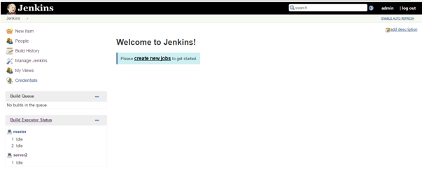

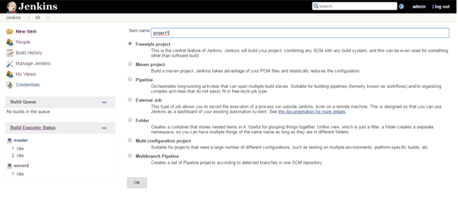

-If you want to run on specific "slave" choose "Restrict where this project can be run" as show below

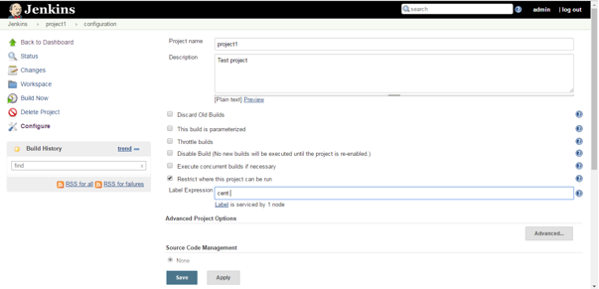

-Copy the git link from Git hub (Use Https)

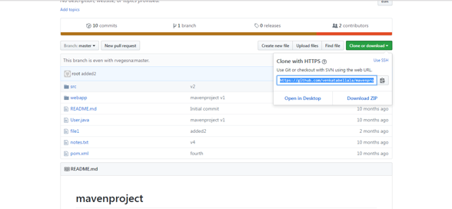

-Install "mavan" from "Configure System"

-Now we need to install "JDK" and "mavan" as show below screen shot

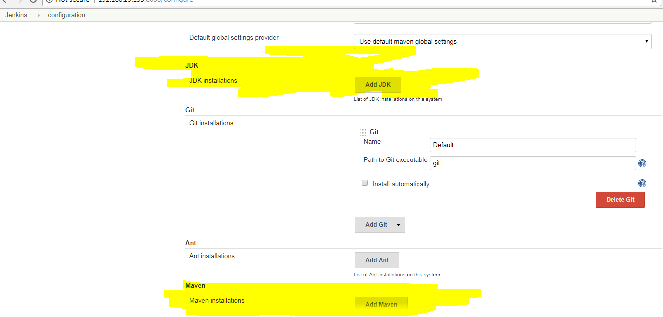

-Now we are going to start with JDK "Add JDK"

-Specific Name of the JDK by "JAVA"

-Apply and save

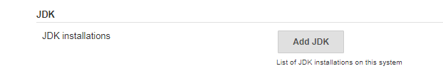

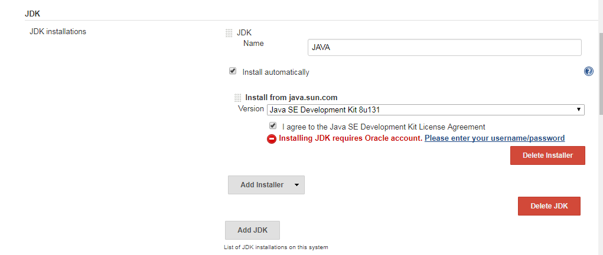

-Now "mavan" and click "add mavan" and "apply" and "save"

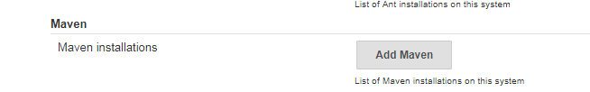

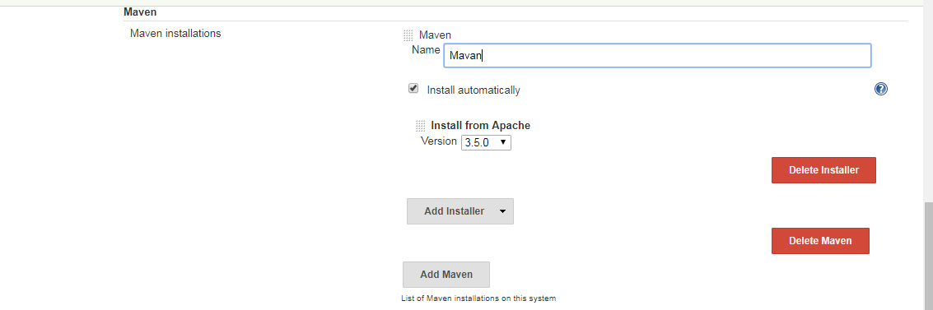

-To run/add sample project, go to Configure setting

-Now click "new item"

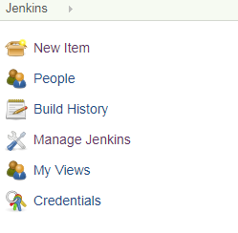

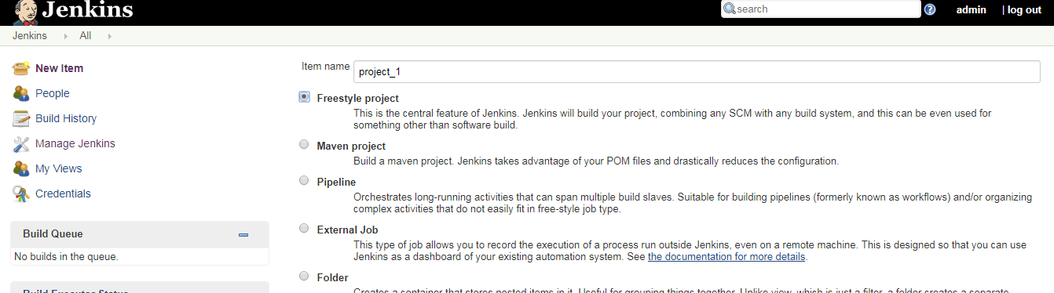

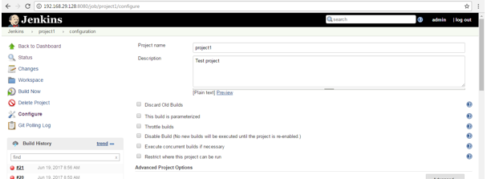

-Now go to source code Management option and clickon Git radio button

- Provide the Git Repository URL

- Select the Poll SCM check box and schedule according to the requirement.

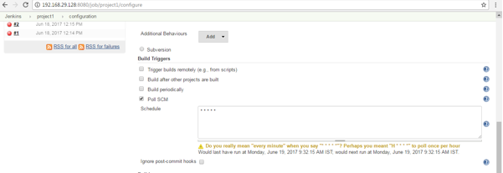

-Select from the dropdown list for mavan "mvn"

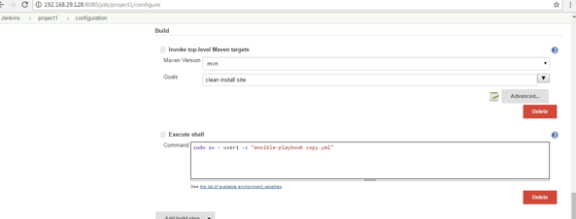

-Now we are going to “BUILD" as show below

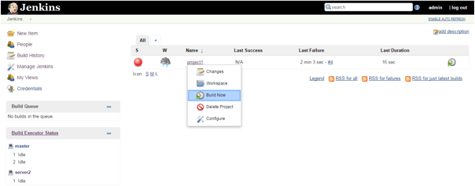

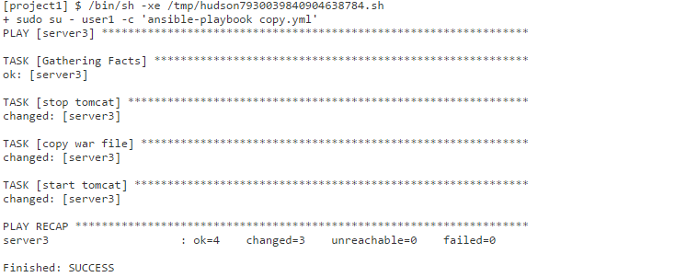

When we hit the Tomcat URL, we will get the below page:

