Bastion Host: *A special purpose computer on a network specifically designed and configured to withstand attacks.*

In the context of SSH for AWS, a bastion host is a server instance itself that you must SSH into before you are able to SSH into any of the other servers in your VPC.

Here are the steps I took to set one up:

**Step 1:** Create an EC2 instance on AWS. I choose a micro sized instance since it is on the free-tier and it’s only purpose is to access other servers.

**Step 2:** Create a security group for the Bastion host that opens up port 22 for SSH and select “My IP” as the source. This is so that only you and other teammates that add their IP’s have access to the Bastion.

**Step 3:** Change the security groups of existing instances so that any inbound SSH is only accessible via the Bastion host’s IP address.

**Step 4:** Edit your local ~/.ssh/config file and add the following:

Host bastion

Hostname 11.111.111.11

User username

ForwardAgent yes

Where hostname is the IP address of the bastion host and username is the one that use to log into the server.

Where hostname is the IP address of the bastion host and username is the one that use to log into the server.

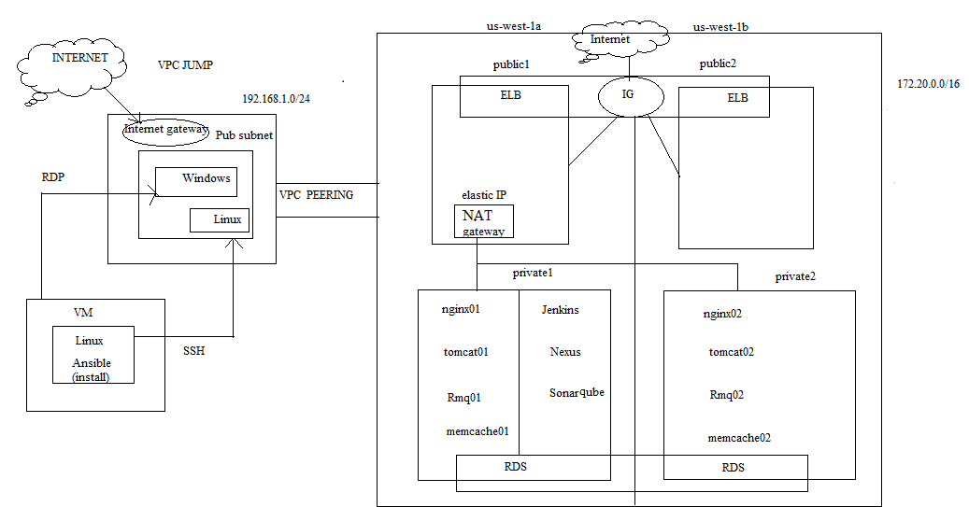

Note: Linux and Windows are JumpServers