Inmar Assignment
Infrastructure Setup.

Note: I have used vagrant for virtual machines

Please find the Architecture

Phase 1 setup

Step 1. login into your AWS account and create an IAM user with full admin access
and give programmatic access type , download the credential file into your
system.

Step 2. Now unzip Inmar.zip file on your host machine & change into
Inmar directory, you will find vagrantfile and Ansible directory

Now type the below command line commands:
- Cd Inmar (folder)
- Ls (here we will find 2 folders ie., a. Ansible (which contains ansible playbooks for creating a infrastructure) 2. Vagrantfile (which creates the virtual machine along with Ansible installation provisioning)
Note: vigrant file is available in GITHUB

Step 3 . Bring up the vagrant VM by using “vagrant up” command

Step 4 .Login into vagrant VM by using “vagrant ssh” command, switch to root user
“sudo -i ” command

Step 5. Export AWS ACCESS_ID and SECRET_KEY in /root /.bashrc file
like below screen shot.

# vi /root /.bashrc
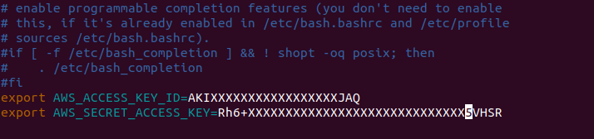

Step 6. After exporting variable in .bashrc, update .bashrc file by using below
command
# source .bashrc

Step 7. Now change into /vagrant directory & goto ansible directory
Now type the below commands to get into the anisble playbooks directory
- # cd /vagrant
- # cd ansible
- ls
- Now you will find the below Ansible Playbooks
    - Ansible.cfg (configuration information)
    - Groups_vars (variable information)
    - Jump-Key.pem (Jump server login key)
    - Inmar_HAVPC (High Avaiability VPC setup)
    - Inmar_setup (Infrastructure setup playbooks)

Step 8. First go through each & every files in ansible directory and try to
understand the playbook.

Step 9. Now run Inmar_HAVPC.yml file, it will setup two VPC’s as
Jumpvpc (creates the public network), Inmar_havpc (private network) & two jump server as Jump Server, WinJumpServer

# ansible-playbook Inmar_HAVPC.yml

Note: jump-key.pem is saved into your current working directory, by using this key
we can login into winjumpServer and jumpserver (ubuntu machine)

Phase 2 setup

Step 1. Login into JumpServer by using below command

# ssh -i jump-key.pem ubuntu@public.ip

setp 2 . Login into winJumpServer
Note: Inorder to login into windows Server we need to have
remmina / RDP in your base machine

I. Goto AWS EC2 Dashboard select winjumpserver and click on
Connect tab above.
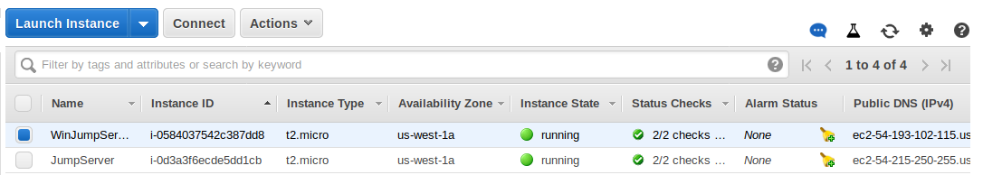
ii. Click on get password, browse your pem key and click on decrypt
password
Note: you can find jump-key.pem file at current directory of host
machine under ansible folder
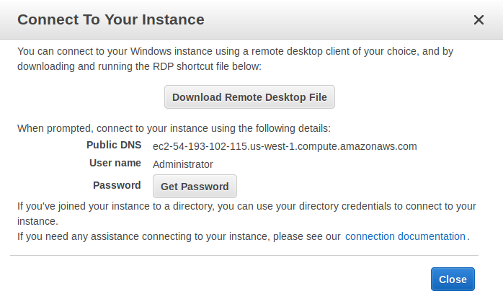
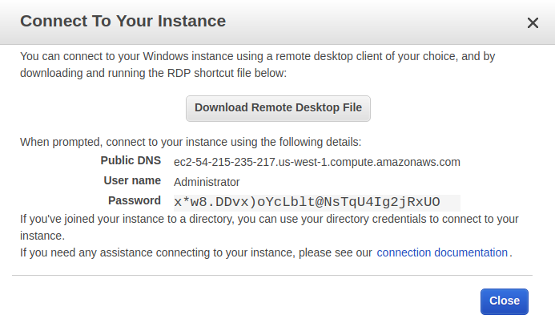
iii. Open remmina (which is used to connect Ubuntu to remote windows machine) on your system, give login details and click on connect. You will be connectted to windows server.

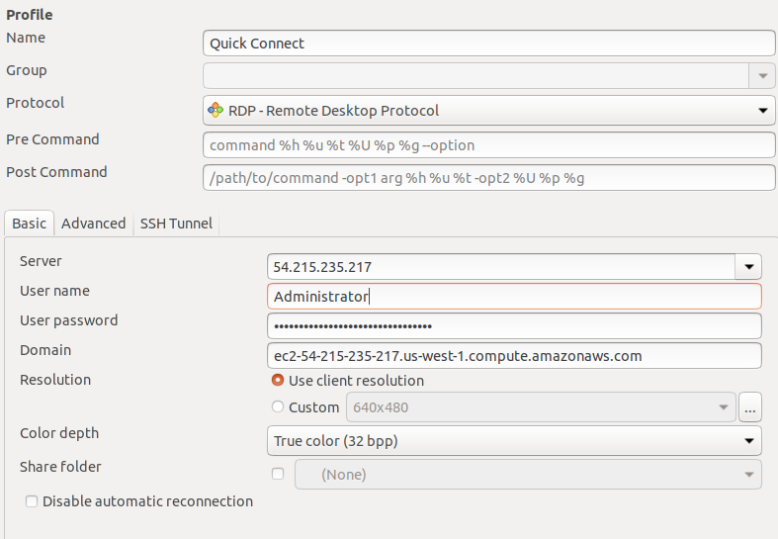
Step 3. Now come back to your jumpServer (EC2 public network instance)

Step 4. Export AWS credentials(access & secret key) at /home /
ubuntu/.bashrc file, as same as you did in vagrant VM.
Note: Follow the same steps how we exported vagrant machine.

Step 5. Under ubuntu user home directory i.e ( /home /ubuntu ) you will
find inmar_stack_setup directory, now go into that directory and
type the below commandline commands:
#ls
#Inmar_stack_setup.tar.gz
#cd Inmar_stack_setup
# Inmar_stack_setup$ ls (You will find the below playbooks)
- Ansible.cfg
- Files
- Group_vars
- Templates
- Inmarinfra.yml

Step 6. Read the playbook (Inmarinfa.yml) & view each and every file
and directory

I. Under “groups _vars” directory we have safevars.yml and
vimnarstack file, safevars.yml is password protected file,
inorder to view that file we have a command

# ansible-vault view safevars.yml (consists of vault password, dbuser, dbpass, rmquser and rmqpass details) (rmq = rabbit mq)

# cat Vimnarstack (consists of vpc, public subnet1, subnet2 and private subnet1 and subnet2 information)

II. Under “files” directory we can see the below files :
- Db_backup.sql
- Jenkins_home.tar.gz
- Nexus_data.tar.gz
- Inmar-v1.war
- db_back.sql is a dump file which will be exported into account
database on RDS instance

- jenkins_home.tar.gz it contains jenkins home directory

- nexus_data.tar.gz it contains all nexus configuration files

- Inmar-v1.war Its a Artifacts that we will push into tomcat server

III. Now go to templates directory and under Template directory contain appication.j2 and ngininmar.j2

- application.j2 it contain application properties file such as database connection, configuration for active and standby host, Rabbitmq configuration etc.
Now type the below commandline commands:
# Inmar_stack_setup/template$ls
# Inmar_stack_setup/template$ cat application.j2

- ngininmar.j2 it contain reverse proxy setting for our nginx server
# Inmar_stack_setup/template$ cat application.j2

Step 7. Now run the playbook Inmarinfra.yml as below command, it
will setup our entire Inmar stack on Inmar-havpc vpc

# Inmar_stack_setup$ansible-playbook Inmarinfra.yml - -ask-vault-pass

Note: Monitor the playbook execution, when RDS instance is spinning up
click enter on every 20-25 sec to engage the session , because RDS
instance takes long time to comes up.

Step 10. After successful execution of playbook, goto AWS EC2
DashBoard to view our infrastructure.
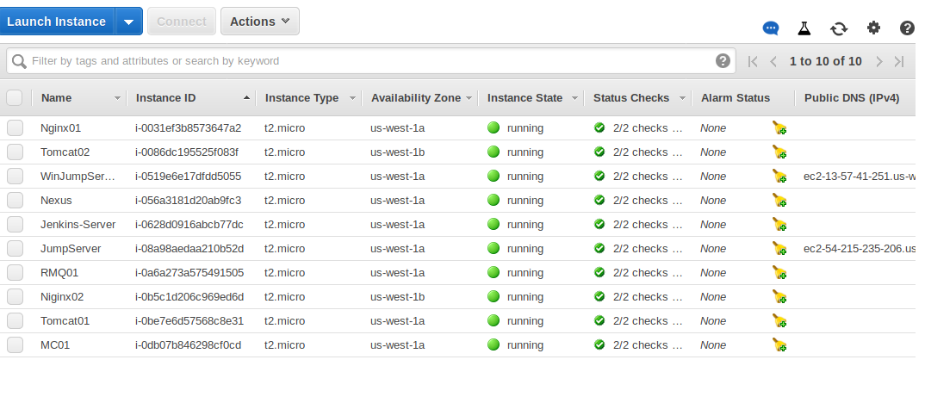
Step 11. Login into nexus server and start the NEXUS service
Note: After execution of Inmarinfra.yml we get Inmar_key.pem file in our current directory login into nexus server by using Inmar_key
Now type the below commands
#cd /usr/local
#/usr/local$export RUN_AS_USER=root
#/usr/local$ls (we will find the below files)
- bin
- etc
- include
- lib
- man
- nexus_data.tar.gz
- sbin
- share
- sonatype-work
- src
- inmar-nexus

Now type #/usr/local$inmar-nexus/bin/nexus start

Step 12. Come back to your WinJumpServer

Step 13. Disable IE security configuration. Click on start menu---> server
Manager----> local server----IE Enhanced security configuration
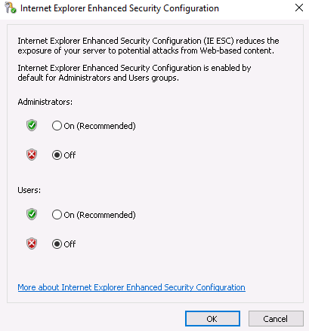

Step 14. Download Crome browser.

Step 15. Hit jenkins-server IP on Crome browser ( i.e private ip : 8080)

Jenkins credentials
- username= admin
- password= admin123

Phase 3 setup

Step 1. Now on Jenkins Dashboard open Inmar-DockerBuild job
click on Configure . Under Docker build and publish setting give
your docker registory (i.e docker hub username and password)
Credentials then save it

Step 2. Open Inmar-versioning-nexus job, Click on Configure
under Nexus artifact upload, provide nexus version, Protocal as HTTP and nexus private ip and save it.

Step 3. Open Inmar-Deploy-QA job, click on Configure under invoke ansible playbook you have to Update
- tomcat private ips
- tomcat credentials
- extra variable (nexus ip)

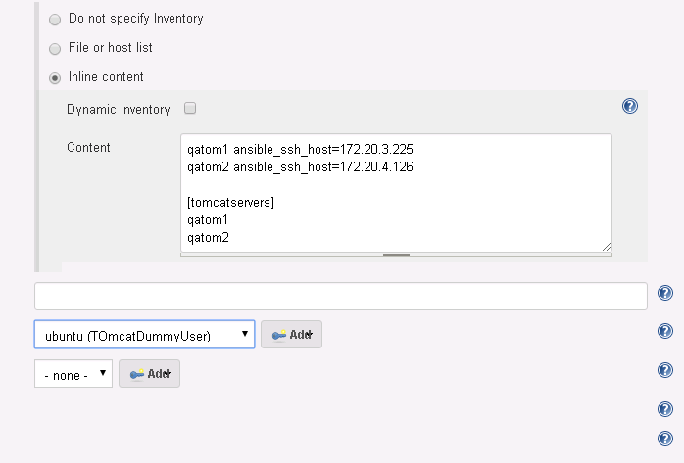

Note : for tomcat credentials we are using key Authentication
goto vagrant VM machine, do following command, it will copy
Inmar_key.pem into vagrant VM

# scp -i jump-key.pem ubuntu@JumpServer-ip:/home/ubuntu/Inmar_stack_setup/Inmar_key.pem .

here . Means your current directory

Note: As we have our default sync folder between host machine and
vagrant VM, so Inmar_key.pem can be listed into your host
machine also, upload that key to your gmail account, now goto
winJumpserver open your gmail account & download
Inmar_key.pem, open the key with wordpad copy everything and
paste into tomcat credentials part

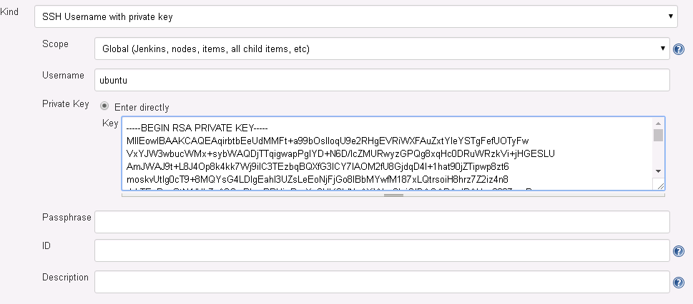
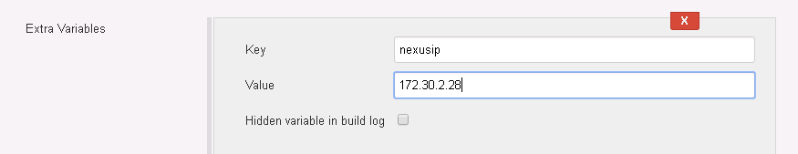

Step 4. Build the PipeLine
Now we create a pipeline for all the jobs created.

The output of the complete Infrastructure :
