Functional Requirement Specification
TNSRTC Reservation Module

Author | Srinivasa Rao S.N.V.
Reviewer | Satish G.V.
Approver

Revision History
Date | Version | Section Changed | Change Description | Author
09-03-2012 | 1.0 | Introduction | Draft Version | Srinivasa Rao S.N.V
14-03-2012 | 1.1 | All sections | Draft Version | Srinivasa Rao S.N.V
Table of Contents
Revision History 1
1 Introduction 3
2 Requirement Specifications 4
3 Manage Online Reservation System Program Overview 4
3.1 Manage User Registration 4
3.2 Manage Search Program 5
3.3 Manage User Accounts 5
3.4 Manage Transaction History 5
3.5 Manage Bus Services 5
3.5.1 Adding Services 5
3.5.2 Editing Services 6
3.5.3 Deleting Services 6
4 Functional Requirements 7
4.1 Manage online reservation system Program 7
4.1.1 Functionality Details 7

Introduction
This document captures the Functional Specification Requirements, of Online Reservation module of the TNSRTC.

Requirement Specifications
As part of enhancing functionality of Reservation system and providing more features to TNSRTC module, the following functionalities are to be provided as part of Online Reservation Management System:-

- Manage User Registration
- Manage Search Program
- Manage User Accounts
- Manage Transaction History
- Manage Bus Services [Routes]
- Manage Ticket Booking, cancellation and printing.

Manage Online Reservation System Program Overview
The intent of this section is to describe the interaction between the user and the online reservation system with the TNSRTC.

Manage User Registration
This section will describe the online reservation system program structure. The system should have one admin user by default and should maintain the end user registration / login.

The system should provide login functionality along with registration of users:
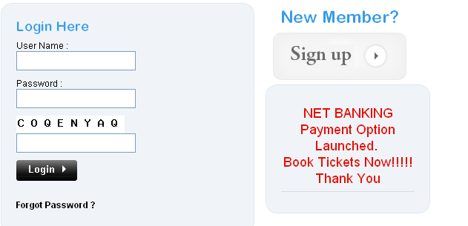

Manage Search Program
The system should provide search option to know the availability of the route and seats.
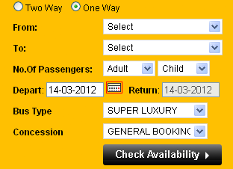

Manage User Accounts
The system should provide the option to maintain the following users:
  - Admin users
  - End users
The system should provide the option to manage the user profiles


Manage Transaction History
The system should provide the option to look at the transactions what the user made.
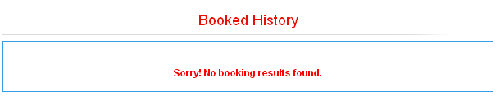

Manage Bus Services
The system should provide the option to look at the various services or routes provided for the passenger commutation.

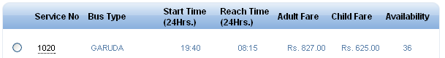

Adding Services
The system should allow the admin user to add new services which are implemented recently to the passengers to avail for commutation.

Editing Services
The system should allow the admin user to update the changes in the service program like in change of time or change in type of bus model etc.

Deleting Services
The system should allow the admin user to remove certain services which cannot continue on different norms like huge fuel consumption, less number of passengers all the time which incurs losses.

Functional Requirements

Manage online reservation system Program
This module would be starting point of the online reservation system management.

Functionality Details
An overview page with provision for Adding / Editing / Deleting and Managing users, services would be logical starting point of the Reservation Module.

Creating a New User Program
Adding a New User Program involves login and registration of the user program.
If the user is not having the login, the system should take the user to Registration page, upon registering it should show successful registration information and ask the user to login. The system should also send an email to the user with the provided email_id at the time of registration with userid, password along with welcome messages, offers if any in the email format.
The following details will need to be captured for a Certification Program:-
- User Id, for login
- User First Name, Last Name
- User communition Address.
- Email Id, contact numbers
- Field Validation – Need to check to ensure that data is entered into required fields and that all validations are performed.

Creating a New Service
Reservation Program may have one or more services available for customers or passengers for commutation:-
- Service Name
- Service No
- Type of Buses available for this Service
- Fare of each passenger according to the selected bus type.
- Origination of the service
- Destination of the service
- Running frequency of the service
- Days of service operation
- Field Validation – Need to check to ensure that correct data is entered into required fields and that all validations are performed.

Creating Requirements for a Ticket Booking
Booking of Ticket may need one or more requirements, which need to be completed. Every Requirement will have the following details associated with it :-

- Booking Ticket will include details like –
  - One way or Two way; From Place; To Place, No of Passengers [No. of Adults, No. of Children]
  - Departing Date when it is one way.
  - Returning Date when it is two way.
  - Bus Model / Type: Garuda, ISUZU etc.
  - Concession Type: Student, CAT Card etc.
- Select Bus Service
  - Once the user provided the above information, the available services should be displayed for the search criteria.
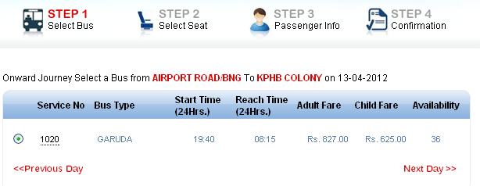
- Select Seats - This will allow the user to choose the seat for each passenger.
  - This should allow the user to choose the seat for each passenger.
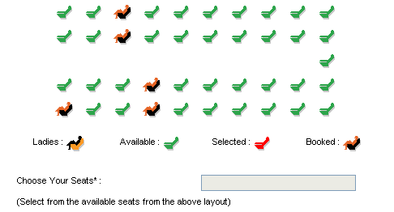
  - Transaction information should be available to the user.
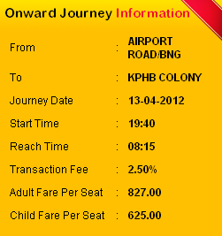
- Passenger information
  - At this point of time need to collect the passenger information..
  - Here the user should have the facility to review his/her transaction summary so he/she can decide whether to proceed further or to go back and edit the information.
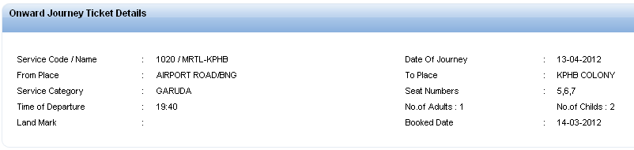
  - Fare summary of the passengers should be available.
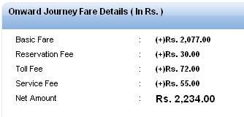
  - Collect the passenger information like age, sex, major etc.
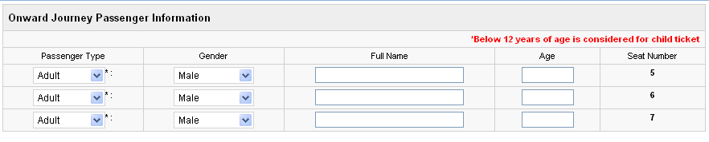
  - Collect the contact information of the Primary passenger.
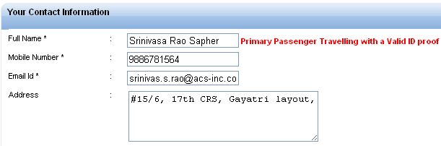
  - Payment gateway - Should collect the information about the payment details.
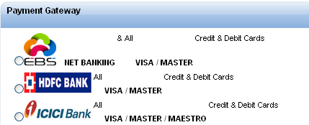
  - Terms and Conditions: The system must make the user to accept the Terms and conditions of the reservation system and provide the link the user to Terms and conditions list.

- Field Validation – Need to check to ensure that correct data is entered into required fields and that all validations are performed.
- Logic Checking – Need to ensure that users are kept from entering setting up data scenarios that are not logical.

