Satish Hiru Gadge
CA2020 BootCamp- Assignment Day-2
TASK 01:
consultadd/
|-- Python
| `-- Django
| `-- restframework
|-- java
| `-- springboot
|-- javascript
| `-- angular
| `-- react
|-- SQL
| `-- mysql
`-- bootcamp
HINT : Use mkdir command in single line
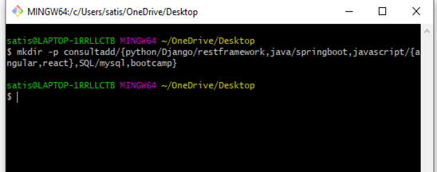
TASK 02:
- Create Directory called consultadd
- Inside that create 5 more directories named them as dir1, dir2, dir3, dir4 and dir5
- What would be the output of Long Listing after creating these directories?
- List all the directories with ls and echo * and see the difference.
Here the visual difference is slash which is present after doing the ls, while it is missing after the echo *. But the beside fact is after doing the ls we get the list of the directory it contains, where as the echo * , print’s the directories it contains.

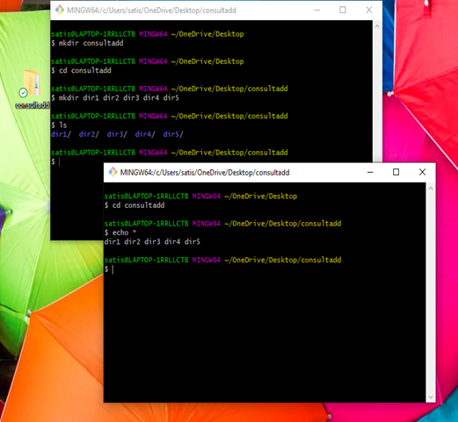

- Create a 2 files named them file1.txt and file2.txt inside dir3
- Move dir5 into the dir3
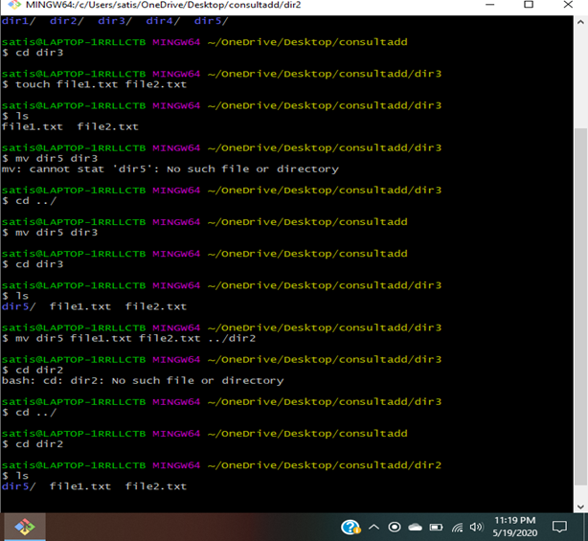

- Remove dir 3 after moving all files from dir3 to dir2.
- Go to the dir2 and create one more file with name index.html
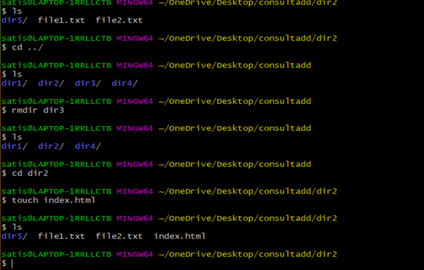

- Move to top level directory
- Check the permission of all files and directory from current place make sure when you do pwd it should be on consultadd
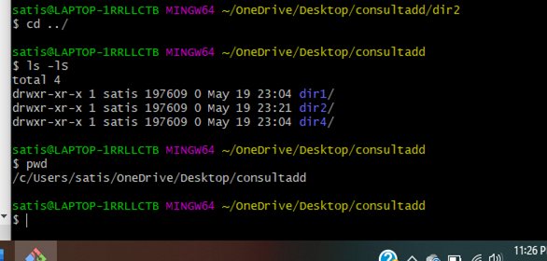

- Rename all files of dir2 with extension of .txt to .py
(Sir while doing I by mistake deleted the folder so I have created a dir name Satish1 and added 5 txt file in it and changed all the 5 into php.

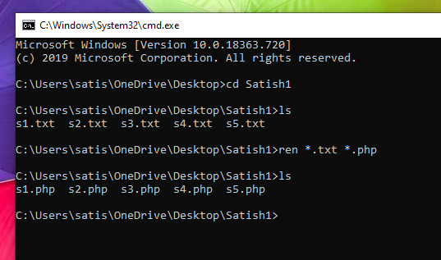

TASK: 03
1 What is Nano Editor?
How to create a sample file in Nano Editor?
How to save file?

- Nano editor is a text editor for Unix and Linux computing systems or operating systems. It includes all the basic functionality you’d expect from a regular text editor, like syntax highlighting, multiple buffers, search and replace with regular expression support, spellchecking, etc. To open a new file or to create a new file use command: $ nano filename. To save the changes made to the file we use Ctrl+o.

2 What is Vi Editor?
Operation in Vi Editor?

- Vi is a screen editor for Linux and Unix where Vi stands for the visual instrument. With Vi editor we can edit an existing file we can also create a new file from the scratch. We can also use the editor to just read the file. The vi editor has three modes of operations- the command mode, the insert mode, and the ex-command mode.

TASK: 04
- Type finger to see your account and name.

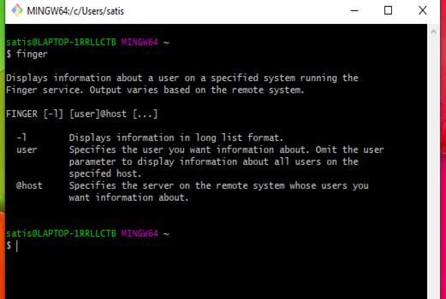

- Type cal to see this month’s calendar.
- Create a file and give a name random.txt to it with content into it which say “Hello Welcome to the Consultadd Inc Bootcamp”.
- Display the same content using cat command.
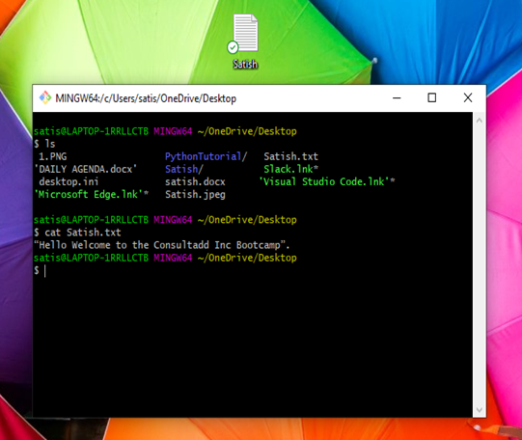

TASK: 05
1 Explain the workflow of the Internet in one paragraph.

- The Internet is just a wire - which can be either the wired or the wireless. When the two computers are connected to this wire they can communicate with each other. Our computer is not a server, a server is a special computer connected directly to the internet, and these servers are mainly controlled by the Internet Service Provider. The data is sent from one device to the other in the form of packets. This packet has the unique IP address and a port number which will first go the router of the Internet Service Provider and where it examines the destination address and send.

2 How LAN is different from the WAN network?

- LAN is a Local-area Network that works in a smaller area, which can be a home, office, or a building. Whereas WAN is a wide-area network, which works in a larger geographical area i.e. city, state, countries, etc. LAN is typically faster and more secure than the WAN, but WAN facilitates more widespread connectivity.

