NODE JS TUTORIAL

* To install nodejs -> go to nodejs official website and install latest version.
* To check version of nodejs : enter in CMD -> type **node -v** press enter.

To use Javascript in browser -> click on … of chrome browser and click on More tools -> Deveeloper tools -> then we can use javascript codes in console window.

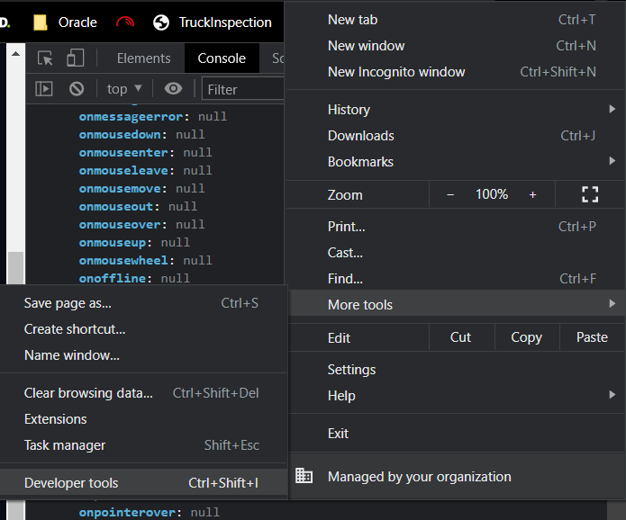

**Blocking vs Non-Blocking I/O** : blocking I/O(input output operations) means it blocks the entire process while doing any input output operations whereas non-blocking I/O doesn’t blocks the process while performing any i/o operations.