Flask Tutorial
Upgrading PIP install packages – pip install --upgrade packageName
Create Virtual Environment inside Python – It will create a separate env all together for our project.
Steps to create -- https://medium.com/linkit-intecs/how-to-create-a-virtual-environment-in-pycharm-a5720cc996b8
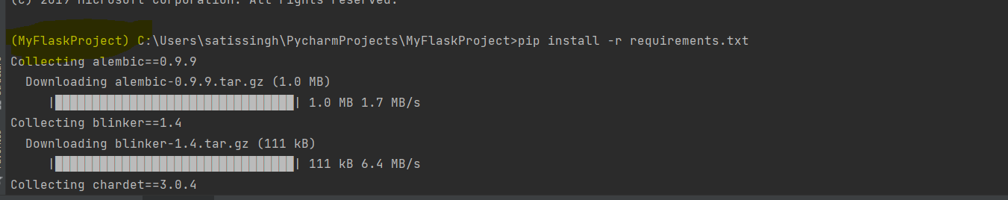
The (MyFlaskProject) indicates we’re working in virtual env. Pip install -r requirements.txt -> to install all libs mentioned in files at once.
Filler – Type lorem and hit tab it’ll fill some big random paragraph automatically in text editor.
Ctrl+alt+s -> to open plugin store in PyCharm.
Divs and Spans allow us to segment portions of our HTML
Steps to link HTML and CSS file:-
In the head tag of html file declare the following tag -- <link rel=”stylesheet” href=”nameOfCSSfile.css”>

CSS
For effecting any tags, we use that specific tag then the { inside this key value pair for the properties }
h1{color : blue ;} this will affect the h1 tag with blue color.
li { color : red; } will affect the li tag.
Every HTML element can accept a class or id attribute.
We can then specifically connect to these classes or ids from our CSS with a special syntax :: . (periods) for a class call # for a id call
Implementing CSS for class : .ClassName{ color : red; }
For ID :: #myId{ color : pink; }
How to use google font API:
Got to this website https://fonts.google.com/ then select any font and copy the link tag and CSS style and paste in your html file. We need to include the following :
The Link tags in html page inside <head> tag
<link rel="preconnect" href="https://fonts.googleapis.com">
<link rel="preconnect" href="https://fonts.gstatic.com" crossorigin>
<link href="https://fonts.googleapis.com/css2?family=Recursive&display=swap" rel="stylesheet">
The CSS styling inside css file
font-family: 'Recursive', sans-serif;
Bootstrap Website:- www.getbootstrap.com
How to link bootstrap with your html code: go to official bootstrap website and copy the css link <!-- CSS only -->
<link href="https://cdn.jsdelivr.net/npm/bootstrap@5.0.2/dist/css/bootstrap.min.css" rel="stylesheet" integrity="sha384-EVSTQN3/azprG1Anm3QDgpJLIm9Nao0Yz1ztcQTwFspd3yD65VohhpuuCOmLASjC" crossorigin="anonymous">
And past the above highlighted inside the <head> tag of our html page.
Python Basics
LEGB Rule : This LEGB stand for Local, Enclosing, Global and Built IN. so during variable scope clarification python tries to find out at Local level, if it fails to find anything at local level then it moves to Enclosing level, if it fails to find anything at enclosing level then it moves to Global level and at last it move for Built In level.

- Representation of a class object : it denotes how we can represent a particular class object. repr is same as str.
def __repr__(self):
return f”Title: {self.title}, Author: {self.Author}, Pages: {self.pages}”
- def __len__(self): : this method implements the len() method
return self.Pages
Package and sub package level import scripts
from MyMainPackage import my_module_name (this applies for scripts present in a folder)
from MyMainPackage.MySubPackage import my_sub_module (this applies for scripts present in sub-folder of main folder)
from MyMainPackage.my_module_name import my_function (this is to import only 1 function from our module)
Basic Hello World in Flask
from flask import Flask import Flask module
app = Flask(__name__) init state. Passing the module name in Flask constructor.
@app.route('/') # 127.0.0.1:500 this defines home page for our web app.
def index(): any method name. this will render the hello world page
return "<h1>Hello World in Flask!</h1>"
if __name__ == '__main__': main method call
app.run() start the web server.
Adding More Route
@app.route('/home') # 127.0.0.1:500/home
def home():
return "<h1>Hello World in Home!</h1>"
Dynamic Route It has 2 aspects 1. A Variable in the route <variable> 2. A parameter passed in to the function. Dynamic route as the name suggests return dynamic pages as per the variable passed.
@app.route('/some_page/<name>')
def other_page(name):
return 'User: {}'.format(name)
Setting Debug Mode to True This helps in discovering our error in webpage so that we can figure out our problem or error.
To enable debug mode we need to set Debug = True while calling the run function inside the main().
if __name__ == '__main__':
app.run(Debug = True)
Whenever the Debut is set to True and we’ve any error then we get the following screen –
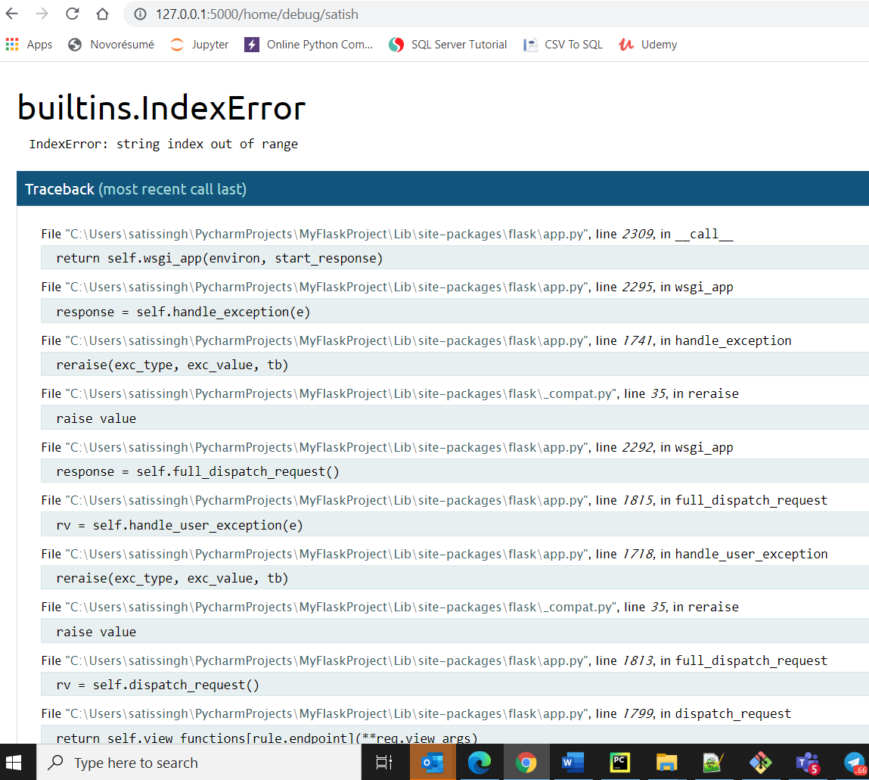
We can even open a console on the webpage itself by entering the PIN from python console.
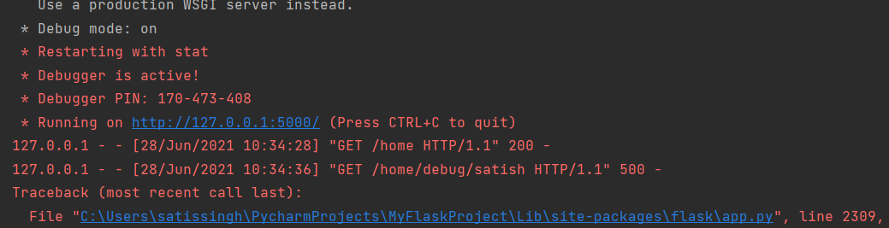
Console on WebPage can be used by entering the PIN –
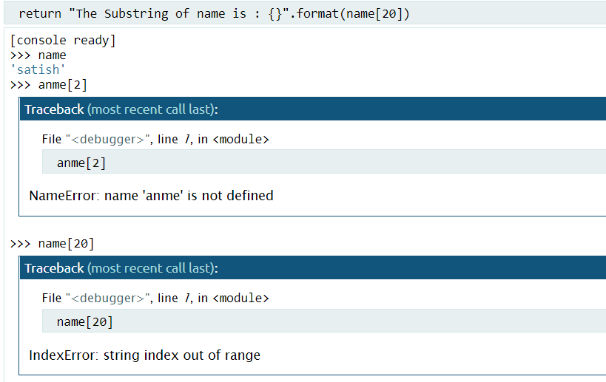
Template Basics Rendering a complete html file in Flask.
The directory structure should be strictly followed FlaskDemo contains PY files and the templates folder contain the template to be rendered.
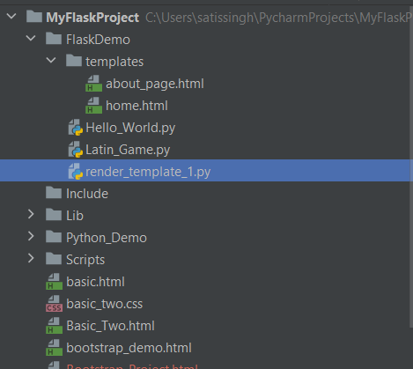
Code :
from flask import Flask, render_template
app = Flask(__name__, template_folder='templates') # templates folder should have home.html file to be rendered.

@app.route('/')
def home_page():
return render_template('home.html') calling render_template function with home.html as parameter.

if __name__ == '__main__':
app.run(debug=True)

JINJA Template
We want a way to be able to use Python code in our app, changing and updating variables and logic, and then send that information to the template. We can use the Jinja template engine to do this. Jinja templating will let us directly insert variables from our Python code to the HTML file.
- The syntax for inserting a variable is {{ some_variable}}
Steps to Pass variable from Python to HTML
# Passing the variable from Python to HTML template using {{my_variable}}
Render_template_1.py
@app.route('/')
def home_page():
my_var = 'Satish'
return render_template('home.html', var_name=my_var) # here we’re setting var_name=my_var and this get passed to our HTML page.
home.html
<h3> Welcome Dear, Your Name is : {{var_name}} received from python file </h3> /* to display our passed variable we uses {{var_name}} */

We can pass multiple parameters inside the render_template function so that it can be displayed in our html page.
my_var = 'Satish' # Passing a single word
my_list = ['Apple', 'Bat', 'Cat'] # Passing a list
return render_template('home.html', var_name=my_var, my_list = my_list)
FLOW CONTRO IN HTML : To iterate over a list or dictionary inside html page.
Syntax – FOR loop in Flask
{% for item in myList %}
{{item}}
{% endfor %}
IF Block in Flask
{% if ‘item’ in myList %}
<p> Found</p>
{% elif someCondition %}
<p> Statement </p>
{% else %}
<p> Not found </p>
{% endif %}

Template Inheritance
We set up a base.html template file with the re-usable aspects of our site. Then we use {% extend “base.html” %} and {% block %} statements to extend these re-usable aspects to other pages.
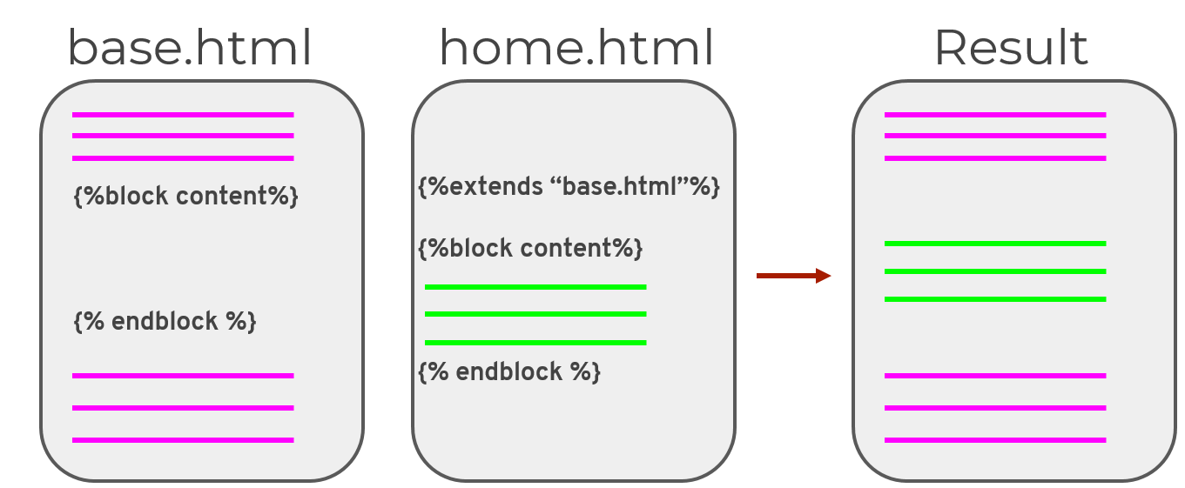
We write the base.html file having all our required components(like header, footer and brand logo etc) and place these two lines
{% block content %}

{% endblock %}

And then in the rest of webpages we write {% extends “base_file.html” %} and all the code for that specific webpage inside this two blocks {% block content %} &
{% endblock %}. The final outcome will be merged version of the two pages.

Base_puppy.html
<!DOCTYPE html>
<html lang="en">
<head>
<meta charset="UTF-8">
<title>Home Page for Puppy</title>
</head>
<body>
<nav class="navbar navbar-expand-lg navbar-light bg-light">
<a class="navbar-brand" href="#">Puppy Rocks</a>
<br>
</nav>
{% block content %}
Should be empty
{% endblock %}
</body>
</html>
Home_puppy.html
<!DOCTYPE html>
{% extends "base_puppy.html" %}
<html lang="en">
<head>
<meta charset="UTF-8">
<title>Home Puppy</title>
</head>
<body>
{% block content %}
<br>
<h1> This is home_pupppy </h1>
<h2> Go to /puppy/name </h2>
{% endblock %}
</body>
</html>
- The Base_Puppy.html holds the nav bar for entire pages. And home_puppy.html is the 2nd webpage which will have the base design from base_puppy.html.
- url_for() : it helps us in linking two webpages. Clicking on a link will redirect us to a particular webpage. Syntax is:
<a href=”{{ url_for(‘method_name’) }}”> click to redirect </a>
<a class="navbar-brand" href="{{ url_for(‘registration_form') }}">Puppy Home Page</a>
Main.py
@app.route('/signup')
def registration_form():
return render_template("registration_form.html")
- <!-- Linking static image to website -->
<a href="{{ url_for('static', filename='cute_puppy.jpg')}}">Click for nature image</a>
- How to get Dynamic Images on webpage when it refreshes using UNSPLASH website ::
<!-- THe below img puts random image from Unsplash websiite each time it refresh -->
<img src="https://source.unsplash.com/1600x900/?nature,water">
- Navigate to different page on click of button
<form action="{{url_for('thank_form')}}"> forms item here </form>
Main.py
@app.route('/thankyou')
def thank_form():
first = request.args.get('first') – to get form field items in python from html
last = request.args.get('last') – in order to get field items name attribute must be declared inside input tag.
print(first, last)
return render_template('thank_form.html', first=first, last=last)
- Printing python variable on HTML page
<h1> Thank You!!! {{first}} {{last}}</h1>
- Brand Logo Implementation : redirects to home page when clicked on Brand Logo
<nav class="navbar navbar-expand-lg navbar-light bg-light">
<a class="navbar-brand" href="{{ url_for('index_form') }}">Home Page</a>
</nav>
Main.py
@app.route('/')
def index_form():
return render_template("index_form.html")
- Adding default error handling Page : if we type something wrong in URL bar and the page doesn’t exists then we show our customized error page.
<!DOCTYPE html>
{% extends "base_form.html" %}
<html lang="en">
<head>
<meta charset="UTF-8">
<title>Not A Valid Page</title>
</head>
<body>
{% block content %}
<div class="jumbotron">
<h1> Sorry could not find the page</h1>
</div>
{% endblock %}
</body>
</html>
Main.py
@app.errorhandler(404) – most important route and 404 code need to be mentioned
def page_not_found(e):
return render_template('not_valid_link.html'), 404
- WTForms
WTForms, a flexible form, rendering and validation library in flask. Using Flask-WTF, we can define the form fields in our Python script and render them using an HTML template. It is also possible to apply validation to the WTF field.
- Every possible HTML form field has a corresponding wtforms class you can import
- wtforms also has validators you can easily insert.
- Validators can perform checks on the form data, such as requiring a field to be filled

Pip install -- pip install flask-WTF
Basic.py
from flask import Flask, render_template
from flask_wtf import FlaskForm
from wtforms import StringField, SubmitField # Import fields which we want to use
app = Flask(__name__)
# Secret key is required to set up wtforms
app.config['SECRET_KEY'] = 'mysecretkey' # secret string of our choice
class InfoForm(FlaskForm): # Creating our class and inheriting FlaskForm
breed = StringField(label="What breed are you?") #we create as many parameters as per our forms requirements.
submit = SubmitField(label="Submit") # creating submit button parameter

@app.route('/', methods=['GET', 'POST'])
def index():
breed = False
form = InfoForm() # instance of our class InfoForm
if form.validate_on_submit(): #if all the validations are passed.
breed = form.breed.data # get the data from form
form.breed.data = '' # set the data on form
return render_template('index.html', form=form, breed=breed) # render html template
if __name__=='__main__':
app.run(debug=True)
index.html
<p>
{% if breed %} # checking if breed is True or not.
The breed you entered was {{breed}}
Update it in the form below:
{% else %}
Please enter your breed:
{% endif %}
</p>
<!-- connecting form to html template -->
<form method="POST">
{{ form.hidden_tag() }} <!-- hidden tag always must : the instance form is coming from py file-->
{{ form.breed.label() }} {{ form.breed() }} # creating label and a input text field
{{ form.submit() }} # creating submit button.
</form>

- Using our class to create form object
class InfoForm(FlaskForm): # Creating our class and inheriting FlaskForm
- breed = StringField(label="What breed are you?", validators=[DataRequired()]) # DataRequired() instance is created
# for validations purpose
- neutered = BooleanField("Have you been neutered?")
- mood = RadioField("Please choose your mood: ", choices=[('mood_one', 'happy'), ('mood_two', 'Excited')])
- food_choice = SelectField("Please pick your favourite food", choices=[('chi', 'chicken'), ('bf', 'beef'), ('fi', 'fish')])
- feedback = TextAreaField(label="Enter any feedback")
- submit = SubmitField(label="Submit") # creating submit button parameter
- Using Session to get data from our html page into python scripts and pass it to other templates: Session is key value pair dictionary.
@app.route('/', methods=['GET', 'POST'])
def index():
# breed = False
form = InfoForm() # instance of our class InfoForm
if form.validate_on_submit():
# breed = form.breed.data #get the data from form
# form.breed.data = '' # set the data on form
# session is key value pair of dictionary used to hold values for user login session
session['breed'] = form.breed.data # get the breed data from template to py file
session['neutered'] = form.neutered.data # get the neutered data
session['mood'] = form.mood.data
session['food'] = form.food_choice.data
session['feedback'] = form.feedback.data
return redirect(url_for('thank_you')) # this is to redirect user to thank you page when all validation
# are met upon clicking on submit button.
return render_template('index.html', form=form) # this return is to render out initial form and is also our homepage.
- Using the session object to display values in our template page
<ul>
<li> Breed: {{ session['breed']}}</li>
<li> Neutered: {{ session['neutered'] }}</li>
<li> Mood: {{ session['mood'] }}</li>
<li> food_choice: {{ session['food'] }}</li>
<li> feedback: {{ session['feedback'] }}</li>
</ul>
- Flash Message(message like alert box in browser) : this are created by help of flash class. The object is created using flash(“our own custom message”) this returns a iterable object which can be iterated in our template to display our messages.
@app.route('/', methods=['GET', 'POST'])
def index():
my_form = FlashFormDemo()
if my_form.validate_on_submit():
flash('You clicked the button') # this return a iterable object consisting of all messages in
# get_flashed_messages()
return redirect(url_for('index')) # redirecting to same index page
return render_template('index.html', form=my_form)
- The flash object sends message to our template index.html and can be printed using the following code.
{% for mes in get_flashed_messages() %}
<div class="alert alert-warning alert-dismissible fade show" role="alert">
<button type="button" class="close" data-dismiss="alert" aria-label="Close" class="fade close">
<span aria-hidden="true">&times;</span>
</button>
{{mes}} <!-- prints our custom message here which is passed from py file -->
</div>
{% endfor %}
<!-- the below code is to render our submit button -->
<form method="POST">
{{ form.hidden_tag() }}
{{ form.submit() }}
- SQL Alchemy – Interacting with database. SQLAlchemy is the Python SQL toolkit and Object Relational Mapper that gives application developers the full power and flexibility of SQL. Using Alchemy the dev needs to worry about the classes only and all the db objects/tables will be created automatically. We define model class which will be used to create our table. In order to set up SQLAlchemy we need to pip install following modules :- SQLAlchemy, SQLAlchemy-Util, Flask-SQLAlchemy,
import os
from flask import Flask
from flask_sqlalchemy import SQLAlchemy
#### SET UP OUR SQLite DATABASE #####
# This grabs our directory
basedir = os.path.abspath(os.path.dirname(__file__))
app = Flask(__name__)
# Connects our Flask App to our Database
app.config['SQLALCHEMY_DATABASE_URI'] = 'sqlite:///' + os.path.join(basedir, 'data.sqlite') # data is the
# name of the sqlite database file.
app.config['SQLALCHEMY_TRACK_MODIFICATIONS'] = False
db = SQLAlchemy(app) # Initialize our db
# Let's create our first model(Table) !and We inherit from db.Model class
class Puppy(db.Model):
# If you don't provide this, the default table name will be the class name
__tablename__ = 'puppies'
# Now create the columns. Full docs: http://docs.sqlalchemy.org/en/latest/core/types.html
id = db.Column(db.Integer, primary_key=True) # Primary Key column, unique id for each puppy
name = db.Column(db.Text) # Puppy name
age = db.Column(db.Integer) # Puppy age in years
# This sets what an instance in this table will have, Note the id will be auto-created for us later, so we don't add it here!
def __init__(self, name, age):
self.name = name
self.age = age
def __repr__(self):
# This is the string representation of a puppy in the model
return f"Puppy {self.name} is {self.age} years old."
Each model class acts a table and the attributes acts as column.
- Basic CRUD(Create, Read, Update, Delete) from DB
from basic import db, Puppy
# Create the tables in the database
db.create_all() # it will creates tables for all or classes(model)
# Create new entries in the database
sam = Puppy('Sammy', 3)
frank = Puppy('Frankie', 4)
# Check ids (haven't added sam and frank to database, so they should be None)
print(sam.id)
print(frank.id)
db.session.add_all([sam, frank]) # adding multiple rows at once using list
db.session.commit() # committing changes to DB
# Check the ids it won't be null as it got inserted in db
# CREATE
my_puppy = Puppy('Rufus', 1) # Creating puppy object using our model class puppy
db.session.add(my_puppy) # adding our 1 puppy to session
db.session.commit() # pushing puppy to db
# READ, Read all puppies
all_puppies = Puppy.query.all()
print(all_puppies)
# Read by ID
# puppy_one = Puppy.query.get(1)
# print(puppy_one.name)
# FILTER BY NAME OR ID
puppy_filter = Puppy.query.filter_by(name='Rufus') # get the rows having name='Rufus'
print(puppy_filter.all())
# Update
first_puppy = Puppy.query.get(1)
first_puppy.age = 10
db.session.add(first_puppy)
db.session.commit()
# DELETE
second_puppy = Puppy.query.get(1)
print(second_puppy)
db.session.delete(second_puppy)
db.session.commit()
# Read all puppies
all_puppies = Puppy.query.all()
print(all_puppies)
- Flask Migrate : When creating a Model for a Database table you will sometimes need to make adjustments to the model, such as adding a new column. Upon making these changes, you will need to migrate these changes in order to update the database table. We can do this with Flask-Migrate :: pip install Flask-Migrate. This allows us to make adjustments in our Model class, and then make sure they take effect in the SQL database. There are 4 main commands used at the command line.
  - Windows only : set FLASK_APP=myapp.py : it sets the FLASK_APP env variables. (dir should be matched, run the cd command if not in same dir:NO SPACE)
  - flask db init : Sets up the migrations directory
  - flask db migrate -m “some message” : Sets up the migration file
  - flask db upgrade : Updates the database with the migration
Once we run the last 4th command, SQLAlchemy will read of FLASK_APP and will upgrade/make our changes in model class reflect in db. Like if we add one extra attributes in our model class, then that extra attrivute must go to db. So there’s change detected in our model class and SQLAlchemy will upgrade the db to add one extra column for our db.
In the below picture we can see one extra column addition. To view SQLite db files download db browser for sqlite from(https://sqlitebrowser.org/dl/)

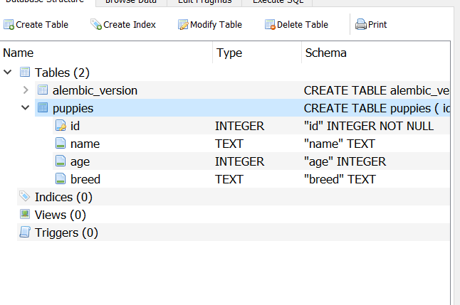
- Create Relationship between tables
# IMPORT STATEMENTS
# 1st table
class Puppy(db.Model):
__tablename__ = 'puppies' # our Table Name
id = db.Column(db.Integer, primary_key=True) # 1st column ID
name = db.Column(db.Text) # 2nd column name
# ONE TO MANY : each puppy can have many toys
toys = db.relationship('Toy', backref='puppy', lazy='dynamic') # to create a foreign key relationship with toy table
# ONE TO ONE : each owner can have one puppy
owner = db.relationship('Owner', backref='puppy', uselist=False) # The Relationship returns collection of objects
#since we can have one puppy one owner so we don't want list to be returned so setting it to False
def __init__(self, name):
self.name = name
def __repr__(self): # to print out object when called.
if self.owner:
return f"Puppy name is {self.name} and owner is {self.owner.name}"
else:
return f"Puppy name is {self.name} and has no owner"
def report_toys(self): # to print toys of dog.
print("Here are my toys")
for toy in self.toys: # the toys attribute returns list of toys for Toy Class
print(toy.item_name) # item_name attribute of Toy class
# our 2nd table Toy
class Toy(db.Model):
__tablename__ = 'toys'
id = db.Column(db.Integer,primary_key = True)
item_name = db.Column(db.Text)
# Connect the toy to the puppy that owns it. We use puppies.id because _tablename__='puppies'
puppy_id = db.Column(db.Integer,db.ForeignKey('puppies.id')) # column in Toy and is foreign key reference puppies table to ID column.
def __init__(self,item_name,puppy_id):
self.item_name = item_name
self.puppy_id = puppy_id
# our 3rd table : Owner
class Owner(db.Model):
__tablename__ = 'owners'
id = db.Column(db.Integer, primary_key = True)
name = db.Column(db.Text)
puppy_id = db.Column(db.Integer, db.ForeignKey('puppies.id'))
def __init__(self, name, puppy_id):
self.name = name
self.puppy_id = puppy_id
- To Add Data in Db using our Model class :
First create object of Model class :: rufus = Puppy('Rufus') creating Puppy class object with name Rufus.
Then we need to add this in session using the following method ::
db.Session.add(objName) add our object to session
db.session.commit()add our object items as row entry in db.
ModelClass.query.all() returns all rows from model class table.
ModelClass.query.filter_by(attributeName=’demo’).all() returns list of all rows having attirubuteName as filter. To access index item use [n]
dbObject.session.add_all([obj1, obj2, obj3)] add multiple objects to database.
ModelClass.query.get(1) gets 1st row from ModelClass table
db.session.delete(model_obj) to delete from model class table.
- Structuring of Application for larger flask application ::
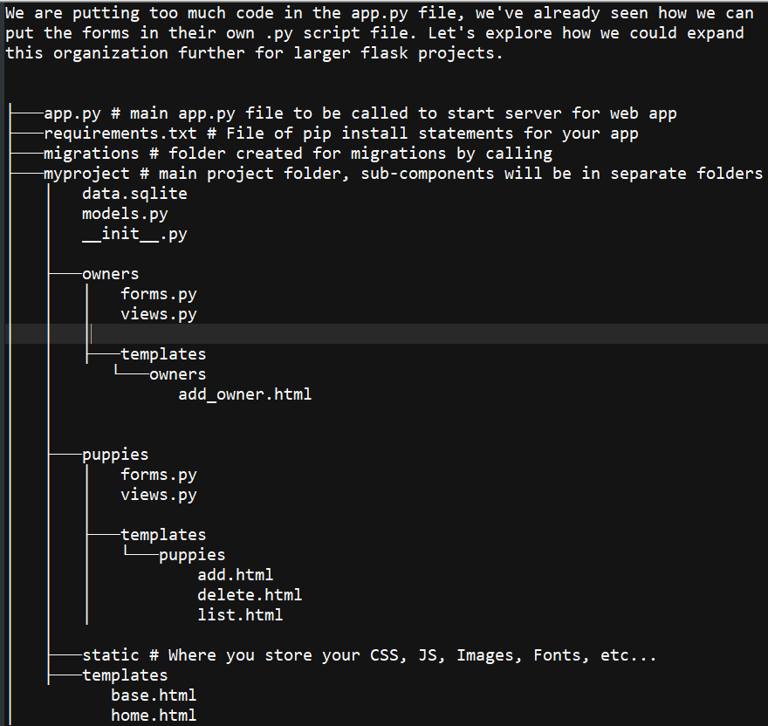
- BluePrints : syntax = BluePrint(‘anyName’, __name__,template_folder=’templates/owner’)
puppies_blueprint = Blueprint('puppies', __name__, template_folder='templates/puppies')
the only changes because of this blueprint is in the url_for() method call. Now instead or passing the method name directly we need to pass the blueprintName.methodName in order to redirect to pages or render pages.
<a class="nav-item nav-link" href="{{ url_for('puppies.add') }}">Add puppy</a>
As we can see above line in html code, we are using bluprintName.methodName
And in app.route(‘/’) we need to use the following :
@owners_blueprints.route('/add', methods=['GET', 'POST'])
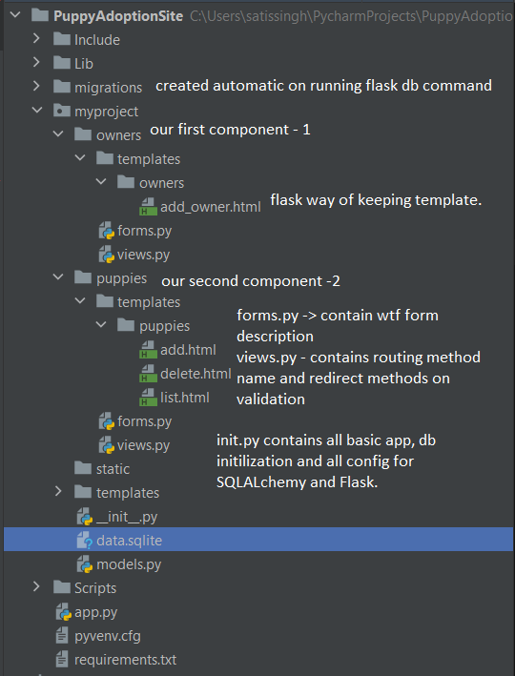

Workflow of Flask Application :
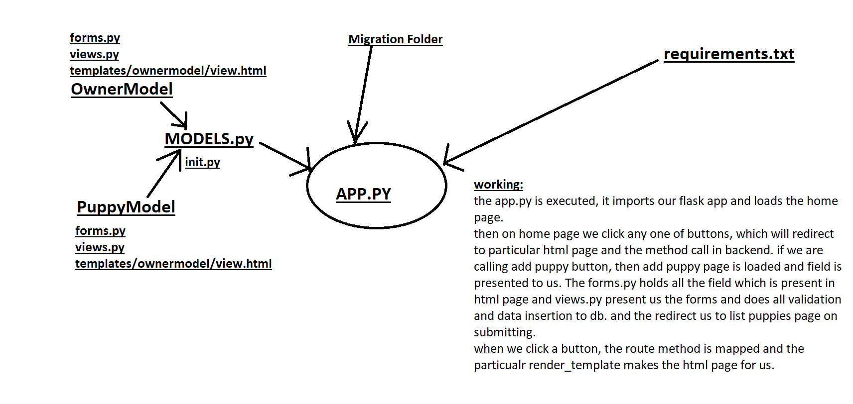
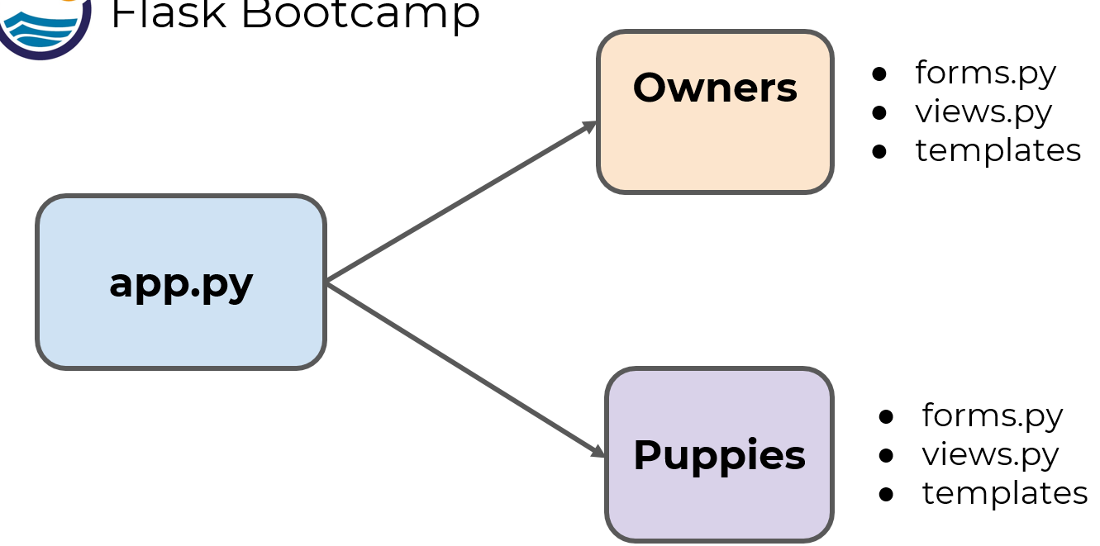
- How to access image file in html which is outside of directory of current html folder. The ../ is used to move 1 directory up. Here we are moving 3 directory up and then referring static folder and then failed.JPG image.
<img src="../../../static/failed.JPG" alt="failed_image">

- Hashing Algorithm :- When your website has User Authentication, you will need to store their usernames and passwords. For security purposes, we will never want to store the raw text of the password. We can use a hash function to help with this. A hash function is an algorithm that can take in a document (password) and return back a secure hash digest. It is secure because given the hash, a person can not determine what the original password was. There are two useful libraries for this:
    - Bcrypt – pip install flask_bcrypt
    - Werkzeug – pip install werkzeug
from flask_bcrypt import Bcrypt
Bcrypt_obj = Bcrypt()
# Encryption
hashed_pass = Bcrypt_obj.generate_password_hash('mysecurepassword')
print(hashed_pass)
# Decrypting
check_wrong = Bcrypt_obj.check_password_hash(hashed_pass, 'wrongpassword') # checks whether string supplied
# matches with the hashed version of password
print("Status of Password: ", check_wrong)
check_right = Bcrypt_obj.check_password_hash(hashed_pass, 'mysecurepassword') # matches the password
print("Status of Password: ", check_right)
- Implementation of Login using flask_login::
Using Flask-Login : pip install Flask-Login. The flask-login library makes adding user authentication to our web applications very easy. The flask-login library has easily callable decorators for adding user functionality. Flask-Login provides user session management for Flask. It handles the common tasks of logging in, logging out, and remembering your users’ sessions over extended periods of time. It will:
- Store the active user’s ID in the session, and let you log them in and out easily.
- Let you restrict views to logged-in (or logged-out) users.
- Handle the normally-tricky “remember me” functionality.
- Help protect your users’ sessions from being stolen by cookie thieves.
- Possibly integrate with Flask-Principal or other authorization extensions later on.
__init__.py
login_manager = LoginManager() # init or login manager
login_manager.init_app(app) # configure our application to have management of login users
# tell users which view to go on login
login_manager.login_view = 'login' # navigate to login view once the user logs in.
models.py : contains our user class table definition.
# this is to grab particular user and validates it and also show corresponding user page
@login_manager.user_loader
def load_user(user_id): # this callback is used to reload the user object from the user ID stored in the session.
return User.query.get(user_id) # get the rows from db on user_id filters
Forms.py: This will be normal. It will contains all our forms class(LoginForm, RegisterForm)
class RegistrationForm(FlaskForm):
email = StringField("Email", validators=[DataRequired(), Email()])
username = StringField("UserName", validators=[DataRequired()])
# the password filed and pass_confirm needs to be same in order to pass the EqualTo requirements.
password = PasswordField("Password: ", validators=[DataRequired(), EqualTo(fieldname='pass_confirm',
message="Password must match")])
pass_confirm = PasswordField("Confirm Password: ", validators=[DataRequired()])
submit = SubmitField('Register!')
def validate_email(self, email): # will be called in app.py to check user email already used or not.
if User.query.filter_by(email=self.email.data).first():
raise ValidationError('Email has been registered')
def validate_username(self, username):
if User.query.filter_by(username=self.username.data).first():
raise ValidationError('Username has been registered')
- App.py: It contains all our routing functions and all our validations.
from myproject import app, db
from flask import render_template, url_for, flash, abort, redirect, request
from flask_login import login_user, login_required, logout_user
from myproject.models import User
from myproject.forms import LoginForm, RegistrationForm
@app.route('/') # definition of our home page
def home():
return render_template('home.html')
@app.route('/welcome')
@login_required # the decorator tells that login is must in order to view the welcome page.
def welcome_user():
return render_template('welcome_user.html')
@app.route('/logout')
@login_required
def logout():
logout_user()
flash("You are logged out now!!!")
return redirect(url_for('home')) # send the user to home page after logout.
@app.route('/login', methods=['GET', 'POST']) # Method called on login
def login():
form = LoginForm() # instance of login form
if form.validate_on_submit():
# Validate whether the user exists or not. Getting the user from db
user = User.query.filter_by(email=form.email.data).first() # get the email or user entered on html page.
# Here checking the password with Hashed Version if its matching or not.
if user is not None and user.check_password(password=form.password.data):
login_user(user) # if matched then call the in-built login user fn of loginModule which will redirect to home page
flash("Logged in Success")
next = request.args.get('next') # next is inbuild variable in flask login module which hold the last
# request page by user and once authenticated it will redirect to that page.
if next == None or not next[0]=='/':
next = url_for('welcome_user')
return redirect(next)
flash("Invalid UserName or password")
print("User Account Not Found")
return render_template('login.html', form=form)
@app.route('/register', methods=['GET', 'POST'])
def register():
print("Inside Register Form")
form = RegistrationForm()
# print(form.email.data, form.username.data)
if form.validate_on_submit():
print("Register Validated")
# We can check whether the email has been registered or username has been taken
#we can check for username existence, if username is taken flash error message
user = User(email= form.email.data, username=form.username.data, password=form.password.data)
db.session.add(user)
db.session.commit()
flash("Thanks for registering") # this message is passed to html and we can get from get_flashed_messages()
# then we can iterate over the method to print our flash message on html page.
return redirect(url_for('login'))
return render_template('register.html', form=form)
if __name__ == '__main__':
app.run(debug=True)
- API DEMO : REST API : So far we’ve only visited our sites manually. This means needing to serve information visually through templates and views. But what if we just wanted direct information access? What if we wanted a server to directly access our database. This is where our REST API comes into picture. REST stands for Representational State Transfer. It allows us to provide interactions and operations between computer systems online. Systems that support and are compliant with REST are often known as RESTful.
Definition of API :- API is the acronym for Application Programming Interface, which is a software intermediary that allows two applications to talk to each other. Each time you use an app like Facebook, send an instant message, or check the weather on your phone, you’re using an API. When you use an application on your mobile phone, the application connects to the Internet and sends data to a server. The server then retrieves that data, interprets it, performs the necessary actions and sends it back to your phone. The application then interprets that data and presents you with the information you wanted in a readable way. This is what an API is - all of this happens via API.
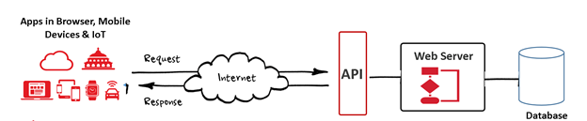
The API is not the database or even the server, it is the code that governs the access point(s) for the server.
During the 2000s, we had SOAP Services which were leveraged for some of the same use cases. REST provides a lighter-weight alternative. Many developers found SOAP cumbersome and hard to use. REST is easy to understand, and it’s simple to write and document. This ease of use also makes it easy for other developers to understand and write applications.
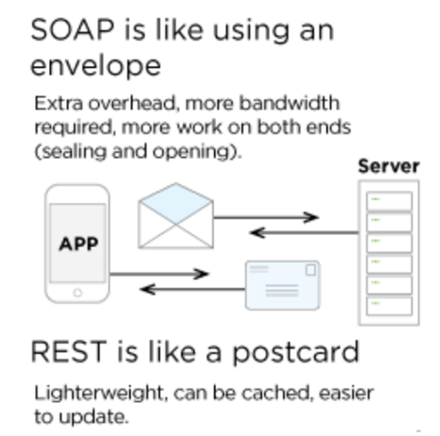
REST supports many data formats, but the predominant use of JSON means better support for browser clients. JSON sets a standardized method for consuming API payloads so that you can take advantage of its connection to JavaScript and the browser.
Security of API: Your phone’s data is never fully exposed to the server, and likewise the server is never fully exposed to your phone. Instead, each communicates with small packets of data, sharing only that which is necessary—like ordering takeout. You tell the restaurant what you would like to eat, they tell you what they need in return and then, in the end, you get your meal.
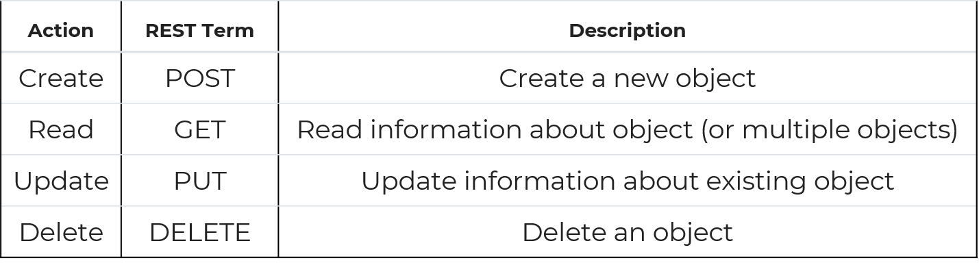

from flask import Flask
from flask_restful import Resource, Api
app = Flask(__name__)
api = Api(app) # make the API available for our app
class HelloWorld(Resource): # our class inheriting Resource class.
def get(self):
return {'Hell' : 'World'}
api.add_resource(HelloWorld, '/') # from postman we can make get req to home page and it will return the dict
if __name__ =='__main__': # run the app and then make get req from postman on the (http://127.0.0.1:5000/)
app.run(debug=True)
# All Postman files are saved in my account. Need to run the python scripts and then make postman request.
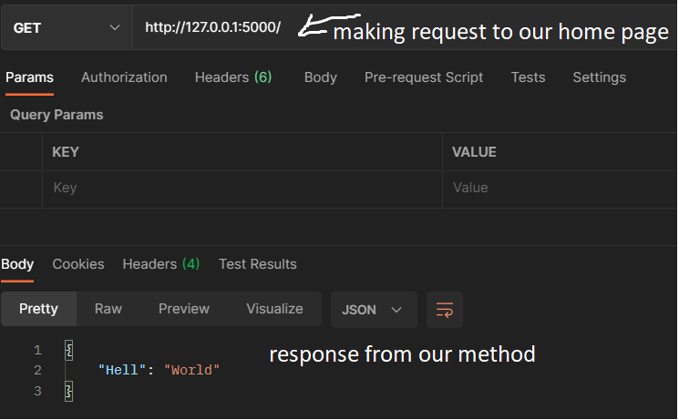
- Implement requests using GET/POST/DELETE
from flask_restful import Resource, Api
from flask import Flask
app = Flask(__name__)
api = Api(app) #Creates API wrapper for our application
# Define Resource(Class on which GET/POST/DELETE) request will be made
puppies = [] # it is list of dictionaries : name value pair
class Puppies(Resource):
# all the get/post/delete method should be having same signature if they're in same class
# GET
def get(self, name):
for pupp in puppies:
if pupp['name'] == name:
print(puppies)
return pupp
print(puppies)
return {'name' : None }
# POST
def post(self, name):
puppies.append({'name':name}) # append the name value pair to our puppies list
print(puppies)
return {'note':'Puppy Added'}
# DELETE
def delete(self, name):
for index, pupp in enumerate(puppies):
if pupp['name'] == name:
puppies.pop(index)
print(puppies)
return {'note': 'Delete Success'}
return {'Failed' : 'Not Found so not deleted'}
class AllPuppies(Resource):
# GET All Puppies
def get(self):
print(puppies)
return puppies
api.add_resource(AllPuppies, '/puppy/allpuppies')
api.add_resource(Puppies, '/puppy/<string:name>') #values inside<> this indicate the variable of string type which will be dynamic
if __name__=='__main__':
app.run(debug=True)
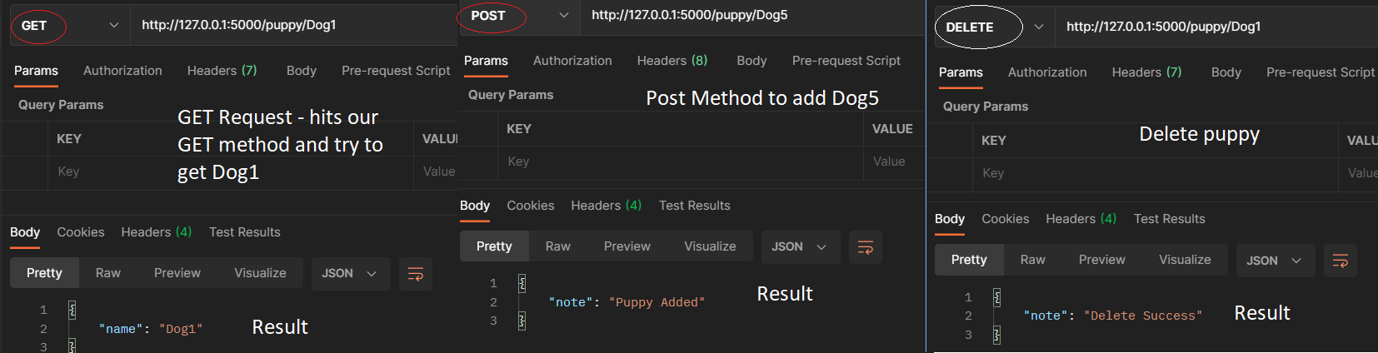
Get All Puppies from Postman
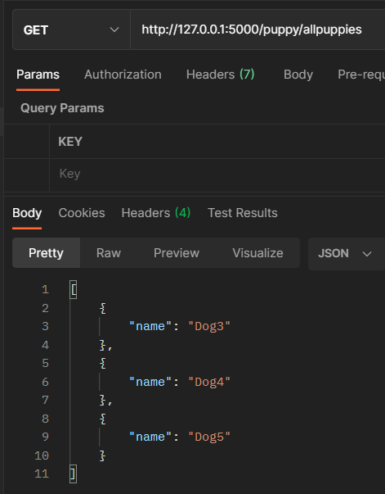
- JSON Web Token(JWT) :: It is JSON Object which is used to securely transfer information over the web(between two parties). It can be used for an authentication system and can also be used for information exchange. The token is mainly composed of header, payload, signature. These three parts are separated by dots(.). JWT defines the structure of information we are sending from one party to the another, and it comes in two forms – Serialized, Deserialized. The Serialized approach is mainly used to transfer the data through the network with each request and response. While the deserialized approach is used to read and write data to the web token.
Deserialized JWT in the deserialized form contains only the header and the payload. Both of them are plain JSON objects.
Serialized - JWT in the serialized form represents a string of the following format: [header].[payload].[signature]
Header - A header in a JWT is mostly used to describe the cryptographic operations applied to the JWT like signing/decryption technique used on it. It can also contain the data about the media/content type of the information we are sending.
{
"typ":"JWT",
"alg":"HS256"
}
Payload - The payload is the part of the JWT where all the user data is actually added. This data is also referred to as the ‘claims’ of the JWT. This information is readable by anyone so it is always advised to not put any confidential information in here. This part generally contains user information. This information is present as a JSON object then this JSON object is encoded to BASE64URL. We can put as many claims as we want inside a payload, though unlike header, no claims are mandatory in a payload.
{
"userId":"b07f85be-45da",
"iss": "https://provider.domain.com/",
"sub": "auth/some-hash-here",
"exp": 153452683
}
Signature - This is the third part of JWT and used to verify the authenticity of token. BASE64URL encoded header and payload are joined together with dot(.) and it is then hashed using the hashing algorithm defined in a header with a secret key. Format: HASHINGALGO( base64UrlEncode(header) + “.” + base64UrlEncode(payload),secret)
- Flask_jwt :
If we try to make a request to a resource which requires authentication the we will get the following error. If we require a method to be accessed only when the user is authenticated then we need to decorate the method definition with the @jwt_required() decorator.
class AllPuppies(Resource):
# GET All Puppies
@jwt_required() # it requires authentication to see all puppies.
def get(self):
return puppies
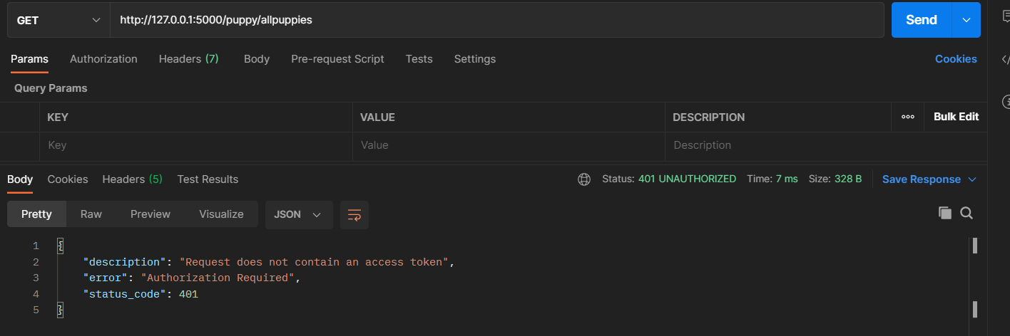
- To get authorized token we need to register with the website using our username and password. When we implement JWT the following route automatically gets created to implement our authorization functionality http://127.0.0.1:5000/auth.
- Steps to get access token in Postman ::-> make a POST request to the link http://127.0.0.1:5000/auth but before that edit headers and Body of postman.
For header
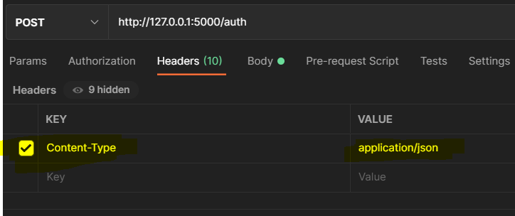
For Body Part
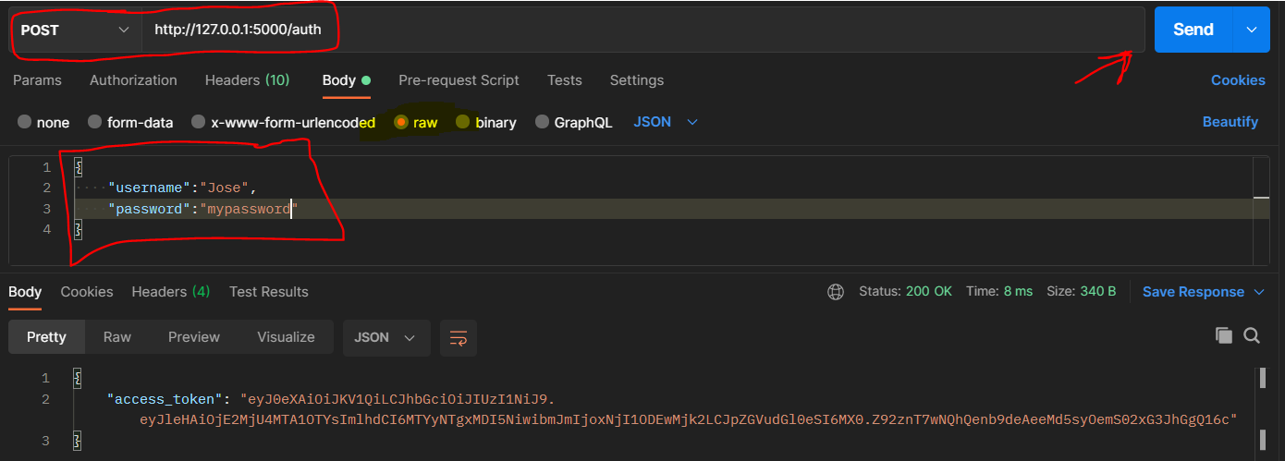
Use the access token to make request now
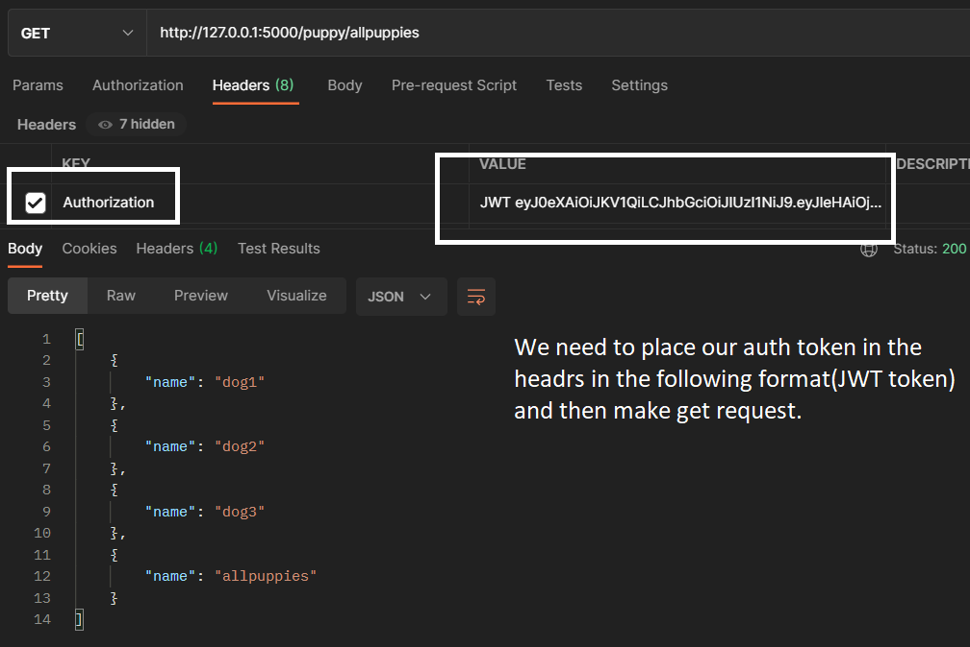

- A complete demo of API making GET/POST/DELTE calls from Postman
from flask import Flask
from flask_sqlalchemy import SQLAlchemy
from flask_restful import Resource, Api
import os
from flask_migrate import Migrate
app = Flask(__name__)
basedir = os.path.abspath(os.path.dirname(__file__))
app.config['SECRET_KEY'] = 'secretkey'
app.config['SQLALCHEMY_DATABASE_URI'] = 'sqlite:///'+os.path.join(basedir, 'data.sqlite')
app.config['SQLALCHEMY_TRACK_MODIFICATIONS'] = False
api = Api(app)
db = SQLAlchemy(app)
Migrate(app, db)
# our Model Class
class Puppy(db.Model):
__tablename__ = 'puppy_api'
name = db.Column(db.String(80), primary_key = True)
def __init__(self, name):
self.name = name
def json(self):
return {"name": self.name}
def __str__(self):
return f"{self.name} "
class Puppies(Resource):
# all the get/post/delete method should be having same signature if they're in same class
# GET
def get(self, name):
puppy = Puppy.query.filter_by(name=name).first()
if puppy:
print(puppy)
return puppy.json()
else:
return {'name' : 'Not Found' }, 404
# POST
def post(self, name):
pupp_add = Puppy(name=name)
db.session.add(pupp_add) # append the name value pair to our puppies list
db.session.commit()
print(pupp_add)
return {'note':'Puppy Added'}
# DELETE
def delete(self, name):
pupp_del = Puppy.query.filter_by(name=name).first()
if name:
db.session.delete(pupp_del)
print(pupp_del)
db.session.commit()
return {'Deleted' : 'Deleted Puppy'}
else:
return {'Puppy':'Not Found to be deleted'}
class AllPuppies(Resource):
# GET All Puppies
# @jwt_required() # it requires authentication to see all puppies.
def get(self):
puppies = Puppy.query.all()
print(puppies)
return [pupp.json() for pupp in puppies]
api.add_resource(Puppies, '/puppy/<string:name>')
api.add_resource(AllPuppies, '/puppy/all')
if __name__ == '__main__':
app.run(debug=True)

- Deploying an APP on Heroku servers(https://www.freecodecamp.org/news/how-to-deploy-a-nodejs-app-to-heroku-from-github-without-installing-heroku-on-your-machine-433bec770efe/)
In order to deploy app on Heroku server we need follow some process in our Flask application.
- Create a requirements.txt in the root folder using the following command : pip freeze > requirements.txt
- Create a Procfile(name of file) without any extension and paste the following content into it : web: gunicorn app:app
- Make sure to pip install gunicorn
- Then run the following command : Heroku git:remote -a my-heroku-app-name
- Make a git repository and commit all files to it using : git commit -am “adding files”: this will deploy our app.
- The website is accessible at : app-name.herokuapp.com(https://hello-satish.herokuapp.com/)
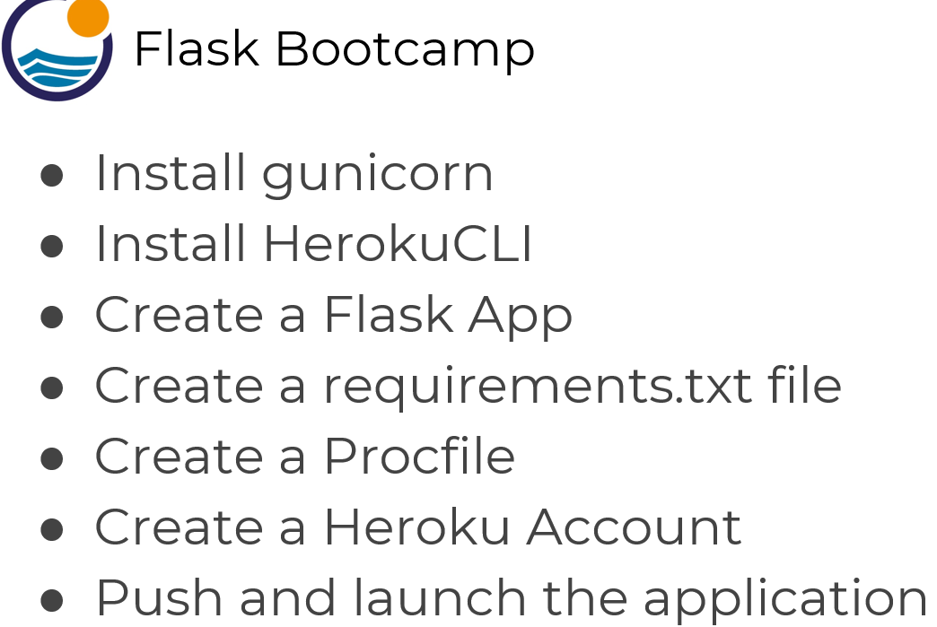
- Modal Object(https://getbootstrap.com/docs/5.0/components/modal/)

- Final Project Link (https://github.com/satishkr39/Blog_Website.git)
Functions -- create a company blog page, where multiple users can log in, create blog posts, and update or delete their existing blog posts.
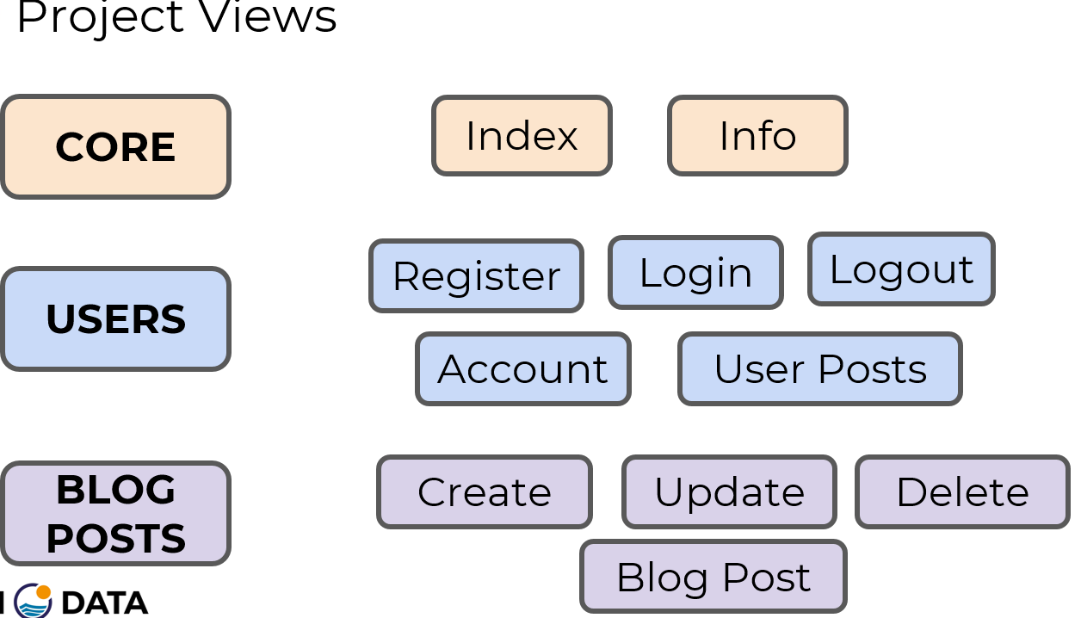
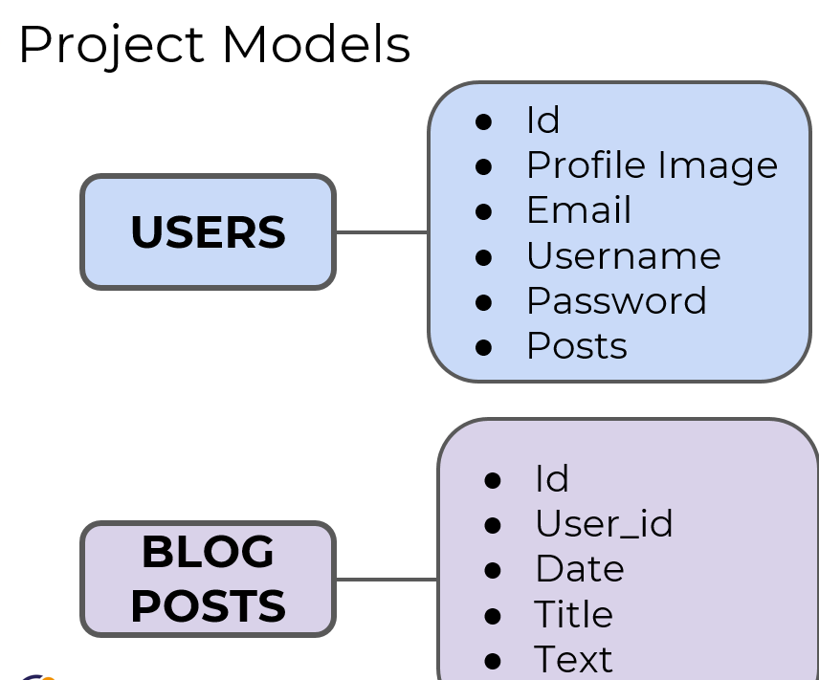

S
sg

