UiPath Interview Question –

Private Property of UiPath:

Protecting Sensitive Information

To protect sensitive information that is logged during the execution of your automation at the Verbose level, you can choose not to log variable and argument values in both Orchestrator and Studio.
To do this, you can select the Private property check box from the activities that use sensitive information.
Send Window Message:-
You can use default if you do not want to work in the background, if you want a process to take place in background, ie, you do not want to lose your cursor control, then you can use SendWindowMessage or SimulateType. The latter is faster, but does not support hotkeys,

Learn details about queue.
Remember the properties panel of different activities.
Diff between Get Transaction item and Get Queue item?
Learn about recent release of UiPath.
Queue Trigger
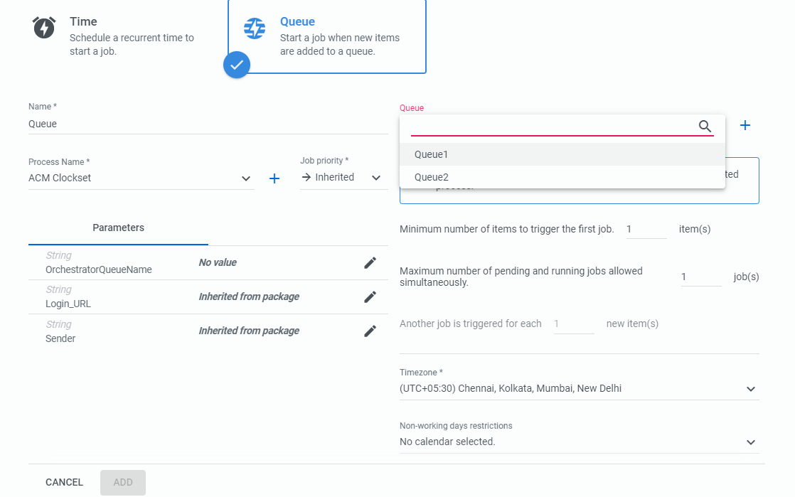
Create Queue-
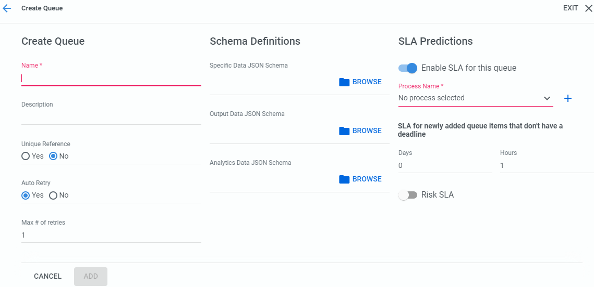

Properties Panel of Queues:
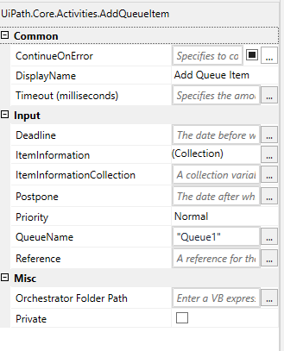 Item Information – Contains the item that need to be added to queue1.
Priority can be Normal, High, or Low.
Reference – it is to group some items based on some name.
Get Transaction Item –
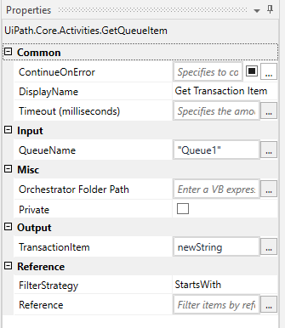
Set Transaction Status
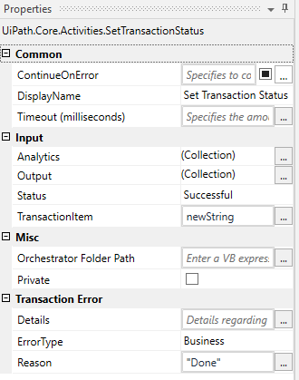
Status can be – Successful or Fail
Error Type – Business or Application
Get Queue Items
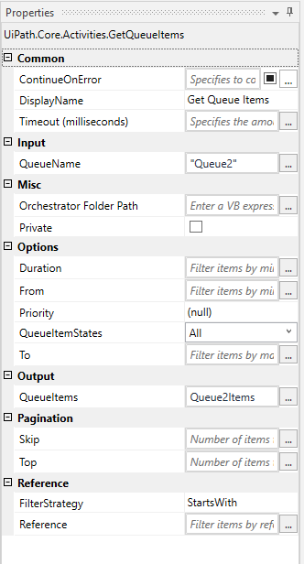
QueueItemStates – All, New, InProgress, Successful, Failed, Retried, Deleted, Abandoned,
Add Transaction Item –adds an item in the queue, starts the transaction and sets the status to In Progress. It can also be configured to add a custom reference to each transaction.
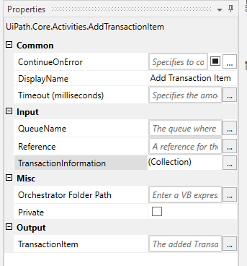 Mentrion the item in TransactionInformation to add.

Queue:-
A queue is a container that enables you to hold an unlimited number of items. Queue items can store multiple types of data, such as invoice information or customer details. This information can be processed in other systems - SAP or Salesforce, for instance.
The data stored in, and output from, Queue items is free form by default. For situations where a specific schema is needed, such as integrations with other applications, processing machine-generated forms, or analytics, you can upload custom JSON schemas to ensure that all Queue item data is in the proper format. if the resulting data does not conform the schema, that item fails with a Business Exception.
As soon as queue items are processed, they become transactions.
Transactions Overview
You can search for a specific transaction or a group of them, according to a custom reference, which is added through the Reference property of the Add Queue Item and Add Transaction Item activities.
To achieve better control in terms of Orchestrator performance, the Specific Data size of queue items is limited to 1 MB with the Queue.MaxSpecificDataSizeInKiloBytes parameter. Anything beyond this limit cannot be added to a queue, and it returns the 403 - Payload Too Large error code. If you need to upload larger items, store the large data in external storage and only reference the link within the item.

How to navigate to Transaction Details?
Go to Queue Tab -> Click … then View Transaction -> We will get all queue items, select any one and click … then View Details.
The Transaction Details window contains three tabs:
- Details - enables you to view the exact information added to a transaction, as well as the statuses it went through, and the number of times it was retried.
- Comments - enables you to view and add transaction-related comments in case you need to share information about a specific transaction with your teammates. All the users with View, Edit, and Delete permissions on Queues and Transactions can add, edit, or remove comments, respectively; however, keep in mind you can make changes to your own comments only.
- History - enables you to see what action was performed by who, see who the reviewer is and what the review status is. For more information, see the Managing Transactions and Field Descriptions for Transactions pages.

Processing Order
Within any given queue, the transactions are processed hierarchically, according to this order:
- Items that have a Deadline, as follows:
a. in order of Priority; and
b. according to the set Deadline for items with the same Priority.
- Items with no Deadline, in order of Priority, and
a. according to the rule First In, First Out for items with the same Priority.

Queue Item Statuses
Queue items can have two types of statuses:
- Item Statuses
- Revision Statuses

Item Statuses
These statuses let you know if an item has been processed or not, and the stage of the process at a particular time. Item statuses are displayed in the Status column, in the Transactions page. Queue items can go through the following statuses:
- New - the item has just been added to the queue with the Add Queue Item activity, or the item was postponed, or a deadline was added to it, or the item was added after an attempt and failure of a previous queue item with auto-retry enabled.
- In Progress - the item was processed with the Get Transaction Item or the Add Transaction Item activity; when an item has this status, your custom progress status is also displayed, in the Progress column;
- Failed - the item did not meet a business or application requirement within the project and was therefore sent to a Set Transaction Status activity, which changed its status to Failed;
- Successful - the item was processed and sent to a Set Transaction Status activity, which changed its status to Successful;
- Abandoned - the item remained in the In Progress status for a long period of time (approx. 24 hours) without being processed;
- Retried - the item failed with an application exception and was retried. After the Robot finishes retrying the item, the status changes to Failed or Successful, according to your workflow.
- Deleted - the item has been manually selected from the Transactions page and marked as deleted; an item with this status can no longer be processed.

Revision Statuses
These statuses let you perform version control but only of queue items that have been abandoned or have failed with an application or business exception. These statuses have to be manually set per item, by an assigned reviewer. All changes are tracked in the History tab of the Audit Details window. The reviewer can be assigned only when the item status is failed or abandoned, and reviewers cannot be changed after a revision status was added to the item. Only logged in reviewers can see requests assigned to them in the Review Requests page. Moreover, queue items can be assigned for revision in bulk.
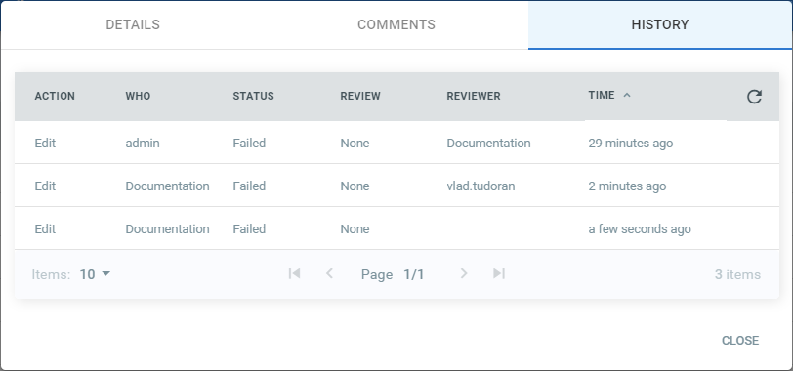
The following statuses are available:
- None - this is the default status. It is set to all items, even if they failed or not.
- In Review - a user has marked an item that has failed with app exception as in the process of being reviewed. This status does not have other implications in Orchestrator or Studio than changing the value in the Revision column on the Queues page.
- Verified - a user has marked an item as verified. Items cannot be retried after the user sets this status. There are no other implications in Orchestrator or Studio than changing the value in the Revision column on the Queues page.
- Retried - the item has been marked manually for retry. As a result, a new queue item with the New status is created. This is displayed in the Items Details window of the indicated transaction.

Business Exception vs Application Exception
It is important to choose the correct type of exception with which a transaction is failed, because this choice influences whether Orchestrator chooses to retry the transaction of the queue item or not, as follows:
An Application Exception describes an error rooted in a technical issue, such as an application that is not responding.
A Business Exception describes an error rooted in the fact that certain data which the automation project depends on is incomplete or missing.
Set Transaction Status activity can be used to shape the logic of your project in a way that encapsulates this distinction in several ways:
- If the Set Transaction Status activity fails the transaction with an Application Exception and the Auto Retry option in the Create Queue page is set to Yes when the queue is created, the queue item is retried.
- By default, Orchestrator does not retry transactions which are failed due to Business Exceptions. This happens because an inconsistency between the transaction value and the business requirement means that there might be errors in the initial data which the queue items were created from. Additional actions might be required to fix this type of issue, and logging this type of exception can be useful.
- An If or Flow Decision activity can be used to take different courses of action if a transaction is failed with a certain type of exception, such as using the Log Message activity to log a custom message or the Message Box activity to display a window containing information about the event.

Studio Activities Used with Queues

These activities are part of the UiPath.System.Activities activities package, and can be found in the Activities panel, under Orchestrator > Queues.
- Add Queue Item - populates the queue with items, defines a time frame when these items must be processed, and adds a custom reference to each item. By default, when an item is added to the queue its status is New.
- Add Transaction Item - adds an item in the queue, starts the transaction and sets the status to In Progress. It can also be configured to add a custom reference to each transaction.
- Bulk Add Queue Items - adds a collection of items from a specified DataTable to a specified queue and sets the items' statuses to New.
- Delete Queue Items - deletes items with the New status from a specified queue. In order to execute this activity in Studio, the Robot has to be connected to Orchestrator and the Robot role needs Edit, Create, and Delete permissions on queues and Delete permissions on transactions. The activity runs under the Robot which executes it.
- Get Queue Items - retrieves a list of up to 100 transactions from an indicated queue, according to multiple filters, such as creation date, priority, state, and reference.
- Wait Queue Item - retrieves a queue item from a specified queue and stores it in a QueueItem variable. At runtime, in case the specified queue is empty, this activity sends a message to Orchestrator stating it is ready to receive a queue item and then waits for a new item to be added to the queue. Once retrieved, the status of the item is set to In Progress.
- Get Transaction Item - gets an item from the queue so that you can process it (start the transaction) and sets its status to In Progress.
- Postpone Transaction Item - adds time parameters between which a transaction must be processed (not before Postpone and no later than Deadline).
- Set Transaction Progress - helps you create custom progress statuses for In Progress transactions. This can be placed in key places in your automation project, to inform you of its progress if, for example, it crashes. This option can be useful in the troubleshooting process.
- Set Transaction Status - changes the status of the transaction item to Failed (with an Application or Business Exception) or Successful. Application Exceptions should be used when an app you are automating fails or is not responding, while Business Exceptions should be used when a certain transaction value does not meet a business requirement. For more information on this choice, see the Business Exception vs Application Exception article.

Note:
Items that fail with an Application Exception are retried if you have configured the Auto Retry options in the queue, in Orchestrator.
There are other activities developed to be used with queues as part of other Orchestrator features. For example, long-running workflows use the following queues activities that are part of the UiPath.Persistence.Activities activities package:
- Add Queue Item and Get Reference - adds a queue item with parameters and retrieves the corresponding queue item object stored in a QueueItemData in order to wait for transaction completion at any time during the execution of the workflow.
- Wait for Queue Item and Resume - suspends the execution of the current workflow until a specified transaction is completed. To designate a transaction, a QueueItemData object obtained from the Add Queue Item and Get Reference activity must be supplied. Upon completion of the transaction, the execution of the workflow is resumed.

Global Exception Handler
SUGGEST EDITS
The Global Exception Handler is a type of workflow designed to determine the project’s behavior when encountering an execution error. Only one Global Exception Handler can be set per automation project.

📘

Note:
The Global Exception Handler is not available for library projects, only processes.
The Global Exception Handler has two arguments, that should not be removed.
The first argument is errorInfo with the In direction and it stores information about the error that was thrown and the workflow that failed. The level of the error to be logged can be set in the Log Message activity.

📘

Note:
Use the ActivityInfo property for errorInfo to get the name of the activity which threw the exception and view it in the Output panel.
The second argument, result has the Out direction and it is used for determining the next behavior of the process when it encounters an error. The following values can be assigned to the result argument:
- Continue - The exception is re-thrown.
- Ignore - The exception is ignored, and the execution continues from the next activity.
- Retry - The activity which threw the exception is retried. Use the RetryCount method for errorInfo to count the number of times the activity is retried.
- Abort - The execution stops after running the current Global Exception Handler.

📘

Note:
Any workflow may be flagged as a Global Exception Handler in Studio, except for library projects.

Handling Errors During Debugging
When an exception is detected during debugging, the activity which faulted is highlighted, the execution is paused, and the exception's type and details are mentioned in the Locals and Call Stack panels.
Debugging actions like Continue, Stop, Retry, Ignore, Restart and Slow Step are available in the ribbon. Ignore is used for continuing the execution from the next activity.
The Retry button retries to execute the current activity, without the Global Exception Handler stepping in. The Continue action runs the Global Exception Handler, taking into consideration the previously chosen values for the result argument, either Continue, Ignore, Retry or Abort.

📘

Note:
When using the Global Exception Handler with a project that includes a Try Catch, make sure to group activities into a Sequence inside the Try container. Otherwise, the Global Exception Handler does not execute.
In the case of nested activities, the Global Exception Handler executes for each activity in the call stack. However, it does not execute for activities directly encapsulated in a Try Catch, unless they're contained in an activity.

Asset Management
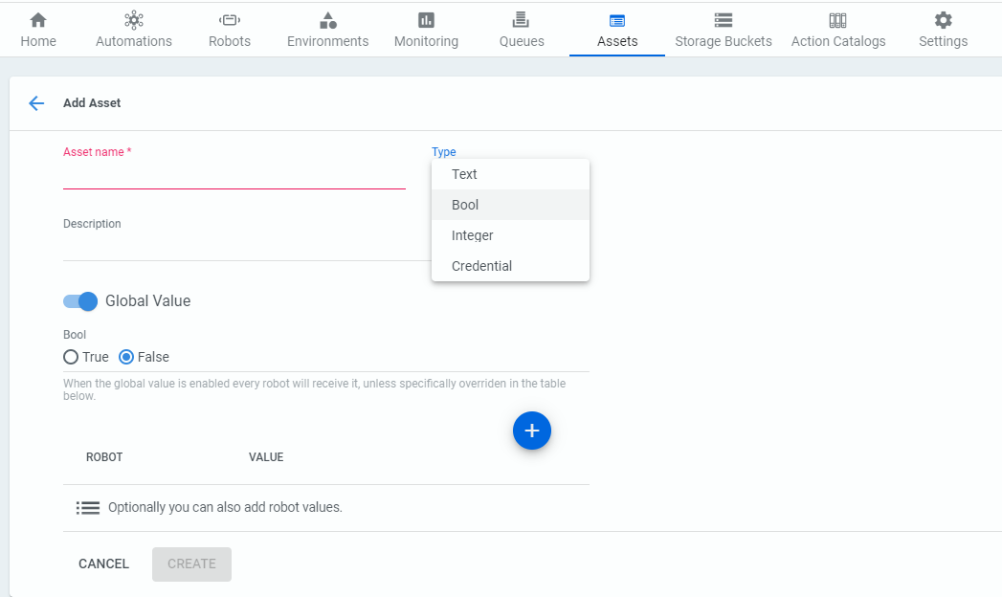

Relative Selector –
We can use Relative Selector using UiExplorer.
We begin by indicating the First Name textbox again on the screen, then we select the First Name label as our anchor.
The selector we get is not good enough because it still contains the automatically generated dynamic ID which is not useful. So we will remove the id attribute and let us test the flow.

Slide - 3

What are Selectors?
A Selector in UiPath Studio is a feature that enables the identification of the User Interface elements through its address and attributes stored as XML fragments.

Selectors are properties of UI automation activities;

The element identification is done to perform specific activities in an automation project. Selectors are generated automatically every time we use an activity that interacts with graphical user interface elements.

We can think of the element identification process achieved through Selectors as a postman that delivers letters to a certain address.
The postman to deliver the letters, a specific path is required and must contain structured and hierarchized details such as Country > City > Zip Code > Street Name > Street Number > Apartment Number. Similarly, UiPath Studio requires the detailed path to a specific element within the user interface.

What are some business scenarios in which Selectors are useful?
Most of the times when an automated process involves working with UI elements, selectors are used. Typical activities include:
- Clicking buttons
- Inputting or scraping text in/from a field on a website
- Choosing an option from a drop-down list

Slide – 4
The Structure of Selectors- Explain the figure
electors are made of nodes. And each node is made of tags and attributes. Let's take an example to explain the two. Below is a selector node.
- Tags-
- Nodes in the selector XML fragment
- Correspond to a visual element on the screen
- First node is the app window
- Last node is the element itself
For example:
- wnd (window)
- html (web page)
- ctrl (control)
- webctrl (web page control)
- java (Java application control)

Attributes -\
Every attribute has a name and a value. You should use only attributes with constant or known values.

For example:
- parentid=‘slide-list-container’
- tag=‘A’
- aaname=‘Details’
- class=‘btn-dwnl’
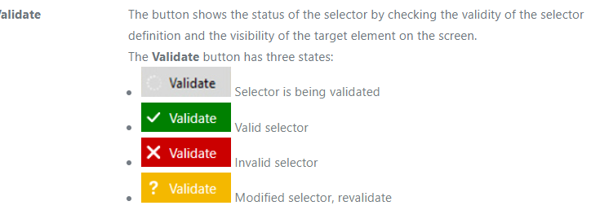
Show the demo1
Slide-5

UI Explorer is an advanced tool that enables you to create a custom selector for a specific UI element.
It is available as a standalone tool you can download from the Resource Center in your Automation Cloud instance, or from Studio only if the UiPath.UIAutomation.Activities package is installed as a dependency to the project.

It is mainly used to
- Add or remove attributes
- Add parent or children tags
- Use wildcards to replace changing values

What are some business scenarios in which I will use the Property Explorer?
- When you want to start an activity after a certain attribute changed its value (using the Wait Attribute activity)
- When you want to change the value of an attribute on a webpage, like its visibility (using the Set Attribute activity)
- When you want to check the state of a certain UI element by checking on an attribute (using the Get Attribute activity)

The UI Frameworks
In order to return the best selector for the element of interest, we can switch between the different UI Frameworks available in UiExplorer.
Default - This is the proprietary method which usually works correctly with all types of user interfaces.
Default Accessibility - This represents an earlier solution from Microsoft that makes apps accessible. It is recommended when using legacy software, if the default framework does not work as expected.
Ui Automation - This is the improved accessibility model from Microsoft, which is recommended when using newer applications in case the default framework does not work as expected
Show the Demo2;

Slide – 6

Partial Selctors
- Don’t contain the tags and attributes of the top-level window, thus the activities with partial selectors must be enclosed in containers
- Generated by the Desktop Recorder
- Best suited for performing multiple actions in the same window.

Full Selctros
- Contain all the tags and attributes needed to identify a UI element, including the top-level window
- Generated by the Basic Recorder
- Best suited when the actions performed require switching between multiple windows.
Demo – FullVsPartialWebPage & FullVsPartialDemo

Slide – 7

fine-tuning of selectors required?
A dynamic selector uses a variable or an argument as a property for the attribute of your target tag.
This allows the selector to easily identify a target element based on the value of the variable or argument, and not an exact string, which might change, depending on interactions inside your automation project. As such, the variable or argument can be changed to interact with a different element, without changing the selector itself. A dynamic selector has the following form, with the specifications:
- tag - the target tag, such as <ctrl/>
- attribute - the target attribute, such as name='menuItem'
- {{Value}} - the name of the variable or argument which holds the property of the element you want to interact with
Why is dynamic selctor required ?
- Thee workflow uses files that have timestamp in the name;
- The environment in which a workflow was built has different parameters than the production environment (for example, the application version);
- The use of dynamic selectors would improve the reliability and robustness of the automation.

Slide-8

About Fuzzy Search
Most times the selector changes based on user action as a result of which the selector gets failed.
Often enough, top-level tag values are subject to dynamic changes because the target application rewrites them based on your actions. For example, a web page title can change during the automation process, which makes corresponding selector invalid.
In this regard, the selector’s fuzzy search capabilities enable you locate strings based on a pattern, rather than on an exact match to your input. This results in a more flexible method of identifying elements and validates selectors according to multiple attributes, even if some are prone to change during the automation process.

How Fuzzy Search Works
In order to use the fuzzy search capabilities, a couple of matching options need to be included in the top-level tag of the target selector, as follows:
matching:<tag_name>=fuzzy
Allows you to specify the target search tag, determined by the <tag_name> value.
fuzzyLevel:<tag_name>=<numerical_value>
Determines the matching threshold for the target <tag_name>. It supports a numerical value from 0 to 1, as follows:
- Closer to 0 - returns results with lower similarity to the <tag_name>
- Closer to 1 - returns results with higher similarity to the <tag_name>

Regex Selector –
RegEx, is a special text string for describing a search pattern. This makes them ideally suited for searching, text processing, and data validation. Using the RegEx search capabilities in selectors enables you to identify multiple target element with a single search execution. Without RegEx, multiple selectors would have been built to identify each target element.
matching:<tag_name>=’regex’
Allows you to specify the target search tag, determined by the <tag_name> value.
<tag_name>='<regex_command>'
Allows you to specify the search pattern through the <regex_command> expression used to identify the <tag_name>.

Demo – Slide8

Slide-9
Non Greedy Selector

About Non-Greedy Search
The Non-Greedy search makes it possible to identify the target element from a pool of similar applications, matching the attributes you specify. It needs to be included in the top-level tag of a selector.
If a generated selector contains the idx attribute, its value is set by default to *.

How Non-Greedy Search Works
Introducing Non-Greedy search in your selectors instructs it to search through all the active windows or browser instances which match the top-level tags of your selector, and not just the window instances in focus. Non-Greedy search makes use of the idx() attribute, which needs to be included in the top-level tag, as follows:
Debugging

If we talk of our team, then debugging basically means to put as many message boxes until we reach the root cause of the problem.
Debugging is the process of detecting and removing of existing and potential errors (also called as ‘bugs’) in a software code that can cause it to behave unexpectedly or crash. To prevent incorrect operation of a software or system, debugging is used to find and resolve bugs or defects.

Whenever we start dev we actually make dev in pieces and then integrate together to make them functional as a unit.
When various subsystems or modules are tightly coupled, debugging becomes harder as any change in one module may cause more bugs to appear in another. Sometimes it takes more time to debug a program than to code it. So it It is recommended to perform debugging during the design stage of the automation project, at activity, file and project level.

Sometimes we find that some activity is not working and that can be detected while running the flow but we won’t get too much info regarding which activity failed and why it failed. So in order to avoid this it’s better to debug our developed flow properly then run it.

GetAppCredentials.
Most of the times it happens like we don’t know how and why are values are getting null. So in order to debug that we will message boxes at different places to check till where the values are getting passed. And once we find out the root cause of our problem we will end with having too many message boxes and then actual headache start to remove all the message box.

Even during deployment if we forget one message box then it will be a problem for us.
So in today session we will see how we can replace the message box with the actual style of debug. Instead of using message box we will use debug points and various debug panel in order to find the root cause of our problem.

Slide – 3
The retry, ignore and the restart are enable only if any error or exception is raised.
The Test Activity context menu option part of the Designer panel is used for running a test on the currently selected activity. When clicked, the Locals panel opens displaying the variables and arguments in scope.
Test Activity can be used in two ways:
- add default values to properties and test
- add arguments and/or properties to activity properties and use the Local panel to add values after clicking the Test Activity option.
Double-click the value field of a variable or argument, or click the icon in the Locals panel, and add a new value. Next, click Step Into to focus and execute the activity, and monitor the variable or argument's value in the Locals panel.

TestActivity.xaml
Step Over
Unlike the Step Into action, Step Over exevute the current container and stop once done.
This action comes in handy for skipping analysis of large containers which are unlikely to trigger any issues during execution.
Step Over is available using the F10 keyboard shortcut.

Step Out
As the name suggests, this action is used for stepping out and pausing the execution at the level of the current container. Step Out completes the execution of activities in the current container, before pausing the debugging. This option works well with nested sequences.
Step Out is available using the Shift + F11 keyboard shortcut.

Log Activities
If enabled, debugged activities are displayed as Trace logs in the Output panel. Note that Highlight Elements and Log Activities options can only be toggled before debugging, and persist when reopening the automation project. This is not applicable for invoked workflows unless these files are opened in the Designer panel.
Logs are automatically sent to Orchestrator if connected, but you can have them stored locally by disabling the Allow Development Logging option from the Settings tab in the Add or Edit Robot window.

Slide – 5
The Locals panel displays properties or activities and user-defined variables and arguments. The panel shows:
- Exceptions - the description and type of the exception.
- Arguments
- Variables
- Properties of previously executed activity - only input and output properties are displayed.
- Properties of current activity
Integrated.xaml
Now we will see the test activity example with the local panel help.
TestActivity.xaml

Slide-6
Double-clicking an item in the Call Stack panel, focuses and highlights the selected activity in the Designer panel.

Slide-7

Breakpoints
Breakpoints are used to purposely pause the debugging process on an activity which may trigger execution issues. Setting a condition and/or hit count turns the simple breakpoint to a conditional one.
You can place and modify a breakpoint on any activity as follows:
- from the context menu, right-click an activity and select Toggle Breakpoint;
- by selecting the activity, and clicking the Breakpoints button on the Debug tab;
- by pressing F9 while the desired activity is selected.

Type | Description
Breakpoints | Breakpoints pause the debugging process before the activity is executed. Breakpoints can have the following states:  Enabled -  Disabled -
Conditional Breakpoints | Conditional breakpoints are breakpoints that depend on a set condition and/or a hit count. Conditional breakpoints can have the following states:  Enabled -  Disabled -
Tracepoints | Tracepoints are breakpoints with set logged messages. When the tracepoint is reached during debugging, the message is logged at trace level. Tracepoints can have the following states:  Enabled -  Disabled -
Conditional Tracepoints | Conditional tracepoints have a set condition or hit count, and a logged message. The message is logged when the condition is met the number of times stated in the hit count field. Conditional tracepoints can have the following states:  Enabled -  Disabled -

Field Descriptions for Breakpoint Settings
The Breakpoint Settings window has the following options:
Option | Description
Condition | The condition for the breakpoint. If the condition is met during debugging, the execution breaks and the activity is highlighted.
Hit Count | Specifies the number of times the condition must be met before the execution breaks. If the hit count is higher than the number of times the condition can be met, the execution does not stop upon encountering the breakpoint. The maximum hit count value is 32,767.
Log Message | Specifies the message to be logged at trace level when the condition is met. The message is visible in the Output panel. If a condition is not set, the message is still logged.
Continue execution when logging | If selected, the execution is not paused when the condition is met and the specified message is logged. Available only if a log message was previously set.

Context Menu for Breakpoints
Right-click an item in the Breakpoints panel to open the context menu with the following options:
Option | Description
Delete | Deletes the selected breakpoints.
Focus | Jumps to the breakpoint in the Designer panel.
Enable | Enables the selected breakpoints.
Disable | Disables the selected breakpoints.
Settings | Opens the Breakpoint Settings window for adding a condition to the breakpoint.

Slide – 8

The Watch Panel
SUGGEST EDITS
Similar to the Call Stack panel, the Watch panel is only visible during debugging. It can be set to display the values of variables or arguments, and values of user-defined expressions that are in scope. These values are updated after each activity execution while debugging.
ariables or arguments can be added to the Watch panel in the following ways:
- In the Watch panel, click the Add Watch field and type the name of the variable or argument;
- In the Locals panel, right-click a variable or argument and select Add to Watch;
- In the Variables or Arguments panel, right-click a variable or argument and select Add Watch.
To copy a value from the Watch panel, select the value, right-click and select Copy.
To remove one or more entries from the panel, right-click and select Delete or Clear All.

