SQL Server DBA
.bak files can be restored using Restore database option(Right click on database-> select restore-> go to file-> locate the file)
.mdf file can be restored using Attach Database option(Right click on database-> select attach-> locate the file)
Steps to restore .bak file(Download and Install AdventureWorks Database (tutorialgateway.org))
Right click on database and select Restore Database
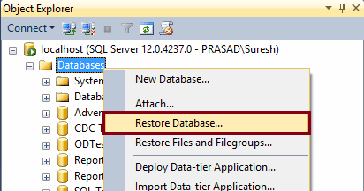
Go to Device the select File and click ADD and then Locate the .bak file
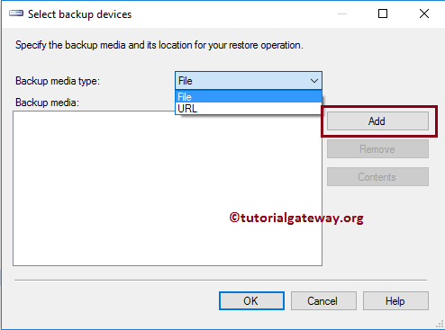Then click ok to restore the database file.
Code for restoring DB
USE [master]
RESTORE DATABASE [AdventureWorks2019]
FROM DISK = N'C:\Program Files\Microsoft SQL Server\MSSQL15.MSSQLSERVER_NEW\MSSQL\DATA\AdventureWorks2019.bak'
WITH FILE = 1, NOUNLOAD, STATS = 5
Taking BackUp of DataBase
Right Click on DataBase Name -> Click Task -> Select Backup -> Select all fields and click on backup.
TO restore follow the above process.
BACKUP DATABASE [AdventureWorks2019]
TO DISK = N'C:\Program Files\Microsoft SQL Server\MSSQL15.MSSQLSERVER_NEW\MSSQL\DATA\AdventureWorks2019.bak'
WITH NOFORMAT, NOINIT, NAME = N'AdventureWorks2019-Full Database Backup', SKIP, NOREWIND, NOUNLOAD, STATS = 10
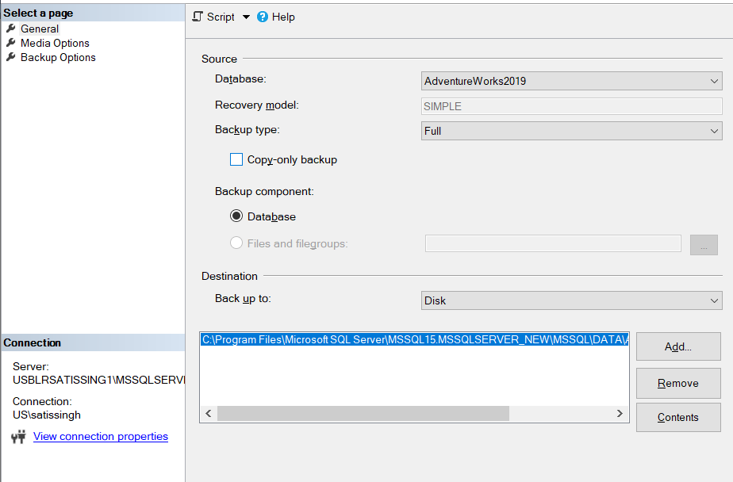
Recovery Model(https://www.sqlshack.com/understanding-database-recovery-models/)
A recovery model is a database configuration option that determines the type of backup that one could perform, and provides the ability to restore the data or recover it from a failure.
3 types – Simple, FULL, BULK_LOGGED
- Changing the recovery model
Right Click on DB Name -> Go to Properties -> Go to Options -> Select from Recovery model
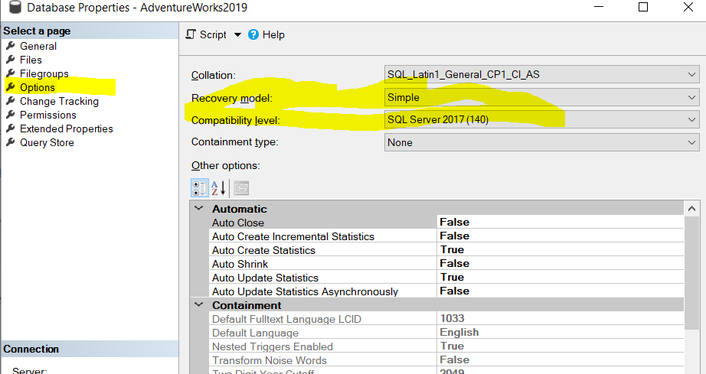
Simple
SIMPLE recovery model is the simplest among the available models. It supports full, differential, and file level backups. Transaction log backups are not supported. Point-in-time and page restore are not supported, only the restoration of the secondary read-only file is supported.

Full
All the transactions (DDL (Data Definition Language) + DML (Data Manipulation Language)) are fully recorded in the transaction log file. The log sequence is unbroken and is preserved for the databases restore operations. Unlike the Simple recovery model, the transaction log file is not auto-truncated during CHECKPOINT operations. All restore operations are supported, including point-in-time restore, page restore and file restore.

Bulk Logged
It’s a special purpose database configuration option and it works similar to FULL recovery model except that certain bulk operations can be minimally logged. The transaction log file uses a technique known as minimal logging for bulk operations. The catch is that it’s not possible to restore specific point-in-time data.
Reasons to choose the bulk logged recovery model:
- Use minimal logging technique to prevent log file growth
- If the database is subjected to periodic bulk operations
- WAL (Write-Ahead-Logging) - The transactions that occur on the database first get registered into the transaction log file and then the data is written to the disk
View the Recovery Model for each db
SELECT name, recovery_model,recovery_model_desc FROM sys.databases

To change the recovery model, execute the alter database statement with set recovery option. For example, the recovery model of the database is set to SIMPLE using.
ALTER DATABASE MODEL SET RECOVERY SIMPLE ;
Backup Types
A database backup can, but does not have to, contain entire database. This depends on the backup type and your backup strategy which can involve different backup types. It’s recommended to start any backup strategy by creating a full database backup.
- Full SQL Database backup
A full backup type holds the entire database and the part of the transaction log containing uncommitted transactions that will be rolled back or replayed during the recovery process in order to make data consistent upon restore. This is required as SQL Server does not pause activities in the database while it is being backed up, which means that the database can be modified during the backup process.
The full backup serves as the starting point for subsequent differential and transaction log backups. Moreover, differential and transaction log backups cannot be created if the full database backup has never been created. A typical scenario for a full database backup creation is once per day, followed by transaction log backups during the day.
- Differential SQL Backup
In case only the changes applied after the last full backup was taken need to be backed up, use the differential database backup type. Each differential backup contains all changes that occurred since the last full backup. This means that other previously created differential backups may be considered as obsolete. Also, in case of databases with a large number of changes, differential backups can easily become larger than the database itself. To overcome this and to benefit from the use of differential backups, it’s recommended to take full backups in intervals short enough to keep differential backups smaller than the full backup.
- Transaction Log Backup
This backups provide maximum data protection in case of a database disaster. Note that you cannot create a transaction log backup if the database uses the Simple recovery model. A transaction log backup contains only transactions that occurred after the last transaction log backup was taken. A sequence of transaction log backups taken one after another, after the full of bulk-logged database backup creates a full log chain. The chain allows database restoration to a point-in-time, presuming the last transaction log backup doesn’t contain any of minimally logged operations.

Point In Time Recovery
Select DB -> Right Click and Select Task -> Restore DB -> Click TimeLine
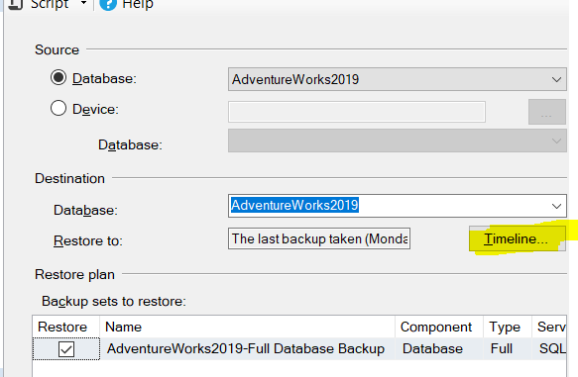
Select Radio button Specific date and time and fill the time in field and click OK. Then Restore.
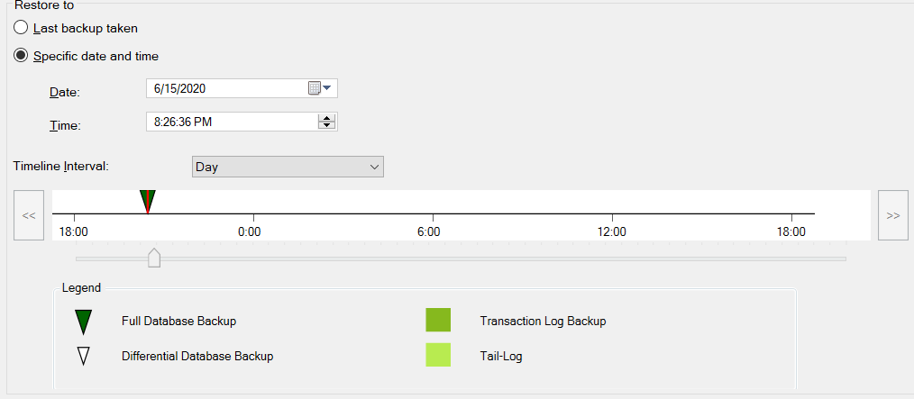

RECOVERY vs NORECOVERY(https://www.stellarinfo.com/blog/ms-sql-restore-with-recovery-and-norecovery/)
Recovery – It is default action. The RECOVERY command requests the current RESTORE to roll back all uncommitted transactions. When all uncommitted transactions are rolled back the database is placed into a ready state. The database is ready to use. The database doesn’t goes offline.
RESTORE DATABASE [dbName] FROM DISK = N'FileName.bak' WITH FILE = 1, NOUNLOAD, STATS = 5, RECOVERY
NORECOVERY – when you need to restore multiple backups. It puts the database in ‘RESTORING’ state to prevent users from accessing the database unless additional backups are restored. Restore with NORECOVERY is used for restoring each database backup except the last. The last backup can be restored using the RECOVERY option to bring the db online for usage.
For example, if you need to restore a full db backup followed by a transaction log backup, the full backup will be restored with NORECOVERY argument and then the log backup will be restored with recovery. Here’s how to do it:
RESTORE DATABASE [dbName] FROM DISK = N'c:\sql\earnings.bak' WITH FILE = 2, NORECOVERY, NOUNLOAD, STATS = 5
RESTORE LOG [dbName] FROM DISK = N'C:\Program Files\Microsoft SQL Server\MSSQL14.MSSQLSERVER\MSSQL\Backup\earnings_LogBackup_2018-12-21_12-24-25.bak' WITH FILE = 1, NOUNLOAD, STATS = 5, RECOVERY
Note: In the above query, the first command restores the db with NORECOVERY option, and the second command restores the log backup using the RECOVERY option to make db Online again.

Steps – Right click on dbName -> Tasks -> restore db -> options Page -> select dropdown.
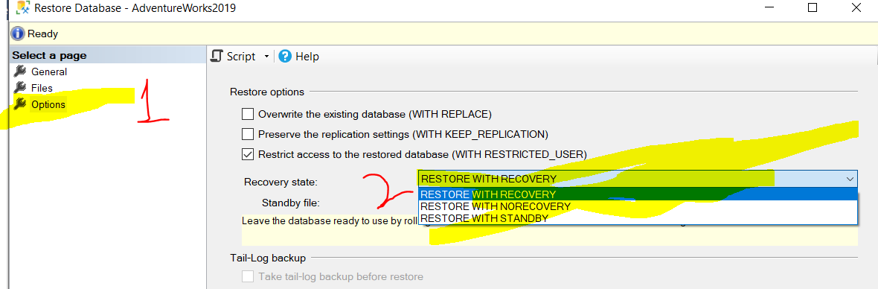
POINT_INTIME RECOVERY
Restore the Database and put it into the Full Recovery Model(Loading of new db).
Backup it up(the loaded db take backup).
Run any query of insertion or deletion on any table to change from original.
Wait for some time and then navigate to db -> Task -> Restore -> Database -> Click TimeLine ->
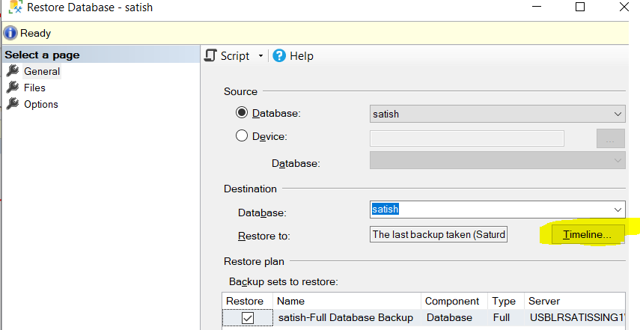 Then Select Specific date & time and select few minutes back date and click OK. Again click OK for restore.
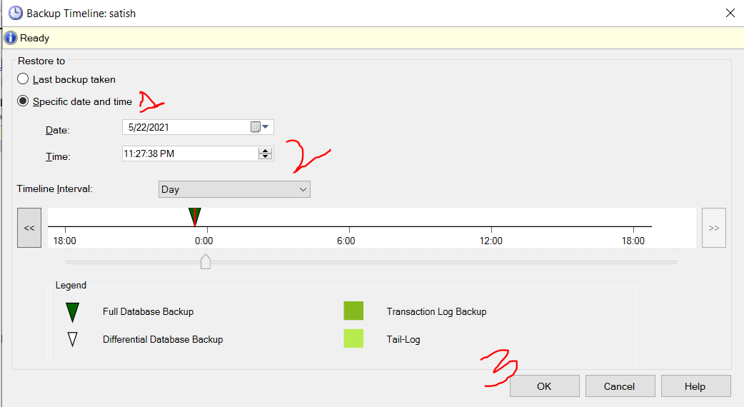

SP_SPACEUSED
The system procedure is used to get usuage stats of db, tables. The output of the stored procedure, sp_spaceused, is a pair of result sets(2 tables) when the @objname parameter is omitted. The stored procedure accepts the @oneresultset parameter starting from SQL 2016, therefore, the result can be viewed in a single result pane(in 1 table). sp_spaceused is the most common stored procedure used by any database administrator to check the database space usage details. It displays the number of rows, the disk space reserved, and the disk space used by a table, indexed view.
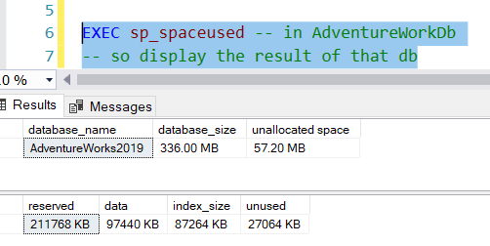
With parameter
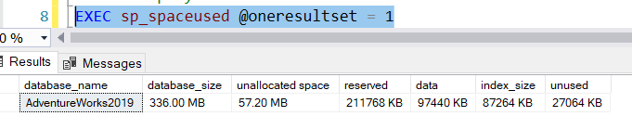
Get stats of a particular table – data is size of table, 48kb is index_size, 400kb is reserved for this table,
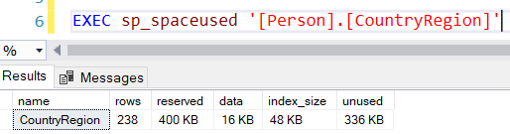
- Exec sp_help ‘tableName/ProcedureName’ – Get details with respect to table or procedure
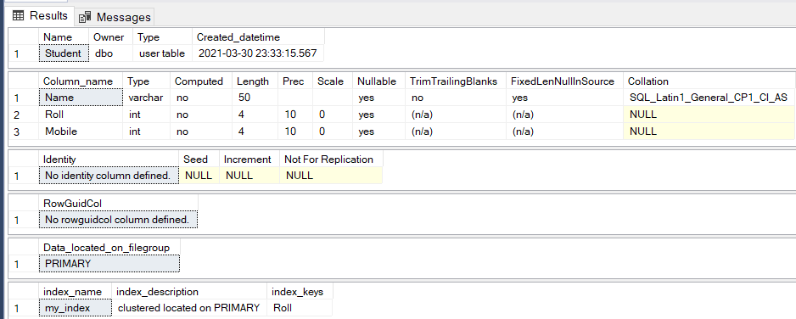
CHANGING SINGLE_USER/MULTI_USER IN SQL SERVER USING GUI
Right click on db -> Select Properties -> Navigate to Options Page -> scroll to down to find RESTRICT_ACCESS option and you can change single/multi user.
ALTER DATABASE [AdventureWorks2019] SET SINGLE_USER WITH NO_WAIT
ALTER DATABASE dbName SET MULTI_USER WITH ROLLBACK IMMEDIATE
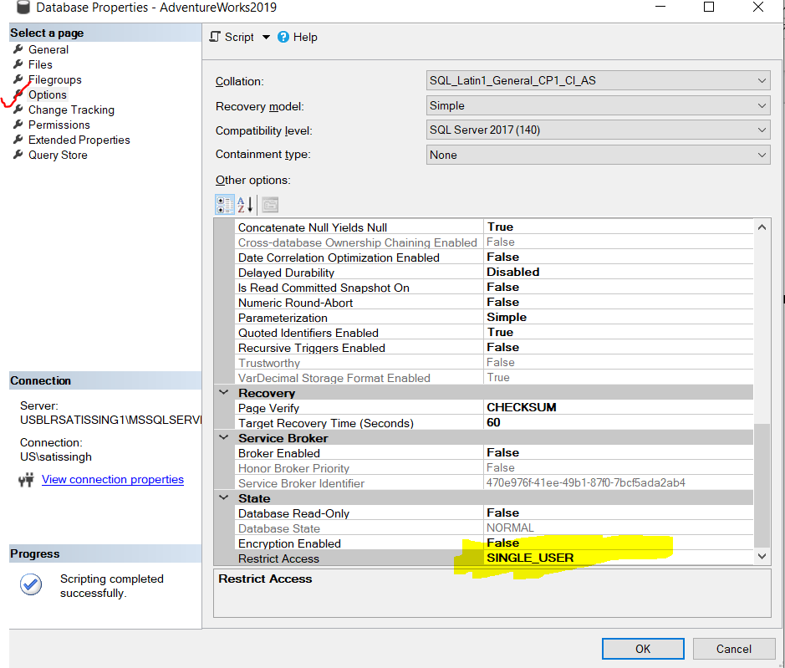
MANAGING USER IN SQL SERVER
The users can be found under 2 sections.
- SQL SERVER INSTANCE ->Security -> Logins :: All the users under this have access to SQL server instance only. We need to give them access for respective db in order to access any db for that instance.
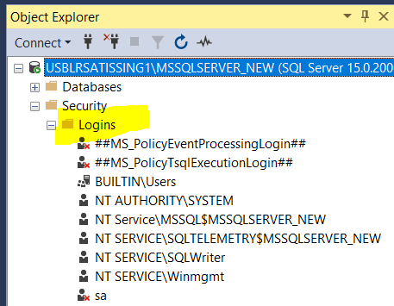
- User under corresponding DB: SQL SERVER INSTANCE -> Database -> dbName ->Security -> Users
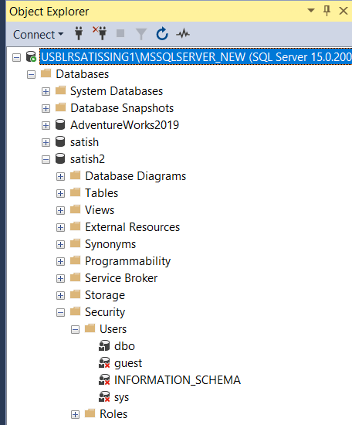The users under this have access to particular db and the server instance.
CREATING LOGIN ACCOUNTS FOR SQL SERVER(https://www.guru99.com/sql-server-create-user.html)
This is the way of giving access to new user. First we need to create user for our local machine by going to system settings… then navigate to INSTANCE -> SECURITY -> LOGINS -> Right Click -> New Login -> Search for login Name -> Select Windows Authentication or SQL Auth and click OK.
- CREATE USER [userName] FOR LOGIN [userName] WITH DEFAULT_SCHEMA=[dbo]
The user will be added and will be visible in user section of object repo. Then we can login using that user.
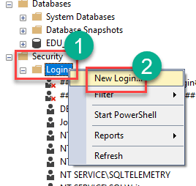
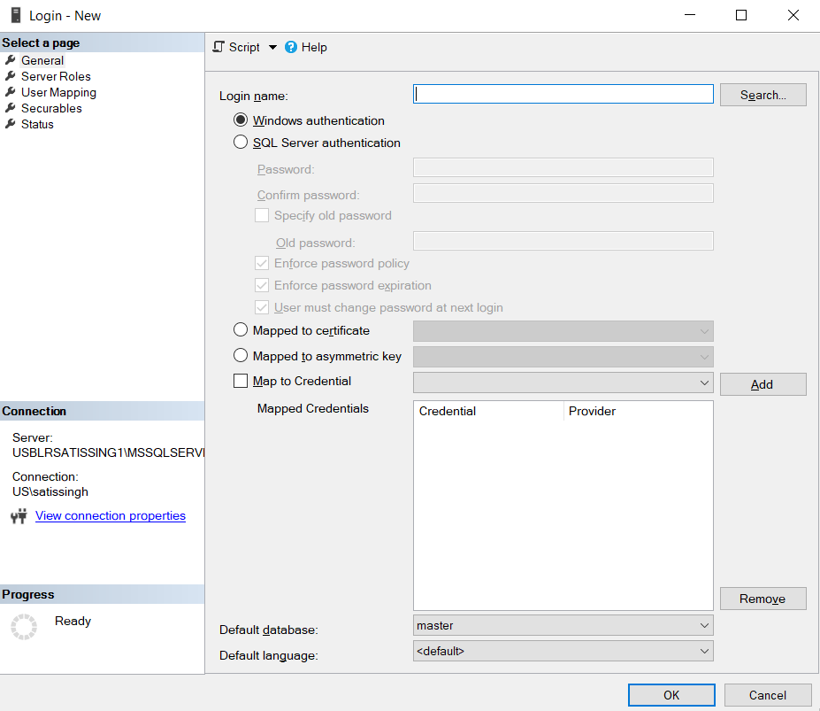
T-SQL Command to create user :: CREATE LOGIN LoginName WITH PASSWORD = '123'; CREATE A USER:: 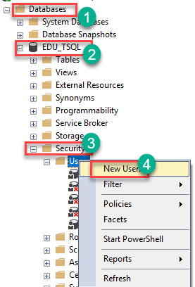
you will get the following screen,
Enter desired User name -> Enter the Login name (created earlier) -> Click OK
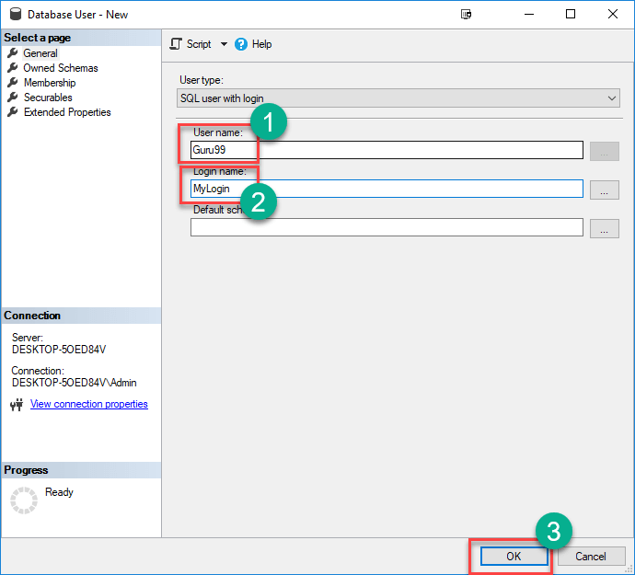
create user <user-name> for login <login-name>
Note: That the query should be executed within the query window. If a user is already created for a Login, SQL Server will throw an error if you create a user for the same login.
PERMISSIONS TO USER :- Permissions refer to the rules that govern the levels of access that users have on the secured SQL Server resources. SQL Server allows you to grant, revoke and deny such permissions. There are two ways to assign permissions in SQL Server:
Assign Permission Using SQL Server Management Studio
Step 1) Connect to your SQL Server instance and expand the folders from the Object Explorer as shown below. Right click on the name of the user, that is, Guru99 then choose Properties.
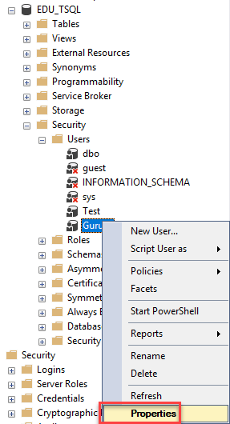
Step 2) In the next screen, -> Click the Securables option from the left. -> Click on Search
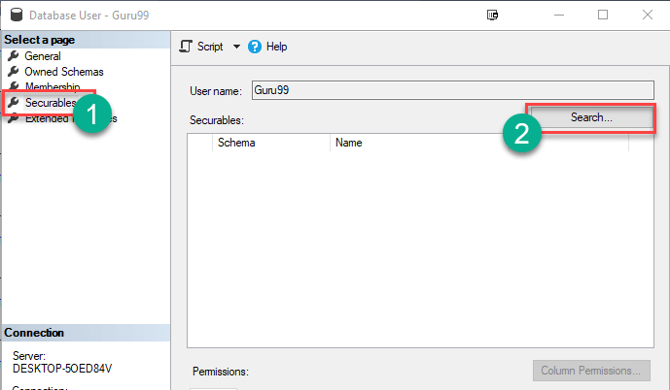
Step 3) In the next window, -> Select "All Objects belonging to the Schema." -> Select Schema name as "dbo" -> Click OK
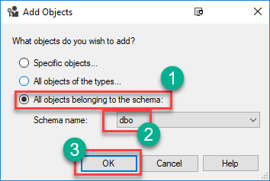
Step 4)Identify Table you want to Grant Permission->In Explicit Permission select Grant->Click Okay
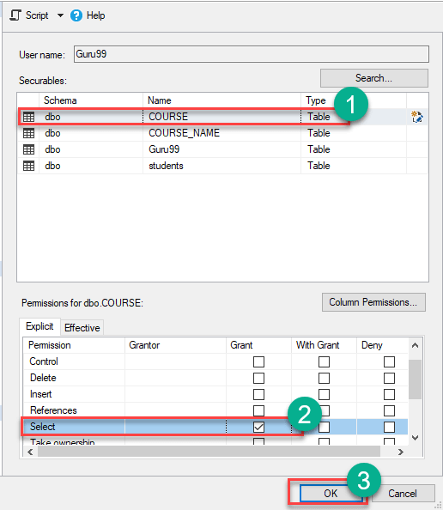
Step 5) The user Guru99 is granted SELECT permission on table Course.
Grant Permission using T-SQL
To grant permission to a user using T-SQL, you first select the database using the use statement. You then assign the permission to the user using the grant statement. Here is the syntax:
use <database-name>
grant <permission-name> on <object-name> to <username\principle>
For example, the following command shows how you can grant the select permission to the user Guru99 on the object (table) named Course within the Database EDU_TSQL:
USE EDU_TSQL
GO
Grant select on Course to Guru99
SQL SERVER ROLES(https://www.red-gate.com/simple-talk/sql/database-administration/sql-server-security-fixed-server-and-database-roles/)
There are total 9 roles.
- SYSADMIN – can perform any task in sql server
- Serveradmin – can set server-wide config option, can shout down the server
- Setupadmin – can mangage linked servers and startup procedures
- Securityadmin – can manage logins and db permissions, read logs, change passwords
- Processadmin – can manage processes running in sql server
- Dbcreator – can create, alter, drop db
- Diskadmin – can manage disk files
- Bulkadmin – can execute bulk insert statements
- Public - Every SQL Server user account belongs to this server role. When a server principal has not been granted or denied specific permissions on a securable object, the user inherits the permissions granted to public on that object. Only assign public permissions on an object when you want the object to be available to all users.
Server Roles
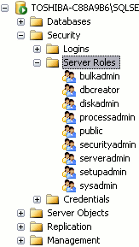view the properties of a server role by right clicking on it. You can then add users to the server role by clicking Add. In the screenshot below, Homer has been added to the securityadmin role.
SQL Server has both server and database resources where access might need to be granted. Access to these resources can be granted to either individual logins or database users or can be granted to roles, for which logins or database users can be members. Granting access via a role is known as role-based security.
Server Based Roles – for servers && dB role – It’s roles for db.
Role-based security is the concept of providing logins and/or database users access to a SQL Server resource by being a member of a role. A role is an object in SQL Server that contains members, much like a Windows group contain members. When a login or database user is a member of a role, they inherit the role’s permissions.
When role-based security is used, the actual access permissions to SQL Server resources are granted to a role and not a specific login or user. Role-based security reduces the amount of administration work needed to grant and manage security when multiple logins or users require the same access to SQL Server resources. Once a role has been set up, and the appropriate permissions are granted to it, it is just a simple matter of adding logins or users to the role to provide them with the same access as the role.
Fixed server roles :: Fixed Server roles have server-wide scope. They come with a set of canned permissions tied to them. The permissions for server roles can’t be changed or extended. There are nine different fixed server roles provided with SQL Server.
Displaying all server role permissions -- EXEC sp_srvrolepermission;
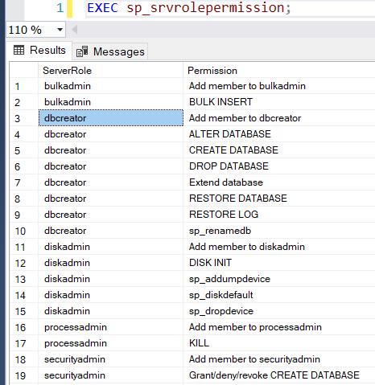
Adding a login to a fixed server role can be done using SQL Server Management Studio (SSMS) or TSQL. To use SSMS, follow these steps: Connect to an instance -> Expand the Security item-> Expand the Server Roles item -> Right-click on the fixed server role and then click on the properties option ->Click on the Add button on Server Roles Properties page-> Select the login or user-defined server role that you want to add to fixed server role-> Click on a series of Ok buttons to complete the addition of new member to the role
Before clicking to add the member, the dialog should look like Figure 1.
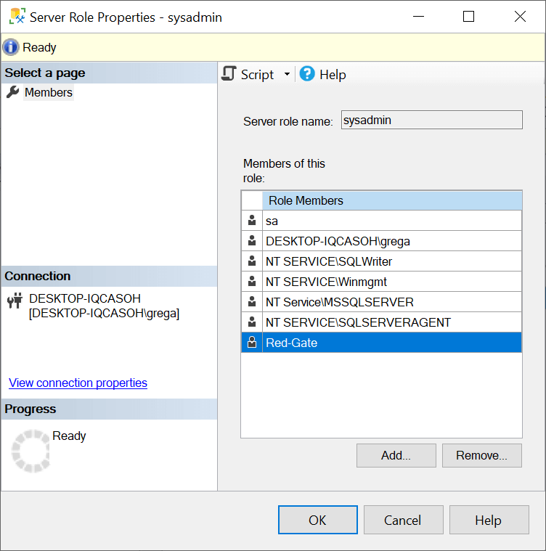
Adding a login to the sysadmin fixed server role. :: ALTER SERVER ROLE sysadmin ADD MEMBER [Red-Gate]; ALTER ROLE [db_datareader] ADD MEMBER [userName]
Removing logins from a fixed server role can be done as easily as you added them by using SSMS or TSQL.
Removing login from sysadmin fixed server role. :: ALTER SERVER ROLE sysadmin DROP MEMBER [Red-Gate];
DATABASE ROLES:: manage security at the database level. Just like server roles, there are two different types of database roles: fixed and user-defined. Fixed database roles are just like fixed server roles, meaning they have a specific set of permissions associated with each one that cannot be altered. Fixed database roles only provide permissions to database resources in a specific database.
If a database user is a member of a fixed database role, they inherit the permissions that have been pre-defined for the fixed database role.
DB_OWNER : Members of the db_owner fixed database role can perform all configuration and maintenance activities on the database, and can also drop the database in SQL Server.
DB_SECURITYOWNER : Members of the db_securityadmin fixed database role can modify role membership for custom roles only and manage permissions. Members of this role can potentially elevate their privileges and their actions should be monitored.
DB_ACCESSADMIN :add or remove access to the database for Windows logins, Windows groups, and SQL Server logins.
DB_BACKUPOPERATOR :can back up the database.
DB_DDLADMIN :run any Data Definition Language (DDL) command in a database.
DB_DATAWRITER : can add, delete, or change data in all user tables.
DB_DATAREADER : can read all data from all user tables.
DB_DENYDATAWRITER : cannot add, modify, or delete any data in the user tables within a database.
DB_DATADENYREADER : cannot read any data in the user tables within a database.

sp_dbfixedrolepermission :: to display all the permissions associated with each fixed database role.
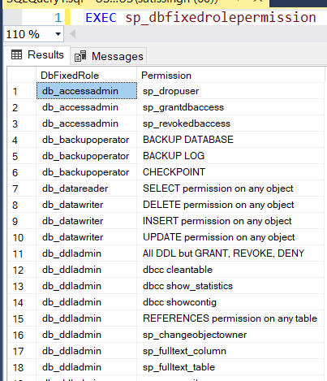
--Show permissions for db_datareader
EXEC sp_dbfixedrolepermission @rolename = 'db_datareader';
In order for a database user to inherit the permissions of a fixed database role, they need to be a member of a fixed database role. To determine if a databases user is a member of a database role, you can review the role membership using SSMS by following the steps:
Connect to an instance & Expand Databases->Expand the database for which you want to review fixed database roles->Expand the Security item->Expand the Roles item then Expand the Database Roles Item->Double click on the role in which you want to see members
Create Schema : CREATE SCHEMA schemaName;
GRANT vs WITH GRANT : The difference between these options is very simple. In case of only GRANT, the username cannot grant the same permission to other users. On the other hand, with the option WITH GRANT, the username will be able to give the permission after receiving requests from other users. Grant will allow the current user to access the object or provide access to the specified user.
CREATE TABLE venkat_Table (ID INT)
GRANT SELECT ON venkat_Table TOVenkatFriend
With grant option is nothing but a higher level of access provider. This will inform the database that, this user will have access to the particular object and he is having necessary previlege to provide access to other users on the object.
GRANT SELECT ON venkat_Table TO VenkatFriend WITH GRANT OPTION
Creating User Defined Roles
CREATE SERVER ROLE roleName; -- creating role
ALTER SERVER ROLE roleName ADD MEMBER username; --adding member to role
DENY/GRANT ANY LOGIN TO roleName; -- giving permission to role
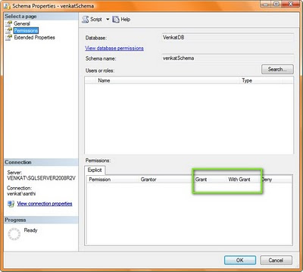
CREATE USER FOR A SPECIFIC DB CREATE USER [TEST] FOR LOGIN [TEST] WITH DEFAULT_SCHEMA=[dbo]
Using GUI -> Go to Specific DB-> Security->User->RightClick and select New User -> Select UserType, fill username, loginName, schema and click OK.
Assigning role to db user : ALTER ROLE db_datareader ADD MEMBER [username]
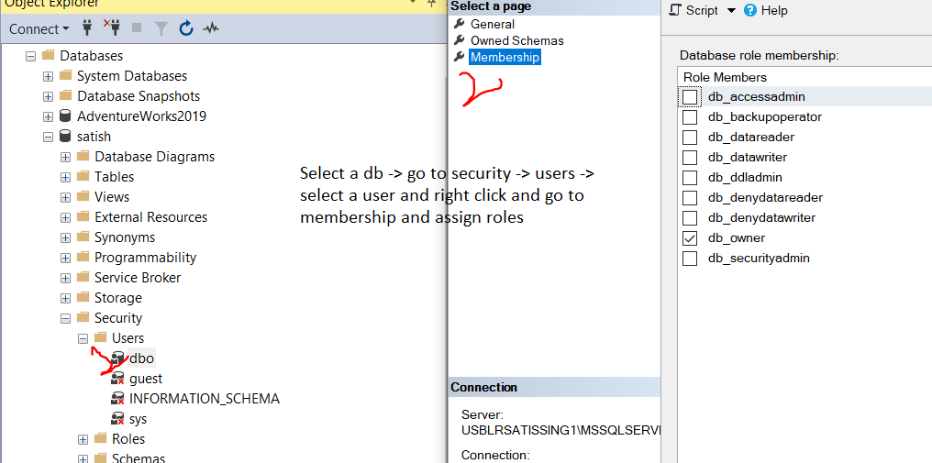
Creating user defined database roles:
The user defined database roles can be created for both user and database roles(pre-defined roles).

