Tableau Training
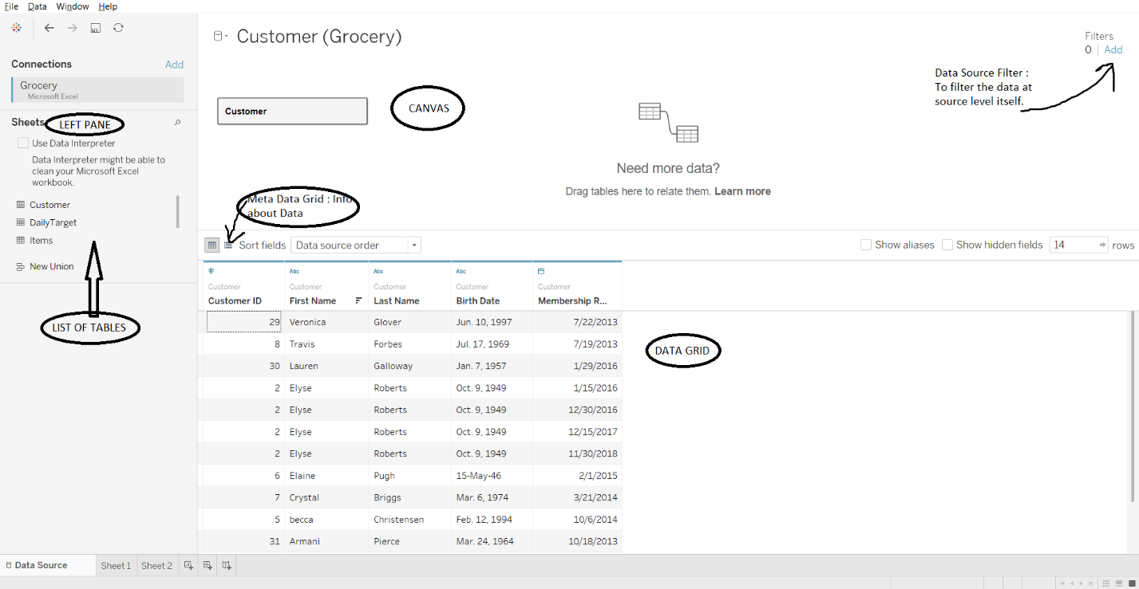
Data Source Filter :filter data at source level. We can filter data on the basis of columns and keep only required rows of our choice.
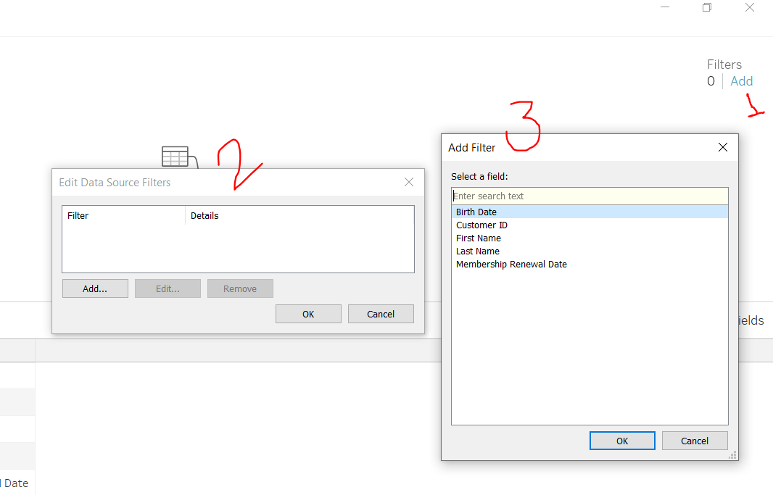
Custom SQL Extract can be only done when we connect to database as data source.
LOD – Level of Detail : if we want to show a particular value at a particular level and it should not change with any addition of level at that time we use LOD. Syntax of LOD – as we can see the sum is constant throughout even after adding so many dimensions.
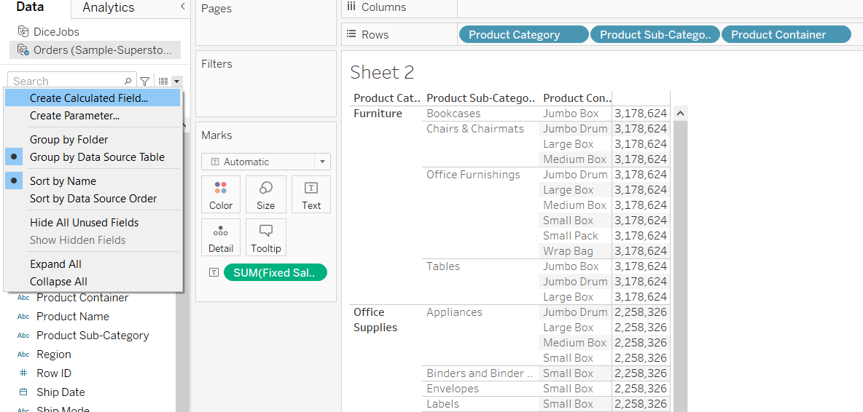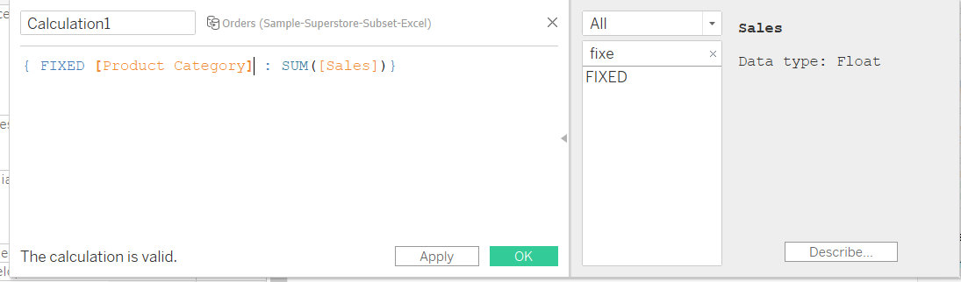
Create Join between two tables OR DATA BLENDING between two tables : Data blending aggregate the data first then uses left join to combine the data. Blend doesn’t cause duplication.
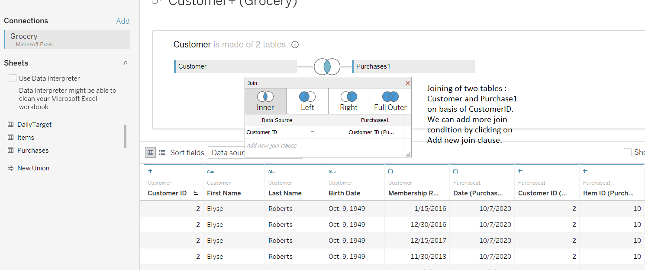
Create Joins between two tables from two different data source
- Add the two data source as normal we do.
- Click on Data -> Edit Blend Relationship ->
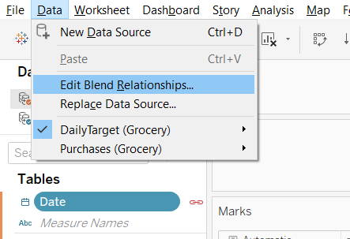
- Select Primay and Secondary Data
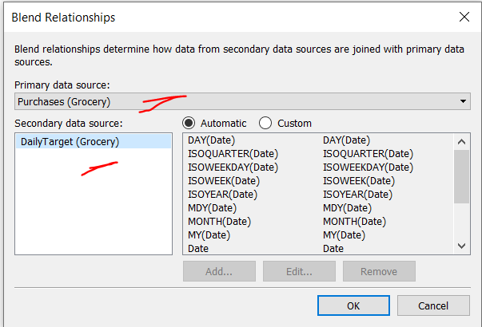
Finally after making all the required joins.
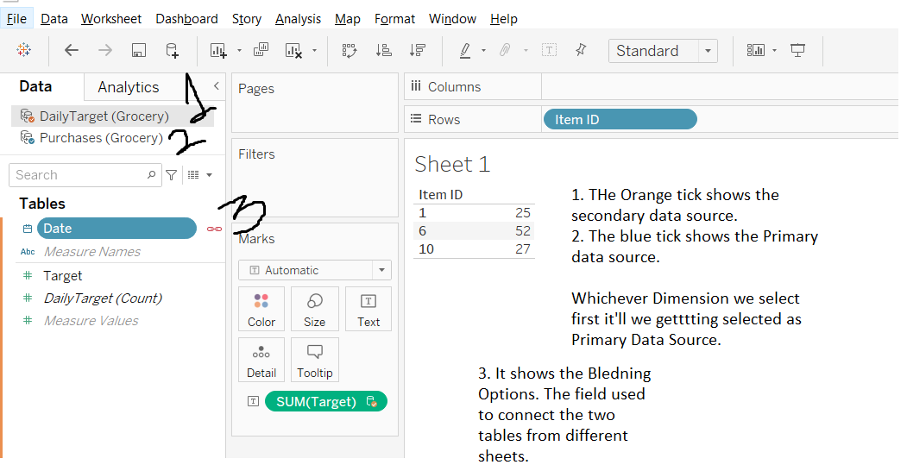
- Relationship happens in logical layer. And Joining condition occurs in physical layer of tableau.

Disaggregate Data ::
It means to open the aggregated data. The SUM of a particular Dimension is broken into individual plots.
Steps to Disaggregate Data -> Go to Analysis Section -> Uncheck the Aggregate Measures Option.
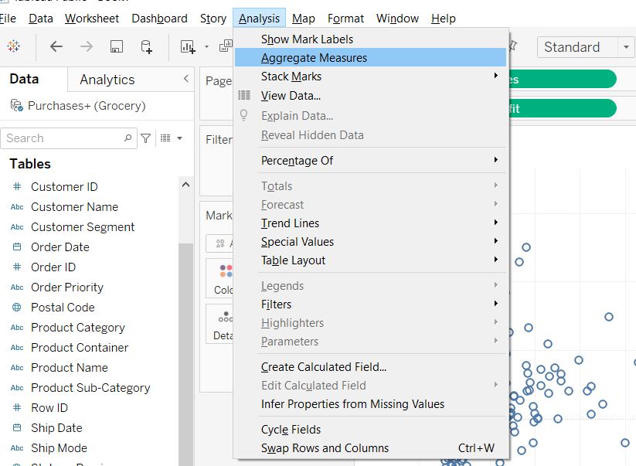
Each pair of circles represent a combination of X,Y values of Sales & Profits.
Steps to show Trend Line :-> Click on Trend Lines and Select Show Trend Lines.
Click on Analytics to View the Multiple Trend Lines
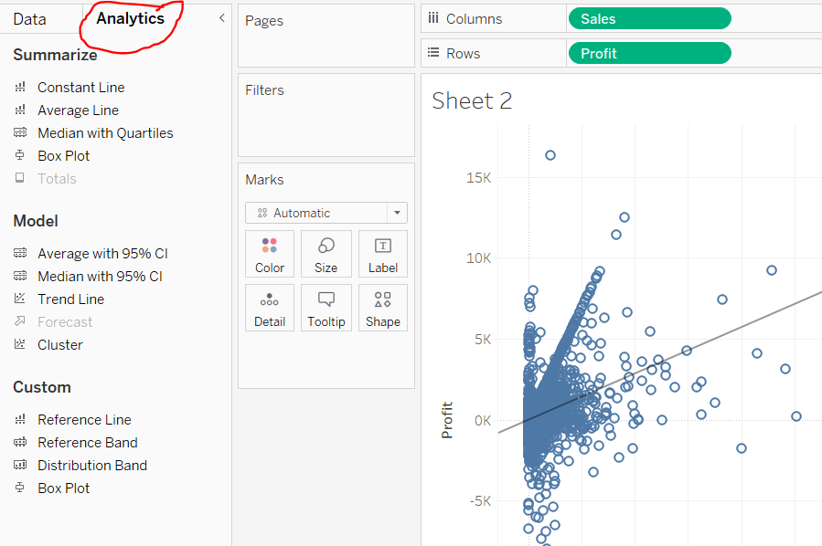
Drag Customer Segment on Color Filter Box to show the trend line for each customer segments.
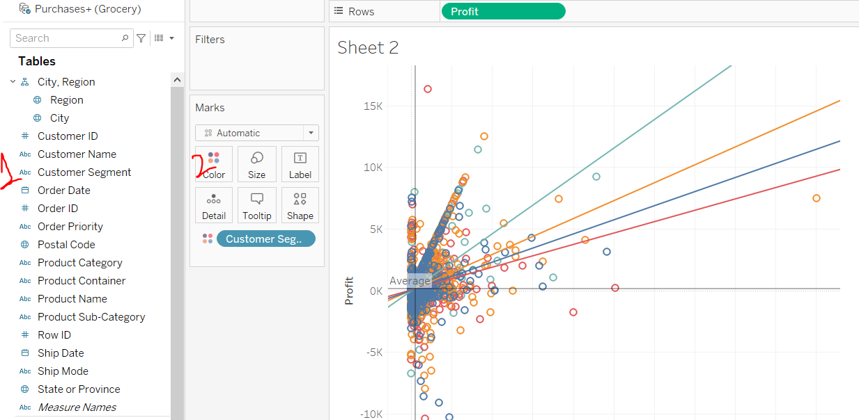
Editing Trend Lines: To edit the trend Lines, we can select different type of Linear, Log, Exponential or Power types of trendline.
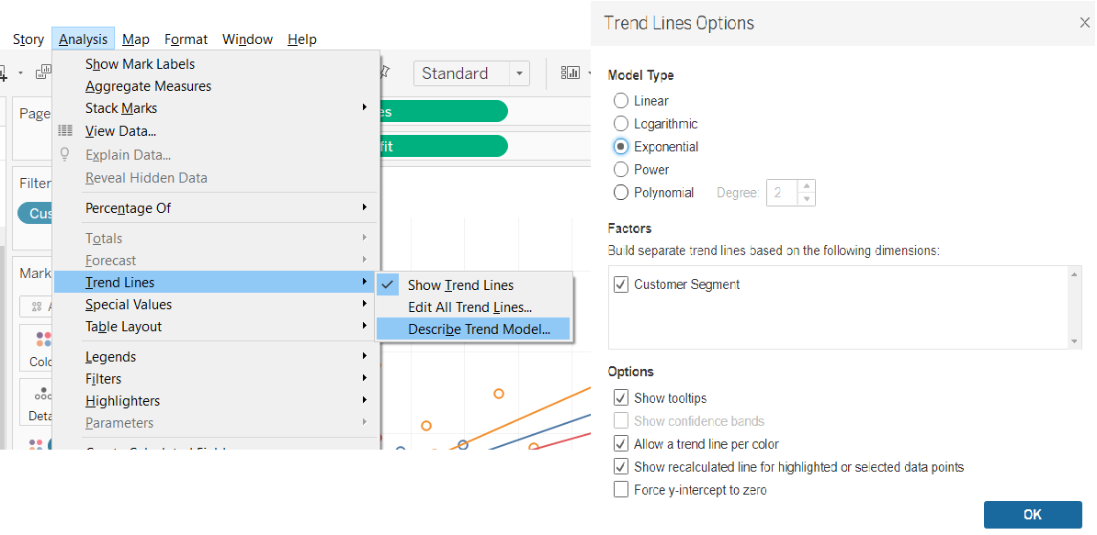
To Display Labels on Graph –
Drag the quantity/Dimension and place in on Label on Mark Panel and that filed will be shown as label in the chart.
How to Show filter on the designer panel –
Place the dimension/quantity on the filter panel as shown below.
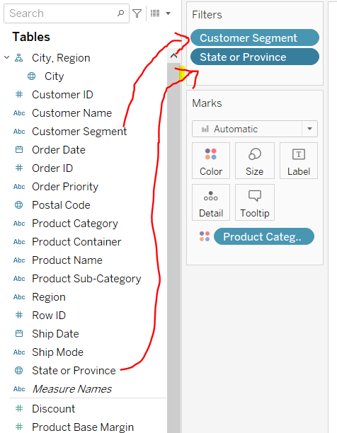Drag the dimension on the filter panel.
Then Enable the Show Filter CheckBox. Then it will be available on the right side of designer panel.
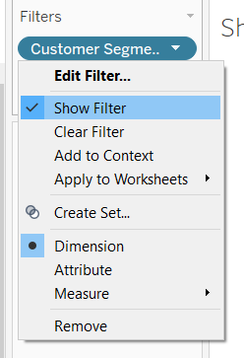
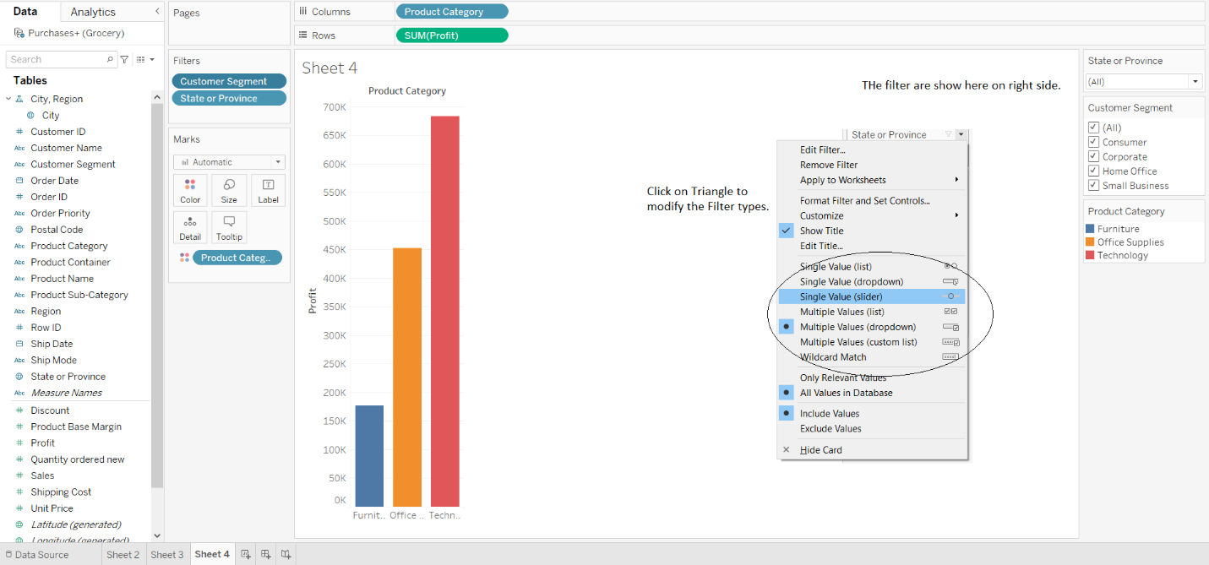
- Press Shift button to place a object into a container.
To add Border, Background on Container object
- Select the container object, go to Layout option and select 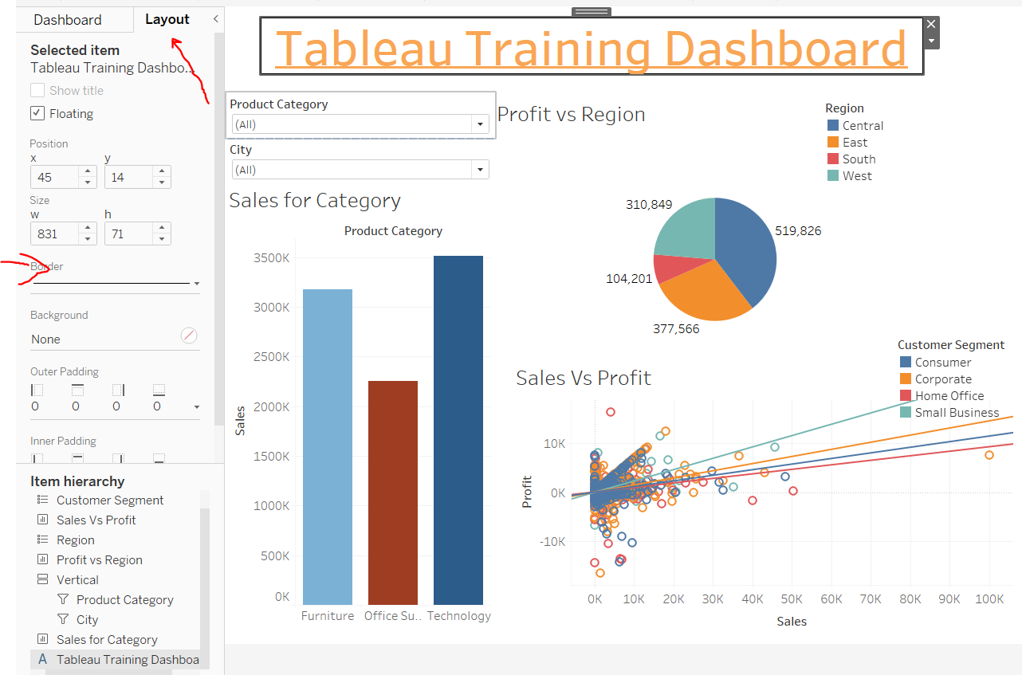
- To put background color on Horizonatal/Vertical Container: First click on the triangle option then Select the Container Vertical/Horizontal. This selection will select all the objects inside the particular container and then we can apply the border/color to entire objects commonly.
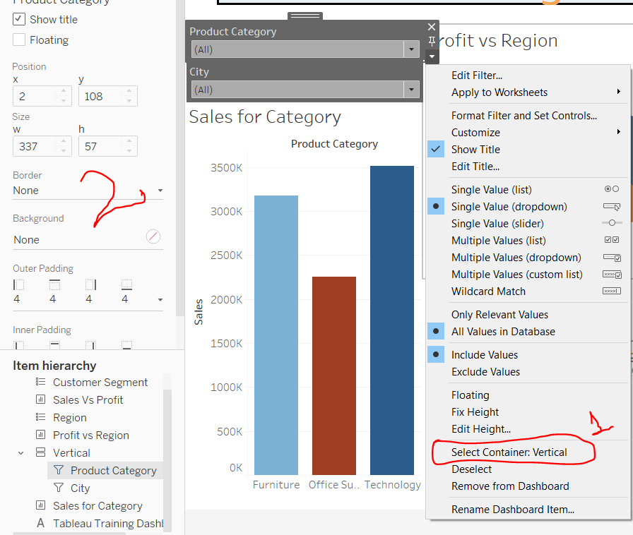
- Giving Background Color to Sheet -
Go to format tab and then click on Shading and then select colors of your choice
Steps to make entire sheet as filter
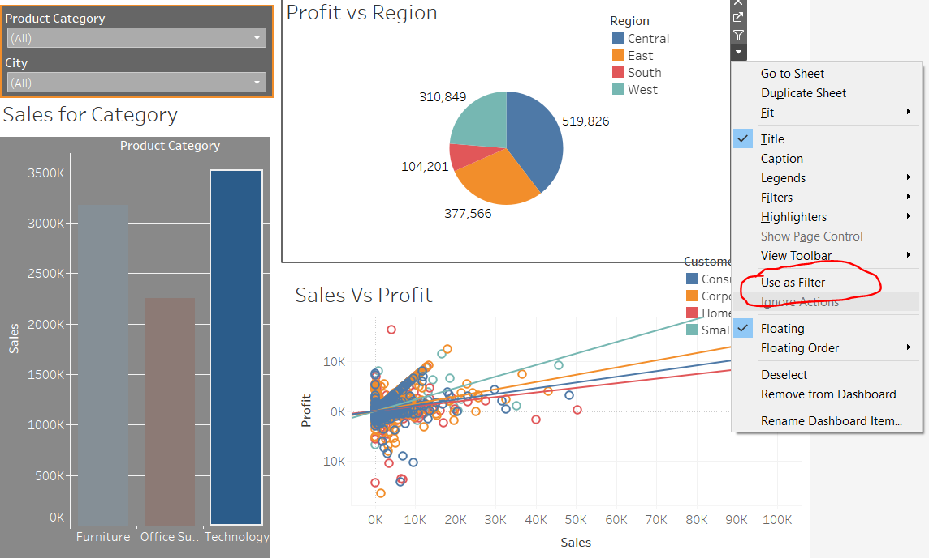
Select a particular sheet and click on dropdown and then select Use As filter. Then if we click on small portion of that sheet entire dashboard will be sorted according to the selection.
- How to make a filter work on selected sheets?
From the filter panel, click on dropdown for the fileter, then select the Apply to worksheets -> then select option accordingly.
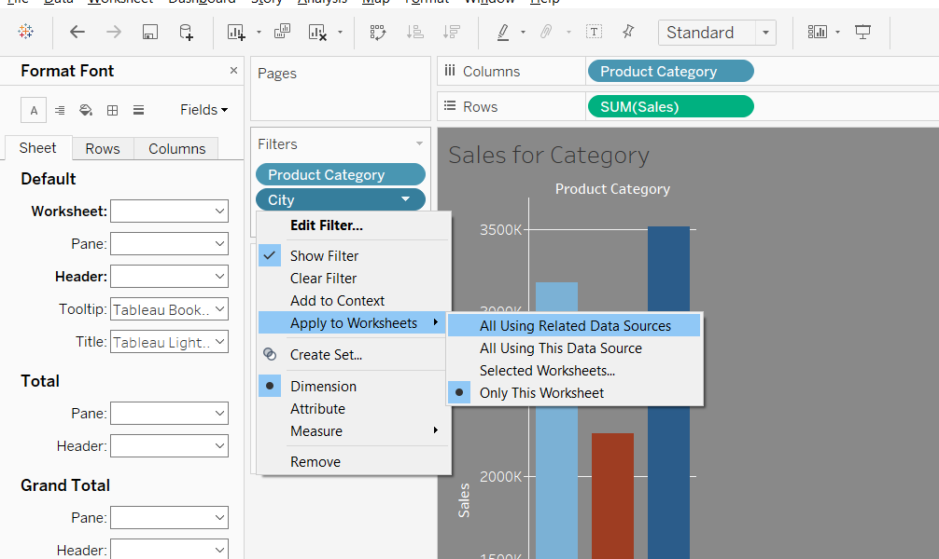
Only this worksheet -> Filter works for current sheet only
Selected Worksheet -> Filter works for selected sheets

Story
Story can have multiple sheets/dashboard.

- Replace Empty Cells(NULL) with Zero
Click on Analysis -> Create Calculated Field -> Give any name for the calculated field
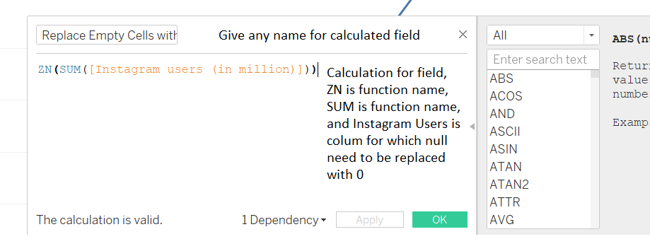
Once done click OK -> and Drag the calculated field on panel to get the sheets.
- Replacing empty values with last value : Follow the same steps as above and only change the calculation field :
IFNULL(
SUM([Instagram users (in million)]),
PREVIOUS_VALUE(0)
)
- Creating Map by using Longitude and Latitude fields from our data set.( https://help.tableau.com/current/pro/desktop/en-us/maps_dualaxis.htm#customonly)
In the Data pane, right-click the custom latitude field and select Geographic Role > Latitude.
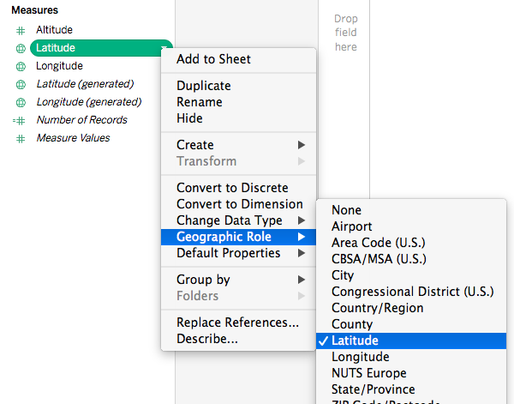
From the Data pane, drag the custom latitude field to the Rows shelf.
From the Data pane, drag the custom longitude field to the Columns shelf.
From the Data pane, under Dimensions, drag a geographic field to Detail on the Marks card.
In this example, the geographic field, Country (Name), is used.
