FARM SENSOR MONITORING SYSTEM

BY : SATISH KUMAR (25BAI11082)
Contents

1. Introduction
2. Problem Statement
3. Objectives
4. System Functional Requirements
5. Non-Functional Requirements
6. System Architecture
7. Process Flow
8. Code
9. Code output
10. Conclusion

1.INTRODUCTION
Agriculture remains the backbone of many economies worldwide, yet farmers continuously face challenges in maintaining optimal environmental conditions required for healthy crop growth. Soil moisture, temperature, and humidity are critical factors influencing plant health and yield. Traditional manual monitoring methods are
Labor intensive, sporadic, and prone to human error, often resulting in inefficient irrigation and suboptimal resource utilization. This document presents a comprehensive design and implementation of a farm sensor monitoring system that simulates continuous environmental data collection and automatic irrigation control. The system aims to enhance farming efficiency by providing timely alerts and automated responses to environmental conditions.

2.PROBLEM STATEMENT

Farmers often struggle to maintain optimal soil moisture, temperature, and humidity levels in their fields, leading to inefficient irrigation, wasted water, and crop stress. Manual monitoring is time-consuming and prone to error, which negatively impacts crop yield and resource usage. The lack of an automated system that can reliably track environmental parameters and respond accordingly hinders agricultural productivity and sustainability.

3.OBJECTIVES
The core objectives of the proposed farm sensor monitoring system include:
• Continuously monitor simulated soil moisture, temperature, and
humidity sensor data to mimic real-world sensing.
• Automatically simulate irrigation by activating a water pump
when soil moisture falls below a predefined threshold.
• Provide timely alerts regarding environmental conditions such
as high temperature or low humidity that may affect crop health.
• Demonstrate practical application of programming and system
design concepts to address agricultural challenges.

4.SYSTEM FUNCTIONAL REQUIREMENTS

To meet the objectives effectively, the system must fulfil the following functional requirements:
• Simulate sensor data generation for soil moisture, temperature,
and humidity in a reliable and consistent manner.
• Display sensor readings and alerts clearly through a user-friendly
console-based interface.
• Automatically activate a water pump simulation when soil moisture
levels are detected below a critical threshold.
• Issue warnings for adverse environmental conditions such as
excessive heat or insufficient humidity.
• Repeat sensor checks at predetermined periodic intervals to ensure
continuous monitoring.

5.NON-FUNCTIONAL REQUIREMENTS

Key non-functional attributes expected include:
• Reliability: Sensor data simulation and system responses must
be consistent and dependable.
• Low latency: The system should process sensor data and generate
alerts with minimal delay.
• Usability: Console output should be intuitive and concise to facilitate
easy interpretation by users.
• Modularity: The codebase should be structured to allow easy
scalability and maintainability for future enhancements.

6.SYSTEM ARCHITECTURE

The system architecture is designed to emulate real-world inter-
actions between sensing, processing, and actuation components in a
modular fashion. It consists of four primary modules:
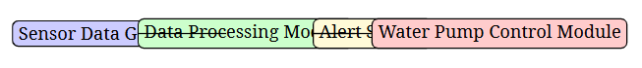

This modular design ensures clear separation of concerns and facilitates future upgrades such as real sensor integration or data logging.

7.PROCESS FLOW

The workflow of the monitoring system follows a cyclical pattern
as detailed below:

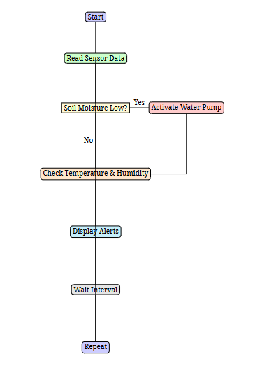

This process ensures continuous monitoring and responsive control actions.

8.CODE

import random
import time

"""Set limits for soil, temperature, and humidity levels."""
soil_limit = 40
temp_limit = 35
humidity_limit = 30

"""Notify the user and start the sensor check."""
print("Welcome to the farm sensor check!")
print("Let's see if everything is okay with the soil and the weather today.")

"""Start the iteration check."""
round_num = 1
while round_num <= 5:
print("Check number:", round_num)

soil = random.randint(20, 60)
temperature = random.randint(25, 40)
humidity = random.randint(20, 50)

print("Soil moisture level is", soil, "percent")
print("Temperature is around", temperature, "degree Celsius")
print("Humidity level is", humidity, "percent")

if soil < soil_limit:
print("Oh no! Soil looks dry, turning on the water pump for 30 seconds.")
time.sleep(30)
print("Water pump is now off.")
else:
print("Soil moisture looks good, no need to water now.")

if temperature > temp_limit:
print("It's pretty hot today! Be sure that plants are safe from heat.")

if humidity < humidity_limit:
print("Humidity is low, opportunity to water your plants carefully.")

print("---------------------------")
round_num += 1
time.sleep(2)

print("That is all for the checks, best wishes your farm stays healthy!")

9.CODE OUTPUT

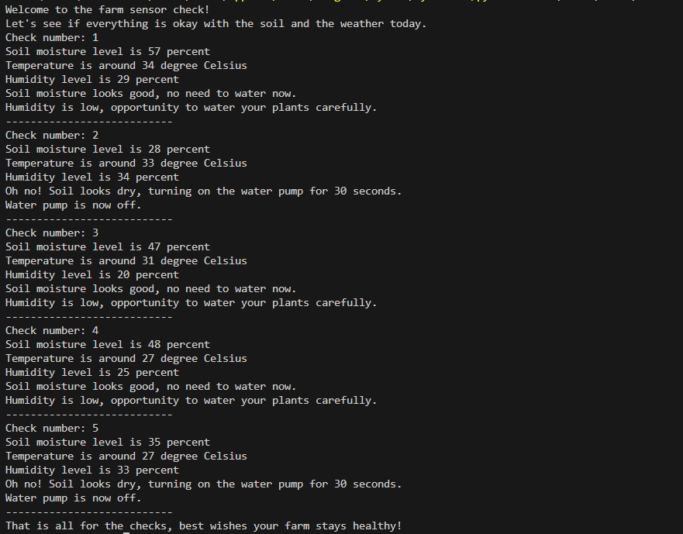

10.CONCUSION

This farm sensor monitoring system demonstrates an effective approach to tackling
the challenges of maintaining optimal soil and environmental conditions for agriculture through automation and intelligent alerts. By simulating sensor data and automating irrigation , the system reduces manual labour and resource wastage while
enhancing crop health monitoring. Its modular design lays a foundation for future integration with physical sensors, data logging, and advanced decision-making algorithms, ultimately contributing to smarter and more sustainable farming practices.

MY GITHUB REPOSITRY LINK

https://github.com/satishkumar637/-Smart-Agriculture-Monitoring-System

THANK YOU

