

DS7010 2526 (T3) Data Science Dissertation

Title:
The use of Machine Learning Techniques in Optimizing Food Manufacturing Operations to meet Demands.
Submitted to: Dr Yang Li
Submitted By: U2907046
Date of Submission: 28/08/2026

Abstract
Accurate demand forecasting is essential in food-related supply chains because inaccurate estimates can contribute to overproduction, food waste, excessive inventory, stock-outs and inefficient resource planning. This study explores the application of machine learning methods for product demand forecasting and critically assesses how these forecasts might aid in the planning of food manufacture. Although it does not explicitly contain manufacturing-specific operational information, the Corporacion Favorita Grocery Sales Forecasting dataset was used as a real-world depiction of downstream retail demand.
A modified CRISP-DM framework was used to implement a quantitative, positivist, and deductive research design. Data cleaning, exploratory analysis, and leakage-aware feature engineering incorporating temporal, lagged-demand, and rolling statistical variables were used to a repeatable sample of 300,000 observations. Regression models for Random Forest, XGBoost, and LightGBM were created and refined using RandomizedSearchCV with TimeSeriesSplit validation. MAE, MSE, RMSE, MAPE, RMSLE, and R2 were used to evaluate their performance on a chronological 60,000-observation test set.
With an MAE of 3.7960, RMSE of 28.3397 and R Square of 0.1312, XGBoost performed the best overall, whereas LightGBM had the lowest MAPE of 0.8277. The low R2 values, however, show that significant variation in individual demand data remained unaccounted for, especially during periods of extremely high demand. Among the most significant predictors were rolling-demand characteristics and historical lag.
The results show that while machine-learning forecasting can offer helpful information for making decisions, the models currently in use are not sufficiently proven for independent commercial deployment. Longer out-of-time validation, forecasting baselines, manufacturing-specific data, uncertainty assessment and integration with production, inventory, labour, capacity, supplier and waste data are all necessary for future deployment. As a result, the study offers a repeatable forecasting methodology that clearly distinguishes between direct production optimization and demand prediction.

Table of Contents
Abstract 2
CHAPTER 1: INTRODUCTION 6
1.1 Introduction and Background 6
1.2 Research Problem 6
1.3 Dataset and Domain Alignment 7
1.4 Research Aim 8
1.5 Research Objectives 8
1.6 Research Questions 8
1.7 Scope and Limitations 8
CHAPTER 2: LITERATURE REVIEW 9
2.1 INTRODUCTION 9
2.2 Supply Chain Management and Food Manufacturing 9
2.3 Demand Forecasting and Production Planning 9
2.4 Traditional Forecasting Techniques 10
2.5 Machine Learning for Demand Forecasting 10
2.6 Forecasting and Optimisation 12
2.7 Critical Synthesis and Research Gap 12
2.8 Literature Review Summary Table 13
CHAPTER 3: METHODOLOGY 16
3.1 Introduction 16
3.2 Research Philosophy 16
3.3 Research Approach and Design 16
3.4 Adaptation of CRISP-DM 17
3.5 Dataset Selection and Methodological Limitation 17
3.6 Data Preparation and Exploratory Analysis 18
3.7 Feature Engineering and Prevention of Data Leakage 18
3.8 Training, Testing and Cross- Validation Strategy 18
3.9 Machine Learning Models and Hyperparameter Optimisation 19
3.10 Model Evaluation 19
3.11 Actual Experimental Configuration 20
3.12 Ethical Considerations and Methodological Limitations 21
3.13 Chapter Summary 21
CHAPTER: 4 IMPLEMENTATION 23
4.1 Introduction 23
4.2 Data Loading and Initial Inspection 23
4.3 Data Cleaning and Quality Assessment 25
4.4 Exploratory Data Analysis(EDA) 26
4.4.1 Distribution of Unit Sales 26
4.5 Temporal Demand Analysis 29
4.6 Correlation Analysis 31
4.7 Feature Engineering and Data Transformation 32
4.8 Chronological Training and Testing Split 33
4.9 Machine Learning Model Development 33
4.10 Hyperparameter Optimisation 34
4.11 Prediction and Model Outputs 34
4.12 Aggregate Forecast Behaviour Across Test Dates 36
4.13 Feature Importance 38
4.14 Model Evaluation and Comparison 40
4.15 Implementation Outputs and Reproducibility 41
4.16 Chapter Summary 42
CHAPTER 5: Results, Discussion, Analysis and Evaluation 43
5.1 Introduction 43
5.2 Overall Model Performance 43
5.3 Comparative Analysis of the Three Models 45
5.3.1 XGBoost 45
5.3.2 LightGBM 45
5.3.3 Random Forest 46
5.4 Actual Vs Predicted Demand 46
5.5 Analysis of High-Demand Forecasting Errors 46
5.6 Feature Importance and Interpretation 47
5.7 Comparison with Existing Literature 48
5.8 Research Question Evaluation 49
5.9 Practical Implications for food manufacturing decision support 50
5.10 Commercial Deployment Readiness 51
5.11 limitations of the Results 52
5.12 Chapter Summary 53
CHAPTER 6: Conclusion and Future Work 54
6.1 Introduction 54
6.2 Evaluation of the Research Questions 54
6.3 Research Contribution 55
6.4 Limitations 55
6.5 Practical Implications 56
6.6 Future Research 57
6.7 Final Conclusion 57
7.0: References 58
8.0: Appendix 60
9.0 Gantt Chart 60

CHAPTER 1: INTRODUCTION

Introduction and Background
Organizations that produce food must constantly adjust their output to meet shifting consumer demands. Food goods are frequently perishable, demand might change owing to seasonality and promotions and poor planning can lead to either overproduction or underproduction, making this difficult. While underproduction can result in shortages, missed sales and worse customer satisfaction, overproduction can raise inventories, operating expenses and food waste. Thus, accurate demand forecasting is a crucial component of efficient production planning.
When demand involves intricate, nonlinear interactions between several variables, traditional forecasting methods, such as moving averages, regression and statistical time-series techniques, may be limited in their ability to produce accurate forecasts. An alternate strategy is offered by machine learning (ML), which finds patterns in past data and incorporates elements like store information, product attributes, promotions and temporal trends.

For product-demand forecasting, this dissertation examines three supervised machine learning algorithms: Random Forest Regressor, XGBoost Regressor and LightGBM Regressor. To ascertain their efficacy in forecasting demand and their potential worth as decision-support tools for food manufacturing planning, their performance is compared.

Research Problem
A key challenge in food manufacturing is determining appropriate production requirements when future demand is uncertain. Inaccurate demand estimates can contribute to excess production, waste and unnecessary resource use or, alternatively, insufficient production and product shortages. Effective production planning therefore depends partly on the quality of information available about expected demand.
Conventional forecasting techniques may not fully capture nonlinear relationships, seasonal behaviour, promotional effects and interactions within large datasets. This creates an opportunity to investigate whether ML techniques can provide more effective demand predictions.
Forecasting and optimization, however, are separate procedures. The models used in this dissertation predict product demand rather than directly optimizing labor allocation, manufacturing schedules, inventory levels, or procurement. Rather, precise demand projections can offer data that bolsters these operational choices. Therefore, rather than directly applying a production-optimization method, the term "optimization" in this research refers to the potential enhancement of manufacturing decision-making through improved demand information.
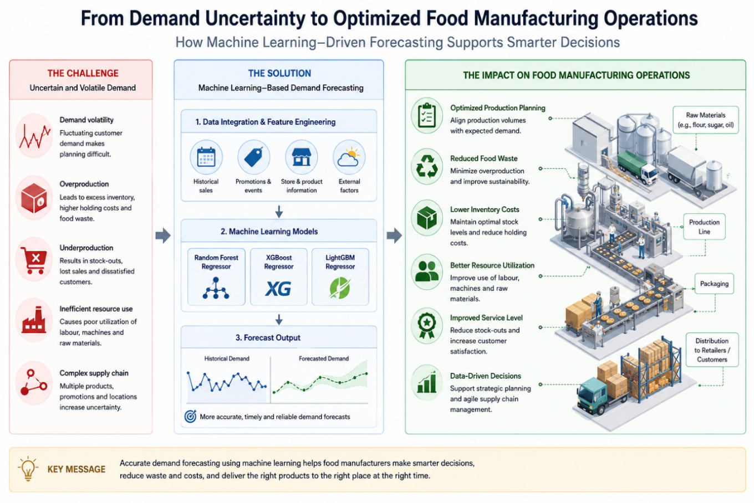
Figure 1.1: Conceptual Overview of Machine Learning Based Demand Forecasting for Food Manufacturing Decision Support
The conceptual rationale for this study is shown in Figure 1.1. Overproduction, underproduction, waste, inventory expenses, and ineffective resource use can all be caused by demand uncertainty. The study looks into whether machine-learning methods may enhance demand forecasting and hence offer helpful data for planning decisions related to food manufacture. Rather than results that the models in this dissertation directly demonstrate, the graphic illustrates the potential practical use of forecasting.

1.3 Dataset and Domain Alignment
The Corporacion Favorita Grocery Sales Forecasting dataset, which includes product, store, promotional, and temporal data together with historical sales data from an Ecuadorian grocery retailer, is used in this study.
The fact that this information reflects retail demand rather than food manufacturing operations is a significant restriction. Manufacturing-specific factors including production capacity, labours requirement, machine utilization, ingredient consumption, and production waste are not included. As a result, the study does not assert that the dataset accurately depicts a manufacturing facility.

The dataset was selected because historical retail sales provide an observable measure of downstream consumer demand, which can inform upstream production-planning decisions. It also provides a large real-world dataset suitable for comparing ML forecasting techniques. Consequently, the findings are interpreted as evidence about demand forecasting and its potential relevance to manufacturing decision support, rather than evidence of direct manufacturing optimisation.

Research Aim
The aim of this research is:
To create and test the machine learning models that uses the past supermarket sales data to estimate product demand and determine how these models might help with production-planning choices in the context of food manufacturing.

Research Objectives
The objectives of this research are as follows:
- To critically examine research on demand forecasting, machine learning and the production planning.
- To preprocess and explore the Corporacion Favorita dataset and identify patterns relevant to demand forecasting.
- To develop and evaluate Random Forest, XGBoost and LightGBM models for predicting product demand.
- To compare model performance using appropriate regression evaluation metrics and identify the most effective forecasting model.
- To critically assess how the forecasting results could support food manufacturing planning while recognising the limitations of using retail sales data.

Research Questions
The study addresses three focused research questions:
- What relevant demand patterns and characteristics can be identified within the Corporacion Favorita dataset?
- How effectively do Random Forest, XGBoost and LightGBM forecast product demand and which model provides the strongest predictive performance?
- How can Machine Learning based demand forecasts support production planning decisions in food manufacturing, considering the limitation of using retail sales data?
These inquiries are closely related to the goals of the study and are addressed by critical interpretation of the findings, comparative model evaluation, and exploratory data analysis.

Scope and Limitations
Instead of direct production optimization, the research focuses on machine learning-based demand predictions. Retail sales data from the past is used to assess Random Forest, XGBoost, and LightGBM. The study does not use mathematical optimization for resource planning, inventory allocation, or production scheduling.
The use of retail data instead of manufacturing data is the main drawback. As a result, conclusions about food production are restricted to the possible use of forecasting results as information for making decisions. Future studies should combine formal production-optimization approaches with demand estimates and evaluate the method using manufacturing-specific data.

CHAPTER 2: LITERATURE REVIEW

2.1 INTRODUCTION
The research pertinent to machine learning-based demand forecasting and its possible contribution to food manufacturing planning is critically reviewed in this chapter. From supply-chain management and food manufacturing to demand forecasting, production planning, conventional forecasting techniques, machine learning, ML-based forecasting, and the connection between forecasting and optimization, the literature is arranged as a research funnel. The research gap that this dissertation fills is identified in the chapter's conclusion.

2.2 Supply Chain Management and Food Manufacturing
The movement of goods, information, and resources between suppliers, producers, distributors, and consumers is coordinated by supply chain management, or SCM. According to Christopher (2016), organizations must strike a balance between cost effectiveness and responsiveness in order to implement effective SCM. Because fluctuations in downstream sales can affect upstream inventories, procurement, and production decisions, demand uncertainty makes this challenging. This was illustrated by Lee et al. (1997) using the bullwhip effect, which shows how the supply chain can magnify relatively slight fluctuations in demand.
Because items may be perishable and operations are impacted by shelf-life constraints, inventory requirements, and shifting customer behavior, these issues are especially important in food supply chains. Although there are still issues with data quality, integration, and practical adoption, Rejeb, Keogh, and Rejeb (2022) discovered that greater supply-chain data availability opens up possibilities for more sophisticated analytical decision-making in the food industry.
As a result, operational progress cannot be ensured by data availability alone. Demand forecasting is a crucial link between market behavior and upstream operations since analytical techniques must transform historical data into relevant evidence for planned decisions.

2.3 Demand Forecasting and Production Planning
Demand forecasting uses pertinent explanatory data and past observations to anticipate future product requirements. Forecasts can affect production plans, procurement needs, and inventory targets in operational settings. Therefore, inaccurate estimates can lead to shortages when demand is underestimated or excess inventory and waste when demand is overestimated.
Zhu et al. (2021) showed that supply-chain data and cross-series learning can enhance forecasting performance using two sizable datasets from pharmaceutical firms. Their approach's utilization of actual industry datasets and supplementary downstream inventory data, as opposed to solely depending on past demand, is a strength. However, due to differences in goods, shelf life, and demand structures, findings from pharmaceutical supply chains cannot be automatically applied to food manufacturing.
Additionally, forecasting and production optimization need to be differentiated. While optimization chooses the best course of action based on goals and limitations, forecasting projects future demand. Therefore, forecast accuracy can enhance the information that planners have access to, but it does not establish the best production plan on its own.

2.4 Traditional Forecasting Techniques
Moving averages, exponential smoothing, regression, and auto-regressive integrated moving averages (ARIMA) are examples of conventional methods. Although they can react slowly to abrupt changes in demand, moving averages are computationally straightforward and helpful for reducing short-term swings. While ARIMA uses autoregressive and moving-average components to depict temporal dependency, exponential smoothing places more emphasis on recent observations and can model trend and seasonality.
Due to their interpretability and ability to function well in situations where time-series structures are somewhat stable, these methods continue to be significant benchmarks. However, their capacity to depict intricate interactions including advertising, product attributes, and other explanatory variables may be limited by their presumptions and primary dependence on historical temporal correlations.
Crucially, it is incorrect to presume that ML is superior to traditional approaches. While performance depends on factors like seasonality, intermittency, and available explanatory information, evidence from the M5 forecasting competition shows that statistical methods can remain competitive for specific levels of data granularity (Makridakis, Spiliotis, and Assimakopoulos, 2022a). Therefore, rather than relying on the presumption that methodological complexity inevitably results in higher accuracy, model selection should be based on empirical examination.

2.5 Machine Learning for Demand Forecasting
By identifying connections between demand and several predictor variables, machine learning offers an alternate strategy. ML algorithms may describe nonlinear relationships and contain temporal, category, and contextual aspects, in contrast to many traditional univariate techniques. According to a recent assessment by Mediavilla, Dietrich, and Palm (2022), artificial intelligence approaches are increasingly being used for demand forecasting, especially as industrial and supply-chain information grow in size and complexity.
Nevertheless, there are drawbacks to machine learning, such as increased computing demands, reliance on high-quality data, hyperparameter selection, and possibly decreased interpretability. Additionally, its performance depends on the dataset. Therefore, the pertinent question is not whether machine learning (ML) always performs better than traditional forecasting, but rather under what data and operational conditions specific algorithms offer useful predictive performance.

Because it assessed forecasting techniques using 42,840 hierarchical Walmart retail sales series with explanatory variables and sporadic demand, the M5 competition offers substantial empirical evidence (Makridakis, Spiliotis, and Assimakopoulos, 2022b). The findings showed that no single modeling technique is superior in all forecasting scenarios, but they also illustrated the promise of machine learning and cross-learning techniques in large-scale retail forecasting.
Random Forest
Predictions from several decision trees built from various samples and feature subsets are combined in Random Forest. Its main benefits are feature-importance measurements, robustness to complicated structured data, and the capacity to predict nonlinear relationships. It serves as a helpful standard for this dissertation because of these qualities.
However, unlike ARIMA or recurrent neural networks, Random Forest does not explicitly model temporal sequence. Therefore, engineering temporal variables like calendar features, lagged sales, and rolling averages is essential to effective demand forecasting. Because of this, Random Forest can be used to examine if structured historical demand features can produce accurate predictions without the need for complicated deep learning.
XGBoost
With the gradient-boosting method known as XGBoost, trees are built one after the other in order to minimize mistakes committed by prior trees. Its computational implementation has made it generally applicable to structured datasets, and regularization and learning-rate adjustments can enhance generalization.
Boosting focuses increasingly on prediction errors and may be more effective at capturing complicated patterns than Random Forest's independent-tree construction. However, hyperparameter configuration affects performance, and badly managed models may overfit training data. In order to determine whether boosting offers an advantage over a bagging-based Random Forest under a consistent preprocessing and testing approach, XGBoost is used in this dissertation.
LightGBM
Another gradient-boosting approach for effective learning from big structured datasets is called LightGBM. Its leaf-wise tree growth and histogram-based approach can describe complicated interactions with less computing power. Evidence from extensive retail forecasting, including studies pertaining to M5, shows that LightGBM can function well when designed and explanatory elements are paired with historical demand.
LightGBM isn't always better, though. For instance, Ziel (2022) highlights the shortcomings of well-known gradient-boosting techniques, such as LightGBM and XGBoost, when addressing specific aspects of sporadic and distributed retail demand. This illustrates the need for an empirical evaluation of performance rather than an assumption.

Deep Learning and LSTM
Long Short-Term Memory (LSTM) networks may simulate intricate temporal behavior and are made to learn sequential dependencies. There is growing interest in these methods, according to reviews of deep learning in SCM (Hosseinnia Shavaki and Ebrahimi Ghahnavieh, 2023). Although they often need more processing power, bigger information, and more intricate tuning, their capacity to develop temporal representations can be useful for predicting.
Because this research employs structured tabular data with designed temporal, categorical, and contextual variables, Random Forest, XGBoost, and LightGBM offer a more suitable comparative framework. By choosing three tree-based ensemble techniques, it is also possible to compare bagging and two boosting strategies in a meaningful way while keeping computing demands reasonable.

2.6 Forecasting and Optimisation
Forecasting and optimization are increasingly treated as related but distinct analytical processes in recent research. For instance, Islam, Amin, and Wardley (2021) suggested a two-stage system in which an optimization model for order allocation and supplier selection was fed the demand forecasts. Similar data-driven frameworks show that optimization transforms forecasting's uncertain future information into operational decisions.
This distinction is crucial to the current study. Instead of using mathematical production optimization, the machine learning models created in this dissertation forecast demand. They are relevant to the food manufacturing industry because better demand forecasts may help with scheduling, inventories, procurement, and production volumes. As a result, claims about optimization are restricted to operational application and decision support.

2.7 Critical Synthesis and Research Gap
Three significant conclusions are drawn from the studied literature. First, because forecast errors can affect both upstream and downstream operational decisions, demand forecasting is crucial to supply-chain and production planning. Second, forecasting success is dependent on the dataset, features, forecast horizon, and evaluation methodology rather than just whether a technique is categorized as conventional or machine learning. Both traditional statistical and machine learning techniques have advantages. Third, although forecasting and optimization are often related, they are nonetheless methodologically separate.
ML forecasting in retail and other supply-chain settings is strongly supported by recent research. However, fewer research clearly acknowledge the limits of translating retail-demand evidence to manufacturing operations while directly examining how comparable ML forecasting results can be understood as decision-support information for food-production planning.

In order to close this gap, this dissertation uses the Corporacion Favorita retail sales dataset to compare Random Forest, XGBoost, and LightGBM utilizing a standard preprocessing, feature-engineering, and evaluation approach. The study ascertains the relative predicting performance of the models and critically assesses how these forecasts could guide food-manufacturing planning, rather than making a direct claim to optimize production. Additionally, it clearly acknowledges that manufacturing-specific operational data would be needed to justify direct production applications and that retail sales serve as a stand-in for downstream demand.
The literature, research questions, methodology, and ensuing empirical analysis are all clearly connected by this positioning.
The literature shows how supply-chain demand uncertainty leads to the requirement for forecasting, which in turn leads to ML-based predictive techniques. While Random Forest, XGBoost, and LightGBM offer various ensemble-learning strategies appropriate for structured demand data, traditional methods continue to be useful benchmarks. Additionally, research shows that while predicting can help with optimization, it is not the same as optimization. The approach and model comparison proposed in Chapter 3 are theoretically supported by these findings.

2.8 Literature Review Summary Table
The literature that is most directly related to the dissertation is summarized in Table 2.1, which also emphasizes how each source influences the current investigation. The comparison demonstrates that forecasting effectiveness depends on context, that forecasts can be improved with deeper explanatory and supply-chain data, and that forecasting and downstream optimization must be kept apart. The empirical results in Chapter 5 are interpreted using these themes.

Table 2.1: Summary and Critical Synthesis of Key Literature
Study | Context / Approach | Main Finding | Limitation / Critical Point | Relevance to this Dissertation
Lee et al. (1997) | Supply-chain demand information; bullwhip effect | Small downstream demand changes can be amplified upstream. | Conceptual supply-chain evidence rather than an ML forecasting comparison. | Explains why forecast quality can affect procurement, inventory and production decisions.
Zhu et al. (2021) | Pharmaceutical supply chains; ML with supply-chain information | Cross-series learning and additional downstream information can improve forecasting. | Different products, shelf lives and operating conditions limit transfer to food manufacturing. | Supports the argument that additional operational/contextual data may improve the current models.
Makridakis, Spiliotis and Assimakopoulos (2022) | M5 large-scale retail forecasting competition | No single forecasting method is best in every setting; performance depends on series and granularity. | Retail competition results do not directly demonstrate manufacturing deployment. | Supports cautious interpretation of the small differences among XGBoost, LightGBM and Random Forest.
Mediavilla, Dietrich and Palm (2022) | Review of AI demand forecasting in SCM | AI/ML use is increasing as supply-chain data become larger and more complex. | Performance depends on data quality, tuning and implementation context. | Justifies evaluating ML while avoiding an assumption of universal superiority.
Ziel (2022) | M5 uncertainty and distributional forecasting | Popular boosting methods can struggle with intermittent/distributed demand and uncertainty. | Focuses on uncertainty rather than the exact operational setting used here. | Helps explain why extreme and heterogeneous demand can remain difficult to predict.
Mitra et al. (2022) | Multi-channel retail; hybrid ML forecasting | A hybrid approach can outperform individual models in the studied setting. | Results are dataset-specific and use a different model architecture. | Suggests hybrid/ensemble approaches as a future extension beyond three stand-alone tree models.
Wang (2023) | Retail sales; LightGBM vs XGBoost | LightGBM outperformed XGBoost in the reported setting. | Different dataset and evaluation design. | Contrasts with the present XGBoost result and demonstrates model ranking is context-dependent.
Wang et al. (2024) | Retail demand; spatial-temporal gradient boosting | Combining cross-sectional and temporal information can improve retail forecasting. | Retail context; not direct manufacturing optimisation. | Supports the use of temporal and contextual engineered features.
Nguyen, Dang and Le (2025) | Grupo Bimbo inventory demand; XGBoost and LightGBM | Relative model performance depends on the evaluation metric. | Case-study context limits universal generalisation. | Consistent with XGBoost leading most metrics while LightGBM achieved the best MAPE here.
Soleimani et al. (2026) | Weekly retail sales; lag features and bagged tree ensemble | Lagged sales and rolling statistics are useful in leakage-aware chronological forecasting. | Different forecasting frequency and model design. | Supports the strong importance of lag and rolling-demand features in the present study.
Islam, Amin and Wardley (2021) | Forecasting/ML linked with optimisation for supplier and order allocation | Forecasts can feed a separate optimisation model to support operational decisions. | Not a food-manufacturing demand-forecasting experiment. | Supports the distinction between forecasting and actual production optimisation.

CHAPTER 3: METHODOLOGY

Introduction
The approach utilized to study machine-learning-based demand forecasting and its possible contribution to food manufacturing planning is explained in this chapter. The study employs a quantitative experimental design organized according to the Cross-Industry Standard Process for Data Mining (CRISP-DM). Three supervised regression models Random Forest, XGBoost, and LightGBM were created by processing historical supermarket sales data. A consistent, time-aware evaluation process was used to compare their forecasting performance.

Forecasting and optimization are distinguished by the approach. Production quantities, timetables, inventory allocations, and resource requirements are not determined mathematically by the applied models; instead, they forecast product demand. Therefore, rather than being used for direct production optimization, forecasts are viewed as decision-support data that may help with future manufacturing planning.

3.2 Research Philosophy
The research philosophy used in the study is positivist. When research topics can be examined using observable facts, quantitative measurement, and methodical empirical testing, positivism is suitable (Saunders, Lewis, and Thornhill, 2019). This is consistent with the current study since numerical sales observations and predetermined regression indicators are used to objectively assess model performance.
The same training, validation, and testing methodology is used for Random Forest, XGBoost, and LightGBM instead of depending on subjective assessments of how successful a particular forecasting technique is. MAE, MSE, RMSE, MAPE, RMSLE, and R2 are used to gage their performance. Thus, the positivist viewpoint is supported by the application of repeatable computational processes, quantifiable results, and empirical comparison.
The idea does not, however, suggest that model outcomes are generally applicable. Because this study employs retail data rather than manufacturing data, forecasting effectiveness is still dependent on the dataset and experimental settings.

Research Approach and Design
An experimental, deductive, and quantitative method is used. The deductive component comes from the literature reviewed in Chapter 2, which shows that while ensemble tree-based algorithms can model nonlinear relationships in structured demand data, their relative performance varies depending on feature engineering, dataset characteristics, and evaluation methodology.

By contrasting two gradient-boosting techniques (XGBoost and LightGBM) with a bagging technique (Random Forest) under identical analytical conditions, this study empirically assesses these conclusions. Therefore, the goal is to determine which technique works best on the given demand dataset rather than assuming that machine learning is better.
In order to systematically examine variations in predictive performance, the experimental design allows preprocessing, feature engineering, training, and evaluation processes to be similar across models.

3.4 Adaptation of CRISP-DM
The study follows CRISP-DM because it provides a structured framework covering Business Understanding, Data Understanding, Data Preparation, Modelling, Evaluation and Deployment.
CRISP-DM was adapted specifically for this dissertation as follows:
- Business Understanding: Uncertainty about future demand and the possible repercussions of using erroneous demand data for production planning were identified as the operational challenge.
- Data Understanding: The structure, data kinds, missing values, duplicates, temporal coverage, and demand characteristics of the Corporacion Favorita dataset were examined.
- Data Preparation: Involved cleaning and transforming the data, encoding categorical variables, and creating rolling-demand, lag, and temporal features.
- Modelling: A standardized preprocessing pipeline and hyperparameter-search technique were used to create the Random Forest, XGBoost, and LightGBM regression models.
- Evaluation: Multiple regression metrics were used to compare models over an untested chronological testing period.
- Deployment: There was no actual industrial deployment. Instead, deployment was theoretically examined by assessing how demand predictions may give production planners information to support their decisions.
This modification avoids overclaiming: the dissertation does not use an automated manufacturing optimization system, rather CRISP-DM frames the ML inquiry.

Dataset Selection and Methodological Limitation
The study makes use of the Corporacion Favorita Grocery Sales Forecasting dataset, which includes information about items, stores, promotions, holidays, and other contextual factors in addition to historical sales transactions from an Ecuadorian grocery organization.
The fact that this is a retail dataset rather than a food-manufacturing dataset is a significant methodological restriction. Production capacity, equipment utilization, labor availability, processing times, ingredient consumption, supplier limitations, and manufacturing waste are not directly included. As a result, retail sales cannot be compared to production activities.
Retail sales offer an observable depiction of downstream product demand, which serves as methodological rationale for its use. Estimates of downstream demand can influence upstream choices about inventory, procurement, and production needs in a larger supply chain. Additionally, there are enough temporal and contextual observations in the dataset to enable comparison machine learning forecasting.
As a result, the empirical research assesses retail demand forecasts and interprets its applicability to food manufacturing as possible decision support. Validation utilizing operational data unique to manufacturing would be necessary for direct applicability.

3.6 Data Preparation and Exploratory Analysis
Examining column types, missing observations, duplicate entries, and invalid values was the first step in data preparation. To facilitate chronological analysis, transaction dates were changed to datetime format. One-Hot Encoding was used to transform categorical data, and suitable imputation was used inside the modeling pipeline to address missing numerical and categorical values.
Because they might indicate product returns rather than data errors, negative sales findings were handled with caution. Negative target values were limited to zero for the forecasting implementation; this is acknowledged as a drawback.
Descriptive statistics, boxplots, histograms, temporal demand analysis, and correlation analysis were all part of exploratory data analysis (EDA). The target distribution was also described using QQ plots and Shapiro-Wilk and Kolmogorov-Smirnov tests. Instead of being presumptions needed by the chosen tree-based algorithms, these normalcy assessments were exploratory.

Feature Engineering and Prevention of Data Leakage
Temporal demand behavior was represented through feature engineering. Year, month, week, day of the week, quarter, and weekend status were among the calendar variables. Rolling statistics and lagged observations were used to depict historical demand data.
Data leakage, in which information not available at prediction time inadvertently enters model training and results in unreasonably high performance, received special attention. Within each store-product series, observations were arranged chronologically prior to the creation of historical features. Only prior observations were used to create lag variables. In order to prevent the current target value from contributing to its own predictors, rolling statistics were computed after the demand series was shifted by one period.
This architecture makes sure that data from the upcoming testing phase won't affect the creation of the model.

Training, Testing and Cross- Validation Strategy
The most recent 20% were set aside for an unseen testing phase, while the first 80% were utilized for model development.
In order to give the models most of the historical observations for learning while keeping a sizable enough future period for independent assessment, an 80:20 split was used. More significantly, the intended forecasting scenario is reflected in chronological splitting as opposed to random splitting: future demand should be projected using historical data.
Rather, during hyperparameter optimization, TimeSeriesSplit was employed. By gradually training on earlier observations and validating on later times, this maintains temporal ordered.
Since the implementation was carried out with FAST_MODE=True, TimeSeriesSplit with three validation folds was utilized for hyperparameter optimization in the final reported experiment. By training on past observations and validating on later observations, time-series cross-validation maintained chronological ordered. This maintained reasonable processing requirements for the 300,000-observation dataset while lowering the possibility that subsequent observations might affect model selection.

Machine Learning Models and Hyperparameter Optimisation
Three supervised regression algorithms were evaluated:
Random Forest Regressor was chosen as a bagging-based ensemble benchmark because it offers feature-importance information, can depict nonlinear relationships, and is somewhat resilient to noise.
XGBoost Regressor was chosen as a gradient-boosting method that uses regularization and subsampling techniques to control model complexity while sequentially correcting residual prediction mistakes.
LightGBM Regressor was chosen as a substitute gradient-boosting framework with leaf-wise tree growth and histogram-based learning for computational efficiency on big structured datasets.
Using these three algorithms allows comparison between bagging and two established boosting approaches under the same dataset and evaluation framework.
Hyperparameters were optimised using RandomizedSearchCV rather than an exhaustive parameter search. Randomised search was selected because evaluating every possible parameter combination would have imposed substantial computational requirements on the 300,000-observation dataset. RandomizedSearchCV was combined with TimeSeriesSplit so that model selection preserved the temporal structure of the forecasting problem.

3.10 Model Evaluation
Several complementary regression measures, including Mean Absolute Error (MAE), Mean Squared Error (MSE), Root Mean Squared Error (RMSE), Mean Absolute Percentage Error (MAPE), Root Mean Squared Logarithmic Error (RMSLE), and the coefficient of determination (R Square), were used to evaluate the model's performance.
While RMSE gives larger mistakes more weight, MAE measures normal absolute predicting error. Although it is used in conjunction with error-based measurements, R Square shows the percentage of target variation that a model explains. To prevent undefined percentage mistakes, MAPE was only computed for observations with non-zero actual demand. Due to the extreme skewness of the demand distribution, RMSLE was incorporated.Based on a single metric, no model was deemed superior. Together, interpretability, computational behavior, and overall forecasting performance were taken into account.

Actual Experimental Configuration
A repeatable sample of 300,000 observations from the Corporacion Favorita dataset was used for the final experiment. Unit_sales was the target variable in the 37-column processed dataset, which spanned the time frame from January 1, 2013, to September 1, 2013. The combination of store_nbr and item_nbr was used to identify individual demand series.

The dataset was split using the predetermined 80:20 temporal split after being arranged chronologically. This resulted in 60,000 testing observations and 240,000 training observations, with the testing period starting on July 1, 2013. This made sure that later observations that weren't utilized for training were used to evaluate the model's performance.

Prior to onehot expansion, the modeling dataset included 34 input predictor variables: four ordinal/high-cardinality variables, five nominal categorical variables, and twenty-five numerical variables.

RandomizedSearchCV and TimeSeriesSplit were used to optimize hyperparameters. Three time-series cross-validation folds were utilized because the final experiment was run with FAST_MODE=True. For the 300,000-observation dataset, this design was chosen to preserve chronological validation while maintaining reasonable processing requirements. To increase reproducibility, a fixed random seed of 42 was utilized when appropriate.
For Random Forest, 150 estimators, a maximum depth of 12, a minimum sample split of 2, a minimum sample leaf of 1, and a maximum feature count of 0.7 were found to be the ideal hyperparameters.
The configuration chosen for XGBoost included 400 estimators, a learning rate of 0.05, a maximum depth of 4, a minimum child weight of 5, a subsample ratio of 0.7, and a column subsampling ratio of 0.7.
The ideal setup for LightGBM included 400 estimators, a learning rate of 0.05, a maximum depth of 10, 63 leaves, a minimum of 20 kid samples, a subsample ratio of 0.7, and a column subsampling ratio of 0.85.
The identical chronological training and testing datasets and preprocessing framework were used to train and assess all three models. This consistency made sure that variations in forecasting performance were not caused by variations in experimental treatment, but rather by variations in the algorithms.
Pandas, NumPy, scikitlearn, XGBoost, and LightGBM were used in the Python 3 implementation of the experiment.The saved experimental summary files did not include the precise RandomizedSearchCV searchiteration count and computer hardware specs, therefore they are provided as estimates rather than exact data.

3.12 Ethical Considerations and Methodological Limitations
When appropriate, a fixed random seed and repeatable pipeline were employed, and the original data was kept apart from the produced outputs.
Domain transfer continues to be the primary restriction. It is not always possible to extrapolate findings from one Ecuadorian grocery store to other markets or food production facilities. Moreover, direct production optimization is not demonstrated by increased forecasting accuracy. To find the best production quantities or schedules, manufacturing-specific factors and a different optimization process would be required.

3.13 Chapter Summary
In order to organize the research from problem definition to data preparation, modeling, and assessment, CRISP-DM was modified. The forecasting experiment's temporal integrity was maintained by the use of leakage-safe feature engineering, TimeSeriesSplit validation, and chronological train-test splitting.
The retail-to-manufacturing transfer is thus specifically acknowledged as a methodological restriction, and its results are assessed as possible decision-support data for food-manufacturing planning.

Figure 3.1: Flowchart
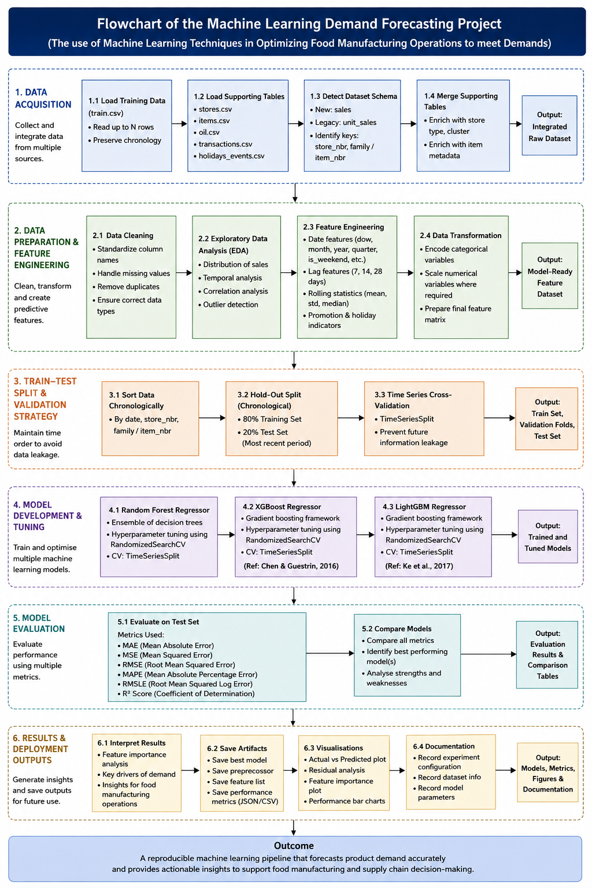

CHAPTER: 4 IMPLEMENTATION

4.1 Introduction
The Corporacion Favorita Grocery Sales Forecasting dataset was used in the Python implementation, which adhered to the technique outlined in Chapter 3. The implementation's goals were to convert the unprocessed transactional data into a dataset suitable for modeling, examine demand characteristics, design variables that could represent operational and temporal behavior, train and optimize three machine-learning models, and assess the models' capacity to predict future demand.
To provide for a consistent comparison, Random Forest, XGBoost, and LightGBM were all developed within the same experimental framework. Instead than duplicating a large amount of Python source code in this chapter, the program's results are used to illustrate the implementation. The appendices contain the full Python implementation as well as any necessary output files. This strategy enables the chapter to concentrate on the choices made during implementation and the data generated by the computational workflow.

4.2 Data Loading and Initial Inspection
Along with additional details about stores, items, transactions, holidays, and other contextual factors, the source data included transactional sales observations.
Unit_sales, which represented the observed demand for a certain product, was the primary response variable. Because demand behavior varies significantly between products and locales, store and item identifiers were kept.
The experimental dataset, which covered the period from January 1, 2013, to September 1, 2013, had 300,000 observations and 37 columns after integration and preprocessing. To enable consistent replication of the experiment, a reproducible sampling approach was employed.

======================================================================
FIGURE 4.1 - INITIAL STRUCTURE OF THE PROCESSED DATASET
======================================================================

Dataset shape: (300000, 37)
Date range: 2013-01-01 to 2013-09-01

Main columns:
['date', 'store_nbr', 'item_nbr', 'family', 'unit_sales', 'onpromotion']

First 5 rows:
date store_nbr item_nbr family unit_sales onpromotion
2013-01-01 25 378685 DAIRY 8.000 0
2013-01-01 25 373152 PERSONAL CARE 1.000 0
2013-01-01 25 584076 MEATS 2.873 0
2013-01-01 25 1037845 GROCERY I 1.000 0
2013-01-01 25 890371 GROCERY I 1.000 0
======================================================================
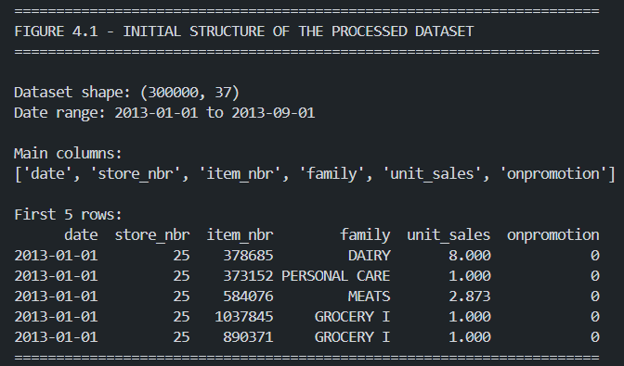
Figure 4.1: Initial Structure of the processed dataset
The preprocessing and feature-engineering workflow that was used resulted in a dataset with 300,000 observations and 37 variables that covered the time frame from January 1, 2013, to September 1, 2013, as seen in Figure 4.1. The output verifies the existence of important demand-related characteristics, such as product family, unit sales, store and product identifiers, and promotional status. The exploratory analysis and machine learning studies that followed were based on this processed dataset.

4.3 Data Cleaning and Quality Assessment
Numerical fields were formatted appropriately, duplicate observations were checked, missing values were evaluated, and dates were transformed into a consistent datetime representation. Additionally, the target variable was examined for abnormal or erroneous observations.
Because the original Favorita dataset is made up of multiple connected data sources rather than a single modeling table, the preprocessing step was very crucial. Therefore, before modeling, information about retailers, goods, transactions, and holidays had to match the transactional sales records.
The type and function of each variable determined how missing values were handled. The goal was to maintain valuable observations while avoiding inaccuracies or deceptive model behavior due to inadequate records.
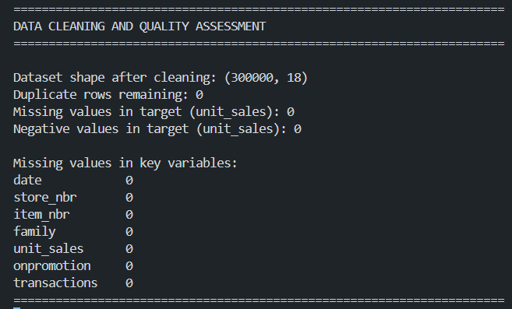
Figure 4.2: data quality assessment following preprocessing and cleaning
The ensuing feature-engineering procedure, which produced additional temporal, lag-based, rolling, and derived variables, is reflected in the difference between the 18 variables reported at the cleaning step and the 37 variables displayed in Figure 4.1. As a result, Figure 4.1 shows the increased dataset following feature engineering, while Figure 4.2 shows the dataset just after cleaning.

4.4 Exploratory Data Analysis(EDA)
The distribution of unit sales, extreme observations, temporal demand volatility, and correlations between numerical variables were all given special consideration.

4.4.1 Distribution of Unit Sales
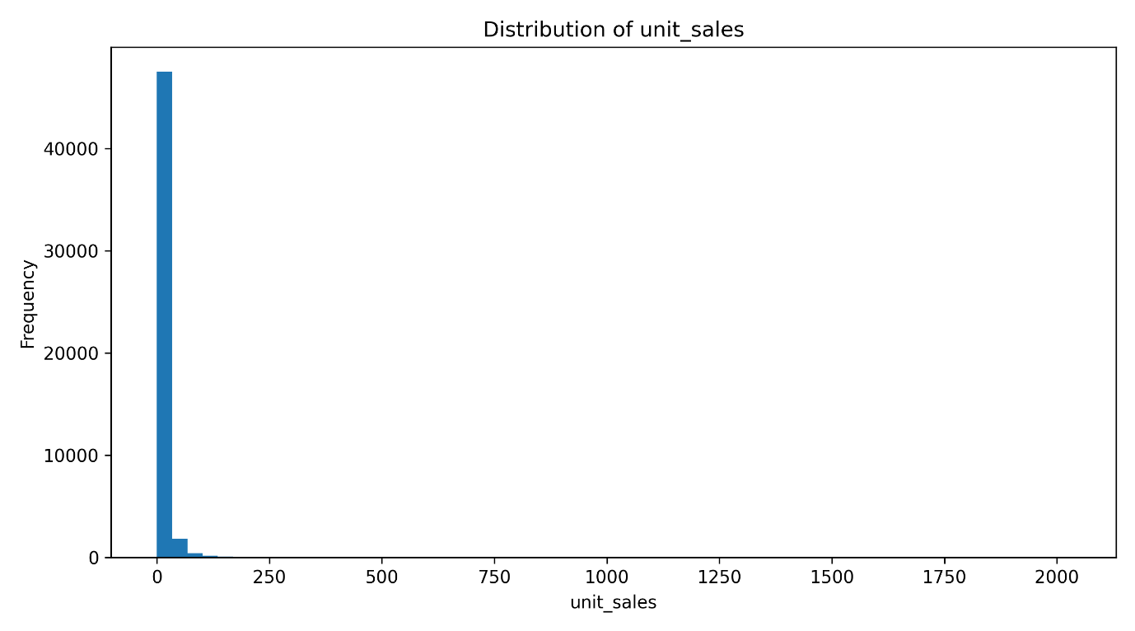
Figure 4.3: Distribution of Unit Sales
Figure 4.3 demonstrates that the target variable is strongly positively skewed. A fairly small number of observations stretch well into the upper tail, while the majority of observations are focused at relatively modest sales amounts. This suggests that the dataset contains extremely high sales observations and that demand is not normally distributed.

The Boxplot provides further evidence of this characteristics.
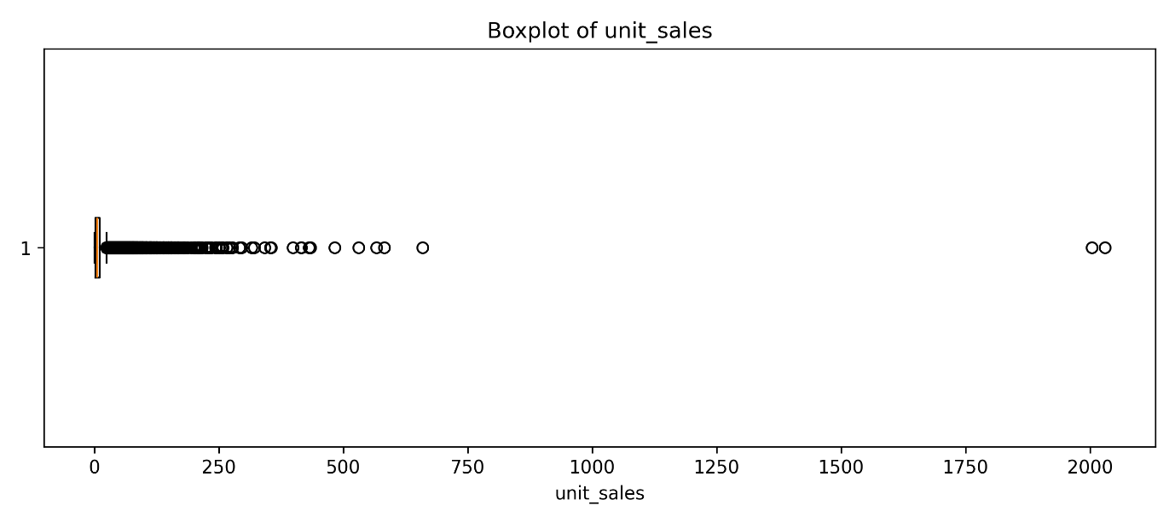
Figure 4.4: Boxplot of Unit Sales
As shown in Figure 4.4, There are several observations that fall outside of the upper whisker, including a very tiny number of very big values that are close to 2,000 units. Since high-demand occurrences can reflect actual operational behavior rather than data errors, these observations were not automatically eliminated just because they were statistically extreme. When the goal is to create a forecasting system that may assist with production planning, maintaining valid demand spikes is very crucial.

The Q-Q Plot provides additional confirmation:
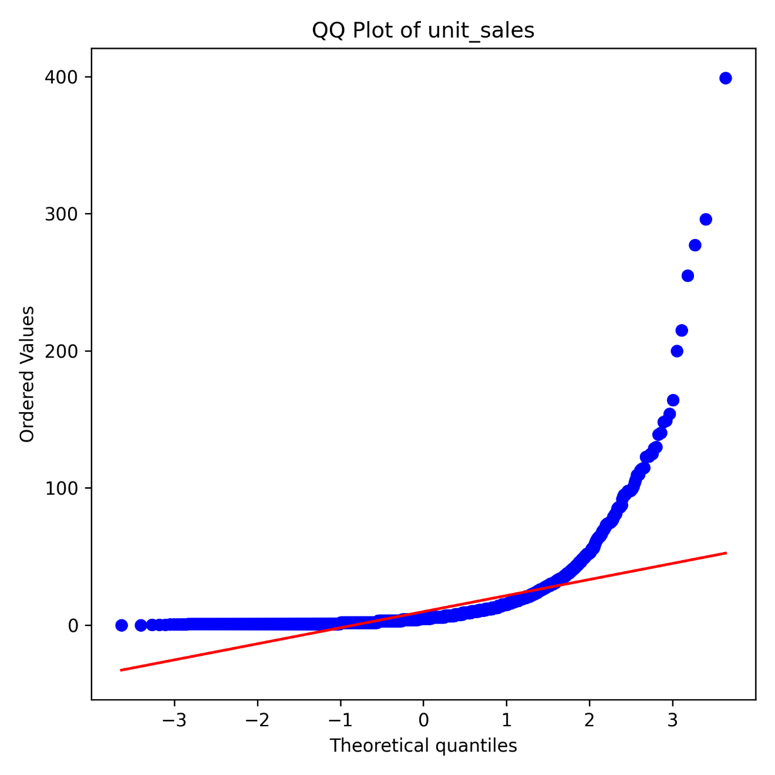
Figure 4.5: Q-Q Plot of Unit Sales
Unit_sales does not follow a normal distribution, as evidenced by the significant departure from the theoretical reference line, especially in the upper quantiles. The use of tree-based machine-learning techniques, which do not require the response variable to meet a normalcy assumption, was backed by this.

4.5 Temporal Demand Analysis
Demand behavior is also looked at over time because the study focuses on demand forecasting.
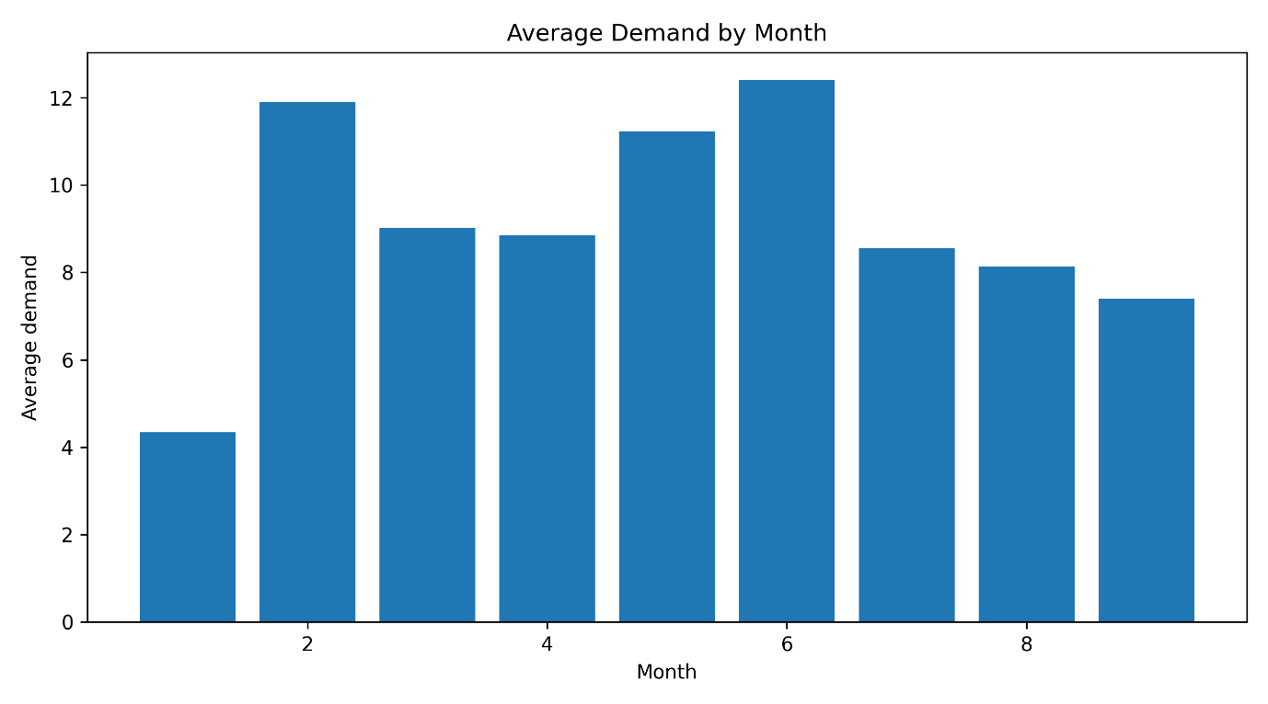
Figure 4.6: Average demand by month
Figure 4.6 indicates meaningful variation in average demand across the observed months. The average demand was comparatively low in January, rose significantly in February, peaked in May and June, and then began to decline in the latter half of the observation period. This fluctuation supports the inclusion of calendar-related factors and shows that demand was not constant throughout time.

Weekly behaviour was also investigated:
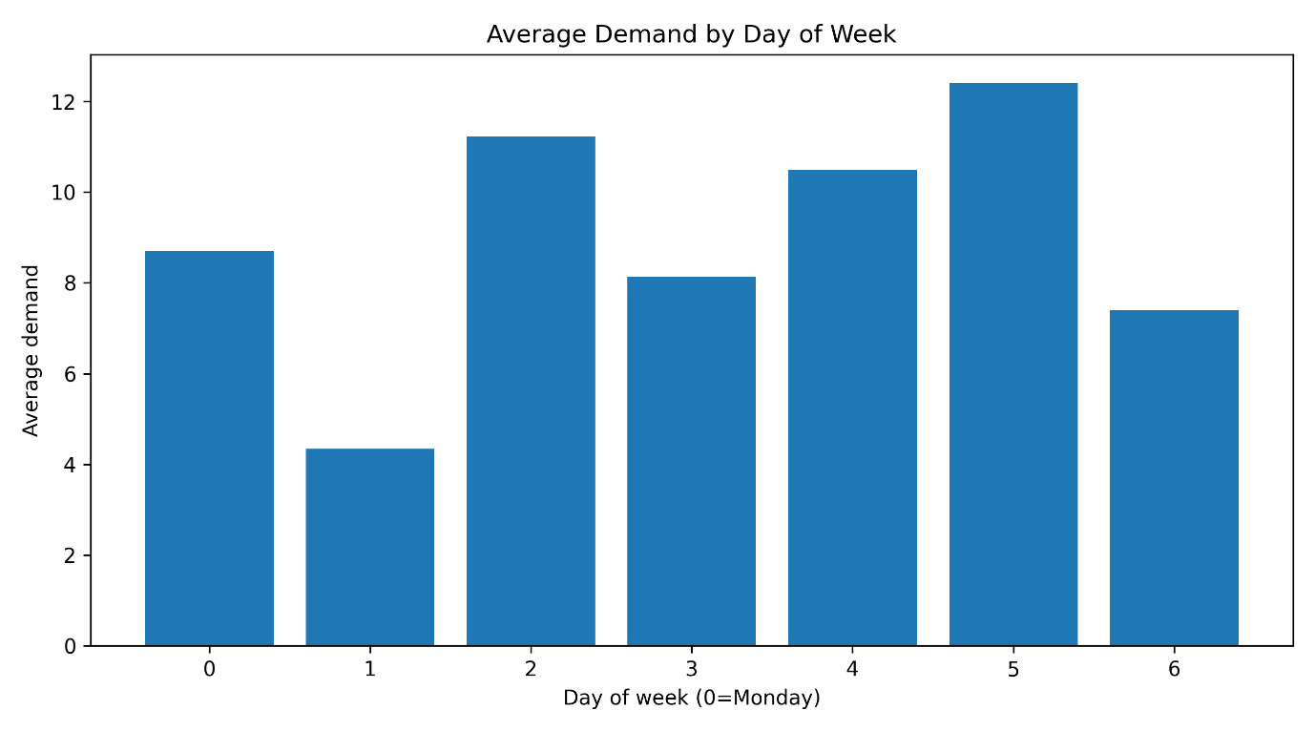
Figure 4.7: Average demand by week
Figure 4.7 demonstrates clear day-of-week variation. Day 1 had the lowest demand, while days 2, 4, and 5 saw significantly greater levels. Day 5 had the highest average level in the plotted sample. This gave the forecasting models empirical support for adding day-of-week and cyclical calendar variables.

4.6 Correlation Analysis
Relationships between numerical predictors were examined using a correlation matix.
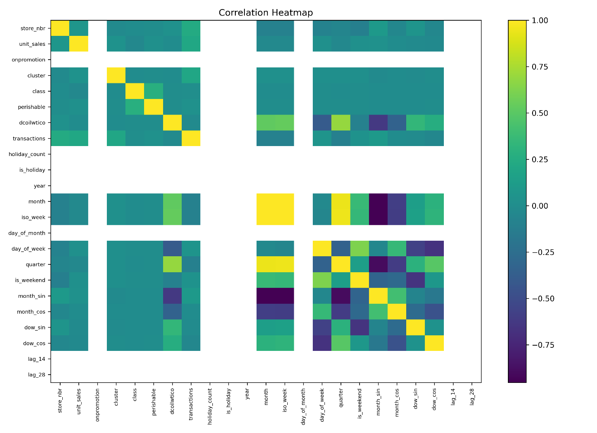
Figure 4.8: Correlation heatmap of numerical features
Relationships between store attributes, transactions, product attributes, and calendar-derived features are depicted in the heatmap. Because they reflect linked elements of the same temporal structure, several designed calendar variables exhibit strong correlations with one another. For instance, related information is inherently present in month, quarter, and cyclical month transformations.
The lack of a significant simple linear correlation between unit_sales and numerous individual predictors does not, however, mean that those variables are not useful. Pairwise Pearson correlations are insufficient to capture nonlinear linkages and interactions, while Random Forest, XGBoost, and LightGBM can.
Therefore, rather than being the exclusive criterion for feature removal, the correlation analysis was used mostly for exploratory comprehension.

4.7 Feature Engineering and Data Transformation
The date field was used to create calendar variables, such as month, ISO week, day of week, quarter, and weekend status. Additionally, sine and cosine representations were used to produce cyclical transformations for the month and day-of-week variables. These factors made it possible to more accurately depict recurrent calendar behavior.
Lag and rolling-window features were used to incorporate historical demand data. In addition to rolling means and rolling standard deviations computed over several windows, the incorporated features included prior demand data such as lag_1 and longer lag durations. These variables were created to give the models information about demand fluctuation and recent levels.
While nominal categorical variables were transformed using one-hot encoding, higher-cardinality variables were encoded separately to prevent an excessively large sparse feature space.
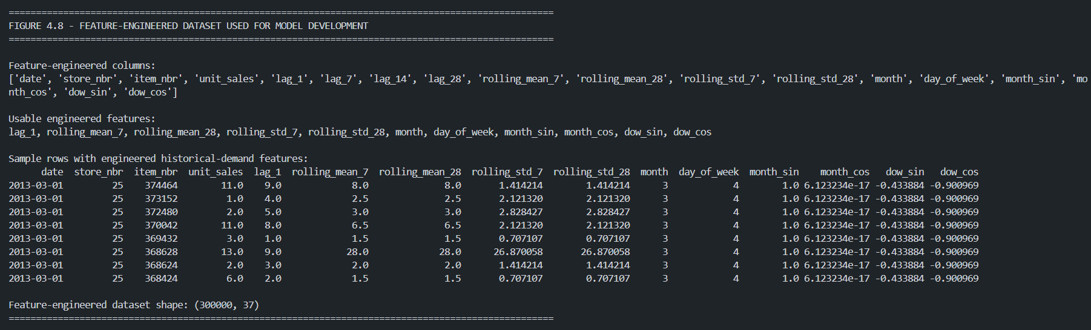
Figure 4.9: Sample of the feature- engineered dataset used for model development.
Figure 4.9 provides implementation evidence of the feature-engineering stage. 37 columns were created by adding temporal, cyclical, and historical demand variables to the processed dataset. In addition to calendar-derived variables like month, day of week, and cyclical sine/cosine transformations, the integrated historical features included lag_1, rolling means over 7 and 28 periods, and rolling standard deviations over the same windows. The sample that is shown attests to the fact that these designed variables had numerical values that could be used and were accessible for further model development.
Longer lag variables were also created during implementation, but because many store-item series lacked enough historical data, their useable coverage was restricted to the chosen 300,000-observation sample. As a result, missing historical values were addressed during the preprocessing step, and the modeling pipeline mostly depended on the rolling statistical and recent demand data that was available.

4.8 Chronological Training and Testing Split
Because the study focuses on forecasting, a traditional random train-test split was purposefully avoided. Distributing observations at random between training and testing sets would not accurately replicate a true forecasting environment and would allow information from subsequent periods to impact the training process.
As a result, the processed observations were split using an 80:20 temporal split and arranged chronologically. The training dataset consisted of the first 240,000 observations, and the unseen testing dataset consisted of the final 60,000 observations. On July 1, 2013, the testing session started.
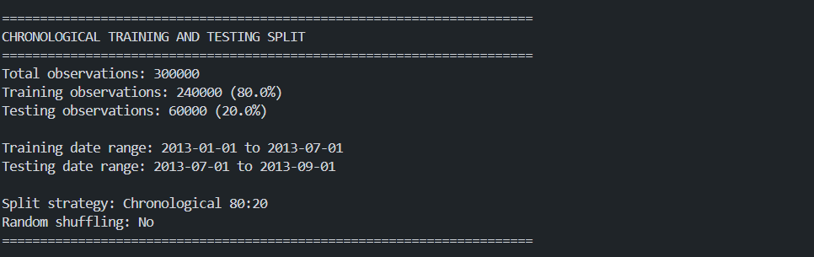
Figure 4.10 Chronological training and testing split used for model development
Table 4.2: Final Experimental Data Split
Component | Observations | Percentage
Training set | 240,000 | 80%
Testing set | 60,000 | 20%
Total | 300,000 | 100%
In addition to ensuring that model evaluation was carried out on later observations that were not utilized during model training, this chronological approach maintained the temporal ordering of the observations.

4.9 Machine Learning Model Development
Three supervised regression techniques were used: LightGBM, XGBoost, and Random Forest. To make it possible to compare the predicting performance of all three models reliably, the same training and testing partitions and preprocessing framework were used.
A bagging-based ensemble technique called Random Forest was used to model nonlinear relationships and interactions between predictors. Gradient-boosting techniques, such as XGBoost and LightGBM, reduce prediction errors by building consecutive decision trees. As a result, the three algorithms offered complementary tree-based methods for assessing the accuracy of demand forecasts.

These models were chosen because a variety of interrelated factors, such as past sales behavior, product and shop attributes, transaction activity, and temporal patterns, impact retail demand. These relationships might be nonlinear, making it challenging to accurately depict them using more straightforward linear methods. The algorithms were especially applied in this work to predict retail demand using the Corporacion Favorita dataset. Instead of directly optimizing manufacturing schedules or output volumes, the generated projections are regarded as possible inputs to production-planning decision support.

4.10 Hyperparameter Optimisation
RandomizedSearchCV and TimeSeriesSplit were used to optimize the model design. The executed fast configuration produced 12 fits for each method by evaluating four randomly chosen hyperparameter combinations per model using three time-series validation folds. This method reduced the processing needs for the 300,000-observation dataset while maintaining temporal ordering throughout validation. The final selected configurations were:
Table 4.3: Selected model hyperparameters
Model | Selected configuration
Random Forest | n_estimators=150; max_depth=12; min_samples_split=2; min_samples_leaf=1; max_features=0.7
XGBoost | n_estimators=400; learning_rate=0.05; max_depth=4; min_child_weight=5; subsample=0.7; colsample_bytree=0.7
LightGBM | n_estimators=400; learning_rate=0.05; max_depth=10; num_leaves=63; min_child_samples=20; subsample=0.7; colsample_bytree=0.85

Table 4.3 presents the final hyperparameter configurations selected during model tuning. The forecasting problem's chronological structure was maintained by combining three-fold TimeSeriesSplit validation with RandomizedSearchCV. Each algorithm's four potential parameter combinations were assessed in the executed fast configuration, yielding 12 validation fits per model. The final Random Forest, XGBoost, and LightGBM models were then fitted using the chosen configurations to produce predictions for the unseen chronological test set.

4.11 Prediction and Model Outputs
Each model was fitted using the chronological training dataset after hyperparameter optimization and used to produce predictions for the unobserved test observations. To ensure consistency in the comparison of the three algorithms, predictions were generated separately for Random Forest, XGBoost, and LightGBM using the same preprocessing pipeline and test dataset.

To visually evaluate how closely the forecasts matched observed demand, actual-versus-predicted graphs were utilized. Perfect agreement between actual and anticipated values is shown by the diagonal reference line. Greater deviations suggest more predicting mistakes, while predictions around this line indicate comparatively accurate projections.
For most observations, the three models were able to reflect the broad link between observed and expected demand, as shown in Figure 4.11. Extremely high-demand observations showed larger variances, suggesting that extreme demand values were harder to forecast than regular demand levels. The distribution found during the exploratory study is highly right-skewed, which is consistent with this behavior.
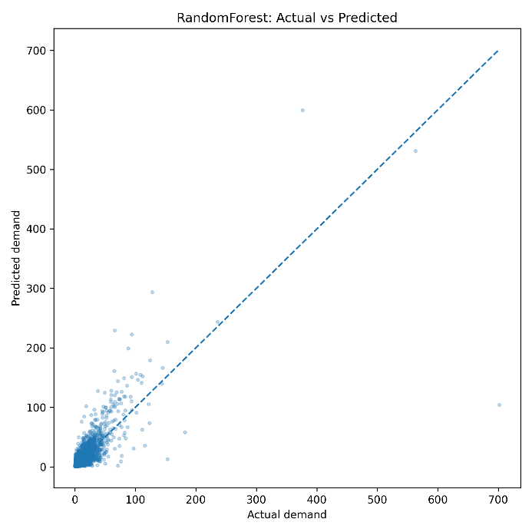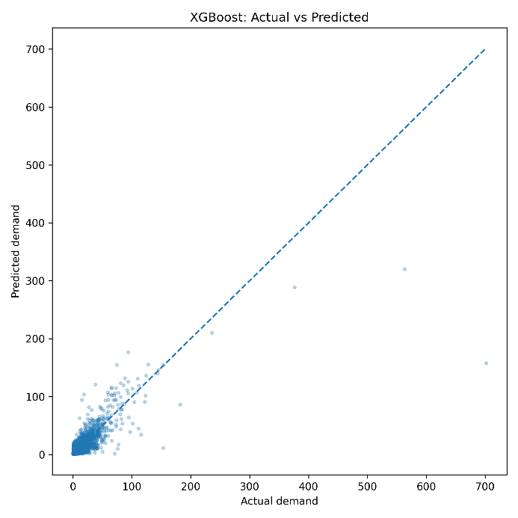
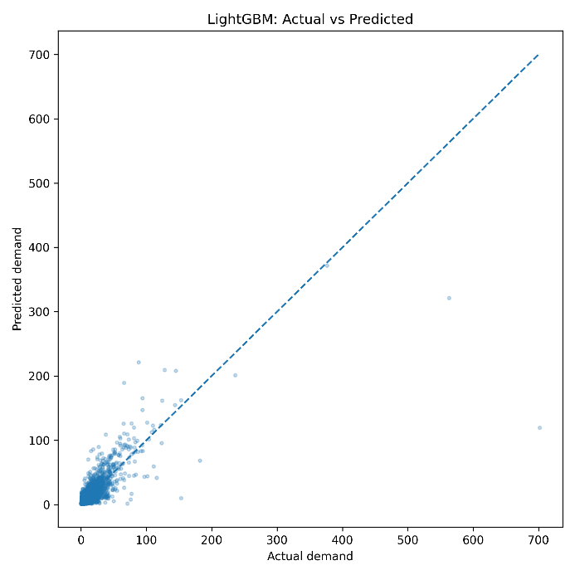
Figure 4.11: Actual vs predicted demand for:
- Random Forest
- XG Boost
- LightGBM
Figure 4.11 compares the actual and predicted unit sales generated by the three machine-learning models on the unseen test dataset. Perfect agreement between observed and anticipated demand is represented by the diagonal reference line. For most observations, all three models were able to reflect the broad link between actual and expected demand; however, situations with unusually high demand showed higher discrepancies. This behavior suggests that high demand observations were more challenging to predict with accuracy and is consistent with the strongly right-skewed distribution found during exploratory analysis. With the lowest MAE and RMSE on the test dataset, XGBoost went on to earn the best overall numerical performance among the three models.

4.12 Aggregate Forecast Behaviour Across Test Dates
The chronological test dataset's accessible dates were used to aggregate predictions in order to determine whether the three algorithms replicated more extensive shifts in overall demand. Three distinct dates 1 July, 1 August, and 1 September 2013 were included in the test partition. As a result, this research does not provide a continuous daily time-series examination, but rather date-level aggregate behavior.

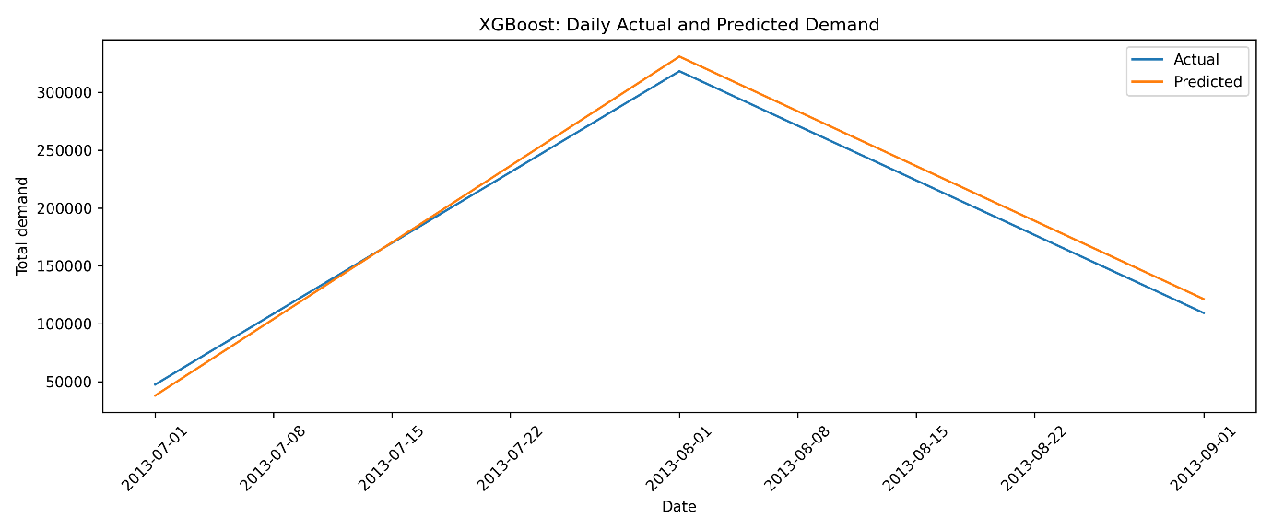
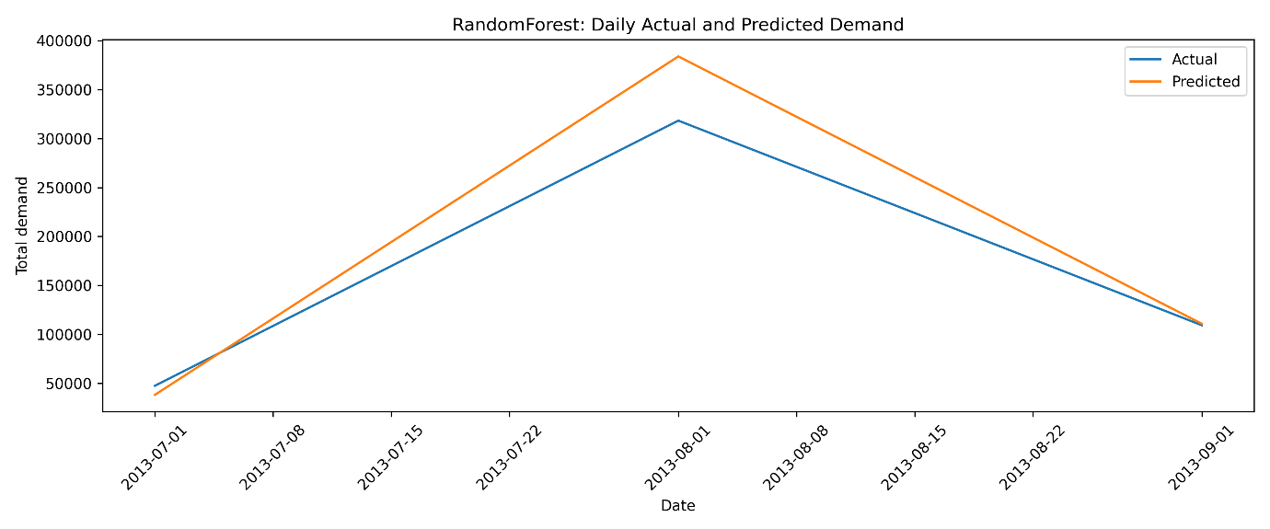
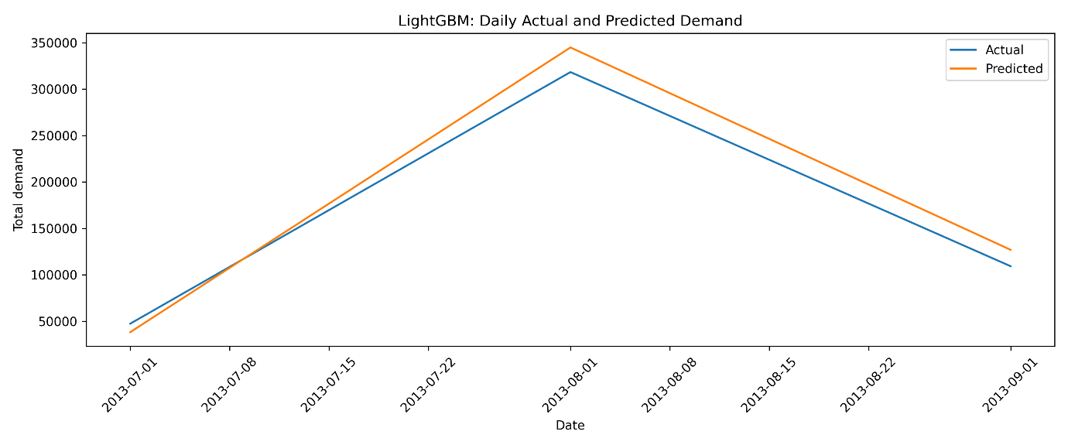
Figure 4.12: Aggregated actual and predicted demand across the test dates for:
- Random Forest
- XGBoost
- LightGBM
Figure 4.10 shows that all three models reproduced the broad rise in aggregate demand from July to August and the subsequent reduction in September. However, variations in anticipated magnitude were clearly visible. The actual aggregate demand for August was roughly 318,350 units, while Random Forest, XGBoost, and LightGBM predicted roughly 383,949, 330,997, and 344,871 units, respectively. As a result, on the test date with the highest demand, XGBoost was closest to the observed aggregate demand. To varied degrees, all three models overestimated aggregate demand in September.

Additional graphical proof of model behavior at the accessible date level is provided by these results. However, the figure should not be taken as proof of consistent daily predicting ability because the test dataset only includes three distinct dates. Therefore, the observation-level evaluation criteria described in Section 4.14 serve as the foundation for the main comparison of model performance.

4.13 Feature Importance
To determine which predictors made the most contributions to demand forecasting, feature significance was taken from each training model. This investigation showed how the three algorithms generated predictions using contextual factors, product attributes, and past demand.

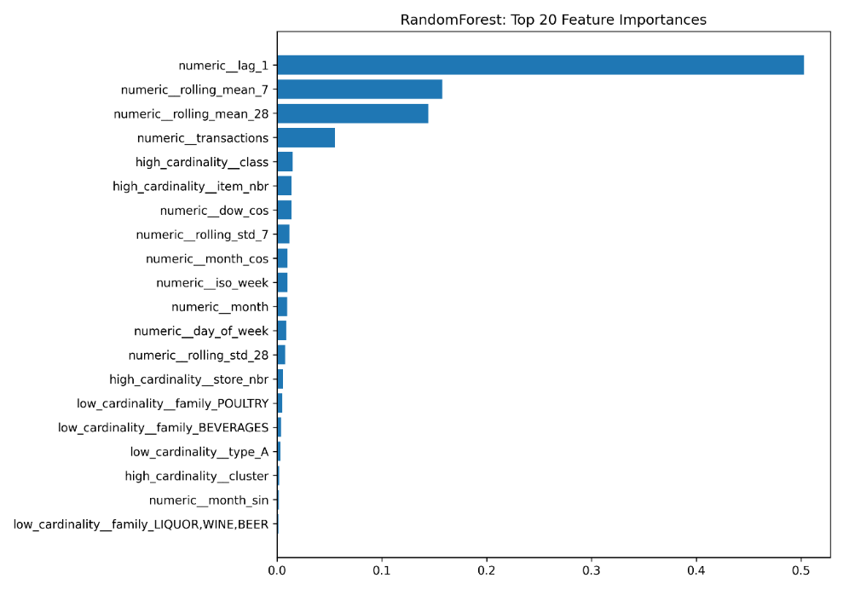
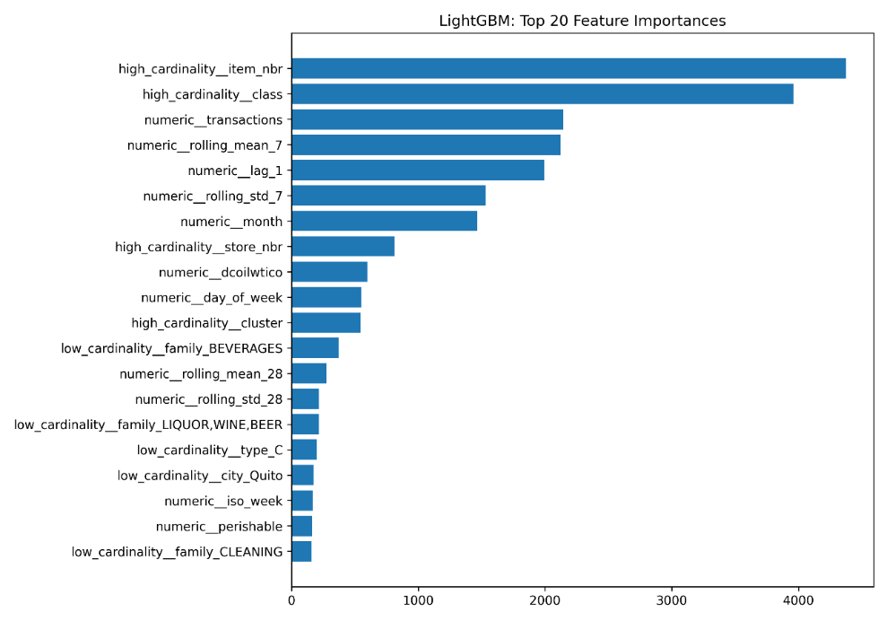
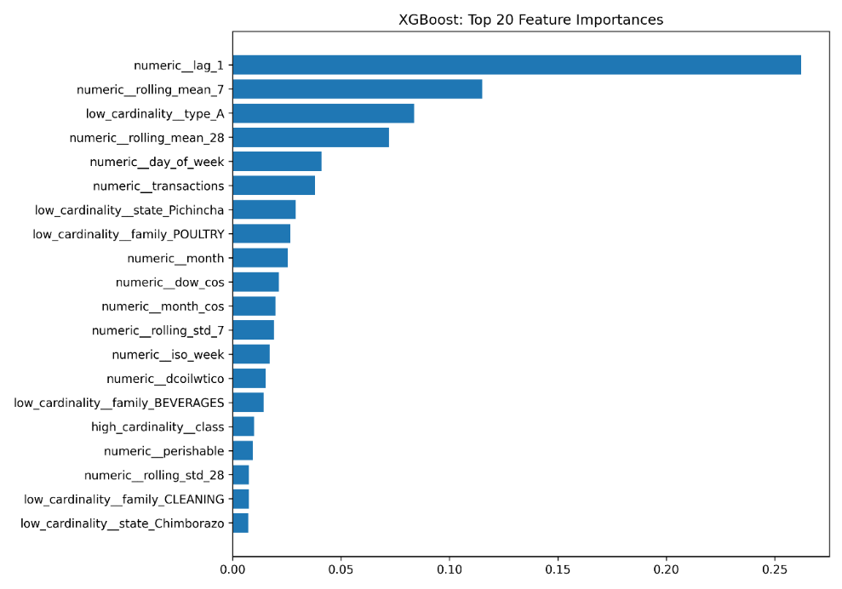
Figure 4.13: Top Feature Importance for:
- Random Forest
- XGBoost
- LightGBM
Figure 4.13 demonstrates that the three models differed in the relative importance assigned to the available predictors. With lag_1 and rolling-demand statistics emerging as significant predictors, historical-demand data was especially significant in Random Forest and XGBoost. This suggests that current sales activity offered valuable data for predicting future demand. LightGBM assigned relatively more weight to contextual and product-related attributes in addition to historical-demand variables. The three tree-based algorithms' different learning methods are reflected in these variations. Overall, the feature-engineering approach used in this work is supported by the presence of engineered historical-demand variables among the significant predictors, which shows that recent demand patterns offered significant predictive information.

4.14 Model Evaluation and Comparison
To guarantee a uniform and equitable comparison, the three forecasting models were assessed using the same chronological test dataset with 60,000 observations. Mean Absolute Error (MAE), Root Mean Squared Error (RMSE), Mean Absolute Percentage Error computed on non-zero data (MAPE), coefficient of determination (R-square), and Root Mean Squared Logarithmic Error (RMSLE) were used to evaluate the model's performance. Because MAE and RMSE directly quantify the size of forecasting mistakes, they were given special attention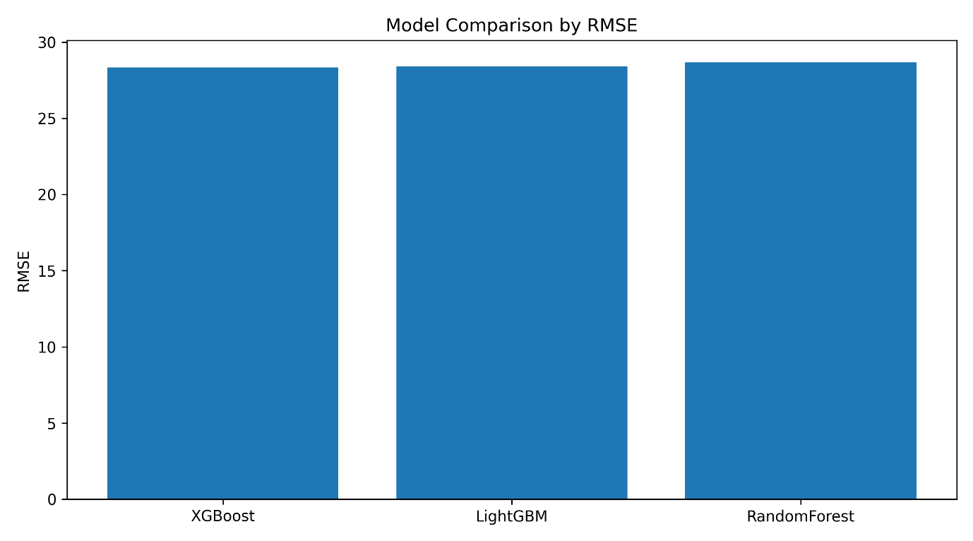
Figure 4.14: Comparison of RMSE across Random Forest, XGBoost and LightGBM
Figure 4.14 demonstrates that the forecasting performance of the three models was relatively similar. However, Random Forest generated the highest RMSE, whereas XGBoost and LightGBM had the lowest RMSE. Because it shows a smaller overall gap between observed and expected demand, a lower RMSE suggests greater predictive performance.

Table 4.4: Test-set performance of the three forecasting models.
Model | MAE | RMSE | R Square
Random Forest | 4.289 | 28.684 | 0.110
XGBoost | 3.796 | 28.340 | 0.131
LightGBM | 3.964 | 28.422 | 0.126

Table 4.4 demonstrates that XGBoost produced the lowest MAE (3.796) and RMSE (28.340) along with the highest R square value (0.131), demonstrating the best overall predictive performance. With an RMSE of 28.422 and an MAE of 3.964, LightGBM behind XGBoost in performance. With an MAE of 4.289 and RMSE of 28.684, Random Forest generated relatively more forecasting errors and the lowest R2 value (0.110). The comparatively minor difference in RMSE between XGBoost and LightGBM suggests that both gradient-boosting techniques had comparable predictive performance on the test dataset, even though XGBoost thus produced the best overall results.
A significant amount of variation in individual demand measurements remained unexplained, as seen by the relatively low R square values across all three models. This is in line with the demand behavior that was shown to be very varied and right-skewed during exploratory analysis, especially the existence of abnormally big demand data. As a result, rather of depending just on one performance statistic, the findings should be analyzed utilizing a variety of evaluation criteria.

4.15 Implementation Outputs and Reproducibility
To save evidence from every phase of the experiment, the implementation produced a set of output files. The training/testing configuration, chosen hyperparameters, model predictions, feature-importance outputs, correlation matrix, dataset summary, data-quality summary, normality test findings, and final evaluation metrics were among them.
Instead of immediately including these machine-readable files into the chapter, the tables and figures above provide a summary of the main results. To facilitate inspection and reproducibility, the entire Python program and any accompanying output files should be published electronically or in the dissertation appendices.
Reproducibility was further supported when a fixed random seed of 42 was used. An auditable connection between the implementation and the results presented in Chapter 5 is also made possible by preserving saved model parameters, forecasts, and evaluation outcomes.

4.16 Chapter Summary
Using the Corporacion Favorita dataset, this chapter illustrated the practical use of the suggested machine-learning demand-forecasting system. A modeling dataset of 300,000 observations and 37 variables was created by loading, integrating, cleaning, and transforming the source data. Extreme demand observations, a significantly right-skewed distribution of unit sales, and significant temporal variation in demand were all found by exploratory analysis.
After then, feature engineering was used to depict historical and temporal demand behavior. Cyclical transformations, rolling statistical features, lagged-demand data, and calendar-based variables were created and integrated into the modeling framework. An 80:20 temporal split was used to divide the processed observations chronologically, resulting in 240,000 training observations and 60,000 unseen testing observations.
Random Forest, XGBoost, and LightGBM are three supervised machine-learning algorithms that were created using a standardized preprocessing and evaluation architecture. In order to preserve temporal ordering during model selection, RandomizedSearchCV with three-fold TimeSeriesSplit validation was used to optimize model configurations. Following that, predictions were made for the chronological test dataset and assessed using standard performance metrics.
For each of the three algorithms, the implementation produced predictions and model-interpretation outputs with success. Historical-demand variables, such as rolling data and recent lagged demand, significantly influenced prediction, according to feature-importance analysis. With the lowest MAE (3.796), RMSE (28.340), and highest R square(0.131), XGBoost had the best overall performance, according to the final test-set evaluation. XGBoost outperformed LightGBM, and Random Forest had relatively larger forecasting mistakes. However, the comparatively slight variations in RMSE show that the three models' predictive performance is generally equal.
All things considered, the implementation created a repeatable experimental environment for assessing machine-learning methods for demand forecasting. The results produced in this chapter serve as the empirical basis for Chapter 5, where the results are more thoroughly evaluated in light of the study's limitations, current literature, research aims, and implications for food manufacturing operations.

CHAPTER 5: Results, Discussion, Analysis and Evaluation

5.1 Introduction
The outcomes of the machine-learning demand-forecasting paradigm used in Chapter 4 are presented and critically assessed in this chapter. Using numerous regression measures, Random Forest, XGBoost, and LightGBM were assessed on the same chronological test dataset. In addition to determining which model had the lowest predicting error, the research takes into account the causes of performance variations, the impact of designed characteristics, how the models behaved under high-demand observations, and the implications of the results for operational decision support.
The findings are also examined in light of the body of research on demand forecasting. Because the Corporacion Favorita dataset reflects grocery retail demand rather than actual food-manufacturing production data, extra caution is used when evaluating the operational implications. As a result, the models created in this study estimate demand rather than directly optimizing production volumes, timetables, labor allocation, or inventory choices.

5.2 Overall Model Performance
Using the same 60,000-observation chronological test set, all three models were assessed using MAE, MSE, RMSE, MAPE, RMSLE, and R Square. XGBoost yielded the best overall numerical result, with MAE = 3.7960, RMSE = 28.3397, RMSLE = 0.5409, and R Suare = 0.1312. LightGBM had the lowest MAPE of 0.8277 and was quite close, with RMSE = 28.4217 and R Square = 0.1262. Random Forest yielded the lowest R2 of roughly 0.1100, the maximum MAE of 4.2890, and the RMSE of 28.6838. As a result, the absolute performance differences between XGBoost and LightGBM are rather tiny, and the ranking is not consistent across all evaluation metrics.
The most significant discovery is that all three models had poor explanatory power, not just that XGBoost scored first. With an R2 of 0.1312, XGBoost only accounted for around 13.1% of the variation in the individual test observations; the fitted model and available predictor variables were unable to account for about 86.9% of the variation. Even less variation was described by Random Forest and LightGBM. Because the MAE and RMSLE results show that the models caught useful demand patterns for many observations, this does not imply that the models failed entirely. However, promises about predicting dependability are severely constrained by the low R2, especially for highly volatile items and extreme demand measurements. As a result, rather than being extremely precise or production-ready forecasting systems, the models should be viewed as comparative research prototypes.
The poor R2 values align with traits found in Chapter 4's exploratory research. A comparatively small number of observations had exceptionally high demand, unit sales were highly positively skewed, and several predictors had weak simple linear correlations with demand. As actual demand rose, the actual-versus-predicted study also revealed an increase in prediction dispersion. Additionally, only a small number of unique dates were represented by the chronological test partition, and the experiment employed a 300,000-observation sample of the larger Corporacion Favorita dataset. Because of these features, it is challenging to explain individual demand measurements with the factors at hand.
The modeling dataset can also be lacking significant explanatory features. Variables like specific product prices, promotional intensity, stock availability, weather, local events, rival activity, and broader economic conditions can all have an impact on demand shocks. As a result, the low R2 values can be a reflection of both the modeling algorithms and the scant explanatory data at their disposal.
Therefore, rather than being understood alone, R2 should be read in conjunction with error-based measurements. When a forecasting model's absolute errors are acceptable for a given planning choice, it may nevertheless have some practical usefulness. However, there is not enough solid evidence in the existing data to support an immediate commercial implementation. Before the models could accurately inform practical production commitments, more extensive out-of-time validation, segment-level evaluation, forecast uncertainty estimates, and comparisons against more straightforward statistical or naive forecasting baselines would be necessary.
Table 5.1: Test-set Performance of the ML models
Model | MAE | MSE | RMSE | MAPE* | RMSLE | R Square
Random Forest | 4.2890 | 822.7613 | 28.6838 | 0.8692 | 0.5603 | 0.1100
XGBoost | 3.7960 | 803.1371 | 28.3397 | 0.8328 | 0.5409 | 0.1312
LightGBM | 3.9644 | 807.7940 | 28.4217 | 0.8277 | 0.5432 | 0.1262
MAPE was calculated on zero observations.
Numerical proof that XGBoost had the best overall performance is provided by the results. It has the highest R2 (0.1312) and the lowest MAE (3.7960), MSE (803.1371), RMSE (28.3397), and RMSLE (0.5409). With an R2 of 0.1262 and an RMSE of 28.4217, LightGBM was very competitive. Random Forest yielded the lowest R2 (0.1100) and the highest MAE (4.2890) and RMSE (28.6838).
However, care should be taken when interpreting the differences. The two gradient-boosting algorithms performed equally, as evidenced by XGBoost's RMSE being just about 0.082 lower than LightGBM's. Additionally, LightGBM obtained the lowest MAPE (0.8277) on non-zero data. Therefore, it would be incorrect to say that XGBoost dominated all evaluation criteria.
Additionally noteworthy are the comparatively low R2 values. Only a small percentage of the variation in individual test data could be explained by even the best model. As a result, even though XGBoost was the best algorithm evaluated, the findings do not show near-perfect predictions. The demand data continued to show significant inexplicable fluctuation.

5.3 Comparative Analysis of the Three Models

5.3.1 XGBoost
The sequential gradient-boosting mechanism of XGBoost may be responsible for its relatively high performance. Gradient boosting gradually concentrates on residual prediction mistakes, in contrast to Random Forest, which builds several trees mostly separately. When demand is impacted by intricate relationships between past sales, temporal traits, goods, retailers, and contextual factors, this can be helpful.
The result is in line with data from recent retail predictions. For instance, Hobor et al. (2026) discovered that XGBoost achieved the lowest RMSE in their retail context when comparing statistical, tree-based, and deep-learning techniques. Similar to this, studies on spatial-temporal gradient boosting have shown how important it is to combine cross-sectional and temporal data for predicting a large number of retail products (Wang et al., 2024).
This dissertation does not, however, prove that XGBoost is always better. Its benefit was unique to the experiment's dataset, characteristics, sampling plan, hyperparameters, and forecasting setup.
However, the outcome does not prove that XGBoost is always better. Its benefit was unique to the experiment's dataset, feature set, sampling plan, hyperparameters, and assessment framework.

5.3.2 LightGBM
With an RMSE difference of less than 0.1, LightGBM's performance was quite similar to XGBoost's. Gradient-boosted decision-tree techniques were usually well matched to the structured feature set employed in this experiment, according to its competitive performance.
Although published comparisons do not indicate a uniformly better boosting algorithm, this result is also consistent with earlier studies. For instance, Nguyen, Dang, and Le (2025) discovered that performance leadership was dependent on the evaluation metric when comparing XGBoost with LightGBM on the Grupo Bimbo inventory-demand dataset. In a similar vein, Wang (2023) found that LightGBM outperformed XGBoost when using a different retail dataset and forecasting setup.
This validates a key finding of the current study: algorithm performance is not an intrinsic feature of a model family, but rather depends on the dataset and metric.This validates a key finding of the current study: algorithm performance is not an intrinsic characteristic of a model family, but rather depends on the dataset and metric.
LightGBM's performance should also be evaluated in light of earlier studies. While Wang (2023) observed better LightGBM performance than XGBoost in a different retail forecasting scenario, Nguyen, Dang, and Le (2025) discovered that the relative performance of XGBoost and LightGBM might vary based on the evaluation criteria. In contrast, LightGBM had the lowest MAPE in the current trial, while XGBoost had the best overall performance. Neither technique can be considered universally superior due to the rather tiny difference between the two boosting models. Rather, it seems that the assessment metric, feature engineering, hyperparameter setting, and dataset characteristics all affect how well they function.

5.3.3 Random Forest
Although Random Forest generated marginally larger mistakes than the boosting algorithms, it was still able to simulate nonlinear demand relationships. Its bagging construction is one explanation. While boosting techniques iteratively focus on residual mistakes, Random Forest minimizes variation by averaging independently generated trees. The diverse demand patterns shown in this dataset might have benefited from the latter process.
However, Random Forest's RMSE of 28.6838 and XGBoost's 28.3397 show that there wasn't a significant difference. Therefore, the results do not show that Random Forest is inappropriate for demand forecasting, but they do support gradient boosting in this specific experiment.

5.4 Actual Vs Predicted Demand
Beyond the aggregate error measurements, the actual-versus-predicted charts produced in Chapter 4 offer more proof.
The actual-versus-predicted charts, as seen in Figure 4.11, offer more proof of the three models' predicting behavior.
The graphs show that for a large portion of the usual demand range, predictions from all three methods were centered quite close to observed values. However, when real unit sales grew, prediction dispersion rose. As a result, the models seemed more trustworthy for normal observations than for instances of high demand.
This finding contributes to the explanation of why RMSE values were significantly higher while MAE values remained relatively low. While RMSE gives larger errors more weight through squaring, MAE weights individual errors linearly. Therefore, RMSE can be significantly increased by a relatively small number of severe forecasting errors.
This distinction is crucial for operational application. For a wide number of common products, a forecasting model might function well, but for things with exceptionally high demand, it might still result in significant inaccuracies.

5.5 Analysis of High-Demand Forecasting Errors
The exploratory analysis found that unit_sales had a relatively small number of extremely large observations and was highly right-skewed. At these increased demand levels, the forecast plots later showed greater variances.
This behavior could be explained by a number of variables. Unusual buying habits, events, product-specific impacts, or other contextual factors that might not be fully captured by the current predictors can all lead to extreme demand. Additionally, compared to ordinary sales observations, high-volume observations are far less frequent, giving the models fewer relevant examples to learn from.
Here, the experimental dataset's constraints are pertinent. The dataset does not include all the variables that would characterize a food manufacturing environment, such as production capacity, raw material availability, labor constraints, production lead times, machine downtime, and detailed manufacturing schedules, even though store, product, transaction, and temporal information was included.
Errors centered around demand peaks may be significant from an operational standpoint. If forecasts were utilized directly for planning, underestimating very high demand might lead to inadequate product availability, while significantly overestimating demand could promote excess inventory or production. Nevertheless, this dissertation did not directly measure either of these results. They are not proven production results, but rather possible consequences of forecasting mistake.

5.6 Feature Importance and Interpretation
Additional information about the data that the models employed was revealed via feature-importance analysis. The findings demonstrated the impact of historical demand data, especially lag_1 and rolling demand statistics in Random Forest and XGBoost. This implies that there was information in recent sales behavior that may be used to forecast future demand.
Figure 4.13: Top feature importances for (a) Random Forest, (b) XGBoost and (c) LightGBM shows that historical demand data, especially lag_1 and rolling demand statistics in Random Forest and XGBoost, had an impact on all of the fitted models. This implies that useful predictive information for predicting future demand was present in recent sales behavior. LightGBM distributed predicted importance in a slightly different way, emphasizing contextual and product-related information in addition to historical-demand aspects.
The significance of rolling and lagging data is in line with earlier forecasting studies. The usefulness of rolling statistics and lag-based feature engineering in a chronological retail-sales forecasting framework was shown by Soleimani et al. (2026). In a similar vein, Nguyen, Dang, and Le (2025) demonstrated that inventory-demand forecasting utilizing gradient-boosting algorithms can benefit greatly from previous demand data. The feature-engineering approach used in this dissertation is supported by these results. However, feature importance should not be regarded as proof of causation; rather than proving that altering a predictor will inevitably result in a change in demand, high importance implies predictive usefulness within the fitted model.
LightGBM distributed predicted importance in a slightly different way, emphasizing contextual and product-related information in addition to historical-demand aspects. Despite being trained on the same underlying data, the differences show that the three algorithms did not exploit the constructed feature space in the same way.
Recent forecasting research supports the significance of rolling and lagged data. Using lagged sales, rolling statistics, and chronological validation, Soleimani et al. (2026) created a leakage-safe weekly retail-sales forecasting framework for weekly retail sales. They integrated lagged sales and rolling statistics into tree-based forecasting models and placed a strong emphasis on chronological validation to prevent leakage. In a similar vein, inventory-demand forecasting was discovered to be influenced by past demand and recent sales.
The feature-engineering approach used in this dissertation is supported by these results. Feature importance, however, should not be seen as proof of causation. A variable with a high model relevance implies predictive usefulness within the fitted model; however, this does not imply that a change in the variable would definitely result in a commensurate change in demand.

5.7 Comparison with Existing Literature
The empirical results both qualify and partially corroborate the literature presented in Chapter 2. Studies showing competitive performance from gradient-boosting algorithms in structured retail forecasting align with XGBoost's greatest overall performance. For instance, Wang et al. (2024) showed the importance of integrating cross-sectional and temporal data in gradient-boosting techniques. The current study's feature-importance findings are in line with those of Soleimani et al. (2026), since rolling statistics and lagged demand were two of the most significant predictors. The need of leakage-safe historical-demand features in retail forecasting is further supported by this.
However, the current investigation does not show that XGBoost has a general advantage. While Nguyen, Dang, and Le (2025) discovered that the favored model depended on the evaluation criteria, Wang (2023) reported better LightGBM performance in a different retail forecasting context. This conclusion is supported by the current results, which show that LightGBM had the lowest MAPE while XGBoost performed best across MAE, RMSE, RMSLE, and R Square. Additionally, there was very little RMSE difference between XGBoost and LightGBM. These results thus corroborate the literature-review claim that forecasting performance is not a feature of a single algorithm but rather depends on dataset properties, feature engineering, forecast horizon, and evaluation criteria.
The literature highlighting the potential advantages of machine learning is significantly qualified by the low R2 values. Makridakis, Spiliotis, and Assimakopoulos (2022) discuss evidence from the M5 forecasting competition that shows no modeling family is dominant under all forecasting conditions. Ziel (2022) also draws attention to issues related to sporadic, scattered, and unpredictable retail demand. In a similar vein, the models in this dissertation demonstrated higher prediction errors at extreme demand levels and only accounted for a tiny percentage of observation-level demand fluctuation. Consequently, even while the findings show that tree-based machine learning can find some helpful predictive structure, they do not substantiate the more robust assertion that demand uncertainty can be resolved only by increasing model complexity.
The results also support Zhu et al. (2021)s claim about the importance of more supply-chain data. Their research showed that forecasting performance might be enhanced by using more comprehensive supply-chain data. Although historical lag and rolling-demand factors were significant predictors in the current dissertation, the poor R2 values indicate that many demand fluctuations could not be explained by the contextual variables that were available. Therefore, rather than just adding a more complicated algorithm, providing richer external and operational information may yield better gains. This is also in line with Rejeb, Keogh, and Rejeb (2022), who note the promise of supply-chain data as well as ongoing issues with data integration and quality.
Lastly, the findings' operational interpretation aligns with Islam, Amin, and Wardley's (2021) treatment of forecasting and optimization as connected but separate analytical phases. The models created in this study produce estimations of anticipated demand; they do not ascertain practical production numbers, labor needs, machine schedules, or ingredient purchases. Therefore, a sufficiently verified forecasting model, factory-specific operational data, and an extra optimization or decision-support layer would be required for a commercially viable food production system. As a result, rather than offering proof of direct food manufacturing optimization, this dissertation offers evidence regarding a potential forecasting input to operational planning.

5.8 Research Question Evaluation
1) What relevant demand patterns and characteristics can be identified within the Corporacion Favorita Dataset?
Several significant aspects of demand were found in the Corporacion Favorita dataset through exploratory analysis. The unit_sales variable has a substantial right skew, with a small number of extremely high-demand data and the majority of observations clustered at relatively low sales levels. Additionally, demand fluctuated throughout the months and days of the week, suggesting a significant temporal structure as opposed to a steady demand pattern. Additionally, the investigation revealed that rolling statistics and recent historical demand contained helpful prediction information. These results supported the forecasting models' use of calendar, lagged-demand, and rolling-window features. They also provided an explanation for why the biggest prediction mistakes happened at abnormally high demand levels.
2) How effectively do Random Forest, LightGBM and XGBoost forecast product demand and which model provides the strongest predictive performance?
Although all three models were able to identify predictive structure in the test data, XGBoost performed the best overall. XGBoost has the highest R square (0.1312) and the lowest MAE (3.7960), MSE (803.1371), RMSE (28.3397), and RMSLE (0.5409). Random Forest generated the highest MAE (4.2890) and RMSE (28.6838), whereas LightGBM produced the lowest MAPE (0.8277) and RMSE (28.4217). While the low R2 values across all models suggest that significant variation in individual demand data remained unexplained, the comparatively small discrepancies between XGBoost and LightGBM demonstrate that both gradient-boosting techniques performed similarly.

3) How can ML based demand forecasts support production planning decisions in food manufacturing, considering the limitations of using retail sales data?
Decisions about production planning, procurement, inventory control, and waste reduction may be supported by the forecasting outputs' evidence-based demand data. However, the Corporacion Favorita dataset does not include production capacity, labor, ingredient, machine, or scheduling restrictions; instead, it depicts grocery retail demand rather than manufacturing activities. Therefore, rather than direct production optimization, the study shows forecasting-based decision assistance. Validation utilizing production-specific data and, if optimization is needed, a different decision or optimization model would be necessary for any manufacturing application.

5.9 Practical Implications for food manufacturing decision support
Demand projections of this kind may help upstream manufacturing choices by giving information about anticipated product requirements, even when the underlying data represent supermarket retail sales.
Forecasts could assist planners in anticipating shifts in downstream demand and utilizing this data to determine production needs. Estimates of future ingredient and packaging requirements for procurement could be based on anticipated demand. Forecasts could help with inventory management decisions that aim to strike a balance between surplus stock and product availability. Initiatives to reduce waste may also benefit from forecast data, especially for perishable goods where overproduction could cause spoiling.
These are not the results of the experiment; rather, they are possible uses. There was no implementation of a production plan, inventory policy, procurement amount, or waste-minimization algorithm, and there was no empirical measurement of waste, cost, or stock-out reduction.
As a result, the dissertation's definition of optimization should be understood as the possible application of enhanced demand data to assist with operational planning. Demand forecasting, not quantitative production optimization, is carried out by the implemented system itselfFigure 5.1: Path from research prototype to commercially deployable decision support
The extra steps needed before the forecasting framework created in this dissertation could be deemed appropriate for commercial use are shown in Figure 5.1. Instead of being a deployable production-planning system, the current implementation is a forecasting prototype. Longer-term shadow-mode validation against current planning techniques would come after the incorporation of manufacturing-specific operational data. Controlled integration with ERP, MRP, or other production-planning systems should only be taken into consideration when reliable forecasting and operational performance had been shown.

5.10 Commercial Deployment Readiness
Immediate commercial implementation would not be warranted in light of the given results. The test time is too short to show consistent performance over typical operating cycles, the best R2 value is only 0.1312, and high-demand observations reveal greater predicting mistakes. Therefore, there could be a significant risk of both overproduction and underproduction if these estimates are automatically used to establish production amounts.
A shadow-mode pilot would be the first step in a more suitable deployment plan. This method would not automatically manage production; instead, the machine-learning projections would be produced in tandem with the production planners' current forecasts or judgments. Then, using both statistical metrics and operational indicators like forecast bias, service levels, stock-outs, waste, inventory levels, and schedule adherence, performance may be tracked over a number of months and across several product categories. To help planners identify forecasts that need to be manually reviewed, prediction intervals or other indicators of forecast uncertainty should be made available.

Before being used in the food manufacturing industry, the data architecture would also need to be enhanced. Manufacturing-specific data, such as production orders and actual production output, bill-of-material or recipe requirements, ingredient and packaging inventory, supplier lead times, labor availability, machine capacity and downtime, production changeover constraints, shelf-life information, and manufacturing waste, should be integrated with retail or customer-demand data. Unexpected demand swings may also be explained by external factors such as weather, local events, specific price changes, and more comprehensive promotional material.
The forecasting component should only be linked to ERP/MRP systems or a different optimization model used for production planning once lengthier out-of-time validation shows consistent performance against suitable forecasting baselines. Therefore, rather than being a commercially deployable autonomous forecasting system, the current implementation should be viewed as a research prototype and decision-support framework.

5.11 limitations of the Results
The results' interpretation and commercial relevance are directly impacted by a number of restrictions. First, rather than food manufacturing processes, the Corporacion Favorita dataset depicts grocery retail interactions. Production capacity, ingredient availability, labor needs, machine utilization, processing times, production changes, supplier lead times, shelf-life limitations, and manufacturing waste are all not immediately captured by it. Retail sales can serve as a stand-in for downstream customer demand, but without further manufacturing data validation, the current findings are unable to show how well the models would function in a real food production setting.
Second, instead of using the entire Corporacion Favorita dataset, the experiment employed a replicable sample of 300,000 observations, and the 60,000-observation testing split only included three different dates: July 1, August 1, and September 1, 2013. This limited temporal coverage is not enough to provide steady daily, weekly, or seasonal generalization, even though observation-level measures allow consistent comparison between the three models. The evidence of forecasting reliability would be significantly greater with a longer rolling-origin or walk-forward examination that covers more future dates.
Third, a significant restriction is represented by the low R2 values. With the highest R2 of 0.1312, XGBoost was able to explain most of the variation in individual demand measurements. For high-demand observations, the actual-versus-predicted analysis also showed rising inaccuracies. This implies that the chosen modeling techniques may not adequately represent the demand-generating process, or that significant explanatory factors may be missing from the feature set. Longer historical coverage, rival activity, weather, local events, stock availability, and more specific price and promotional information are all possible additions. These should also be integrated with production capacity, inventory of ingredients, labor availability, machine limitations, lead times from suppliers, and waste data for a manufacturing application.
Fourth, only three tree-based ensemble methods were included in the model comparison. Naive forecasting methods, conventional statistical models, probabilistic forecasting methods, LSTM or Transformer models, and hybrid ensembles were not used in the study. Therefore, it is not possible to draw the conclusion that the chosen machine-learning techniques' increased complexity offers a sufficient incremental gain over more straightforward forecasting methods. Future studies should assess forecast uncertainty in addition to point-prediction accuracy and incorporate suitable baseline models.
Lastly, there was no empirical testing of commercial implementation. A live data pipeline, automatic retraining procedure, model-monitoring framework, planner override mechanism, or connection with ERP, MRP, or production-planning systems were not implemented in the study. Additionally, there was no measurement of operational outcomes including food waste reduction, stock-outs, customer service quality, inventory holding costs, and production efficiency. As a result, rather than being independent commercial forecasting systems, the existing models should be viewed as research prototypes.

5.12 Chapter Summary
The predicting outcomes produced by Random Forest, XGBoost, and LightGBM were critically assessed in this chapter. With an MAE of 3.7960, RMSE of 28.3397, and R2 of 0.1312, XGBoost fared the best overall, whereas LightGBM came in second with the lowest MAPE. Forecasting mistakes were somewhat higher with Random Forest. Nevertheless, the findings showed that significant variance in demand remained unaccounted for and that model differences were very small.
While actual-versus-predicted research showed more forecasting difficulty for severe demand observations, feature-importance analysis emphasized the predictive significance of rolling previous data and recent demand. These results reinforced that model performance depends on the dataset, features, evaluation measure, and experimental setup, and they were generally in line with recent studies that support tree-based ensemble techniques for retail forecasting.
The results show how machine-learning demand forecasting can yield valuable data for operational decision support. Nevertheless, the study does not show direct optimization of food-manufacturing activities because the dataset represents retail demand and no optimization algorithm was used. Rather, it creates a forecasting framework that, when combined with relevant manufacturing data and operational restrictions, may help guide decisions about production, procurement, inventory, and waste management.

CHAPTER 6: Conclusion and Future Work

6.1 Introduction
The use of machine learning approaches for demand forecasting was examined in this dissertation, along with how better demand data might help with planning decisions related to food production operations. The Corporacion Favorita Grocery Sales Forecasting dataset's historical sales and contextual data were used to create and assess Random Forest, XGBoost, and LightGBM. Using a chronological experimental framework, the study compared the three algorithms' predicted performance and looked at the contributions of historical-demand, temporal, product, and contextual factors.
In this chapter, the research questions are directly addressed, the main contribution of the study is identified, its limits are acknowledged, its practical consequences are taken into consideration, and future research priorities are identified. Conclusions are limited to what the empirical analysis has shown.

6.2 Evaluation of the Research Questions
1) What relevant demand patterns and characteristics can be identified within the Corporacion Favorita Dataset?
Numerous extreme high-demand observations, a substantially right-skewed demand distribution, and distinct temporal fluctuation across months and days of the week were all found in the research. Additionally, rolling statistics and recent demand data offered helpful forecasts. These features demonstrate the diverse and temporally structured demand in the chosen retail sample, which validated the forecasting models' usage of engineering historical and calendar variables.
2) How effectively do Random Forest, LightGBM and XGBoost forecast product demand and which model provides the strongest predictive performance?
With an MAE of 3.7960, RMSE of 28.3397, and R2 of 0.1312, XGBoost had the best overall performance in this trial. Random Forest generated significantly higher errors, but LightGBM performed similarly and had the lowest MAPE. Therefore, rather than proving universal superiority, the results show that XGBoost is the strongest model under the particular dataset, feature-engineering, chronological split, and tuning configuration used.

3) How can ML based demand forecasts support production planning decisions in food manufacturing, considering the limitations of using retail sales data?
The findings suggest that demand information from ML-based projections could help with decisions about waste management, inventories, procurement, and production scheduling. Nevertheless, the study did not analyze manufacturing outcomes or use a production-optimization algorithm; instead, it relied on retail sales data. Therefore, rather than directly optimizing food manufacturing operations, its demonstrated benefit is demand-forecasting decision assistance; direct application would require factory-specific data and clear operational restrictions.

6.3 Research Contribution
This dissertation's main contribution is the creation and comparison of a repeatable machine-learning framework for demand forecasting that makes use of three ensemble algorithms based on trees. Within a uniform experimental framework, the study included chronological data partitioning, temporal and historical-demand feature engineering, time-series-aware cross-validation, hyperparameter tweaking, and several evaluation measures.
Additionally, the study showed how current historical-demand data is predictively relevant. Rolling statistical traits and lagged demand were found to be significant predictors, indicating that recent sales behavior provided valuable information for predicting future demand.
A further contribution is the explicit examination of how retail-demand forecasting may provide upstream information relevant to food-manufacturing planning. Rather than treating forecasting and optimisation as equivalent, the final study distinguishes between them: forecasting predicts expected demand, whereas optimisation requires additional decision variables, constraints and objectives. This distinction provides a more realistic interpretation of the contribution of machine learning to operational planning.

6.4 Limitations
Dataset-domain alignment is the biggest drawback. The Corporacion Favorita dataset represents grocery store sales rather than manufacturing operations, despite the dissertation's focus on food production operations. Production volumes, manufacturing capacity, ingredient availability, labor requirements, production schedules, machine utilization, lead times, and production waste are all not immediately captured. As a result, the results cannot be taken as concrete proof that the models will perform similarly in a food manufacturing setting.
The experimental sample is the subject of a second restriction. Instead of using the entire Favorita dataset, the modeling experiment employed 300,000 observations. Additionally, only three distinct dates within the chosen sample were represented by the 60,000 observations in the test set. This limits the inferences that can be made from aggregate temporal analysis and hinders the study's ability to show consistent daily predicting accuracy over a longer test period.
Additionally, the models' R2 values were very low, indicating that a significant amount of demand volatility remained unaccounted for. Extremely high-demand observations were especially difficult to predict, indicating the need for more explanatory data or different modeling techniques.
Lastly, rather than manufacturing optimization, the study assessed forecasting accuracy. Downstream operational results were not measured, and no mathematical optimization process was used.
As a result, commercial readiness is restricted. Because of the significant uncertainty caused by the low R2 values, limited testing window, and retail-to-manufacturing domain mismatch, the existing models should not be utilized to automate production commitments. They are now useful as a forecasting layer prototype that shows an analytical workflow and pinpoints the kinds of data that may be used to support a more comprehensive production-planning system.

6.5 Practical Implications
Notwithstanding these drawbacks, the results may be useful. Operational planning can benefit from an evidence-based input from accurate demand estimates. Forecasts may help planners in a food manufacturing setting estimate future product requirements, which may then influence decisions about production scheduling, ingredient procurement, and inventories.
Decisions about waste management may also be indirectly influenced by forecasting. Organizations may be able to spot possible discrepancies between planned production and anticipated requirements with the use of better information about projected demand. Nevertheless, actual manufacturing data and operational performance metrics would need to be used to test these advantages, as this dissertation offers no concrete proof of waste reduction or cost savings.
Therefore, rather than a finished production-optimization system, the results should be understood as showing a possible decision-support capability.
Future commercial translation should use a phased deployment process that includes offline back-testing with a longer manufacturing history, comparison with statistical and naive forecasting baselines, shadow-mode forecasting in conjunction with production planners, monitored pilot use with human overrides, and only then controlled integration with production-planning systems. Forecast bias, service level, stock-outs, waste, inventory cost, and adherence to production schedules should all be considered success criteria in addition to forecast-error measurements.

6.6 Future Research
Validating the forecasting system with actual food manufacturing data is the top goal for future study. Customer demand, manufacturing volumes, ingredient inventory, waste, labor availability, machine capacity, lead times, and production schedules should all ideally be included in this data. This would make it possible to directly assess the connection between manufacturing performance and forecast accuracy.
Integrating forecasts with a true optimization component is a second priority. In order to calculate production volumes, inventory requirements, or production schedules according to operational restrictions, forecasted demand may be used as an input to mathematical optimization or other decision models. This would make it possible for future studies to assess optimization instead of just predictions.
Third, future studies ought to assess performance over significantly more distinct times and employ a longer chronological test window. This would allow for meaningful daily or weekly forecast review and strengthen the evidence for temporal generalization.
Lastly, other forecasting architectures such as Transformer-based time-series models, LSTM networks, and hybrid/ensemble techniques should be studied. Instead of assuming that greater model complexity will inevitably lead to better predicting performance, their inclusion should be assessed against suitable statistical and machine-learning baselines.

6.7 Final Conclusion
This dissertation shows that historical retail-demand data can be used to derive valuable predictive information using machine-learning techniques. XGBoost outperformed the other two algorithms in terms of overall forecasting performance, however LightGBM yielded results that were almost identical and there was still a significant amount of unexplained demand variance.
Therefore, it is important to understand the study's contribution proportionally. It doesn't show how machine learning improves food manufacturing processes directly. Rather, it illustrates a repeatable framework for demand forecasting, the results of which may help with future factory planning and optimization choices.
The results lay the groundwork for further studies that combine demand predictions with actual manufacturing data and explicit optimization techniques. Before claims about benefits in procurement, inventory control, production efficiency, or waste reduction could be empirically proven, such integration would be required.

7.0: References
Chen, T. and Guestrin, C. (2016) ‘XGBoost: A scalable tree boosting system’, Proceedings of the 22nd ACM SIGKDD International Conference on Knowledge Discovery and Data Mining, pp. 785–794. doi: 10.1145/2939672.2939785.
Christopher, M. (2016) Logistics & Supply Chain Management. 5th edn. Harlow: Pearson.
Fildes, R., Kolassa, S. and Ma, S. (2022) ‘Post-script Retail forecasting: Research and practice’, International Journal of Forecasting, 38(4), pp. 1319–1324. doi: 10.1016/j.ijforecast.2021.09.012.
Fildes, R., Ma, S. and Kolassa, S. (2022) ‘Retail forecasting: Research and practice’, International Journal of Forecasting, 38(4), pp. 1283–1318. doi: 10.1016/j.ijforecast.2019.06.004.
Hastie, T., Tibshirani, R. and Friedman, J. (2009) The Elements of Statistical Learning: Data Mining, Inference, and Prediction. 2nd edn. New York: Springer.
Hobor, L., Brčić, M., Polutnik, L. and Kapetanović, A. (2026) ‘Comparative analysis of modern machine learning models for retail sales forecasting’, Croatian Operational Research Review, 17(2), pp. 285–296. doi: 10.17535/crorr.2026.0021.
Hochreiter, S. and Schmidhuber, J. (1997) ‘Long short-term memory’, Neural Computation, 9(8), pp. 1735–1780. doi: 10.1162/neco.1997.9.8.1735.
Hosseinnia Shavaki, F. and Ebrahimi Ghahnavieh, A. (2023) ‘Applications of deep learning into supply chain management: A systematic literature review and a framework for future research’, Artificial Intelligence Review, 56(5), pp. 4447–4489. doi: 10.1007/s10462-022-10289-z.
Islam, S., Amin, S.H. and Wardley, L.J. (2021) ‘Machine learning and optimization models for supplier selection and order allocation planning’, International Journal of Production Economics, 242, 108315. doi: 10.1016/j.ijpe.2021.108315.
Ke, G., Meng, Q., Finley, T., Wang, T., Chen, W., Ma, W., Ye, Q. and Liu, T.-Y. (2017) ‘LightGBM: A highly efficient gradient boosting decision tree’, Advances in Neural Information Processing Systems, 30, pp. 3146–3154.
Lee, H.L., Padmanabhan, V. and Whang, S. (1997) ‘Information distortion in a supply chain: The bullwhip effect’, Management Science, 43(4), pp. 546–558.
Makridakis, S., Spiliotis, E. and Assimakopoulos, V. (2022) ‘M5 accuracy competition: Results, findings, and conclusions’, International Journal of Forecasting, 38(4), pp. 1346–1364. doi: 10.1016/j.ijforecast.2021.11.013.
Mediavilla, M.A., Dietrich, F. and Palm, D. (2022) ‘Review and analysis of artificial intelligence methods for demand forecasting in supply chain management’, Procedia CIRP, 107, pp. 1126–1131. doi: 10.1016/j.procir.2022.05.119.
Mitra, A., Jain, A., Kishore, A. and Kumar, P. (2022) ‘A comparative study of demand forecasting models for a multi-channel retail company: A novel hybrid machine learning approach’, SN Operations Research Forum, 3(4), article 58. doi: 10.1007/s43069-022-00166-4.
Nguyen, N.P.T., Dang, T.T. and Le, D.D. (2025) ‘Inventory demand forecasting using XGBoost and LightGBM algorithms: A case study of Grupo Bimbo’, Advances in Transdisciplinary Engineering. doi: 10.3233/ATDE250516.
Petropoulos, F. et al. (2022) ‘Forecasting: Theory and practice’, International Journal of Forecasting, 38(3), pp. 705–871. doi: 10.1016/j.ijforecast.2021.11.001.
Rejeb, A., Keogh, J.G. and Rejeb, K. (2022) ‘Big data in the food supply chain: A literature review’, Journal of Data, Information and Management, 4, pp. 33–47. doi: 10.1007/s42488-021-00064-0.
Saunders, M.N.K., Lewis, P. and Thornhill, A. (2019) Research Methods for Business Students. 8th edn. Harlow: Pearson.
Soleimani, A., Hassanzadeh Amin, S., Baki, F. and Shah, B. (2026) ‘Forecasting weekly sales using lag-based feature engineering and a bagged tree ensemble’, Machine Learning with Applications, 24, 100922. doi: 10.1016/j.mlwa.2026.100922.
Wang, G. (2023) ‘Sales forecast of retail commodity on the basis of LightGBM and Xgboost’, in Proceedings of the International Conference on Financial Innovation, FinTech and Information Technology (FFIT 2022). EAI. doi: 10.4108/eai.28-10-2022.2328402.
Wang, J., Chong, W.K., Lin, J. and Hedenstierna, C.P.T. (2024) ‘Retail demand forecasting using spatial-temporal gradient boosting methods’, Journal of Computer Information Systems, 64(5), pp. 652–664. doi: 10.1080/08874417.2023.2240753.
Zhu, X., Ninh, A., Zhao, H. and Liu, Z. (2021) ‘Demand forecasting with supply-chain information and machine learning: Evidence in the pharmaceutical industry’, Production and Operations Management, 30(9), pp. 3231–3252. doi: 10.1111/poms.13426.
Ziel, F. (2022) ‘M5 competition uncertainty: Overdispersion, distributional forecasting, GAMLSS, and beyond’, International Journal of Forecasting, 38(4), pp. 1546–1554. doi: 10.1016/j.ijforecast.2021.09.008.

8.0: Appendix
Dataset: Dataset
Python Code: Python Code
Outputs: Outputs

9.0 Gantt Chart
Task | Start Date | End Date
Proposal Submission | 1 May 2026 | 22 May 2026
Introduction | 23 May 2026 | 5 June 2026
Literature Review | 6 Jun 2026 | 19 Jun 2026
Methodology | 20 June 2026 | 26 June 2026
Implementation | 27 June 2026 | 20 July 2026
Results & Analysis | 21 July 2026 | 7 Aug 2026
Final Writing & Review | 8 Aug 2026 | 27 Aug 2026
Final Submission | 28 Aug 2026 | 28 Aug 2026

