\



|  |
| --- |
| Real-Time Project (For Industry Experience) |

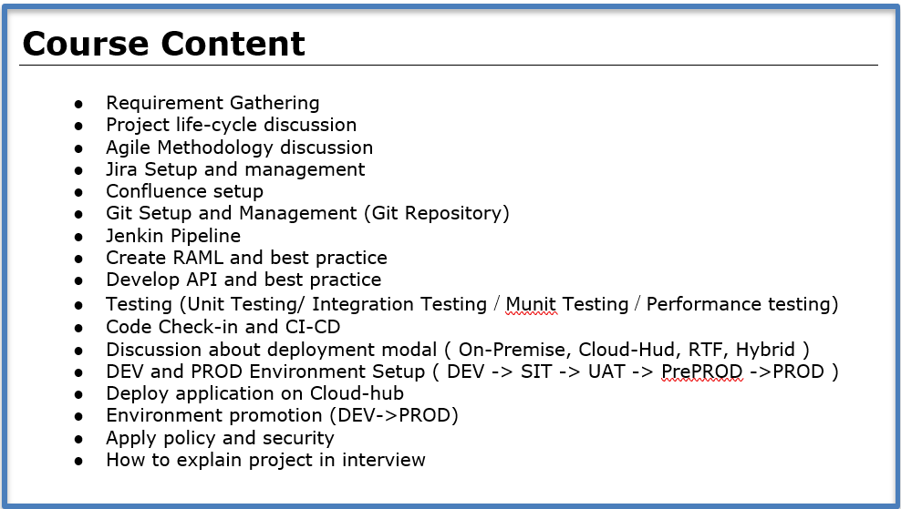



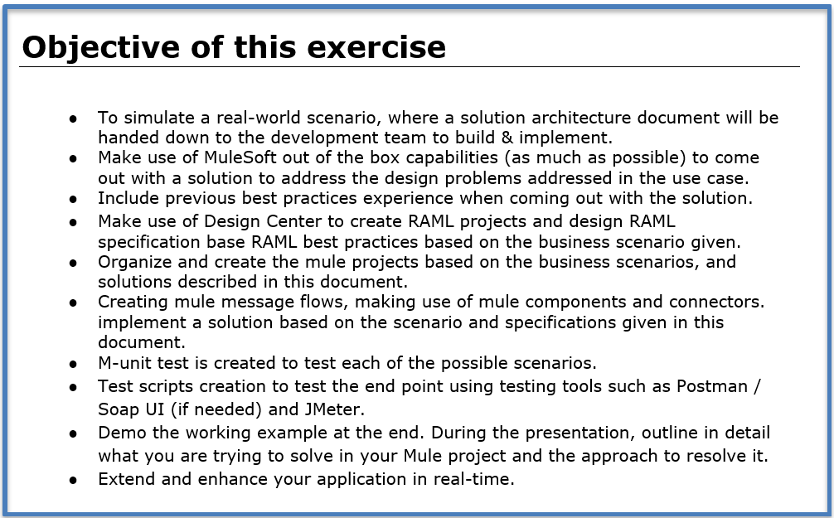



# **SOFTWARE LIST**

1. Anypoint platform account: Done (https://anypoint.mulesoft.com/login/)

<https://anypoint.mulesoft.com/login/signin>? - Completed

1. Anypoint studio software - Completed
2. Git repository - ([kumarmuletraining1@gmail.com](mailto:kumarmuletraining1@gmail.com)): Done (<https://github.com/>) - Completed
3. Git Desktop - Completed
4. Postman: Done (<https://www.postman.com/downloads/>) - Completed
5. Maven: Done: java -version ( https://maven.apache.org/download.cgi)
6. JDK: Done: mvn -version
7. Salesforce Account: Done (https://developer.salesforce.com/signup)
8. Remote MySQL Account (https://console.clever-cloud.com/)
9. Jira account (Trail - 6, Agile approach for creation of Story, Bug) (https://id.atlassian.com/)
10. Confluence
11. SMS/Email Account SMTP Protocol
12. Splunk Setup
13. Jenkin for CICD.
14. Secure property jar ( <https://docs.mulesoft.com/mule-runtime/4.4/_attachments/secure-properties-tool.jar>)



# **CONNECTOR**

1. Salesforce
2. Database
3. SMTP
4. Object Store
5. HTTP
6. API_Kit
7. Secure Property
8. O-auth

# **KEY COMPONENT**

1. Batch Process
2. Catching
3. Choice Router
4. Scatter Gather
5. For loop
6. On-Error Continue
7. On-Error Propagate
8. Raise Error
9. Scheduler

**SECURITY POLICY**

1. **O-Auth**
2. ClientID Enforcement
3. Rate Limiting
4. Http Caching
5. Basic Auth
6. Spike control



**SCHEDULE**

########################################################

**Duration: 6 week - 8 week**

**Indian Time (IST)**

Satday : 07:30 AM to 10:30 AM: 15 min Break

Sunday : 07:30 AM to 10:30 AM: 15 min Break

**Doubt Session : Weekday**

**US Time (EST)**

Satday : 10:00 PM to 01:00 AM: 15 min Break

Sunday : 10:00 PM to 01:00 AM: 15 min Break

**Doubt Session : Weekday**

**Registration Contact: +91 7411764131 (WhatsApp Only)**

**Mulesoft Basic knowledge:**

1. Training : <https://www.youtube.com/watch?v=i6gWE0JCi5k&list=PL2LUDEomJp_jNB4v-rFn6GmpbOZqkhIlR&ab_channel=DevelopersGuide>

2. project : <https://www.youtube.com/watch?v=zZUtdFsLcIk&list=PL2LUDEomJp_hyALpjtwK2AI1rGs9G6u-J&ab_channel=DevelopersGuide>

3. Dataweave : <https://www.youtube.com/watch?v=uq_hp0PK7JA&list=PL2LUDEomJp_iMwTXhKE3PdjItSHLvJ7vT>

4. Interview : <https://www.youtube.com/watch?v=J8sG4e-o-Eo&list=PL2LUDEomJp_hCWdgBdLyU8GMcyfw2O7a7&ab_channel=DevelopersGuide>

**CONTACT FOR REGISTRATION**

**+91 7411764131**

**(WHATSAPP CALL OR MESSAGE)**