**5Steps to Install Java :**

1. Goto [www.oracle.com](http://www.oracle.com)
2. Goto Dowloads
3. Select JavaSE
4. Download JDK

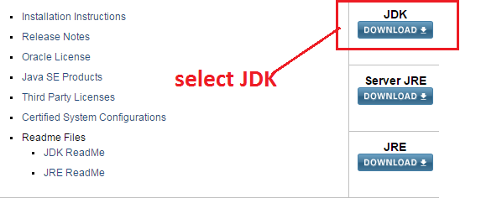

1. Accept the Agreement and download the corresponding version of java exe file based on OS
2. Click on the .exe file and give next –next –next it will install java

**Setup Environmental Variables**

Step 1: Goto Start select Computer

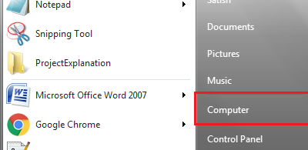

Step 2: Give a right click on Computer and select Properties

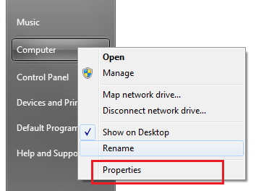

Step 3: Select Advanced System Settings

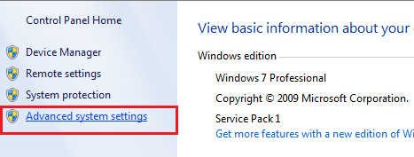

Step 4 : select Environmental Variables

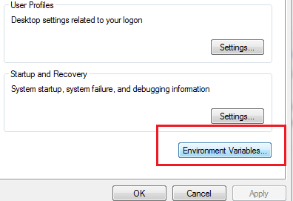

Step 5 :select User Variables and Click on New Button

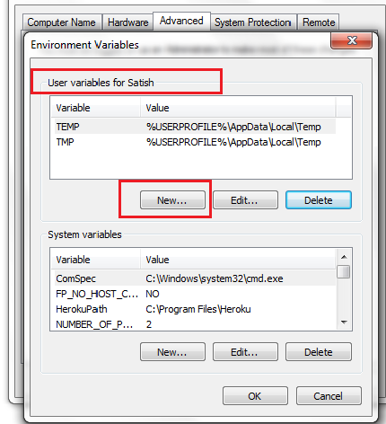

Step 6 :Enter Variable Name : PATH

Value as Path of BIN in the in Program Fiels

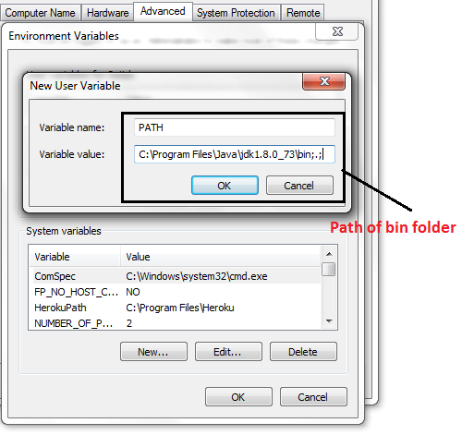

Step 7 : Select OK

Step 8: Select OK

Step 9: Select Ok

**Test the java installation**

Step 1: In the Command Line

Step 2: Type javac and click enter

Step 3: If receive java files then Java is successfully installed else you will receive unrecognized command JavaC

Installation of eclipse

1. Goto <http://www.eclipse.org>
2. Click on on download



1. Select Eclipse IDE for java Developer and select 32 /64 os

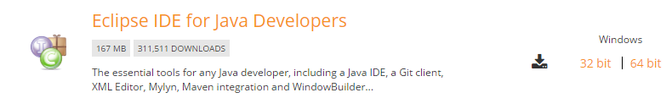

1. Download Mars



1. Zip file is downloaded
2. Extract the zip file



1. Open the eclipse folder and select eclipse logo

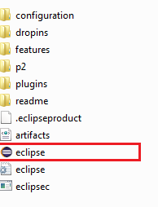

8. Select Run

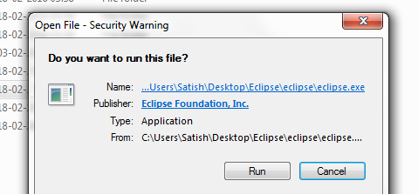

1. It will open the eclipse



1. Choose the workspace ( Location where projects developed from eclipse should be stored) and click ok

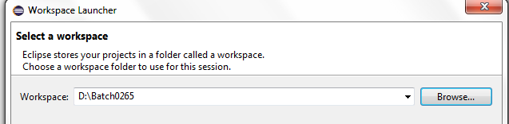

1. Eclipse will be opened in java mode

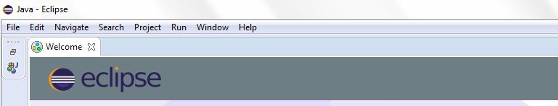

1. Install the plugin for salesforce and eclipse

<http://media.developerforce.com/force-ide/eclipse42>

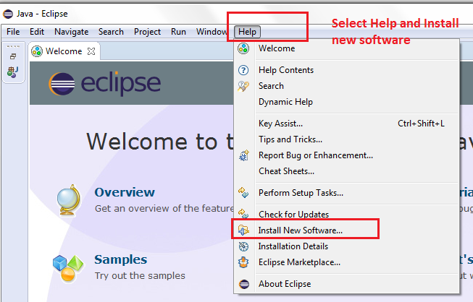

1. Select Add button

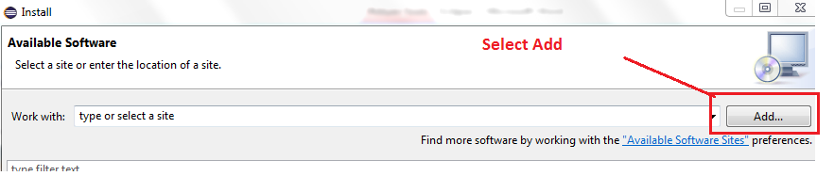

1. In Name give : Force.com IDE

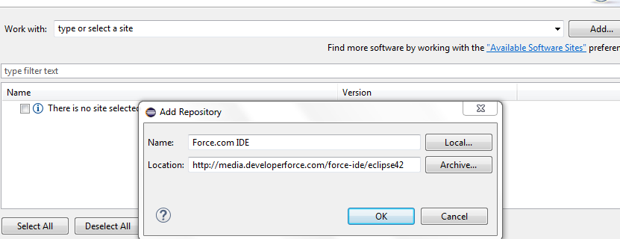

1. Select Force.com IDE

Force .com Debugger

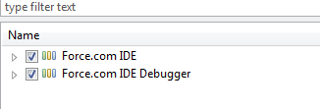

1. Click On next

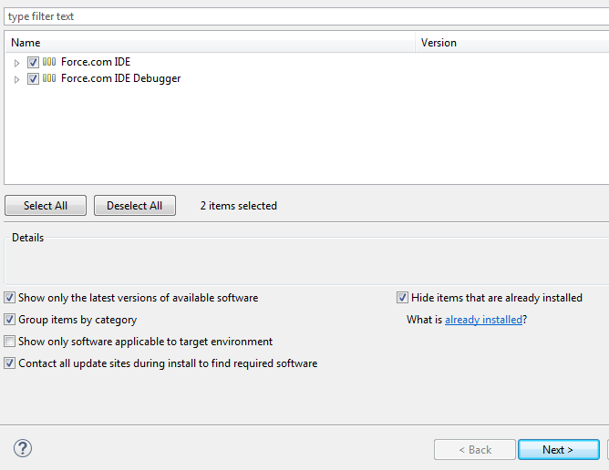

1. Click on Next :

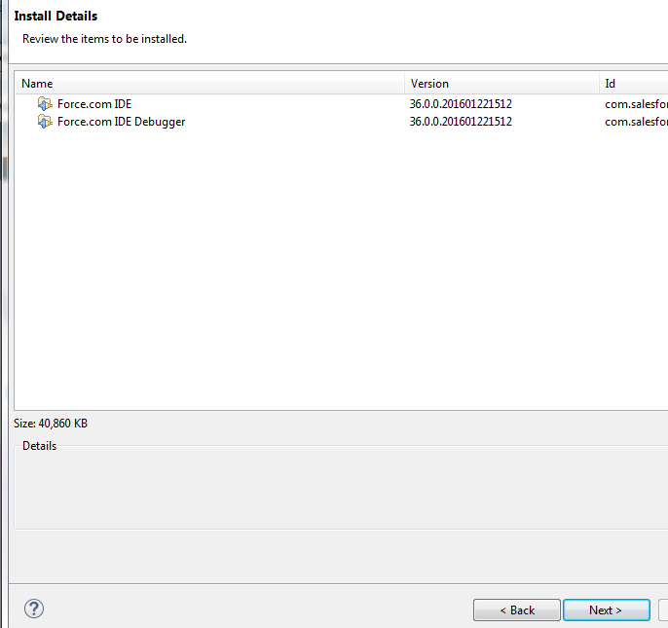

1. Accept the Agreement and click Finish

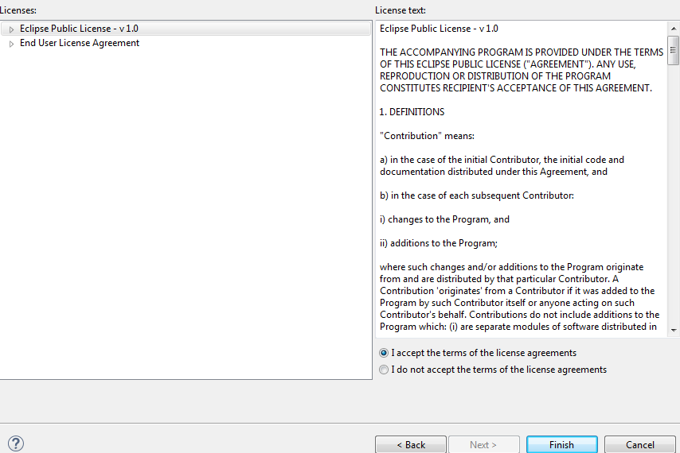

1. Change the perspective to force.com

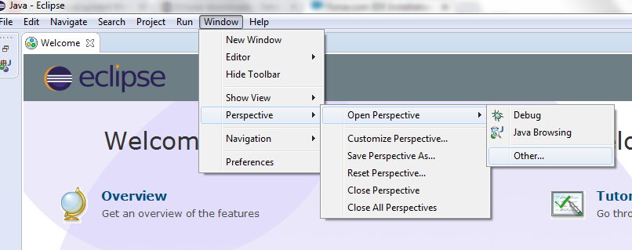

1. Select Other and select Force.com

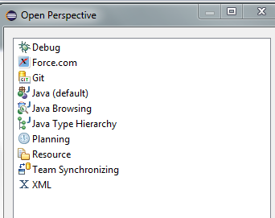

1. Eclipse will change to Force.com

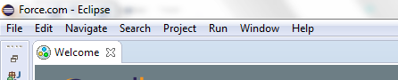

Loading the salesforce project from salesforce Account

1. Goto File
   1. New
      1. Force.com Project

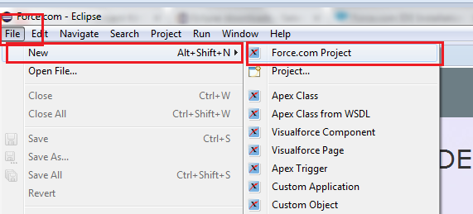

1. 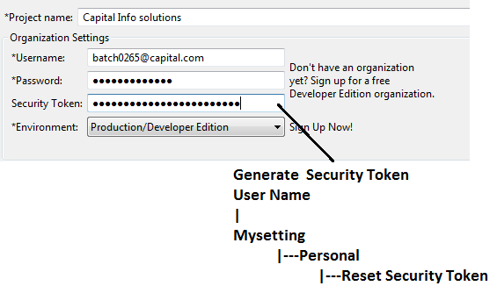

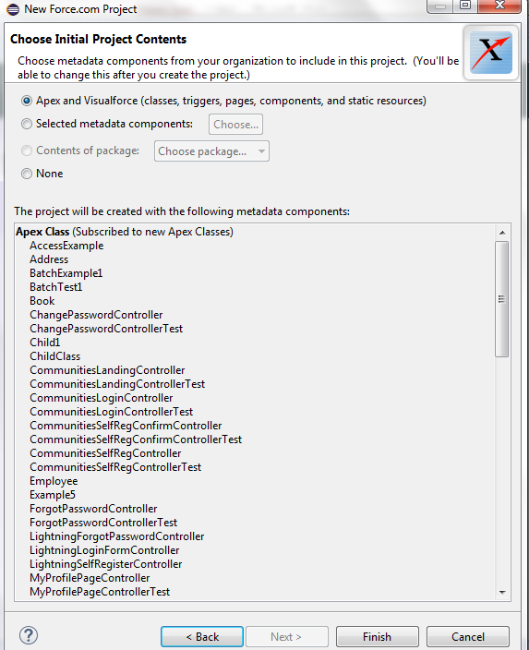

Click on finish

1. Enable the Online mode.

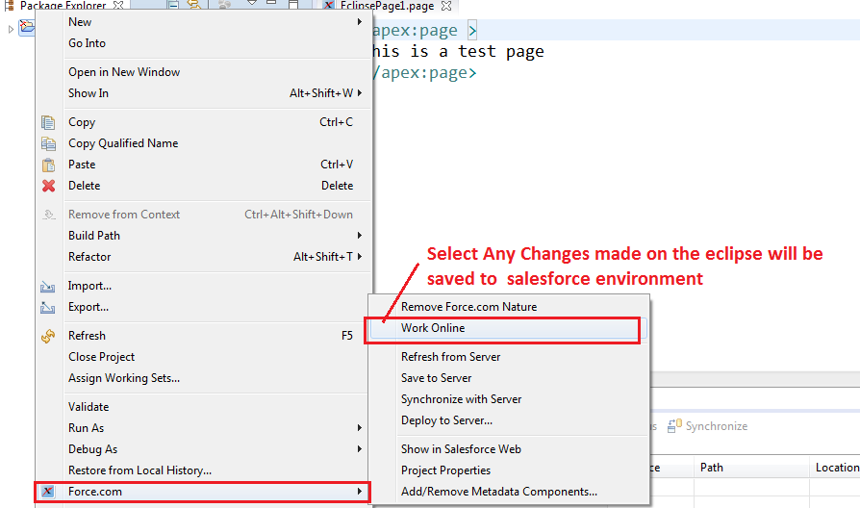

If you want to go with version controlling

1. Share the project with Team

Project Name

|-🡪Right Click

|-🡪 Force.com

|-🡪 Team Share

|-🡪 Share the Project

1. Add to index

Deployments

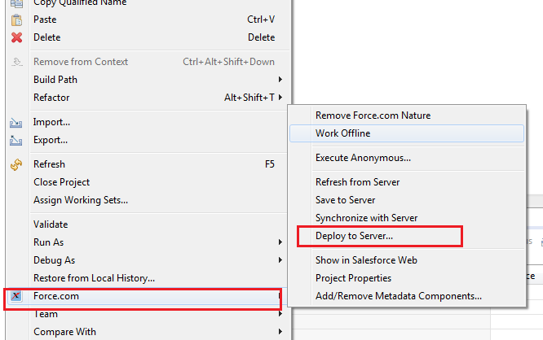

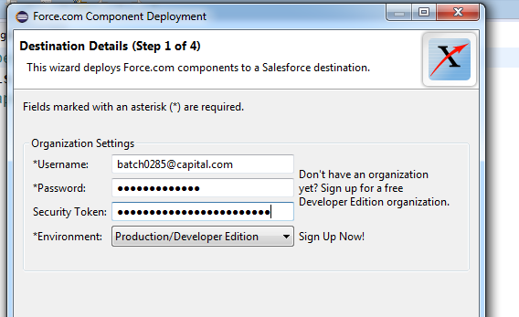

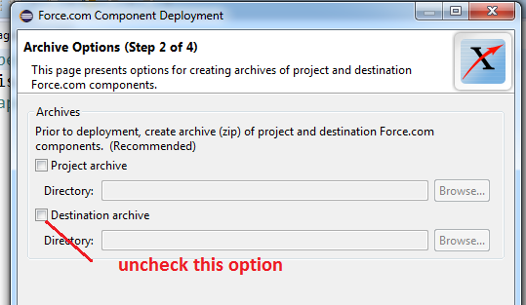

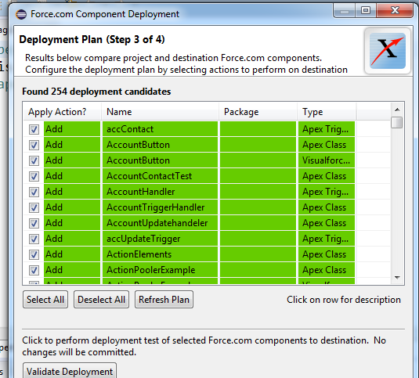

Select the components what you want to deploy and click on validate .

If validate is success then click on deploy.