**Project Report Template**

**Title of Project: Farmconnect**  
**Name of the Innovator:** **satish kumar R G   
Start Date:** **13-10-2025**

**End Date: 17-10-2025**

***Day 1: Empathise & Define***

*Step 1: Understanding the Need*

* Which problem am I trying to solve?

I’m solving the problem of Farmers who often struggle to find reliable buyers and fair prices for their produce, while buyers like retailers, wholesalers, or exporters find it difficult to source quality farm products directly from producers.

* Who is affected by this problem?
* How did I find out about this? [Select whichever is applicable]
* Interviews
* Observation
* Online Research
* AI Tools

*Step 2: What is the problem?*

Many farmers struggle to sell their produce at fair prices because they rely on middlemen.  
Buyers also find it hard to connect directly with reliable farmers for quality products.  
This gap leads to unfair pricing, wasted produce, and reduced profits for both sides.  
FarmConnect aims to bridge this gap by directly linking farmers and buyers.

Why is this problem important to solve?

This problem matters because it affects real people — farmers who work tirelessly yet earn too little for their efforts. By creating a fair, direct link between farmers and buyers, we can help farmers get the income they deserve and buyers get fresh, quality produce.  
It also reduces waste and builds trust in the food system, making it better for everyone.

**Take-home task**

Ask 2-3 people what they think about the project:

* **1. Farmer (From a Rural Area):**  
  "I love this idea! It would let me sell my crops directly and earn what I deserve, without losing money to middlemen."
* **2. Teacher (Career Guidance Teacher):**  
  "This project is impressive because it encourages entrepreneurship and problem-solving. It shows students how technology can create real impact, helping farmers while building a sustainable business model. It’s a great example of combining social good with career skills."
* **3. AGRI-student(From GKVK):**  
  "This project is great! It uses tech to help farmers earn more and makes the supply chain smarter."

*AI Tools you can use for Step 1 and 2:*

**AI Tools Used:**

**1. Meta MGX**

* **Used as a no-code development tool to design and deploy the FarmConnec**t**app.**
* **It helps create interactive workflows, user interfaces, and logic without programming.**
* **Ideal for building features like user registration, location-based data, and skill modules.**

**2. ChatGPT**

* **Used for idea generation, content structuring, and chatbot conversation design.**
* **Helped in framing the AI-powered virtual assistant’s responses for guiding farmers.**
* **Also useful for generating career recommendations, FAQs, and improving user interaction flow.**

**3. Chatbot References (Structure Design):  
To design the AI virtual assistant, you can take reference from:**

* **Google Dialogflow – for understanding intent detection and response flow.**
* **IBM Watson Assistant – for creating structured Q&A and personalized career guidance.**
* **Microsoft Bot Framework – for understanding conversation trees and user profile integration.**

***Day 2: Ideate***

*Step 3: Brainstorming solutions*

* List **at least 5 different solutions** (wild or realistic):
* **Virtual Farming Advisor** – An AI assistant that guides farmers on crop selection, pest control, and best practices based on local conditions.
* **Agri-Skill Learning Platform** – A website or app offering courses on modern farming techniques, organic farming, and sustainable agriculture.
* **Farmer-Buyer Meetups** – Organizing offline or online sessions where farmers can connect directly with buyers and wholesalers.
* **Crop Market Alerts App** – Sends notifications about current market prices, demand trends, and government support schemes.
* **Local Mentor Network** – Connects farmers with experienced agriculture experts or successful farmers in their area for guidance.
* **FarmConnect Hub** – A digital platform combining AI advice, skill modules, real-time market info, and direct buyer connections to empower farmers and improve profits.

*Step 4: My favourite solution:*

My favourite solution is **FarmConnect**, a complete digital platform designed to empower farmers. It combines an AI-powered virtual assistant for personalized farming guidance, skill development modules for modern agricultural techniques, and real-time connections to buyers, markets, and government schemes. Built using Meta MGX, the platform is easy to access, update, and use anytime, making it a long-term, practical, and impactful solution for improving farmers’ income and efficiency*.*

*Step 5: Why am I choosing this solution?*

I am choosing **FarmConnect** because it combines AI-powered farming guidance, skill development, and direct connections to buyers and markets in one platform. It is easy to use, accessible anytime, and designed to empower farmers to make better decisions, increase their income, and reduce waste.

*AI Tools you can use for Step 3-5:*

**AI Tools for Step 3–5**

1. **Meta MGX**
   * Design and build the **FarmConnect app** without coding.
   * Create the AI assistant, skill modules, and location-based features.
2. **ChatGPT**
   * Brainstorm solutions and generate ideas for farming guidance features.
   * Structure conversations for the AI virtual assistant.
   * Write content for skill modules, FAQs, and recommendations.
3. **AI Chatbot References (for design and flow)**
   * **Dialogflow** – Understands user intent and conversation flow.
   * **IBM Watson Assistant** – Designs structured Q&A for personalized guidance.
   * **Microsoft Bot Framework** – Connects user inputs with recommendations and actions.
4. **AI Research Tools**
   * **Google Scholar / Research AI** – Explore existing solutions and innovative ideas.
   * **AI Text & Summarization Tools** – Summarize solutions, select the best approach, and present clearly.
5. **AI Design Tools for Take-Home Task**
   * **Canva AI / CoPilot AI / Meta AI** – Generate images, mockups, or visual designs for your FarmConnect solution

***Day 3: Prototype & Test***

*Step 6: Prototype – Building my first version*

What will my solution look like?

* **Home Screen:** Greets farmers and asks simple details like age, farm size, location, and crops.
* **AI Farm Assistant:** A friendly chat tool that gives tips on crop care, weather, irrigation, pests, and government schemes.
* **Skill Development:** Quick, interactive modules on modern farming techniques, sustainability, and basic business skills.
* **Location-Based Help:** Shows nearby suppliers, equipment stores, buyers, and training centres on a map.
* **Farm Dashboard:** Tracks learning, crop progress, irrigation, and saved market opportunities, helping farmers make smarter decisions.

**Design Style:**

* **Simple and intuitive:** Easy navigation with clear icons and minimal text.
* **Bright and engaging:** Colorful visuals and friendly illustrations make learning fun.
* **Mobile-friendly:** Optimized for smartphones to ensure smooth access anytime, anywhere.

**Prototype Tools:**

* Built using **Meta MGX**, no coding required, with all features **interactive and testable**.

What AI tools will I need to build this?

**AI Tools Needed to Build farmconect**

**Meta MGX**

* A no-code platform used to design and launch the FarmConnect app.
* Helps create interactive screens, chat features, and dashboards easily — no coding required.

**ChatGPT (or similar AI models)**

* Powers the AI Farm Assistant that chats with farmers and answers their questions.
* Gives personalized tips on crops, irrigation, weather, and government schemes based on each farmer’s data.

**AI Chatbot Design Frameworks**

* Tools like **Google Dialogflow**, **IBM Watson Assistant**, or **Microsoft Bot Framework** help design natural and smooth conversations.
* Make sure the chatbot understands farmer queries and responds clearly, even in regional languages.

**AI Recommendation Systems (optional but useful)**

* Suggest the best crops to grow depending on soil, weather, and rainfall patterns.
* Recommend ideal irrigation schedules, fertilizers, and nearby markets for selling produce.

What AI tools I finally selected to build this solution?

1. **Chat GPT**
2. **Metamgx**

**< Build The Innovation>**

**<DASHBOAD OF THE TOOL>**

**Tool Link:**  **https://farmconnect.mgx.world/**

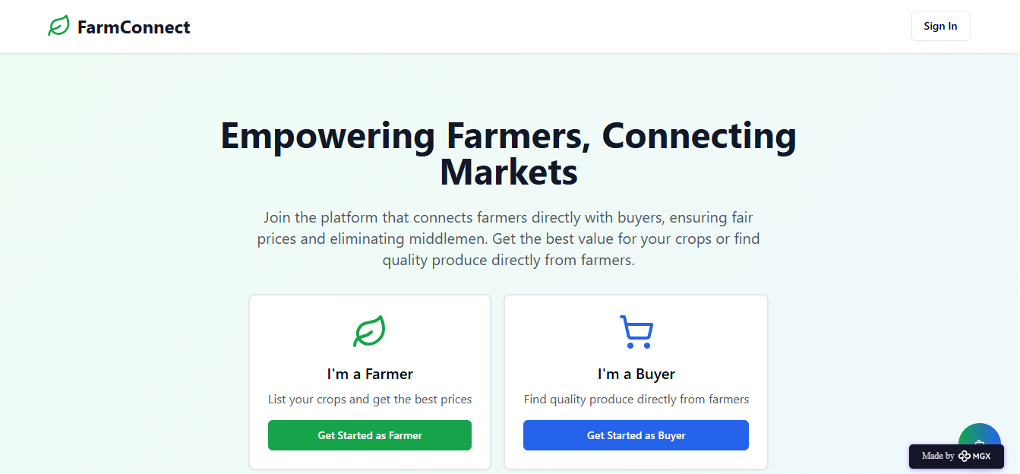

INTERNAL WORKING OF TOOL

Profile creation:

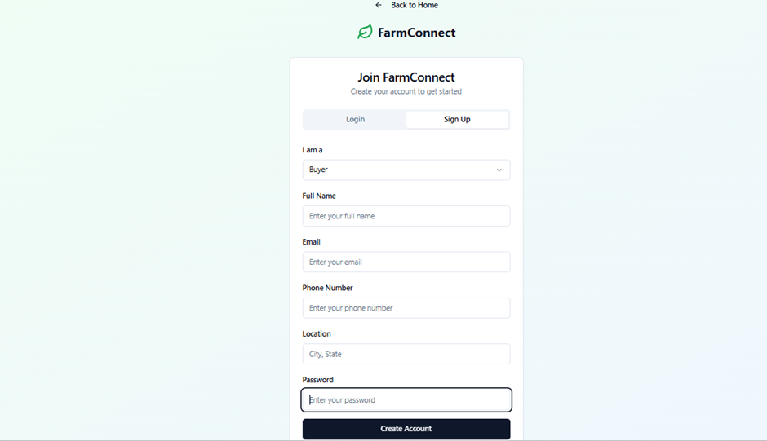

Tailoring recommendations using AI assistant:

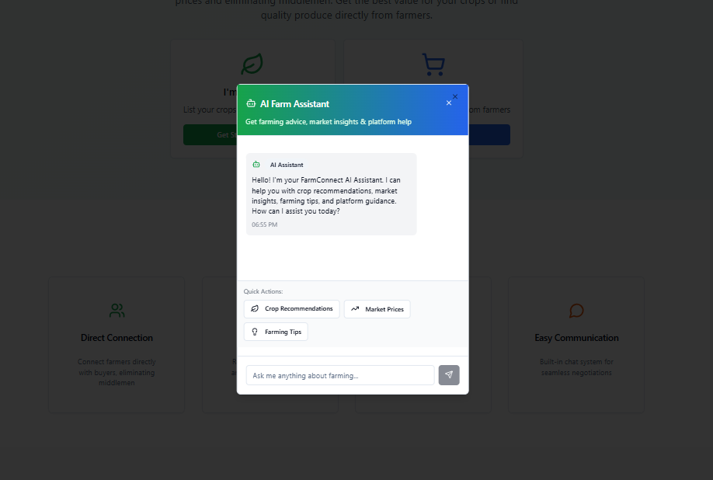

Recommendations based on Registered Profile:

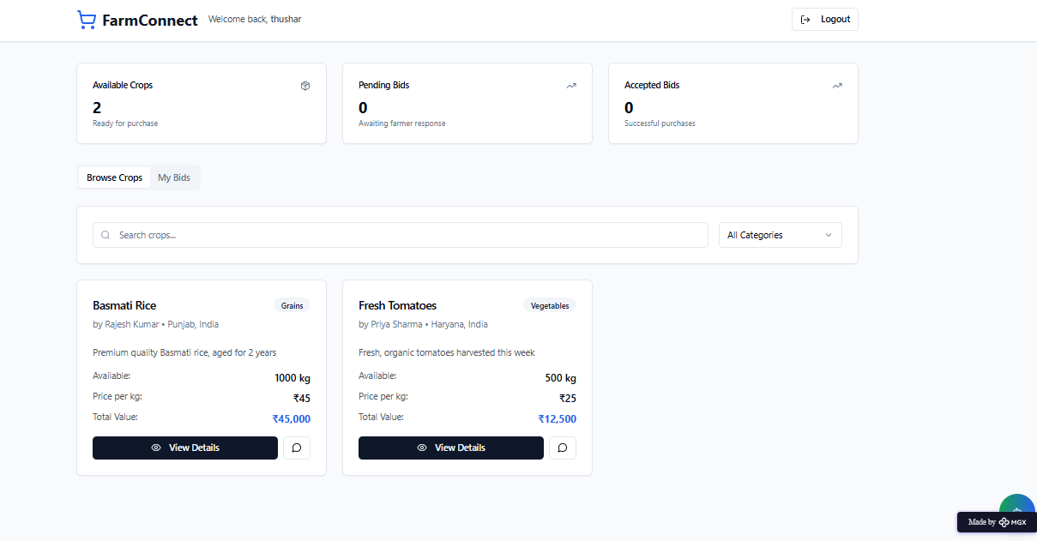

Recommendations based on Profile:

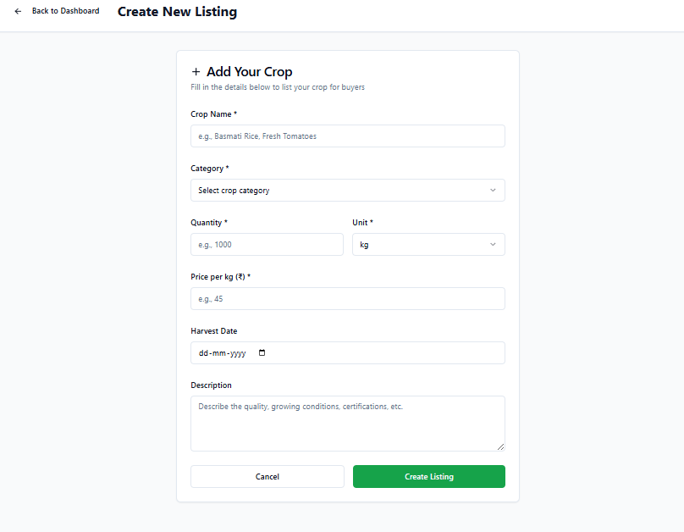

*Step 7: Test – Getting Feedback*

Who did I share my solution with?

I shared my **FarmerConnect** solution with:

* **Local farmers** – to understand if the platform is easy to use and truly helps them connect with buyers.
* **Agricultural officers and experts** – to gather insights on how well the app supports modern farming practices and market access.
* **Buyers and traders** – to check if the platform makes it easier to find and purchase quality produce directly from farmers.
* **Peers and mentors** – for feedback on improving the platform’s design, usability, and features for rural communities.

What feedback did I receive?

Feedback: Pros and Cons

Pros (Positive Insights from Feedback):

Farmers appreciated the platform for connecting directly with buyers, reducing dependency on middlemen.

1. The concept of a digital marketplace for agricultural produce was seen as highly useful and relevant.
2. Features like crop suggestions, market insights, and nearby opportunities were considered practical and valuable.

Cons (Areas for Improvement):

1. Some farmers found the interface slightly complex and suggested simpler navigation for first-time users.
2. Limited awareness of digital tools in rural areas could affect adoption.
3. Suggestions to include more localized information, like weather alerts, soil recommendations, and transport logistics.

**My Response for The Feedback:**  
FarmConnect is an idea created using a **no-code tool (Meta MGX)**. As it’s an initial prototype, the resources and integrations are limited. To fully integrate all features and access a wider range of career, scholarship, and skill-building resources, we would need **collaborations with different platforms and organizations**. The current limitations are due to the constraints of the prototype environment, but the concept demonstrates the **potential, usability, and impact** of the platform for farmers and people earning through agriculture.

👍 What works well:

**What Works Well for FarmConnect**

* **Lifetime Access:** Built on Meta MGX, the platform can be updated or modified anytime without subscription fees.
* **No-Code Management:** Farmers and admins can manage listings and profiles without technical skills.
* **Smart Recommendations:** AI tools suggest profitable crops, buyers, and nearby opportunities tailored to each farmer.
* **Market Insights:** Provides actionable information on crop demand, pricing trends, and local market conditions.
* **Location-Based Connections:** Helps farmers find nearby buyers, cooperatives, and training programs easily.
* **Mobile-Friendly and Intuitive:** Designed for easy navigation and smooth use on smartphones, even in rural areas.

🔧 What needs improvement:

* **AI Recommendations:** Some suggestions (e.g., crop or buyer matches) could be more accurate and context-aware.
* **Interactive Features:** Certain tools, like market analytics or logistics tracking, are limited or not fully functional in the current prototype.
* **Resource Integration:** More data on pricing trends, weather updates, and farming best practices could enhance usability.
* **Partnerships and Collaborations:** Linking with cooperatives, government schemes, and agricultural organizations would expand the platform’s value.

*AI Tools you can use for Step 6-7:*

**ChatGPT/Perplexity AI/Claude AI/Canva AI/Chatling AI/Figma AI/Metamgx/Gamma AI**: You can use these tools to build solutions/models or mock-up dummy prototypes

***Day 4: Showcase***

*Step 8: Presenting my Innovation:*I am presenting **FarmConnect**, a digital platform connecting farmers with buyers and market opportunities. It features:

* **AI-powered recommendations:** Suggests profitable crops, nearby buyers, and relevant opportunities based on farm data.
* **Market insights and analytics:** Provides information on pricing trends, demand, and crop performance.
* **Location-based connections:** Helps farmers find nearby cooperatives, training programs, and buyers easily.
* **User-friendly, mobile-first interface:** Built on Meta MGX with lifetime access, easy updates, and simple navigation for rural users.

**Impact:** FarmConnect empowers farmers to make informed decisions, increases access to markets, improves income potential, and bridges the gap between rural producers and buyers.

**<SHOWCASE YOUR INNOVATION TO YOUR PEERS>**

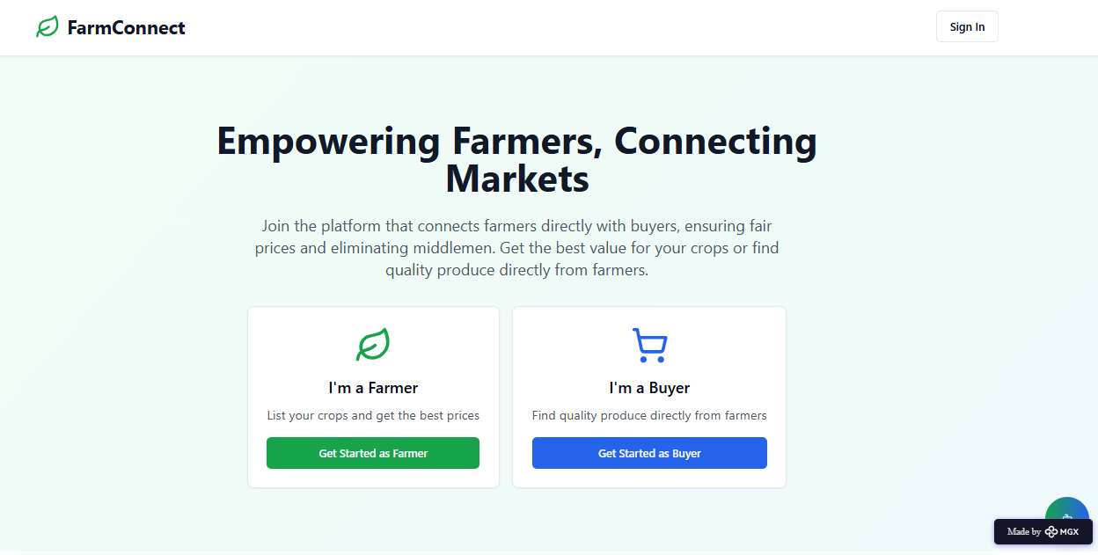

*Step 9: Reflections*

* What did I enjoy the most during this project-based learning activity?

I enjoyed creating **FarmConnect** using a no-code platform and seeing my idea come to life as an interactive solution. It was exciting to design features like AI-powered crop recommendations, market insights, and location-based buyer connections, and to imagine how the platform could help farmers improve their income and access opportunities more easily.

What was my biggest challenge during this project-based learning activity?

My biggest challenge was integrating all features seamlessly in the prototype using a no-code platform. It was particularly difficult to ensure that AI-powered crop recommendations, market insights, and location-based buyer connections worked together effectively within the limitations of available tools and resources.

**Take-home task**

[*https://github.com/satishnayak510-dev/FarmConnect-no-code-application*](https://github.com/satishnayak510-dev/FarmConnect-no-code-application)

*AI Tools you can use for Step 8:*

**Canva AI:** You can use this to design your pitch document. Download your pitch document as a PDF file and upload on GitHub