Data Analytics Capstone

Evaluating the Business Impact of Artificial Intelligence Adoption Across the Quality Engineering Lifecycle

Final Report

Satish Venugopal

Walsh College

QM640: Data Analytics Capstone

Mentor: Dr. Sanhita Karmakar

Summer 2026 Term

13-August-2026

GitHub Repository and Reproducibility Materials
Repository URL: https://github.com/satisho/QM640_Data-Analytics_Capstone
The repository provides the evaluator with the raw dataset, cleaned analytical datasets, final analysis notebook, supporting code, model outputs, figures, tables, and final report evidence. The active repository URL for this submission is shown above. The repository structure separates immutable raw data from processed data and generated artefacts so the complete analytical path can be reviewed and reproduced.
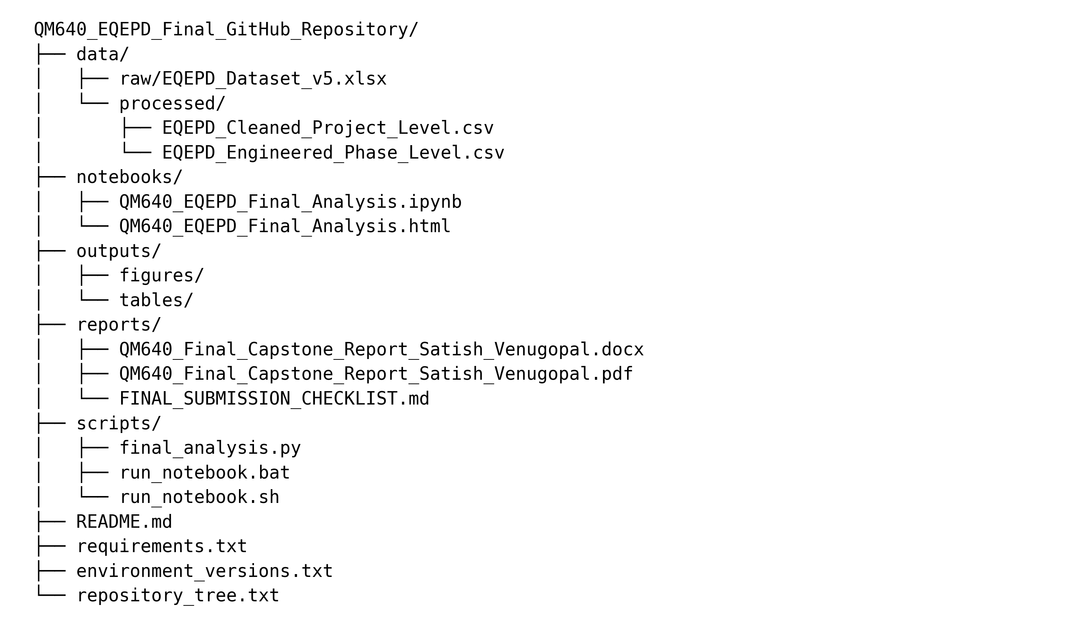

Figure 1: Final Repository Folder Structure
Note. The folder structure reflects the final capstone submission package, including final robustness outputs, the final notebook, environment metadata, and submission checklist.
Final repository paths are data/raw/EQEPD_Dataset_v5.xlsx for the immutable source workbook; data/processed/ for cleaned project-level and engineered phase-level datasets; notebooks/QM640_EQEPD_Final_Analysis.ipynb for the cumulative analysis; outputs/ for statistical, model, and figure evidence; and reports/ for the final DOCX/PDF and submission checklist.

Abstract
Artificial Intelligence (AI) is increasingly used across enterprise Quality Engineering (QE), yet leaders often lack comparable evidence showing where AI produces measurable productivity value and where conventional approaches remain more appropriate. This study evaluates the business impact of AI adoption across six QE lifecycle phases using the Enterprise Quality Engineering Performance Dataset (EQEPD). The final analytical approach combines descriptive analysis, non-parametric hypothesis testing, Welch sensitivity testing, effect-size estimation, sprint-clustered multiple regression, and supervised machine-learning regression. Deep-learning and agentic models were not required because the available data are structured operational measures rather than high-dimensional unstructured inputs.
The dataset contains 459 raw project/application/team sprint records from 2023-2026, 457 clean project records after duplicate removal, and 2,705 valid phase-level productivity observations, including 906 AI-assisted and 1,799 traditional observations. Analysis was implemented in Python using Pandas, NumPy, SciPy, Statsmodels, scikit-learn, Matplotlib, Jupyter, and CPU-based computation.
Four research questions examine overall AI productivity, variation by lifecycle phase, contextual drivers, and predictive usefulness. AI-assisted activities averaged 16.95% productivity improvement compared with -4.63% for traditional activities, a 21.58-percentage-point difference; the Mann-Whitney test was significant at p < .001 and Cohen's d was 1.16. Phase effects were also significant (Kruskal-Wallis H = 92.72, p < .001), with Regression Testing, Test Design, and Automation Development producing the strongest mean improvement and together accounting for approximately 94.5% of positive AI-assisted hours saved. The primary sprint-clustered regression associated AI use with a 16.69-percentage-point improvement after controls. The final Random Forest model achieved grouped holdout MAE = 5.69 percentage points, RMSE = 7.29, and R-squared = .405; grouped five-fold cross-validation produced mean R-squared = .471. Robustness checks preserved the main conclusions across outlier treatments, denominator thresholds, regression specifications, and repeated grouped splits.
The proposed implementation is a governed QE portfolio decision-support capability that helps leaders prioritise phases for AI scaling, controlled expansion, or targeted pilots while retaining human validation, quality acceptance criteria, model-error visibility, and explicit governance controls. The study therefore translates operational evidence into a practical adoption roadmap while clearly separating productivity association, predictive usefulness, causal evidence, and full financial return on investment.

Introduction

Background and Context
Artificial Intelligence (AI) is increasingly embedded in the software delivery lifecycle, where it is used to generate requirements-based tests, suggest test scenarios, create automation code, prioritise regression suites, classify defects, and support release decisions. Within enterprise Quality Engineering (QE), these capabilities are attractive because testing frequently consumes a substantial share of delivery effort and is often constrained by short release cycles, large regression inventories, and uneven access to specialised testing skills. The operational promise is straightforward: if AI can reduce the effort required to plan, design, automate, execute, and analyse tests without lowering quality, organisations may release software faster and redirect skilled engineers toward higher-value work. The management challenge is that this promise is often communicated through tool demonstrations or isolated pilots rather than through consistent project-level evidence.
The setting for this capstone is an enterprise QE portfolio represented by the Enterprise Quality Engineering Performance Dataset (EQEPD). The dataset records project, application, team, sprint, complexity, workload, AI-use, baseline-effort, and actual-effort information across six lifecycle phases: Test Planning, Test Design, Automation Development, Test Execution, Regression Testing, and Defect Management. The principal stakeholders are QE leaders who decide where to invest, delivery managers who plan effort and staffing, test architects who select suitable use cases, and project teams whose operating practices influence whether AI assistance produces sustainable value. For these stakeholders, a phase-level view is important because AI may create strong benefits in repetitive and information-intensive activities while producing smaller gains in activities that depend heavily on judgement, environment stability, or physical execution.
Prior research demonstrates that machine learning and large language models can support several testing activities, including test generation, test prioritisation, and test planning, but it also identifies reliability, maintainability, hallucination, and human-oversight concerns (Durelli et al., 2019; Haldar & Capretz, 2026; Wang et al., 2024). This makes empirical measurement essential. A credible adoption decision should distinguish observed effort reduction from perceived convenience, compare AI-assisted work with a meaningful traditional baseline, and account for project context. It should also avoid treating all lifecycle phases as equivalent, because the economics and risks of automating regression selection differ from those of generating a test strategy or deciding defect severity.
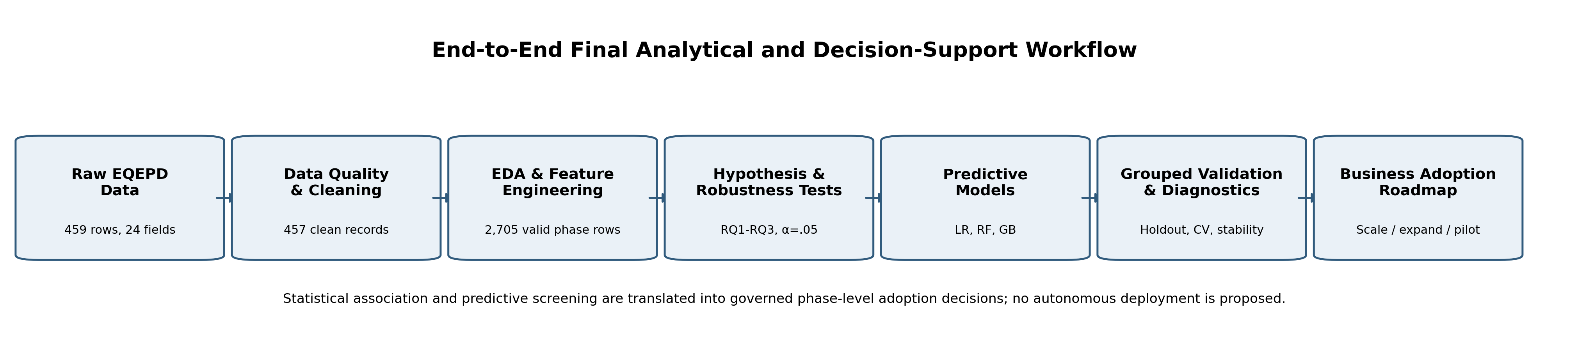
This final report presents the completed project as a standalone study. It retains the data preparation, exploratory analysis, statistical testing, and baseline modelling developed for the interim milestone and adds final robustness checks, predictive validation, implementation recommendations, user-benefit framing, and reproducibility packaging. A reader can therefore understand the problem, methods, evidence, conclusions, and operational boundaries without referring to the earlier report.

Figure 2: End-to-End Final Analytical and Decision-Support Workflow

Note. The workflow connects data preparation, explanatory analysis, robustness testing, predictive modelling, grouped validation, and a governed phase-based adoption roadmap.

Problem Statement
The objective of this study is to explain and predict Y = productivity improvement percentage for QE project/sprint and phase observations using X = AI usage, lifecycle phase, baseline effort, workload, complexity, application context, year, sprint, and engineered AI-adoption features over 2023-2026. Success is evaluated through statistical significance and effect sizes for explanatory questions and through MAE, RMSE, R-squared, grouped holdout performance, and grouped cross-validation for predictive usefulness. Organisations are investing in AI-enabled QE, but without this evidence they risk applying AI uniformly across phases with materially different economics, operational constraints, and governance needs.

Purpose of the Study
The purpose of the study is to explain and predict productivity improvement associated with AI adoption across the QE lifecycle. The explanatory component evaluates whether AI usage is associated with a statistically and practically meaningful reduction in effort and whether results differ by lifecycle phase. The predictive component compares supervised regression models that estimate overall project/sprint productivity improvement from project context, baseline workload, and AI-adoption features. The intended output is not an autonomous investment engine; it is an evidence-based decision-support framework that helps QE leaders identify stronger candidate phases, recognise uncertainty, and define the additional measures needed for a complete business case.

Final Project Status (Completion Snapshot)
Status | Work Items
Completed | Data profiling and cleaning; project- and phase-level feature engineering; EDA; RQ1-RQ3 hypothesis testing; sprint-clustered regression; predictive model comparison; final sensitivity and specification checks; repeated grouped validation; feature-importance stability; error diagnostics; business adoption roadmap.
Reproducibility | Raw and processed datasets, final analysis notebook, final analysis script, environment/version manifest, statistical tables, figures, and report evidence are included in the final package.
Submission-ready | Final standalone DOCX and PDF, active GitHub repository reference, APA-oriented bibliography, appendices, figure/table references, and final submission checklist are included.
Table 1: Final Project Status
Note. All analytical, robustness, reporting, and final packaging activities required for this submission have been completed.

Scope and Objectives

Research Problems Identified
- Measurement inconsistency. AI benefits are commonly described through time saved, productivity, quality improvement, or user perception, but these measures are not always defined consistently. This project uses baseline and actual effort to create a common phase-level productivity measure.
- Lifecycle heterogeneity. The suitability of AI differs across Test Planning, Test Design, Automation Development, Test Execution, Regression Testing, and Defect Management. A portfolio average can conceal phases that are ready to scale and phases that require controlled pilots.
- Context and confounding. Teams that adopt AI may also differ in application maturity, complexity, workload, leadership support, and delivery period. The analysis therefore examines project characteristics and uses regression controls rather than attributing every observed difference directly to AI.
- Decision-support uncertainty. Even when statistical relationships are strong, project-level prediction may remain imperfect. The study evaluates whether models are sufficiently accurate for directional prioritisation and explicitly defines the boundary between model support and managerial judgement.

Research Objectives
- Evaluate the relationship between AI adoption and productivity improvement across selected QE activities.
- Compare AI-assisted and traditional approaches using consistently calculated effort-based metrics.
- Identify the lifecycle phases that produce the highest mean improvement and cumulative effort savings.
- Determine which project and workload characteristics are associated with productivity improvement after statistical controls.
- Compare interpretable and nonlinear regression models using leakage-aware grouped validation.
- Translate final evidence into a phased adoption, governance, and measurement approach for enterprise QE decision-makers.

Research Questions and Hypotheses
Question | Research Focus | Null Hypothesis | Alternative Hypothesis
RQ1 | Does AI adoption significantly improve productivity across QE activities? | H₀₁: No significant difference between AI-assisted and traditional activities. | H₁₁: AI-assisted activities show significantly higher productivity improvement.
RQ2 | Does AI-generated business value differ across QE lifecycle phases? | H₀₂: Productivity improvement does not differ across phases. | H₁₂: One or more phases differ significantly.
RQ3 | Which project characteristics and QE factors influence productivity improvement? | H₀₃: No project or QE factor has a significant relationship with improvement. | H₁₃: One or more factors have a significant relationship.
RQ4 | Can machine-learning models predict productivity improvement and identify priority AI-adoption areas? | H₀₄: Models do not provide useful predictive or prioritisation value. | H₁₄: Models provide useful directional prediction and prioritisation.
Table 2: Research Questions and Hypotheses
Note. A 95% confidence level and significance threshold of α = .05 are used for the inferential analyses

Study Scope
The study includes anonymised project/application/team observations from 2023 through 2026 and covers six QE phases. It analyses binary AI-use indicators, project complexity, user-story volume, test-case volume, baseline effort, and actual effort. The primary definition of business value is effort reduction expressed as hours saved and percentage productivity improvement. Direct financial cost, licence cost, defect leakage, automation coverage, test coverage, AI tool identity, AI-assistance intensity, and human-review effort are not available in the current dataset. Consequently, the final findings should be interpreted as evidence about operational productivity rather than a complete return-on-investment calculation.

Contributions and Expected Value
Practical contribution. Establishes a consistent effort-based framework for comparing AI-assisted and traditional QE activities and for prioritising lifecycle phases using both percentage improvement and total hours saved.
Technical contribution. Combines robust non-parametric inference, sprint-clustered regression, leakage-aware grouped validation, interpretable baselines, nonlinear ensemble models, and repeated-split sensitivity checks in one reproducible analytical package.
Value to stakeholders. Gives QE leaders, delivery managers, test architects, and project teams evidence for deciding where to scale AI, where to expand cautiously, and where to retain targeted pilots while monitoring quality and risk.

Literature Review

Literature Review Approach
The literature review was designed to support all four research questions rather than provide a broad history of AI. Searches focused on peer-reviewed journal articles, conference papers, systematic reviews, and established statistical-learning references. Sources were identified through IEEE Xplore, SpringerLink, ScienceDirect, ACM-related indexes, and scholarly metadata services using combinations of the terms artificial intelligence, machine learning, large language models, software testing, quality engineering, test generation, regression testing, test prioritisation, productivity, Random Forest, Gradient Boosting, mean absolute error, and root mean square error. Priority was given to studies published from 2019 through 2026 for the domain review, with older foundational sources retained where they define widely used methods.
Inclusion criteria required a direct connection to software testing or QE, an empirical or structured-review method, clear findings relevant to productivity, test effectiveness, adoption risk, or model selection, and sufficient bibliographic information for APA 7 citation. Purely promotional tool descriptions, articles without identifiable methods, and studies focused only on testing AI systems rather than using AI to improve testing were excluded unless they offered a transferable governance insight. The final set combines domain evidence with methodological foundations so that model choice and evaluation decisions are linked to both the software-testing problem and accepted data-science practice.

Summary of Key Literature
Author (Year) | Domain/Context | Dataset/Setting | Method(s) | Key Findings | How It Supports RQ(s)/Decisions
Durelli et al. (2019) | Machine learning in software testing | Systematic mapping of peer-reviewed studies | Mapped ML techniques and testing activities | ML was concentrated in test generation, defect prediction, and related automation tasks; industrial evidence was less mature. | Supports the lifecycle framing and the need for operational evidence across RQ1–RQ3.
Wang et al. (2024) | Large language models in software testing | Survey of LLM-based testing research | Taxonomy and research landscape | LLMs can support test generation and related tasks, but reliability, evaluation, and human oversight remain central concerns. | Supports AI-use cases and the governed interpretation of RQ1, RQ2, and RQ4.
Haldar & Capretz (2026) | Automated test-plan generation | Three open-source web applications; five LLMs | Empirical generation and standards-based evaluation | Generated plans showed useful potential but variable quality; human validation remained necessary. | Explains why Test Planning may show lower or less stable gains and informs RQ2.
Ouédraogo et al. (2026) | LLM unit-test generation | 216,300 tests across Defects4J, SF110, and CMD | Large-scale comparison of four models and five prompting methods | Reasoning prompts improved structural quality, yet hallucination and compilation failures remained; hybrid validation was recommended. | Supports feature/use-case specificity and human review for RQ2 and RQ4.
Ardic et al. (2026) | Human–AI interaction in testing | Observational study with 12 students | Workflow observation and outcome assessment | Participants reported time savings and lower cognitive load, alongside trust, quality, and ownership concerns. | Provides a human-factors explanation for variation not captured by the dataset; relevant to RQ3.
Romero et al. (2026) | Test-case prioritisation | Evolving software builds and test histories | AutoML with grammar-guided genetic programming | Adaptive pipelines reduced the ML expertise required and adjusted to changes across builds. | Supports Regression Testing as a high-value AI area and motivates nonlinear models for RQ2/RQ4.
Yoo & Harman (2012) | Regression test optimisation | Survey of minimisation, selection, and prioritisation methods | Structured literature survey | Regression optimisation can reduce testing cost and improve early fault detection under time constraints. | Provides theoretical support for the strong Regression Testing results in RQ2.
Garousi et al. (2020) | Industry testing challenges | Empirical industry study | Practitioner evidence and challenge analysis | Testing outcomes depend on organisational, process, tooling, and skill constraints rather than technique alone. | Supports contextual controls and cautions against causal overstatement in RQ3.
Raharjana et al. (2025) | Deep learning in software testing | 737 Scopus-indexed publications | Bibliometric analysis | Research increased sharply after 2017, led by defect prediction, code analysis, and automated testing, with important gaps remaining. | Establishes the maturity and uneven coverage of the field for RQ1–RQ3.
Breiman (2001) | Random Forest methodology | General supervised-learning setting | Ensemble of decorrelated decision trees | Random Forests model nonlinear relationships and interactions while reducing the instability of individual trees. | Justifies a robust nonlinear model for RQ4.
Friedman (2001) | Gradient Boosting methodology | General regression and classification setting | Sequential additive modelling | Gradient boosting improves predictions by iteratively fitting residual error and can capture complex tabular patterns. | Justifies a second nonlinear benchmark for RQ4.
Willmott & Matsuura (2005) | Model error evaluation | Comparative discussion of error metrics | Analytical comparison of MAE and RMSE | MAE is directly interpretable as average error; RMSE gives greater weight to larger misses. | Supports reporting multiple complementary performance metrics for RQ4.
Table 3: Literature Relevance Matrix
Note. The matrix summarises 12 directly relevant sources. Additional statistical references are included in the bibliography and used in the methodology discussion.

Thematic Synthesis of the Literature

AI Value Is Activity-Specific
The literature consistently shows that “AI in testing” is not a single intervention. Durelli et al. (2019) mapped machine-learning applications across multiple activities, while Wang et al. (2024) documented a rapidly expanding landscape of large-language-model use cases. The strongest evidence tends to appear where historical data, repetitive decisions, or structured artefacts are available—for example, test generation, defect prediction, and regression prioritisation. This pattern supports the project’s decision to analyse six phases separately. A single portfolio average would be insufficient because the input artefacts, human judgement requirements, and cost of an incorrect output differ by phase. The literature therefore provides a conceptual basis for RQ2 and for reporting both percentage improvement and total effort saved rather than treating adoption as uniformly beneficial.

Productivity Gains Require Validation and Human Oversight
Recent empirical work on large language models provides a balanced view of productivity. Haldar and Capretz (2026) found that LLM-generated test plans could improve automation and efficiency, but plan quality varied and still required human validation. Ouédraogo et al. (2026) observed improved readability and structure under stronger prompting strategies, yet also reported persistent hallucination-related failures and high compilation-failure rates in some settings. Ardic et al. (2026) found perceived time-saving and cognitive-load benefits alongside concerns about trust, quality, and ownership. Together, these findings justify measuring effort reduction while preserving explicit governance boundaries. In this capstone, productivity improvement is not treated as proof that output quality is automatically acceptable; it is treated as one dimension of business value that must ultimately be combined with quality and risk measures.

Regression Testing Is a Strong Candidate for Data-Driven Optimisation
Regression Testing has an established history of algorithmic optimisation. Yoo and Harman (2012) showed that test minimisation, selection, and prioritisation address the cost and timing constraints of repeatedly executing large suites. Romero et al. (2026) extended this logic by demonstrating that automated machine learning can adapt test-prioritisation pipelines as software builds evolve. This evidence is directly pertinent to the EQEPD results because Regression Testing is both repetitive and historically measurable, making it well suited to data-driven selection and prioritisation. The literature does not guarantee that every regression context will achieve the same benefit, but it makes a higher final productivity result in this phase theoretically plausible and provides a rationale for prioritising it in the phase comparison.

Model Performance Must Be Interpretable in Operational Terms
The methodological literature supports comparing a transparent linear baseline with nonlinear ensemble models. Linear Regression provides coefficients that help explain direction and magnitude, while Random Forest and Gradient Boosting can represent interactions and nonlinear relationships that are common in project data (Breiman, 2001; Friedman, 2001; James et al., 2021). Reporting MAE, RMSE, and R² avoids relying on a single performance statistic. MAE communicates average error in percentage points, RMSE highlights occasional large misses, and R² describes the proportion of variation explained on unseen data (Willmott & Matsuura, 2005). This combination aligns the model evaluation with RQ4: the question is not merely which algorithm ranks first, but whether the resulting error is acceptable for directional portfolio screening and whether the model’s limitations are clearly disclosed.

Materials and Method

Data Source(s) and Access
The analysis uses the Enterprise Quality Engineering Performance Dataset (EQEPD), an anonymised and aggregated academic dataset prepared for this capstone (Venugopal, 2026). The dataset does not contain client names, employee identifiers, source code, production data, or personally identifiable information. The evaluator will access the source workbook and processed files through the GitHub repository identified on page 2. The raw workbook should remain unchanged in the data/raw directory, while cleaned and engineered outputs should be stored under data/processed so that transformations are transparent and reproducible.
The source is cited as an unpublished data set because it is project-specific rather than downloaded from a public statistical portal. The final repository URL on page 2 provides the source workbook, cleaned datasets, code, final model outputs, and report evidence so an evaluator can inspect the transformations independently of the narrative report.

Dataset Overview
Dataset Measure | Value
Raw records (rows) | 459
Raw variables (columns) | 24
Time period | 2023–2026
Unit of analysis | Project/application/team observation for a sprint
Exact duplicates identified | 2
Clean project/sprint observations | 457
Potential phase observations | 2,742 (457 × 6 phases)
Valid phase productivity observations | 2,705
AI-assisted valid phase observations | 906
Traditional valid phase observations | 1,799
Applications after standardisation | 8
Teams after standardisation | 8
Primary phase target | Productivity Improvement % = (Baseline − Actual) / Baseline × 100
Primary project target | Overall Productivity Improvement % based on total baseline and actual effort
Table 4: Dataset Overview

Note. Counts are based on the supplied analytical package. A phase observation is valid only when baseline and actual effort allow the productivity target to be calculated.

Each raw record contains six AI-use indicators, six baseline-effort fields, and six actual-effort fields in addition to project context. The wide raw structure is appropriate for operational data capture, but statistical comparison across phases is easier in a long phase-level structure. The transformation therefore creates one row per project/sprint/phase combination and carries the relevant AI flag, baseline effort, actual effort, and context variables into that row. This produces up to 2,742 phase observations before excluding cases where the productivity outcome cannot be calculated.
The phase-level target expresses the percentage by which actual effort is below or above baseline. Positive values indicate effort reduction, zero indicates performance exactly at baseline, and negative values indicate that actual effort exceeded the baseline. For example, a baseline of 20 hours and actual effort of 16 hours produces (20 − 16) / 20 × 100 = 20% productivity improvement. A baseline of 20 hours and actual effort of 22 hours produces −10%, indicating an overrun. The project-level target aggregates effort across all six phases before calculating the percentage, preventing a small phase from receiving the same weight as a large phase.

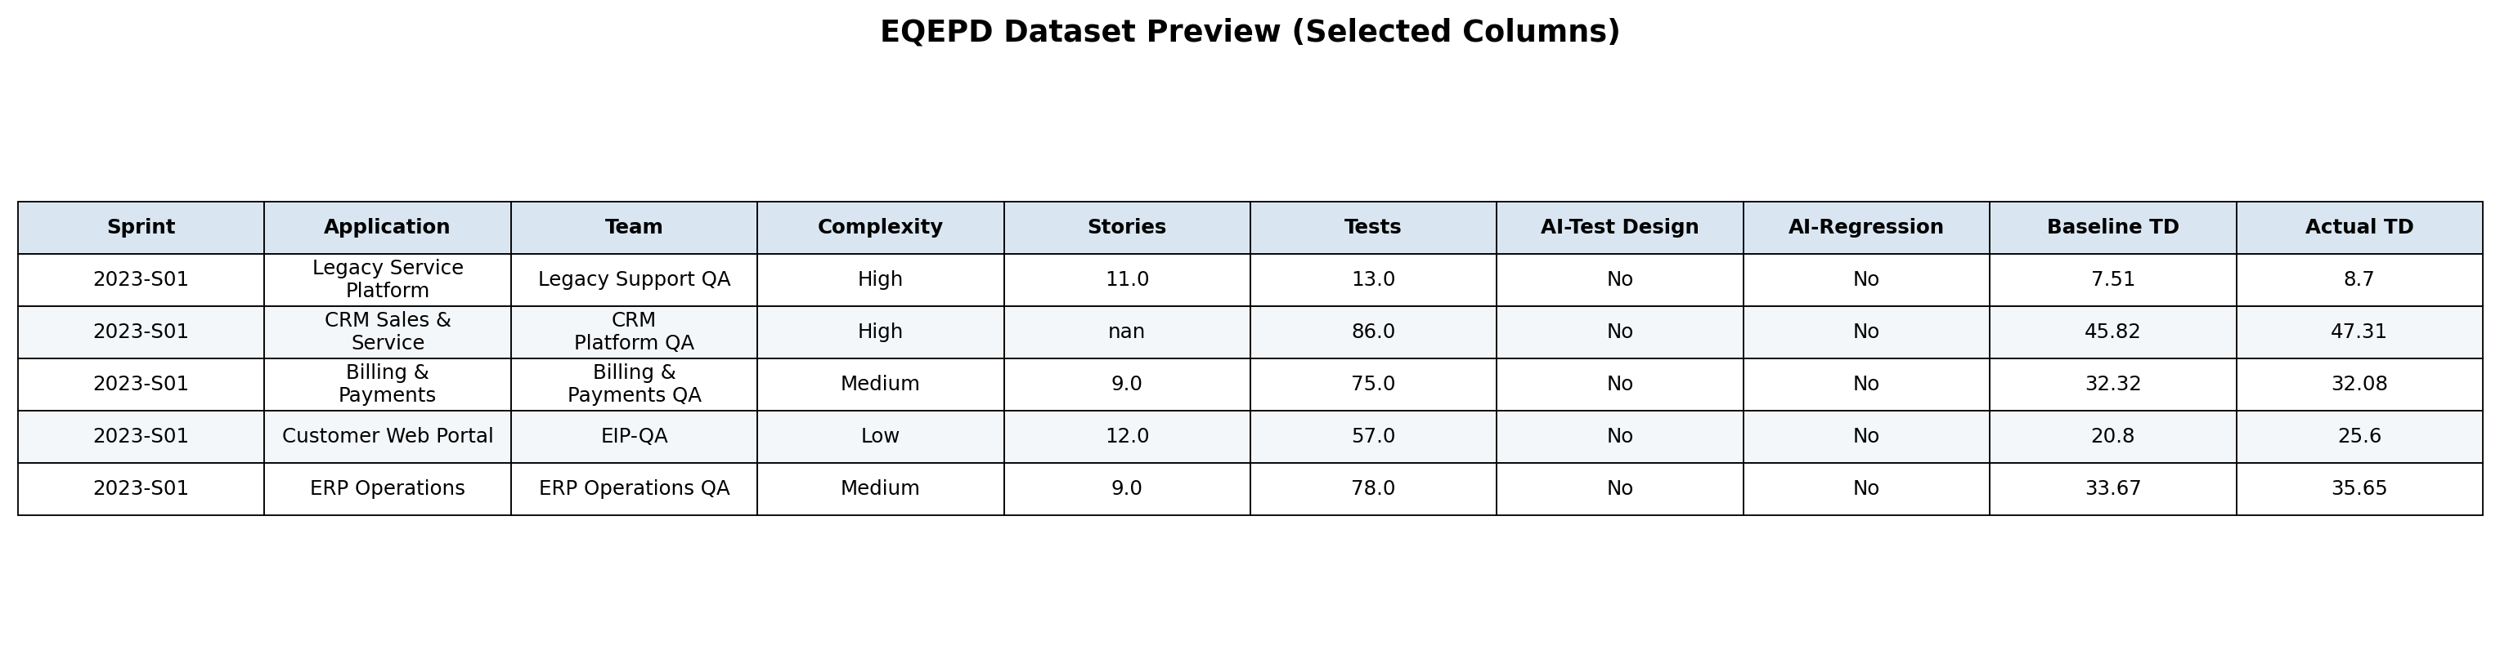

Figure 3: EQEPD Dataset Preview

Note. Selected columns from the first five records are displayed for readability. The complete 24-column source workbook is to be made available in the GitHub repository.

Data Dictionary (Summary)
Variable Name | Definition | Datatype | Allowed Values/Range | Missing Values Handling | Notes
Sprint # | Delivery period identifier; source of year and sprint-number features | Text | YYYY-Snn | Not imputed | Grouping variable for validation
Application_Name | Anonymised application/platform category | Categorical | Standardized to 8 applications | Mode not used; category retained | One-hot encoded for models
Team_Name | Anonymised QE team category | Categorical | Standardised to 8 teams | Category retained | Potential organisational context
Complexity | Assessed project complexity | Ordinal category | Low, Medium, High | Standardised aliases | One-hot encoded
User story count | User stories in the observation | Numeric count | Non-negative | Median imputation | Workload proxy
test case count | Test cases in the observation | Numeric count | Non-negative | Median imputation | Testing-intensity proxy
AI Usage Testing Phase (…) | AI use in each of six phases | Binary category | Yes/No | Standardised variants | Converted to 1/0 flags
Baseline effort (…) | Expected effort hours for each phase | Numeric continuous | Greater than 0 for target calculation | Not imputed for outcomes | Primary denominator
Actual effort (…) | Observed effort hours for each phase | Numeric continuous | Non-negative | Not imputed for outcomes | Primary observed effort
QE_Phase | Lifecycle phase in long dataset | Categorical | Six named phases | Derived | Used in phase comparison
Effort_Saved | Baseline effort minus actual effort | Numeric continuous | Positive or negative | Derived only when both efforts valid | Absolute operational benefit
Productivity_Improvement_Pct | Relative phase effort reduction | Numeric continuous | Unbounded in raw calculation | No imputation; winsorised only for modelling | Primary RQ1–RQ3 outcome
AI_Phase_Count | Number of phases using AI | Integer | 0–6 | Derived | Adoption breadth
AI_Adoption_Rate | AI_Phase_Count divided by 6 | Numeric proportion | 0–1 | Derived | Normalised adoption breadth
Overall_Productivity_Improvement_Pct | Aggregate project/sprint effort reduction | Numeric continuous | Unbounded in raw calculation | Winsorised at 1st/99th percentiles for modelling | RQ4 target
AI_Exposure by Phase | AI flag multiplied by phase baseline share | Numeric proportion | 0–1 | Derived | Workload-weighted AI use
Table 5: Data Dictionary Summary
Note. The complete field-level dictionary, including all six baseline, actual-effort, and AI-use fields, is provided in Appendix B.

GitHub Data Availability Statement
The raw and processed datasets are included in the GitHub repository under the following paths:
- Raw data: data/raw/EQEPD_Dataset_v5.xlsx;
- processed project data: data/processed/EQEPD_Cleaned_Project_Level.csv;
- processed phase data: data/processed/EQEPD_Engineered_Phase_Level.csv;
- code and notebooks: notebooks/QM640_EQEPD_Final_Analysis.ipynb and scripts/final_analysis.py;
- model outputs: outputs/.
The final package includes a README, requirements file, and environment version manifest documenting Python/package versions, execution order, target definitions, and confidentiality constraints. The repository URL shown on page 2 is the reference location for submission and reproducibility materials.

System Overview and Architecture
The final analytical system is a reproducible decision-support pipeline. Raw EQEPD data are ingested from Excel, profiled and cleaned, reshaped into project- and phase-level analytical datasets, explored for trends and distributional behaviour, tested against four research questions, and then passed to supervised regression models. As shown in Figure 2, grouped validation and diagnostic checks sit between modelling and the business adoption roadmap so that model output is not treated as a direct automated decision.

Workflow Components
Data ingestion - The source workbook is read from data/raw/EQEPD_Dataset_v5.xlsx; immutable raw data are separated from processed outputs.
Data preprocessing- Exact duplicates are removed, category aliases are standardised, contextual counts are median-imputed, and effort values used to construct outcomes are not imputed.
Exploratory data analysis - Adoption trends, phase adoption, productivity distributions, effort savings, AI breadth, and correlations are reviewed before hypothesis testing and modelling.
Feature engineering - Phase-level productivity, effort saved, AI flags, AI Phase Count, baseline shares, AI exposure, year/sprint, and workload ratios are derived without using actual-effort or outcome-derived predictors in the predictive feature set.
Model development and evaluation - Linear Regression, Random Forest, and Gradient Boosting are compared using sprint-grouped holdout data, grouped five-fold cross-validation, repeated grouped splits, MAE, RMSE, and R-squared.
Decision-support output - Statistical evidence, model diagnostics, phase-level productivity, and total hours saved are translated into scale-now, controlled-expansion, and targeted-pilot implementation tiers.

Minimum Sample Size and Power Analysis
A conservative planning check used a two-sample comparison approximation with effect size d = 0.30, alpha = .05, power = .80, and an approximately 2:1 traditional-to-AI allocation. The resulting minimum was 132 AI-assisted and 264 traditional observations (396 total). The final phase-level sample contains 906 AI-assisted and 1,799 traditional observations, substantially exceeding this planning threshold. Because the primary RQ1 test is non-parametric, this calculation is used as an approximate adequacy check rather than as a claim that every phase-specific subgroup is equally powered.
Assumption | Value
Assumed standardized effect size | d = 0.30
Significance / power | alpha = .05 / power = .80
Allocation | Traditional:AI = 2:1
Minimum required | 132 AI + 264 traditional = 396
Observed | 906 AI + 1,799 traditional = 2,705
Table 6: Minimum Sample Size / Power Adequacy Check
Note. The power calculation is a planning approximation for the primary two-group comparison; inference in the report uses the tests specified for each research question.

Tools and Technologies
Tool & Technology | Purpose
Python 3.13.5 | Analysis execution and automation.
Pandas 2.2.3 and NumPy 2.3.5 | Data preparation and feature engineering.
SciPy 1.17.0 and Statsmodels 0.14.6 | Hypothesis testing, effect sizes, regression, and cluster-robust inference.
Scikit-learn 1.8.0 | Preprocessing pipelines, grouped validation, Linear Regression, Random Forest, Gradient Boosting, and permutation importance
Matplotlib 3.10.8 | EDA, model-comparison, diagnostic, and business-value figures
Jupyter/nbconvert | Analytical documentation

CPU-based computation was sufficient for this structured tabular dataset. Deep-learning and agentic models were not used because they were not necessary to answer the four research questions.

Data Preparation, EDA, and Statistical Methods

Data Cleaning
Data cleaning was deliberately conservative so that the analysis would not remove operationally difficult cases merely because they were unusual. The raw workbook contained 459 records and 24 variables. Two rows were exact duplicates and were removed, leaving 457 project/sprint observations. Near-duplicate rows were not automatically discarded because repeated application/team/sprint combinations can represent legitimate records. The duplicate rule was therefore exact equality across all columns, which is reproducible and avoids subjective deletion.
Missingness was limited and dispersed. User story count had the highest missing count at six records (1.31%). Five values were missing in actual Regression Testing effort, five in actual Automation Development effort, four in actual Test Design effort, and four in baseline Automation Development effort; other affected fields had between two and three missing values. Contextual count variables were median-imputed because they are predictors rather than outcomes and because median imputation is less sensitive to skew. Baseline and actual effort were not imputed for productivity calculations. Imputing these fields would manufacture the dependent variable and could create artificial evidence of improvement. Instead, only the affected phase observation was excluded when the target could not be computed.
Categorical inconsistencies were standardised before grouping. Application labels were consolidated from 15 raw variants to 8 standardised applications, and team labels were reduced from 13 variants to 8 teams. AI-use entries such as Yes, YES, Y, yes, No, NO, N, and no were mapped to consistent Yes/No values. Complexity abbreviations and case variants were mapped to Low, Medium, and High. Year and sprint number were parsed from Sprint # to support trend analysis and grouped validation. These transformations were documented rather than applied silently so that an evaluator can compare raw and cleaned categories.
Potential outliers were reviewed rather than removed. The phase-level productivity distribution produced 86 observations outside the conventional 1.5 interquartile-range bounds, with approximate bounds of −41.00% and 48.25%. Such values may represent genuine overruns, unusually successful automation, small denominators, or data-entry issues. They were retained for descriptive and non-parametric hypothesis testing because excluding them could suppress legitimate operational variability. For predictive modelling only, the project-level target was winsorised at the 1st and 99th percentiles to reduce the influence of extreme outcomes on model stability while preserving the records.
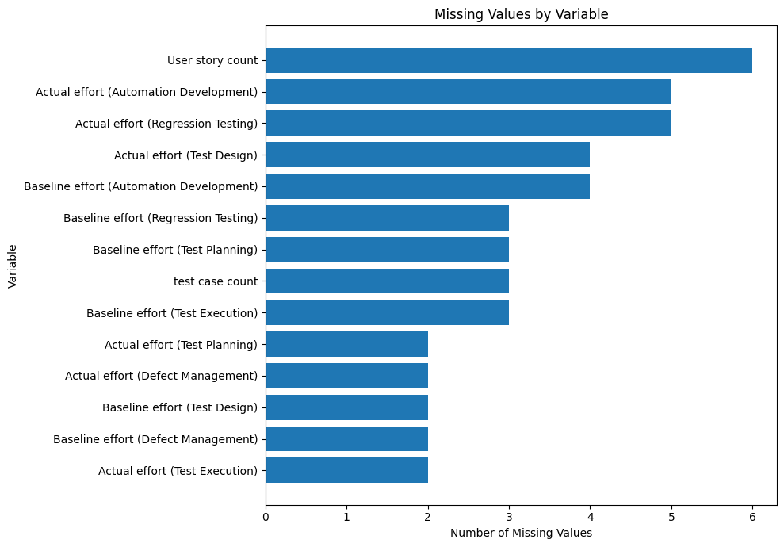
Figure 4: Missing Values by Variable

Note. Missingness was below 1.31% for every variable. Context counts were median-imputed, while effort fields were not imputed for outcome calculation.
Issue | Variables Affected | Detection Method | Treatment Applied | Rationale
Missing values | User story count, test case count, selected baseline/actual effort fields | Null counts and percentages | Median-impute contextual counts; do not impute effort outcomes; exclude only invalid phase target | Preserves predictor coverage without creating artificial productivity values
Exact duplicates | All 24 raw columns | Full-row equality check | Remove 2 exact duplicates | Avoids double-counting while retaining legitimate repeated contexts
Application aliases | Application_Name | Unique-value and frequency review | Consolidate 15 raw labels to 8 applications | Prevents fragmented group statistics
Team aliases | Team_Name | Unique-value and frequency review | Consolidate 13 raw labels to 8 teams | Creates consistent organisational categories
AI label variants | Six AI-use variables | Value-frequency review | Map Yes/YES/Y and No/NO/N variants to Yes/No | Required for valid binary comparison
Complexity variants | Complexity | Unique-value review | Map abbreviations and case variants to Low/Medium/High | Supports interpretable grouping and modelling
Outliers | Productivity improvement targets | Histogram, boxplot, IQR rule | Retain for EDA and hypothesis tests; winsorise project target only for models | Balances operational realism and model stability
Target leakage | Actual effort and derived outcome fields | Feature lineage review | Exclude actual effort, effort saved, and outcome-derived fields from predictive features | Prevents future information from inflating RQ4 performance

Table 7: Data Cleaning Log

Exploratory Data Analysis Results

AI Adoption Trend
AI adoption increased materially over the four-year period. The proportion of phase observations marked as AI-assisted rose from 7.17% in 2023 to 20.66% in 2024, 42.67% in 2025, and 64.20% in 2026. Figure 5 therefore describes a staged adoption journey rather than a single transition. This matters for interpretation because later observations may also reflect improved tooling, user familiarity, process maturity, or portfolio selection. Year and sprint variables are retained in the influence model to reduce the risk that the AI coefficient merely captures a time trend.
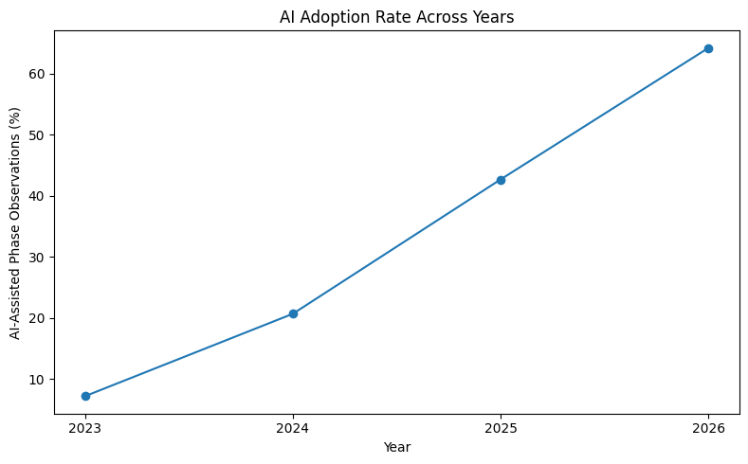
Figure 5: AI Adoption Rate Across Years

Note. The adoption rate is the percentage of phase observations with AI_Used = Yes in each year.

Adoption by QE Lifecycle Phase
Adoption was uneven across the lifecycle, as shown in Figure 6. Test Design had the highest AI-use rate at 66.08%, followed by Automation Development at 54.27% and Regression Testing at 38.29%. Defect Management was 24.95%, Test Planning was 13.13%, and Test Execution was only 6.13%. This distribution is operationally meaningful: phases with more structured digital artefacts and reusable patterns appear to have adopted AI earlier, whereas activities tied to environments, execution dependencies, and high-consequence judgement show lower penetration. The phase differences also mean that raw totals alone cannot be used to infer value; both adoption volume and phase-level improvement must be examined.
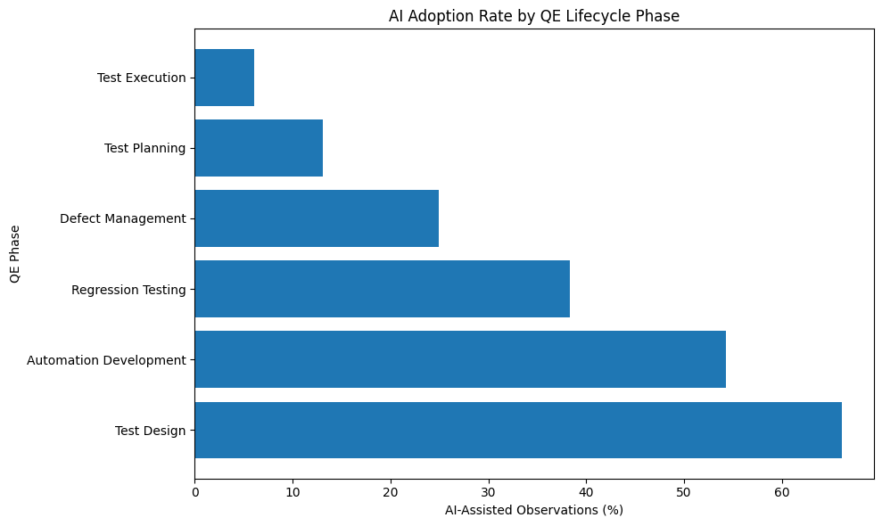
Figure 6: AI Adoption Rate by QE Lifecycle Phase

Note. Test Design and Automation Development account for the highest adoption rates, while Test Execution remains the least adopted phase.

AI-Assisted Versus Traditional Productivity
The central exploratory comparison shows a substantial gap between AI-assisted and traditional work. Across 906 valid AI-assisted phase observations, mean productivity improvement was 16.95% and median improvement was 20.26%. Across 1,799 traditional observations, mean improvement was −4.63% and median improvement was −2.71%. The AI-assisted group saved 4,417.6 hours in aggregate, whereas traditional observations exceeded baseline effort by 1,184.1 hours. Figure 7 shows that the distributions overlap, so AI does not guarantee a positive outcome in every case, but the centre of the AI-assisted distribution is clearly higher. The gap is later tested formally under RQ1.

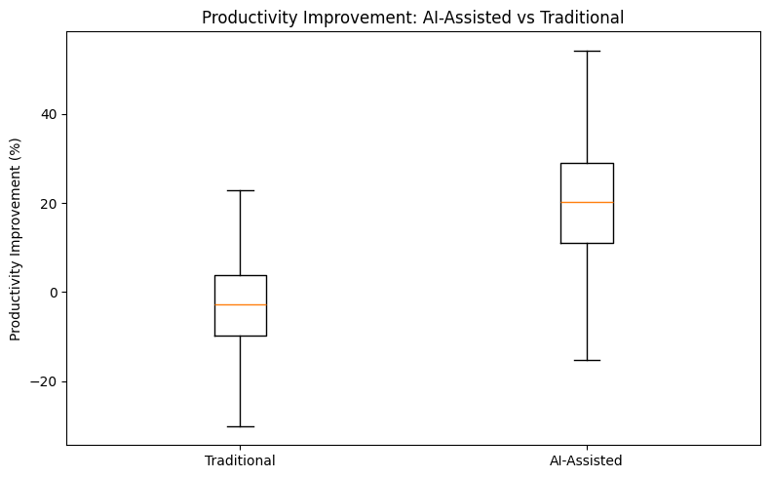
Figure 7: Productivity Improvement for AI-Assisted and Traditional Activities

Note. The boxplot suppresses extreme points for visual clarity; all valid observations remain in the statistical analysis.

Productivity and Business Value by Phase
Phase-level analysis indicates that AI value is not uniform. Regression Testing produced the highest mean improvement at 22.23%, followed by Test Design at 19.92% and Automation Development at 16.62%. Defect Management averaged 10.27%, Test Planning 6.46%, and Test Execution 3.93%. Cumulative effort savings tell a complementary story: Test Design saved approximately 1,857.6 hours and Automation Development 1,420.2 hours because they combine substantial improvement with larger adoption volume. Regression Testing saved 896.6 hours despite fewer AI-assisted observations. Figure 8 therefore supports a two-dimensional prioritisation approach: percentage improvement indicates efficiency, while total hours saved indicates portfolio-scale impact.
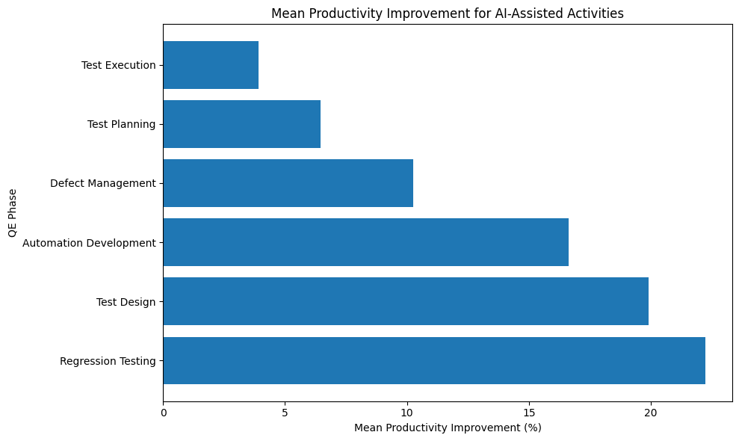
Figure 8: Mean Productivity Improvement for AI-Assisted Activities by Phase

Note. Regression Testing has the highest mean percentage improvement; Test Design and Automation Development also demonstrate strong final value.

Breadth of AI Adoption
Overall project/sprint productivity increased as AI was used across more lifecycle phases. Records with no AI averaged −4.62% overall productivity, while projects using AI in one, two, three, and four phases averaged 0.98%, 6.89%, 9.73%, and 12.97%, respectively. Projects with five phases averaged 16.93%, and the small group with all six phases averaged 18.47%. Figure 9 suggests that adoption breadth is a useful portfolio signal, but it should not be read as causal proof that adding AI to every phase automatically creates improvement. More mature teams may both adopt AI broadly and manage delivery more effectively. This is why AI Phase Count is treated as a predictive feature and the final recommendations retain phase-specific governance.
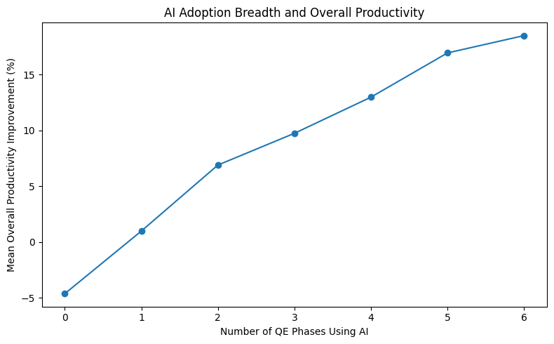
Figure 9: Relationship Between AI Adoption Breadth and Overall Productivity

Note. The six-phase group contains only seven records, so its mean is less stable than estimates for larger groups.
Figure/Table Reference | What It Shows | Key Insight | Why It Matters | Decision/Next Step
Figure 5 | AI adoption by year | Adoption rose from 7.17% in 2023 to 64.20% in 2026 | Time trend may influence RQ1/RQ3 | Retain year and sprint controls
Figure 6 | Adoption by phase | Test Design and Automation Development lead; Test Execution lags | Supports phase-specific RQ2 analysis | Avoid uniform rollout assumptions
Figure 7 | AI vs traditional productivity | AI group centre is materially higher than traditional | Direct preliminary evidence for RQ1 | Use Mann–Whitney and effect sizes
Figure 8 | AI productivity by phase | Regression Testing, Test Design, and Automation Development lead | Identifies likely priority areas for RQ2 | Run Kruskal–Wallis and post-hoc tests
Figure 9 | AI breadth and overall productivity | Wider adoption is associated with stronger overall results | Provides candidate feature for RQ4 | Include AI Phase Count and exposure features
Table 8: EDA Insight Summary

Model Development and Evaluation

Choice of Models With Justification
The modelling stage addresses two distinct analytical needs. First, a multiple linear regression at the phase level is used to estimate the relationship between AI usage and productivity while controlling for phase, application, complexity, baseline effort, workload, year, and sprint. Cluster-robust standard errors are calculated by sprint because six phase observations can originate from the same project/sprint record. This model is primarily explanatory: the AI coefficient can be interpreted in percentage points after other included factors are held constant.
Second, three supervised regression algorithms are compared at the project/sprint level for RQ4. Linear Regression is included as an interpretable baseline and to test whether the relationship is approximately additive. Random Forest Regression is included because project outcomes may depend on nonlinear thresholds and interactions among AI breadth, baseline workload, phase allocation, complexity, and application context. Gradient Boosting Regression is included because sequentially correcting residual errors often performs well on structured tabular data. Comparing these models provides a more defensible result than reporting only the highest-performing algorithm.
The validation design is intentionally grouped by sprint. An 80/20 holdout split assigns complete sprint groups to either training or test data so that records from the same delivery period do not appear on both sides. Grouped five-fold cross-validation is then used to assess stability. This is stricter than a random row split and reduces information leakage caused by shared timing, organisational context, or portfolio conditions. The target is winsorised only in the predictive dataset at the 1st and 99th percentiles; actual effort and all variables derived from actual outcomes are excluded from the feature set.

Features Included and Feature Engineering
Feature | Original/Engineered | Type | Reason for Inclusion | Used in Model(s)
Application_Name | Original | Categorical | Captures platform/context differences | All predictive models
Team_Name | Original | Categorical | Captures organisational context; reviewed for potential overfitting | All predictive models
Complexity | Original | Categorical | Represents assessed delivery difficulty | All predictive models
User story count | Original | Numeric | Workload size proxy | All predictive models
test case count | Original | Numeric | Testing volume/intensity proxy | All predictive models
Baseline effort by phase | Original | Numeric | Expected workload distribution | All predictive models
Total_Baseline_Effort | Engineered | Numeric | Overall project effort scale | All predictive models
AI indicator by phase | Original recoded | Binary | Identifies where AI is applied | All predictive models
AI_Phase_Count | Engineered | Integer 0–6 | Measures breadth of adoption | All predictive models
AI_Adoption_Rate | Engineered | Proportion | Normalises adoption breadth | Sensitivity/alternative specification
Baseline Share by Phase | Engineered | Proportion | Represents workload allocation across lifecycle | All predictive models
AI Exposure by Phase | Engineered | Proportion | Weights AI use by phase workload | All predictive models
Story-to-Test Ratio | Engineered | Numeric | Proxy for test intensity per requirement | All predictive models
Year and Sprint Number | Engineered | Numeric | Controls temporal adoption/maturity patterns | Influence model; candidate predictive controls
Actual effort / effort saved | Outcome-derived | Excluded | Would reveal the target and create leakage | None
Table 9: Feature Set and Usage
Note. Categorical variables are one-hot encoded. Numeric variables are median-imputed; scaling is applied where required by the model pipeline.

Evaluation Metrics (Formulae and Illustrative Calculations)
Metric | Formula | Interpretation | Used For | Illustrative Calculation
Productivity Improvement % | ((Baseline − Actual) / Baseline) × 100 | Relative effort reduction; positive is favourable | Outcome engineering | Baseline 20, actual 16: (4/20)×100 = 20%
MAE | (1/n) Σ |yᵢ − ŷᵢ| | Average absolute prediction error in percentage points | Model comparison | Observed 12, predicted 8: absolute error = 4 points
RMSE | √[(1/n) Σ (yᵢ − ŷᵢ)²] | Penalises large prediction errors more strongly | Model comparison | Errors 2 and 6: √[(4+36)/2] = 4.47
R² | 1 − [Σ(yᵢ − ŷᵢ)² / Σ(yᵢ − ȳ)²] | Share of unseen target variance explained | Model comparison | R² = .405 means 40.5% of test variation explained
Cohen’s d | (Mean₁ − Mean₂) / pooled SD | Standardised practical difference between two means | RQ1 effect size | d ≈ 1.16 indicates a large difference
Rank-biserial correlation | 2U/(n₁n₂) − 1 (direction depends on group order) | Non-parametric effect size for Mann–Whitney | RQ1 robustness | |r| near .71 indicates strong separation
Table 10: Evaluation Metrics and Formulae
Note. Only regression and statistical-comparison metrics relevant to this project are retained; classification metrics such as accuracy, precision, recall, and F1-score are not applicable

Results

Results by Research Question

RQ1: Does AI Adoption Significantly Improve QE Productivity?
Final evidence strongly supports a productivity difference. AI-assisted phase observations averaged 16.953% improvement, compared with -4.629% for traditional observations, a difference of 21.582 percentage points. Because the distribution contains outliers and Levene's test indicates unequal variance, Mann-Whitney U is retained as the primary comparison: U = 1,392,443, p < .001. Welch's t-test produced a consistent sensitivity result, t = 27.481, p < .001. Cohen's d = 1.159 and rank-biserial correlation = .709 indicate a practically large separation. The final decision is to reject H01.
Sensitivity | AI/Traditional N | AI Mean | Traditional Mean | Difference (pts) | MW p
Primary - all valid observations | 906/1799 | 16.95% | -4.63% | 21.58 | < .001
Outcome winsorized at 1st/99th percentiles | 906/1799 | 16.85% | -4.40% | 21.25 | < .001
Baseline effort >= 5 hours | 906/1772 | 16.95% | -4.57% | 21.52 | < .001
Baseline effort >= 10 hours | 856/1371 | 17.53% | -4.23% | 21.76 | < .001
Exclude 1.5-IQR outcome extremes | 879/1740 | 18.16% | -2.26% | 20.42 | < .001
Table 11: RQ1 Sensitivity Analysis
Note. The AI advantage remains approximately 20.4-21.8 percentage points across all reported treatments and remains statistically significant at p < .001.

RQ2: Does Business Value Differ Across QE Lifecycle Phases?
The final Kruskal-Wallis test across AI-assisted phases produced H = 92.721, p < .001, with epsilon-squared = .097, confirming that lifecycle phase is materially associated with the distribution of productivity improvement. Holm-adjusted pairwise Mann-Whitney tests are significant in 13 of 15 comparisons. Regression Testing has the highest mean improvement at 22.23%, followed by Test Design at 19.92% and Automation Development at 16.62%. Test Planning (6.46%) and Test Execution (3.93%) remain the weakest AI-assisted phases. H02 is rejected.

RQ3: Which Factors Influence Productivity Improvement?
A multiple linear regression was estimated using the valid phase-level dataset. The productivity-improvement outcome was winsorised at the 1st and 99th percentiles to reduce the influence of extreme values. The model included AI usage, baseline effort, user-story count, test-case count, year, sprint number, lifecycle phase, complexity, and application as predictors. Sprint-clustered robust standard errors were used to account for potential dependence among observations belonging to the same sprint.
AI usage showed the strongest statistical association with productivity improvement among the coefficients reported in the model. After controlling for the other included variables, AI usage was associated with a 16.686-percentage-point increase in productivity improvement, B = 16.686, 95% CI [14.247, 19.125], p < .001. Test-case count also had a statistically significant positive association with productivity improvement, B = 0.050, 95% CI [0.014, 0.086], p = .006.
Lifecycle phase was also associated with productivity improvement. Relative to the omitted phase reference category, Test Execution was associated with lower productivity improvement, B = −6.223, 95% CI [−10.049, −2.398], p = .001. Defect Management was also associated with lower productivity improvement, B = −4.673, 95% CI [−7.592, −1.755], p = .002, as was Test Planning, B = −6.144, 95% CI [−9.984, −2.304], p = .002. In contrast, Test Design was associated with higher productivity improvement, B = 3.077, 95% CI [0.763, 5.391], p = .009.
Among the application categories, Customer Web Portal had a statistically significant positive coefficient relative to the omitted application reference category, B = 2.563, 95% CI [0.133, 4.992], p = .039. The coefficients for baseline effort, user-story count, year, low complexity, Enterprise Data Platform, Mobile Service App, and CRM Sales & Service were not statistically significant at the .05 level.
These results represent conditional associations within the fitted regression model and should not be interpreted as evidence of causal effect.
Specification sensitivity strengthens the interpretation: the AI-usage coefficient ranges from 16.17 to 18.05 percentage points across raw-outcome, 1st/99th winsorised, 5th/95th winsorised, team-control, application-control, and reduced-control specifications; every AI coefficient remains significant at p < .001. The final decision is to reject H0_3 while retaining the observational and non-causal interpretation.

RQ4: Can Models Predict Improvement and Support Prioritisation?
Random Forest produced the strongest final canonical sprint-grouped holdout performance, with MAE = 5.687 percentage points, RMSE = 7.287, and R-squared = .405. Linear Regression produced MAE = 5.802, RMSE = 7.460, and R-squared = .376; Gradient Boosting produced MAE = 5.940, RMSE = 7.514, and R-squared = .367. In grouped five-fold cross-validation, Random Forest again ranked first with mean R-squared = .471 and SD = .082. Across 10 alternative grouped holdout splits, Random Forest had mean R-squared = .401 (SD = .098) and achieved the best R-squared in 7 of 10 splits. H0_4 is rejected only in the directional decision-support sense: predictive error remains too large for precise budgeting or autonomous commitments. Figures 10, 12, and 14 show the canonical model comparison, actual-versus-predicted dispersion, and repeated grouped-split variability that support this interpretation.

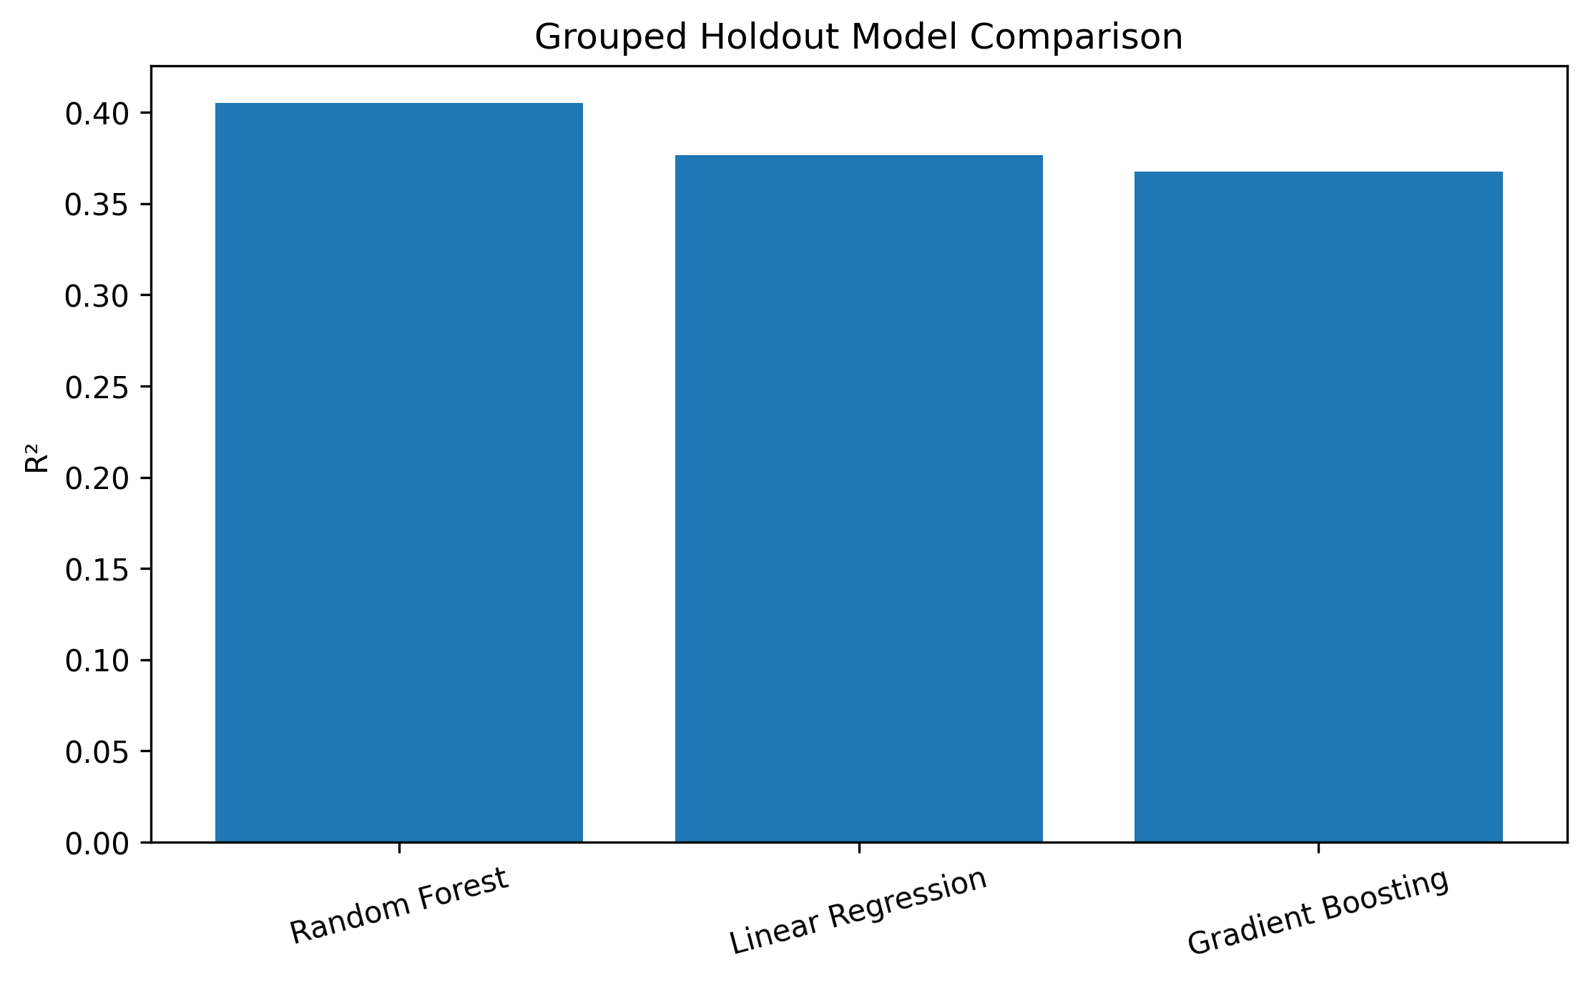
Figure 10: Grouped Holdout Model Comparison

Note. Random Forest achieved the highest R-squared on the canonical sprint-grouped holdout. Final grouped cross-validation and repeated-split checks confirm that the ranking is generally stable, although model error remains operationally meaningful.
Model | Feature Set | Validation Approach | Metric 1 | Metric 2 | Key Takeaway
Random Forest | Project context, baseline workload, AI breadth, phase shares/exposures | 80/20 sprint-grouped holdout; 5-fold grouped CV; 10 repeated splits | MAE 5.687 / RMSE 7.287 | R² .405 | Best canonical result; CV R² .471; best in 7/10 repeated splits
Linear Regression | Same encoded feature set with scaled numeric fields | Same grouped validation | MAE 5.802 / RMSE 7.460 | R² .376 | Strong transparent baseline; CV R² .426
Gradient Boosting | Same encoded feature set | Same grouped validation | MAE 5.940 / RMSE 7.514 | R² .367 | Competitive nonlinear model; CV R² .446

Table 12: Final Model Performance Comparison

Feature Importance and Stability
Permutation importance identifies AI Phase Count as the dominant model feature. In the canonical split its decrease in R-squared is approximately .403; across five alternative grouped splits the mean importance remains .269 (SD = .041) and is positive in every split. Phase-specific AI exposure variables and baseline-share features are much smaller. This stability supports AI adoption breadth as a useful screening signal, but the feature may also proxy programme maturity, standardisation, leadership support, or selection effects and therefore must not be interpreted causally. Figure 13 visualises the mean permutation importance and its variation across alternative grouped splits.
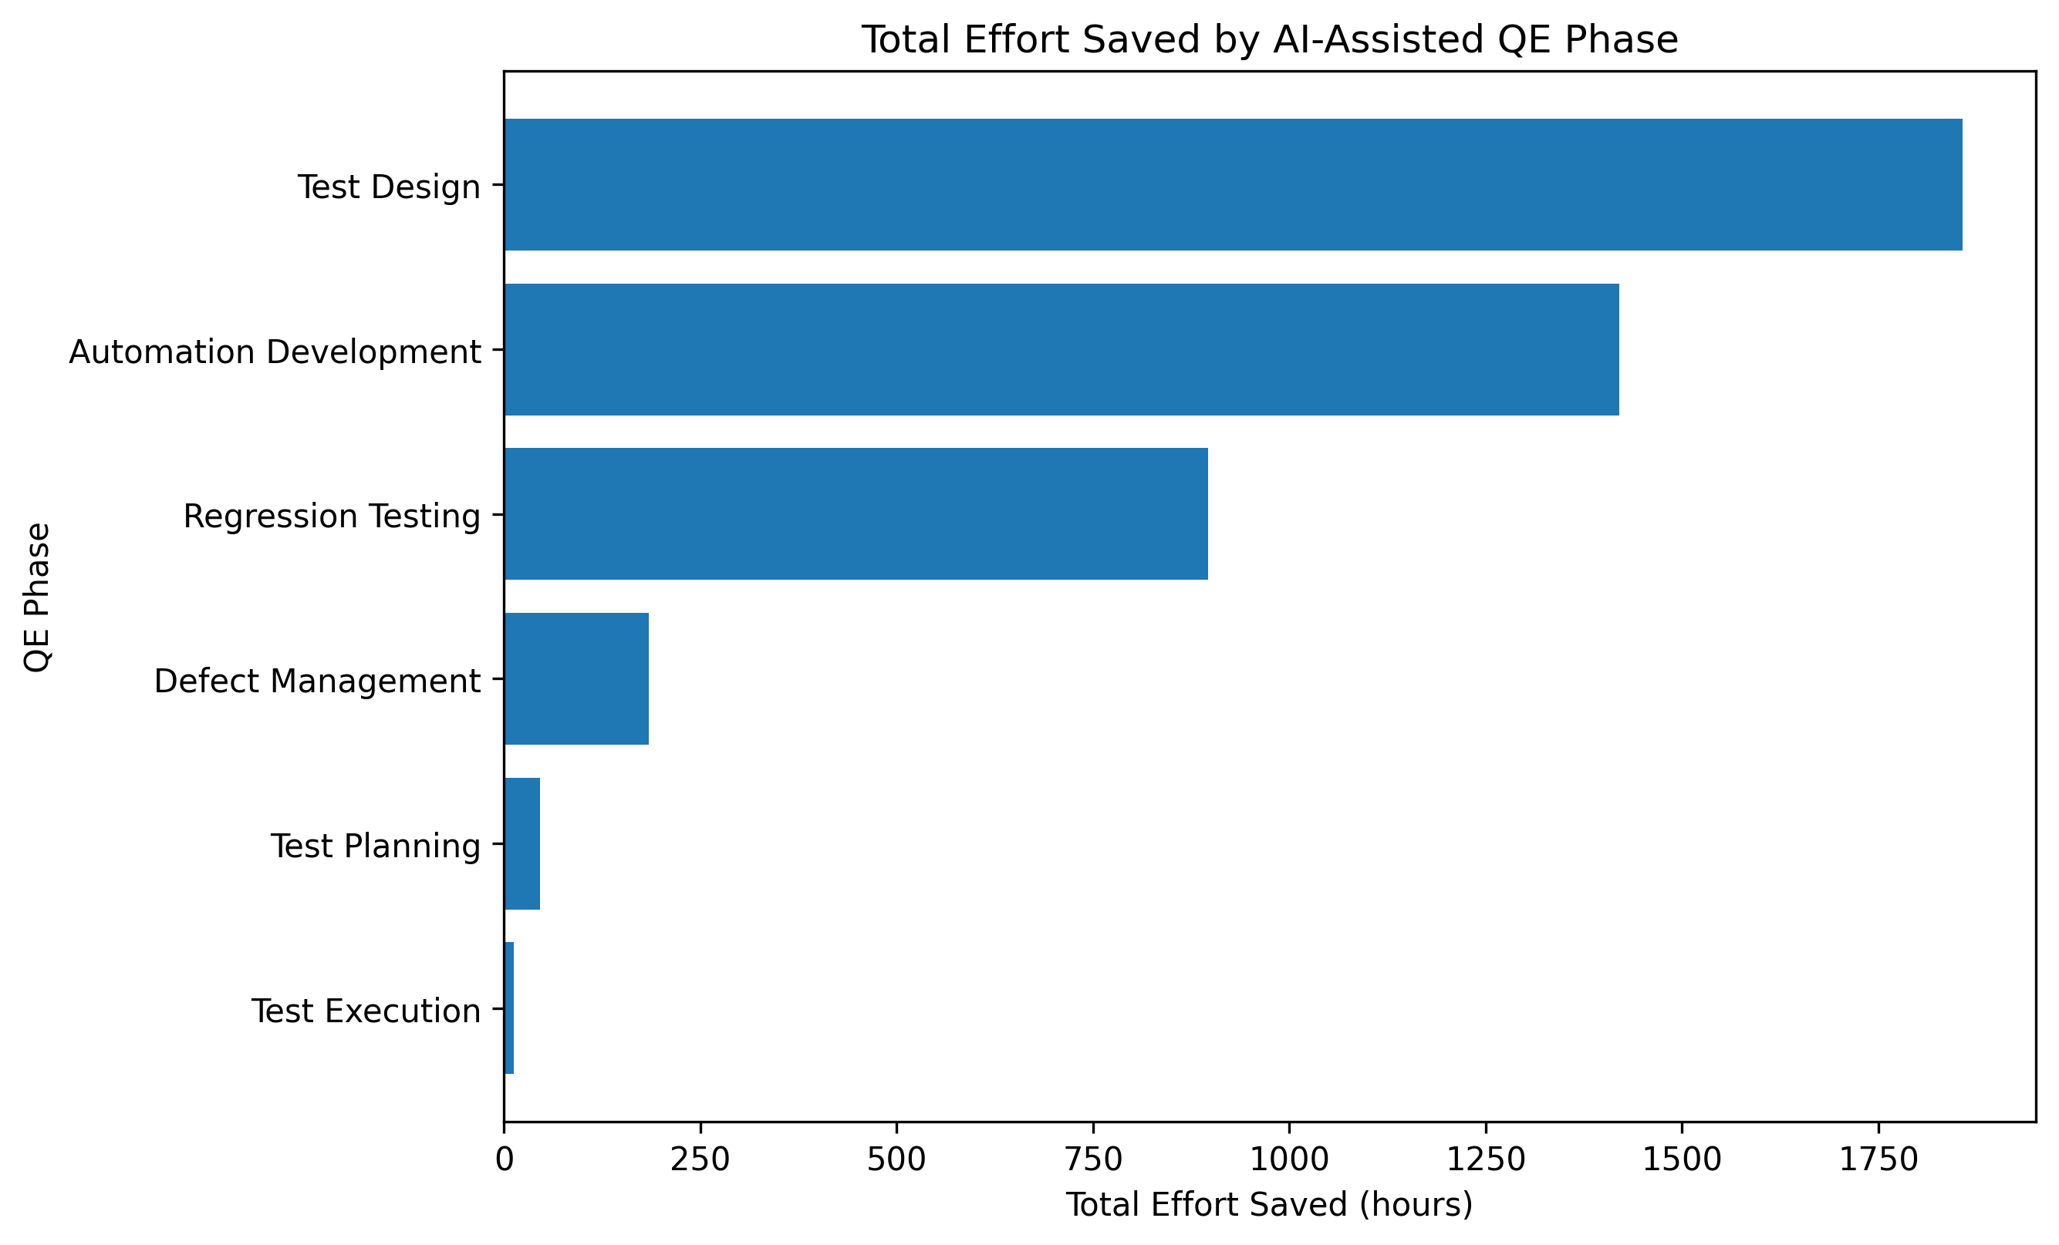
Figure 11: Total Effort Saved by AI-Assisted QE Phase
Note. Test Design, Automation Development, and Regression Testing account for approximately 94.5% of all positive effort saved across AI-assisted observations.
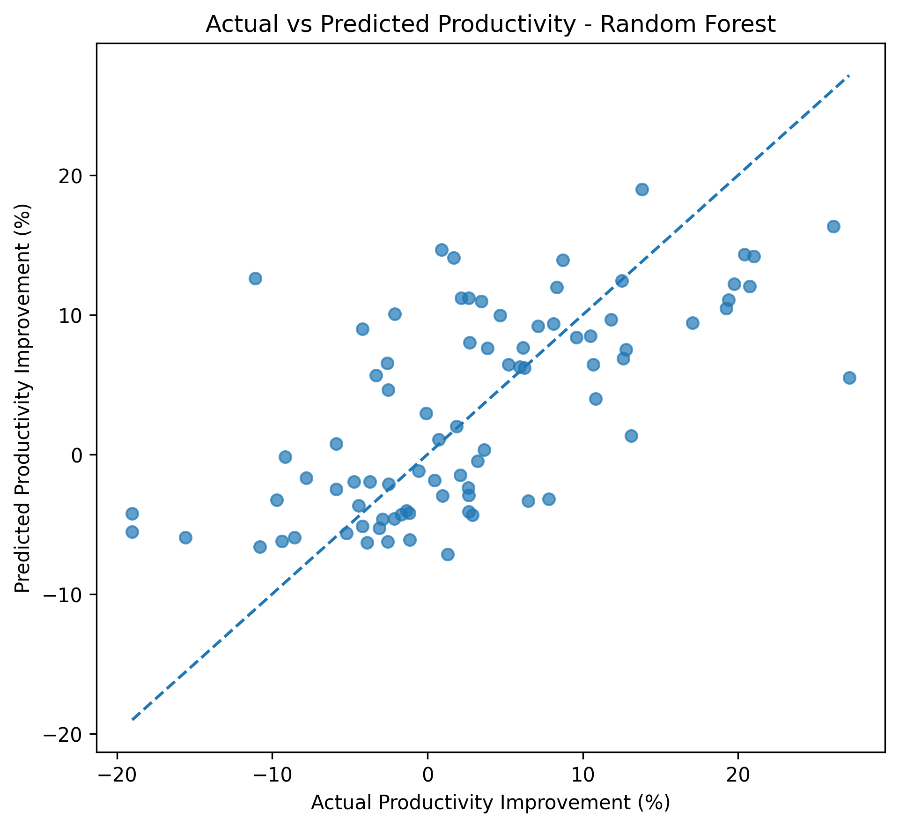
Figure 12: Actual Versus Predicted Productivity - Random Forest
Note. Predictions follow the observed direction but retain visible dispersion around the 45-degree reference line, supporting directional rather than precise use.
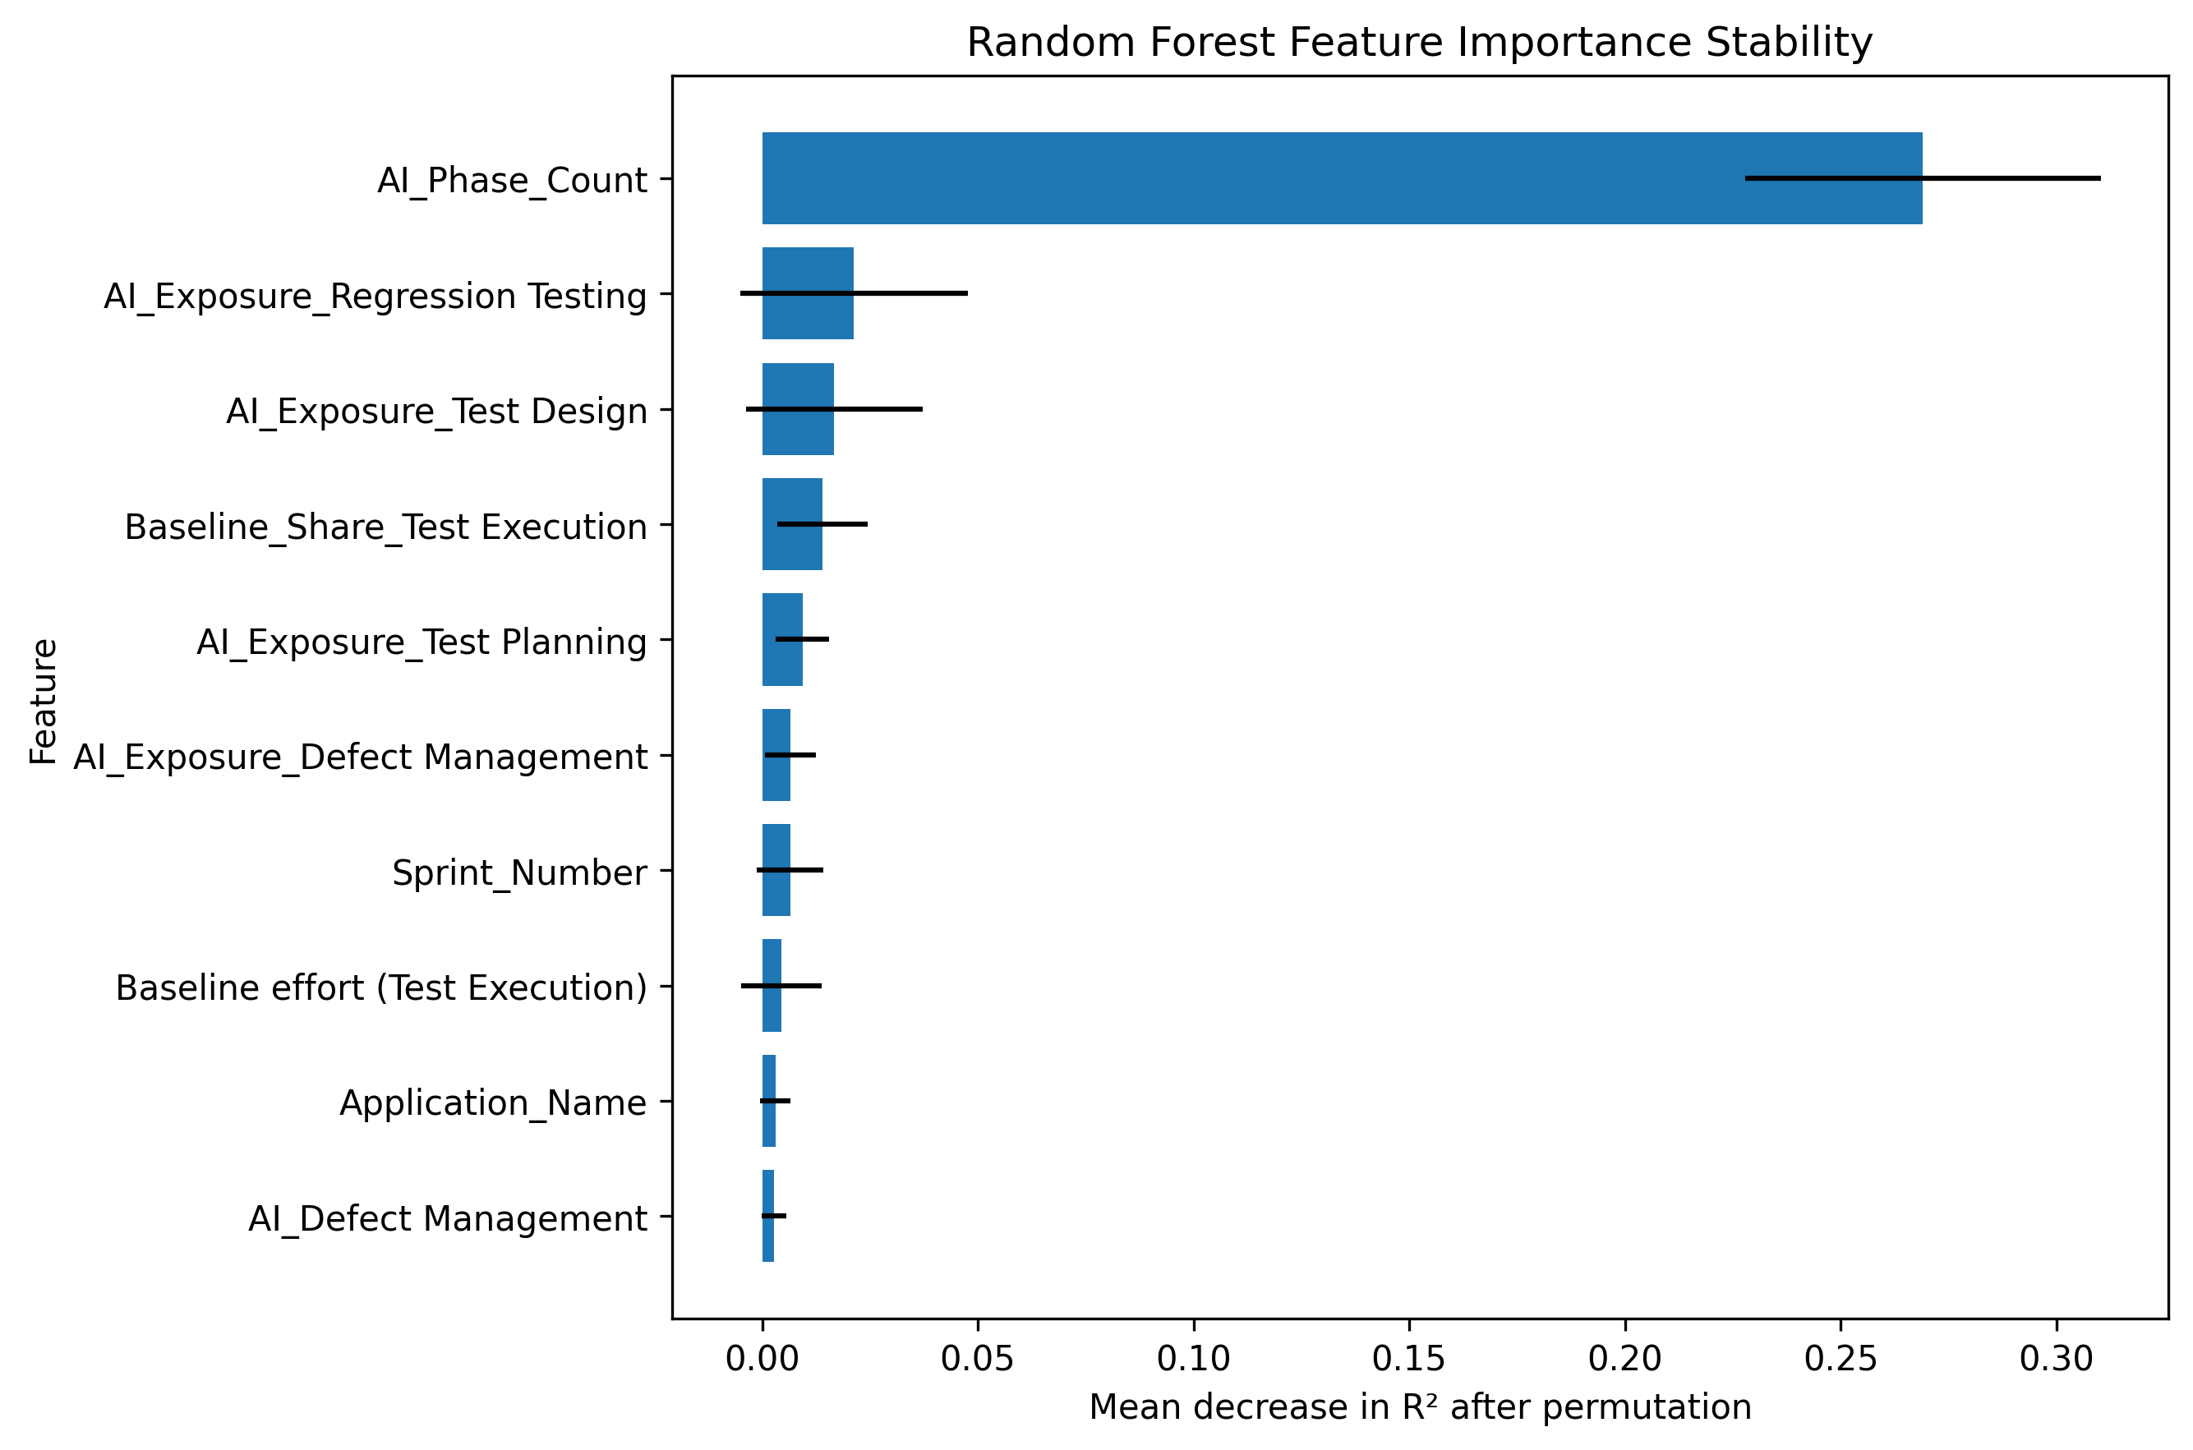
Figure 13: Random Forest Feature-Importance Stability
Note. AI Phase Count remains the dominant stable input across alternative grouped splits; smaller feature effects vary more across samples.
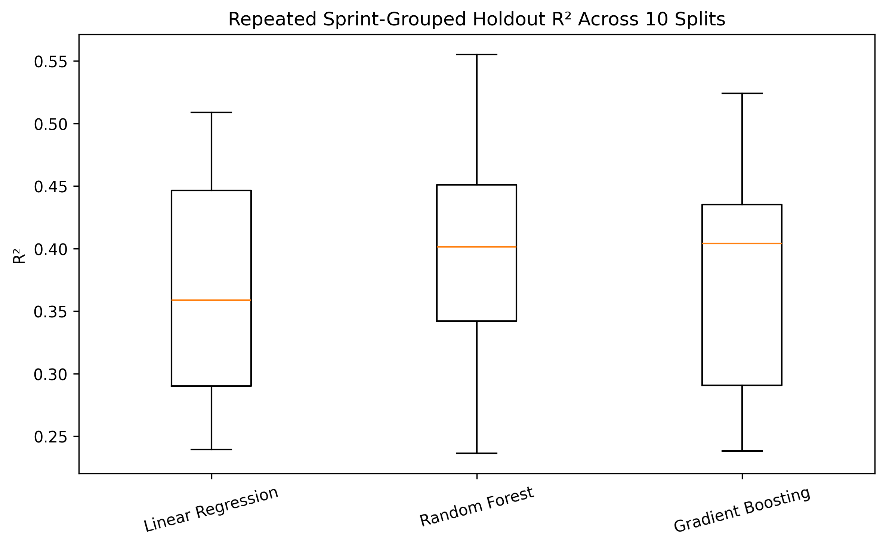
Figure 14: Repeated Sprint-Grouped Holdout R-squared
Note. Random Forest has the strongest average repeated-split performance, but all models show variability across held-out sprint groups.
RQ | Final Evidence | Hypothesis Decision | Business Interpretation | Boundary
RQ1 | AI mean 16.95% vs traditional -4.63%; U=1,392,443; p<.001; d=1.16; sensitivity stable | Reject H0_1 | AI-assisted activities show large operational productivity advantage | Association; not proof of quality or causality
RQ2 | H=92.721; p<.001; epsilon-squared=.097; 13/15 post-hoc comparisons significant | Reject H0_2 | Scale strongest phases first rather than uniform adoption | Some AI phase subgroups are smaller
RQ3 | AI coefficient +16.69 points in primary model; 16.17-18.05 across specifications; p<.001 | Reject H0_3 | AI remains the strongest measured association after controls | Observational confounding remains
RQ4 | RF holdout R²=.405, MAE=5.687; grouped CV R²=.471; best in 7/10 repeated splits | Reject H0_4 for directional use | Use for portfolio screening and prioritisation | Not precise enough for budgets or individual assessment
Table 13: Final Research Question Conclusions

Practical Significance
The study provides practical evidence that AI adoption should be treated as a phase-specific productivity strategy rather than as a uniform technology programme. Across 906 AI-assisted phase observations, total effort saved is 4,417.63 hours, whereas the 1,799 traditional observations collectively show -1,184.13 hours of effort saved, indicating net overrun relative to baseline. These totals are not a financial ROI calculation because labour rates, licence costs, quality outcomes, and rework costs are not available; they nevertheless make the operational magnitude of the observed productivity difference concrete.
The concentration of benefit is also actionable. Test Design contributes approximately 1,857.58 hours saved, Automation Development 1,420.18 hours, and Regression Testing 896.61 hours. Together these three phases account for about 94.5% of all positive effort saved within AI-assisted observations. The evidence therefore supports targeted scaling in phases with repetitive, structured, information-rich work while keeping human validation stronger in judgement-intensive or low-volume phases. Figure 11 visualises this concentration of cumulative effort savings by phase.
QE Phase | AI Activities | Mean Improvement | Total Hours Saved | Adoption Tier
Regression Testing | 171 | 22.23% | 896.6 | Scale now
Test Design | 297 | 19.92% | 1857.6 | Scale now
Automation Development | 242 | 16.62% | 1420.2 | Scale now
Defect Management | 111 | 10.27% | 184.4 | Controlled expansion
Test Planning | 58 | 6.46% | 46.2 | Targeted pilot
Test Execution | 27 | 3.93% | 12.7 | Targeted pilot
Table 14: Phase-Level Business Value and Adoption Priority
Note. Priority tiers combine statistical phase evidence, observed productivity, cumulative effort savings, and governance considerations; they are not automated deployment decisions.

Implementation and User Benefit

Deployment Approach
The proposed deployment is a batch or dashboard-based decision-support capability rather than a real-time autonomous AI controller. On a scheduled cadence, a validated project/sprint extract would pass through the same preprocessing and feature-engineering pipeline, after which the selected Random Forest model would produce directional productivity estimates and a phase-priority view. Historical phase evidence, confidence boundaries, model diagnostics, and governance rules should be displayed alongside any prediction.

System Integration
A practical enterprise integration can follow: QE planning and execution data -> controlled analytics extract -> validation and feature engineering -> model scoring and statistical benchmarks -> business-intelligence dashboard -> QE leader review and adoption decision. The model should be versioned with its training data, feature definitions, validation metrics, and approval history. Predictions should not trigger staffing, performance, or release decisions without human review.

User Interaction
QE leaders and delivery managers would select an application, sprint profile, workload, complexity, and planned AI coverage. The interface would return historical phase benchmarks, expected productivity direction, model error information, and the recommended adoption tier. Test architects could then inspect the evidence before approving scale-up, defining a controlled pilot, or retaining the traditional approach.

Benefits to Users
Operational efficiency. Focuses AI enablement on phases with stronger observed productivity and effort-savings evidence.
Financial decision support. Provides hours-saved evidence that can later be combined with labour, licence, and quality costs to create a complete ROI model.
Strategic value. Replaces broad AI adoption claims with a measurable portfolio framework and exposes uncertainty rather than hiding it.
Governance value. Preserves human approval, quality acceptance criteria, and explicit boundaries for model use.

Example Use Case
A QE leader preparing a release with a large regression inventory can review the historical Regression Testing evidence (22.23% mean improvement across AI-assisted observations), the project-level model estimate, and grouped-validation error before choosing an AI-enabled regression-selection approach. The system would recommend a scale-now tier when the project resembles successful historical contexts, but the leader would still confirm test coverage, environment readiness, defect risk, and human review before implementation.

Limitations and Further Improvements
- The dataset does not contain direct financial cost, AI licence cost, defect leakage, test coverage, automation coverage, rework, quality-acceptance measures, or customer-impact measures. Productivity is therefore only one component of business value.
- The study is observational. AI-adopting teams may differ from traditional teams in maturity, process discipline, leadership, toolchain, or project selection. Regression controls reduce but do not eliminate confounding, so results are associations rather than causal estimates.
- AI usage is binary by phase. Tool type, model type, frequency, prompt quality, assistance intensity, human-review effort, and governance maturity are not measured and may explain variation inside the AI-assisted group.
- Multiple phase observations originate from the same project/sprint record. Sprint-clustered inference and grouped validation address dependence, but a future hierarchical or mixed-effects design could model project, team, application, sprint, and phase structure more directly.
- Percentage improvement can be unstable when baseline effort is small. Final denominator-threshold and outlier sensitivity checks preserve the AI advantage, but absolute hours saved should remain visible alongside percentages.
- The Random Forest explains about 40.5% of unseen variation in the canonical holdout and about 47.1% on average in grouped cross-validation. Segment-level error varies, indicating that important operational predictors remain unmeasured; the model is not suitable for precise budgets or individual performance assessment.

Future Improvements and Future Scope
- Add direct cost, labour rate, AI licence, infrastructure, rework, defect leakage, escaped-defect, test-coverage, automation-coverage, and quality-acceptance variables to convert productivity evidence into a complete risk-adjusted ROI model.
- Capture AI tool/model identity, assistance intensity, prompt pattern, human-review effort, training maturity, and governance controls so the analysis can distinguish different forms of AI adoption rather than a binary Yes/No flag.
- Extend the dataset across more organisations, applications, and delivery periods and perform external validation on a held-out enterprise or time period before broader deployment.
- Evaluate hierarchical/mixed-effects models and quasi-experimental approaches such as matched comparisons, difference-in-differences, or staggered adoption designs when suitable longitudinal data become available.
- Add uncertainty intervals, calibration checks, scenario analysis, and more detailed error diagnostics to the decision-support interface so users see prediction risk together with point estimates.
- Evaluate phase-specific predictive models where sample size permits, especially for Regression Testing, Test Design, and Automation Development, instead of relying only on one project-level target.
- Incorporate explainability methods and governed feature review to distinguish actionable drivers from proxy variables such as AI Phase Count.
- Track realised benefits after deployment so recommended adoption tiers can be recalibrated against actual cost, quality, and productivity outcomes.
- Extend the framework into a reusable enterprise QE benchmarking capability that compares AI value by lifecycle phase while preserving privacy, governance, and human approval.

Future work should preserve the distinction established in this study between statistical association, predictive usefulness, causal evidence, and realised business value. The current results justify governed phase-level decision support; broader automation of investment decisions should wait until cost, quality, external-validation, and causal evidence are materially stronger.

Bibliography
Ardic, B., Le Dilavrec, Q., & Zaidman, A. (2026). How students use generative AI for software testing: An observational study. Empirical Software Engineering, 31, Article 167. https://doi.org/10.1007/s10664-026-10898-0
Breiman, L. (2001). Random forests. Machine Learning, 45(1), 5–32. https://doi.org/10.1023/A:1010933404324
Durelli, V. H. S., Durelli, R. S., Borges, S. S., Endo, A. T., Eler, M. M., Dias, D. R. C., & Guimarães, M. de P. (2019). Machine learning applied to software testing: A systematic mapping study. IEEE Transactions on Reliability, 68(3), 1189–1212. https://doi.org/10.1109/TR.2019.2892517
Friedman, J. H. (2001). Greedy function approximation: A gradient boosting machine. The Annals of Statistics, 29(5), 1189–1232. https://doi.org/10.1214/aos/1013203451
Garousi, V., Felderer, M., Kuhrmann, M., Herkiloğlu, K., & Eldh, S. (2020). Exploring the industry’s challenges in software testing: An empirical study. Journal of Software: Evolution and Process, 32(8), e2251. https://doi.org/10.1002/smr.2251
Haldar, S., & Capretz, L. F. (2026). Automated test plan generation using large language models. Software Quality Journal, 34, Article 8. https://doi.org/10.1007/s11219-026-09744-9
James, G., Witten, D., Hastie, T., & Tibshirani, R. (2021). An introduction to statistical learning: With applications in R (2nd ed.). Springer. https://doi.org/10.1007/978-1-0716-1418-1
Ouédraogo, W. C., Kaboré, A. K., Li, Y., Tian, H., Koyuncu, A., Klein, J., Lo, D., & Bissyandé, T. F. (2026). Prompt engineering in LLMs for automated unit test generation: A large-scale study. Empirical Software Engineering, 31, Article 103. https://doi.org/10.1007/s10664-026-10840-4
Raharjana, I. K., Husna, O. I., Hariyanti, E., & Fauzi, S. S. M. (2025). Mapping the landscape of deep learning in software testing: A bibliometric analysis. Discover Artificial Intelligence, 5(1), Article 402. https://doi.org/10.1007/s44163-025-00596-z
Romero, J. R., Ramírez, A., & García-Martínez, C. (2026). Automated machine learning for test case prioritisation. Empirical Software Engineering, 31, Article 120. https://doi.org/10.1007/s10664-026-10862-y
Venugopal, S. (2026). Enterprise Quality Engineering Performance Dataset (EQEPD) [Unpublished data set]. https://github.com/satisho/QM640_Data-Analytics_Capstone
Wang, J., Huang, Y., Chen, C., Liu, Z., Wang, S., & Wang, Q. (2024). Software testing with large language models: Survey, landscape, and vision. IEEE Transactions on Software Engineering, 50(4), 911–936. https://doi.org/10.1109/TSE.2024.3368208
Willmott, C. J., & Matsuura, K. (2005). Advantages of the mean absolute error over the root mean square error in assessing average model performance. Climate Research, 30, 79–82. https://doi.org/10.3354/cr030079
Yoo, S., & Harman, M. (2012). Regression testing minimization, selection and prioritization: A survey. Software Testing, Verification and Reliability, 22(2), 67–120. https://doi.org/10.1002/stvr.43040

Appendix A: Core Analytical Calculations and Final Robustness Checks
The final executed Jupyter notebook summarises and verifies the principal analytical outputs. The complete reproducible regeneration logic is provided in scripts/final_analysis.py. The extracts below document the core calculations referenced in the report without reproducing the full script.

# Phase-level effort and productivity
phase_data['Effort_Saved'] = phase_data['Baseline_Effort'] - phase_data['Actual_Effort']
phase_data['Productivity_Improvement_Pct'] = ( phase_data['Effort_Saved'] / phase_data['Baseline_Effort'] * 100)

# Project-level target
project_data['Total_Effort_Saved'] = ( project_data['Total_Baseline_Effort'] - project_data['Total_Actual_Effort'])
project_data['Overall_Productivity_Improvement_Pct'] = ( project_data['Total_Effort_Saved'] / project_data['Total_Baseline_Effort'] * 100)

Final robustness outputs are generated by scripts/final_analysis.py and written to outputs/tables/. Key final files include Final_RQ1_Sensitivity_Analysis.csv, Final_RQ3_Regression_Stability.csv, Final_Grouped_Cross_Validation.csv, Final_Repeated_Grouped_Holdout_Summary.csv, and Final_Permutation_Importance_Stability.csv.

Appendix B: Complete Field-Level Data Dictionary
Variable Name | Definition | Datatype | Allowed Values/Range | Missing Values Handling | Notes
Sprint # | Project delivery sprint identifier | Text | YYYY-Snn | Not imputed | Used to derive Year and Sprint_Number; grouping key
Application_Name | Anonymised application/platform | Categorical | 8 standardised values | Retained as category | One-hot encoded
Team_Name | Anonymised QE team | Categorical | 8 standardised values | Retained as category | One-hot encoded / context
Complexity | Project complexity | Categorical | Low, Medium, High | Aliases standardised | One-hot encoded
User story count | Number of user stories | Numeric count | Non-negative | Median imputed | Workload predictor
test case count | Number of test cases | Numeric count | Non-negative | Median imputed | Testing-volume predictor
AI Usage Testing Phase (Test Planning) | AI assistance used in Test Planning | Binary category | Yes/No | Variants standardised | Converted to binary flag
AI Usage Testing Phase (Test Design) | AI assistance used in Test Design | Binary category | Yes/No | Variants standardised | Converted to binary flag
AI Usage Testing Phase (Automation Development) | AI assistance used in Automation Development | Binary category | Yes/No | Variants standardised | Converted to binary flag
AI Usage Testing Phase (Test Execution) | AI assistance used in Test Execution | Binary category | Yes/No | Variants standardised | Converted to binary flag
AI Usage Testing Phase (Regression Testing) | AI assistance used in Regression Testing | Binary category | Yes/No | Variants standardised | Converted to binary flag
AI Usage Testing Phase (Defect Management) | AI assistance used in Defect Management | Binary category | Yes/No | Variants standardised | Converted to binary flag
Baseline effort (Test Planning) | Expected effort for Test Planning in hours | Numeric continuous | Normally > 0 | Not imputed for outcomes | Target denominator
Baseline effort (Test Design) | Expected effort for Test Design in hours | Numeric continuous | Normally > 0 | Not imputed for outcomes | Target denominator
Baseline effort (Automation Development) | Expected effort for Automation Development in hours | Numeric continuous | Normally > 0 | Not imputed for outcomes | Target denominator
Baseline effort (Test Execution) | Expected effort for Test Execution in hours | Numeric continuous | Normally > 0 | Not imputed for outcomes | Target denominator
Baseline effort (Regression Testing) | Expected effort for Regression Testing in hours | Numeric continuous | Normally > 0 | Not imputed for outcomes | Target denominator
Baseline effort (Defect Management) | Expected effort for Defect Management in hours | Numeric continuous | Normally > 0 | Not imputed for outcomes | Target denominator
Actual effort (Test Planning) | Observed effort for Test Planning in hours | Numeric continuous | ≥ 0 | Not imputed for outcomes | Used only to create outcomes; excluded from predictors
Actual effort (Test Design) | Observed effort for Test Design in hours | Numeric continuous | ≥ 0 | Not imputed for outcomes | Used only to create outcomes; excluded from predictors
Actual effort (Automation Development) | Observed effort for Automation Development in hours | Numeric continuous | ≥ 0 | Not imputed for outcomes | Used only to create outcomes; excluded from predictors
Actual effort (Test Execution) | Observed effort for Test Execution in hours | Numeric continuous | ≥ 0 | Not imputed for outcomes | Used only to create outcomes; excluded from predictors
Actual effort (Regression Testing) | Observed effort for Regression Testing in hours | Numeric continuous | ≥ 0 | Not imputed for outcomes | Used only to create outcomes; excluded from predictors
Actual effort (Defect Management) | Observed effort for Defect Management in hours | Numeric continuous | ≥ 0 | Not imputed for outcomes | Used only to create outcomes; excluded from predictors
Year | Calendar year derived from Sprint # | Integer | 2023–2026 | Derived | Trend/control feature
Sprint_Number | Numeric sprint sequence derived from Sprint # | Integer | Positive | Derived | Trend/control feature
QE_Phase | Lifecycle phase in long-format data | Categorical | Six phases | Derived | Phase comparison
AI_Used | Standardised phase-level AI indicator | Binary category | Yes/No | Derived from phase field | RQ1 grouping
AI_Used_Flag | Numeric phase-level AI indicator | Binary numeric | 0/1 | Derived | Regression input
Baseline_Effort | Phase baseline effort in long data | Numeric continuous | > 0 for target | No imputation | Phase workload
Actual_Effort | Phase actual effort in long data | Numeric continuous | ≥ 0 | No imputation | Outcome input only
Effort_Saved | Baseline_Effort − Actual_Effort | Numeric continuous | Positive/negative | Derived | Absolute benefit
Productivity_Improvement_Pct | Effort_Saved / Baseline_Effort × 100 | Numeric continuous | Can be positive/negative | Derived; winsorised only in selected model use | RQ1–RQ3 target
Total_Baseline_Effort | Sum of six phase baselines | Numeric continuous | Positive | Derived | Project scale
Total_Actual_Effort | Sum of six phase actuals | Numeric continuous | Non-negative | Derived | Outcome input; excluded from model features
Total_Effort_Saved | Total baseline − total actual | Numeric continuous | Positive/negative | Derived | Project absolute benefit
Overall_Productivity_Improvement_Pct | Total saved / total baseline × 100 | Numeric continuous | Can be positive/negative | Derived; winsorised 1st/99th for models | RQ4 target
AI_Phase_Count | Count of phase AI flags | Integer | 0–6 | Derived | Adoption breadth
AI_Adoption_Rate | AI_Phase_Count / 6 | Numeric proportion | 0–1 | Derived | Normalised breadth
Baseline_Share_<Phase> | Phase baseline / total baseline | Numeric proportion | 0–1 | Derived | Workload allocation
AI_Exposure_<Phase> | AI phase flag × baseline share | Numeric proportion | 0–1 | Derived | Workload-weighted AI use
Story_to_Test_Ratio | test case count / (user story count + 1) | Numeric continuous | ≥ 0 | Derived | Test intensity proxy
Table B1: Complete Raw and Engineered Data Dictionary
Note. Angle-bracket notation indicates a repeated engineered field for each of the six QE phases. The notebook contains the exact column names exported to the processed files.

Appendix C: Final Submission Checklist
Requirement | Status
Title page, term/date, and page numbers | Complete
Active GitHub repository reference after title page | Complete
Standalone 300-350 word abstract | Complete
Background, measurable problem statement, purpose, four RQs, and contributions | Complete
Literature review with minimum 10 sources and APA-style bibliography | Complete - 12 sources in matrix; 14 bibliography entries
Data source, dataset overview, data dictionary, and access paths | Complete
Data cleaning, EDA, feature engineering, and hypotheses | Complete
Minimum sample size / power adequacy check | Complete
Architecture/workflow and tools/technologies | Complete
Statistical tests at alpha=.05 with effect sizes and sensitivity checks | Complete
Grouped predictive modelling with MAE, RMSE, R-squared, CV, and repeated splits | Complete
Results by RQ with tables and visual evidence | Complete
Practical significance and phase-level adoption roadmap | Complete
Implementation, integration, user interaction, benefits, and example use case | Complete
Limitations, future improvements, and future scope | Complete
Final DOCX/PDF, code, data, figures, tables, README, and environment metadata | Complete
Table C1: Final Report Requirement Checklist

Appendix D: Reproducibility Environment and Final Output Manifest
The final analysis outputs were regenerated using the environment below. Exact versions are also recorded in environment_versions.txt and outputs/tables/Final_Execution_Environment.csv.
Component | Version
Python | 3.13.5
NumPy | 2.3.5
Pandas | 2.2.3
Matplotlib | 3.10.8
SciPy | 1.17.0
Statsmodels | 0.14.6
scikit-learn | 1.8.0
openpyxl | 3.1.5
nbconvert | 7.17.1
Table D1: Final Analysis Execution Environment
Note. CPU-based execution was used; no GPU, deep-learning framework, or agentic runtime was required.

Final package evidence includes the raw workbook, two processed analytical datasets, final notebook, final analysis script, statistical and model tables, Figures 1-14, final DOCX/PDF, README, requirements file, repository tree, and submission checklist.

