Data Analytics Capstone

Evaluating the Business Impact of Artificial Intelligence Adoption Across the Quality Engineering Lifecycle

Interim Report

Satish Venugopal

Walsh College

QM 640 – Data & Analytics – Capstone Project

Mentor: Dr. Sanhita Karmakar

14-July-2026

GitHub Repository and Reproducibility Materials
Repository URL: https://github.com/satisho/QM640_Data-Analytics_Capstone
The repository will provide the evaluator with the raw dataset, cleaned analytical datasets, executed notebook, supporting code, model outputs, and report evidence. The exact repository address was not included in the supplied final-submission package, so the highlighted placeholder above must be replaced with the active link before the report is submitted.
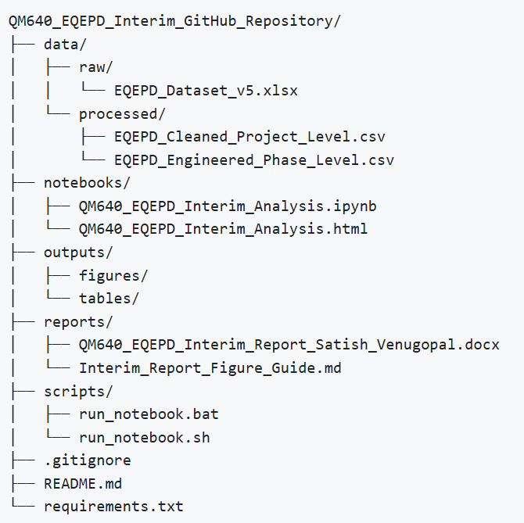

Figure 1: Proposed Repository Folder Structure
Note. The folder structure is aligned with the files named in the capstone submission package. The active repository URL must be inserted before submission
Planned repository paths are data/raw/EQEPD_Dataset_v5.xlsx for the source workbook, data/processed/ for the cleaned project-level and engineered phase-level files, notebooks/ for the executed Jupyter notebook, outputs/ for statistical and model results, and reports/ for the interim and final reports. This structure separates immutable raw data from processed data and analysis artefacts, making it easier for an evaluator to reproduce the work without modifying the source file.

Introduction

Background and Context
Artificial Intelligence (AI) is increasingly embedded in the software delivery lifecycle, where it is used to generate requirements-based tests, suggest test scenarios, create automation code, prioritise regression suites, classify defects, and support release decisions. Within enterprise Quality Engineering (QE), these capabilities are attractive because testing frequently consumes a substantial share of delivery effort and is often constrained by short release cycles, large regression inventories, and uneven access to specialised testing skills. The operational promise is straightforward: if AI can reduce the effort required to plan, design, automate, execute, and analyse tests without lowering quality, organisations may release software faster and redirect skilled engineers toward higher-value work. The management challenge is that this promise is often communicated through tool demonstrations or isolated pilots rather than through consistent project-level evidence.
The setting for this capstone is an enterprise QE portfolio represented by the Enterprise Quality Engineering Performance Dataset (EQEPD). The dataset records project, application, team, sprint, complexity, workload, AI-use, baseline-effort, and actual-effort information across six lifecycle phases: Test Planning, Test Design, Automation Development, Test Execution, Regression Testing, and Defect Management. The principal stakeholders are QE leaders who decide where to invest, delivery managers who plan effort and staffing, test architects who select suitable use cases, and project teams whose operating practices influence whether AI assistance produces sustainable value. For these stakeholders, a phase-level view is important because AI may create strong benefits in repetitive and information-intensive activities while producing smaller gains in activities that depend heavily on judgement, environment stability, or physical execution.
Prior research demonstrates that machine learning and large language models can support several testing activities, including test generation, test prioritisation, and test planning, but it also identifies reliability, maintainability, hallucination, and human-oversight concerns (Durelli et al., 2019; Haldar & Capretz, 2026; Wang et al., 2024). This makes empirical measurement essential. A credible adoption decision should distinguish observed effort reduction from perceived convenience, compare AI-assisted work with a meaningful traditional baseline, and account for project context. It should also avoid treating all lifecycle phases as equivalent, because the economics and risks of automating regression selection differ from those of generating a test strategy or deciding defect severity.
This interim report presents the project as a standalone study. It explains the research problem, literature foundation, data structure, cleaning decisions, exploratory findings, modelling plan, and preliminary results. The analytical work is substantially advanced: the raw data has been profiled and cleaned, project-level records have been transformed into phase-level observations, exploratory data analysis has been completed, initial statistical tests have been run, and three predictive models have been compared. Remaining work is focused on final sensitivity checks, presentation of business recommendations, repository publication, and final report packaging.

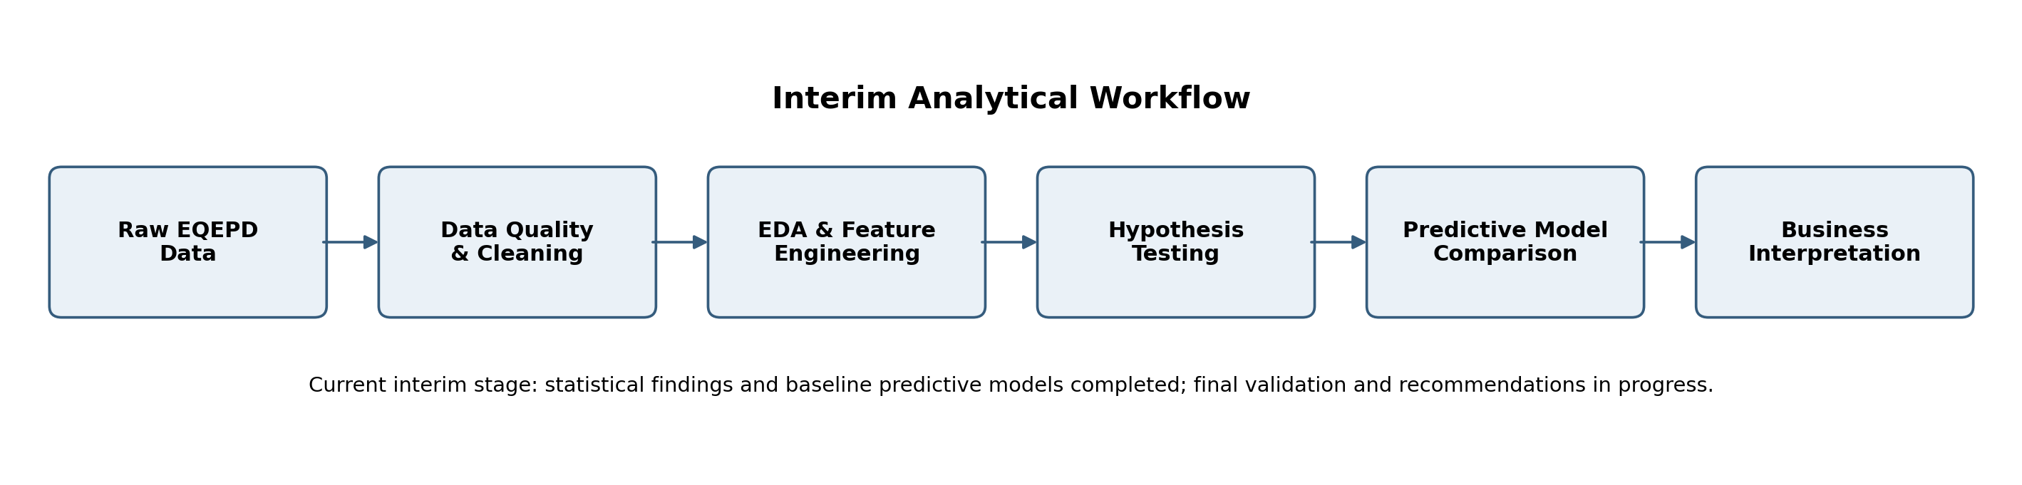

Fi
Figure 2: Interim Analytical Workflow

Note. The workflow links data preparation, explanatory analysis, statistical testing, predictive modelling, and business interpretation. At the interim stage, the first five analytical steps have preliminary outputs.

Problem Statement
Organisations are investing in AI-enabled QE, but they often lack comparable operational evidence showing whether AI-assisted activities deliver higher productivity than traditional activities, which lifecycle phases generate the strongest value, and which project characteristics influence the outcome. Without this evidence, investment may be spread uniformly across unsuitable use cases, pilot results may be overgeneralised, and expected savings may be based on vendor claims rather than observed effort. This project addresses the gap by creating consistent productivity measures from baseline and actual effort, comparing AI-assisted and traditional phase observations, examining phase-level differences, controlling for project context, and testing whether machine-learning models can provide useful directional estimates for future prioritisation.

Purpose of the Study
The purpose of the study is to explain and predict productivity improvement associated with AI adoption across the QE lifecycle. The explanatory component evaluates whether AI usage is associated with a statistically and practically meaningful reduction in effort and whether results differ by lifecycle phase. The predictive component compares supervised regression models that estimate overall project/sprint productivity improvement from project context, baseline workload, and AI-adoption features. The intended output is not an autonomous investment engine; it is an evidence-based decision-support framework that helps QE leaders identify stronger candidate phases, recognise uncertainty, and define the additional measures needed for a complete business case.

Interim Project Status (Progress Snapshot)
Status | Work Items
Completed | Raw workbook inventory; data-type and missing-value profiling; exact duplicate removal; categorical standardisation; project-level and phase-level dataset construction; initial exploratory data analysis; RQ1 and RQ2 hypothesis tests; preliminary regression analysis; baseline model comparison.
In progress | Robustness review of statistical assumptions; grouped cross-validation interpretation; feature-importance stability review; integration of findings by research question; APA 7 formatting; preparation of reproducibility materials and narrative evidence.
Pending | Insert active GitHub URL; complete final sensitivity checks; finalise business recommendations and adoption roadmap; validate the final notebook execution from a clean environment; publish the final submission package.
Table 1: Interim Project Status
Note. Status reflects the analytical work represented in the supplied capstone package while preserving an interim distinction between preliminary evidence and final conclusions.

Scope and Objectives

Research Problems Identified
- Measurement inconsistency. AI benefits are commonly described through time saved, productivity, quality improvement, or user perception, but these measures are not always defined consistently. This project uses baseline and actual effort to create a common phase-level productivity measure.
- Lifecycle heterogeneity. The suitability of AI differs across Test Planning, Test Design, Automation Development, Test Execution, Regression Testing, and Defect Management. A portfolio average can conceal phases that are ready to scale and phases that require controlled pilots.
- Context and confounding. Teams that adopt AI may also differ in application maturity, complexity, workload, leadership support, and delivery period. The analysis therefore examines project characteristics and uses regression controls rather than attributing every observed difference directly to AI.
- Decision-support uncertainty. Even when statistical relationships are strong, project-level prediction may remain imperfect. The study evaluates whether models are sufficiently accurate for directional prioritisation and explicitly defines the boundary between model support and managerial judgement.

Research Objectives
- Evaluate the relationship between AI adoption and productivity improvement across selected QE activities.
- Compare AI-assisted and traditional approaches using consistently calculated effort-based metrics.
- Identify the lifecycle phases that produce the highest mean improvement and cumulative effort savings.
- Determine which project and workload characteristics are associated with productivity improvement after statistical controls.
- Compare interpretable and nonlinear regression models using leakage-aware grouped validation.
- Translate preliminary evidence into a phased adoption and measurement approach for enterprise QE decision-makers.

Research Questions and Hypotheses
Question | Research Focus | Null Hypothesis | Alternative Hypothesis
RQ1 | Does AI adoption significantly improve productivity across QE activities? | H₀₁: No significant difference between AI-assisted and traditional activities. | H₁₁: AI-assisted activities show significantly higher productivity improvement.
RQ2 | Does AI-generated business value differ across QE lifecycle phases? | H₀₂: Productivity improvement does not differ across phases. | H₁₂: One or more phases differ significantly.
RQ3 | Which project characteristics and QE factors influence productivity improvement? | H₀₃: No project or QE factor has a significant relationship with improvement. | H₁₃: One or more factors have a significant relationship.
RQ4 | Can machine-learning models predict productivity improvement and identify priority AI-adoption areas? | H₀₄: Models do not provide useful predictive or prioritisation value. | H₁₄: Models provide useful directional prediction and prioritisation.
Table 2: Research Questions and Hypotheses
Note. A 95% confidence level and significance threshold of α = .05 are used for the inferential analyses

Study Scope
The study includes anonymised project/application/team observations from 2023 through 2026 and covers six QE phases. It analyses binary AI-use indicators, project complexity, user-story volume, test-case volume, baseline effort, and actual effort. The primary definition of business value is effort reduction expressed as hours saved and percentage productivity improvement. Direct financial cost, licence cost, defect leakage, automation coverage, test coverage, AI tool identity, AI-assistance intensity, and human-review effort are not available in the current dataset. Consequently, the interim findings should be interpreted as evidence about operational productivity rather than a complete return-on-investment calculation.

Literature Survey

Literature Review Approach
The literature review was designed to support all four research questions rather than provide a broad history of AI. Searches focused on peer-reviewed journal articles, conference papers, systematic reviews, and established statistical-learning references. Sources were identified through IEEE Xplore, SpringerLink, ScienceDirect, ACM-related indexes, and scholarly metadata services using combinations of the terms artificial intelligence, machine learning, large language models, software testing, quality engineering, test generation, regression testing, test prioritisation, productivity, Random Forest, Gradient Boosting, mean absolute error, and root mean square error. Priority was given to studies published from 2019 through 2026 for the domain review, with older foundational sources retained where they define widely used methods.
Inclusion criteria required a direct connection to software testing or QE, an empirical or structured-review method, clear findings relevant to productivity, test effectiveness, adoption risk, or model selection, and sufficient bibliographic information for APA 7 citation. Purely promotional tool descriptions, articles without identifiable methods, and studies focused only on testing AI systems rather than using AI to improve testing were excluded unless they offered a transferable governance insight. The final set combines domain evidence with methodological foundations so that model choice and evaluation decisions are linked to both the software-testing problem and accepted data-science practice.

Summary of Key Literature
Author (Year) | Domain/Context | Dataset/Setting | Method(s) | Key Findings | How It Supports RQ(s)/Decisions
Durelli et al. (2019) | Machine learning in software testing | Systematic mapping of peer-reviewed studies | Mapped ML techniques and testing activities | ML was concentrated in test generation, defect prediction, and related automation tasks; industrial evidence was less mature. | Supports the lifecycle framing and the need for operational evidence across RQ1–RQ3.
Wang et al. (2024) | Large language models in software testing | Survey of LLM-based testing research | Taxonomy and research landscape | LLMs can support test generation and related tasks, but reliability, evaluation, and human oversight remain central concerns. | Supports AI-use cases and the governed interpretation of RQ1, RQ2, and RQ4.
Haldar & Capretz (2026) | Automated test-plan generation | Three open-source web applications; five LLMs | Empirical generation and standards-based evaluation | Generated plans showed useful potential but variable quality; human validation remained necessary. | Explains why Test Planning may show lower or less stable gains and informs RQ2.
Ouédraogo et al. (2026) | LLM unit-test generation | 216,300 tests across Defects4J, SF110, and CMD | Large-scale comparison of four models and five prompting methods | Reasoning prompts improved structural quality, yet hallucination and compilation failures remained; hybrid validation was recommended. | Supports feature/use-case specificity and human review for RQ2 and RQ4.
Ardic et al. (2026) | Human–AI interaction in testing | Observational study with 12 students | Workflow observation and outcome assessment | Participants reported time savings and lower cognitive load, alongside trust, quality, and ownership concerns. | Provides a human-factors explanation for variation not captured by the dataset; relevant to RQ3.
Romero et al. (2026) | Test-case prioritisation | Evolving software builds and test histories | AutoML with grammar-guided genetic programming | Adaptive pipelines reduced the ML expertise required and adjusted to changes across builds. | Supports Regression Testing as a high-value AI area and motivates nonlinear models for RQ2/RQ4.
Yoo & Harman (2012) | Regression test optimisation | Survey of minimisation, selection, and prioritisation methods | Structured literature survey | Regression optimisation can reduce testing cost and improve early fault detection under time constraints. | Provides theoretical support for the strong Regression Testing results in RQ2.
Garousi et al. (2020) | Industry testing challenges | Empirical industry study | Practitioner evidence and challenge analysis | Testing outcomes depend on organisational, process, tooling, and skill constraints rather than technique alone. | Supports contextual controls and cautions against causal overstatement in RQ3.
Raharjana et al. (2025) | Deep learning in software testing | 737 Scopus-indexed publications | Bibliometric analysis | Research increased sharply after 2017, led by defect prediction, code analysis, and automated testing, with important gaps remaining. | Establishes the maturity and uneven coverage of the field for RQ1–RQ3.
Breiman (2001) | Random Forest methodology | General supervised-learning setting | Ensemble of decorrelated decision trees | Random Forests model nonlinear relationships and interactions while reducing the instability of individual trees. | Justifies a robust nonlinear model for RQ4.
Friedman (2001) | Gradient Boosting methodology | General regression and classification setting | Sequential additive modelling | Gradient boosting improves predictions by iteratively fitting residual error and can capture complex tabular patterns. | Justifies a second nonlinear benchmark for RQ4.
Willmott & Matsuura (2005) | Model error evaluation | Comparative discussion of error metrics | Analytical comparison of MAE and RMSE | MAE is directly interpretable as average error; RMSE gives greater weight to larger misses. | Supports reporting multiple complementary performance metrics for RQ4.
Table 3: Literature Relevance Matrix
Note. The matrix summarises 12 directly relevant sources. Additional statistical references are included in the bibliography and used in the methodology discussion.

Thematic Synthesis of the Literature

AI Value Is Activity-Specific
The literature consistently shows that “AI in testing” is not a single intervention. Durelli et al. (2019) mapped machine-learning applications across multiple activities, while Wang et al. (2024) documented a rapidly expanding landscape of large-language-model use cases. The strongest evidence tends to appear where historical data, repetitive decisions, or structured artefacts are available—for example, test generation, defect prediction, and regression prioritisation. This pattern supports the project’s decision to analyse six phases separately. A single portfolio average would be insufficient because the input artefacts, human judgement requirements, and cost of an incorrect output differ by phase. The literature therefore provides a conceptual basis for RQ2 and for reporting both percentage improvement and total effort saved rather than treating adoption as uniformly beneficial.

Productivity Gains Require Validation and Human Oversight
Recent empirical work on large language models provides a balanced view of productivity. Haldar and Capretz (2026) found that LLM-generated test plans could improve automation and efficiency, but plan quality varied and still required human validation. Ouédraogo et al. (2026) observed improved readability and structure under stronger prompting strategies, yet also reported persistent hallucination-related failures and high compilation-failure rates in some settings. Ardic et al. (2026) found perceived time-saving and cognitive-load benefits alongside concerns about trust, quality, and ownership. Together, these findings justify measuring effort reduction while preserving explicit governance boundaries. In this capstone, productivity improvement is not treated as proof that output quality is automatically acceptable; it is treated as one dimension of business value that must ultimately be combined with quality and risk measures.

Regression Testing Is a Strong Candidate for Data-Driven Optimisation
Regression Testing has an established history of algorithmic optimisation. Yoo and Harman (2012) showed that test minimisation, selection, and prioritisation address the cost and timing constraints of repeatedly executing large suites. Romero et al. (2026) extended this logic by demonstrating that automated machine learning can adapt test-prioritisation pipelines as software builds evolve. This evidence is directly pertinent to the EQEPD results because Regression Testing is both repetitive and historically measurable, making it well suited to data-driven selection and prioritisation. The literature does not guarantee that every regression context will achieve the same benefit, but it makes a higher preliminary productivity result in this phase theoretically plausible and provides a rationale for prioritising it in the phase comparison.

Model Performance Must Be Interpretable in Operational Terms
The methodological literature supports comparing a transparent linear baseline with nonlinear ensemble models. Linear Regression provides coefficients that help explain direction and magnitude, while Random Forest and Gradient Boosting can represent interactions and nonlinear relationships that are common in project data (Breiman, 2001; Friedman, 2001; James et al., 2021). Reporting MAE, RMSE, and R² avoids relying on a single performance statistic. MAE communicates average error in percentage points, RMSE highlights occasional large misses, and R² describes the proportion of variation explained on unseen data (Willmott & Matsuura, 2005). This combination aligns the model evaluation with RQ4: the question is not merely which algorithm ranks first, but whether the resulting error is acceptable for directional portfolio screening and whether the model’s limitations are clearly disclosed.

Data Description

Data Source(s) and Access
The analysis uses the Enterprise Quality Engineering Performance Dataset (EQEPD), an anonymised and aggregated academic dataset prepared for this capstone (Venugopal, 2026). The dataset does not contain client names, employee identifiers, source code, production data, or personally identifiable information. The evaluator will access the source workbook and processed files through the GitHub repository identified on page 2. The raw workbook should remain unchanged in the data/raw directory, while cleaned and engineered outputs should be stored under data/processed so that transformations are transparent and reproducible.
The source is cited as an unpublished data set because it is project-specific rather than downloaded from a public statistical portal. Once the repository is active, the bibliography entry and the GitHub page should be updated with the permanent URL. The repository is also expected to contain the executed notebook and exported HTML report so that tables, plots, statistical tests, and model results can be inspected independently of this narrative report.

Dataset Overview
Dataset Overview
Dataset Measure | Value
Raw records (rows) | 459
Raw variables (columns) | 24
Time period | 2023–2026
Unit of analysis | Project/application/team observation for a sprint
Exact duplicates identified | 2
Clean project/sprint observations | 457
Potential phase observations | 2,742 (457 × 6 phases)
Valid phase productivity observations | 2,705
AI-assisted valid phase observations | 906
Traditional valid phase observations | 1,799
Applications after standardisation | 8
Teams after standardisation | 8
Primary phase target | Productivity Improvement % = (Baseline − Actual) / Baseline × 100
Primary project target | Overall Productivity Improvement % based on total baseline and actual effort

Note. Counts are based on the supplied analytical package. A phase observation is valid only when baseline and actual effort allow the productivity target to be calculated.

Each raw record contains six AI-use indicators, six baseline-effort fields, and six actual-effort fields in addition to project context. The wide raw structure is appropriate for operational data capture, but statistical comparison across phases is easier in a long phase-level structure. The transformation therefore creates one row per project/sprint/phase combination and carries the relevant AI flag, baseline effort, actual effort, and context variables into that row. This produces up to 2,742 phase observations before excluding cases where the productivity outcome cannot be calculated.
The phase-level target expresses the percentage by which actual effort is below or above baseline. Positive values indicate effort reduction, zero indicates performance exactly at baseline, and negative values indicate that actual effort exceeded the baseline. For example, a baseline of 20 hours and actual effort of 16 hours produces (20 − 16) / 20 × 100 = 20% productivity improvement. A baseline of 20 hours and actual effort of 22 hours produces −10%, indicating an overrun. The project-level target aggregates effort across all six phases before calculating the percentage, preventing a small phase from receiving the same weight as a large phase.
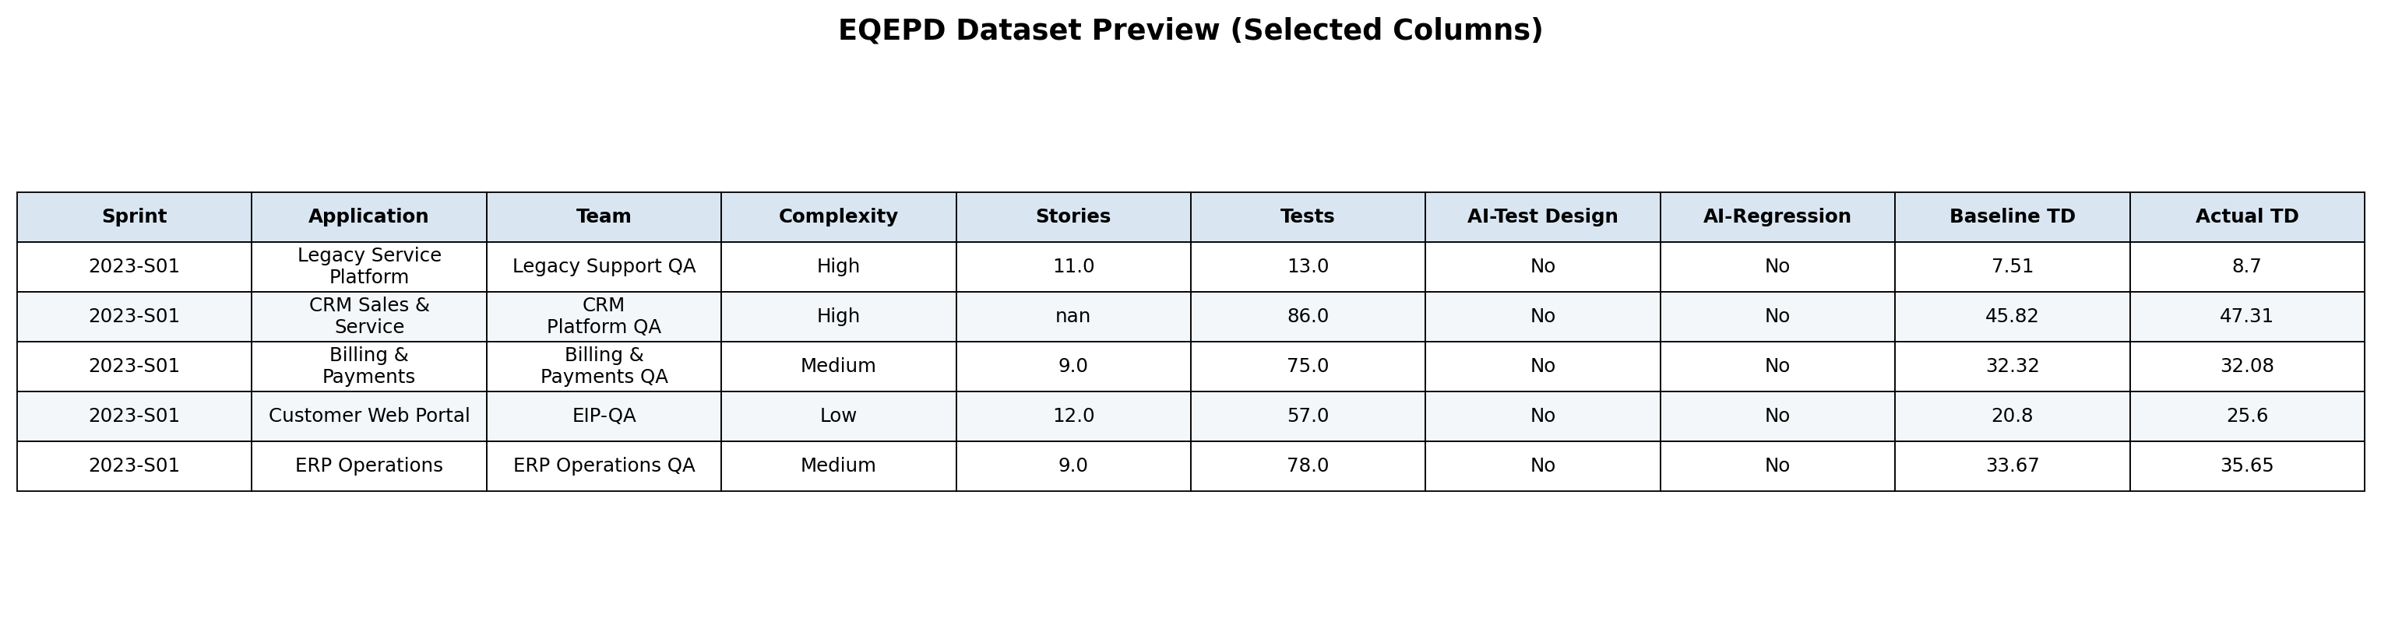

Figure 3: EQEPD Dataset Preview

Note. Selected columns from the first five records are displayed for readability. The complete 24-column source workbook is to be made available in the GitHub repository.

Data Dictionary (Summary)
Variable Name | Definition | Datatype | Allowed Values/Range | Missing Values Handling | Notes
Sprint # | Delivery period identifier; source of year and sprint-number features | Text | YYYY-Snn | Not imputed | Grouping variable for validation
Application_Name | Anonymised application/platform category | Categorical | Standardized to 8 applications | Mode not used; category retained | One-hot encoded for models
Team_Name | Anonymised QE team category | Categorical | Standardised to 8 teams | Category retained | Potential organisational context
Complexity | Assessed project complexity | Ordinal category | Low, Medium, High | Standardised aliases | One-hot encoded
User story count | User stories in the observation | Numeric count | Non-negative | Median imputation | Workload proxy
test case count | Test cases in the observation | Numeric count | Non-negative | Median imputation | Testing-intensity proxy
AI Usage Testing Phase (…) | AI use in each of six phases | Binary category | Yes/No | Standardised variants | Converted to 1/0 flags
Baseline effort (…) | Expected effort hours for each phase | Numeric continuous | Greater than 0 for target calculation | Not imputed for outcomes | Primary denominator
Actual effort (…) | Observed effort hours for each phase | Numeric continuous | Non-negative | Not imputed for outcomes | Primary observed effort
QE_Phase | Lifecycle phase in long dataset | Categorical | Six named phases | Derived | Used in phase comparison
Effort_Saved | Baseline effort minus actual effort | Numeric continuous | Positive or negative | Derived only when both efforts valid | Absolute operational benefit
Productivity_Improvement_Pct | Relative phase effort reduction | Numeric continuous | Unbounded in raw calculation | No imputation; winsorised only for modelling | Primary RQ1–RQ3 outcome
AI_Phase_Count | Number of phases using AI | Integer | 0–6 | Derived | Adoption breadth
AI_Adoption_Rate | AI_Phase_Count divided by 6 | Numeric proportion | 0–1 | Derived | Normalised adoption breadth
Overall_Productivity_Improvement_Pct | Aggregate project/sprint effort reduction | Numeric continuous | Unbounded in raw calculation | Winsorised at 1st/99th percentiles for modelling | RQ4 target
AI_Exposure by Phase | AI flag multiplied by phase baseline share | Numeric proportion | 0–1 | Derived | Workload-weighted AI use
Table 5: Data Dictionary Summary
Note. The complete field-level dictionary, including all six baseline, actual-effort, and AI-use fields, is provided in Appendix B.

GitHub Data Availability Statement
The raw and processed datasets will be available in the GitHub repository under the following paths:
- Raw data: data/raw/EQEPD_Dataset_v5.xlsx;
- processed project data: data/processed/EQEPD_Cleaned_Project_Level.csv;
- processed phase data: data/processed/EQEPD_Engineered_Phase_Level.csv;
- code and notebooks: notebooks/QM640_EQEPD_Capstone_Final.ipynb;
- model outputs: outputs/.
The repository should also include a README that states the Python environment, package versions, execution order, target definitions, and any ethical or confidentiality constraints. The active URL is provided in page 2.

Analysis

Data Cleaning
Data cleaning was deliberately conservative so that the analysis would not remove operationally difficult cases merely because they were unusual. The raw workbook contained 459 records and 24 variables. Two rows were exact duplicates and were removed, leaving 457 project/sprint observations. Near-duplicate rows were not automatically discarded because repeated application/team/sprint combinations can represent legitimate records. The duplicate rule was therefore exact equality across all columns, which is reproducible and avoids subjective deletion.
Missingness was limited and dispersed. User story count had the highest missing count at six records (1.31%). Five values were missing in actual Regression Testing effort, five in actual Automation Development effort, four in actual Test Design effort, and four in baseline Automation Development effort; other affected fields had between two and three missing values. Contextual count variables were median-imputed because they are predictors rather than outcomes and because median imputation is less sensitive to skew. Baseline and actual effort were not imputed for productivity calculations. Imputing these fields would manufacture the dependent variable and could create artificial evidence of improvement. Instead, only the affected phase observation was excluded when the target could not be computed.
Categorical inconsistencies were standardised before grouping. Application labels were consolidated from 15 raw variants to 8 standardised applications, and team labels were reduced from 13 variants to 8 teams. AI-use entries such as Yes, YES, Y, yes, No, NO, N, and no were mapped to consistent Yes/No values. Complexity abbreviations and case variants were mapped to Low, Medium, and High. Year and sprint number were parsed from Sprint # to support trend analysis and grouped validation. These transformations were documented rather than applied silently so that an evaluator can compare raw and cleaned categories.
Potential outliers were reviewed rather than removed. The phase-level productivity distribution produced 86 observations outside the conventional 1.5 interquartile-range bounds, with approximate bounds of −41.00% and 48.25%. Such values may represent genuine overruns, unusually successful automation, small denominators, or data-entry issues. They were retained for descriptive and non-parametric hypothesis testing because excluding them could suppress legitimate operational variability. For predictive modelling only, the project-level target was winsorised at the 1st and 99th percentiles to reduce the influence of extreme outcomes on model stability while preserving the records.
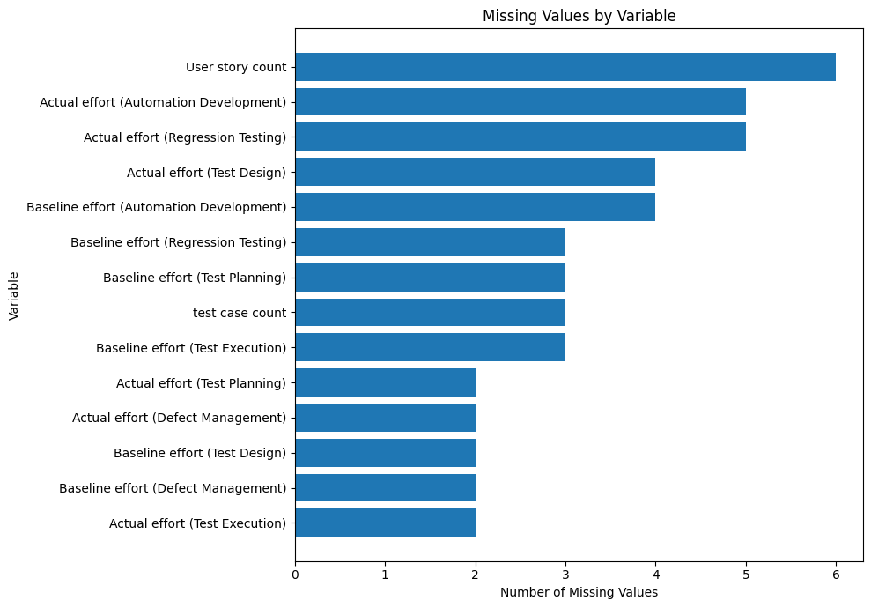
Figure 4: Missing Values by Variable

Note. Missingness was below 1.31% for every variable. Context counts were median-imputed, while effort fields were not imputed for outcome calculation.

Issue | Variables Affected | Detection Method | Treatment Applied | Rationale
Missing values | User story count, test case count, selected baseline/actual effort fields | Null counts and percentages | Median-impute contextual counts; do not impute effort outcomes; exclude only invalid phase target | Preserves predictor coverage without creating artificial productivity values
Exact duplicates | All 24 raw columns | Full-row equality check | Remove 2 exact duplicates | Avoids double-counting while retaining legitimate repeated contexts
Application aliases | Application_Name | Unique-value and frequency review | Consolidate 15 raw labels to 8 applications | Prevents fragmented group statistics
Team aliases | Team_Name | Unique-value and frequency review | Consolidate 13 raw labels to 8 teams | Creates consistent organisational categories
AI label variants | Six AI-use variables | Value-frequency review | Map Yes/YES/Y and No/NO/N variants to Yes/No | Required for valid binary comparison
Complexity variants | Complexity | Unique-value review | Map abbreviations and case variants to Low/Medium/High | Supports interpretable grouping and modelling
Outliers | Productivity improvement targets | Histogram, boxplot, IQR rule | Retain for EDA and hypothesis tests; winsorise project target only for models | Balances operational realism and model stability
Target leakage | Actual effort and derived outcome fields | Feature lineage review | Exclude actual effort, effort saved, and outcome-derived fields from predictive features | Prevents future information from inflating RQ4 performance

Table 6: Data Cleaning Log

Exploratory Data Analysis Results

AI Adoption Trend
AI adoption increased materially over the four-year period. The proportion of phase observations marked as AI-assisted rose from 7.17% in 2023 to 20.66% in 2024, 42.67% in 2025, and 64.20% in 2026. Figure 5 therefore describes a staged adoption journey rather than a single transition. This matters for interpretation because later observations may also reflect improved tooling, user familiarity, process maturity, or portfolio selection. Year and sprint variables are retained in the influence model to reduce the risk that the AI coefficient merely captures a time trend.
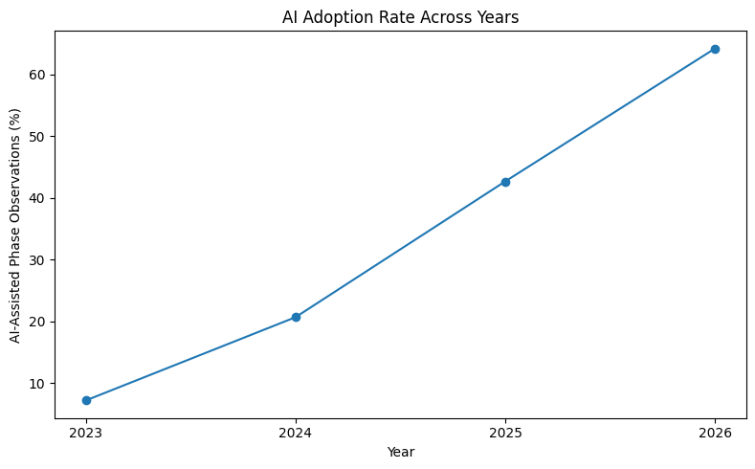
Figure 5: AI Adoption Rate Across Years

Note. The adoption rate is the percentage of phase observations with AI_Used = Yes in each year.

Adoption by QE Lifecycle Phase
Adoption was uneven across the lifecycle, as shown in Figure 6. Test Design had the highest AI-use rate at 66.08%, followed by Automation Development at 54.27% and Regression Testing at 38.29%. Defect Management was 24.95%, Test Planning was 13.13%, and Test Execution was only 6.13%. This distribution is operationally meaningful: phases with more structured digital artefacts and reusable patterns appear to have adopted AI earlier, whereas activities tied to environments, execution dependencies, and high-consequence judgement show lower penetration. The phase differences also mean that raw totals alone cannot be used to infer value; both adoption volume and phase-level improvement must be examined.
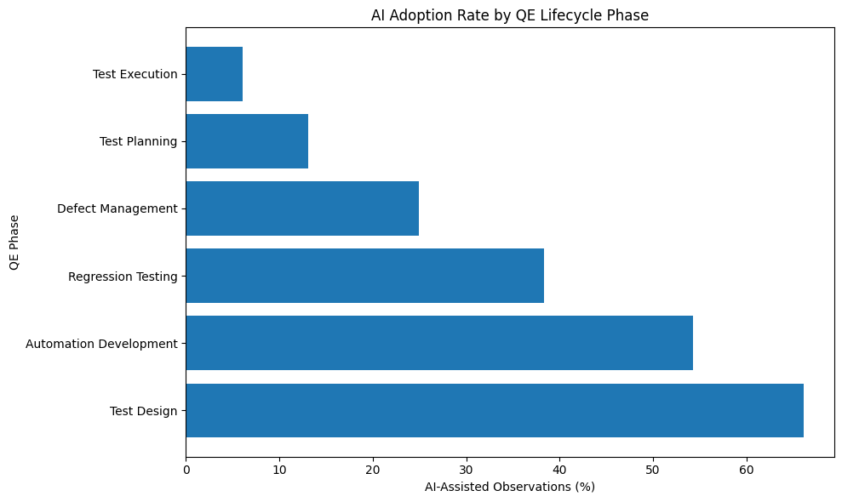
Figure 6: AI Adoption Rate by QE Lifecycle Phase

Note. Test Design and Automation Development account for the highest adoption rates, while Test Execution remains the least adopted phase.

AI-Assisted Versus Traditional Productivity
The central exploratory comparison shows a substantial gap between AI-assisted and traditional work. Across 906 valid AI-assisted phase observations, mean productivity improvement was 16.95% and median improvement was 20.26%. Across 1,799 traditional observations, mean improvement was −4.63% and median improvement was −2.71%. The AI-assisted group saved 4,417.6 hours in aggregate, whereas traditional observations exceeded baseline effort by 1,184.1 hours. Figure 7 shows that the distributions overlap, so AI does not guarantee a positive outcome in every case, but the centre of the AI-assisted distribution is clearly higher. The gap is later tested formally under RQ1.

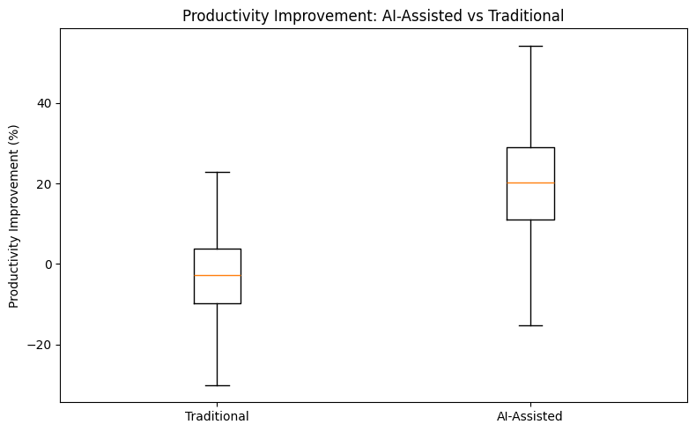
Figure 7: Productivity Improvement for AI-Assisted and Traditional Activities

Note. The boxplot suppresses extreme points for visual clarity; all valid observations remain in the statistical analysis.

Productivity and Business Value by Phase
Phase-level analysis indicates that AI value is not uniform. Regression Testing produced the highest mean improvement at 22.23%, followed by Test Design at 19.92% and Automation Development at 16.62%. Defect Management averaged 10.27%, Test Planning 6.46%, and Test Execution 3.93%. Cumulative effort savings tell a complementary story: Test Design saved approximately 1,857.6 hours and Automation Development 1,420.2 hours because they combine substantial improvement with larger adoption volume. Regression Testing saved 896.6 hours despite fewer AI-assisted observations. Figure 8 therefore supports a two-dimensional prioritisation approach: percentage improvement indicates efficiency, while total hours saved indicates portfolio-scale impact.
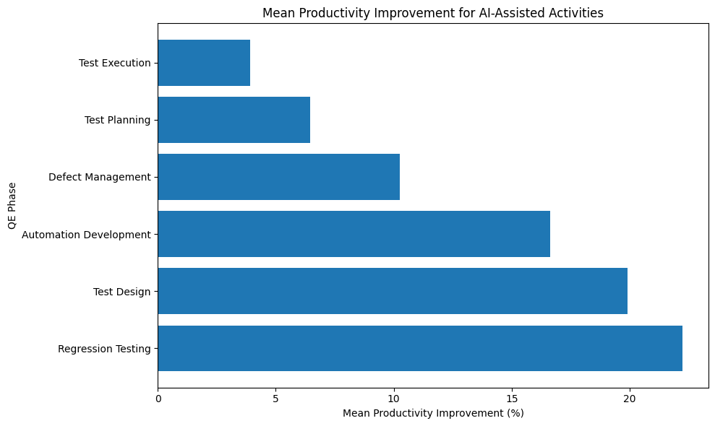
Figure 8: Mean Productivity Improvement for AI-Assisted Activities by Phase

Note. Regression Testing has the highest mean percentage improvement; Test Design and Automation Development also demonstrate strong preliminary value.

Breadth of AI Adoption
Overall project/sprint productivity increased as AI was used across more lifecycle phases. Records with no AI averaged −4.62% overall productivity, while projects using AI in one, two, three, and four phases averaged 0.98%, 6.89%, 9.73%, and 12.97%, respectively. Projects with five phases averaged 16.93%, and the small group with all six phases averaged 18.47%. Figure 9 suggests that adoption breadth is a useful portfolio signal, but it should not be read as causal proof that adding AI to every phase automatically creates improvement. More mature teams may both adopt AI broadly and manage delivery more effectively. This is why AI Phase Count is treated as a predictive feature and the final recommendations retain phase-specific governance.
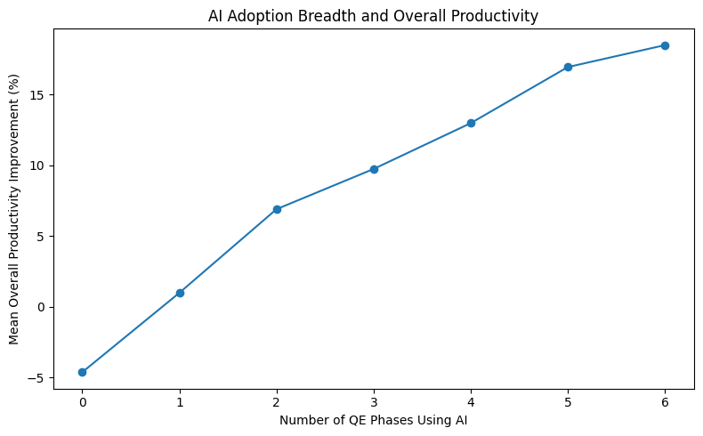
Figure 9: Relationship Between AI Adoption Breadth and Overall Productivity

Note. The six-phase group contains only seven records, so its mean is less stable than estimates for larger groups.
Figure/Table Reference | What It Shows | Key Insight | Why It Matters | Decision/Next Step
Figure 5 | AI adoption by year | Adoption rose from 7.17% in 2023 to 64.20% in 2026 | Time trend may influence RQ1/RQ3 | Retain year and sprint controls
Figure 6 | Adoption by phase | Test Design and Automation Development lead; Test Execution lags | Supports phase-specific RQ2 analysis | Avoid uniform rollout assumptions
Figure 7 | AI vs traditional productivity | AI group centre is materially higher than traditional | Direct preliminary evidence for RQ1 | Use Mann–Whitney and effect sizes
Figure 8 | AI productivity by phase | Regression Testing, Test Design, and Automation Development lead | Identifies likely priority areas for RQ2 | Run Kruskal–Wallis and post-hoc tests
Figure 9 | AI breadth and overall productivity | Wider adoption is associated with stronger overall results | Provides candidate feature for RQ4 | Include AI Phase Count and exposure features

Table 7: EDA Insight Summary

Modelling

Choice of Models With Justification
The modelling stage addresses two distinct analytical needs. First, a multiple linear regression at the phase level is used to estimate the relationship between AI usage and productivity while controlling for phase, application, complexity, baseline effort, workload, year, and sprint. Cluster-robust standard errors are calculated by sprint because six phase observations can originate from the same project/sprint record. This model is primarily explanatory: the AI coefficient can be interpreted in percentage points after other included factors are held constant.
Second, three supervised regression algorithms are compared at the project/sprint level for RQ4. Linear Regression is included as an interpretable baseline and to test whether the relationship is approximately additive. Random Forest Regression is included because project outcomes may depend on nonlinear thresholds and interactions among AI breadth, baseline workload, phase allocation, complexity, and application context. Gradient Boosting Regression is included because sequentially correcting residual errors often performs well on structured tabular data. Comparing these models provides a more defensible result than reporting only the highest-performing algorithm.
The validation design is intentionally grouped by sprint. An 80/20 holdout split assigns complete sprint groups to either training or test data so that records from the same delivery period do not appear on both sides. Grouped five-fold cross-validation is then used to assess stability. This is stricter than a random row split and reduces information leakage caused by shared timing, organisational context, or portfolio conditions. The target is winsorised only in the predictive dataset at the 1st and 99th percentiles; actual effort and all variables derived from actual outcomes are excluded from the feature set.

Features Included and Feature Engineering

Feature | Original/Engineered | Type | Reason for Inclusion | Used in Model(s)
Application_Name | Original | Categorical | Captures platform/context differences | All predictive models
Team_Name | Original | Categorical | Captures organisational context; reviewed for potential overfitting | All predictive models
Complexity | Original | Categorical | Represents assessed delivery difficulty | All predictive models
User story count | Original | Numeric | Workload size proxy | All predictive models
test case count | Original | Numeric | Testing volume/intensity proxy | All predictive models
Baseline effort by phase | Original | Numeric | Expected workload distribution | All predictive models
Total_Baseline_Effort | Engineered | Numeric | Overall project effort scale | All predictive models
AI indicator by phase | Original recoded | Binary | Identifies where AI is applied | All predictive models
AI_Phase_Count | Engineered | Integer 0–6 | Measures breadth of adoption | All predictive models
AI_Adoption_Rate | Engineered | Proportion | Normalises adoption breadth | Sensitivity/alternative specification
Baseline Share by Phase | Engineered | Proportion | Represents workload allocation across lifecycle | All predictive models
AI Exposure by Phase | Engineered | Proportion | Weights AI use by phase workload | All predictive models
Story-to-Test Ratio | Engineered | Numeric | Proxy for test intensity per requirement | All predictive models
Year and Sprint Number | Engineered | Numeric | Controls temporal adoption/maturity patterns | Influence model; candidate predictive controls
Actual effort / effort saved | Outcome-derived | Excluded | Would reveal the target and create leakage | None
Table 8: Feature Set and Usage
Note. Categorical variables are one-hot encoded. Numeric variables are median-imputed; scaling is applied where required by the model pipeline.

Evaluation Metrics (Formulae and Illustrative Calculations)

Metric | Formula | Interpretation | Used For | Illustrative Calculation
Productivity Improvement % | ((Baseline − Actual) / Baseline) × 100 | Relative effort reduction; positive is favourable | Outcome engineering | Baseline 20, actual 16: (4/20)×100 = 20%
MAE | (1/n) Σ |yᵢ − ŷᵢ| | Average absolute prediction error in percentage points | Model comparison | Observed 12, predicted 8: absolute error = 4 points
RMSE | √[(1/n) Σ (yᵢ − ŷᵢ)²] | Penalises large prediction errors more strongly | Model comparison | Errors 2 and 6: √[(4+36)/2] = 4.47
R² | 1 − [Σ(yᵢ − ŷᵢ)² / Σ(yᵢ − ȳ)²] | Share of unseen target variance explained | Model comparison | R² = .405 means 40.5% of test variation explained
Cohen’s d | (Mean₁ − Mean₂) / pooled SD | Standardised practical difference between two means | RQ1 effect size | d ≈ 1.16 indicates a large difference
Rank-biserial correlation | 2U/(n₁n₂) − 1 (direction depends on group order) | Non-parametric effect size for Mann–Whitney | RQ1 robustness | |r| near .71 indicates strong separation
Table 9: Evaluation Metrics and Formulae
Note. Only regression and statistical-comparison metrics relevant to this project are retained; classification metrics such as accuracy, precision, recall, and F1-score are not applicable

Preliminary Results

Preliminary Findings by Research Question

RQ1: Does AI Adoption Significantly Improve QE Productivity?
Preliminary evidence strongly supports a productivity difference. AI-assisted phase observations averaged 16.953% improvement, compared with −4.629% for traditional observations, a difference of 21.582 percentage points. Because the distribution contained outliers and Levene’s test indicated unequal variances, the Mann–Whitney U test was selected as the primary comparison. The result was U = 1,392,443, p < .001. Welch’s t-test produced a consistent sensitivity result, t = 27.481, p < .001. Cohen’s d was 1.159 and the rank-biserial correlation was approximately 0.709, indicating that the difference is not only statistically significant but also practically large. At the interim stage, H₀₁ is rejected, subject to final documentation and sensitivity review.

RQ2: Does Business Value Differ Across QE Lifecycle Phases?
The preliminary Kruskal–Wallis test across AI-assisted phases produced H = 92.721, p < .001, with epsilon-squared = .097. This indicates that phase membership explains a meaningful portion of the rank variation and that the six phases should not be treated as equivalent. Holm-adjusted pairwise Mann–Whitney tests were significant in 13 of 15 comparisons. Regression Testing, Test Design, and Automation Development form the strongest group by mean improvement; Test Planning and Test Execution form the weakest. Test Design and Regression Testing were not significantly different after adjustment, and Test Planning and Test Execution were also not significantly different. H₀₂ is therefore rejected at the interim stage.

RQ3: Which Factors Influence Productivity Improvement?
A multiple linear regression was estimated using the valid phase-level dataset. The productivity-improvement outcome was winsorised at the 1st and 99th percentiles to reduce the influence of extreme values. The model included AI usage, baseline effort, user-story count, test-case count, year, sprint number, lifecycle phase, complexity, and application as predictors. Sprint-clustered robust standard errors were used to account for potential dependence among observations belonging to the same sprint.
AI usage showed the strongest statistical association with productivity improvement among the coefficients reported in the model. After controlling for the other included variables, AI usage was associated with a 16.686-percentage-point increase in productivity improvement, B = 16.686, 95% CI [14.247, 19.125], p < .001. Test-case count also had a statistically significant positive association with productivity improvement, B = 0.050, 95% CI [0.014, 0.086], p = .006.
Lifecycle phase was also associated with productivity improvement. Relative to the omitted phase reference category, Test Execution was associated with lower productivity improvement, B = −6.223, 95% CI [−10.049, −2.398], p = .001. Defect Management was also associated with lower productivity improvement, B = −4.673, 95% CI [−7.592, −1.755], p = .002, as was Test Planning, B = −6.144, 95% CI [−9.984, −2.304], p = .002. In contrast, Test Design was associated with higher productivity improvement, B = 3.077, 95% CI [0.763, 5.391], p = .009.
Among the application categories, Customer Web Portal had a statistically significant positive coefficient relative to the omitted application reference category, B = 2.563, 95% CI [0.133, 4.992], p = .039. The coefficients for baseline effort, user-story count, year, low complexity, Enterprise Data Platform, Mobile Service App, and CRM Sales & Service were not statistically significant at the .05 level.
These results represent conditional associations within the fitted regression model and should not be interpreted as evidence of causal effect.

RQ4: Can Models Predict Improvement and Support Prioritisation?
Random Forest produced the strongest preliminary grouped holdout performance, with MAE = 5.685 percentage points, RMSE = 7.286, and R² = .405. Linear Regression was close, with MAE = 5.802, RMSE = 7.460, and R² = .376. Gradient Boosting produced MAE = 5.935, RMSE = 7.512, and R² = .368. Grouped five-fold cross-validation also ranked Random Forest first, with mean CV R² = .471 and standard deviation = .083. The model therefore provides moderate directional value: an average absolute error near 5.7 percentage points may be acceptable for screening a portfolio, but it is too large for precise budgeting or automatic commitments. Preliminary support is provided for H₁₄, with the qualification that the model is decision support rather than an autonomous forecast.

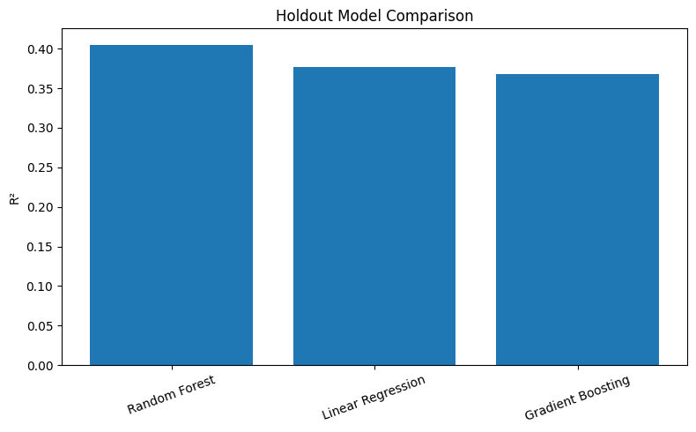
Figure 10: Grouped Holdout Model Comparison

Note. Random Forest achieved the highest preliminary R² on sprint-grouped holdout data. Differences among models are moderate, so final selection also considers stability and interpretability.

Model | Feature Set | Validation Approach | Metric 1 | Metric 2 | Key Takeaway
Random Forest | Project context, baseline workload, AI breadth, phase shares and exposures | 80/20 sprint-grouped holdout; grouped 5-fold CV | MAE 5.685 | R² .405 | Best holdout and CV performance; useful for directional screening
Linear Regression | Same encoded feature set with scaled numeric fields | 80/20 sprint-grouped holdout; grouped 5-fold CV | MAE 5.802 | R² .376 | Strong transparent baseline; coefficients easier to explain
Gradient Boosting | Same encoded feature set | 80/20 sprint-grouped holdout; grouped 5-fold CV | MAE 5.935 | R² .368 | Competitive but did not exceed Random Forest in current tuning

Table 10: Preliminary Model Performance Comparison

Preliminary Feature Importance
Permutation importance for the selected Random Forest identifies AI Phase Count as the dominant feature, with a mean decrease in R² of approximately .403 when permuted. The next features—baseline Test Planning effort, Test Execution baseline share, and phase-specific AI exposure variables—have much smaller importance values. This result is consistent with the exploratory breadth pattern, but it should not be interpreted as causal proof. AI Phase Count may also proxy programme maturity, standardisation, and leadership support. Final reporting should therefore pair the importance chart with partial dependence or sensitivity checks and should avoid presenting the model as evidence that every project should enable all six phases.

RQ | Work Completed | Preliminary Output | Interim Decision | Remaining Work
RQ1 | Completed preliminary test | AI mean 16.95% vs traditional −4.63%; p < .001; large effect | Reject H₀₁ provisionally | Final sensitivity narrative
RQ2 | Completed omnibus and post-hoc tests | H = 92.721; p < .001; 13/15 adjusted comparisons significant | Reject H₀₂ provisionally | Final phase-priority interpretation
RQ3 | Completed preliminary influence model | AI coefficient +16.686 points; p < .001; model R² .272 | Reject H₀₃ provisionally | Check specification stability
RQ4 | Baseline models completed | Random Forest holdout R² .405, MAE 5.685 | Partial support for H₁₄ | Final tuning, diagnostics, and usage boundaries
Table 11: Research Question Progress and Interim Decision

Interim Limitations and Risks
- The dataset is anonymised and does not contain direct financial cost, licence cost, defect leakage, test coverage, automation coverage, rework, or quality-acceptance measures. Productivity is therefore an incomplete proxy for total business value.
- The analysis is observational. AI-adopting teams may differ from traditional teams in maturity, process discipline, leadership, toolchain, or project selection. Regression controls reduce but do not eliminate confounding.
- AI usage is binary by phase. The data does not distinguish tool type, frequency, assistance intensity, prompt quality, or human-review effort, all of which may explain variation within the AI-assisted group.
- Multiple phase observations originate from the same project/sprint record. Cluster-robust inference and grouped validation address dependence, but a future hierarchical model may represent application, team, sprint, and phase structure more directly.
- Percentage improvement can be unstable when baseline effort is small. Non-parametric tests and winsorisation reduce sensitivity, but final reporting should also show absolute hours saved and minimum baseline thresholds.
- The best predictive model explains approximately 40.5% of unseen variation. Important operational predictors remain unmeasured, and the model should not be used for precise budgets or individual performance assessment.

Next Steps for the Final Report
- Insert the active GitHub repository URL and verify that the evaluator can access all raw, processed, code, and output files.
- Re-run the notebook from a clean environment and record Python and package versions in the README.
- Complete sensitivity checks for alternative outlier treatment, model specifications, and grouped validation seeds.
- Review residual and error distributions and identify project segments where prediction error is materially higher.
- Validate the stability of permutation importance and test whether AI Phase Count remains dominant under alternative feature sets.
- Integrate productivity findings with governance considerations from the literature, especially human validation and output-quality controls.
- Finalise the phase-based adoption roadmap: scale now, controlled expansion, and targeted pilots.
- Complete APA 7 checks for headings, table/figure references, citations, bibliography, page numbering, and appendix cross-references.
- Prepare the final report and archive the immutable submission package in the repository.

The final report will retain the distinction between statistical association, predictive usefulness, and causal evidence. Recommendations will be framed as phased decisions supported by observed productivity and operational context, not as a claim that AI should be applied uniformly to every QE activity. Code used to calculate the core productivity measures and model metrics is summarised in Appendix A, and the complete field-level data dictionary is provided in Appendix B.

Bibliography
- Ardic, B., Le Dilavrec, Q., & Zaidman, A. (2026). How students use generative AI for software testing: An observational study. Empirical Software Engineering, 31, Article 167. https://doi.org/10.1007/s10664-026-10898-0
- Breiman, L. (2001). Random forests. Machine Learning, 45(1), 5–32. https://doi.org/10.1023/A:1010933404324
- Durelli, V. H. S., Durelli, R. S., Borges, S. S., Endo, A. T., Eler, M. M., Dias, D. R. C., & Guimarães, M. de P. (2019). Machine learning applied to software testing: A systematic mapping study. IEEE Transactions on Reliability, 68(3), 1189–1212. https://doi.org/10.1109/TR.2019.2892517
- Friedman, J. H. (2001). Greedy function approximation: A gradient boosting machine. The Annals of Statistics, 29(5), 1189–1232. https://doi.org/10.1214/aos/1013203451
- Garousi, V., Felderer, M., Kuhrmann, M., Herkiloğlu, K., & Eldh, S. (2020). Exploring the industry’s challenges in software testing: An empirical study. Journal of Software: Evolution and Process, 32(8), e2251. https://doi.org/10.1002/smr.2251
- Haldar, S., & Capretz, L. F. (2026). Automated test plan generation using large language models. Software Quality Journal, 34, Article 8. https://doi.org/10.1007/s11219-026-09744-9
- James, G., Witten, D., Hastie, T., & Tibshirani, R. (2021). An introduction to statistical learning: With applications in R (2nd ed.).Springer. https://doi.org/10.1007/978-1-0716-1418-1
- Ouédraogo, W. C., Kaboré, A. K., Li, Y., Tian, H., Koyuncu, A., Klein, J., Lo, D., & Bissyandé, T. F. (2026). Prompt engineering in LLMs for automated unit test generation: A large-scale study. Empirical Software Engineering, 31, Article 103. https://doi.org/10.1007/s10664-026-10840-4
- Raharjana, I. K., Husna, O. I., Hariyanti, E., & Fauzi, S. S. M. (2025). Mapping the landscape of deep learning in software testing: A bibliometric analysis. Discover Artificial Intelligence, 5(1), Article 402. https://doi.org/10.1007/s44163-025-00596-z
- Romero, J. R., Ramírez, A., & García-Martínez, C. (2026). Automated machine learning for test case prioritisation. Empirical Software Engineering, 31, Article 120. https://doi.org/10.1007/s10664-026-10862-y
- Venugopal, S. (2026). Enterprise Quality Engineering Performance Dataset (EQEPD) https://github.com/satisho/QM640_Data-Analytics_Capstone
- Wang, J., Huang, Y., Chen, C., Liu, Z., Wang, S., & Wang, Q. (2024). Software testing with large language models: Survey, landscape, and vision. IEEE Transactions on Software Engineering, 50(4), 911–936. https://doi.org/10.1109/TSE.2024.3368208
- Willmott, C. J., & Matsuura, K. (2005). Advantages of the mean absolute error over the root mean square error in assessing average model performance. Climate Research, 30, 79–82. https://doi.org/10.3354/cr030079
- Yoo, S., & Harman, M. (2012). Regression testing minimization, selection and prioritization: A survey. Software Testing, Verification and Reliability, 22(2), 67–120. https://doi.org/10.1002/stvr.430

Appendix A: Core Analytical Calculations
The executed Jupyter notebook in the GitHub repository contains the complete code. The extracts below document the principal calculations referenced in the report and are included to support reproducibility without reproducing the entire notebook.

# Phase-level effort and productivity
phase_data['Effort_Saved'] = phase_data['Baseline_Effort'] - phase_data['Actual_Effort']
phase_data['Productivity_Improvement_Pct'] = ( phase_data['Effort_Saved'] / phase_data['Baseline_Effort'] * 100)

# Project-level target
project_data['Total_Effort_Saved'] = ( project_data['Total_Baseline_Effort'] - project_data['Total_Actual_Effort'])
project_data['Overall_Productivity_Improvement_Pct'] = ( project_data['Total_Effort_Saved'] / project_data['Total_Baseline_Effort'] * 100)

# Leakage-aware grouping concept
# Split by Sprint # so the same sprint never appears in both train and test data.

Appendix B: Complete Field-Level Data Dictionary
Variable Name | Definition | Datatype | Allowed Values/Range | Missing Values Handling | Notes
Sprint # | Project delivery sprint identifier | Text | YYYY-Snn | Not imputed | Used to derive Year and Sprint_Number; grouping key
Application_Name | Anonymised application/platform | Categorical | 8 standardised values | Retained as category | One-hot encoded
Team_Name | Anonymised QE team | Categorical | 8 standardised values | Retained as category | One-hot encoded / context
Complexity | Project complexity | Categorical | Low, Medium, High | Aliases standardised | One-hot encoded
User story count | Number of user stories | Numeric count | Non-negative | Median imputed | Workload predictor
test case count | Number of test cases | Numeric count | Non-negative | Median imputed | Testing-volume predictor
AI Usage Testing Phase (Test Planning) | AI assistance used in Test Planning | Binary category | Yes/No | Variants standardised | Converted to binary flag
AI Usage Testing Phase (Test Design) | AI assistance used in Test Design | Binary category | Yes/No | Variants standardised | Converted to binary flag
AI Usage Testing Phase (Automation Development) | AI assistance used in Automation Development | Binary category | Yes/No | Variants standardised | Converted to binary flag
AI Usage Testing Phase (Test Execution) | AI assistance used in Test Execution | Binary category | Yes/No | Variants standardised | Converted to binary flag
AI Usage Testing Phase (Regression Testing) | AI assistance used in Regression Testing | Binary category | Yes/No | Variants standardised | Converted to binary flag
AI Usage Testing Phase (Defect Management) | AI assistance used in Defect Management | Binary category | Yes/No | Variants standardised | Converted to binary flag
Baseline effort (Test Planning) | Expected effort for Test Planning in hours | Numeric continuous | Normally > 0 | Not imputed for outcomes | Target denominator
Baseline effort (Test Design) | Expected effort for Test Design in hours | Numeric continuous | Normally > 0 | Not imputed for outcomes | Target denominator
Baseline effort (Automation Development) | Expected effort for Automation Development in hours | Numeric continuous | Normally > 0 | Not imputed for outcomes | Target denominator
Baseline effort (Test Execution) | Expected effort for Test Execution in hours | Numeric continuous | Normally > 0 | Not imputed for outcomes | Target denominator
Baseline effort (Regression Testing) | Expected effort for Regression Testing in hours | Numeric continuous | Normally > 0 | Not imputed for outcomes | Target denominator
Baseline effort (Defect Management) | Expected effort for Defect Management in hours | Numeric continuous | Normally > 0 | Not imputed for outcomes | Target denominator
Actual effort (Test Planning) | Observed effort for Test Planning in hours | Numeric continuous | ≥ 0 | Not imputed for outcomes | Used only to create outcomes; excluded from predictors
Actual effort (Test Design) | Observed effort for Test Design in hours | Numeric continuous | ≥ 0 | Not imputed for outcomes | Used only to create outcomes; excluded from predictors
Actual effort (Automation Development) | Observed effort for Automation Development in hours | Numeric continuous | ≥ 0 | Not imputed for outcomes | Used only to create outcomes; excluded from predictors
Actual effort (Test Execution) | Observed effort for Test Execution in hours | Numeric continuous | ≥ 0 | Not imputed for outcomes | Used only to create outcomes; excluded from predictors
Actual effort (Regression Testing) | Observed effort for Regression Testing in hours | Numeric continuous | ≥ 0 | Not imputed for outcomes | Used only to create outcomes; excluded from predictors
Actual effort (Defect Management) | Observed effort for Defect Management in hours | Numeric continuous | ≥ 0 | Not imputed for outcomes | Used only to create outcomes; excluded from predictors
Year | Calendar year derived from Sprint # | Integer | 2023–2026 | Derived | Trend/control feature
Sprint_Number | Numeric sprint sequence derived from Sprint # | Integer | Positive | Derived | Trend/control feature
QE_Phase | Lifecycle phase in long-format data | Categorical | Six phases | Derived | Phase comparison
AI_Used | Standardised phase-level AI indicator | Binary category | Yes/No | Derived from phase field | RQ1 grouping
AI_Used_Flag | Numeric phase-level AI indicator | Binary numeric | 0/1 | Derived | Regression input
Baseline_Effort | Phase baseline effort in long data | Numeric continuous | > 0 for target | No imputation | Phase workload
Actual_Effort | Phase actual effort in long data | Numeric continuous | ≥ 0 | No imputation | Outcome input only
Effort_Saved | Baseline_Effort − Actual_Effort | Numeric continuous | Positive/negative | Derived | Absolute benefit
Productivity_Improvement_Pct | Effort_Saved / Baseline_Effort × 100 | Numeric continuous | Can be positive/negative | Derived; winsorised only in selected model use | RQ1–RQ3 target
Total_Baseline_Effort | Sum of six phase baselines | Numeric continuous | Positive | Derived | Project scale
Total_Actual_Effort | Sum of six phase actuals | Numeric continuous | Non-negative | Derived | Outcome input; excluded from model features
Total_Effort_Saved | Total baseline − total actual | Numeric continuous | Positive/negative | Derived | Project absolute benefit
Overall_Productivity_Improvement_Pct | Total saved / total baseline × 100 | Numeric continuous | Can be positive/negative | Derived; winsorised 1st/99th for models | RQ4 target
AI_Phase_Count | Count of phase AI flags | Integer | 0–6 | Derived | Adoption breadth
AI_Adoption_Rate | AI_Phase_Count / 6 | Numeric proportion | 0–1 | Derived | Normalised breadth
Baseline_Share_<Phase> | Phase baseline / total baseline | Numeric proportion | 0–1 | Derived | Workload allocation
AI_Exposure_<Phase> | AI phase flag × baseline share | Numeric proportion | 0–1 | Derived | Workload-weighted AI use
Story_to_Test_Ratio | test case count / (user story count + 1) | Numeric continuous | ≥ 0 | Derived | Test intensity proxy
Table B1: Complete Raw and Engineered Data Dictionary
Note. Angle-bracket notation indicates a repeated engineered field for each of the six QE phases. The notebook contains the exact column names exported to the processed files.

Appendix C: Interim Submission Checklist
Requirement | Status
Title page and page numbers | Complete
Standalone introduction and problem statement | Complete
GitHub link immediately after title page | Complete
Four research questions | Complete
Minimum 10 literature sources | Complete—12 sources in matrix; 16 bibliography entries
Dataset source, overview, and access paths | Complete
Mandatory data dictionary | Summary in main report; full dictionary in Appendix B
Data cleaning log | Complete
EDA figures with interpretation | Complete
Model justification and feature table | Complete
Evaluation metrics with formulae/calculations | Complete
Preliminary results by RQ | Complete
Limitations and next steps | Complete
APA 7 final check | Complete
Table C1: Interim Report Requirement Checklist

