# P2. Group-18 Database Management and Database Design

# Database System for an E-Commerce

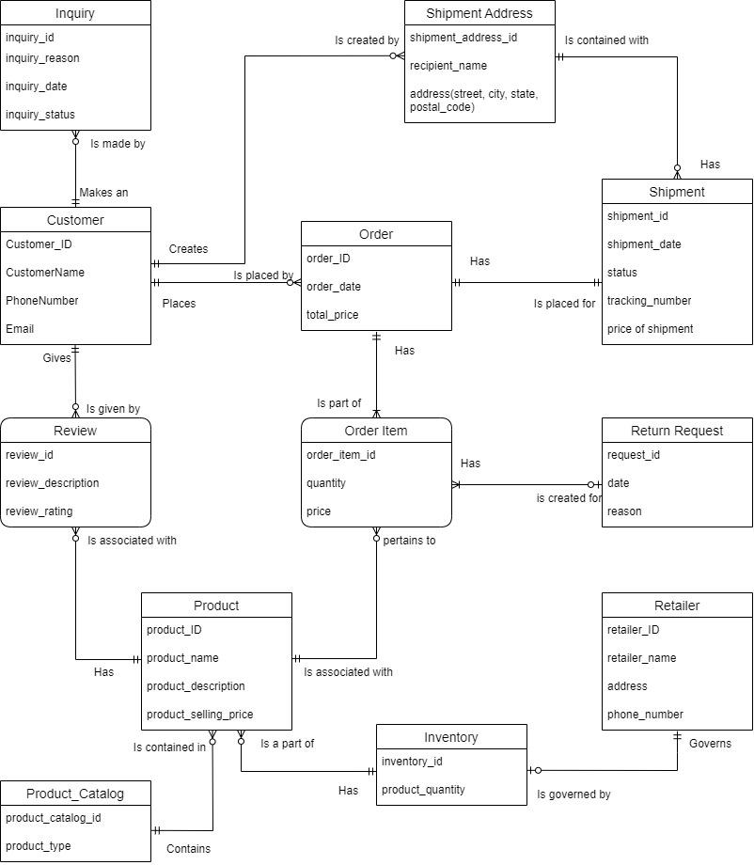

**CUSTOMER:**

Entity Description: It is an entity that consists of data of the customer.

Attributes and Description:

Customer ID: The customer ID is a unique identification number assigned to each individual customer, who enrolled in the e-commerce website. This attribute is basically a numeric or alphanumeric code, which is different for every customer.

Customer Name: Customer name is the personal name of everyone, who enrolls as a user of an online platform.

Customer Ph no: Customer phone number is an attribute that saves the contact number information of the customer’s account. It is used to update the customer about the order verification, shipment, and delivery status.

Customer Email ID: Customer Email ID is one of the essential attributes that tells about the unique email address information connected with an individual customer’s account. It is used to communicate with the customer regarding order confirmation and also to update about shipment and delivery status.

**Relationships**:

A customer can place an order for the products he/she is interested in. While ordering the product, the customer can give a shipment address to which the shipment of the order can be delivered. A customer may also give reviews of the products that he/she ordered and can also raise an inquiry request if needed.

A Customer may create any number of Shipment Addresses.

A Customer can make any number of Inquiry requests.

A Customer can place any number of Orders.

A Customer may review any number of Products.

**ORDER Item:**

Entity Description: It represents each item that is part of the order

Attributes and Description:

Order ITEM ID: The order item ID is a unique identifier associated with each individual item and this attribute also helps in order tracking, shipping, delivery, returns, and refunds.

Quantity: The order quantity is one of the important attributes in e-commerce where it tells about the number of units of a specific item that the customer has ordered as part of their purchase.

Price: the order price is the total cost of the item that the customer has ordered.

**Relationships:**

An order item is an associative entity used to describe a relation between a product and an order. An order has mandatory one to many order items and an order item is a part of mandatory one order.

A product is associated with zero or more order items and an order item pertains to a mandatory one product.

An order item has zero or one return request.

**ORDER:**

Entity Description: Order entity has the data related to the order placed by the customer.

**Attributes and Description:**

Order ID: It is a distinctive identifier associated with each individual customer order in an e-commerce system which helps in order tracking, customer communication, shipping, returns, and refunds.

Order date: The order date attribute tells about the specific date and time when a customer places an order for products or items.

Total price: The total price attribute gives information about the cumulative cost of the entire customer order.

**Relationships:**

An order is placed by a customer and each order will have details about the products ordered, total price etc. An order is associated with a shipment and each product that is part of the order is maintained as an order item.

An Order is placed by a Customer.

An order must have a Shipment.

An order must have at least one Order Item.

**RETURN REQUEST:**

Entity Description: It represents the return initiated by the customer.

Attributes and Description:

Request ID: It is a unique identifier assigned to each customer’s request to return an item in an e-commerce system.

Date: This attribute gives information about the specific date and time when a customer submits a request to return an item they have previously purchased.

Reason: This attribute gives information about the specific cause or explanation given by the customer to return a product or item.

**Relationships:**

A return request is created for mandatory one or more order items.

**SHIPMENT:**

Entity Description: This entity represents of shipment that has been processed after the order placed by the customer.

Attributes and Description:

Shipment ID: This is a unique identification number, which can be either numeric or alphanumeric. It is used to efficiently retrieve all data related to the purchase delivery.

Shipment Date: The shipment date signifies the anticipated delivery date of the purchased product. This information is vital for managing customer purchase shipments.

Tracking Number: A distinctive identification number assigned to each purchase delivery. It enables real-time monitoring of the delivery's status and location.

Status: This attribute provides crucial real-time updates regarding the shipment's whereabouts and progress.

Price: This attribute specifies the value of the product or service. It denotes the cost the customer must pay to acquire it. This value may vary based on discounts and promotions.

**Relationships:**

A shipment has details related to tracking number, status and so on which are helpful in tracking the status of the shipment.

A Shipment has exactly one Shipment Address.

A Shipment is associated with an Order.

**SHIPMENT ADDRESS:**

Entity Description: This entity represents the shipment address of the customers to deliver their orders.

Attributes and Description:

Shipment Address ID: This unique identification number signifies the individual shipping address for each product. It is used to track shipping address, especially in logistics.

Recipient Name: This attribute designates the name of the individual who receives the product during delivery.

Shipment Address (Street, City, State, Postal Code): This crucial attribute stores information about the precise location where the product is to be delivered. It encompasses the street name, city, state, and postal code, ensuring accurate delivery.

**Relationships:**

A Shipment address is created by a customer. It contains details related to the recipient’s name and the address to which the shipment should be delivered.

A Shipment Address is be created by a Customer.

A Shipment Address can have any number of Shipments associated with it.

**Inquiry:**

Entity Description: It represents the concern or complaint raised by the customer.

Attributes and Description:

Inquiry_ID: This is a unique identification number, which can be either numeric or alphanumeric. It is used to efficiently retrieve all data related to the customer's inquiry.

Inquiry_Reason: This attribute designates the reason the customer has reached the helpline for any kind of assistance.

Inquiry_Date: This attribute stores information about the date the customer has reached the helpline for any kind of assistance.

Inquiry_Status: This attribute holds the status of the issue raised by the customer. Like whether the issue is solved or not solved or under hold.

**Relationships:**

An Inquiry is made by a customer to get any support for the issue he/she is facing.

An Inquiry request is made by only the Customer.

**Product:**

Entity Description: This entity represents the data related to the product available in the e-commerce platform.

Attributes and Description:

Product_ID: This is a unique identification number, which can be either numeric or alphanumeric. It is used to efficiently retrieve all data related to the product.

Product_Name: This attribute holds the name of the product.

Product_Description: This attribute stores a brief note about the product.

Product_Selling_Price: This attribute has the current selling price of the product.

**Relationship:**

The product has zero or more reviews associated with it. Each review is given for mandatory one product.

A product catalog has zero or many products contained in it. each product contained in a mandatory one-product catalog.

Inventory has zero or more products. Each product is a part of the one and only inventory.

**Inventory:**

Entity Description: It represents the data related to the Warehouse and availability of the product stock.

Attributes and Description:

Inventory_ID: This is a unique identification number, which can be either numeric or alphanumeric. It is used to efficiently retrieve all data about the product in the inventory.

Product_Quality: This attribute holds the information about the quality of the product in the inventory.

**Relationship:**

Inventory has zero or many products.

Each Inventory is governed by one retailer.

**Retailer:**

Entity Description: It represents the seller who is registered in the e-commerce platform.

Attributes and Description:

Retailer_ID: This is a unique identification number, which can be either numeric or alphanumeric. It is used to efficiently retrieve all data about the retailer selling the product

Retailer_Name: This attribute holds the name of the retailer.

Address: This attribute has the address information of the retailer’s address.

Phone_number: This attribute designates the phone number of the retailers.

Relationship:

Each retailer governs zero or one inventory.

**Review:**

Entity Description: This entity represents the review given by the customer on the products.

Attributes and Description:

Review_ID: This is a unique identification number, which can be either numeric or alphanumeric. It is used to efficiently retrieve all data about the product given by the customer.

Review_Description: This attribute holds the review given to a product by a customer.

Review_Rating: This attribute designates the rating given to a review.

**Relationship:**

A Review is given by a customer for a product that he/she purchased. It is associated with the Product.

A Review is given by only one Customer.

A Review is associated with only one Product.

**Product Catalog:**

Entity Description: This entity represents the major category under which all of the products fall.

Attributes and Description:

Product_Catalog_Id: This is a unique identification number, which can be either numeric or alphanumeric. It is used to efficiently retrieve all the product catalogs.

Product_Type: This attribute holds the information about the product categories under which different products fall.

**Relationship:**

Each product catalog contains zero to many products.

**Core business objectives –**

1. To maintain the e-commerce database and store data pertaining to the placing of an order by a customer, tracking the order using shipment and shipment address entity. It also stores the data of all the inquiries that are raised by a specific customer.
2. A customer can review a specific product. This information is stored in the review entity.
3. By gathering specific prices of the product and order item and shipment price, we retrieve the revenue generated by analyzing the e-commerce system entities.
4. We also track the package if it is delivered successfully to the customer using the shipment entity. This enhances the efficiency of the business.
5. A return request can be generated by the customer through the order.