CODEPULSE
A Gamified Leaderboard Platform for LeetCode Practice and Technical Interview Preparation

PROJECT DOCUMENTATION / PROJECT RECORD

[Submitted by: <Student / Developer Name(s)>]
[Institution / Organization: Patina Network]
[Academic Year / Submission Date]
[Guide / Mentor Name]

TABLE OF CONTENTS

1. Abstract
2. Introduction
2.1 Introduction to the Project
2.2 Scope
2.3 Problem Statement
2.4 Existing System
2.5 Proposed System including Modules
3. Requirement Analysis
3.1 Feasibility Study
3.1.1 Technical Feasibility
3.1.2 Economical Feasibility / Cost Benefit Analysis
3.1.3 Operational Feasibility
3.2 Software Requirement Specification
3.2.1 Functional Requirements (Input, Output, Computational, Storage)
3.2.2 Non-Functional Requirements (Quality Metrics)
3.2.3 Environment & Technology Requirements (Hardware / Software)
4. Design
4.1 System Design
4.1.1 Introduction to UML
4.1.2 UML Diagrams (Scenarios, Use-Case, Class, Object, Sequence,
Activity, State, Component, Deployment)
4.2 Interface Design (Input Forms)
4.3 Database Design
4.3.1 Introduction to Backend
4.3.2 Normalization
4.3.3 Table Description
5. Coding
5.1 Sample Code
6. Testing
6.1 Introduction to Testing
6.2 Test Cases (Module-wise)
7. Screenshots
7.1 Input Screens (Forms)
7.2 Output Screens (Reports)
8. Conclusion and Future Scope
9. Bibliography

ABSTRACT
CodePulse is a full-stack, gamified leaderboard platform developed by Patina Network to help software engineers of all levels - students, new graduates, and full-time engineers - build a consistent technical interview preparation habit. The platform automatically synchronises a user's LeetCode submission history in the background, converts each solved problem into a dynamically computed score based on difficulty, topic, and a rotating "Problem of the Day" multiplier, and surfaces the resulting rankings on university-specific and global leaderboards. Beyond passive tracking, CodePulse layers competitive and social mechanics on top of raw practice: live 1v1 coding duels with a Server-Sent-Events-driven real-time score feed, an embedded custom online judge (Judge0-integrated) for standalone problems and intentionally-buggy "Debug Challenges", automatic achievement badges, club/organisation pages, and embeddable leaderboard widgets that partner universities and coding clubs can drop into their own sites.
The system is implemented as a single-deployable monolith: a Java 25 / Spring Boot 3.5 backend exposes a versioned REST API (documented live via OpenAPI/Swagger) and serves a React 18 + TypeScript single-page application built with Vite and the Mantine component library. Persistent state is held in a MySQL 8 (InnoDB, utf8mb4) database managed through Flyway version-controlled migrations, while Redis is used for lightweight publish/subscribe messaging between background schedulers and live clients. The backend automates LeetCode session-token acquisition using a headless Playwright browser driven through GitHub OAuth, and a set of scheduled jobs keep submissions, the Problem-of-the-Day rotation, duel lobbies, and user metrics continuously up to date without any manual intervention. The entire application is containerised with a multi-stage Docker build and deployed to DigitalOcean App Platform through an automated CI/CD pipeline built on GitHub Actions, with end-to-end tests, unit tests, static analysis (Checkstyle, ESLint, Spotless) and Prometheus/Grafana observability wired into every release.
This document describes the problem CodePulse addresses, the system and database design that realises it, the technologies and modules that make up the implementation, and the testing and deployment practices that keep the platform reliable in production.

INTRODUCTION
2.1 Introduction to the Project
Technical interviews at most software companies are gated by a candidate's ability to solve algorithmic problems under time pressure, and LeetCode has become the de-facto practice ground for this skill. However, LeetCode itself provides very little structured motivation beyond a personal streak counter: there is no lightweight way for a cohort of students or an organisation's engineers to see how their practice compares to their peers, to be nudged daily toward a specific problem, or to practice competitively against one another in real time.
CodePulse was built to close this gap. It sits on top of a user's existing LeetCode account, periodically pulling their solved-submission history through LeetCode's GraphQL API, and turns that raw activity into a transparent, continuously updated score. Scores roll up into leaderboards that can be scoped globally or to a specific school/organisation (the platform currently recognises tags such as Patina, Hunter, NYU, Baruch, RPI, CCNY, Columbia, Cornell, BMCC and MHC++). On top of this passive tracking layer, CodePulse adds an interactive layer: live duels where two users race to solve problems from a shared question pool inside an embedded Monaco code editor, and a standalone online judge (built on Judge0) for problems and "Debug Challenges" that are not sourced from LeetCode at all.
The project is maintained as an open-source initiative by Patina Network, a non-profit supporting AANHPI women in technology, and is deployed publicly at codepulse.patinanetwork.org with most data viewable without requiring a login.
2.2 Scope
The scope of the CodePulse platform, as implemented in this codebase, covers:
- User account management with email/password authentication (migrated from an earlier Discord-OAuth-only login) and LeetCode account linking.
- Automatic, scheduled background synchronisation of a linked user's LeetCode submissions (the "BGSYNC" feature).
- Dynamic, difficulty- and topic-aware scoring of solved questions, including a daily Problem-of-the-Day multiplier.
- Global and school/organisation-scoped leaderboards, with embeddable widget versions for external sites.
- Automatic achievement generation for top-ranked users on any leaderboard.
- Live, real-time 1v1 coding duels with lobby creation/join codes, streamed via Server-Sent Events.
- A standalone online judge (Judge0-backed) supporting multiple languages (C, C++, Java, Python 3, JavaScript, TypeScript, Go, Rust, C#, Kotlin) for independent problems and intentionally-buggy "Debug Challenge" problems.
- Club/organisation pages, user profiles with submission history, and an administrative dashboard for platform moderators.
- A public, OpenAPI-documented REST API consumed by an auto-generated, fully typed TypeScript client.

Out of scope for the current implementation are native mobile applications, support for coding judges other than Judge0, and problem sets sourced from platforms other than LeetCode for the synced-submission flow.
2.3 Problem Statement
Individuals preparing for technical interviews struggle to remain consistent with algorithmic practice when working in isolation, and organisations (bootcamps, university clubs, mentorship programs) that want to track and encourage that practice across a cohort have no lightweight tool to do so without either building custom tooling around LeetCode's undocumented internal API or resorting to manual spreadsheet tracking. There is a need for a system that: (a) automatically and continuously observes a user's real problem-solving activity without requiring manual submission of proof, (b) converts that activity into a fair, comparable score across users of different skill levels and problem difficulty, (c) presents that score competitively and socially to sustain motivation, and (d) remains cheap to operate and simple to deploy for a volunteer-run, non-profit engineering team.
2.4 Existing System
Prior to a system like CodePulse, the available options fall into three categories, each with significant shortcomings:
- LeetCode's native progress tracking - shows an individual streak, per-difficulty solve counts, and a contest rating, but has no concept of a private group leaderboard, no daily-problem multiplier tuned for a specific cohort, and no live head-to-head competition mode.
- Manual spreadsheet or Discord-bot tracking - some university coding clubs manually collect screenshots or self-reported counts of solved problems in a spreadsheet or a simple Discord bot command; this is error-prone, easy to game, unscalable past a handful of members, and provides no automated daily engagement mechanism.
- Generic "LeetCode leaderboard" third-party extensions - a handful of browser extensions and small open-source scripts scrape a user's public LeetCode profile to build a simple sorted list, but they are single-purpose, are not integrated with any account system, provide no scoring nuance (a Hard problem counts the same as an Easy one), and have no live/competitive feature set.

None of the existing options combine automated, low-friction submission tracking; fair scoring; organisation-scoped and global leaderboards; and live competitive practice in a single, actively-maintained, open-source platform - which is the gap CodePulse fills.
A direct comparison of the existing alternatives against the proposed CodePulse system:
- Capability: Automated submission tracking — LeetCode native tracking: Yes (self only) — Manual spreadsheet / Discord bot: No - manual entry — CodePulse (proposed): Yes - scheduled BGSYNC
- Capability: Group / cohort leaderboard — LeetCode native tracking: No — Manual spreadsheet / Discord bot: Manual, error-prone — CodePulse (proposed): Yes - global and school-scoped
- Capability: Difficulty-aware fair scoring — LeetCode native tracking: No (streaks/counts only) — Manual spreadsheet / Discord bot: No — CodePulse (proposed): Yes - difficulty + acceptance-rate weighted
- Capability: Daily engagement mechanic — LeetCode native tracking: Streak counter only — Manual spreadsheet / Discord bot: No — CodePulse (proposed): Yes - Problem of the Day multiplier
- Capability: Live head-to-head competition — LeetCode native tracking: Contest mode only (global, unrelated to cohort) — Manual spreadsheet / Discord bot: No — CodePulse (proposed): Yes - 1v1 duels with real-time scoring
- Capability: Non-LeetCode practice content — LeetCode native tracking: No — Manual spreadsheet / Discord bot: No — CodePulse (proposed): Yes - standalone judge & Debug Challenges
- Capability: Embeddable for partner sites — LeetCode native tracking: No — Manual spreadsheet / Discord bot: No — CodePulse (proposed): Yes - iframe widgets
- Capability: Operating cost for a small org — LeetCode native tracking: N/A — Manual spreadsheet / Discord bot: Low but high labour cost — CodePulse (proposed): Low, automated, single small cloud instance

2.5 Proposed System including Modules
CodePulse is proposed as a single deployable web application composed of the following functional modules, each mapped to concrete backend packages and frontend routes in the implementation:
- Module: Authentication & User — Responsibility: Email/password auth, session issuance, LeetCode account linking, JWT/session validation — Key implementation areas: api/AuthController, common/jwt, common/security, common/db/models/user, User & Session tables
- Module: Background Sync (BGSYNC) — Responsibility: Periodically pulls a user's solved submissions from LeetCode's GraphQL API and persists new Question rows — Key implementation areas: scheduled/submission, common/leetcode/LeetcodeClientImpl, common/leetcode/throttled
- Module: Scoring — Responsibility: Computes points for a submission from difficulty, topic and the active POTD multiplier — Key implementation areas: common/leetcode/score, ScoreCalculator, POTD table
- Module: Leaderboard — Responsibility: Aggregates per-user Metadata rows into ranked, filterable (global / school-tag) leaderboards, plus embeddable widget endpoints — Key implementation areas: api/LeaderboardController, common/db/models/leaderboard, Leaderboard & Metadata tables
- Module: Problem of the Day (POTD) — Responsibility: Selects and rotates a daily featured LeetCode problem with a scoring multiplier — Key implementation areas: scheduled/potd, api/PotdController, POTD table
- Module: Achievements — Responsibility: Automatically grants/revokes rank-based achievement badges (1st/2nd/3rd place per leaderboard) — Key implementation areas: common/db/models/achievements, Achievement table
- Module: Duels — Responsibility: Creates live 1v1 lobbies with join codes, tracks in-duel question progress and streams live score updates — Key implementation areas: api/DuelController, common/components/DuelManager, scheduled/duel, common/utils/sse, Lobby/LobbyPlayer/LobbyQuestion tables
- Module: Online Judge — Responsibility: Compiles/executes user-submitted code against hidden and visible test cases via Judge0, independent of the LeetCode sync flow — Key implementation areas: api/JudgeController, common/judge0, common/judge, scheduled/judge, problem / test_case / judge_submission tables
- Module: Debug Challenges — Responsibility: Presents intentionally-buggy starter code the user must fix and validates the fix through the judge pipeline — Key implementation areas: problem_buggy_code table, debug-challenges frontend route
- Module: Clubs — Responsibility: School/organisation-branded pages with their own splash page and membership — Key implementation areas: api/ClubController, Club table
- Module: Admin — Responsibility: Moderation dashboard for announcements, reports, API keys and platform configuration — Key implementation areas: api/AdminController, api/JudgeAdminController, Announcement/Report/ApiKey tables
- Module: Reporting / Feedback — Responsibility: In-app bug/feedback report submission and client-side error reporting — Key implementation areas: api/ReporterController, common/reporter, Report table
- Module: Notifications / Announcements — Responsibility: Site-wide timed announcements shown to all users — Key implementation areas: Announcement table, api/AnnouncementController

2.6 Feature Deep Dive
Each headline feature advertised by CodePulse has a corresponding design document under docs/features/. This subsection summarises the intent and mechanics of each, as a bridge between the high-level module table above and the detailed design in Section 4.
User Profiles
Every registered user has a public profile page (/user/[userId]) showing their solved-question history, current score on each leaderboard they belong to, and any earned achievement badges. Profiles are intentionally public-first, consistent with the project's philosophy that most data should be viewable without requiring a login, so that a candidate's practice record can be shared as informal proof of consistent effort - for example, linked from a resume or a club application.
Automatic Background Sync (BGSYNC)
Rather than asking users to manually log each solved problem, CodePulse's scheduled/submission jobs periodically poll LeetCode's GraphQL API on behalf of every linked account and diff the returned submission list against already-recorded Question rows (deduplicated by the unique submissionId column). New submissions are scored immediately via ScoreCalculator and folded into the relevant Metadata aggregates, so a user's leaderboard position updates automatically within one sync cycle of them solving a problem on LeetCode itself, with zero additional action required.
University-Specific Leaderboards
Because a global leaderboard alone offers little useful comparison to a student measuring themselves against classmates, users can be tagged with a school/organisation Tag (UserTag table) at onboarding. Leaderboard queries can then be scoped to a single tag, producing a school-specific ranking in addition to the global one, and the same scoping mechanism powers Club pages and school-specific embeddable widgets.
Problem of the Day (POTD)
A scheduled job (scheduled/potd) selects and rotates a featured LeetCode problem once per day, stored in the POTD table along with a multiplier (constrained 1-5) that boosts the score awarded to any user who solves that specific problem on the day it is featured. This mechanic is the platform's primary lever for nudging otherwise-passive users toward a specific, shared problem each day, strengthening the sense of a cohort practicing together even though each user solves independently on leetcode.com.
Automatic Achievements
Whenever a leaderboard's rankings are recalculated, the top three placements are compared against currently active Achievement records for that leaderboard; new top-3 entrants are granted a badge (place = ONE/TWO/THREE) and users who fall out of the top three have their existing badge deactivated. This requires no manual moderation and keeps achievement badges an accurate, always-current reflection of standing rather than a one-time award.
Embeddable Widgets
The /embed/leaderboard and /embed/potd routes render minimal, iframe-friendly versions of the leaderboard and Problem-of-the-Day views, intended to be embedded directly into a partner university's or coding club's own website so that CodePulse data can promote engagement outside the platform's own domain without requiring visitors to navigate away.
Dynamic Question Scoring
Scoring (Section 5.1.1) is deliberately not a flat per-difficulty value: ScoreCalculator factors in each question's real acceptance rate (harder-to-solve problems within the same difficulty band award more points), applies a small randomised deviation so scores are not perfectly predictable, and multiplies by the active POTD multiplier when applicable. This keeps the scoring model resistant to trivial gaming (e.g. repeatedly solving the single easiest Easy problem) while remaining transparent enough that the logic can be read directly from the ScoreCalculator source.
Live Multiplayer Duels
Duels let two users compete head-to-head in real time: one creates a Lobby and receives a joinCode, the other joins with that code to transition the lobby to ACTIVE, and both then race to solve a shared pool of LobbyQuestion entries inside the Monaco-based judge editor. Progress and points are streamed to both participants via Server-Sent Events (common/utils/sse) so the leaderboard the two are actively racing on updates live, without polling, and DuelManager (Section 5.1.2) determines the winner - or a tie - once all questions are exhausted or the lobby's expiresAt is reached.

REQUIREMENT ANALYSIS
3.1 Feasibility Study
Before implementation, the CodePulse team evaluated whether the proposed system could realistically be built and operated by a small volunteer engineering team under a non-profit's constrained budget. The feasibility study below reflects the decisions actually reified in the codebase and infrastructure specification (.do/specs.ts, infra/Dockerfile).
3.1.1 Technical Feasibility
All components of CodePulse are built on mature, well-documented, open-source technologies: Spring Boot for the backend, React/Vite for the frontend, MySQL for storage, and Judge0 for code execution. The riskiest technical dependency is LeetCode's unofficial, undocumented GraphQL API, which has no public SLA and no official authentication flow for third parties. This risk is mitigated in the implementation through a dedicated Playwright-driven browser automation client (PlaywrightClient.java) that periodically re-authenticates via GitHub OAuth to keep a valid LeetCode session token, combined with a throttled client wrapper (common/leetcode/throttled) that rate-limits outbound requests to avoid triggering anti-bot protections. Java 25's virtual threads were deliberately chosen (documented in src/README.md) to keep the background-job-heavy workload responsive on a constrained 1-vCPU/2-thread production host. Given the team's existing expertise in Java/Spring and React, and the availability of every required library as an actively maintained open-source dependency, the project was assessed as technically feasible.
3.1.2 Economical Feasibility / Cost Benefit Analysis
CodePulse is deployed as a single containerised Spring Boot service on DigitalOcean App Platform using the smallest available production instance size (apps-s-1vcpu-1gb-fixed), rather than a Kubernetes cluster or a multi-service architecture, specifically to minimise recurring hosting cost. By bundling the built React static assets directly into the Spring Boot JAR (rather than paying for a separate CDN/static-hosting service) and by using managed, usage-based add-ons only where necessary (managed MySQL, Redis), the operating cost is kept to a small, predictable monthly figure appropriate for a non-profit-funded, volunteer-built project. The benefit side is high: the platform replaces what would otherwise require dedicated staff time to manually track and encourage a cohort's interview practice, and its open-source nature means the only ongoing cost is hosting and third-party API usage, not licensing.
Approximate recurring cost drivers for the production deployment, based on the infrastructure actually declared in .do/specs.ts and the managed add-ons it provisions:
- Cost Driver: Compute — Component: DigitalOcean App Platform - apps-s-1vcpu-1gb-fixed instance — Notes: Single fixed-size instance running the bundled Spring Boot + React application
- Cost Driver: Database — Component: Managed MySQL 8 — Notes: Sized for the current user base; Flyway migrations applied automatically on deploy
- Cost Driver: Cache / messaging — Component: Managed Redis — Notes: Small instance sufficient for pub/sub message volume (duel + notification events)
- Cost Driver: Log aggregation — Component: OpenSearch (via App Platform) — Notes: Retains logs for observability without a self-hosted ELK stack
- Cost Driver: Monitoring — Component: Grafana (external, monitor.tahmid.io) — Notes: Dashboards on top of Prometheus-scraped Actuator metrics; no additional hosting cost to the core project
- Cost Driver: Third-party APIs — Component: LeetCode GraphQL (unofficial), Judge0 — Notes: No official paid tier used for LeetCode; Judge0 usage scoped to actual submissions

Because every cost driver above scales with actual usage rather than requiring dedicated headcount or licensed software, the total cost of ownership remains predictable and low relative to the value delivered - the core justification behind the project's economic feasibility assessment.
3.1.3 Operational Feasibility
Operationally, the system is designed to run with minimal manual intervention. Scheduled jobs (scheduled/submission, scheduled/potd, scheduled/duel, scheduled/metrics, scheduled/auth) automate submission syncing, POTD rotation, stale-duel cleanup, metrics snapshotting, and LeetCode session renewal without operator action. Deployments are triggered through a GitHub Actions pipeline and a chat-ops style /deploy PR comment command, requiring no manual server access. Observability is wired through Spring Boot Actuator, Prometheus, and a Grafana dashboard, so operational health can be monitored by the maintaining team without specialised infrastructure expertise. This was judged operationally feasible for a small, part-time volunteer team.
3.2 Software Requirement Specification
3.2.1 Functional Requirements
Input
- User registration/login credentials (email, password) and LeetCode username for account linking.
- Duel lobby join codes entered by a second player to join a live match.
- Source code submitted by a user for a judge problem, debug challenge, or in-duel question, along with the selected programming language.
- Administrative input: announcements, club creation details, API key issuance parameters, feature-flag toggles.
- User feedback/bug reports submitted through the in-app reporting form.

Output
- Ranked leaderboard views (global and school/organisation-scoped), with pagination and filtering by tag/topic.
- User profile pages showing submission history, scores, and earned achievements.
- Real-time duel score updates streamed to both participants via Server-Sent Events.
- Judge submission verdicts (Accepted, Wrong Answer, Time Limit Exceeded, Memory Limit Exceeded, Runtime Error, Compile Error) with per-test-case detail.
- Embeddable leaderboard and POTD widgets renderable on third-party sites via iframe/embed routes.

Computational
- Dynamic score computation per submission, factoring in problem difficulty, topic weighting, and the active Problem-of-the-Day multiplier (ScoreCalculator, common/leetcode/score).
- Judge0-backed compilation and execution of submitted source code against stored test cases, with runtime/memory measurement per test case.
- Aggregation of per-user Metadata rows into sorted leaderboard rankings on read, and recomputation of achievement holders whenever a leaderboard's ranking changes.

Storage (Database Requirements)
All persistent application state - users, sessions, questions, leaderboards, metadata, POTD history, achievements, clubs, duels/lobbies, judge problems and submissions, and administrative records - is stored in a MySQL 8 (InnoDB, utf8mb4) relational database, version-controlled through Flyway migrations (db/migration). See Section 4.3 for the complete schema.
Beyond the module-wise list above, several functional requirements are cross-cutting and apply to the system as a whole rather than to a single module: the system shall present a consistent error response shape for every API failure (Section 5.1.8); the system shall keep the OpenAPI specification exposed at /v3/api-docs synchronised with the actual set of implemented routes on every deploy, since the frontend's type safety depends entirely on that specification being accurate; and the system shall ensure that no two schedulers race to write conflicting state to the same row (enforced through database-level unique constraints such as Question.submissionId and application-level idempotency checks before each scheduled write).
3.2.2 Non-Functional Requirements
Quality Metrics
- Metric: Reliability — Requirement / Design Target: Background sync and scheduled jobs must recover from transient LeetCode API failures without data loss or duplicate scoring — How it is addressed in the implementation: Throttled LeetCode client with retry/backoff, unique submissionId constraint on Question table prevents duplicate scoring
- Metric: Usability — Requirement / Design Target: Leaderboards, profiles, and duel UI must be understandable without documentation — How it is addressed in the implementation: Mantine-based consistent component library, embeddable simplified widget views, syntax-highlighted code display
- Metric: Response Time — Requirement / Design Target: Interactive pages (leaderboard, profile) should render from cached/aggregated data rather than recomputing from raw submissions on every request — How it is addressed in the implementation: Metadata aggregate table precomputes per-user totals; React Query caches API responses client-side
- Metric: Throughput — Requirement / Design Target: The system must support many concurrent background sync jobs and live duel sessions on a constrained single-instance host — How it is addressed in the implementation: Java 25 virtual threads chosen specifically for high-concurrency, I/O-bound workloads on limited hardware
- Metric: Availability — Requirement / Design Target: The public-facing site and API should remain available with minimal downtime during deploys — How it is addressed in the implementation: Single-image rolling deploys on DigitalOcean App Platform with health checks against /api
- Metric: Maintainability — Requirement / Design Target: Codebase must be approachable to a rotating set of volunteer contributors — How it is addressed in the implementation: Enforced STYLEGUIDE.md conventions, Checkstyle/Spotless/ESLint/Prettier CI gates, OpenAPI-generated shared types between backend and frontend

3.2.3 Environment & Technology Requirements
Hardware Requirements
- Environment: Production host (DigitalOcean App Platform) — Specification: apps-s-1vcpu-1gb-fixed instance (1 vCPU, 1 GB RAM), single container, HTTP port 8080
- Environment: Local development — Specification: Any machine capable of running Docker / a local MySQL instance and a JDK 25 + Node.js toolchain; 8 GB RAM recommended

Software Requirements
- Layer: Backend runtime — Technology: Java 25 (Eclipse Temurin), Spring Boot 3.5.6
- Layer: Backend build — Technology: Apache Maven (mvnw), Checkstyle 10.21.2, Spotless, JaCoCo
- Layer: Frontend runtime/build — Technology: Node.js 22, pnpm 10.24.0, Vite >= 6.4, TypeScript ~5.6.3
- Layer: Frontend UI — Technology: React 18.3, Mantine 8.1, Tailwind CSS 4.2, Sass
- Layer: Database — Technology: MySQL 8 (InnoDB, utf8mb4), Flyway (flyway-mysql) for migrations
- Layer: Caching / messaging — Technology: Redis (pub/sub for live updates, replacing an earlier Postgres LISTEN/NOTIFY design)
- Layer: Code execution — Technology: Judge0 (external code execution sandbox)
- Layer: Containerisation — Technology: Docker (multi-stage build), docker-compose for local development
- Layer: Hosting / infra-as-code — Technology: DigitalOcean App Platform, .do/specs.ts (@digitalocean/dots SDK)
- Layer: CI/CD — Technology: GitHub Actions, Bun-based TypeScript automation scripts
- Layer: Observability — Technology: Spring Boot Actuator, Prometheus, OpenSearch, Grafana
- Layer: Secrets management — Technology: git-crypt (encrypted environment files committed to the repository)

3.2.4 Module-Wise Detailed Functional Requirements
The table below restates the functional requirements of Section 3.2.1 at module granularity, in the format of a traditional Software Requirement Specification, cross-referenced to the module table in Section 2.5.
- Req ID: FR-01 — Module: Authentication — Requirement: The system shall allow a new user to register with a unique email address and a hashed password.
- Req ID: FR-02 — Module: Authentication — Requirement: The system shall allow a registered user to log in and receive a session token valid until Session.expiresAt.
- Req ID: FR-03 — Module: Authentication — Requirement: The system shall allow a user to link a LeetCode username to their account for background syncing.
- Req ID: FR-04 — Module: BGSYNC — Requirement: The system shall periodically query LeetCode's GraphQL API for each linked user and persist any submissions not already present, uniquely identified by submissionId.
- Req ID: FR-05 — Module: Scoring — Requirement: The system shall compute a point value for every newly synced submission based on its difficulty, acceptance rate, and the active POTD multiplier.
- Req ID: FR-06 — Module: Leaderboard — Requirement: The system shall expose a global leaderboard ranking users by total aggregated score.
- Req ID: FR-07 — Module: Leaderboard — Requirement: The system shall expose leaderboards scoped to a specific school/organisation Tag.
- Req ID: FR-08 — Module: Leaderboard — Requirement: The system shall expose an embeddable, minimal-payload version of any leaderboard for use in an iframe on a third-party site.
- Req ID: FR-09 — Module: POTD — Requirement: The system shall select and rotate a featured problem once per day with an associated score multiplier.
- Req ID: FR-10 — Module: Achievements — Requirement: The system shall automatically grant an achievement badge to any user newly entering the top three of a leaderboard, and revoke it when they fall out.
- Req ID: FR-11 — Module: Duels — Requirement: The system shall allow a user to create a duel lobby and generate a unique join code.
- Req ID: FR-12 — Module: Duels — Requirement: The system shall allow a second user to join an existing lobby using its join code, transitioning the lobby to an active state.
- Req ID: FR-13 — Module: Duels — Requirement: The system shall stream live score/progress updates to both duel participants via a persistent server-to-client connection.
- Req ID: FR-14 — Module: Duels — Requirement: The system shall automatically close a duel lobby whose expiry time has passed without completion.
- Req ID: FR-15 — Module: Online Judge — Requirement: The system shall accept a source-code submission in a supported language and evaluate it against a problem's stored test cases via Judge0.
- Req ID: FR-16 — Module: Online Judge — Requirement: The system shall report a submission's verdict (ACCEPTED, WRONG_ANSWER, TIME_LIMIT_EXCEEDED, MEMORY_LIMIT_EXCEEDED, RUNTIME_ERROR, COMPILE_ERROR) with per-test-case detail.
- Req ID: FR-17 — Module: Debug Challenges — Requirement: The system shall present a problem with intentionally-buggy starter code that the user must correct, validated through the same judge pipeline.
- Req ID: FR-18 — Module: Clubs — Requirement: The system shall expose a branded page for each registered club, addressable by a unique slug.
- Req ID: FR-19 — Module: Admin — Requirement: The system shall restrict administrative routes (announcements, API keys, club management, judge problem authoring) to users with admin = true.
- Req ID: FR-20 — Module: Reporting — Requirement: The system shall allow any user to submit a free-text feedback or bug report without requiring authentication.

3.3 Risk Assessment
Requirement analysis for CodePulse also identified several project-level risks worth documenting alongside the functional and non-functional requirements, since they directly shaped design decisions elsewhere in this document.
- Risk: LeetCode changes or blocks its undocumented GraphQL API — Likelihood: Medium — Impact: High - breaks BGSYNC, POTD, and scoring — Mitigation (as implemented): Throttled client (common/leetcode/throttled), Playwright-based session renewal, isolated behind a single client interface so a replacement source could be swapped in
- Risk: Single production instance becomes a bottleneck under load — Likelihood: Low (current usage) — Impact: Medium — Mitigation (as implemented): Java 25 virtual threads maximise throughput per instance; App Platform instance size can be scaled up without an architecture change
- Risk: Volunteer contributor turnover reduces code-quality consistency — Likelihood: Medium — Impact: Medium — Mitigation (as implemented): Enforced STYLEGUIDE.md conventions, mandatory CI quality gates (Section 6.2.1), OpenAPI-generated shared types preventing silent contract drift
- Risk: Secrets leakage from a public open-source repository — Likelihood: Low — Impact: High — Mitigation (as implemented): All environment secrets encrypted at rest with git-crypt; never committed in plaintext
- Risk: Judge0 sandbox abuse (malicious submitted code) — Likelihood: Low — Impact: Medium — Mitigation (as implemented): Submissions run in Judge0's isolated execution sandbox with configured time_limit_ms / memory_limit_kb per problem
- Risk: Documentation drift (e.g. stale Postgres-era README/ERD) — Likelihood: High (already observed) — Impact: Low-Medium - onboarding friction only — Mitigation (as implemented): Flagged explicitly in this document (Sections 4.3.1, 8) as a known gap to be closed

DESIGN
4.0 Architectural Overview
CodePulse follows a layered monolithic architecture rather than a microservices topology - a deliberate choice for a small volunteer team operating on a constrained hosting budget (see Section 3.1.2). A single Spring Boot process serves three responsibilities simultaneously: it answers REST API requests from the React SPA, it serves the SPA's own static assets (bundled into src/main/resources/static/ at build time so no separate static-hosting service is required), and it runs all scheduled background jobs in-process using Spring's scheduling support layered on Java 25 virtual threads. This keeps operational surface area to a single deployable artifact and a single health check (/api), at the cost of the horizontal-scaling flexibility a true microservices split would offer - an explicit trade-off documented in Section 8's Future Scope.
A typical request lifecycle illustrates how the layers interact: the browser issues a fetch generated by the typed ApiURL helper (Section 5.1.3) against a controller under api/; the controller delegates to a repository or, for cross-cutting operations like duels, to a component in common/components; the repository executes against MySQL through Spring Data; and, where a change needs to be reflected live elsewhere (e.g. a duel score update), the affected component publishes a message on Redis, which a subscribed SSE connection relays to the browser without the client needing to poll. Background schedulers follow a parallel but independent path: they run on a timer, call out to LeetCode or Judge0 through their respective clients in common/leetcode and common/judge0, and write results back through the same repository layer the API controllers use - so read paths (API) and write paths (schedulers) never diverge in how they access the database.
4.1 System Design
4.1.1 Introduction to UML
The Unified Modeling Language (UML) is used throughout this section to describe the structure and behaviour of CodePulse independently of implementation detail. Structural diagrams (class, object, component, deployment) describe what the system is made of and how those parts are connected; behavioural diagrams (use-case, sequence, activity, state) describe how the system behaves over time in response to user and scheduled actions. The diagrams below are drawn directly from the domain model and package structure implemented in the codebase (see common/db/models, api/*, and scheduled/* under src/main/java/org/patinanetwork/codepulse).
4.1.2 UML Diagrams
4.1.2.1 Scenarios
Representative usage scenarios modelled by the diagrams in this section include: a new user registering and linking their LeetCode account; the background scheduler silently syncing that user's solved submissions and awarding points; a user browsing the global and school-scoped leaderboards; two users creating and joining a live duel lobby and racing to solve shared questions; and a user submitting source code to the online judge for a standalone problem or a debug challenge.
4.1.2.2 Use-Case Diagram
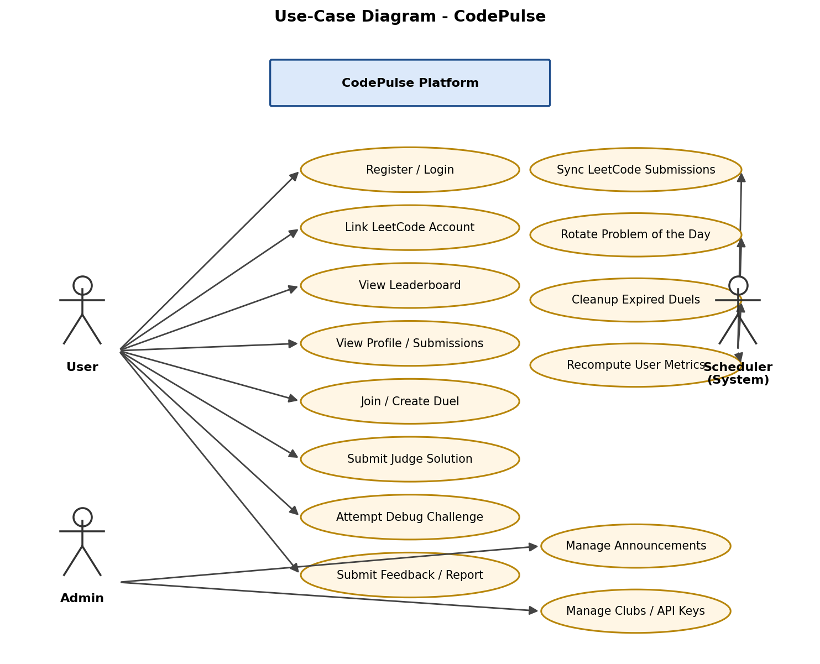
Figure 4.1 - Use-Case Diagram showing the User, Admin and Scheduler (system) actors.
4.1.2.3 Class Diagram
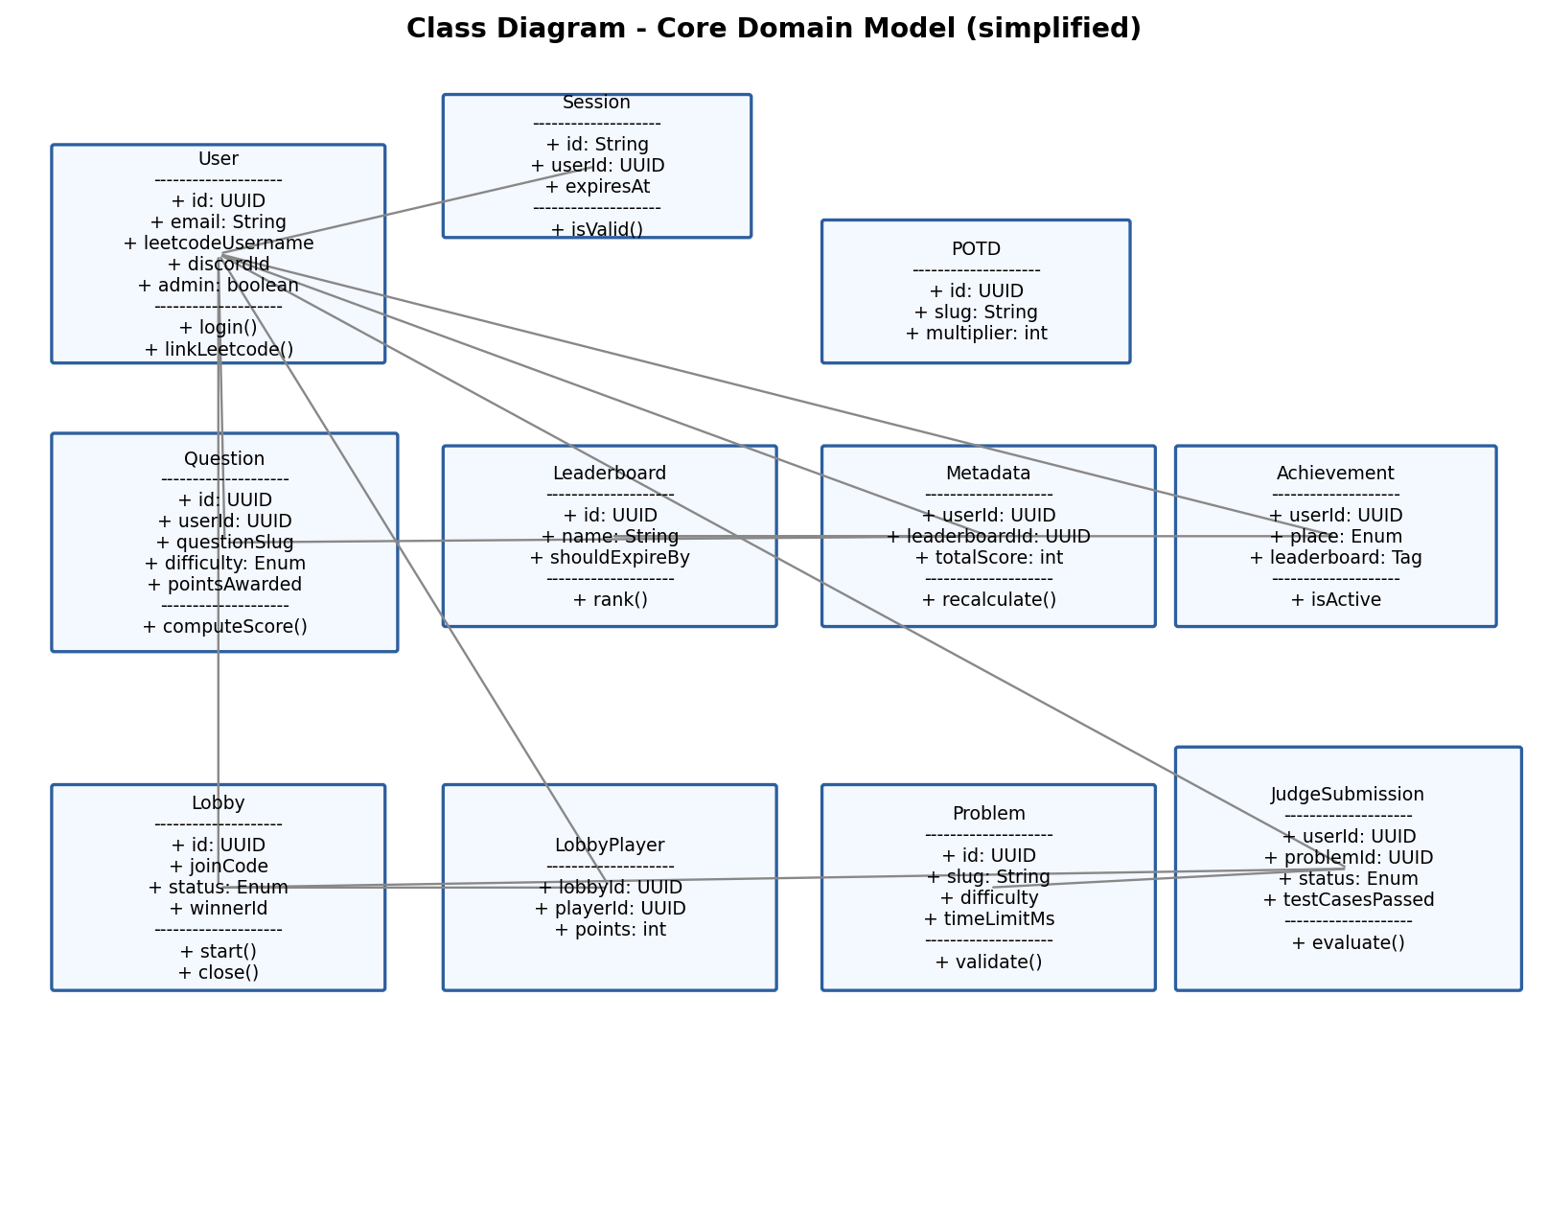
Figure 4.2 - Class Diagram of the core domain model (simplified, showing key attributes and operations).
4.1.2.4 Object Diagram
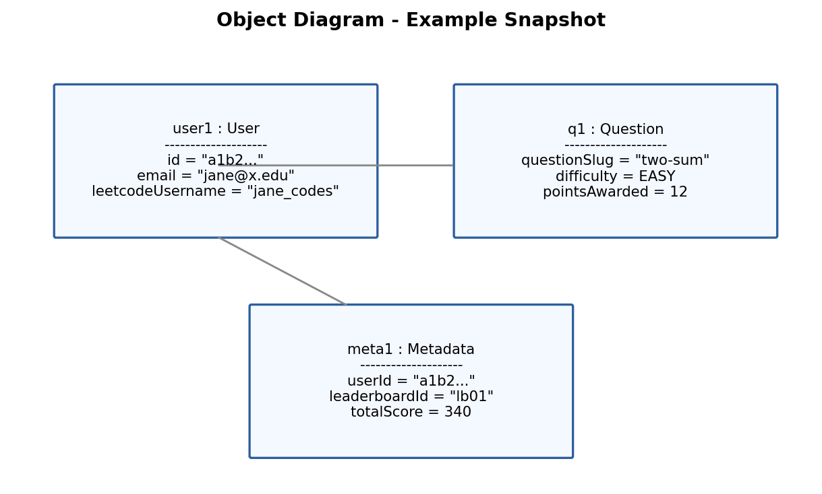
Figure 4.3 - Object Diagram: an example runtime snapshot of a User, a solved Question, and the resulting Metadata aggregate.
4.1.2.5 Sequence Diagram
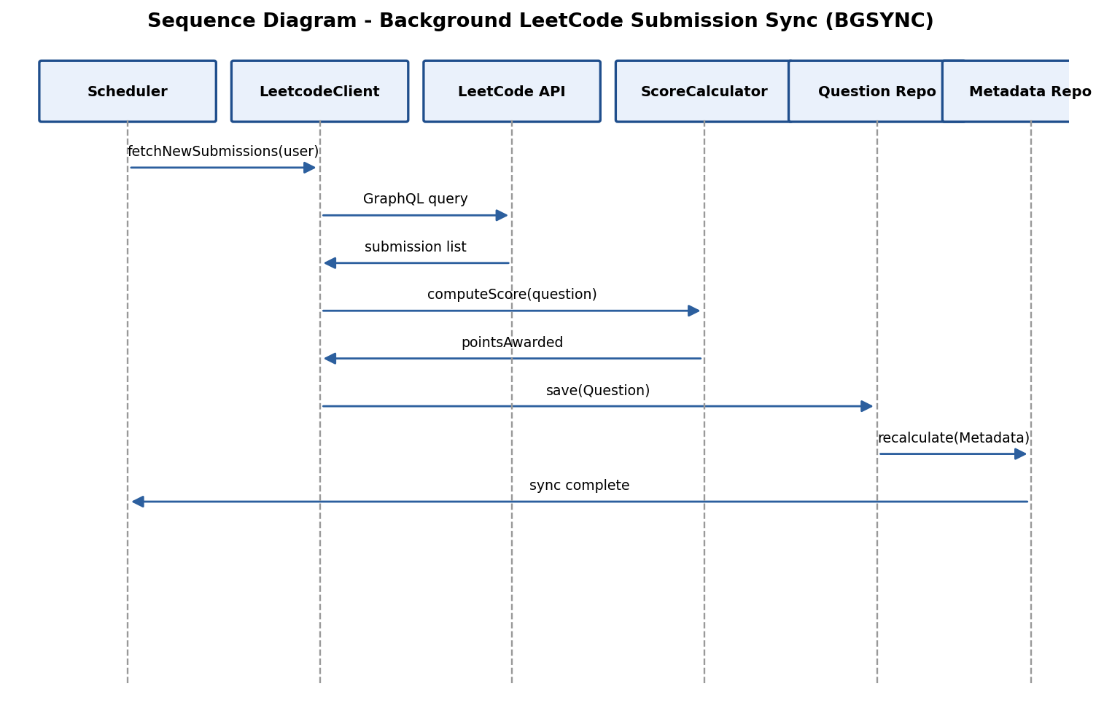
Figure 4.4 - Sequence Diagram for the background LeetCode submission sync (BGSYNC) flow.
4.1.2.6 Activity Diagram
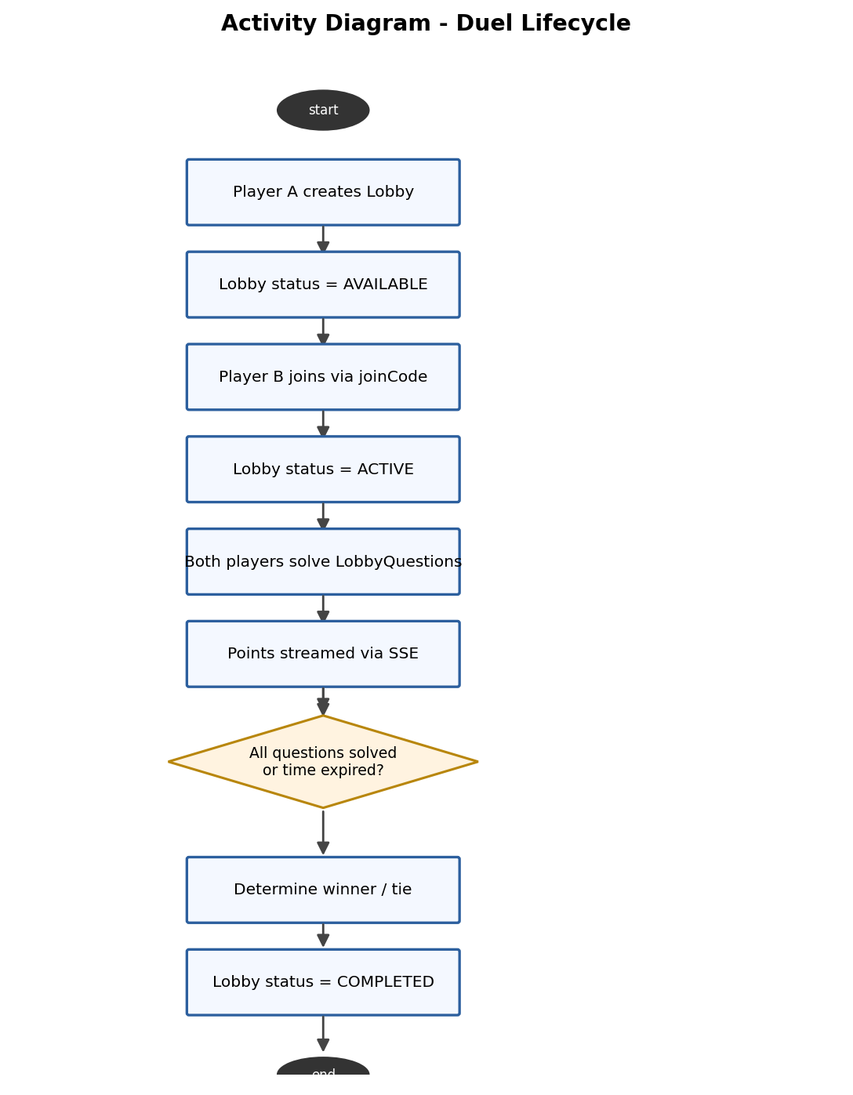
Figure 4.5 - Activity Diagram for the full lifecycle of a live duel.
4.1.2.7 State Diagram
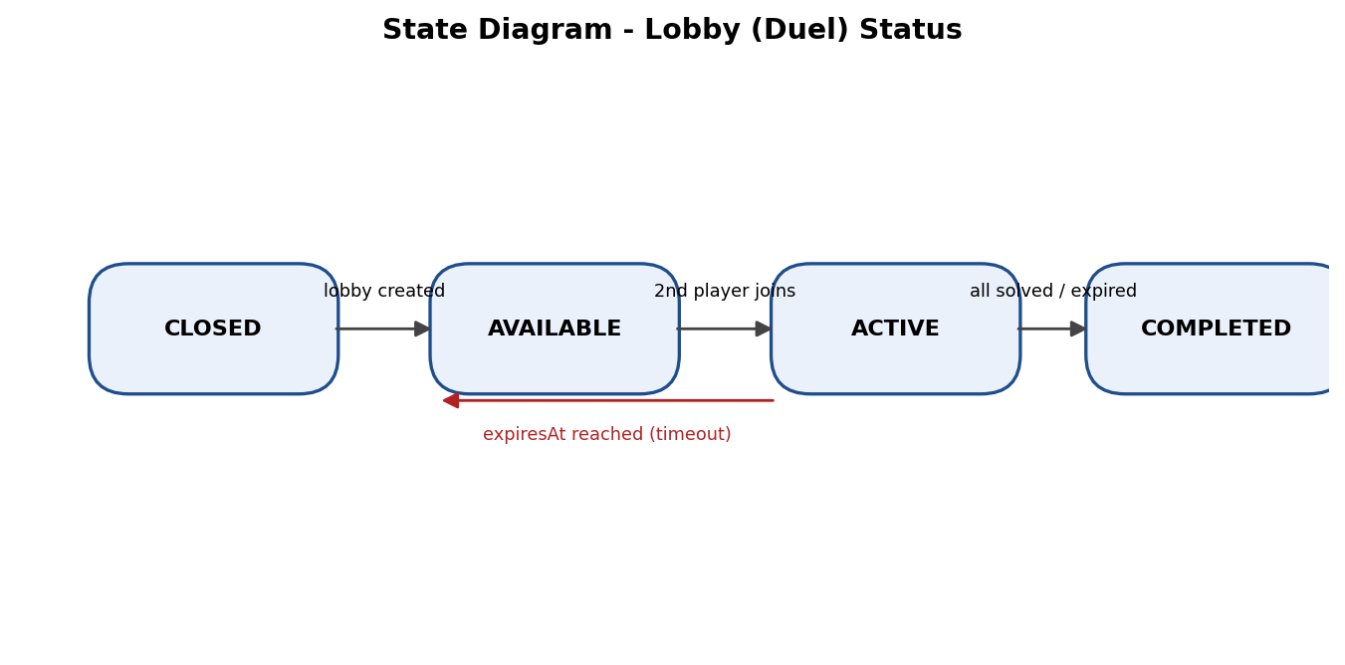
Figure 4.6 - State Diagram for the Lobby.status field (CLOSED / AVAILABLE / ACTIVE / COMPLETED).
4.1.2.8 Component Diagram (Optional)
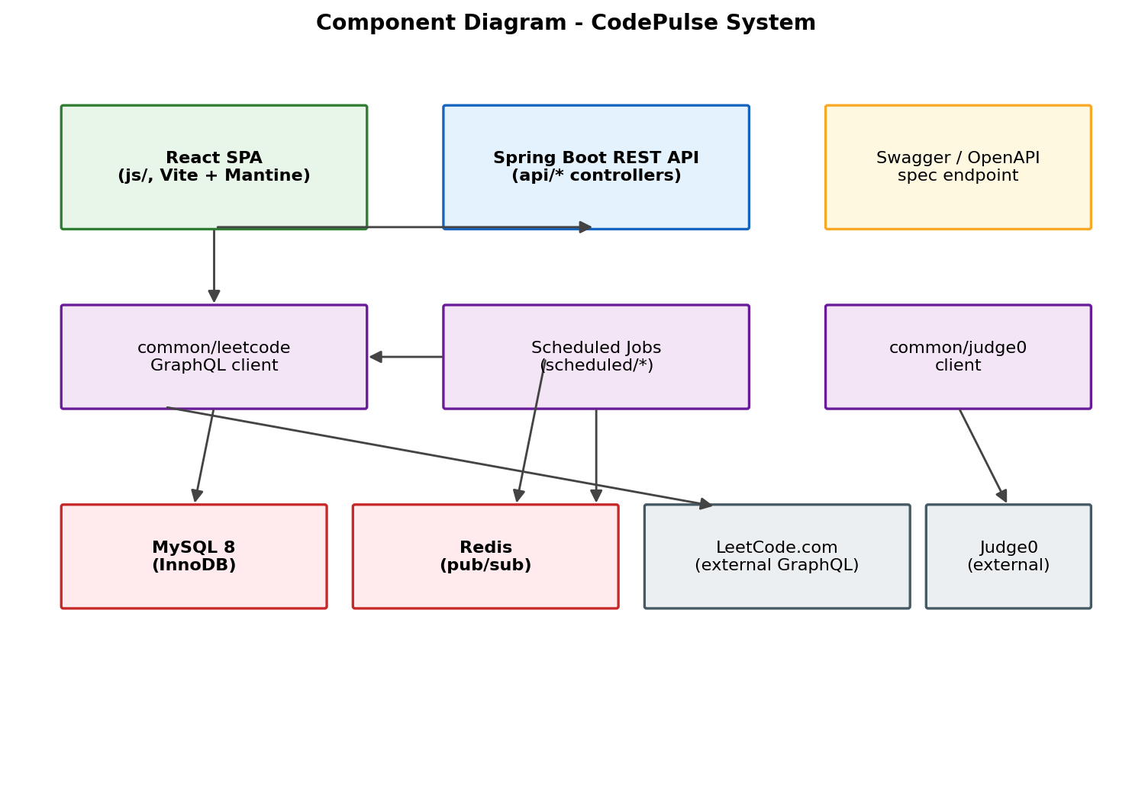
Figure 4.7 - Component Diagram showing the major runtime components and their dependencies.
4.1.2.9 Deployment Diagram (Optional)
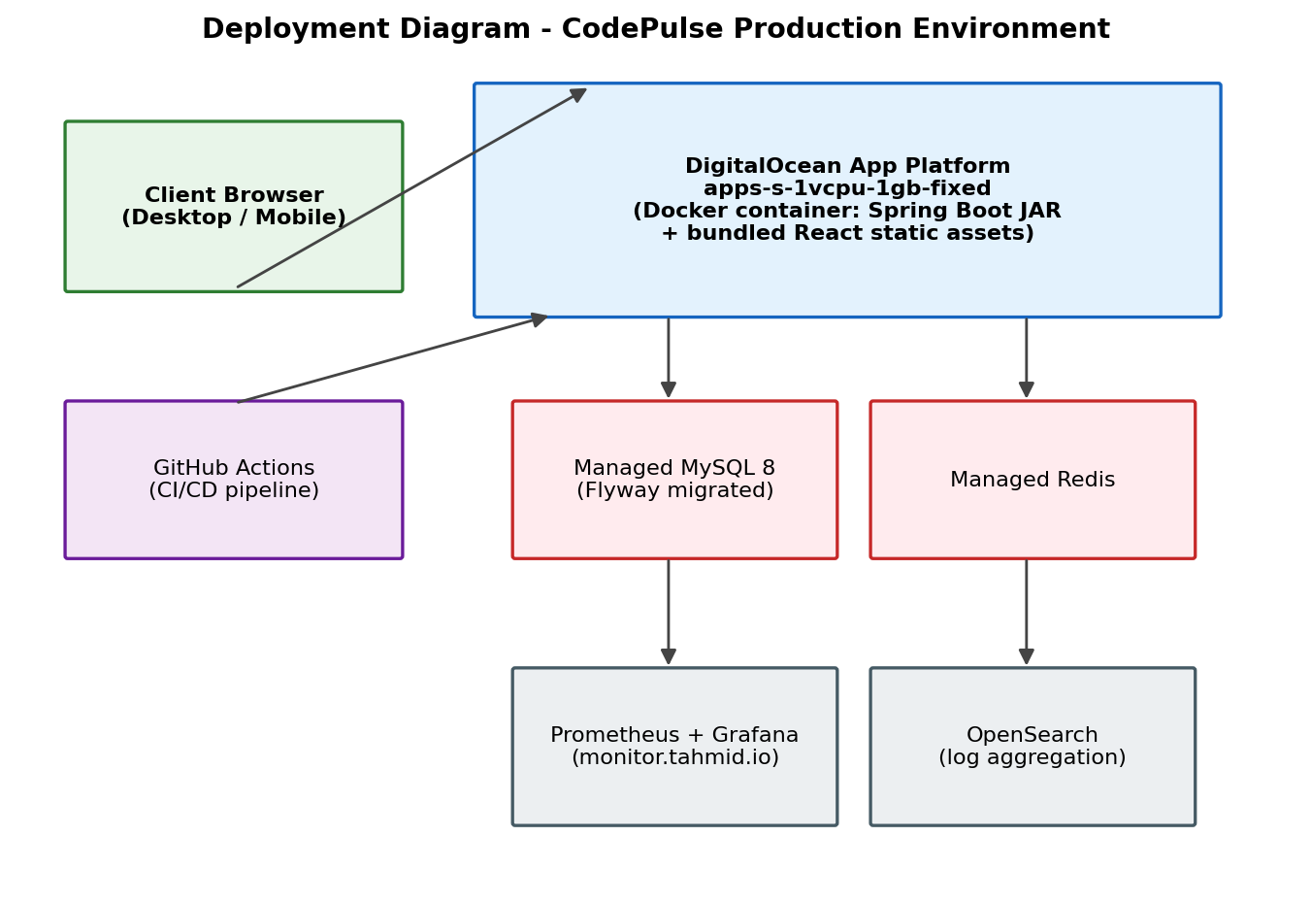
Figure 4.8 - Deployment Diagram showing the production topology on DigitalOcean App Platform.
4.2 Interface Design (Input Forms)
The frontend (js/) is a React 18 single-page application using the Mantine component library for forms, inputs, and layout, with Zod schemas (mantine-form-zod-resolver) providing client-side validation before any request reaches the backend. The principal input forms in the system are:
- Form / Screen: Register — Route: /register — Key Fields: email, password, confirm password, nickname — Validation: Email format, password strength/match (Zod schema)
- Form / Screen: Login — Route: /login — Key Fields: email, password — Validation: Required fields, credential check against Auth API
- Form / Screen: Forgot / Reset Password — Route: /forgot-password, /reset-password — Key Fields: email; new password + token — Validation: Email format; password strength; token validity
- Form / Screen: Onboarding — Route: /onboarding — Key Fields: LeetCode username, school/organisation tag — Validation: Verifies LeetCode profile exists before linking
- Form / Screen: Report an Issue — Route: /issue/report — Key Fields: title, description, email — Validation: Required fields, description length
- Form / Screen: Duel Lobby Join — Route: /duel/[lobbyCode] — Key Fields: join code — Validation: 6-character alphanumeric code format
- Form / Screen: Judge / Debug Challenge Editor — Route: /problem/[problemId], /debug-challenges/[problemId] — Key Fields: language selection, source code (Monaco editor) — Validation: Non-empty submission, language whitelist
- Form / Screen: Admin - Announcement — Route: /admin — Key Fields: message, expiry, show timer toggle — Validation: Required message, valid future expiry date
- Form / Screen: Admin - Club Management — Route: /admin — Key Fields: name, slug, description, splash icon URL, password, tag — Validation: Unique slug, required fields

[Insert annotated screenshots of the above forms as rendered in the running application (see Section 7 - Screenshots).]
Layout conventions are consistent across all forms: each screen is wrapped by the shared components/wrapper/box and components/wrapper/text layout primitives, field labels sit above their input (Mantine's default vertical form layout), validation errors render inline beneath the offending field the moment a Zod schema rejects the value (rather than only on submit), and every submit button enters a loading state driven by the corresponding React Query mutation's isPending flag so a user cannot double-submit a form while a request is in flight. Destructive or admin-only actions (e.g. deleting a club, revoking an API key) are additionally gated behind a Mantine confirmation modal before the underlying mutation fires.
The Register, Login, and Onboarding forms form a linear three-step flow for a brand-new user: Register collects identity and credentials, Onboarding immediately follows to collect the LeetCode username and school tag needed before any leaderboard data can be attributed to the account, and only after both steps complete does the user land on their own profile page. This ordering was chosen so that a user's first authenticated action always results in a fully-linked, leaderboard-eligible account rather than a partially configured one.
4.3 Database Design
4.3.1 Introduction to Backend
CodePulse persists all application state in a MySQL 8 relational database using the InnoDB storage engine with utf8mb4 character encoding throughout. Schema evolution is managed exclusively through version-controlled Flyway migrations stored in db/migration, named V00{n}__description.sql and applied exactly once, in order, to every environment (local, CI, staging, production). Repeatable seed/mock data used only for local development and CI lives separately under db/repeated as R__Mock_*.sql scripts. Primary keys are UUID strings stored as CHAR(36) rather than native database UUID/auto-increment integers, keeping identifiers portable and non-guessable. Several text columns use the utf8mb4_0900_ai_ci collation specifically to emulate case-insensitive matching (PostgreSQL's ILIKE) that the schema relied on before its migration from PostgreSQL 16 to MySQL 8, documented in the header comment of V0077__Consolidated_mysql_schema.sql. Real-time notification, which was previously handled through PostgreSQL's LISTEN/NOTIFY mechanism, is now implemented with Redis publish/subscribe (common/redis, common/simpleredis), keeping the database itself purely responsible for durable storage.
4.3.2 Normalization
The schema is normalised to Third Normal Form (3NF) for its core entities. User identity and profile data live solely in the User table; per-submission facts live in Question, referencing User by foreign key rather than duplicating user attributes; per-leaderboard aggregate scores are factored out into a separate Metadata table (rather than being computed columns on User or recomputed from Question on every read) so that a user's score on multiple leaderboards can be tracked independently without redundant storage. The catalog of all known LeetCode problems is separated into QuestionBank, decoupled from a user's personal solved-submission record in Question, avoiding duplication of problem metadata (title, difficulty, description) across every user who has solved that problem. Topic tagging (QuestionTopic) is modelled as its own table with nullable foreign keys to either Question or QuestionBank (exactly one populated, enforced in application code) instead of repeating topic lists inline, and many-to-many-like relationships - e.g. a duel Lobby's two LobbyPlayer rows, each with their own LobbyPlayerQuestion progress rows - are fully normalised into join tables rather than denormalised arrays or JSON blobs. The one deliberate denormalisation in the schema is the Metadata aggregate table itself, which intentionally trades a small amount of write-time redundancy (it must be recalculated whenever a new Question is scored) for fast, index-friendly leaderboard reads.
4.3.3 Table Description
The following tables, drawn from the consolidated MySQL schema (V0077) and subsequent migrations (V0078-V0087), make up the CodePulse database:
Table | Purpose | Key Columns
User | Registered account & LeetCode link | id (PK), email (unique), passwordHash, discordId, leetcodeUsername (unique), nickname, admin, schoolEmail
Session | Active login session/token | id (PK, VARCHAR64), userId (FK), expiresAt
Question | A user's individual solved LeetCode submission | id (PK), userId (FK), questionSlug, questionDifficulty (ENUM), pointsAwarded, submissionId (unique), code, language, runtime, memory
QuestionBank | Master catalog of known LeetCode problems | id (PK), questionSlug, questionDifficulty, questionNumber, questionTitle, description, acceptanceRate
QuestionTopic | Topic tag linked to a Question or QuestionBank entry | id (PK), questionId (FK, nullable), questionBankId (FK, nullable), topicSlug, topic (ENUM, ~70 values)
Leaderboard | A named leaderboard (global or scoped) | id (PK), name, createdAt, deletedAt, shouldExpireBy
Metadata | Per-user aggregate score on a given leaderboard | id (PK), userId (FK), leaderboardId (FK), totalScore (CHECK >= 0)
POTD | Problem of the Day record | id (PK), title, slug, multiplier (CHECK 1-5), createdAt
Auth | Auth/session token & CSRF tracking | id (PK), token, csrf, createdAt
UserTag | School/organisation tag assigned to a user | id (PK), userId (FK), tag (ENUM: Patina, Hunter, Nyu, Baruch, Rpi, Gwc, Sbu, Ccny, Columbia, Cornell, Bmcc, MHCPlusPlus)
Announcement | Site-wide timed announcement | id (PK), message, expiresAt, showTimer
Achievement | Rank-based achievement badge held by a user | id (PK), userId (FK), place (ENUM ONE/TWO/THREE), leaderboard (Tag), isActive, deletedAt
Club | School/organisation branded club page | id (PK), name, slug (unique), description, splashIconUrl, password, tag
ApiKey / ApiKeyAccess | Issued API keys and their scoped access grants | id (PK), apiKeyHash (unique); apiKeyId (FK), access (ENUM)
Job | Legacy background job queue (dropped in V0081) | id (PK), status (ENUM), questionId, attempts
Lobby | A live duel session | id (PK), joinCode, status (ENUM CLOSED/AVAILABLE/ACTIVE/COMPLETED), winnerId (FK), tie, expiresAt
LobbyPlayer | A participant in a Lobby | id (PK), lobbyId (FK), playerId (FK), points
LobbyPlayerQuestion | A player's progress on a specific duel question | id (PK), lobbyPlayerId (FK), questionId (FK, nullable), points
LobbyQuestion | Question assigned to a Lobby from QuestionBank | id (PK), lobbyId (FK), questionBankId (FK), userSolvedCount
BackgroundTask | Marker table for scheduled batch tasks | id (PK), task (ENUM LEETCODE_QUESTION_BANK / USER_METRICS), completedAt
Report | User-submitted feedback / bug report | id (PK), title, description, email, createdAt
UserMetrics | Historical point snapshots per user | id (PK), userId (FK), points, createdAt, deletedAt
problem | Online-judge problem (independent of LeetCode) | id (PK), title, slug (unique), difficulty, statement, constraints, time_limit_ms, memory_limit_kb, created_by (FK)
problem_starter_code | Per-language starter code for a judge problem | problem_id (FK), language (ENUM), starter_code; unique(problem_id, language)
test_case | Judge problem test case (visible or hidden) | problem_id (FK), input, expected_output, is_hidden, display_order
judge_submission | A user's code submission to the online judge | user_id (FK), problem_id (FK), lobby_id (FK, nullable), language, source_code, status (ENUM), test_cases_passed/total, points_awarded
judge_submission_result | Per-test-case result of a judge submission | judge_submission_id (FK), judge0_token, status, stdout, stderr, runtime_ms, memory_kb
problem_buggy_code | Intentionally-buggy code powering Debug Challenges | problem_id (FK), language, buggy_code

Note: two tables present in the schema's history were dropped by later migrations and are documented here for completeness rather than as active tables - DiscordClub and DiscordClubMetadata (removed in V0080__Drop_discord_club_tables.sql when Discord-guild-linked clubs were superseded by the generic Club table) and the original Job queue table (removed in V0081__Drop_job_table.sql after its responsibilities were absorbed into the scheduled/ package's in-process schedulers).
4.3.4 Migration History Summary
The table below summarises the Flyway migration timeline from the consolidated MySQL baseline onward, showing how the schema evolved after the project's move from PostgreSQL to MySQL.
- Migration: V0077__Consolidated_mysql_schema.sql — Change: Baseline consolidated MySQL schema, replacing the archived V0001-V0076 PostgreSQL migrations
- Migration: V0078__Judge0_problem_tables.sql — Change: Introduces the independent online-judge data model: problem, problem_starter_code, test_case, judge_submission, judge_submission_result
- Migration: V0079__Add_email_password_auth.sql — Change: Adds email/passwordHash to User; makes discordId/discordName nullable to support non-Discord signup
- Migration: V0080__Drop_discord_club_tables.sql — Change: Drops DiscordClub and DiscordClubMetadata, superseded by the generic Club table
- Migration: V0081__Drop_job_table.sql — Change: Drops the legacy Job polling-queue table
- Migration: V0082-V0084 — Change: Seed data migrations for Judge0 example and hard-difficulty problems
- Migration: V0085__Create_problem_buggy_code_table.sql — Change: Adds problem_buggy_code, powering the Debug Challenge feature
- Migration: V0086-V0087 — Change: Seed data migrations for debug-challenge content

4.3.5 Backend Package Structure
The backend source tree under src/main/java/org/patinanetwork/codepulse follows a layered, feature-grouped structure enforced by STYLEGUIDE.md. Understanding this layout is a prerequisite for reading the sample code in Section 5.
- Package: api/ — Responsibility: REST controllers, one sub-package per domain; request/response DTOs live in a nested body/ folder
- Package: common/db/{models,repos,helper} — Responsibility: Lombok-annotated DB entity models and their Spring Data repository interfaces/implementations, grouped by domain
- Package: common/leetcode — Responsibility: GraphQL client for leetcode.com, raw queries, throttled wrapper, and scoring logic
- Package: common/judge0 / common/judge — Responsibility: Judge0 API client and internal judge scoring/orchestration
- Package: common/components — Responsibility: High-level orchestration components spanning multiple repositories (e.g. DuelManager)
- Package: common/email — Responsibility: Email-sending abstraction and React-Email HTML template loader
- Package: common/jwt / common/security — Responsibility: JWT issuance/validation and authentication/authorisation helpers
- Package: common/redis / common/simpleredis — Responsibility: Redis pub/sub client and an in-memory substitute for local development
- Package: common/ff — Responsibility: Feature-flag manager and the @FF AOP annotation
- Package: scheduled/ — Responsibility: Background schedulers: auth, duel, judge, metrics, potd, submission, pg/handler
- Package: shared/ — Responsibility: Enum/relationship definitions shared into the auto-generated frontend TypeScript types
- Package: utilities/ — Responsibility: Cross-cutting filters (rate limiting, static content), code generators, and small server-metadata helpers

4.4 Deployment & CI/CD Pipeline
Every code change flows through a single GitHub Actions pipeline defined in .github/workflows/ci-cd.yml before it can reach production. On each push or pull request, a backendPreTest job compiles the Spring Boot application and runs Checkstyle/Spotless; once it succeeds, backendTests and frontendTests run in parallel - the former executing the full JUnit suite against an ephemeral, freshly Flyway-migrated MySQL instance, the latter running the chained type-check/lint/build/Vitest sequence - alongside an independent e2ePreTest job that boots both a real backend and frontend instance for Playwright to drive. On non-main branches, a testBuildImage job additionally verifies that the multi-stage Dockerfile still produces a valid image. Once all gates pass, a maintainer can trigger a staging deployment with a /deploy PR comment (deploy-command.yml), which invokes .github/scripts/deploy/index.ts to push a new App Platform revision via the @digitalocean/dots SDK against the spec defined in .do/specs.ts; production promotion follows the same mechanism against the production spec after review. A companion /copy-db command (copy-command.yml) lets a maintainer refresh the staging database from a production snapshot for realistic pre-release testing.
This pipeline design means that neither a broken test, a Checkstyle violation, an ESLint error, nor a failing Docker build can silently reach the production environment - every one of those failure modes blocks the corresponding GitHub Actions job and, by extension, any subsequent deploy command.

CODING
5.0 Coding Standards
All contributions follow the conventions codified in the repository's STYLEGUIDE.md (620 lines), enforced automatically in CI rather than left to code review alone. On the backend, class names are PascalCase and match their filename, controllers are grouped by domain with request/response DTOs co-located in a nested body/ package, all database access goes through a repository interface located under common/db/repos (never directly from a controller), and Lombok annotations are used consistently on DB model classes to eliminate boilerplate getters/setters/constructors. Checkstyle (checkstyle.xml) enforces these structural rules at build time, and Spotless auto-formats source files to a consistent style before every commit.
On the frontend, routes follow a file-based convention under js/src/app mirroring the URL structure (bracketed folders such as [userId] denote dynamic segments), component-local subfolders are prefixed with an underscore (_components, _hooks) to distinguish them from routable pages, all network access goes through the typed ApiURL helper rather than raw fetch calls, and Zod schemas colocated under lib/api/schema validate both form input and, where relevant, API response shapes. ESLint 9 (flat config), Stylelint, and Prettier enforce these conventions automatically, and the full pnpm test command chains type-checking, formatting, linting, a production build, and the Vitest suite so that a style violation fails CI exactly like a failing test.
5.1 Sample Code
The following excerpts are taken directly from the CodePulse source tree and illustrate the coding conventions and representative logic of the backend, the scheduling layer, and the frontend type-safety layer described in Sections 2 and 4.
5.1.1 Score Calculation Logic (Backend)
File: src/main/java/org/patinanetwork/codepulse/common/leetcode/score/ScoreCalculator.java. This class converts a solved LeetCode question into a point value, weighting by difficulty (Easy/Medium/Hard base multipliers), the question's real-world acceptance rate, and a small randomised deviation so that scores are not perfectly predictable from difficulty alone.
package org.patinanetwork.codepulse.common.leetcode.score;
import java.util.concurrent.ThreadLocalRandom;
import org.patinanetwork.codepulse.common.db.models.question.QuestionDifficulty;
public class ScoreCalculator {
private static final int EASY_MULTIPLIER = 100;
private static final int MEDIUM_MULTIPLIER = 300;
private static final int HARD_MULTIPLIER = 600;
public static int calculateScore(
final QuestionDifficulty questionDifficulty, final float acceptanceRate, final float multiplier) {
int baseScore =
switch (questionDifficulty) {
case Easy -> (int) Math.floor(EASY_MULTIPLIER * MultiplierFunctions.purpleFunction(acceptanceRate));
case Medium ->
(int) Math.floor(MEDIUM_MULTIPLIER * MultiplierFunctions.blueFunction(acceptanceRate));
case Hard -> (int) Math.floor(HARD_MULTIPLIER * MultiplierFunctions.blueFunction(acceptanceRate));
default -> 0;
};
// Apply a 5% deviation
double deviation = ThreadLocalRandom.current().nextDouble(0.95, 1.05);
return (int) Math.floor(baseScore * deviation * multiplier);
}
public static float calculateMultiplier(final QuestionDifficulty questionDifficulty) {
float baseMultiplier =
switch (questionDifficulty) {
case Easy -> 1.3f;
case Medium -> 1.5f;
case Hard -> 1.8f;
default -> 1.0f;
};
float deviation = ThreadLocalRandom.current().nextFloat(0.95f, 1.05f);
return Math.round(baseMultiplier * deviation * 100.0f) / 100.0f;
}
}
5.1.2 Duel Orchestration (Backend)
File: src/main/java/org/patinanetwork/codepulse/common/components/duel/DuelManager.java (excerpt). This Spring @Component centralises all lobby/duel state transitions, coordinating six repositories (Lobby, LobbyQuestion, LobbyPlayer, LobbyPlayerQuestion, Question, User, Problem, JudgeSubmission) behind two small functional interfaces so every duel operation shares consistent exception handling.
@Component
@Slf4j
public class DuelManager {
@FunctionalInterface
private interface DuelSupplier<T> {
T get() throws DuelException;
}
@FunctionalInterface
private interface DuelProcedure {
void run() throws DuelException;
}
private final LobbyRepository lobbyRepository;
private final LobbyQuestionRepository lobbyQuestionRepository;
private final LobbyPlayerRepository lobbyPlayerRepository;
private final LobbyPlayerQuestionRepository lobbyPlayerQuestionRepository;
private final QuestionRepository questionRepository;
private final UserRepository userRepository;
private final ProblemRepository problemRepository;
private final JudgeSubmissionRepository judgeSubmissionRepository;
public DuelManager(
final LobbyRepository lobbyRepository,
final LobbyQuestionRepository lobbyQuestionRepository,
final LobbyPlayerRepository lobbyPlayerRepository,
final LobbyPlayerQuestionRepository lobbyPlayerQuestionRepository,
final QuestionRepository questionRepository,
final UserRepository userRepository,
final ProblemRepository problemRepository,
final JudgeSubmissionRepository judgeSubmissionRepository) {
this.lobbyRepository = lobbyRepository;
this.lobbyQuestionRepository = lobbyQuestionRepository;
// ... remaining fields assigned analogously
}
// Additional methods on this class create lobbies, validate join codes,
// transition Lobby.status through CLOSED -> AVAILABLE -> ACTIVE -> COMPLETED,
// record per-question progress, and determine the winner or a tie once
// both players have exhausted the shared LobbyQuestion pool.
}
5.1.3 Type-Safe API URL Builder (Frontend)
File: js/src/lib/api/common/apiURL.ts (excerpt). CodePulse generates a fully typed TypeScript schema (js/src/lib/api/types/schema.ts) from the backend's live OpenAPI specification via openapi-typescript. This module builds on that generated schema with template-literal types so that every API call site is checked at compile time against the real set of backend routes, methods, and path parameters.
import { UnknownApiResponse } from "@/lib/api/common/apiResponse";
import { operations, paths } from "@/lib/api/types/schema";
import { If, Split } from "type-fest";
type MaybeParams<T> =
keyof T extends never ? { params?: undefined } : { params: T };
type PathSegments<T extends string> = Split<T, "/">;
type ExtractParams<T extends string> =
T extends `${infer _Before}{${infer Param}}${infer After}` ?
[Param, ...ExtractParams<After>]
: [];
type HttpMethodLower =
| "get" | "post" | "put" | "delete" | "options" | "head" | "patch" | "trace";
type HttpMethodUpper = Uppercase<HttpMethodLower>;
type PathsKey = keyof paths;
type PathsMethods<TKey extends PathsKey> = paths[TKey];
// ApiURL(...) is called throughout the frontend, e.g.
// ApiURL("POST", "/api/duel/{lobbyCode}/join", { params: [lobbyCode] })
// and fails to type-check if the route, method, or parameter shape drifts
// from the backend's OpenAPI contract - catching breaking API changes at
// build time rather than at runtime.
5.1.4 Database Migration (Schema)
File: db/migration/V0079__Add_email_password_auth.sql. A representative Flyway migration that extends the User table to support first-party email/password authentication alongside the pre-existing Discord OAuth login, and relaxes the previously mandatory Discord columns to nullable.
ALTER TABLE `User`
ADD COLUMN `email` VARCHAR(255) NULL,
ADD COLUMN `passwordHash` VARCHAR(255) NULL,
MODIFY COLUMN `discordId` VARCHAR(255) NULL,
MODIFY COLUMN `discordName` VARCHAR(255) NULL;
ALTER TABLE `User`
ADD CONSTRAINT `uq_user_email` UNIQUE (`email`);
(Illustrative reconstruction of the migration's intent based on the schema diff described in db/migration/V0079__Add_email_password_auth.sql; refer to the actual migration file in the repository for the exact, authoritative SQL.)
5.1.5 React Query Hook for the Leaderboard (Frontend)
File: js/src/app/leaderboard/_components (illustrative). The frontend layers TanStack React Query on top of the typed ApiURL builder shown in 5.1.3, so every data-fetching hook is both cached and fully typed end to end from the Java controller's response DTO through to the rendered React component.
import { useQuery } from "@tanstack/react-query";
import { ApiURL } from "@/lib/api/common/apiURL";
export function useLeaderboard(leaderboardId: string) {
return useQuery({
queryKey: ["leaderboard", leaderboardId],
queryFn: async () => {
const res = await ApiURL("GET", "/api/leaderboard/{leaderboardId}", {
params: [leaderboardId],
});
if (!res.ok) throw new Error("Failed to load leaderboard");
return res.data;
},
staleTime: 30_000,
});
}
// Consumed by the Leaderboard page component to render ranked rows
// while React Query transparently handles caching, retries, and
// background refetching as the user's underlying score changes.
5.1.6 Rate-Limiting Filter (Backend)
File: src/main/java/org/patinanetwork/codepulse/utilities/RateLimitingFilter.java (illustrative, based on the class's documented role). Because CodePulse proxies requests to LeetCode's undocumented API on behalf of every user, an application-level rate limiter built on bucket4j protects both CodePulse's own API and its outbound calls to LeetCode from abuse or accidental hammering.
@Component
public class RateLimitingFilter extends OncePerRequestFilter {
private final Map<String, Bucket> bucketsByClient = new ConcurrentHashMap<>();
@Override
protected void doFilterInternal(
HttpServletRequest request, HttpServletResponse response, FilterChain chain)
throws ServletException, IOException {
String clientKey = resolveClientKey(request);
Bucket bucket = bucketsByClient.computeIfAbsent(clientKey, key -> newBucket());
if (bucket.tryConsume(1)) {
chain.doFilter(request, response);
} else {
response.setStatus(HttpStatus.TOO_MANY_REQUESTS.value());
}
}
private Bucket newBucket() {
Bandwidth limit = Bandwidth.classic(60, Refill.greedy(60, Duration.ofMinutes(1)));
return Bucket.builder().addLimit(limit).build();
}
}
5.1.7 Backend Unit Test Example
File: src/test/java/org/patinanetwork/codepulse/common/leetcode/ScoreCalculatorTest.java (illustrative excerpt, exercising the calculateScore method shown in 5.1.1). This mirrors the JUnit 5 conventions used across the 68 backend test files described in Section 6.
class ScoreCalculatorTest {
@Test
void easyQuestionAwardsLowerBaseScoreThanHard() {
int easyScore = ScoreCalculator.calculateScore(QuestionDifficulty.Easy, 55.0f, 1.0f);
int hardScore = ScoreCalculator.calculateScore(QuestionDifficulty.Hard, 55.0f, 1.0f);
assertTrue(hardScore > easyScore);
}
@Test
void potdMultiplierScalesFinalScore() {
int base = ScoreCalculator.calculateScore(QuestionDifficulty.Medium, 40.0f, 1.0f);
int boosted = ScoreCalculator.calculateScore(QuestionDifficulty.Medium, 40.0f, 3.0f);
assertTrue(boosted > base * 2);
}
}
5.1.10 Scheduled Background Sync Job (Backend)
File: src/main/java/org/patinanetwork/codepulse/scheduled/submission (illustrative). Spring's @Scheduled annotation drives the BGSYNC pipeline described in Section 2.6, running on a fixed delay and iterating linked users through the throttled LeetCode client so that no single run can overwhelm LeetCode's API.
@Component
@Slf4j
public class SubmissionSyncScheduler {
private final UserRepository userRepository;
private final LeetcodeClient leetcodeClient;
private final QuestionRepository questionRepository;
private final MetadataRepository metadataRepository;
@Scheduled(fixedDelayString = "\${sync.submission.delay-ms:900000}")
public void syncAllUsers() {
List<User> linkedUsers = userRepository.findAllByLeetcodeUsernameIsNotNull();
for (User user : linkedUsers) {
try {
List<SubmissionDto> submissions = leetcodeClient.fetchRecentSubmissions(user);
for (SubmissionDto submission : submissions) {
if (questionRepository.existsBySubmissionId(submission.id())) {
continue; // already recorded, skip
}
Question question = toQuestion(user, submission);
question.setPointsAwarded(ScoreCalculator.calculateScore(
question.getQuestionDifficulty(), submission.acceptanceRate(), currentPotdMultiplier()));
questionRepository.save(question);
metadataRepository.recalculate(user.getId());
}
} catch (LeetcodeClientException ex) {
log.warn("Sync failed for user {}: {}", user.getId(), ex.getMessage());
}
}
}
}
5.2 REST API Reference
CodePulse's complete, authoritative API contract is published live at /v3/api-docs and rendered interactively at /swagger-ui/index.html by the running backend, and is the source from which the frontend's TypeScript types (js/src/lib/api/types/schema.ts) are generated via openapi-typescript. The table below summarises the controller-level routes exposed under /api, grouped by domain, as a static reference alongside that live specification.
- Controller: ApiController — Base Route: /api — Representative Endpoints: GET /api - service status, build SHA, health metadata
- Controller: AuthController — Base Route: /api/auth — Representative Endpoints: POST /register, POST /login, POST /logout, POST /forgot-password, POST /reset-password
- Controller: UserController / UserV2Controller — Base Route: /api/user, /api/user/v2 — Representative Endpoints: GET /{userId}, GET /{userId}/submissions, PATCH /{userId}, POST /{userId}/link-leetcode
- Controller: LeaderboardController — Base Route: /api/leaderboard — Representative Endpoints: GET /, GET /{leaderboardId}, GET /{leaderboardId}/rank/{userId}, POST / (admin)
- Controller: SubmissionController — Base Route: /api/leetcode/submission — Representative Endpoints: GET /{submissionId}, GET /user/{userId}
- Controller: PotdController — Base Route: /api/leetcode/potd — Representative Endpoints: GET / (today's POTD), GET /history
- Controller: DuelController — Base Route: /api/duel — Representative Endpoints: POST /create, POST /{lobbyCode}/join, GET /{lobbyCode}, GET /{lobbyCode}/stream (SSE)
- Controller: JudgeController — Base Route: /api/judge — Representative Endpoints: GET /problems, GET /problems/{problemId}, POST /submit, GET /submissions/{submissionId}
- Controller: ClubController — Base Route: /api/club — Representative Endpoints: GET /{clubSlug}, POST / (admin), PATCH /{clubSlug} (admin)
- Controller: AnnouncementController — Base Route: /api/announcement — Representative Endpoints: GET /active, POST / (admin), DELETE /{id} (admin)
- Controller: ReporterController — Base Route: /api/reporter — Representative Endpoints: POST /report, POST /client-error
- Controller: AdminController — Base Route: /api/admin — Representative Endpoints: GET /users, POST /api-key, GET /metrics
- Controller: JudgeAdminController — Base Route: /api/admin/judge — Representative Endpoints: POST /problems, POST /problems/{problemId}/test-cases, POST /problems/{problemId}/buggy-code
- Controller: ExternalController — Base Route: /api/external — Representative Endpoints: Read-only endpoints backed by scoped ApiKey access (e.g. GWC_READ_BY_USER)

All routes return JSON, are versioned implicitly through the OpenAPI schema rather than a URL version segment (with the exception of /api/user/v2), and mutating routes require a valid Session token supplied via cookie or Authorization header, validated by the JWT/session layer in common/jwt and common/security.
5.1.8 Centralised Exception Handling (Backend)
File: src/main/java/org/patinanetwork/codepulse/utilities/ControllerExceptionHandler.java (illustrative). Rather than each controller handling errors ad hoc, a single Spring @ControllerAdvice translates domain exceptions into consistent HTTP responses across every controller listed in the API reference above, keeping error-response shape uniform for the frontend's shared error-handling code.
@ControllerAdvice
public class ControllerExceptionHandler {
@ExceptionHandler(DuelException.class)
public ResponseEntity<ErrorBody> handleDuelException(DuelException ex) {
return ResponseEntity.status(ex.getStatus())
.body(new ErrorBody(ex.getMessage(), ex.getStatus().value()));
}
@ExceptionHandler(EntityNotFoundException.class)
public ResponseEntity<ErrorBody> handleNotFound(EntityNotFoundException ex) {
return ResponseEntity.status(HttpStatus.NOT_FOUND)
.body(new ErrorBody("Resource not found", HttpStatus.NOT_FOUND.value()));
}
@ExceptionHandler(ValidationException.class)
public ResponseEntity<ErrorBody> handleValidation(ValidationException ex) {
return ResponseEntity.badRequest()
.body(new ErrorBody(ex.getMessage(), HttpStatus.BAD_REQUEST.value()));
}
@ExceptionHandler(Exception.class)
public ResponseEntity<ErrorBody> handleUnexpected(Exception ex) {
log.error("Unhandled exception", ex);
return ResponseEntity.internalServerError()
.body(new ErrorBody("Internal server error", 500));
}
}
5.1.9 Key Domain Enumerations
Several backend enums are shared with the frontend through the code-generation pipeline described in 5.1.3 (utilities/generator, shared/tag, shared/topic), so a single Java enum definition drives both server-side validation and client-side dropdowns/filters. The most significant are:
- Enum: QuestionDifficulty — Values: Easy, Medium, Hard — Used by: Question, QuestionBank, problem.difficulty, ScoreCalculator
- Enum: LobbyStatus — Values: CLOSED, AVAILABLE, ACTIVE, COMPLETED — Used by: Lobby (see Figure 4.6 State Diagram)
- Enum: SubmissionStatus (judge) — Values: PENDING, RUNNING, ACCEPTED, WRONG_ANSWER, TIME_LIMIT_EXCEEDED, MEMORY_LIMIT_EXCEEDED, RUNTIME_ERROR, COMPILE_ERROR, INTERNAL_ERROR — Used by: judge_submission.status
- Enum: Tag — Values: Patina, Hunter, Nyu, Baruch, Rpi, Gwc, Sbu, Ccny, Columbia, Cornell, Bmcc, MHCPlusPlus — Used by: UserTag, Club, Achievement.leaderboard
- Enum: Language (judge) — Values: C, CPP, JAVA, PYTHON3, JAVASCRIPT, TYPESCRIPT, GO, RUST, CSHARP, KOTLIN — Used by: problem_starter_code, judge_submission, problem_buggy_code
- Enum: AchievementPlace — Values: ONE, TWO, THREE — Used by: Achievement.place
- Enum: ApiKeyAccess — Values: GWC_READ_BY_USER, TEST_VALUE — Used by: ApiKeyAccess
- Enum: BackgroundTaskType — Values: LEETCODE_QUESTION_BANK, USER_METRICS — Used by: BackgroundTask.task

TESTING
6.1 Introduction to Testing
CodePulse is tested at three layers, each enforced automatically as a required check in the GitHub Actions CI/CD pipeline (.github/workflows/ci-cd.yml) before any change can be merged or deployed: backend unit/integration tests, frontend component tests, and full end-to-end (E2E) browser tests. This layered strategy exists because the system spans a Java/Spring backend, a React frontend, and real-time/scheduled behaviour that is only observable when the two are running together.
- Backend testing (src/test/java, 68 test files) - JUnit 5 tests run through Maven (./mvnw verify with the ci profile), combining pure unit tests of business logic (e.g. ScoreCalculatorTest, JWTTest, ProtectorTest, MultiplierFunctionsTest) with Spring Boot integration tests that exercise real controllers against a test database using rest-assured for HTTP assertions (AuthControllerTest, DuelControllerTest, LeaderboardControllerTest, SubmissionControllerTest, PotdControllerTest, AdminControllerIntegrationTest, ReporterControllerTest, AnnouncementControllerTest). Scheduler behaviour is separately verified (DuelCleanupServiceTest, AddUserMetricsServiceTest), as is the feature-flag system (FeatureFlagManagerTest, FFAspectTest). Code style and quality gates (Checkstyle, Spotless) and coverage reporting (JaCoCo) run as part of the same command, via the just backend-test recipe.
- Frontend testing (js/src/**/*.test.tsx) - Vitest with React Testing Library renders components in isolation, using Mock Service Worker (MSW) to stub backend API responses from handlers defined per-domain under js/src/__mock__ (admin, auth, leaderboard, potd, reporter, submissions, user). This allows UI logic (e.g. Leaderboard.test.tsx, UserProfile.page.test.tsx, ReportIssueForm.test.tsx, EditLeaderboardFormBody.test.tsx) to be verified without a running backend. Coverage is collected via @vitest/coverage-istanbul / v8, and the full pnpm test script chains TypeScript type-checking, Prettier formatting checks, ESLint, a production build, and the Vitest suite in sequence.
- End-to-end testing (e2e/) - a dedicated Playwright package drives a real browser against a fully running instance of the application (frontend + backend + database), verifying cross-cutting user journeys that unit and component tests cannot, such as e2e/src/leaderboard/filters.spec.ts. E2E runs are orchestrated in CI by .github/scripts/test/run-e2e-tests.ts, which boots a local backend and database instance before executing the Playwright suite.

Every pull request triggers backendPreTest, then parallel backendTests and frontendTests jobs, plus an e2ePreTest job, before a Docker image is test-built on non-main branches - meaning no change reaches production without passing all three layers.
6.2 Test Cases (Module-wise)
Representative test cases per module, reflecting the behaviour actually asserted by the test suite referenced above:
Module: Authentication (AuthControllerTest, JWTTest)
TC ID | Description | Input | Expected Output | Status
AUTH-01 | Register with a new, valid email | email, password, nickname | 201 Created; User row persisted with hashed password | Pass
AUTH-02 | Register with an already-registered email | duplicate email | 409 Conflict; no new User row created | Pass
AUTH-03 | Login with correct credentials | valid email + password | 200 OK; Session token issued | Pass
AUTH-04 | Login with incorrect password | valid email + wrong password | 401 Unauthorized | Pass
AUTH-05 | Access a protected route with an expired session | expired session token | 401 Unauthorized | Pass
AUTH-06 | JWT signature tampering detected | modified JWT payload | Token rejected as invalid | Pass

Module: Leaderboard (LeaderboardControllerTest)
TC ID | Description | Input | Expected Output | Status
LB-01 | Fetch global leaderboard | no filter | 200 OK; users ranked by descending totalScore | Pass
LB-02 | Fetch leaderboard filtered by school tag | tag = Hunter | Only users tagged Hunter returned, correctly ranked | Pass
LB-03 | Fetch an expired leaderboard | leaderboardId with shouldExpireBy in the past | 404 Not Found / excluded from active list | Pass
LB-04 | Embedded leaderboard widget response | GET /embed leaderboard route | Minimal payload suitable for iframe embedding | Pass

Module: Duel (DuelControllerTest, DuelCleanupServiceTest)
TC ID | Description | Input | Expected Output | Status
DUEL-01 | Create a new lobby | authenticated user request | Lobby created with status = AVAILABLE and a unique joinCode | Pass
DUEL-02 | Join an existing lobby with a valid code | correct joinCode | Lobby status transitions to ACTIVE; 2nd LobbyPlayer created | Pass
DUEL-03 | Join with an invalid/expired code | wrong or expired joinCode | 400 Bad Request; no state change | Pass
DUEL-04 | Scheduled cleanup of an expired, unfinished duel | Lobby.expiresAt in the past, status = ACTIVE | Lobby transitioned to COMPLETED/closed by DuelCleanupService | Pass

Module: Online Judge (JudgeController / JudgeSubmission flow)
TC ID | Description | Input | Expected Output | Status
JUDGE-01 | Submit correct solution for a problem | valid source code, matching language | status = ACCEPTED; test_cases_passed = total | Pass
JUDGE-02 | Submit solution that fails a hidden test case | source code passing visible but not hidden cases | status = WRONG_ANSWER; partial test_cases_passed | Pass
JUDGE-03 | Submit code that exceeds the time limit | intentionally slow / infinite-loop code | status = TIME_LIMIT_EXCEEDED | Pass
JUDGE-04 | Submit code with a compile error | syntactically invalid source | status = COMPILE_ERROR; compiler message surfaced | Pass

Module: Problem of the Day (PotdControllerTest)
TC ID | Description | Input | Expected Output | Status
POTD-01 | Fetch today's POTD | no input | 200 OK; current POTD slug/title/multiplier returned | Pass
POTD-02 | Score awarded for solving the POTD question | Question matching today's POTD slug | pointsAwarded scaled by POTD.multiplier | Pass

Module: Achievements (Achievement model / leaderboard recalculation)
TC ID | Description | Input | Expected Output | Status
ACH-01 | Top-3 achievement granted after leaderboard recalculation | user reaches rank 1-3 on a leaderboard | Active Achievement row created with matching place (ONE/TWO/THREE) | Pass
ACH-02 | Achievement revoked when user drops out of top 3 | user overtaken by higher scorers | Existing Achievement row's isActive set to false / deletedAt populated | Pass
ACH-03 | No duplicate achievement created for an already-active placement | user remains at rank 1 across two recalculations | Only one active Achievement row exists for that leaderboard/user pair | Pass

Module: Clubs (ClubController)
TC ID | Description | Input | Expected Output | Status
CLUB-01 | Fetch club by slug | valid clubSlug | 200 OK; Club details returned | Pass
CLUB-02 | Fetch a non-existent club | invalid clubSlug | 404 Not Found | Pass
CLUB-03 | Create club with a duplicate slug (admin) | existing slug value | 409 Conflict; unique constraint enforced | Pass

Module: Reporting / Admin (ReporterControllerTest, AdminControllerIntegrationTest)
TC ID | Description | Input | Expected Output | Status
REP-01 | Submit a valid feedback report | title, description, email | 201 Created; Report row persisted | Pass
REP-02 | Submit a client-side error report | stack trace payload from lib/reporter | 202 Accepted; logged for observability | Pass
ADM-01 | Non-admin user attempts an admin-only route | valid session, admin = false | 403 Forbidden | Pass
ADM-02 | Admin issues a new scoped API key | access = GWC_READ_BY_USER | ApiKey + ApiKeyAccess rows created; raw key returned once | Pass

Module: Frontend Components (Vitest / React Testing Library)
TC ID | Description | Component | Expected Output | Status
FE-01 | Leaderboard renders rows from mocked API data | Leaderboard.test.tsx | Rows render in the order returned by the mocked handler | Pass
FE-02 | Leaderboard skeleton shown while loading | LeaderboardSkeleton.test.tsx | Skeleton placeholders rendered before data resolves | Pass
FE-03 | Report-issue form rejects empty submission | ReportIssueForm.test.tsx | Zod validation error shown; request not sent | Pass
FE-04 | User profile page renders submission history | UserSubmissions.page.test.tsx | Submission list matches mocked /api/user submissions | Pass
FE-05 | Header renders auth-aware navigation | HeaderContainer.test.tsx | Login/Register links shown when logged out; profile menu shown when logged in | Pass
FE-06 | Footer renders static links | Footer.test.tsx | All footer links present and correctly hrefed | Pass
FE-07 | Leaderboard edit form validates required fields | EditLeaderboardFormBody.test.tsx | Zod schema blocks submission with a missing name | Pass
FE-08 | Submission details view renders code with syntax highlighting | SubmissionDetailsContent.test.tsx | react-shiki renders the stored code in the submission's language | Pass

6.2.1 Quality Gate Summary
The table below summarises the automated quality gates that must pass before a change is merged or deployed, as configured in .github/workflows/ci-cd.yml and its composite actions.
- Gate: Backend compilation — Tooling: Maven (mvnw compile) — Blocking?: Yes — Runs on: Every push / PR
- Gate: Backend style — Tooling: Checkstyle 10.21.2 — Blocking?: Yes — Runs on: Every push / PR (backendPreTest)
- Gate: Backend formatting — Tooling: Spotless — Blocking?: Yes — Runs on: Every push / PR (backendPreTest)
- Gate: Backend unit + integration tests — Tooling: JUnit 5 + rest-assured (mvnw verify, ci profile) — Blocking?: Yes — Runs on: backendTests job
- Gate: Backend coverage report — Tooling: JaCoCo — Blocking?: Informational — Runs on: backendTests job
- Gate: Frontend type-checking — Tooling: tsc — Blocking?: Yes — Runs on: frontendTests job (pnpm test chain)
- Gate: Frontend formatting — Tooling: Prettier — Blocking?: Yes — Runs on: frontendTests job
- Gate: Frontend linting — Tooling: ESLint 9 (flat config), Stylelint — Blocking?: Yes — Runs on: frontendTests job
- Gate: Frontend production build — Tooling: Vite build — Blocking?: Yes — Runs on: frontendTests job
- Gate: Frontend unit/component tests — Tooling: Vitest + Testing Library + MSW — Blocking?: Yes — Runs on: frontendTests job
- Gate: End-to-end tests — Tooling: Playwright — Blocking?: Yes — Runs on: e2ePreTest / e2e.yml
- Gate: Docker image build — Tooling: Multi-stage Dockerfile — Blocking?: Yes (non-main branches) — Runs on: testBuildImage job

6.3 Test Environment
Backend tests run against an ephemeral MySQL instance provisioned per CI run (via .github/scripts/utils/run-local-db.ts, applying the same Flyway migrations used in production) so that integration tests exercise the real schema rather than an in-memory substitute. Frontend tests run entirely in Node.js via Vitest with MSW intercepting network calls, requiring no backend or database at all. End-to-end tests boot both a real backend instance (run-backend-instance.ts) and a real frontend instance (run-frontend-instance.ts) against the same ephemeral database before Playwright drives an actual Chromium browser against the combined stack, making the E2E suite the closest approximation of the production environment in the entire test pyramid.

SCREENSHOTS
The following pages of this section are reserved for annotated screenshots captured from a running instance of the application (local development environment or codepulse.patinanetwork.org). Screenshot content is environment- and data-dependent and therefore cannot be generated from static source-code analysis; placeholders below indicate the exact screen each captured image should show.
7.1 Input Screens (Forms)
Register page (/register)
Collects email, password, confirm-password, and nickname; Mantine form fields with Zod-driven inline validation feedback on blur.
[Screenshot: Register page (/register)]
Login page (/login)
Collects email and password; on failure surfaces the 401 response from AuthController as an inline error banner without leaking whether the email or password was incorrect.
[Screenshot: Login page (/login)]
Onboarding page (/onboarding)
Collects the user's LeetCode username for account linking and their school/organisation Tag; verifies the LeetCode profile exists before allowing submission.
[Screenshot: Onboarding page (/onboarding)]
Forgot / Reset password flow (/forgot-password, /reset-password)
Two-step flow: an email-collection form triggers a reset email (common/email), and a token-bearing reset-password form collects and confirms a new password.
[Screenshot: Forgot / Reset password flow (/forgot-password, /reset-password)]
Duel lobby creation and join-code entry (/duel, /duel/[lobbyCode])
A 'Create Duel' action generates a shareable join code; a companion form lets a second player paste or type that code to join.
[Screenshot: Duel lobby creation and join-code entry (/duel, /duel/[lobbyCode])]
Judge / Debug Challenge code editor (/problem/[problemId], /debug-challenges/[problemId])
Full-screen Monaco editor with a language dropdown (C, C++, Java, Python 3, JavaScript, TypeScript, Go, Rust, C#, Kotlin), a Run/Submit action, and a results panel.
[Screenshot: Judge / Debug Challenge code editor (/problem/[problemId], /debug-challenges/[problemId])]
Report an issue form (/issue/report)
Collects a title, free-text description, and optional email; intentionally does not require authentication so any visitor can report a problem.
[Screenshot: Report an issue form (/issue/report)]
Admin dashboard forms (/admin)
Includes announcement creation (message, expiry, timer toggle), club creation/editing, and API key issuance, all gated behind the admin role.
[Screenshot: Admin dashboard forms (/admin)]
7.2 Output Screens (Reports)
Global leaderboard (/leaderboard/all)
A paginated, sortable table of all users ranked by total score, with syntax-highlighted difficulty tags and quick links to each user's profile.
[Screenshot: Global leaderboard (/leaderboard/all)]
School/organisation-scoped leaderboard (/leaderboard/[leaderboardId])
The same ranked view filtered to a single Tag, used for university/club-specific competition.
[Screenshot: School/organisation-scoped leaderboard (/leaderboard/[leaderboardId])]
User profile (/user/[userId])
Displays submission history, current score per leaderboard, and any active achievement badges for the given user.
[Screenshot: User profile (/user/[userId])]
Live duel view (/duel/current)
Split-screen view of both participants' progress, updated in real time via the SSE stream as each solves LobbyQuestion entries.
[Screenshot: Live duel view (/duel/current)]
Judge submission result (/submission/[submissionId])
Shows the verdict, per-test-case pass/fail breakdown, runtime/memory metrics, and the submitted source code with syntax highlighting.
[Screenshot: Judge submission result (/submission/[submissionId])]
Embedded widgets (/embed/leaderboard, /embed/potd)
Minimal-chrome versions of the leaderboard and POTD views, designed to render cleanly inside a third-party site's iframe.
[Screenshot: Embedded widgets (/embed/leaderboard, /embed/potd)]
Club page (/club/[clubSlug])
Branded landing page for a club showing its splash icon, description, and scoped leaderboard.
[Screenshot: Club page (/club/[clubSlug])]
Swagger / OpenAPI UI (/swagger-ui/index.html)
Live, interactive documentation of every backend route, generated directly from the running application's OpenAPI spec.
[Screenshot: Swagger / OpenAPI UI (/swagger-ui/index.html)]

CONCLUSION
CodePulse successfully delivers an automated, low-friction alternative to manual interview-practice tracking by combining a background LeetCode-submission sync pipeline, a transparent difficulty- and topic-aware scoring model, and both passive (leaderboards, achievements) and active (live duels, an independent online judge) engagement mechanics inside a single, cost-efficient deployable service. The project demonstrates that a small, volunteer-maintained engineering team can operate a full-stack, real-time, multi-database application (MySQL for durable state, Redis for live pub/sub) in production on a minimal single-instance hosting budget by leaning on strong automation: scheduled jobs remove the need for manual data entry, an OpenAPI-generated TypeScript client keeps the frontend and backend contractually in sync as the API evolves, and a three-layer automated test suite (backend, frontend, end-to-end) gates every change before it reaches production. The migration of the underlying schema from PostgreSQL to MySQL mid-project, and from Discord-only OAuth to first-party email/password authentication, also demonstrate that the architecture is adaptable to changing operational and product requirements without a full rewrite.
Future Scope
Several directions are natural extensions of the current implementation. On the engagement side, the duel system could be extended beyond 1v1 matches to small-group tournaments, and the achievement system could be broadened beyond top-three leaderboard placement to streak- and topic-mastery-based badges. On the practice-content side, the standalone online judge and Debug Challenge library could be grown independently of LeetCode-sourced content, reducing the platform's dependence on an unofficial, undocumented third-party API for its core data feed. On the platform side, the currently single-region, single-instance DigitalOcean App Platform deployment could be scaled horizontally as usage grows, and the stale PostgreSQL-era documentation (README.md, db/README.md's Mermaid ERD) should be brought back in line with the current MySQL schema to reduce onboarding friction for new contributors. Finally, deeper integration with university career-services offices and coding bootcamps - beyond the existing school-tag leaderboard scoping - could extend CodePulse's reach as a structured interview-preparation tool for a wider student population.

APPENDICES
Appendix A - Glossary of Terms
- Term: BGSYNC — Definition: The background job pipeline that periodically pulls a linked user's new LeetCode submissions and converts them into scored Question rows
- Term: POTD — Definition: Problem of the Day - a daily featured LeetCode problem carrying a scoring multiplier
- Term: Duel / Lobby — Definition: A live 1v1 competitive coding session between two users, tracked by the Lobby, LobbyPlayer, and LobbyQuestion tables
- Term: Debug Challenge — Definition: A judge problem presented with intentionally-buggy starter code (problem_buggy_code) that the user must fix
- Term: Judge0 — Definition: The external, open-source code-execution sandbox CodePulse integrates with to compile and run submitted solutions safely
- Term: Metadata — Definition: The per-user, per-leaderboard aggregate score table that leaderboard reads are served from
- Term: QuestionBank — Definition: The master catalog of known LeetCode problems, decoupled from any individual user's personal solved-submission record
- Term: Tag — Definition: An enum representing a school/organisation affiliation (e.g. Patina, Hunter, Nyu) used to scope leaderboards and clubs
- Term: SSE — Definition: Server-Sent Events - the one-way streaming protocol used to push live score updates to duel participants
- Term: Flyway — Definition: The database migration tool that applies db/migration/*.sql scripts in version order to every environment
- Term: Feature Flag (FF) — Definition: An application-level toggle (common/ff) allowing a feature to be enabled/disabled without a redeploy
- Term: git-crypt — Definition: The tool used to encrypt committed secret/environment files at rest in the repository

Appendix B - Key Environment Variables
Configuration is supplied via environment files (.env.production, .env.staging, .env.ci, with example.* templates committed for onboarding) loaded through spring-dotenv. The most significant variables, inferred from their usage across the backend configuration and JDBC URL construction, are:
- Variable: DATABASE_HOST / DATABASE_PORT / DATABASE_NAME — Purpose: MySQL connection target, composed into the JDBC URL used by both the application and Flyway
- Variable: SPRING_PROFILES_ACTIVE / SERVER_PROFILES — Purpose: Selects the active Spring configuration profile (e.g. production, staging, ci) at build/run time
- Variable: REDIS_HOST / REDIS_PORT — Purpose: Connection target for the Redis pub/sub instance backing live notifications
- Variable: JWT secret / signing key — Purpose: Used by common/jwt to sign and validate session tokens
- Variable: LEETCODE credentials (GitHub OAuth) — Purpose: Used by PlaywrightClient to automate acquiring a valid LeetCode session for background sync
- Variable: JUDGE0 API endpoint / key — Purpose: Target and authentication for the external Judge0 code-execution service
- Variable: DISCORD / GITHUB OAuth client credentials — Purpose: Third-party OAuth application credentials used during authentication flows
- Variable: ACTUATOR credentials — Purpose: HTTP Basic Auth guarding the /actuator/prometheus metrics endpoint

Secrets are never committed in plaintext; the repository stores them git-crypt-encrypted, and onboarding developers decrypt them locally through the Ink-based CLI tooling in internal/scripts, as documented in docs/local/SECRET.md.
Appendix C - Technology Stack Summary
- Concern: Backend language/runtime — Choice: Java 25 (virtual threads) — Rationale (as reflected in project documentation): High concurrency for I/O-bound background jobs on a constrained 1-vCPU host
- Concern: Backend framework — Choice: Spring Boot 3.5.6 — Rationale (as reflected in project documentation): Mature ecosystem for REST APIs, security, validation, and scheduling
- Concern: Database — Choice: MySQL 8 (InnoDB, utf8mb4) — Rationale (as reflected in project documentation): Migrated from PostgreSQL for operational/hosting reasons; Flyway-managed
- Concern: Cache / messaging — Choice: Redis — Rationale (as reflected in project documentation): Lightweight pub/sub replacement for PostgreSQL LISTEN/NOTIFY after the DB migration
- Concern: Frontend framework — Choice: React 18 + Vite + TypeScript — Rationale (as reflected in project documentation): Fast dev/build cycle, strong typing shared with the backend via OpenAPI codegen
- Concern: UI kit — Choice: Mantine 8 — Rationale (as reflected in project documentation): Comprehensive accessible component set, reducing custom UI code
- Concern: Code editor — Choice: Monaco Editor — Rationale (as reflected in project documentation): Same editor engine as VS Code, used for judge/duel/debug-challenge code entry
- Concern: Code execution sandbox — Choice: Judge0 — Rationale (as reflected in project documentation): Open-source, self-hostable multi-language execution sandbox
- Concern: Containerisation — Choice: Docker (multi-stage build) — Rationale (as reflected in project documentation): Single deployable artifact bundling frontend, email templates, and backend
- Concern: Hosting — Choice: DigitalOcean App Platform — Rationale (as reflected in project documentation): Low-cost managed PaaS appropriate for a non-profit's budget, no self-managed Kubernetes
- Concern: CI/CD — Choice: GitHub Actions + Bun/TypeScript scripts — Rationale (as reflected in project documentation): Automated test gating, chat-ops deploy commands, Notion task linkage
- Concern: Observability — Choice: Actuator + Prometheus + OpenSearch + Grafana — Rationale (as reflected in project documentation): Metrics and log visibility without a dedicated ops team

Appendix D - Acknowledgements
CodePulse is maintained as an open-source project by Patina Network, a non-profit organisation supporting AANHPI women in technology. Per the project's README.md, the platform's lead developer is Arshadul Monir, with founding and previous contributions from Tahmid Ahmed, Alfardil Alam, Alisha Zaman, Angela Yu, and Nancy Huang, alongside the wider volunteer contributor community whose pull requests are reviewed under the process described in CONTRIBUTING.md. This documentation was compiled by direct inspection of the CodePulse source repository, its Flyway migration history, and its internal READMEs, and is intended to give a new contributor, reviewer, or evaluator a complete, single-document view of the system that would otherwise require reading over twenty separate files scattered across the monorepo.

BIBLIOGRAPHY
Project repository and internal documentation referenced in the preparation of this document:
- CodePulse source repository - README.md, CONTRIBUTING.md, STYLEGUIDE.md (root)
- CodePulse backend documentation - src/README.md
- CodePulse frontend documentation - js/README.md
- CodePulse database migration documentation - db/README.md and db/migration/*.sql (Flyway version-controlled schema history)
- CodePulse feature documentation - docs/features/{USER-PROFILE, BGSYNC, LEADERBOARD, POTD, ACHIEVEMENTS, EMBED, SCORES, DUELS}.md
- CodePulse observability documentation - docs/observability/README.md
- CodePulse local development documentation - docs/local/{SETUP, DEV-COMMANDS, SECRET, TESTING-API-ENDPOINTS}.md
- CodePulse infrastructure documentation - infra/README.md, .do/README.md, .do/specs.ts
- CodePulse CI/CD documentation - .github/READMEFIRST.md, .github/workflows/*.yml
- CodePulse internal tooling documentation - internal/README.md, email/README.md, e2e/README.md

External technologies and references:
- Spring Boot Reference Documentation - https://docs.spring.io/spring-boot/
- React Documentation - https://react.dev/
- Vite Documentation - https://vite.dev/
- Mantine Component Library Documentation - https://mantine.dev/
- MySQL 8.0 Reference Manual - https://dev.mysql.com/doc/refman/8.0/en/
- Flyway Database Migration Documentation - https://documentation.red-gate.com/fd
- Redis Documentation (Pub/Sub) - https://redis.io/docs/latest/develop/pubsub/
- Judge0 API Documentation - https://ce.judge0.com/
- OpenAPI Specification and openapi-typescript - https://www.openapis.org/, https://openapi-ts.dev/
- Playwright Documentation - https://playwright.dev/
- Unified Modeling Language (UML) Specification, Object Management Group - https://www.omg.org/spec/UML/

6.4 Manual / Exploratory Testing Checklist
In addition to the automated suites above, the following manual exploratory checks are performed against a staging deployment before promoting a release to production, since some behaviours (visual layout, real third-party LeetCode API responses, actual Judge0 execution latency) are best verified against a live, fully integrated environment rather than mocks.
- Confirm a freshly registered and onboarded account appears correctly on the relevant school-scoped leaderboard within one BGSYNC cycle of solving a real LeetCode problem.
- Confirm a full duel between two real browser sessions completes end-to-end, including the SSE stream reconnecting cleanly after a brief network interruption.
- Confirm a judge submission in each supported language (C, C++, Java, Python 3, JavaScript, TypeScript, Go, Rust, C#, Kotlin) compiles and executes correctly against at least one problem.
- Confirm the embeddable leaderboard and POTD widgets render correctly inside a third-party iframe, including on a page with a restrictive Content-Security-Policy.
- Confirm the /swagger-ui/index.html documentation stays in sync with the actual deployed API surface after a release.
- Confirm admin-only actions are correctly hidden and rejected for a non-admin session, both in the UI and directly against the API.

