

Beginner’s Guide for Hive

Why was Hive introduced?
Few years ago, Hadoop came into existence for solving queries on huge structured, Semi-structured, and unstructured datasets. Hadoop is considered to be the bestsolution to store and process those huge datasets, because of its advantages like scalability, less infrastructure costs(commodity hardware), data security(replication factor) and MapReduce, which is the best programming structure.
In the beginning big organizations like Facebook, who received huge datasets of raw data on a daily basis, were writing Python scripts to ingest data into the Oracle databases. As the amount of data kept increasing, it was not practical to continue writing lengthy and complex programs. So to handle huge datasets and to process them, Facebook came out with Hive, a language similar to SQL, where there was no need for programmers to write complex programs anymore.
Apache introduced Hive as an open-source and is currently one of the most used Hadoop tools in many organizations.

What is Hive?
Hive is a data warehouse solution built on top of Hadoop for managing huge amount of data stored in HDFS. It provides an SQL-like query language called HiveQL. Hive is designed in such a way that it allows easy data summarization, ad-hoc querying, and analysis of Big Data to Process structured data in Hadoop cluster.
Hive uses HDFS for storage, but stores all the meta information about the database and table in Derby or MySQL database.

HIVE Vs SQL
HIVE | SQL
Hive is a SQL-like scripting language built on MapReduce | According to ANSI, SQL is the standard language for RDMBS, used to communicate with databases
Used for analytics | Used for transactional processing(OLTP) & analytics
Data per query in PBs | Data per query in GBs
Faster execution while performing analytics on Huge data sets compared to SQL | Slower execution while performing analytics on huge data sets compared to HIVE
No Normalization required | Supports Normalization

Installing Hive
Hi Guys Today we will learn how to install Hive. It is very easy and needs only few steps.
before you start installing hive, you should have already installed hadoop. If not please check out hadoop installation post.

Steps to install Hive.

1. Download Hive from Hive 1.2.1. If you want to install other version of Hive, check its comparability with hadoop version that you have already installed. In my case i am using hadoop 1.0.3

2. Go to downloads folder, right click and extract hive-1.2.1-bin.tar.gz.

3. Copy the extracted jar into /home/hduser/hive.

4. Edit /etc/bash.bashrc and export HADOOP_HOME if not set.

on Lubuntu
sudo leafpad /etc/bash.bashrc
on ubuntu
sudo gedit /etc/bash.bashrc

for people new to linux, leafpad and gedit are two editors to edit text files similar to notepad in windows.
5. Insert following statement in file.

export HADOOP_HOME=/home/hduser/hadoop
export HIVE_HOME= /home/hduser/hive
export PATH=$PATH:$HADOOP_HOME/bin
export PATH=$PATH:$HIVE_HOME/bin
export CLASSPATH=$CLASSPATH:/usr/local/hadoop/lib/*:.
export CLASSPATH=$CLASSPATH:/usr/local/apache-hive-1.2.1-bin/lib/*:.

6. Save the file and close it. Now close the terminal and reopen it.

7. Type hive and then enter. if your installation is right , you will log into hive shell.

Now you can run hive queries on this shell. This installation considers embedded meta-store of hive(on derby database).

Hive Shell
Hive provides a default interface, where it allows users to run Hive commands. The CLI (Command Line Interface) is the default Hive shell service which allows users to work on Hive programs.
The following are the commands used to start the Hive shell:

Creating a Database
The purpose of creating a database before creating a table is that the database in Hive is a namespace, where a table or collection of tables should be placed to work on Hive queries. Here the database and the schema represents the same category.
The command to create a database are as follows:
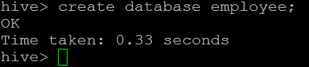

Listing Databases
The show databases command displays the list of databases in HDFS so that the user can select the database he wants to work with.
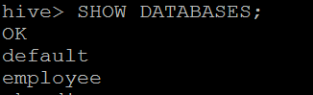

Using a Database
The command to use database is USE. The use database command allows the user to utilize the mentioned database to work with, where he can create new tables in that database and alter particular table contents too.
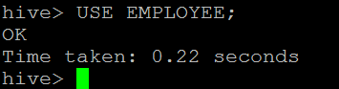

Creating a Table
The command for creating a table is ‘Create’.
Before creating a table, a user must know the following details:
- The create table command allows the user to create a new table with user input attributes/columns.
- Row format delimited Fields terminated by ‘\t’ – This line informs Hive that each column in the file is separated by a tab.
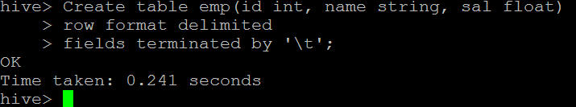
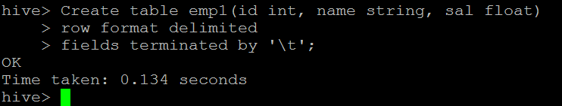

List Tables
The ‘show tables’ command displays the list of tables present in a particular database.
Hive> show Tables;
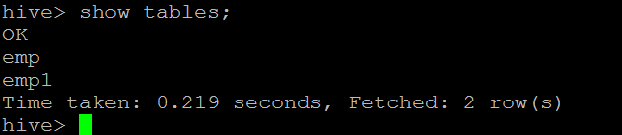
Once the table names are displayed, the user can select a particular table and work on it. The user can also create a new table and start processing the required query.

Describe Schema of the Table
The describe command is similar to adesc command in SQL. The describe command displays table definition/metadata of the mentioned table and the users can see column names and data types associated to that particular column.
Hive>DESCRIBE emp_table;
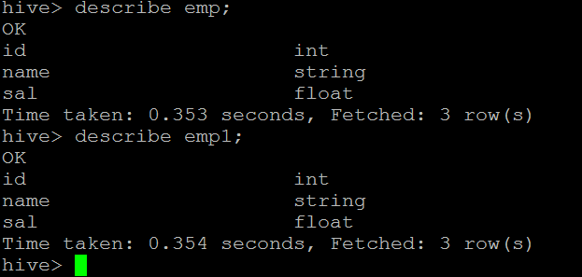

Load a File from the Local File System
We know that Hadoop is designed to work only on huge datasets instead of few selected rows/columns. So, the user needs to loadthe entire file to HDFS and process it using Hive commands.
The command used to load file from local system to HDFS is as follows:
Hive>load data local inpath<filename> into table<tablename>
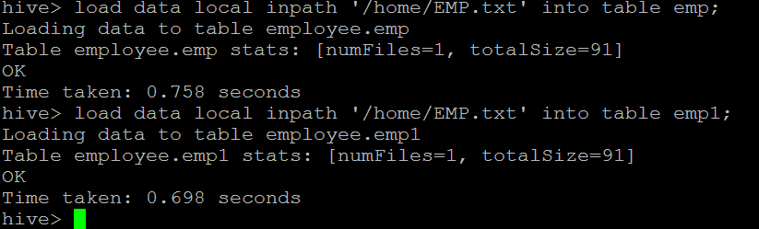

Load File from HDFS
The command used for loading file from HDFS is ‘load data’.
Hive>load data inpath<filename> into table<tablename>

Show Table Contents
Once the selected file is loaded to HDFS,the contents of the table can be checked using the select statement.
The select * statement of a table displays all the columns which are present in that table.
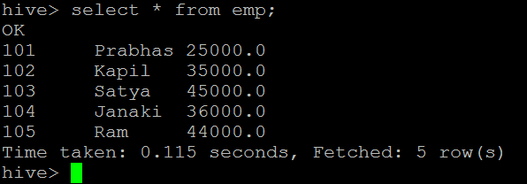

Commonly Used Alter Commands
Some of the commonly used alter commands in Hive are as follows:
Syntax
The statement takes any of the following syntaxes based on what attributes we wish to modify in a table.
ALTER TABLE name RENAME TO new_name
ALTER TABLE name ADD COLUMNS (col_spec[, col_spec ...])
ALTER TABLE name DROP [COLUMN] column_name
ALTER TABLE name CHANGE column_name new_name new_type
ALTER TABLE name REPLACE COLUMNS (col_spec[, col_spec ...])
Rename To… Statement
Renaming the Current Table:
hive> ALTER TABLE EMP RENAME TO EMPLOYEE
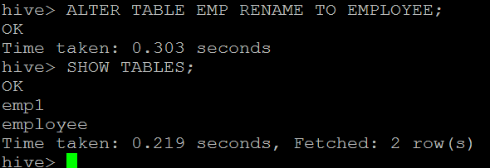

Adding New Columns to an Existing Table:
hive> ALTER TABLE EMPLOYEE ADD COLUMNS (YOJ DATE)
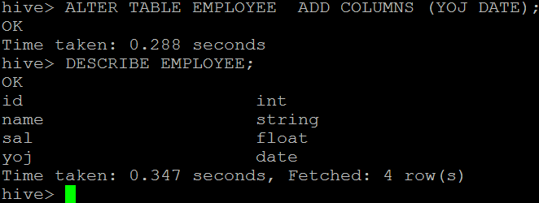

Truncating a Table
The Truncating table command allows users to delete only the content values in the table and not the table schema.
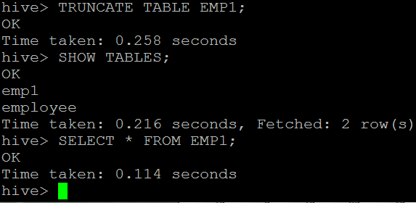
After performing the Truncating command, we can see that the table schema is unaffected but the contents of the table have been deleted.
This is how you can truncate/delete table contents without affecting the table schema.
=====Hive - Drop Table===
Below steps describes how to drop a table in Hive.
When you drop a table from Hive Metastore, it removes the table/column data and their metadata. It can be a normal table (stored in Metastore) or an external table (stored in local file system);
Hive treats both in the same manner, irrespective of their types.
Drop Table Statement
The syntax is as follows:
DROP TABLE [IF EXISTS] table_name;
The following query drops a table named employee:
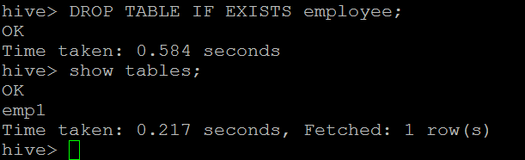

Dropping a Database
The command to drop a database is ‘drop database’. The drop database database_name allows users to drop a particular database from the HDFS memory.
Drop Database Statement: Drop Database is a statement that drops all the tables and deletes the database. Its syntax is as follows:
DROP DATABASE StatementDROP (DATABASE|SCHEMA) [IF EXISTS] database_name
[RESTRICT|CASCADE];
The following queries are used to drop a database. Let us assume that the database name is employee;.
hive> DROP DATABASE IF EXISTS employee;
The following query drops the database using CASCADE. It means dropping respective tables before dropping the database.
hive> DROP DATABASE IF EXISTS userdb CASCADE;
The following query drops the database using SCHEMA.
hive> DROP SCHEMA userdb;
This clause was added in Hive 0.6
Output:Drop userdb database successful.
hive> DROP DATABASE employee;
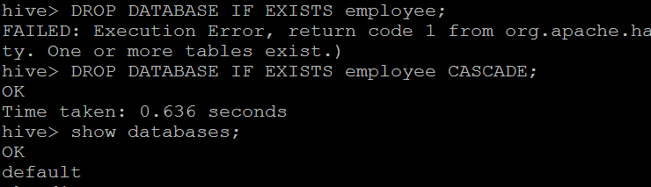

Managed and External Tables in Hive
we will be discussing about the types of tables in Hive and the difference between them and how to create those tables and when to use those tables for a particular dataset.
Hive has two types of tables:
- Managed table
- External table
Let us see about the above tables in detail

Managed table
Managed table is also called as Internal table. This is the default table in Hive. When we create a table in Hive without specifying it as a managed or external, by default we will get a Managed table.
If we create a table as a managed table, the table will be created in a specific location in HDFS.
By default the table data will be created in /usr/hive/warehouse directory of HDFS.
If we delete a Managed table, both the table data and meta data for that table will be deleted from the HDFS.
Let us create a managed table with the below command.
create table employee(Name String, Sal Int)
row format delimited fields terminated by ',';
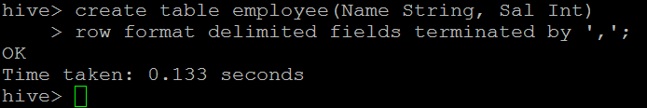
We have successfully created the table and to check the details of the table type the below command:
describe formatted table_name;
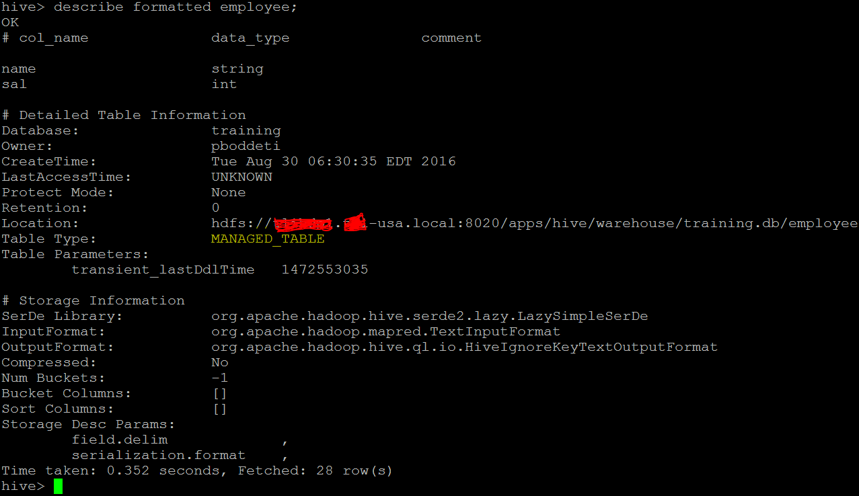
In the above image we can see MANAGED_TABLE as the entry for the option Table type which means that we have created a Managed table.
We will try to load one sample dataset which we have created into the table by using the below command:
Emp1.txt
/home # cat > emp1.txt
Pawan,5000
Ramesh,7000
Krishna,8000
Suresh,9000
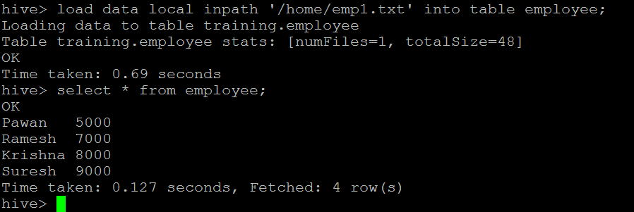
If we check in the hdfs location we can get the contents of the table.
Check the contents of the table in HDFS by using the below command
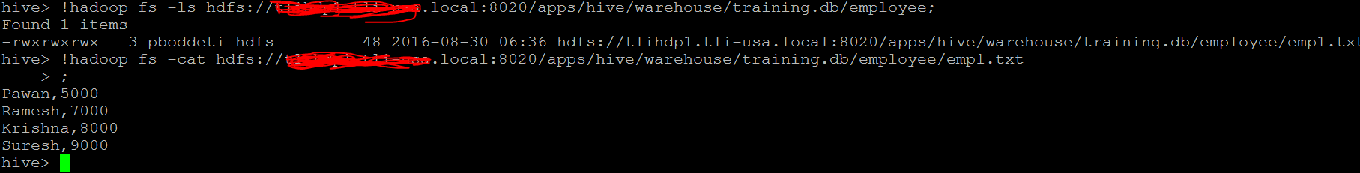
In the above image we can see the contents of the table which is in the hdfs location.
Now let us delete the above created table by using the command
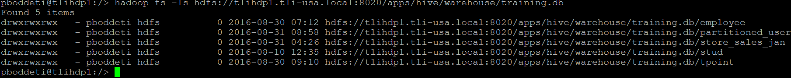

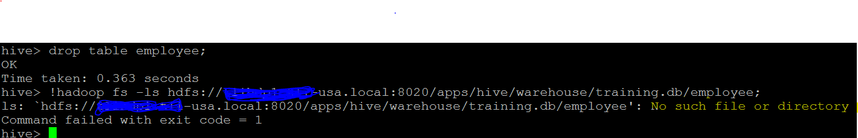

In the above image you can see that it is displaying like No such file or directory because both the table and its contents are deleted from the HDFS location.

Now let us create a table as External table.

EXTERNAL TABLE
External table is created for external use as when the data is used outside Hive. Whenever we want to delete the table’s metadata and want to keep the table’s data as it is, we use External table. External table only deletes the schema of the table.
Let us create an external table by using the below command:
create external table employee(Name String, Sal Int) row format delimited
fields terminated by ',';
Create a table as External table.
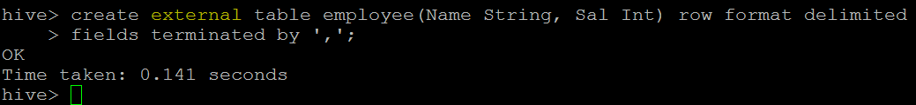
We have now successfully created the external table.
Let us check the details regarding the table using the below command:
Describe formatted employee;
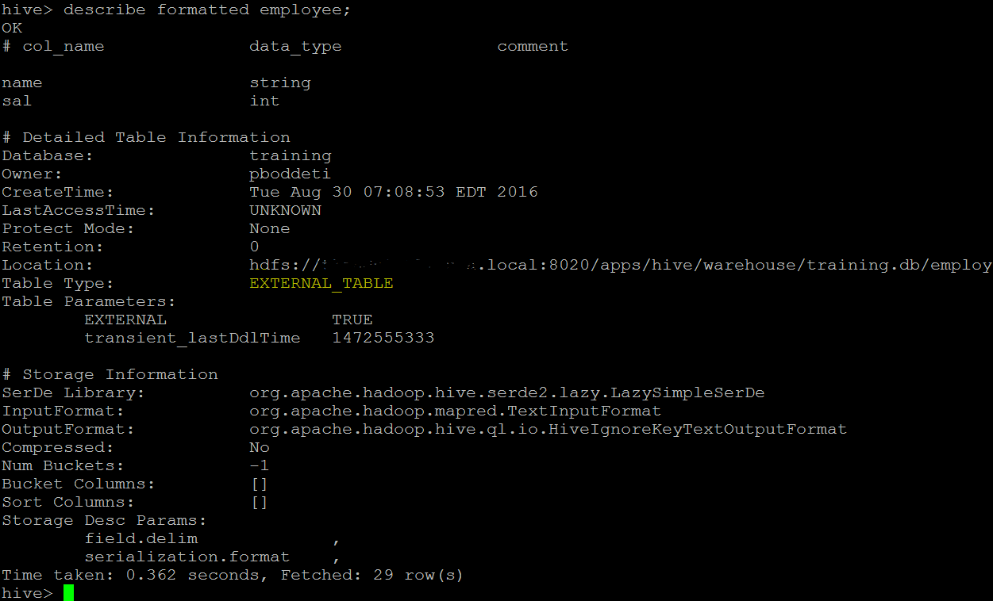
In the above image we can see the EXTERNAL_TABLE as the entry for the option
Table type which says that the above table is an External table.
Now let us load some data into the table using the below command:
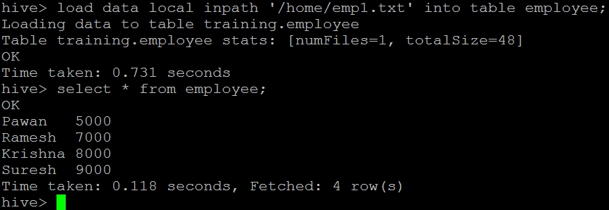
We have successfully loaded data into the Hive table.
Let us check the contents in HDFS by using the below command:
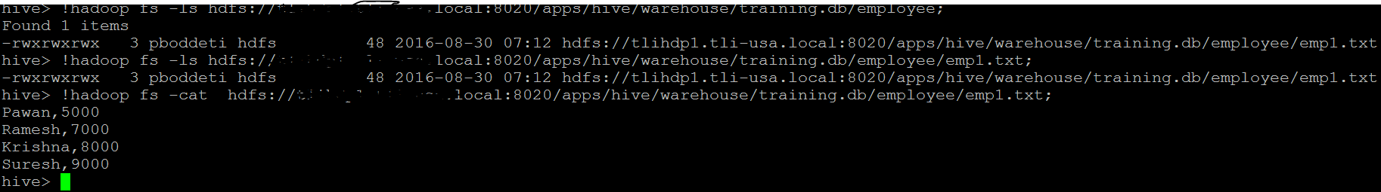
In the above image we can see the contents of the External table inside the HDFS.
Let’s now delete the table using the below command:
Drop table employee;
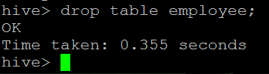
We have successfully deleted the table.
Now let us check the HDFS location of the table using the below command:
You can see that the contents of the table are still present in the HDFS location.
If we create an External table, after deleting the table only the metadata related to table is deleted but not the contents of the table.

When to use External and Managed table

Managed table
- Data is temporary
- Hive to Manage the table data completely not allowing any external source to use the table
- Don’t want data after deletion

External table
- The data is also used outside of Hive. For example, the data files are read and processed by an existing program that doesn’t lock the files
- Hive should not own data and control settings, dirs, etc., you have another program or process that will do those things
- You are not creating table based on existing table (AS SELECT)
- Can create table back and with the same schema and point the location of the data

String Functions in Hive

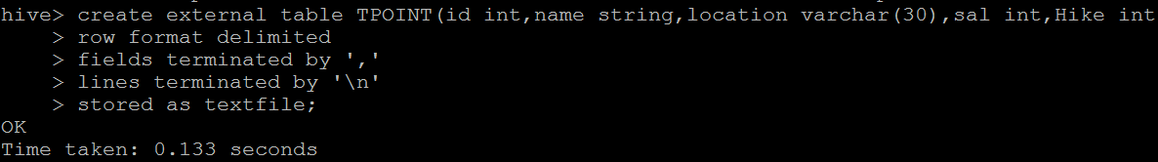

String Functions and Normal Queries:
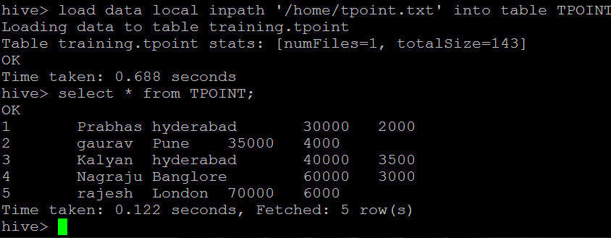

ASCII
ASCII Function converts the first character of the string into its numeric ASCII value

select ASCII(‘hadoop’) from TPOINT where sal=40000;
104
hive> select ASCII(‘Hadoop’) from TPOINT where sal=40000;
72
hive> select ASCII('A') from TPOINT where sal=40000;
65
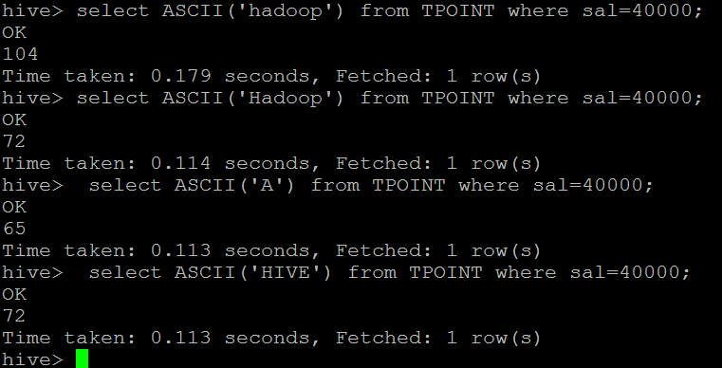

CONCAT
The CONCAT function concatenates all the strings/columns.

select CONCAT(name,'+',location) from TPOINT;
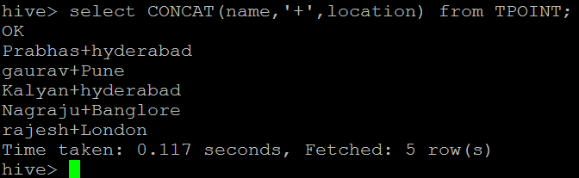
select concat(name,'+',sal) from TPOINT;
hive> select concat(name,'+',sal) from TPOINT;
OK
Prabhas+30000
gaurav+35000
Kalyan+40000
Nagraju+60000
rajesh+70000
Time taken: 0.114 seconds, Fetched: 5 row(s)
hive> select CONCAT(name,' ','Got Hike of',' ',Hike,' ','from',' ',sal) from TPOINT;
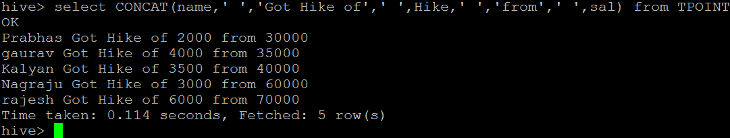
CONCAT_WS
Syntax: “CONCAT_WS(string delimiter, string str1,str2……)”
The CONCAT_WS function concatenates all the strings only strings and Column with datatype string.
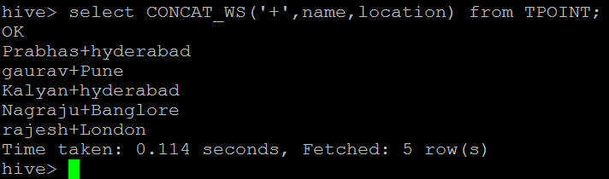
FIND_IN_SET :
Syntax: “FIND_IN_SET(string search_string,string source_string_list)”
The FIND_IN_SET function searches for the search_string in the source_string_list and returns the position of the first occurrence in the source_string_list.
Here the source_string_list should be comma delimited one.
LENGTH :
LENGTH function returns the number of characters in the string.LENGTH function returns the number of characters in the string.
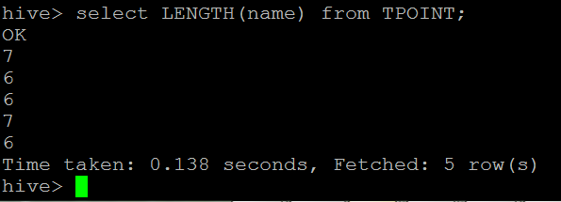
LOWER or LCASE :
The LOWER and LCASE convert the string into the Lower case.
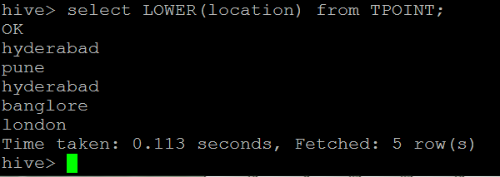
select LCASE(location) from TPOINT;
UPPER or UCASE:
The UPPER and UCASE convert the string into the UPPER case.
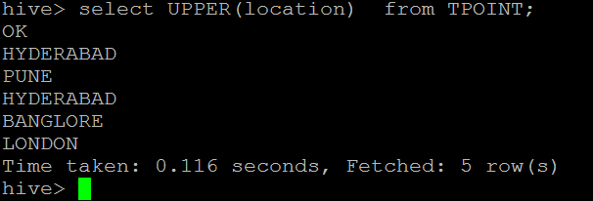
Hive Aggregate Functions
SUM
Returns the sum of the elements in the group or sum of the distinct values of the column in the group.
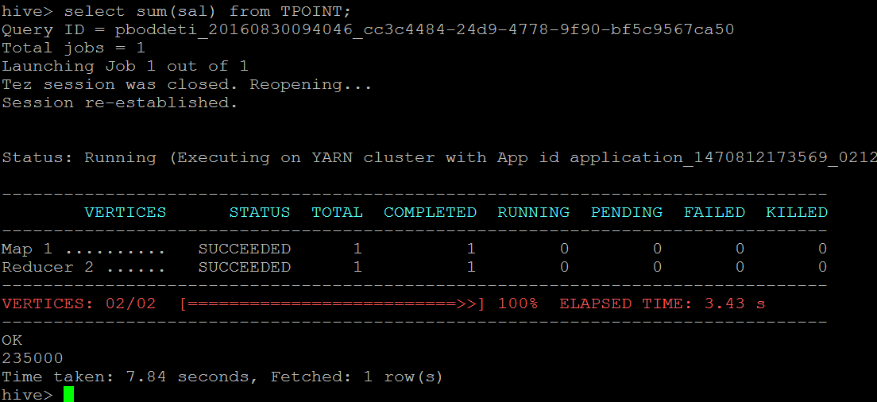
select Sum(sal) from TPOINT where loccation='hyderabad';
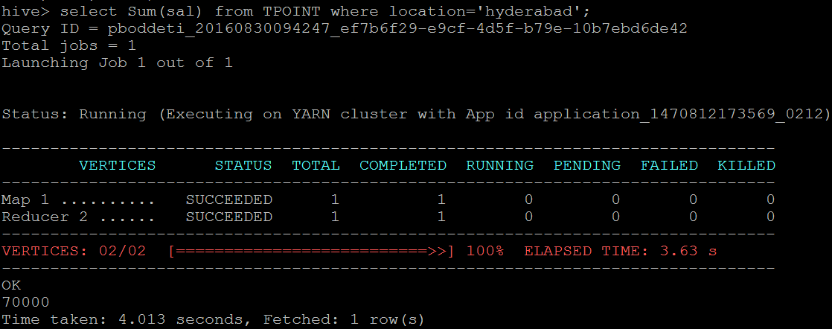
Count
count(*) – Returns the total number of retrieved rows, including rows containing NULL values;
count(expr) – Returns the number of rows for which the supplied expression is non-NULL;
count(DISTINCT expr[, expr]) – Returns the number of rows for which the supplied expression(s) are unique and non- NULL;
select count(*) from TPOINT;
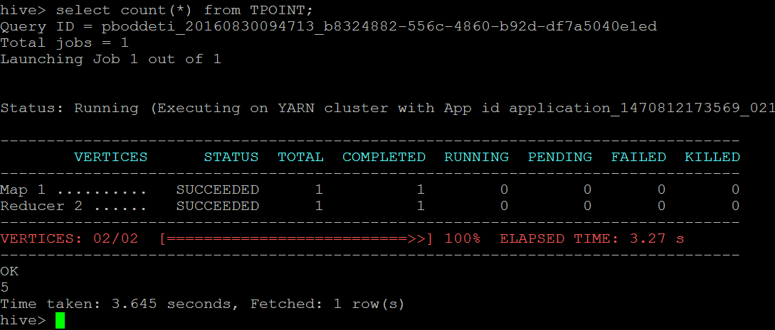
select Sum(sal) from TPOINT where location='hyderabad ‘;
select count(distinct location) from TPOINT;
select count(location) from TPOINT;
Average
Returns the average of the elements in the group or the average of the distinct values of the column in the group
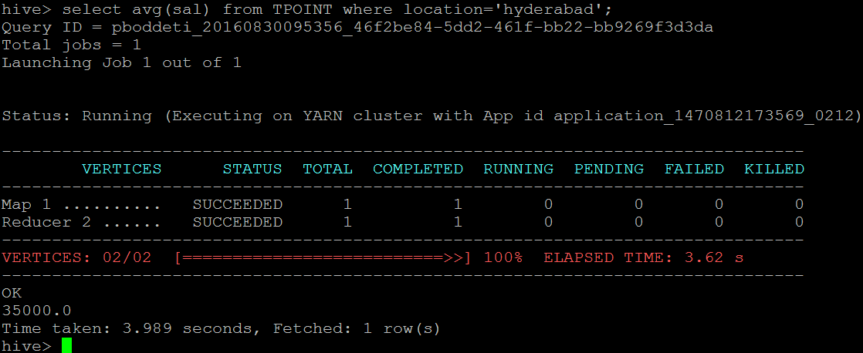
Minimum
Returns the minimum of the column in the group.
hive> select min(sal) from TPOINT;
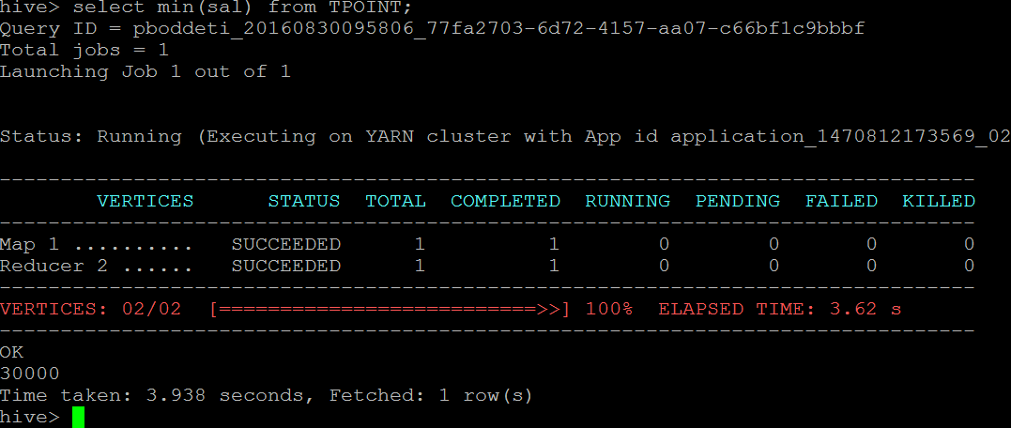
Maximum
Returns the maximum of the column in the group.
hive> select max(sal) from TPOINT;
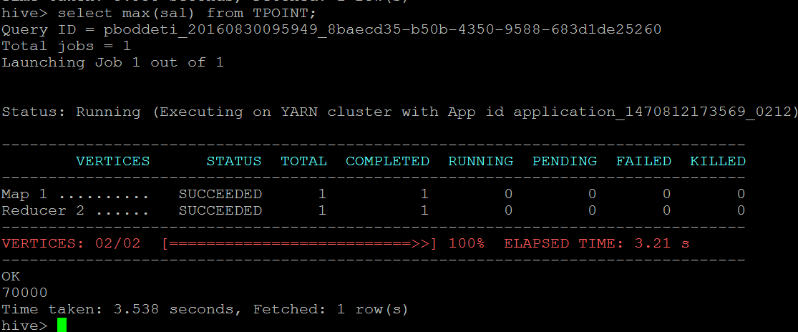
NTILE
This function divides an ordered partition into x groups called buckets and assigns a bucket number to each row in the partition.
This allows easy calculation of tertiles, quartiles, deciles, percentiles and other common summary statistics. (As of Hive 0.11.0.).
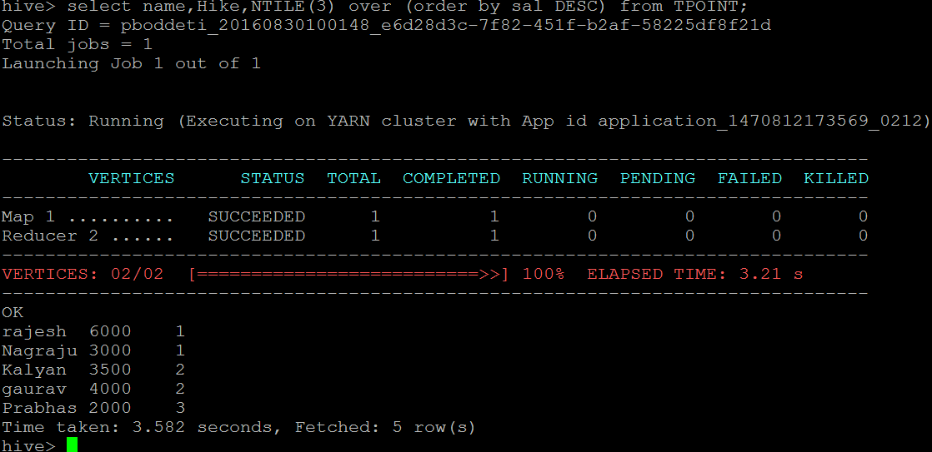
Collections
Returns a set of objects with duplicate elements eliminated.
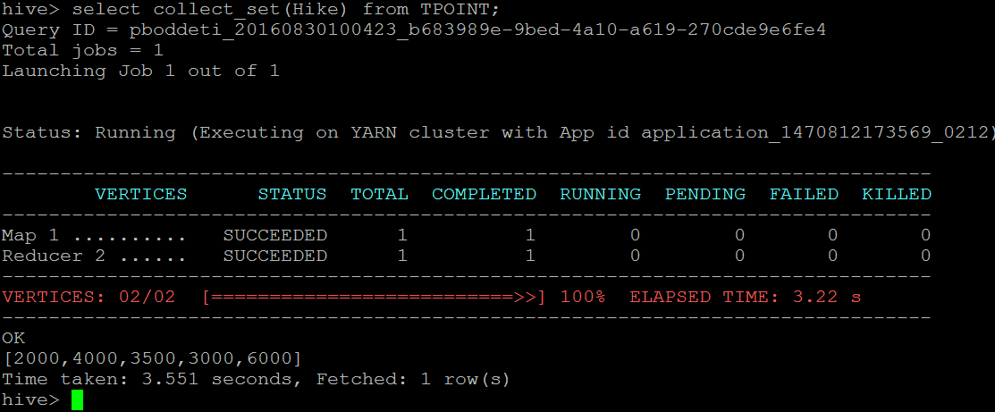
Variance
Returns the variance of a numeric column in the group.
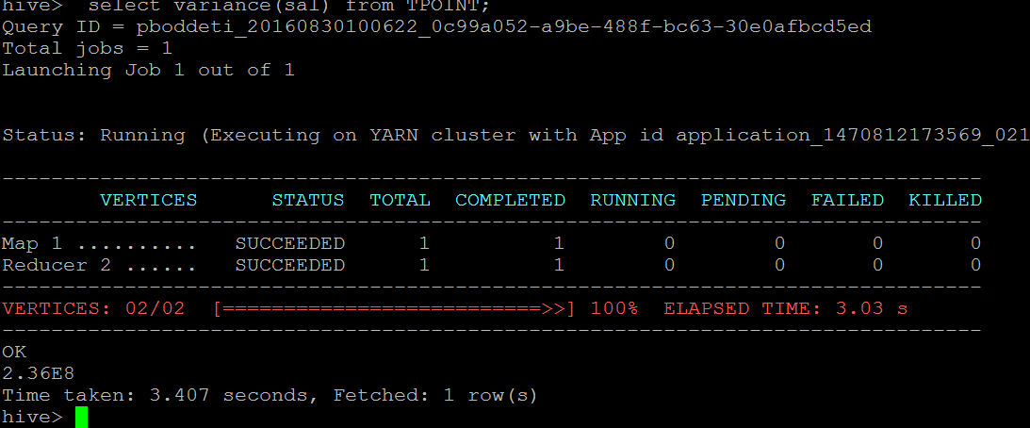
Percentile
Returns the exact pth percentile of a column in the group(does not work with floating point types).
P must be between 0 and 1.
NOTE: A true percentile “ Percentile(BIGINT col,P)”can only be computed for INTEGER values.
Use PERCENTILE_APPROX if you are input is non-integral.
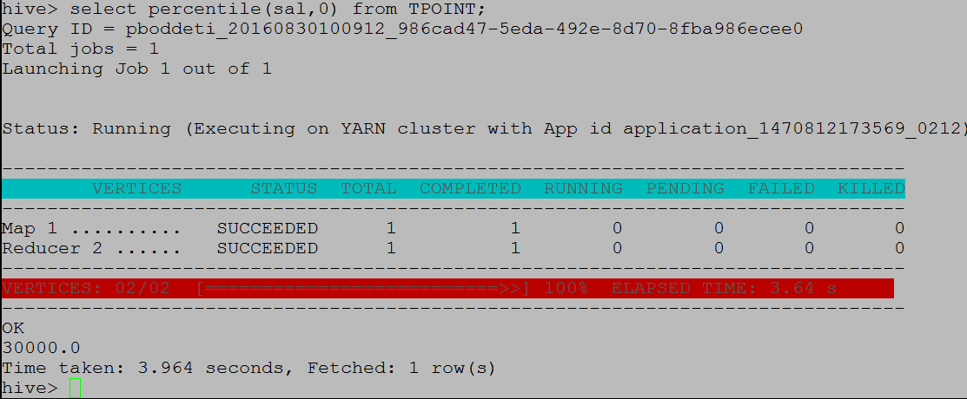

Partitioning In Hive

Partitioning in Hive
Table partitioning means dividing table data into some parts based on the values of particular columns like date or country, segregate the input records into different files/directories based on date or country.
Partitioning can be done based on more than column which will impose multi-dimensional structure on directory storage.
For Example, In addition to partitioning log records by date column, we can also sup divide the single day records into country wise separate files by including country column into partitioning. We will see more about this in the examples.
Partitions are defined at the time of table creation using the PARTITIONED BY clause, with a list of column definitions for partitioning.

Syntax
CREATE [EXTERNAL] TABLE table_name (col_name_1 data_type_1, ....)
PARTITIONED BY (col_name_n data_type_n [COMMENT col_comment], ...);
Advantages
Partitioning is used for distributing execution load horizontally.
As the data is stored as slices/parts, query response time is faster to process the small part of the data instead of looking for a search in the entire data set.
For example, In a large user table where the table is partitioned by country, then selecting users of country ‘IN’ will just scan one directory ‘country=IN’ instead of all the directories.
Limitations
Having too many partitions in table creates large number of files and directories in HDFS, which is an overhead to NameNode since it must keep all metadata for the file system in memory only.
Partitions may optimize some queries based on Where clauses, but may be less responsive for other important queries on grouping clauses.
In Mapreduce processing, Huge number of partitions will lead to huge no of tasks (which will run in separate JVM) in each mapreduce job, thus creates lot of overhead in maintaining JVM start up and tear down. For small files, a separate task will be used for each file. In worst scenarios, the overhead of JVM start up and tear down can exceed the actual processing time.
Example Scenarios
Partitioning is used in real-time log files analysis to segregate the records based on time stamp or date value to see the results day wise quickly.
Another real-time use is that, Customer/user details are partitioned by country/state or department for fast retrieval of subset data pertaining to some category.
Sales records by-product type, country, year and month is another commonly used scenario.
In this post we will try examples of use case 2.
Creation of Partition Table
Managed Partitioned Table
Below is the HiveQL to create managed partitioned_user table as per the above requirements.

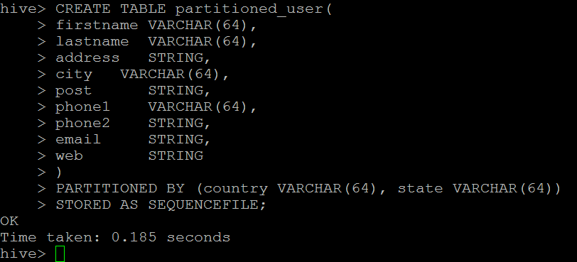
Note that we didn’t include country and state columns in table definition but included in partition definition.
If we include them, then we will encounter error scenario 1. We can verify the partition columns of the table with the help of below command.
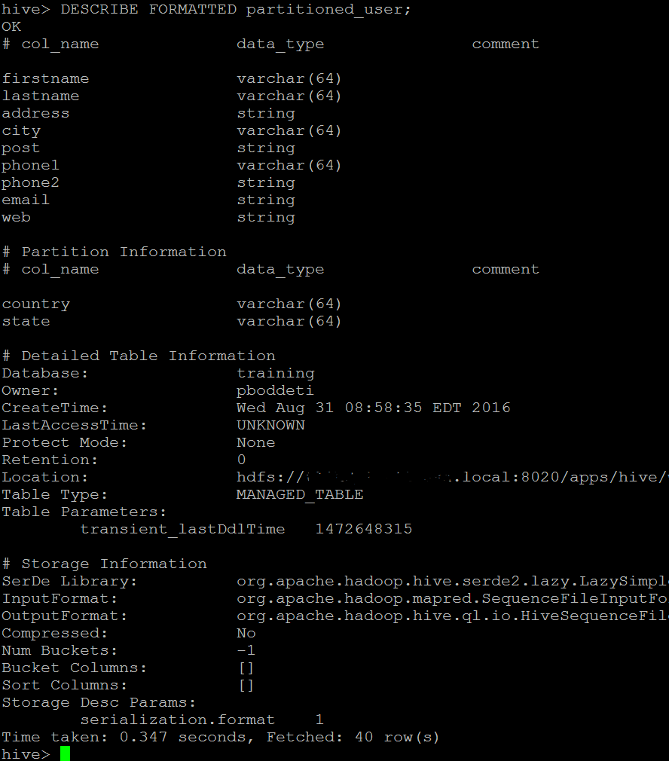
Partitioned columns country and state can be used in Query statements WHERE clause and can be treated regular column names even though there is actual column inside the input file data.
External Partitioned Tables
We can create external partitioned tables as well, just by using the EXTERNAL keyword in the CREATE statement,
but for creation of External Partitioned Tables, we do not need to mention LOCATION clause as we will mention locations of each partitions separately while inserting data into table.
Inserting Data Into Partitioned Tables
Data insertion into partitioned tables can be done in two modes.
Static Partitioning
Dynamic Partitioning
Static Partitioning in Hive
In this mode, input data should contain the columns listed only in table definition (for example, firstname, lastname, address, city, post, phone1, phone2, email and web) but not the columns defined in partitioned by clause (country and state).
If our input column layout is according to the expected layout and we already have separate input files for each partitioned key value pairs,
like one separate file for each combination of country and state values (country=US and state=CA), then these files can be easily loaded into partitioned tables with below syntax.
Loading Data into Managed Partitioned Table From Local FS
Example
For example, lets take below 3 records, which are not containing partitioned columns and save into staticinput.txt file on home directory. And assume that all these records belongs to country=US and State=CA

first_name,last_name,address,city,post,phone1,phone2,email,web
Rebbecca,Didio,171 E 24th St,Leith,7315,03-8174-9123,0458-665-290,rebbecca.didio@didio.com.au,http://www.brandtjonathanfesq.com.au
Stevie,Hallo,22222 Acoma St,Proston,4613,07-9997-3366,0497-622-620,stevie.hallo@hotmail.com,http://www.landrumtemporaryservices.com.au
Mariko,Stayer,534 Schoenborn St #51,Hamel,6215,08-5558-9019,0427-885-282,mariko_stayer@hotmail.com,http://www.inabinetmacreesq.com.au
Now this file can be loaded into partitioned table with below syntax by specifying the country and state value at load time itself.
LOAD DATA LOCAL INPATH 'home/staticinput.txt'
INTO TABLE partitioned_user
PARTITION (country = 'US', state = 'CA');
=========================================
Hive has been one of the preferred tool for performing queries on large datasets, especially when full table scan is done on the datasets.
In the case of tables which are not partitioned, all the files in a table’s data directory is read and then filters are applied on it as a subsequent phase. This becomes a slow and expensive affair especially in cases of large tables.
Without partitioning Hive reads all the data in the directory and applies the query filters on it. This is slow and expensive since all data has to be read.
Very often users need to filter the data on specific column values. To apply the partitioning in hive , users need to understand the domain of the data on which they are doing analysis.
With this knowledge, identification of the frequently queried or accessesd columns becomes easy and then partitioning feature of Hive can be applied on the selected columns.
Owing the fact that Partitions are horizontal slices of data,larger sets of data can be separated into more manageable chunks.
In this blog we are going to discuss about partitioning in hive and ways to use it. The problem with hive is that when we apply where clause then even a simple query in Hive reads the entire dataset.
This decreases the efficiency and becomes a bottleneck when we are required to run the queries on large tables.
This issue can be overcome by implementing partitions in hive.

First Name, Last Name, Roll number are the three columns in the sample data.
We will be creating partitions based on country and state column.
For this we will first create a database and a table:
Note: Columns which are a part of partitioner columns are not included in table definitions.
Using a database:
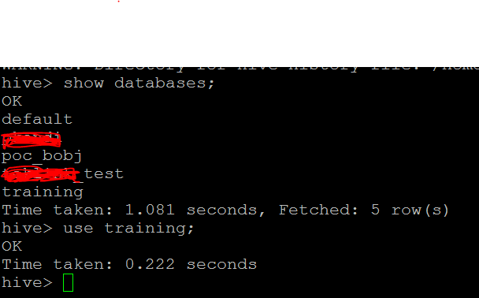
Now you know how to create table, let’s create a table and load data into it. We will take a simple example to understand how data is physically stored in hive managed tables.
I have a database named trainingdb which is empty as of now as shown in below screen.
I will create a new table named employees.
I have overridden default record delimiters and changed.
Fields will be terminated by comma, collection items are terminated by colon, map key-value pairs are terminated by hyphen.
Record is terminated by a new line character. Table is created and we are ready to load data into it.
create table employees(name string,
salary float,
subordinates array<string>,
deductions map<string,float>,
address struct<street:string,city:string,zip:int>)
row format delimited
fields terminated by ','
collection items terminated by ':'
map keys terminated by '-'
lines terminated by '\n'
stored as textfile;
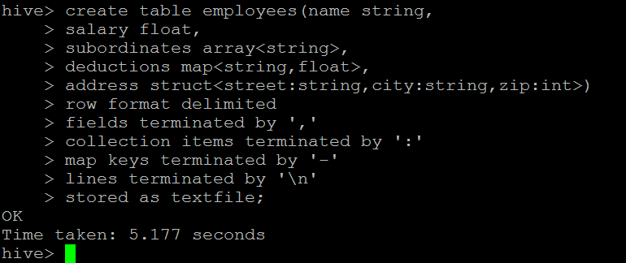

Before we load data into employees table,
let’s go to our database directory and check what’s created their as result of our create table statement.
You will find a new directory named as employees created under training.db directory. We don’t have files as there is no data in our table.
We need a data file to load it into our table. I have created a sample file with just two records to test data load into hive table.
You will notice that, it’s a plain text file and record structure is in compliance with record structure which we defined while creating table
i.e. fields are terminated by comma and so on. For your reference, I have displayed content of my file in below screen.
Prabhakar,10000,Vinay Kumar:Pawan Kadiyala,PF-750:IT-1000,Marathalli:Banglore:560037
Naresh,10000,Gandhi:Rajesh varaha,PF-750:IT-1000,BTM Layout:Banglore:560069
It’s time to load data from file to hive table. Command is very simple as shown in below screen.
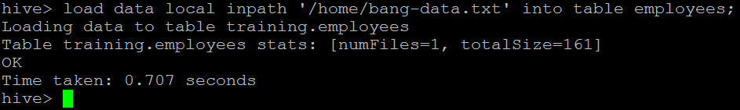
Data is loaded into employees table. Let’s execute a select statement to ensure that table is now holding data
So, we have created a table in hive and loaded data into it.
We executed a select statement and getting results as well. Let’s go back to our database directory and check what is created there.
Simple, we got same table copied into my HDFS database directory. Let’s drop our table and check, does it removed directory and data file as well. I hope you will check it yourself.
Next important thing to understand about hive is partitioned table. Let’s assume we are a global company and we have millions of customers across the globe.
We have large data available about our customers from all over the world and we want to load it into a data warehouse
create table customers(id int,
name string,
city string,
street string,
zip int)
partitioned by(country string,state string)
row format delimited
fields terminated by ',';
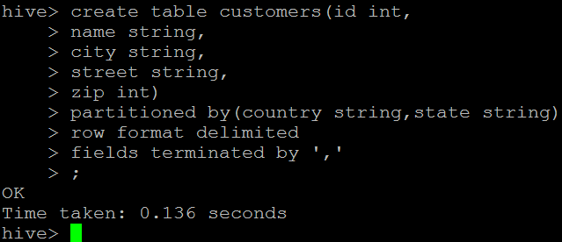

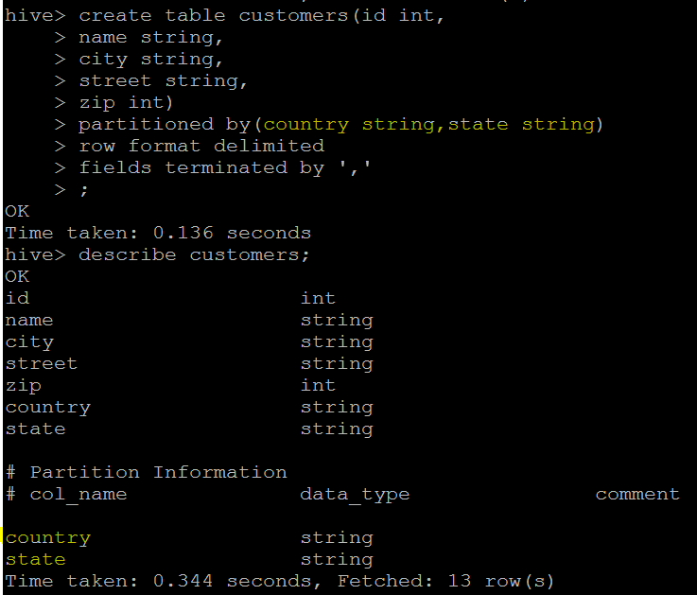

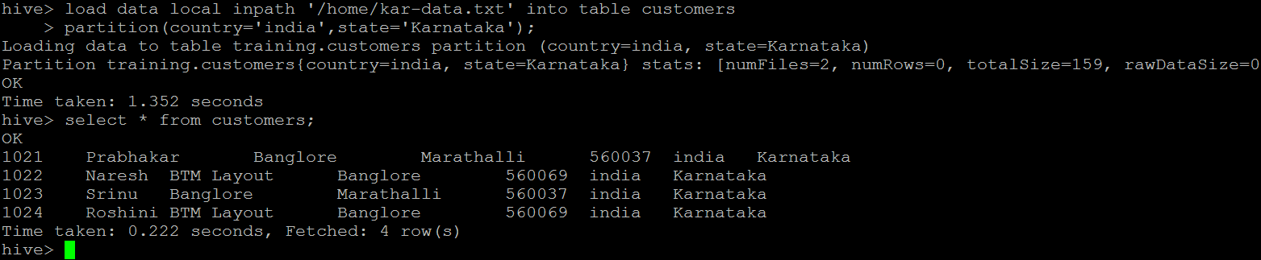
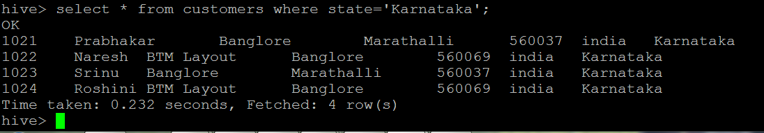

Because it’s external, Hive does not assume it owns the data. Therefore, dropping the table does not delete the data, although the metadata for the table will be deleted. Try it yourself.
Next obvious question would be can I drop a partition? Yes of course. Use SHOW PARTITIONS <table_name>;
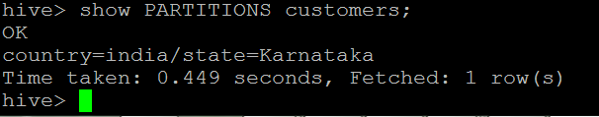
to list all of your partitions and when you know which partition you want to delete use statement like below.
ALTER TABLE customers DROP IF EXISTS PARTITION (country=’india’, state=’karnataka’);
You already know IF EXISTS is optional here.
In above example we added just one partition after creating an external table. If you have several partitions to be added, you don’t need to write multiple alter table statements.
ALTER TABLE <table_name> ADD IF NOT EXISTS
PARTITION (country=’india’,state=’karnataka’) LOCATION '/home/kar-data/'
PARTITION (country=’india’,state=’Andhra’) LOCATION '/home/andhra-data/'
PARTITION (country=’india’,state=’Kerla’) LOCATION '/home/kerla-data/'

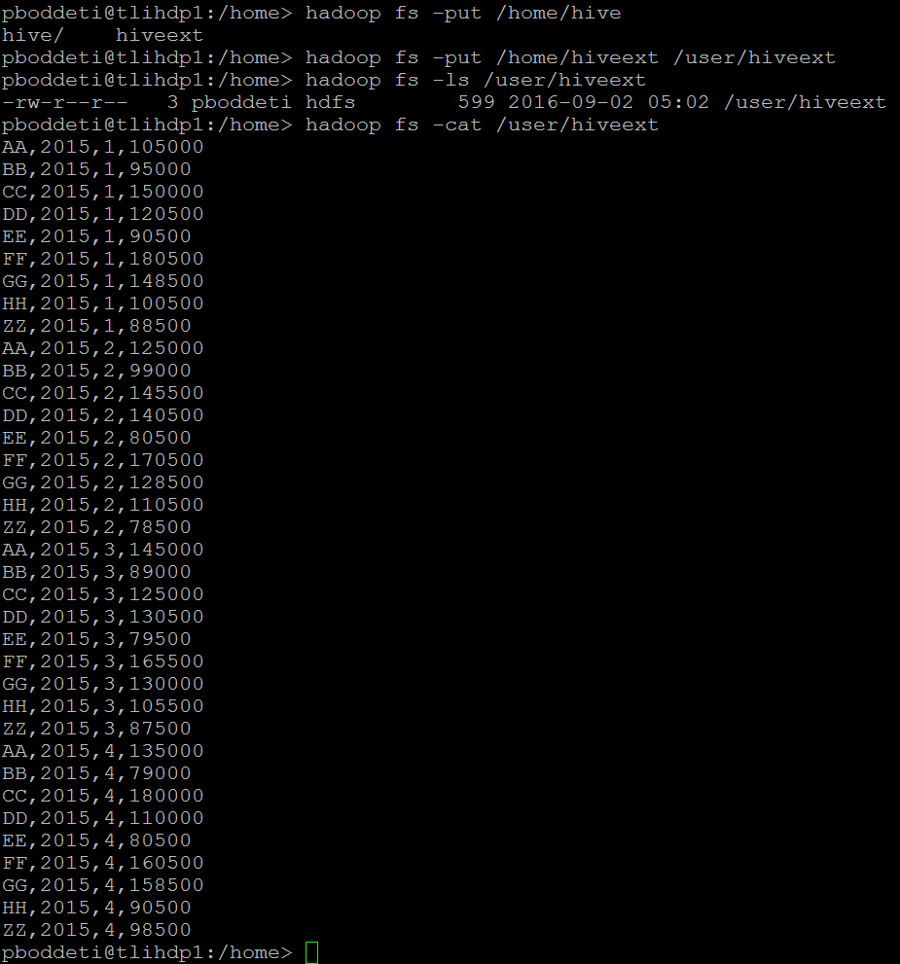
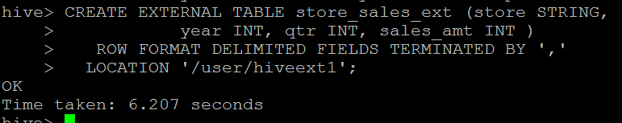
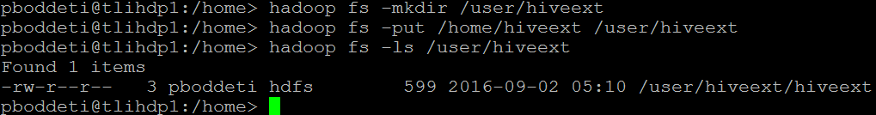

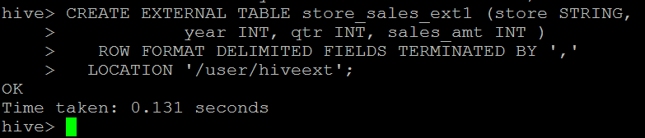
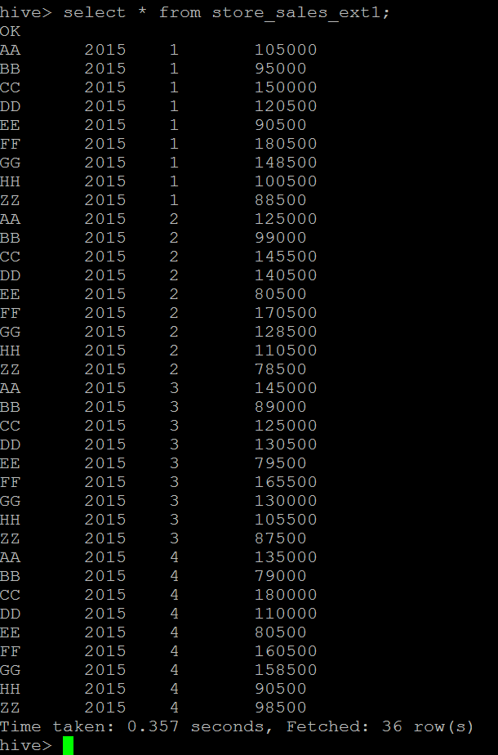
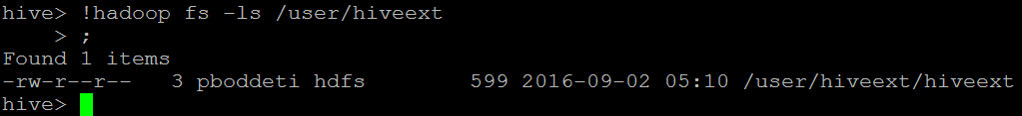
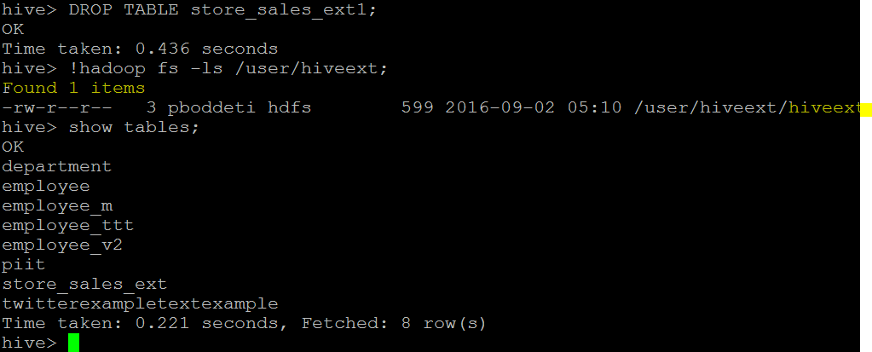
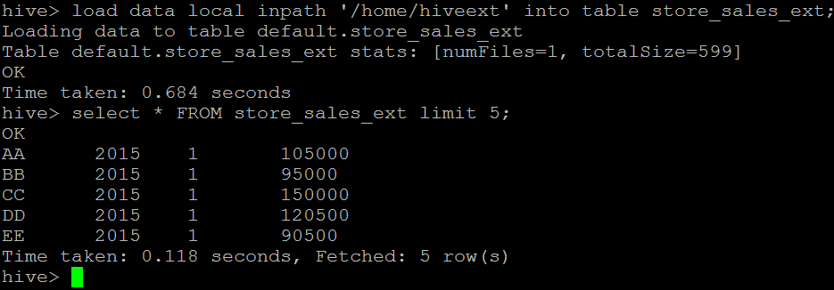

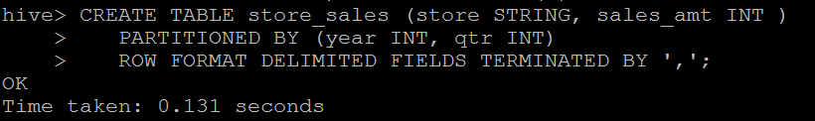
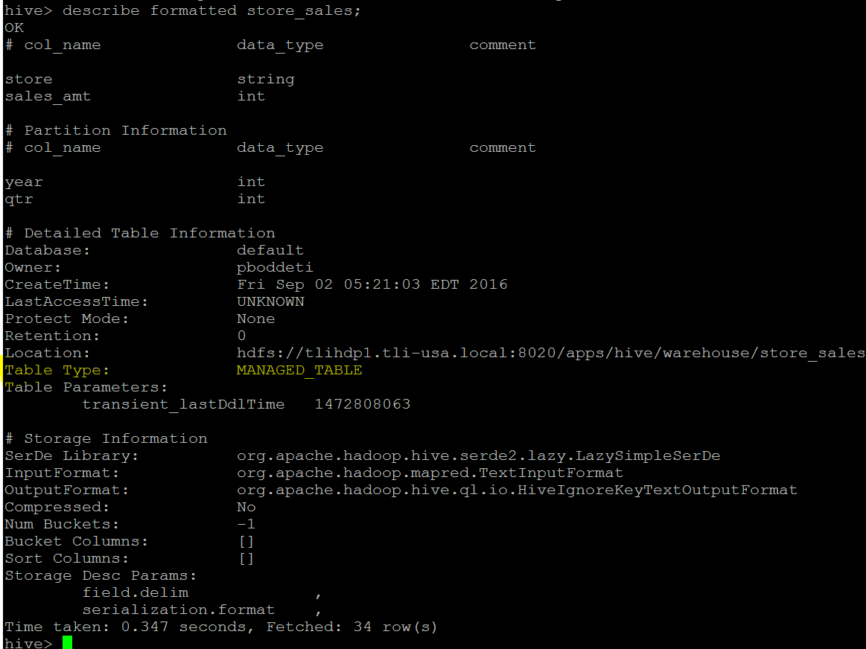
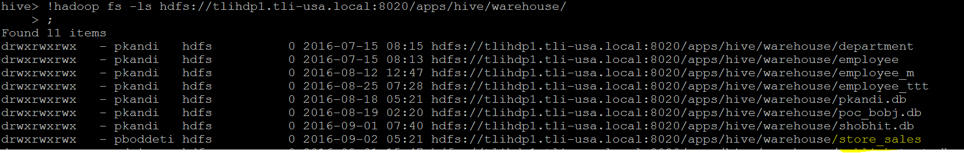

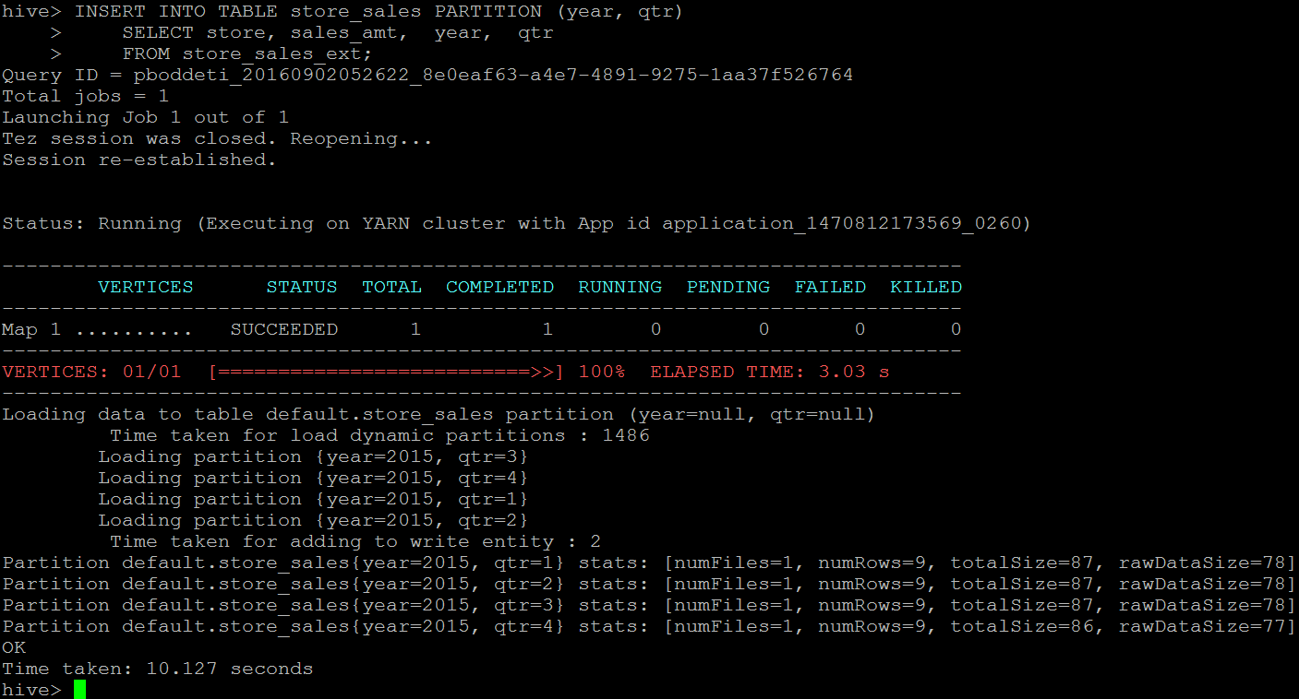

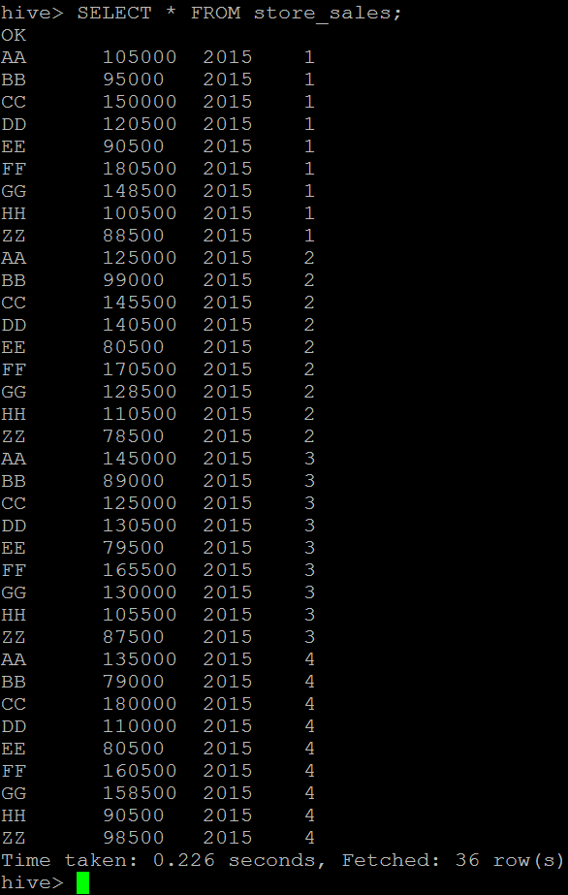

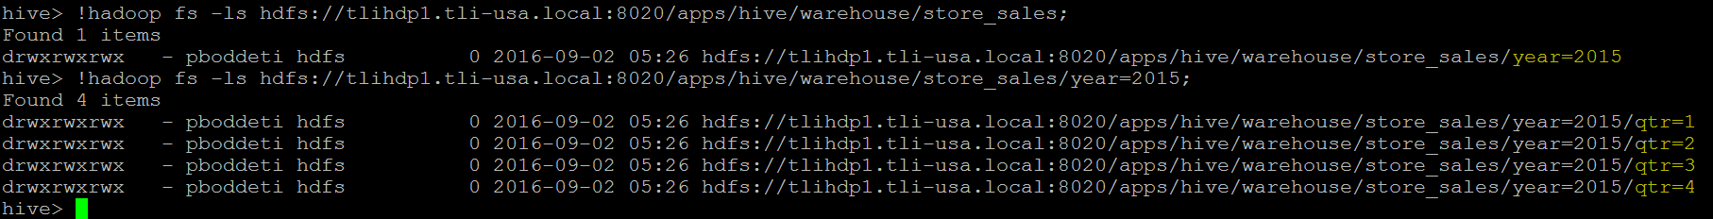

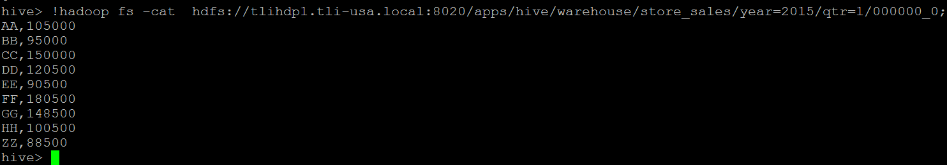

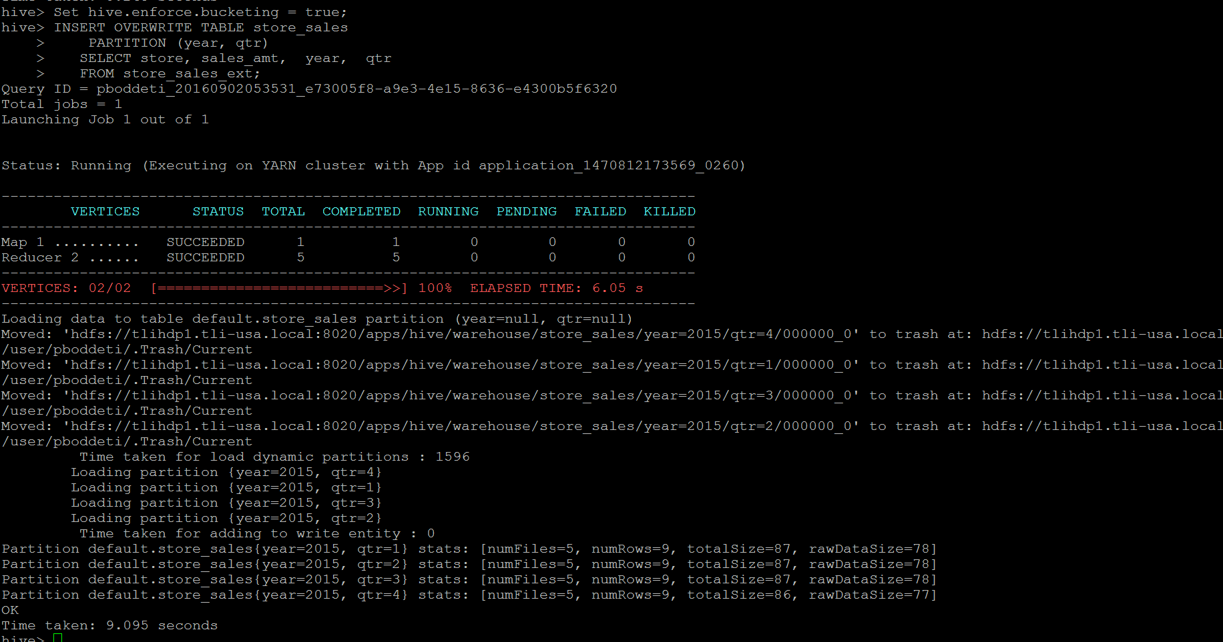

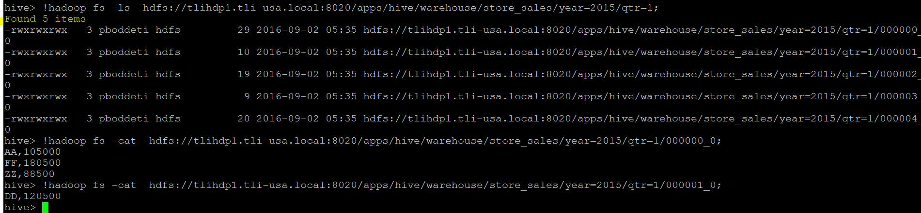
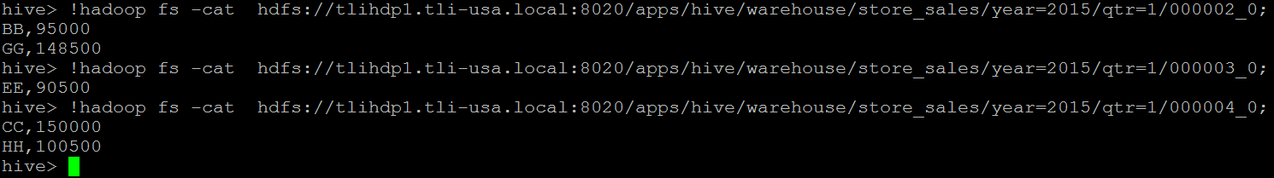
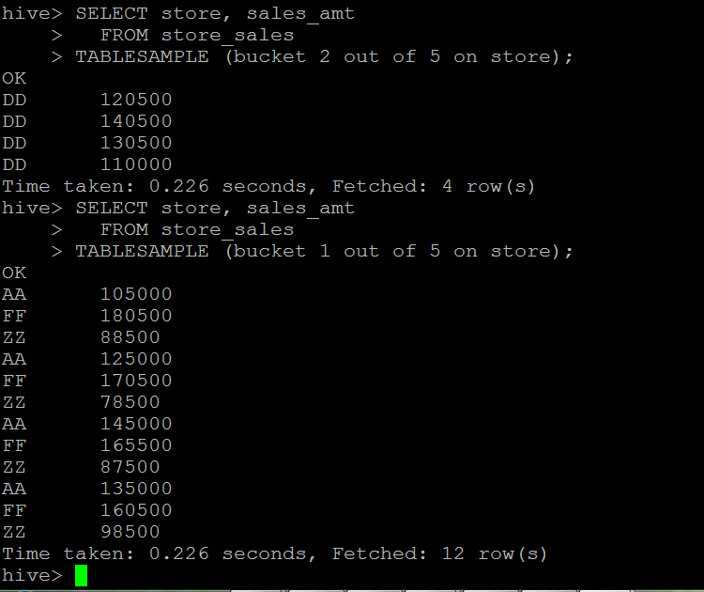

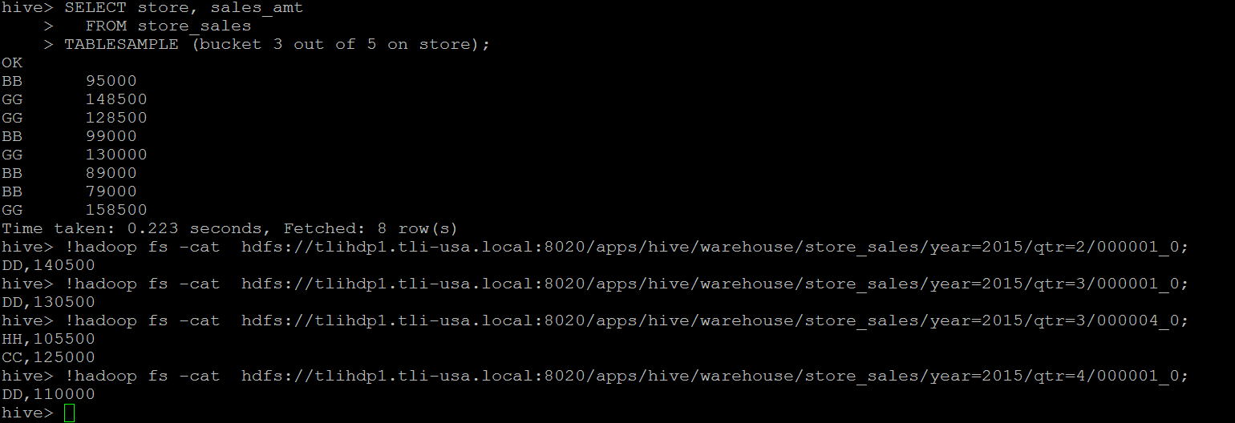

When you create the table and bucket it using the clustered by clause into 32 buckets (as an example),
hive buckets your data into 32 buckets using deterministic hash functions.
Then when you use TABLESAMPLE(BUCKET x OUT OF y),
hive divides your buckets into groups of y buckets and then picks the x'th bucket of each group. For example:
- If you use TABLESAMPLE(BUCKET 6 OUT OF 8),
- hive would divide your 32 buckets into groups of 8 buckets resulting in 4 groups of 8 buckets
and then picks the 6th bucket of each group, hence picking the buckets 6, 14, 22, 30.
- If you use TABLESAMPLE(BUCKET 23 OUT OF 32), hive would divide your 32 buckets into groups of 32,
resulting in only 1 group of 32 buckets, and then picks the 23rd bucket as your result.
- If you use TABLESAMPLE(BUCKET 3 OUT OF 64), hive would divide your 32 buckets into groups of 64 buckets,
resulting in 1 group of 64 "half-bucket"s and then picks the half-bucket that corresponds to the 3rd full-bucket.

Bucketing in Hive

As we all know, Partition helps in increasing the efficiency when performing a query on a table.

Instead of scanning the whole table, it will only scan for the partitioned set and does not scan or operate on the unpartitioned sets,

which helps us to provide results in lesser time and the details will be displayed very quickly because of Hive Partition.

Now, let’s assume a condition that there is a huge dataset. At times, even after partitioning on a particular field or fields,

the partitioned file size doesn’t match with the actual expectation and remains huge

and we want to manage the partition results into different parts. To overcome this problem of partitioning, Hive provides Bucketing concept, which allows user to divide table data sets into more manageable parts.

Thus, Bucketing helps user to maintain parts that are more manageable and user can set the size of the manageable parts or Buckets too.

Bucketing Features in Hive
Hive partition divides table into number of partitions and these partitions can be further subdivided into more manageable parts known as Buckets or Clusters.
The Bucketing concept is based on Hash function, which depends on the type of the bucketing column. Records which are bucketed by the same column will always be saved in the same bucket.
Here, CLUSTERED BY clause is used to divide the table into buckets.
In Hive Partition, each partition will be created as directory. But in Hive Buckets, each bucket will be created as file.
Bucketing can also be done even without partitioning on Hive tables.

Joins:
