1) git clone   
2) pip install -r req.txt  
3) python manage.py makemgrations  
4) python manage.py migrate

6) python manage.py createsuperuser  
7) python manage.py runserver  
  
All images stored inside \*\*screenshots\*\* folder:  
  
Open: http://127.0.0.1:8000/

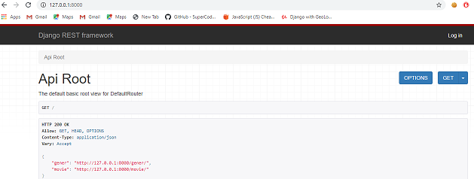

Anonymous User: Can view the gener and movies

"gener": <http://127.0.0.1:8000/gener/>

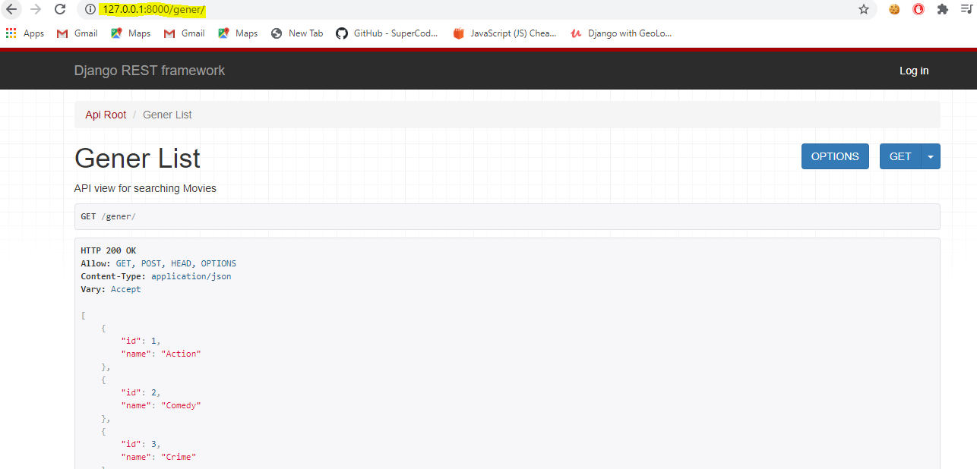

"movie": "http://127.0.0.1:8000/movie/"

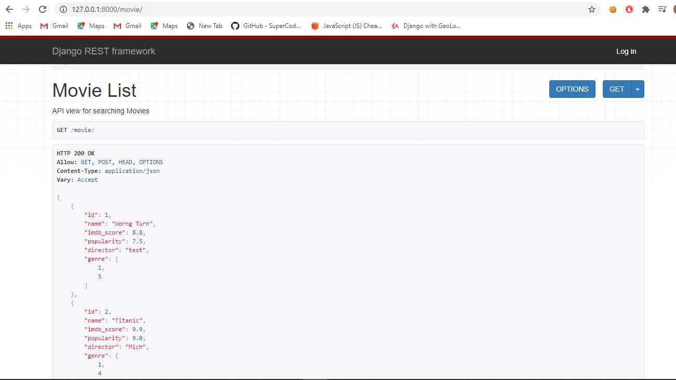

Anonymous User: Can view the gener and movies by id's  
 "http://127.0.0.1:8000/gener/4/"

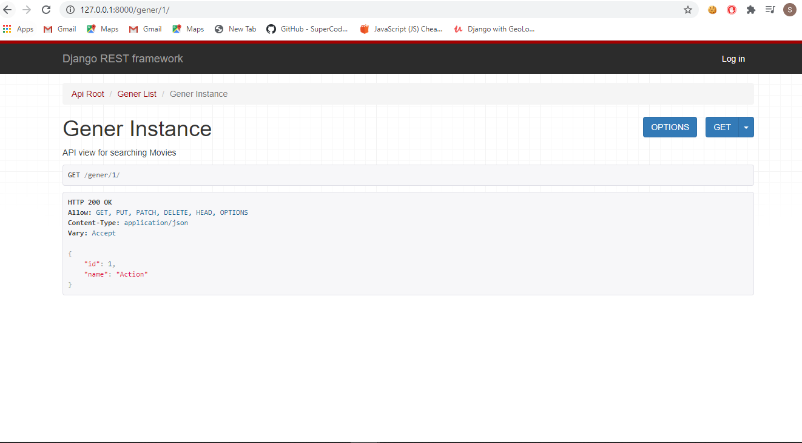

"http://127.0.0.1:8000/movie/"

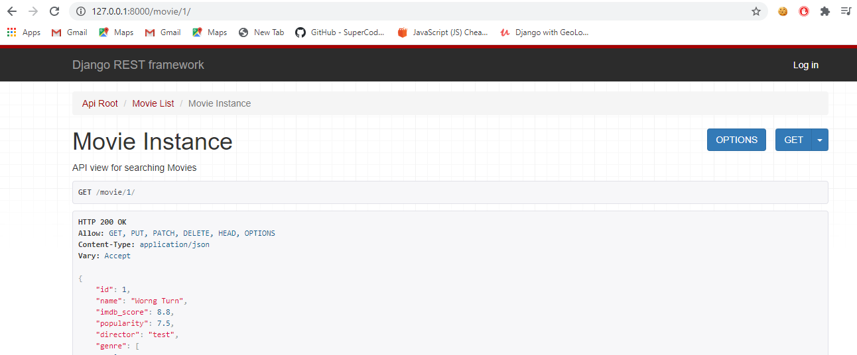

Admin Login:

Username: admin

Password: admin

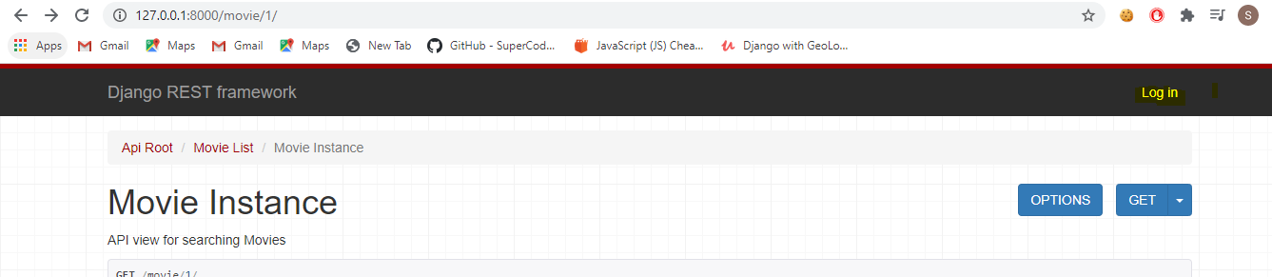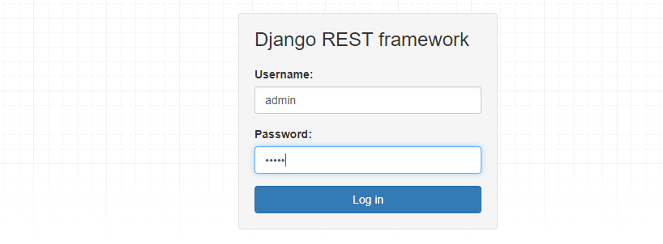

Admin can Edit update delete the gener and Movies

http://127.0.0.1:8000/movie/

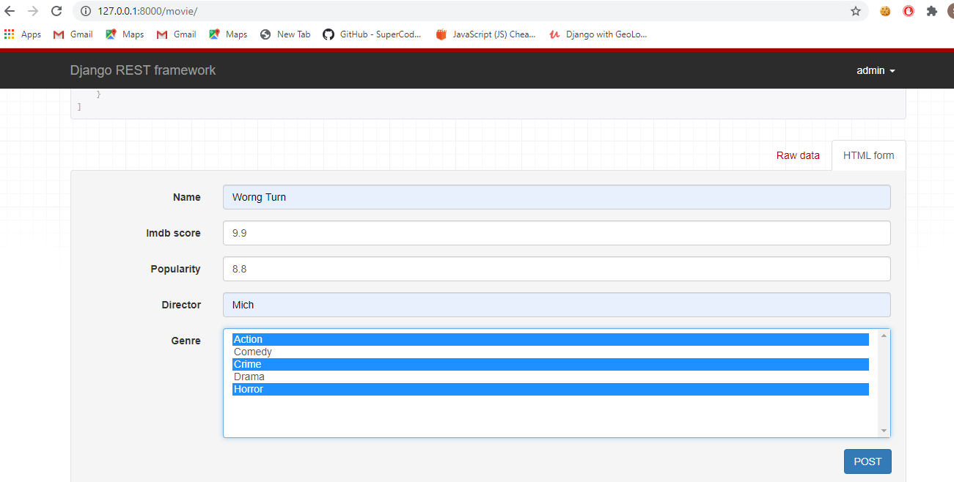

http://127.0.0.1:8000/movie/2/

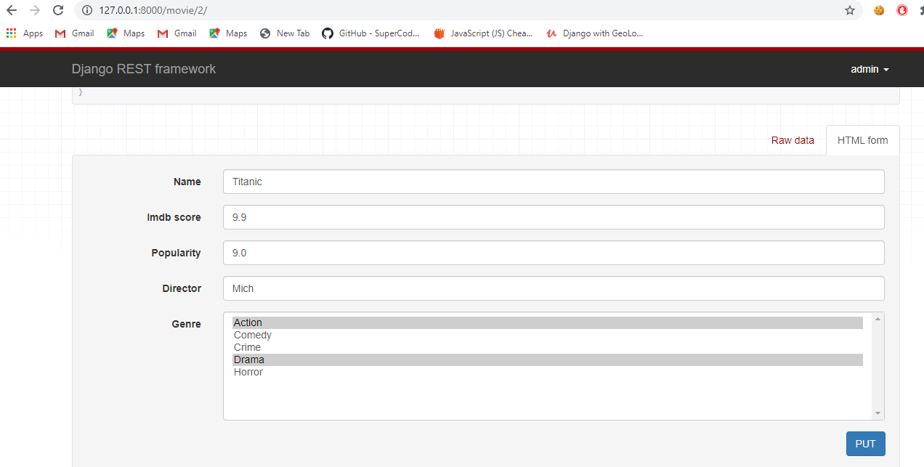

Delete the movies:

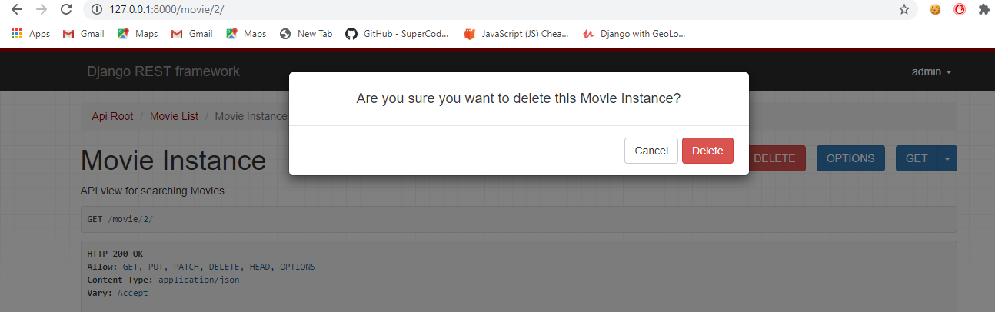

Add the gener:

<http://127.0.0.1:8000/gener/>

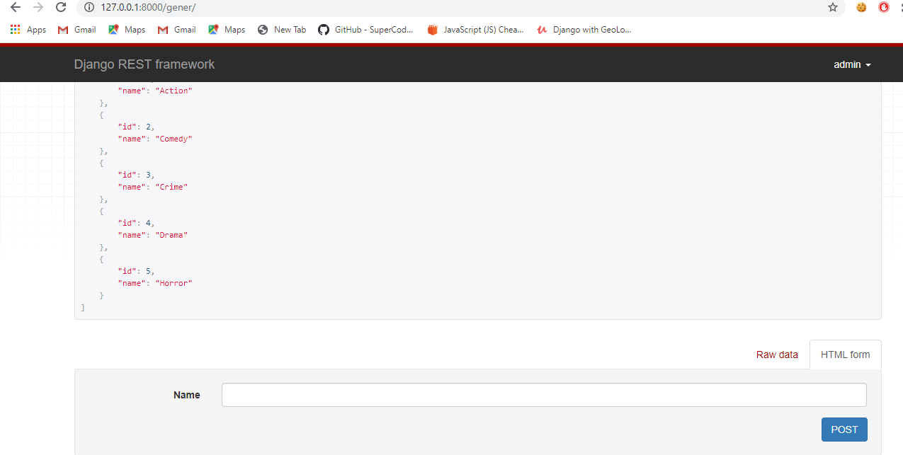

Edit the gener:

<http://127.0.0.1:8000/gener/>1/

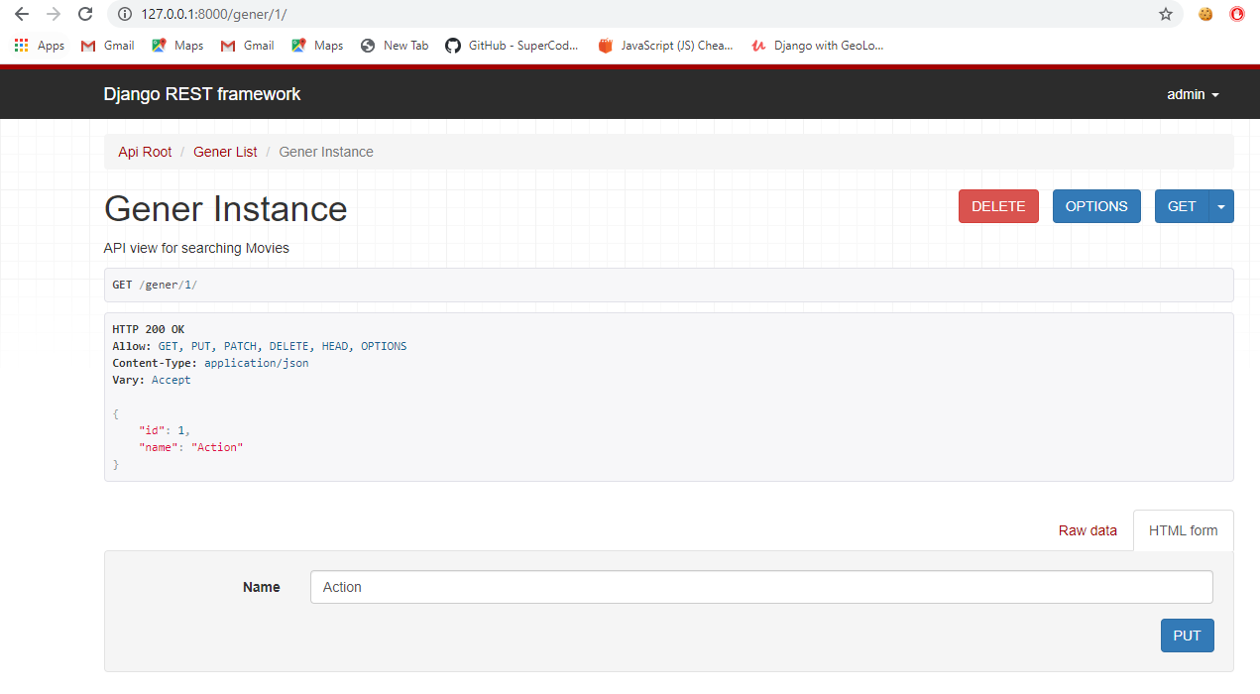

Delete the genre:

<http://127.0.0.1:8000/gener/1/>

