https://medium.com/velotio-perspectives/know-everything-about-spinnaker-how-to-deploy-using-kubernetes-engine-57090881c78f
https://cloud.google.com/solutions/continuous-delivery-spinnaker-kubernetes-engine

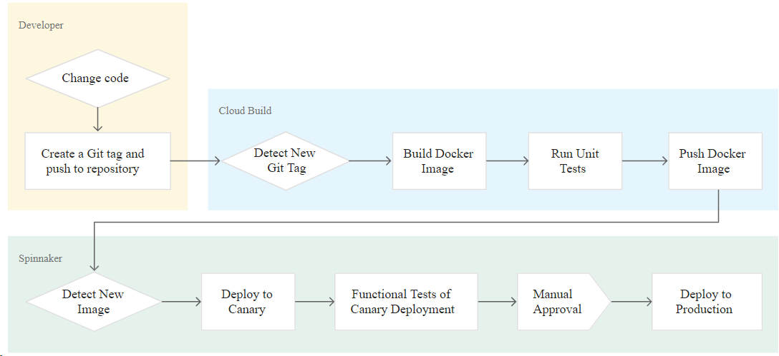

Pipeline Flow and Steps .
1 . Once a developer changes code and pushes it to a repository.
2 . Cloud Build detects the changes, builds the Docker image, tests the image, and pushes the image to GCR
3 . Spinnaker detects the image, deploys image to Canary, and tests the Canary deployment. After a manual approval, Spinnaker deploys the image to production.

GCP Components will be used.
>GKE
> Cloud Load Balancing ( GCP Load Balancer )
> Cloud Build ( GCP Pipeline )
> Cloud Source Repositories ( Git Repository on GCP )
> Container Registry ( Docker Registry on GCP )

Create Project on GCP OR use existing one.
Enable the GKE, Cloud Build, and Cloud Source Repositories APIs.

https://console.cloud.google.com/flows/enableapi?apiid=container,cloudbuild.googleapis.com,sourcerepo.googleapis.com&_ga=2.81277207.-1676509218.1568793572
Now Create A GKE Cluster

Set Up a Kubernetes Cluster
Go to the Console and scroll the left panel down to Compute->Kubernetes Engine->Kubernetes Clusters.
Click Create Cluster.
Choose a name or leave as the default one.
Under Machine Type, click Customize.
Allocate at least 2 vCPU and 5GB of RAM.
Change the cluster size to 2.
Enable Legacy Authorization while customizing the cluster.
Keep the rest of the defaults and click Create.
In a minute or two the cluster will be created and ready to go
Now Setup a Linux machine for operate GCP using Gcloud , and manage GKE using kubectl

Create A Service account with role “storage admin“ and download the json key
Now Export the Env Variables for service account email and project id .
$export SA_EMAIL=spinnaker-storage-account@dvps-learning.iam.gserviceaccount.com
$ export PROJECT=dvps-learning

# Add the Cloud SDK distribution URI as a package source
echo "deb [signed-by=/usr/share/keyrings/cloud.google.gpg] http://packages.cloud.google.com/apt cloud-sdk main" | sudo tee -a /etc/apt/sources.list.d/google-cloud-sdk.list
# Import the Google Cloud Platform public key
curl https://packages.cloud.google.com/apt/doc/apt-key.gpg | sudo apt-key --keyring /usr/share/keyrings/cloud.google.gpg add -
# Update the package list and install the Cloud SDK
sudo apt-get update && sudo apt-get install google-cloud-sdk
Now RUN $gcloud init for setup authentication to gcp account here we can use browser based authentication or use any service account json key which have access to cloud resources .
##using json Key ##
$gcloud auth activate-service-account project-owner-dvps-learning@dvps-learning.iam.gserviceaccount.com --key-file=project-owner-dvps-learning.json --project=dvps-learning
$gcloud auth list

##Now install Kubectl for manage GKE ##
$sudo apt-get update
$sudo apt-get install -y kubectl
##connect gke Cluster using command line ##
$gcloud container clusters get-credentials dvps-cluster --zone us-central1-a --project dvps-learning

Deploying Spinnaker using Helm on K8s via Charts

Install Helm
Download and install the helm binary:
$ wget https://storage.googleapis.com/kubernetes-helm/helm-v2.9.0-linux-amd64.tar.gz
Unzip the file on local system:
$ tar zxfv helm-v2.9.0-linux-amd64.tar.gz
$ sudo chmod +x linux-amd64/helm && sudo mv linux-amd64/helm /usr/bin/helm
Grant Tiller, the server side of Helm, the cluster-admin role in your cluster:
$ kubectl create clusterrolebinding user-admin-binding --clusterrole=cluster-admin --user=$(gcloud config get-value account)
$ kubectl create serviceaccount tiller --namespace kube-system
$ kubectl create clusterrolebinding tiller-admin-binding --clusterrole=cluster-admin --serviceaccount=kube-system:tiller
Grant Spinnaker the cluster-admin role so it can deploy resources across all namespaces:
$ kubectl create clusterrolebinding --clusterrole=cluster-admin --serviceaccount=default:default spinnaker-admin
Initialize Helm to install Tiller in your cluster:
$ helm init --service-account=tiller --upgrade
$ helm repo update
Ensure that Helm is properly installed by running the following command. If Helm is correctly installed, v2.9.0 appears for both client and server.
$ helm version

Configure Spinnaker
$export PROJECT=dvps-learning

2. Create the configuration file ( below variables will be used to provision the resources on helm charts run )
$ export SA_JSON=$(cat spinnaker-sa.json)
$ export PROJECT=$(gcloud info --format='value(config.project)')
$ export BUCKET=$PROJECT-spinnaker-config
$ cat > spinnaker-config.yaml <<EOF
storageBucket: $BUCKET
gcs:
enabled: true
project: $PROJECT
jsonKey: '$SA_JSON'
# Disable minio as the default
minio:
enabled: false
# Configure your Docker registries here
accounts:
- name: gcr
address: https://gcr.io
username: _json_key
password: '$SA_JSON'
email: 1234@5678.com
EOF

Deploy the Spinnaker chart
Use the Helm command-line interface to deploy the chart with the configuration set earlier. This command typically takes five to ten minutes to complete, so we will be providing a deploy timeout with ` — timeout`.

$ helm install -n cd stable/spinnaker -f spinnaker-config.yaml --timeout \ 600 --version 0.3.1

2. After the command completes, run the following command to set up port forwarding to the Spinnaker UI from Cloud Shell:
$ export DECK_POD=$(kubectl get pods --namespace default -l \ "component=deck" -o jsonpath="{.items[0].metadata.name}")
$ kubectl port-forward --namespace default $DECK_POD 8080:9000 >> /dev/null &

3. The above command exposes the Spinnaker UI onto the local machine that we’re using to run all the commands. We can use any port of our choosing instead of 8080 in the above command. Now the UI can be opened onto the URL http://localhost:8080.
Now Download the Sample Git code and push that to GCP Source code repository.
Download the source code:
$ wget https://gke-spinnaker.storage.googleapis.com/sample-app.tgz
Unpack the source code:
$ tar xzfv sample-app.tgz
Change directories to source code:
$ cd sample-app
Set the username and email address for Git commits in this repository. Replace [EMAIL_ADDRESS] with Git email address, and replace [USERNAME] with Git username.
$ git config --global user.email "abc@gmail.com"
$ git config --global user.name "abc"

Make the initial commit to source code repository:
$ git init
$ git add .
$ git commit -m "Initial commit"
Create a repository to host the code:
$ gcloud source repos create sample-app
$ git config credential.helper gcloud.sh
Add our newly created repository as remote:
$ export PROJECT=dvps-learning
$ git remote add origin \ https://source.developers.google.com/p/$PROJECT/r/sample-app
Push the code to the new repository’s master branch:
$ git push origin master
( take little time to reflect )

Now go to Cloud Build and create a trigger which will execute the pipeline one git tag starting from v.* pushed to repository.

As our Repository already on GCP then we have to create trigger only , otherwise we have to connect repository if we using github or bitbucket .

Go to Cloud Build > Create Trigger .
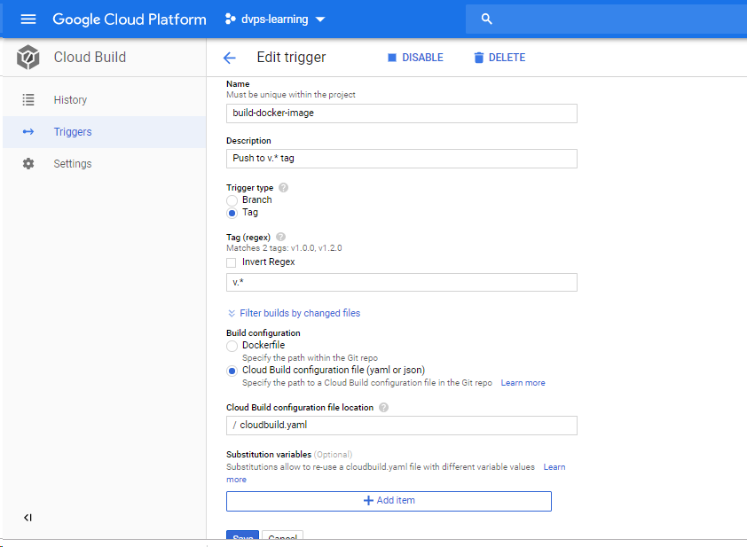
Trigger Created by same way , now create a tag with v.1 then check our pipeline should trigger automatically .
Go to GIT bash console and Create a Git tag:
$ git tag v1.0.0
Push the tag:
$ git push –tags

Once tag will pushed then our Cloud-build pipeline will trigger automatically > go to build history.

Now once our Docker build is working fine with trigger build then create a Deployment pipeline on Spinnaker UI .

As our Spinnaker UI is accessible from Local network only so we should have a GUI machine with same network Like Windows , for my testing purpose I exposed my spinnaker service on Load-Balancer and accessed it from outside .

Create the application
In the Spinnaker UI, click Actions, then click Create Application.

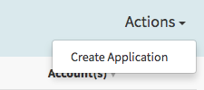
2. In the New Application dialog, enter the following fields:
Name: sample
Owner Email: [your email address]
3. Click Create.
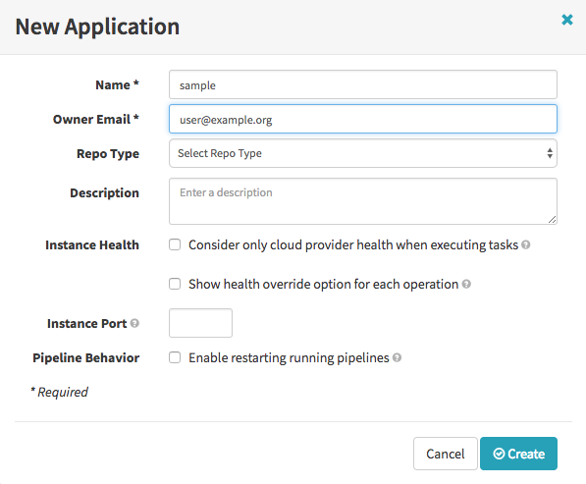

Create service load balancers
To avoid having to enter the information manually in the UI, use the Kubernetes command-line interface to create load balancers for the services. Alternatively, we can perform this operation in the Spinnaker UI.
On the local machine where the code resides, run the following command from the sample-app root directory:
$ kubectl apply -f k8s/services ( it will create the Load Balancers for our services )

From Spinnaker UI Create the deployment pipeline
Now we create the continuous delivery pipeline. The pipeline is configured to detect when a Docker image with a tag prefixed with “v” has arrived in your Container Registry.
Create a new pipeline named say “Deploy”.

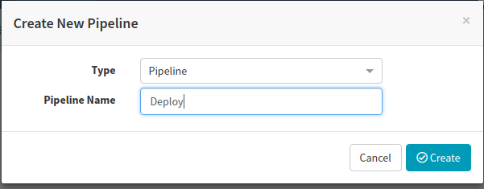
Go to the Config page for the pipeline that we just created and click Pipeline Actions -> Edit as JSON.

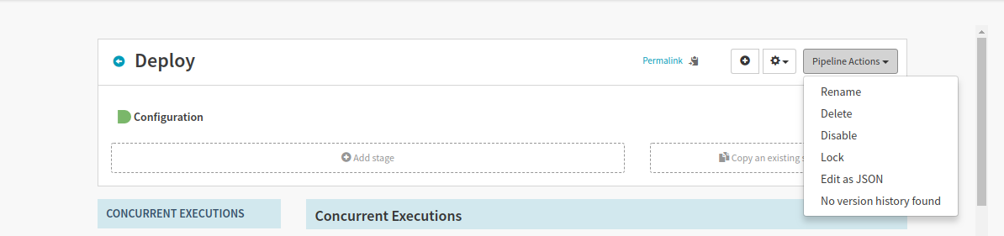
Go to source code and modify the file inside spinnaker/pipeline-deploy.json and replace the PROJECT with GCP PROJECT ( dvps-learning )
With notepad++ just copy the whole file content spinnaker/pipeline-deploy.json.
Click on Update Pipeline and we should have an updated pipeline config now.
In the Spinnaker UI, click Pipelines on the top navigation bar.
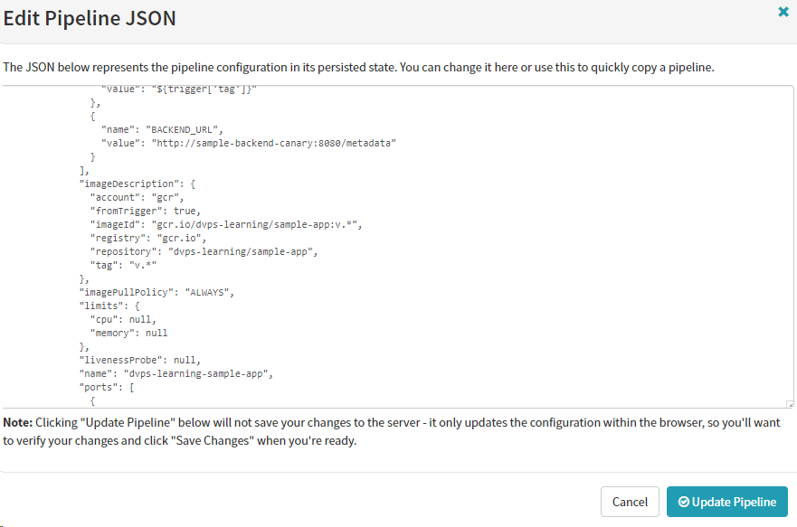

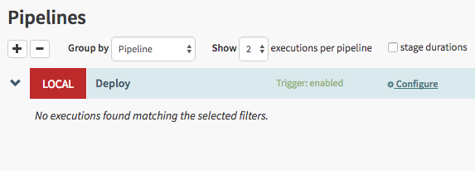
7. Click Configure in the Deploy pipeline.

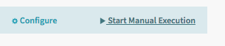
8. The continuous delivery pipeline configuration appears in the UI:

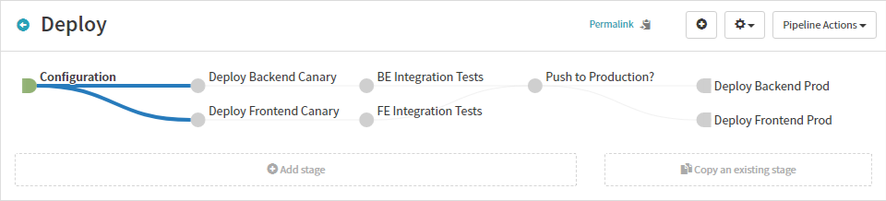

Running the pipeline manually
The configuration we just created contains a trigger to start the pipeline when a new Git tag containing the prefix “v” is pushed. Now we test the pipeline by running it manually.
- Return to the Pipelines page by clicking Pipelines.
- Click Start Manual Execution.
- Select the v1.0.0 tag from the Tag drop-down list, then click Run.
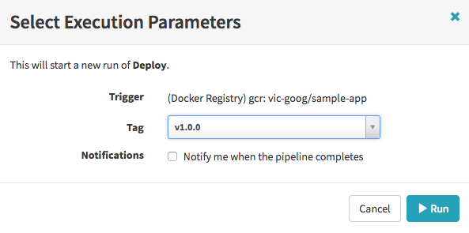
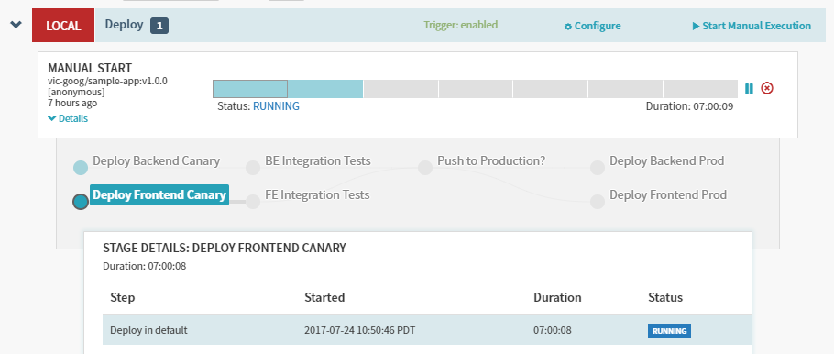

4. After the pipeline starts, click Details to see more information about the build’s progress. This section shows the status of the deployment pipeline and its steps. Steps in blue are currently running, green ones have completed successfully, and red ones have failed. Click a stage to see details about it.
5. After 3 to 5 minutes the integration test phase completes, and the pipeline requires manual approval to continue the deployment.
6. Hover over the yellow “person” icon and click Continue.
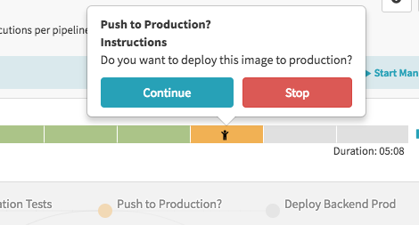
7. Your rollout continues to the production frontend and backend deployments. It completes after a few minutes.
8. To view the app, click Load Balancers in the top right of the Spinnaker UI.


9. Scroll down the list of load balancers and click Default, under sample-frontend-prod.

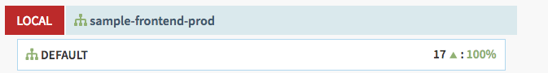
10. Scroll down the details pane on the right and copy application’s IP address by clicking the clipboard button on the Ingress IP.

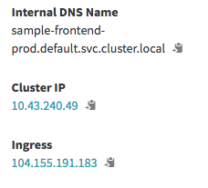
11. Paste the address into the browser to view the production version of the application.

Triggering the pipeline automatically via code changes
Now let’s test the pipeline end to end by making a code change, pushing a Git tag, and watching the pipeline run in response. By pushing a Git tag that starts with “v”, we trigger Container Builder to build a new Docker image and push it to Container Registry. Spinnaker detects that the new image tag begins with “v” and triggers a pipeline to deploy the image to canaries, run tests, and roll out the same image to all pods in the deployment.

1. Change the colour of the app from orange to blue:
$ sed -i 's/orange/blue/g' cmd/gke-info/common-service.go
2. Tag your change and push it to the source code repository:
$ git commit -a -m "Change colour to blue"
$git tag v1.0.1
$git push --tags
Now Entire Pipeline will Start Automatically and App colour will also changed .

