**Assignment #2**

**Flowchart for TriangleSolver.Analyze() method**

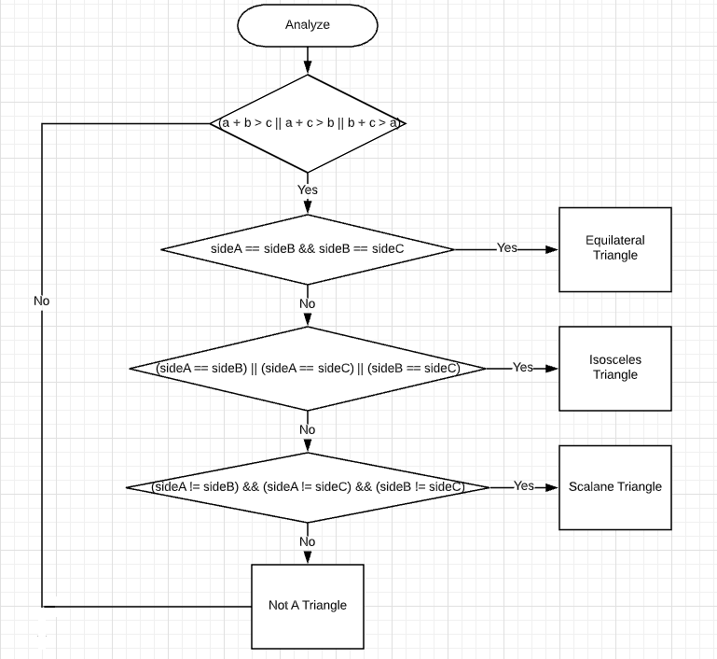

**NUnit Test Cases**

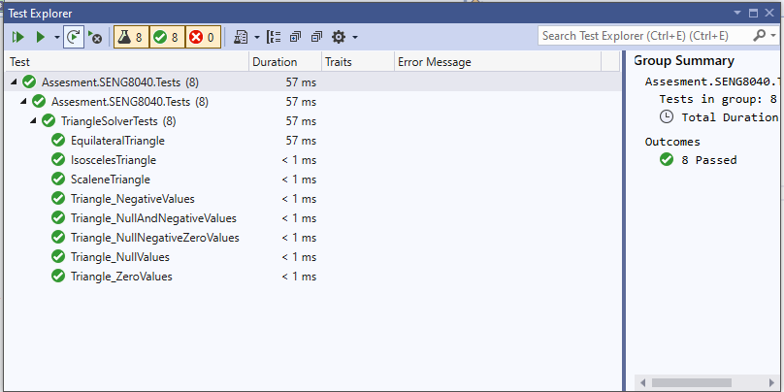

**Test Scenarios**

* Test to determine not a triangle based on the inputs provided with zero values
* Test to determine a triangle is EquilateralTriangle based on the inputs provided with numbers
* Test to determine a triangle is IsoscelesTriangle based on the inputs provided with numbers
* Test to determine a triangle is ScaleneTriangle based on the inputs provided with numbers
* Test to determine a triangle is NotTriangle based on the inputs provided with null values
* Test to determine a triangle is NotTriangle based on the inputs provided with negative values
* Test to determine a triangle is NotTriangle based on the inputs provided with null and negative values
* Test to determine a triangle is NotTriangle based on the inputs provided with null and negative and zero values