Install below mentioned plugins:
- git
- checkstyle
- copy artifacts
- Deploy to container

CJP-package

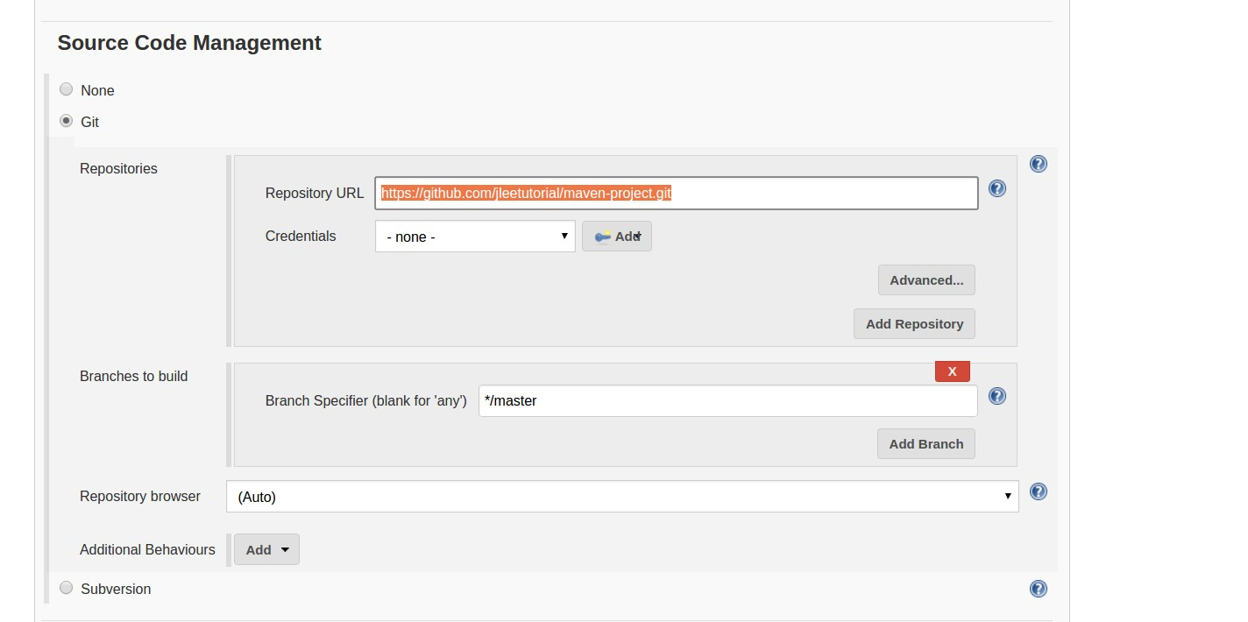

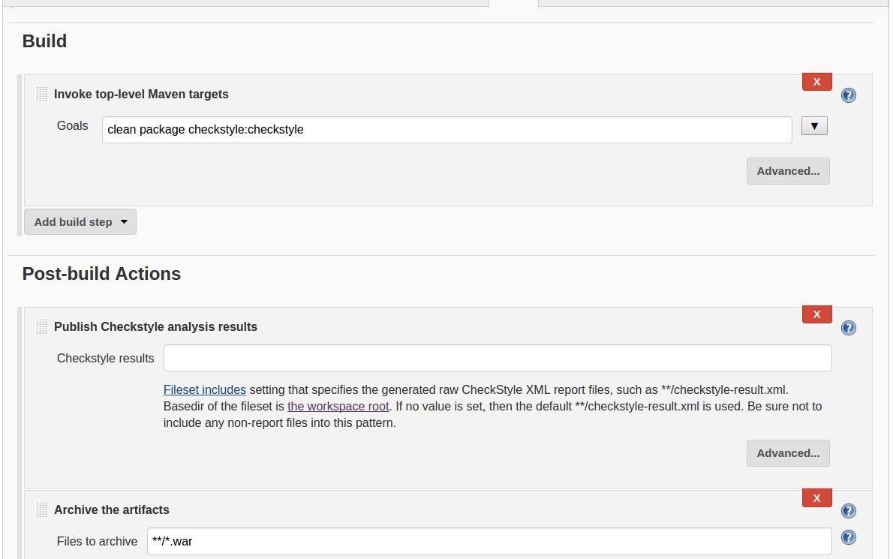
Build & post build steps.

