Introduction:

Basic project which can be used to elect candidates from given list and shows the output.

Research:

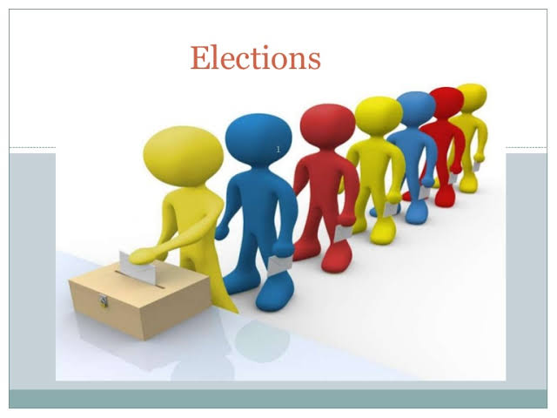

Election is the process of people can choose their candidate. Elections are used in different sectors like political, Movie industry ,In offices Etc.

4w’s&1H:

Who:

* User can use the vote in elections. Admin check and count the votes in detail.

What:

* It is a process of people can choose their candidate.

When:

* The project can be used at the time to elect the candidates.

Where:

* The problem occur in selecting one candidate amoung other candidates.

How:

* User can use the vote by selecting the option of the candidate and then after completion of election the admin declare the the vote count and Leading Candidate in Election.

Detail Requirements:

High Level Requirements:

---TBD in Tabular Format

|  |  |  |  |
| --- | --- | --- | --- |
| ID | Description | Category | Status |
| HR01 | User check their eligible for vote. | Technical | Done |
| HR02 | User use their vote to candidate. | Technical | Done |
| HR03 | Admin count the votes and declare the Leading candidate. | Technical | Done |

Low Level Requirements:

---TBD in Tabular Format

|  |  |  |  |
| --- | --- | --- | --- |
| ID | Description | Category | Status |
| LR01 | Windows/Linux OS | HR01 | Done |
| LR02 | Visual Studio(C Language) | HR02 | Done |
| LR03 | gcc Compiler | HR03 | Done |