Introduction:
Basic project which can be used to elect candidates from given list and shows the output.
Research:
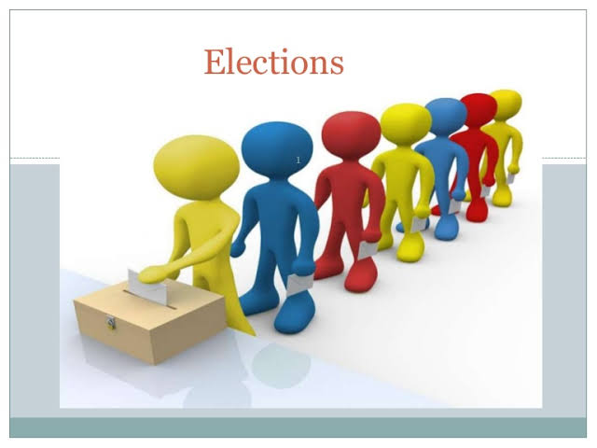
Election is the process of people can choose their candidate. Elections are used in different sectors like political, Movie industry ,In offices Etc.

4w’s&1H:
Who:
- User can use the vote in elections. Admin check and count the votes in detail.
What:
- It is a process of people can choose their candidate.
When:
- The project can be used at the time to elect the candidates.
Where:
- The problem occur in selecting one candidate amoung other candidates.
How:
- User can use the vote by selecting the option of the candidate and then after completion of election the admin declare the vote count and Leading Candidate in Election.
SWOT analysis:
Strengths:
- Increase efficiency
- Reduce Manual work
- Increase accuracy
Weakness:
- Expensive
Opportunities:
- High customer base
- Easy to operate
Threats:
- Technical Errors

Detail Requirements:
High Level Requirements:
---TBD in Tabular Format
ID | Description | Category | Status
HR01 | User check their eligible for vote. | Technical | Done
HR02 | User use their vote to candidate. | Technical | Done
HR03 | Admin count the votes and declare the Leading candidate. | Technical | Done

Low Level Requirements:
---TBD in Tabular Format
ID | Description | Category | Status
LR01 | Windows/Linux OS | HR01 | Done
LR02 | Visual Studio(C Language) | HR02 | Done
LR03 | gcc Compiler | HR03 | Done

