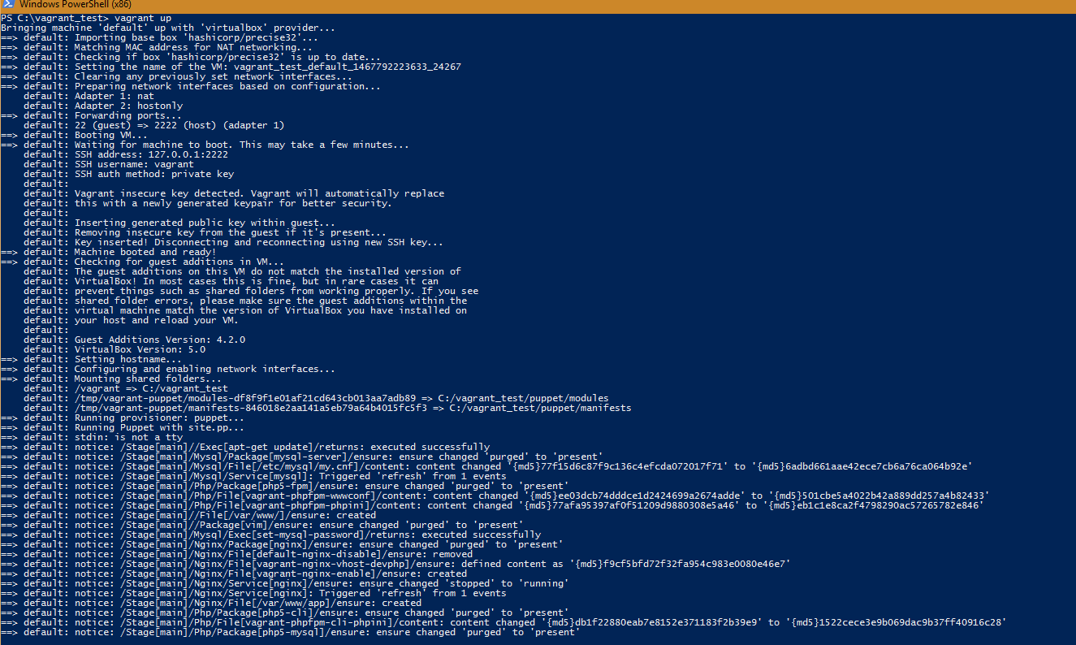

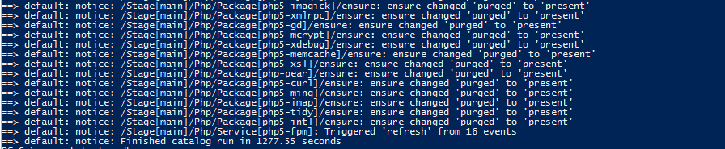

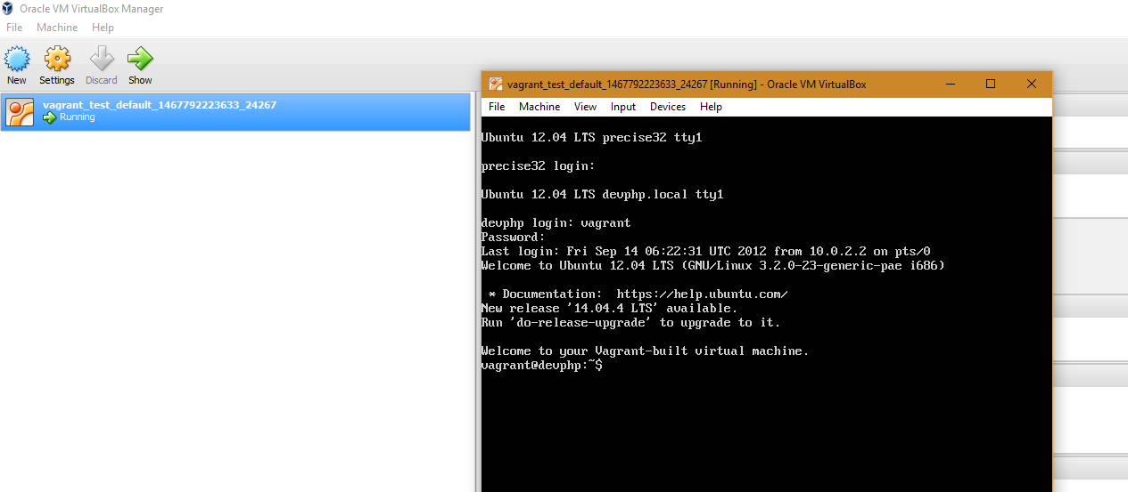

Next install curl rpm and try hit devphp.local/info.php

sudo apt-get install curl

curl devphp.local/info.php