Covid-19 India Dashboard Analysis Using Tableau

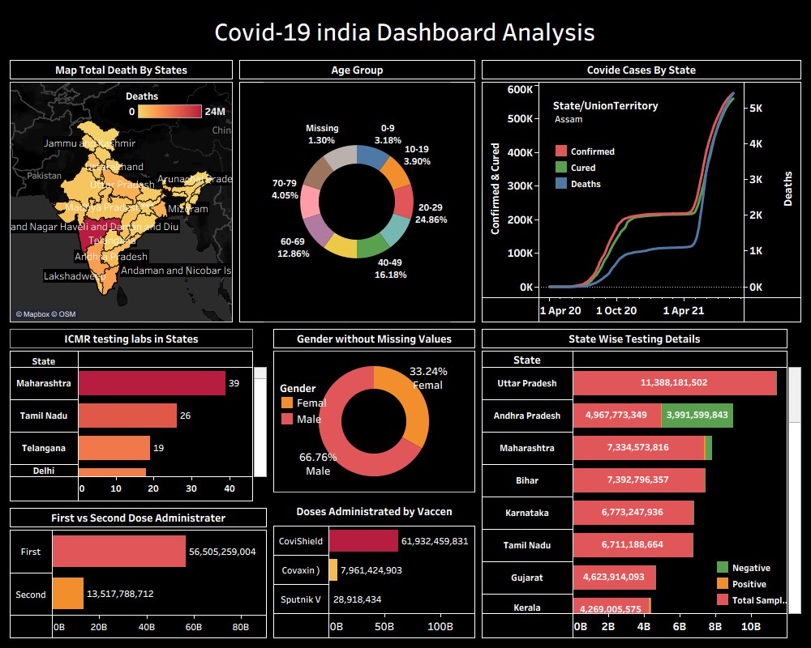

1. Introduction: -
The purpose of this project is to analyze the Covid-19 situation across India using interactive data visualizations. The dashboard provides insights into cases, deaths, testing capacity, vaccination progress, age distribution, and gender-wise trends to help users understand the pandemic impact at a national and state level.

2. Objectives of the Dashboard: -
- To analyze state-wise Covid-19 impact
- To visualize confirmed, cured, and death trends
- To understand age and gender distribution
- To monitor testing capacity across states
- To evaluate vaccination progress and doses administered
- To provide a single dashboard for decision-making
3. Dataset Description: -
- covid_19_india.csv
- StatewiseTestingDetails.csv
- covid_vaccine_statewise.csv
- AgeGroupDetails.csv
- ICMRTestingLabs.csv
- IndividualDetails.csv
- State boundary shapefile for the map.shp
Also add sources (if available).
4. Business Requirements
- BR1: Provide a map visualization of Covid-19 impact across states.
- BR2: Display time-series trend of confirmed, cured, and death cases.
- BR3: Provide age-wise and gender-wise case distribution.
- BR4: Provide vaccination progress insights.
- BR5: Give state-wise testing capacity analysis.
Business requirements are VERY important in industry documentation.

5. Tools Used
- Tableau Desktop – visualization & dashboard creation
- Excel/CSV – dataset cleaning
- Shapefile (.shp) – for India state map
6. Implementation Steps

Data Collection
- Downloaded datasets from public Covid-19 portals
- Cleaned missing values
- Combined multiple files

Data Preparation
- Removed null values
- Merged datasets based on State field
- Converted fields into correct data types

Connecting Data to Tableau
- Imported CSV/Excel files
- Added shapefile for map
- Performed joins or blends between datasets

Creating Visualizations
7. Describe each chart:

1. Total Deaths By State (Map)
- Used India state shapefile
- Applied color gradient
- Filter for state selection

2. Age Group Analysis
- Donut/pie chart
- Percentage distribution by age

3. Covid Cases Trend
- Line chart for Confirmed, Cured, Deaths
- Date on the X-axis

4. ICMR Testing Labs
- Horizontal bar chart

5. Gender Distribution
- Donut chart
- Male vs Female cases

6. State-wise Testing
- Dual bar chart (Positive, Negative, Total Samples)

7. Vaccine Administration
- First vs Second dose comparison
- Vaccine type distribution

8. Dashboard Design
Mention:
- Dark theme
- Consistent color palette
- Filters
- Grid alignment
- Titles and legends

9. Insights & Findings
- Maharashtra recorded the highest number of deaths.
- Majority cases were reported in the 20–29 and 40–49 age groups.
- Male infection rate was almost double compared to females.
- Uttar Pradesh conducted the highest number of tests.
- Covishield was the most widely administered vaccine.

10. Data Source Details
Industry-level documentation MUST include:
- Data source name
- File type
- Data size
- Key columns
- Data owner
- Update frequency
Example Table:
Dataset Name | Source | Size | Format | Update Frequency
Covid Cases | Govt Portal | 20 MB | CSV | Daily
Vaccination Data | CoWIN Data | 10 MB | Excel | Weekly

11. Insights & Business Impact
Explain what decisions the business can make using the dashboard.
Example:
- Identify high-impact states
- Allocate medical resources
- Track vaccination coverage
- Monitor testing capacity
This adds real-world value.

