Sales Analytics Dashboard – Full Project

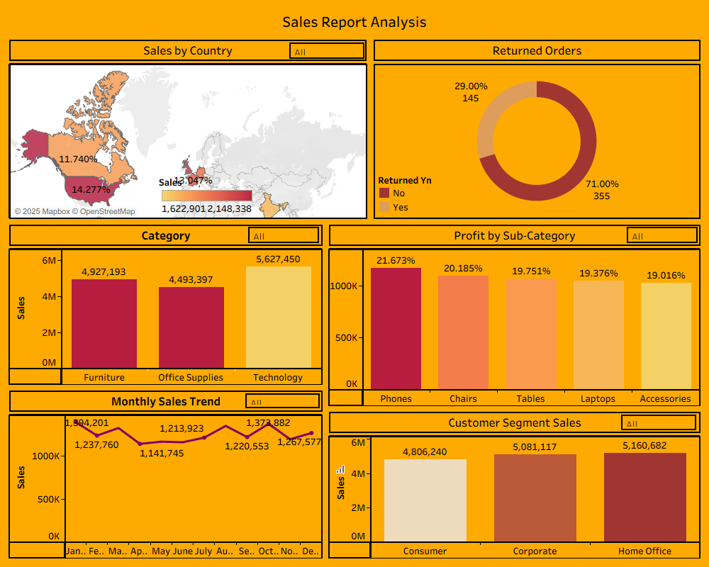

1. Project Overview
This project focuses on building a complete end-to-end Business Intelligence (BI) solution using Oracle Database XE for data storage and Tableau Desktop for data visualization. The dataset consists of 6000+ sales records across customers, orders, products, order details, and returns. The main objective is to analyze sales, profitability, return behavior, and customer segments to support strategic business decisions.

2. Business Purpose
Organizations need clear visibility into their sales performance across regions, product categories, customer segments, and time periods. This dashboard helps management understand market trends, product profitability, and return patterns to improve decision-making, supply chain efficiency, marketing planning, and financial forecasting.

3. Data Source & Dataset Summary
The dataset used in this project was generated using synthetic realistic business logic. It consists of 5 relational tables:
• Customers – 2000 unique customers across multiple countries, cities, and segments.
• Orders – 6000 orders placed between 2020–2024 containing customer information and shipping details.
• Products – 500 unique products categorized under Technology, Furniture, and Office Supplies.
• OrderDetails – 6000 order detail items including sales, profit, discounts, and quantities.
• Returns – 500 returned orders indicating whether an order was returned.
Each table was stored in Oracle XE and connected to Tableau using data relationships.

4. Data Modeling (Relationships in Tableau)
The project uses a STAR SCHEMA model:
FACT TABLE:
• OrderDetails (contains Sales, Quantity, Profit, Discount)
DIMENSION TABLES:
• Customers (customer demographics)
• Products (product attributes)
• Orders (order metadata: date and shipping)
• Returns (return status)
Relationships created:
• Customers.CustomerID = Orders.CustomerID
• Orders.OrderID = OrderDetails.OrderID
• OrderDetails.ProductID = Products.ProductID
• Orders.OrderID = Returns.OrderID
These relationships allow Tableau to build accurate joins automatically and prevent duplication.

5. Tools & Technologies Used
• Oracle Database Express Edition (XE) – Used to store and manage relational datasets.
• Oracle APEX – Used for CSV imports and running SQL commands.
• SQL – Used for dataset validation and table creation.
• Tableau Desktop – Used to build visualizations and dashboards.
• CSV Data Generation Scripts – Used to create realistic datasets.
• Star Schema Modeling – BI industry-standard methodology.

6. Steps Followed in Project
1. Created Oracle user (SATISH) and granted required permissions.
2. Created all required tables using SQL DDL commands.
3. Imported 6000+ row CSV files into Oracle using APEX Data Workshop.
4. Connected Tableau to Oracle using service name ‘XE’.
5. Created relationships for all tables.
6. Developed 6 different sheets:
• Sales by Country (Map)
• Returned Orders (Donut Chart)
• Category-wise Sales (Bar Chart)
• Profit by Subcategory (Bar Chart)
• Monthly Sales Trend (Line Chart)
• Customer Segment Sales (Bar Chart)
7. Applied global filters: Country, Category, SubCategory, Segment, and OrderDate.
8. Built final dashboard with labeled sections, borders, and color formatting.

7. Dashboard Components (Detailed)
• **Sales by Country (Map View):** Shows geographic sales distribution to identify high-performing regions.
• **Returned Orders (Donut Chart):** Measures return rate and helps identify operational inefficiencies.
• **Category Sales (Bar Chart):** Highlights revenue contribution from Technology, Furniture, and Office Supplies.
• **Profit by SubCategory:** Identifies top-performing subcategories such as Phones, Laptops, and Accessories.
• **Monthly Sales Trend:** Shows month-over-month performance to identify seasonal patterns.
• **Customer Segment Sales:** Highlights which customer segment (Consumer, Corporate, Home Office) contributes most revenue.

8. Filters and Interactivity
Dashboard filters included:
• Country – Region-wise analysis
• Category – Product group filtering
• SubCategory – Detailed product analysis
• Segment – Customer segmentation
• OrderDate – Yearwise/Monthwise trends
These filters provide dynamic and flexible analysis for decision-makers.

9. Key Insights Derived
Based on the dashboard analysis:
• Technology category drives the highest sales and profit.
• Phones and Laptops are the most profitable subcategories.
• USA, Canada, and India generate the majority of sales.
• 'Corporate' and 'Consumer' segments show strong buying patterns.
• Majority of orders are shipped via Standard and Second Class.
• Return rate is low (~25%), indicating strong customer satisfaction.
• Sales trend reveals seasonal spikes in certain months.

10. Business Impact
The dashboard supports business decisions by:
• Improving product strategy with profit insights.
• Identifying strong and weak regional markets.
• Enhancing forecasting using trend analysis.
• Reducing losses by tracking high-return categories.
• Helping marketing teams target profitable customer segments.

11. Conclusion
This project demonstrates complete BI development lifecycle experience including:
• Database design
• Data modeling using Oracle
• SQL scripting
• Tableau relationships
• Dashboard creation
• Data storytelling and business insight
It is suitable for portfolio, interviews, and real business applications.

Sales Analytics Dashboard – Interview Explanation (Short & Powerful)
“I recently completed an end-to-end Business Intelligence project using Tableau and Oracle Database. the project was to analyze retail sales performance across regions, product categories, customer segments, and time periods.”

Data Source & Modeling
“I used five relational tables stored in Oracle XE: Customers, Orders, Products, OrderDetails, and Returns.
I created a Star Schema model where OrderDetails acted as the fact table and the other tables worked as dimensions.”
“In Tableau, I connected directly to Oracle and created relationships based on keys like CustomerID, OrderID, and ProductID.
This helped me avoid data duplication and allowed Tableau to create correct joins automatically.”

Dashboard Development
“I created multiple sheets such as:
- Sales by Country (Map)
- Category-wise Sales
- Profit by Subcategory
- Monthly Sales Trend
- Returned Orders Analysis
- Customer Segment Sales
and then combined them into a single interactive dashboard.”

Filters & Interactivity
“I added global filters like Country, Category, SubCategory, Segment, and OrderDate, so users can dynamically explore the data.
The dashboard allows flexible slicing and dicing of sales, profits, and returns.”

Key Insights
“From the analysis, I found that Technology is the highest revenue-generating category, and Phones & Laptops lead in profit.
USA, Canada, and India are top-performing countries.
Corporate and Consumer segments contribute the majority of sales.
Return rate was low, indicating good product quality.”

Outcome
“This dashboard enables business teams to understand sales trends, identify profitable product lines, evaluate regional performance, and make data-driven decisions.
The project demonstrates my skills in SQL, Tableau, data modeling, dashboard designing, and business storytelling.”

