**Exercise 3-SATISH&SALMA(Group-26)**

1.

**Output:**

1. **30 is even.**

**30 is odd.**

**35 is odd.**

1. **30 is even.**

**35 is odd**

2. Assume x = 4 and y = 5, Which of the following is true?

 A. not (x == 4)

 B. x != 4

 C. x == 5

 D. x != 5

3. Take two numbers and check whether the sum is greater than 5, less than 5 or equal to 5.Fill in blanks for the following program.

print("Enter first number")

first = int( input())

print("Enter second number")

second = int( input())

**sum=first+second**

print("Sum is greater than 5:",sum>5)

print("Sum is equal to 5:",**sum==5**)

print("Sum is lesser than 5:",**sum<5**)

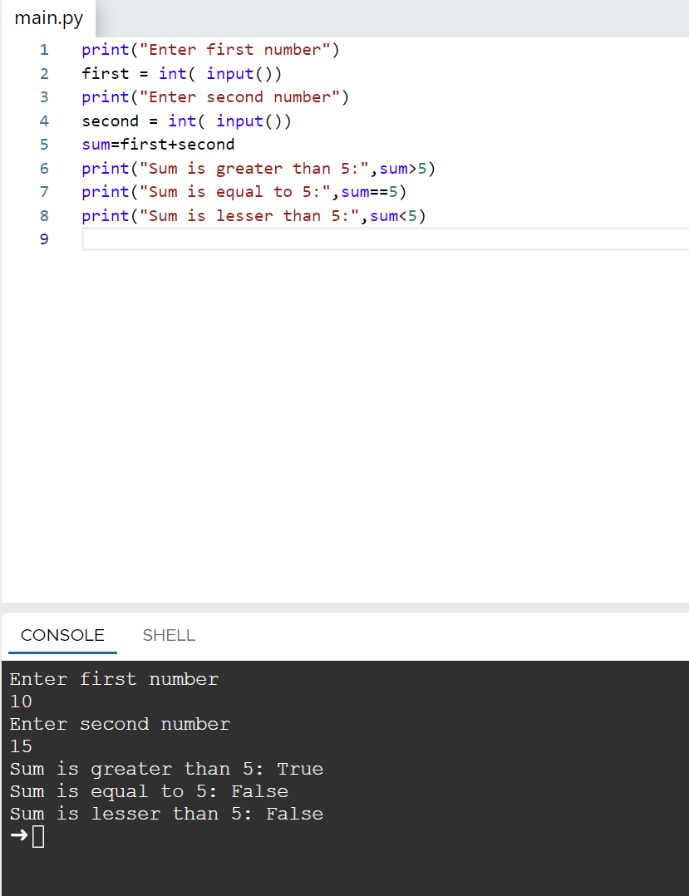

4. Complete the program below that prompts the user to enter the year and the first three letters of a month name (with the first letter in uppercase) and displays the number of days in the month.

Enter a year: 2017

Enter a month (first three letters with the first letter in uppercase): Feb

Feb 2017 has 28 days

year = int(input("enter the year"))

month = str(input("Enter the month"))

if month == "Jan" or month == "Mar" or month == "May" or month == "Jul" or month == "Aug" or month == "Oct" or month == "Dec":

print(month, year, "has 31 days")

elif (month == "Feb"):

if((year%4==0 and year%100!=0) or (year%400==0)):

print(month,year," is a leap year and has 29 days")

else:

print(month,year,"has 28 days")

elif month =="Apr" or month =="Jun" or month=="Sep" or month== "Nov":

print(month,year, "has 30 days")

else:

print(month, "is not a correct month name ")

year = int(input("enter the year"))  
month = str(input("Enter the month"))  
if month == "Jan" or month == "Mar" or month == "May" or month == "Jul" or month == "Aug" or month == "Oct" or month == "Dec":  
 print(month, year, "has 31 days")  
elif (month == "Feb"):  
 if((year%4==0 and year%100!=0) or (year%400==0)):  
 print(month,year," is a leap year and has 29 days")  
 else:  
 print(month,year,"has 28 days")  
elif month =="Apr" or month =="Jun" or month=="Sep" or month== "Nov":  
 print(month,year, "has 30 days")  
else:  
 print(month, "is not a correct month name ")

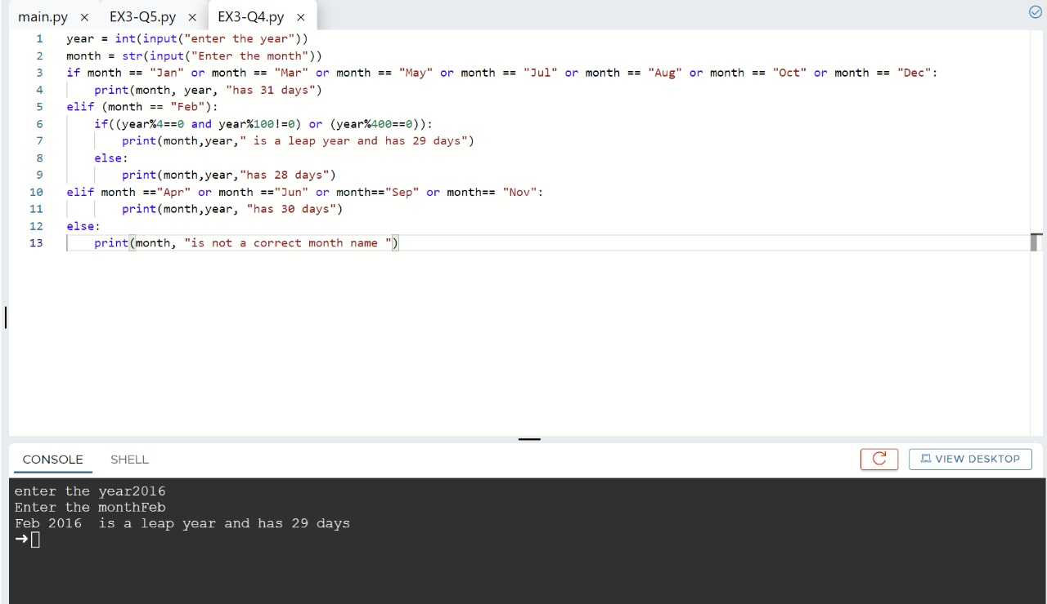

5. Write a program that prompts the user to enter 2 strings and check whether string2 is in string1 or not.

string1=str(input("Enter First string:"))

string2=str(input("Enter Second string:"))

if string2 in string1:

print("String2",string2 ,"is in String1" ,string1)

else:

print("String2",string2 ,"is not in String1" ,string1)

