AIO9 Hardware PCB Architecture & Signal Block Diagram Manual
Detailed PCB Circuit Diagrams, Hardware Chips, Power Rails & Pinout Interfaces
This document details the hardware board architecture, physical PCB component layouts, IC chipsets, power regulation circuits, and signal interconnections for the three main circuit boards in the AIO9 system: Board 1 (ESP32 Core Main PCB), Board 2 (GPRS Modem PCB), and Board 3 (Nuvoton UI PCB).

1. Multi-Board Hardware System Interconnection Diagram
The schematic below illustrates the three physical PCB boards, their onboard microcontrollers, power gates, and inter-board signal header lines:
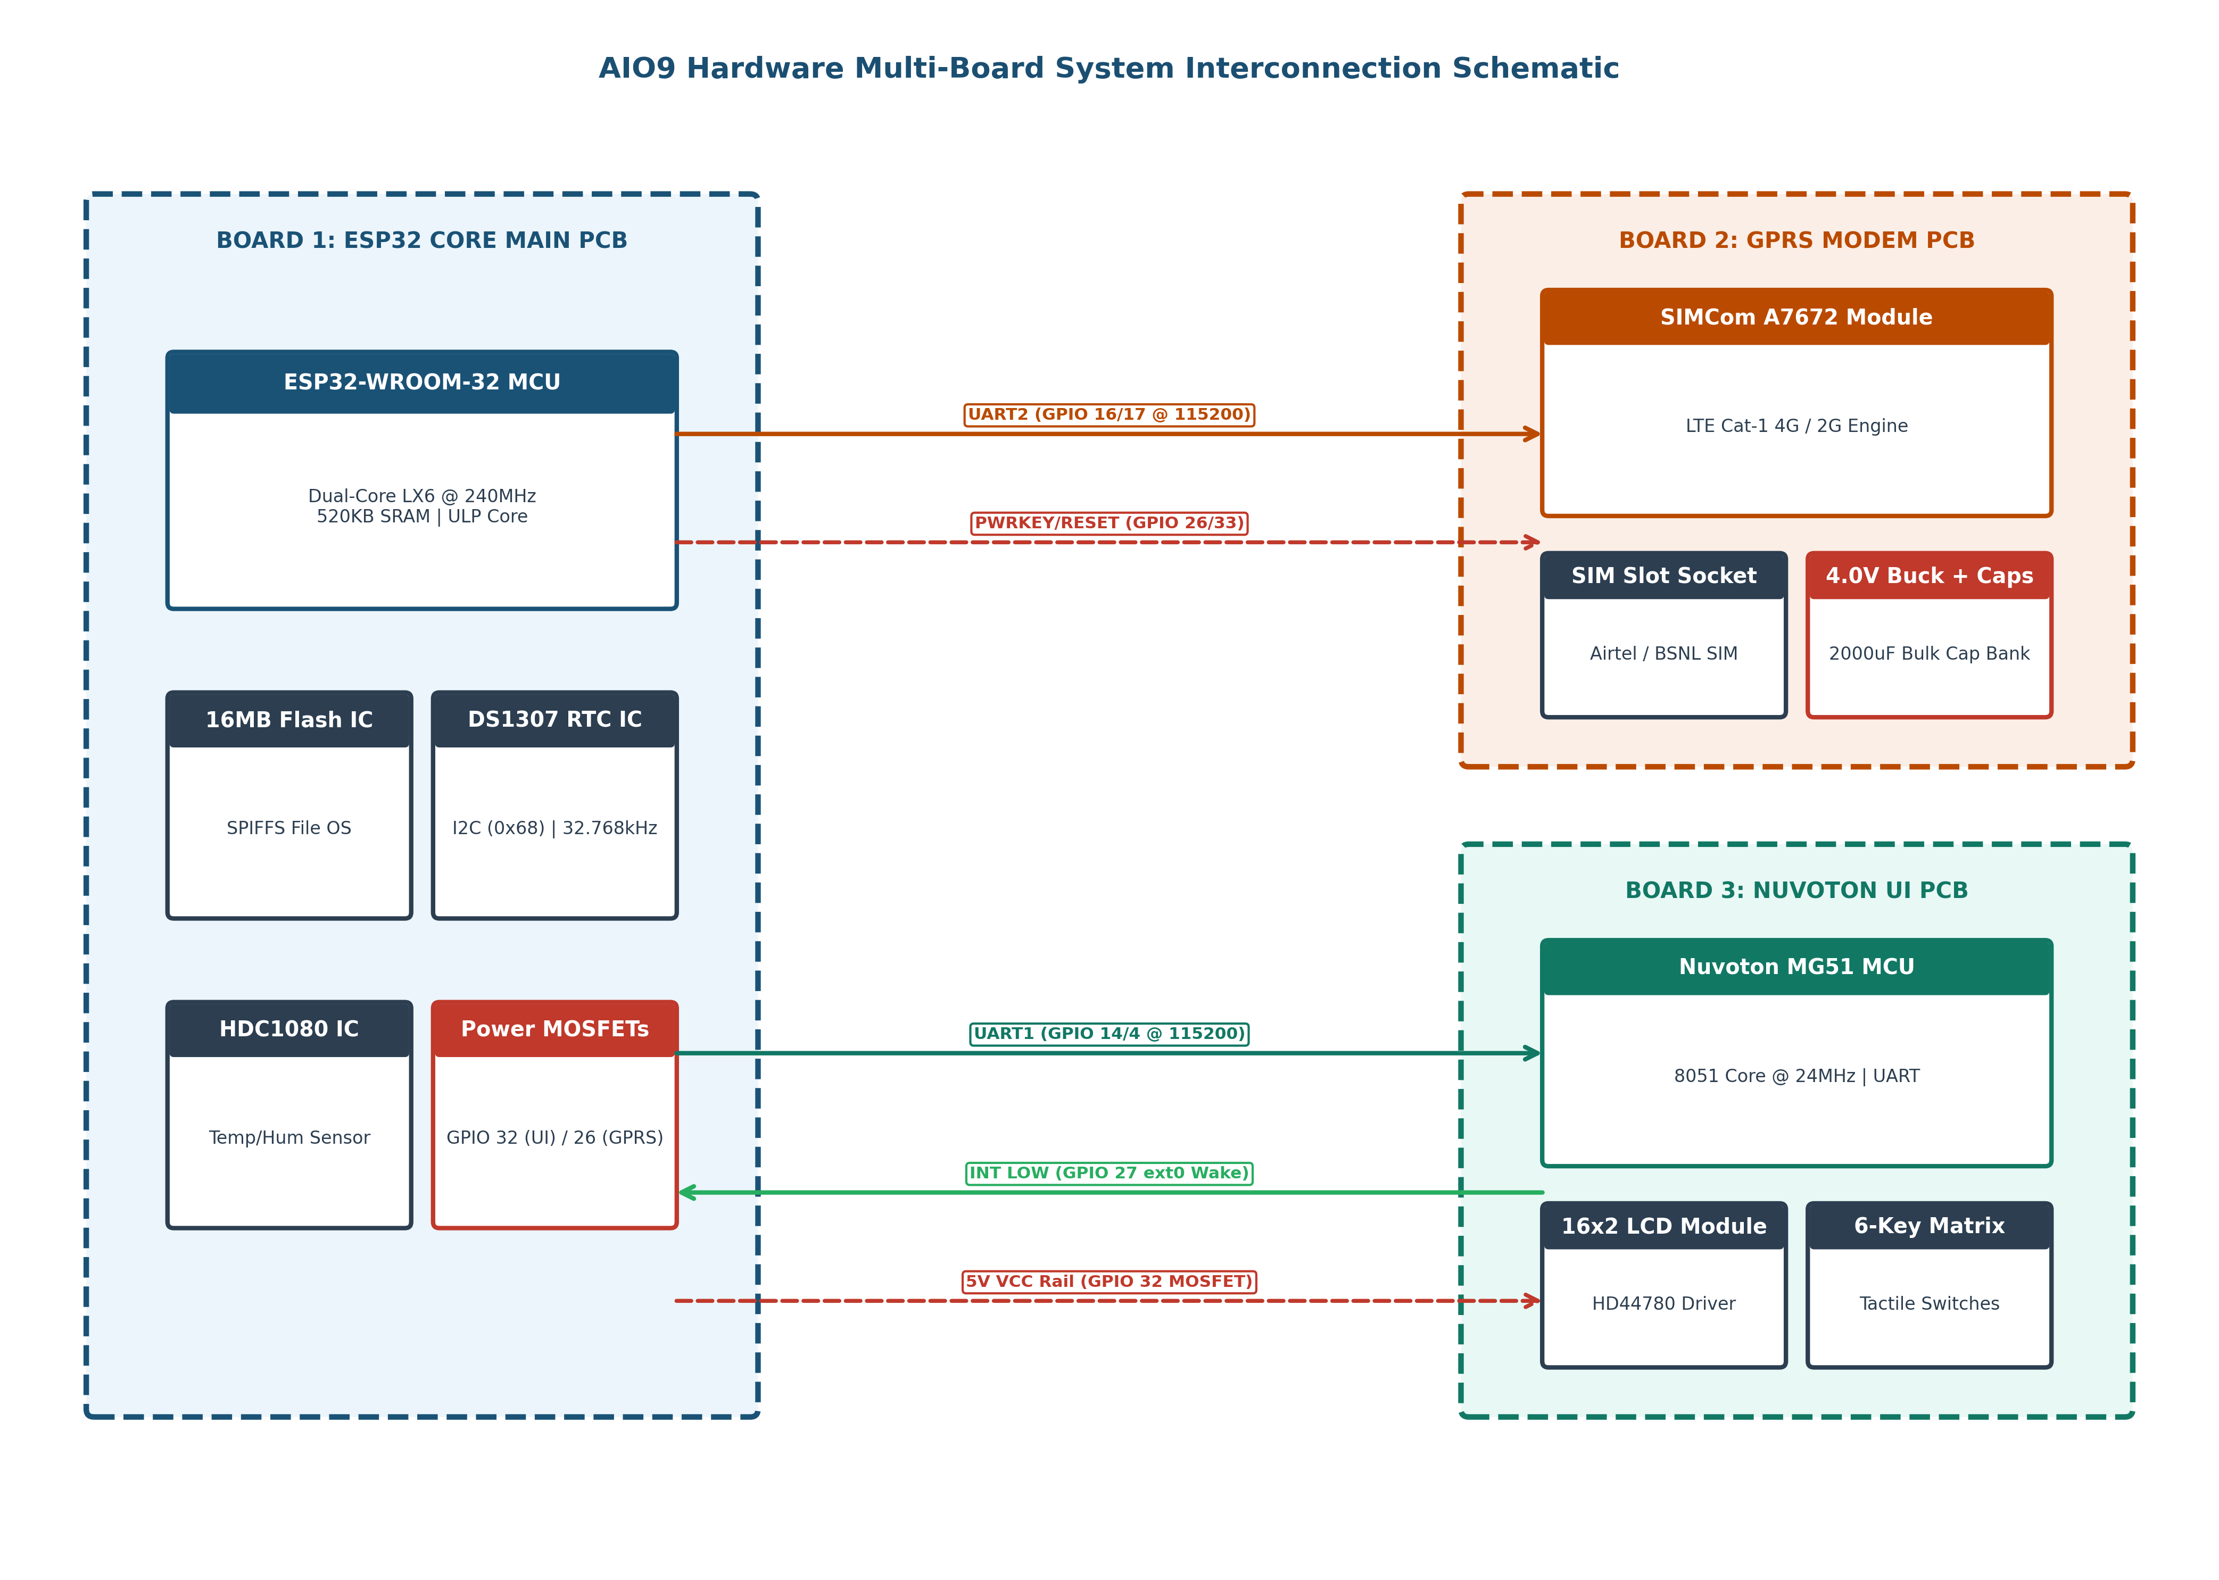

- Inter-Board Header Connections & Bus Protocols:
Header Name | From Board | To Board | Signals & Pins | Protocol / Power Specs
J1 UI Serial Header | Board 1 (ESP32) | Board 3 (Nuvoton) | TX (GPIO 4) ──► RX  RX (GPIO 14) ◄── TX | UART1 @ 115200 Baud, 3.3V Logic. Transmits screen drawing commands & receives remapped key codes.
J2 UI Control Header | Board 3 (Nuvoton) | Board 1 (ESP32) | INT (Nuvoton) ──► GPIO 27  5V VCC ◄── GPIO 32 MOSFET | Open-Collector INT pulls GPIO 27 LOW on keypress to wake ESP32. 5V rail supplied via GPIO 32 P-FET.
J3 Modem Data Header | Board 1 (ESP32) | Board 2 (GPRS) | TX (GPIO 17) ──► RXD  RX (GPIO 16) ◄── TXD | UART2 @ 115200 Baud. AT command interface & Layer-4 TCP socket HTTP POST payload stream.
J4 Modem Power Header | Board 1 (ESP32) | Board 2 (GPRS) | PWRKEY ◄── GPIO 26 / 5  RESET ◄── GPIO 33 / 4 | NPN Transistor driven pulse lines. Controls modem power state & emergency hardware reset.

2. Board 1: ESP32 Core Main PCB Hardware Architecture
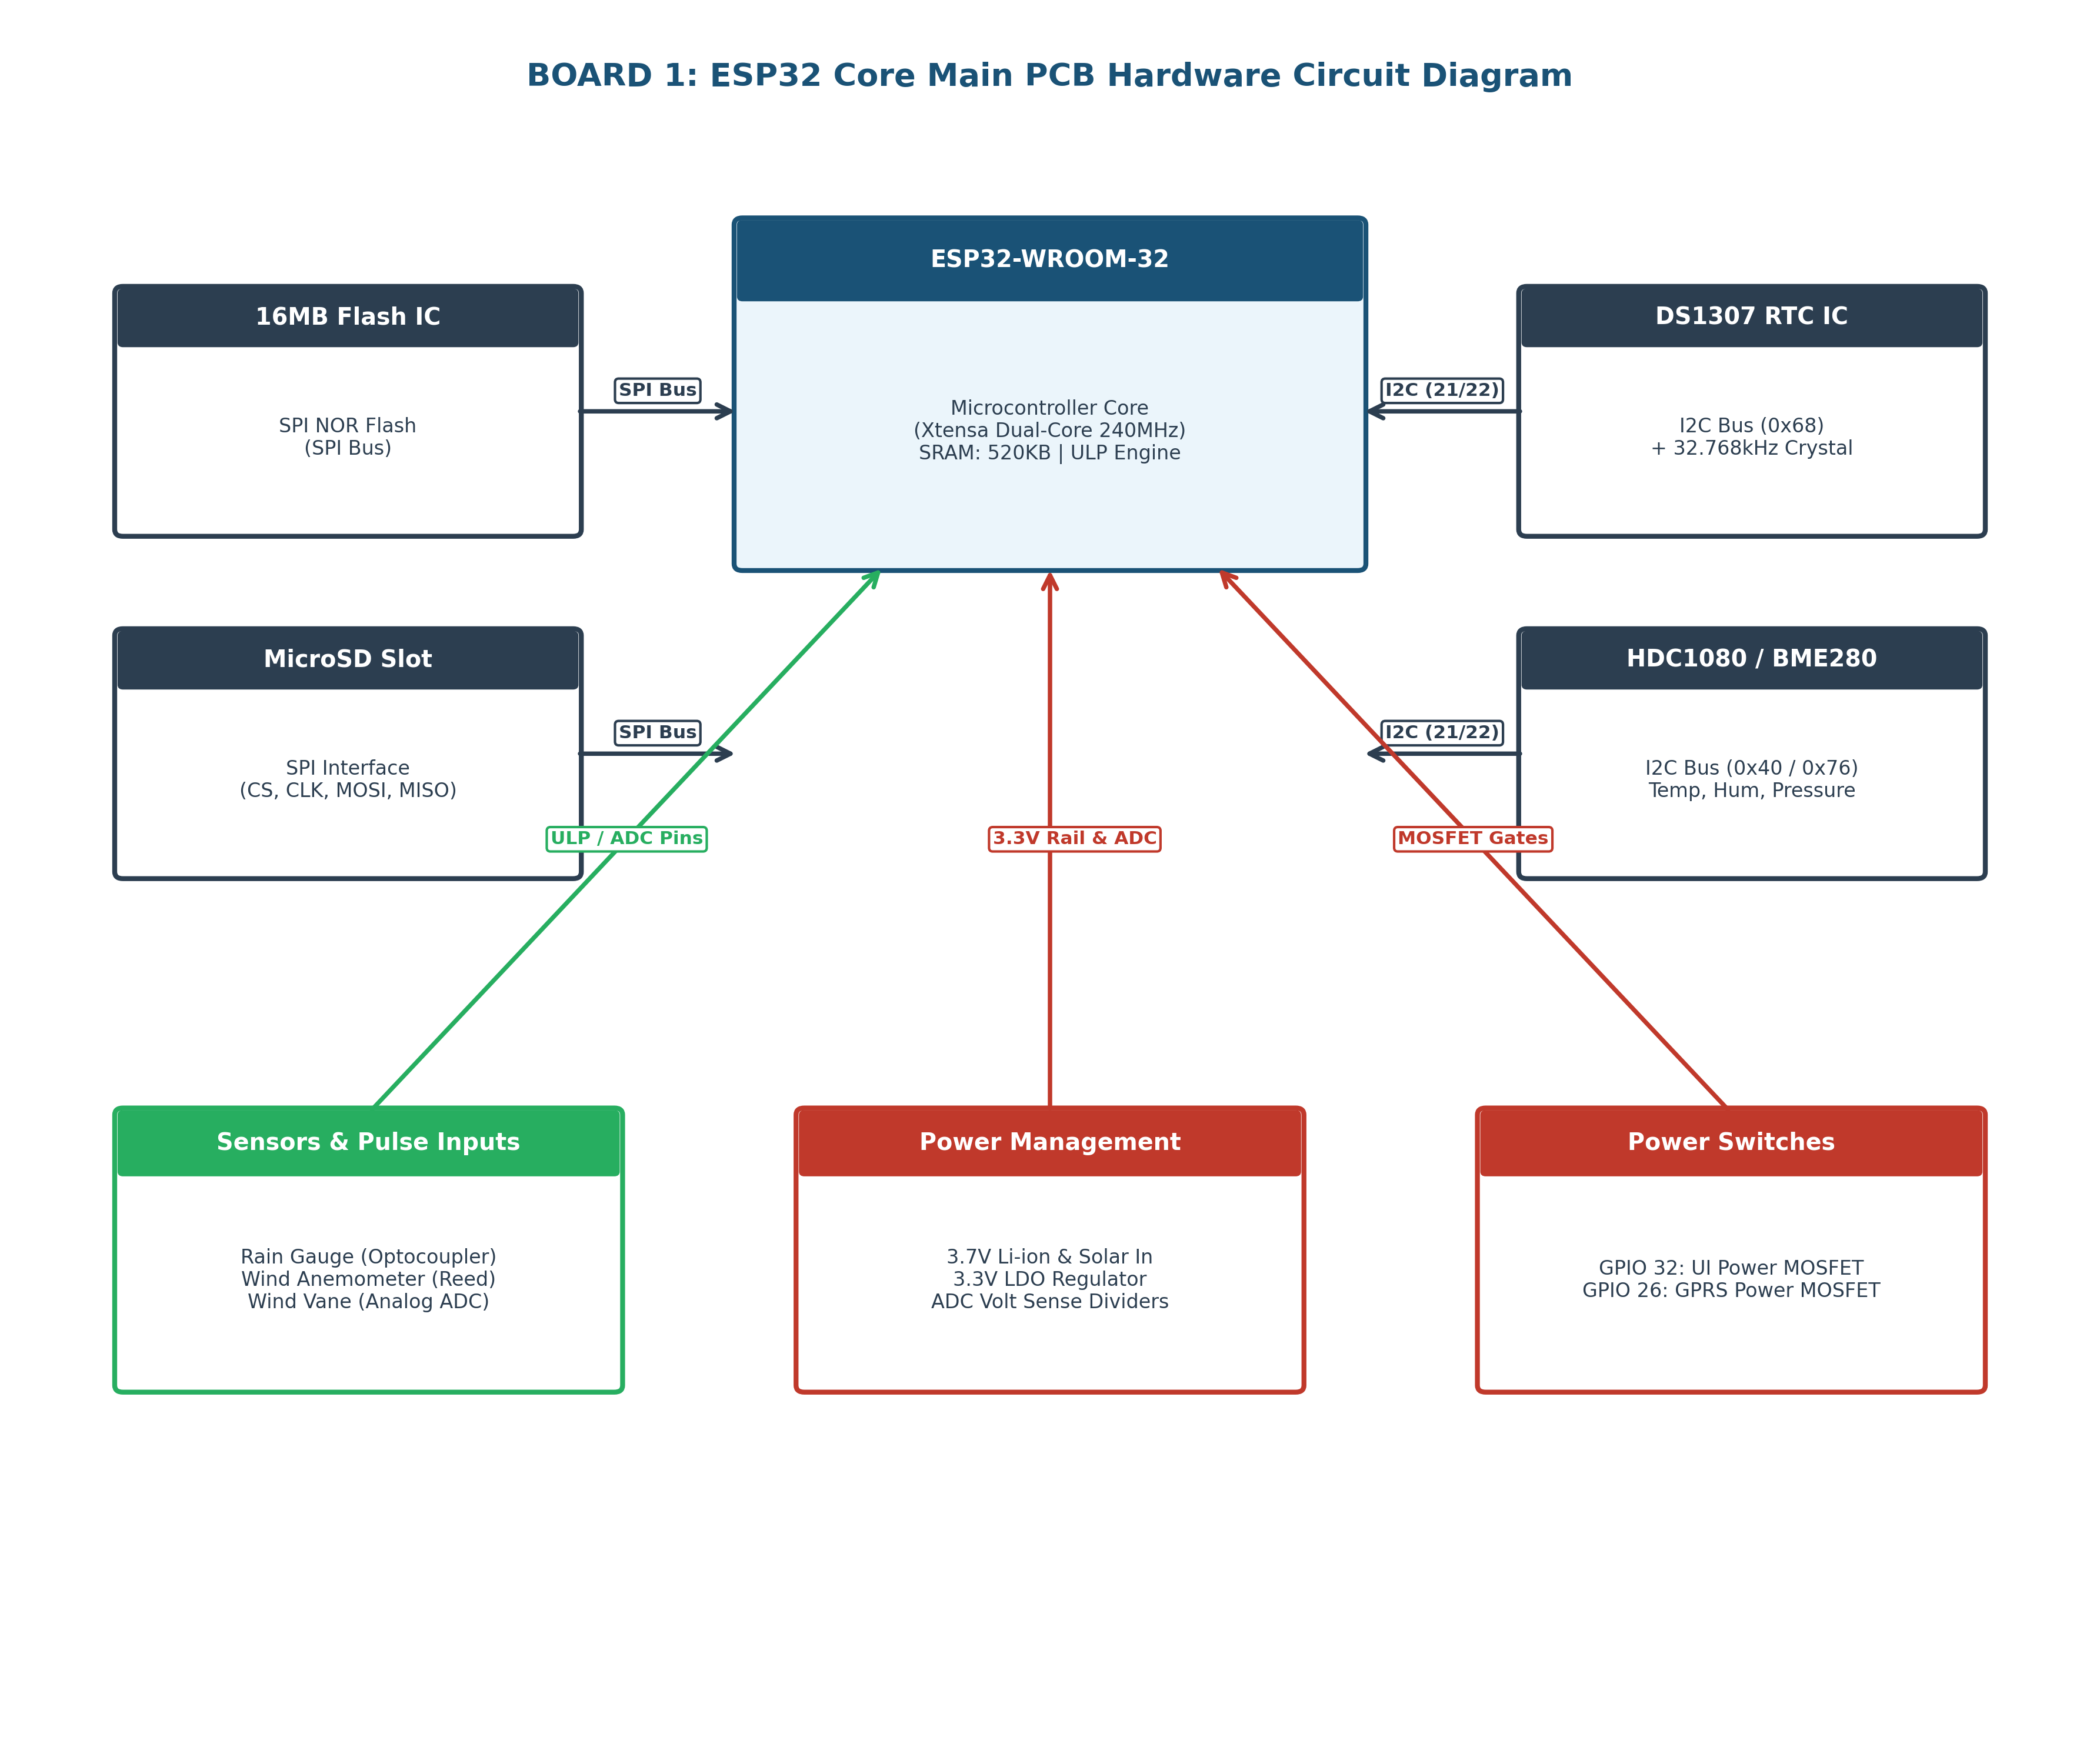
Hardware Component Specifications for Board 1:
■ ESP32-WROOM-32 Module: Dual-Core Xtensa 32-bit LX6 MCU @ 240MHz. Contains 520KB SRAM, ULP Coprocessor for low-power pulse counting, and internal RTC Controller.
■ 16MB SPI NOR Flash IC: High-density flash memory interfaced via SPI bus (CS, CLK, MOSI, MISO). Hosts the SPIFFS filesystem storing cur_file, unsent.txt queue, and APN configuration.
■ DS1307 Real Time Clock IC: Dedicated hardware RTC IC connected to I2C bus at address 0x68. Backed by a 32.768kHz crystal oscillator and CR2032 3V coin cell battery.
■ HDC1080 / BME280 Sensors: Precision relative humidity & temperature digital sensor (I2C 0x40) and barometric pressure sensor (I2C 0x76) for MSLP sea-level calculation.
■ Optocouplers & Pulse Conditioning: Optically isolated input filtering circuits for Tipping Bucket Rain Gauge and Reed Switch Anemometer. Connected directly to ESP32 ULP coprocessor pins.
■ Power Management & MOSFET Gates: 3.3V LDO regulator powering core ICs. High-side P-FET power switches for UI 5V rail (GPIO 32) and GPRS modem power rail (GPIO 26). Resistor ADC voltage dividers for battery & solar sense.

3. Board 2: GPRS Modem PCB Hardware Architecture
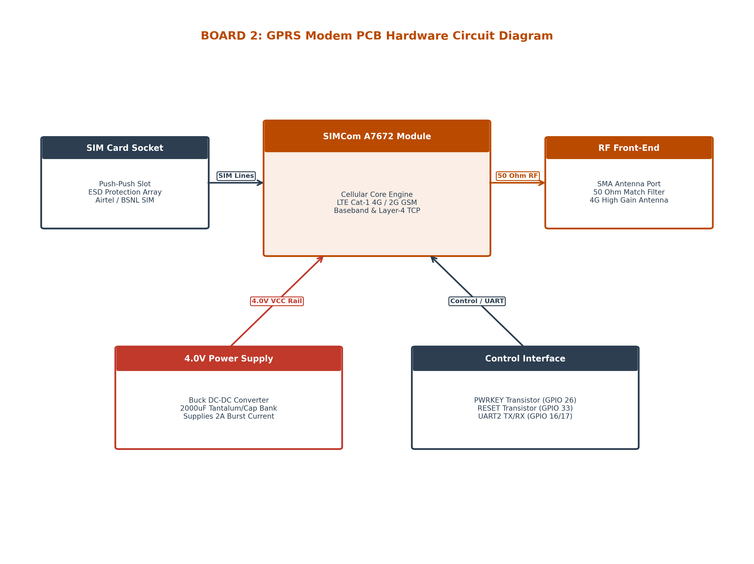
■ SIMCom A7672 Module: Multi-band LTE Cat-1 4G module with 2G GSM/EDGE fallback. Contains integrated Layer-4 TCP socket engine operating over 115200 baud UART.
■ 4.0V Buck Converter & Capacitor Bank: High-efficiency DC-DC step-down converter providing dedicated 4.0V power. Parallel 2000µF Tantalum/Low-ESR capacitor bank supplies 2A peak current during RF transmission bursts.
■ SIM Card Socket & ESD Protection: Push-push SIM card socket with multi-channel TVS diode ESD protection array. Supports 1.8V/3.0V SIM cards for Airtel M2M, Airtel Commercial, BSNL, and Jio.
■ RF Front-End & SMA Connector: 50Ω microstrip transmission line with LC pi-matching network leading to standard SMA female connector and external high-gain cellular antenna.

4. Board 3: Nuvoton UI PCB Hardware Architecture
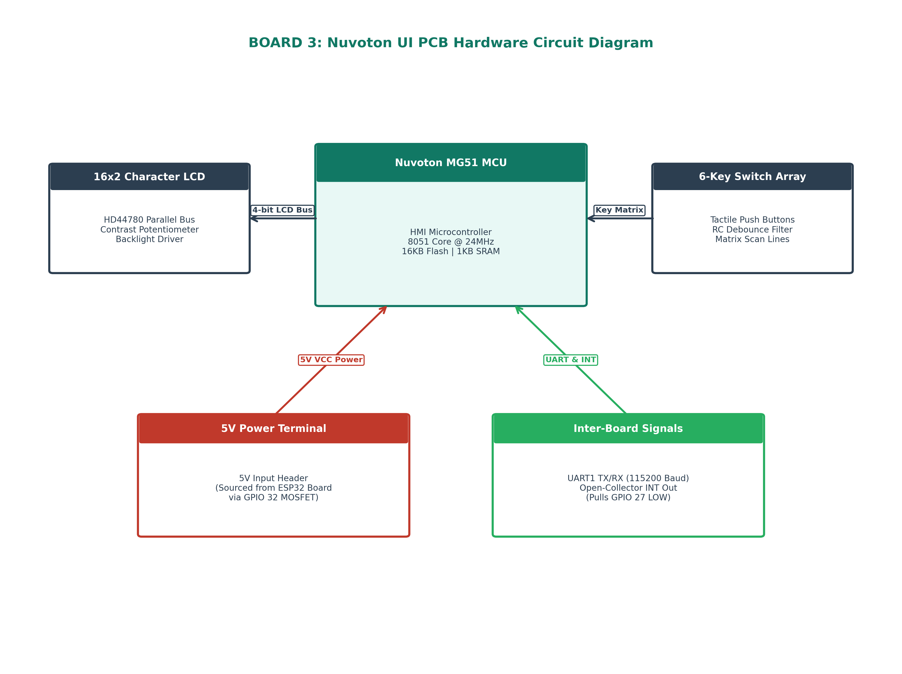
■ Nuvoton MG51FB9AE MCU: High-speed 8051-core 8-bit MCU (24MHz, 16KB Flash, 1KB SRAM). Runs custom UI packet parser and key matrix scanner.
■ 16x2 Character LCD Module: Alphanumeric liquid crystal display with HD44780 parallel controller interface, contrast trimpot adjustment, and transistor-driven LED backlight.
■ 6-Key Tactile Switch Array: Matrix tactile switches (UP, DOWN, LEFT, RIGHT, SET, CLR) with hardware RC filter debouncing. Scanned continuously by Nuvoton GPIOs.
■ Open-Collector Interrupt Circuit: NPN transistor driver pulling the INT line LOW (tied to ESP32 GPIO 27) whenever any key is pressed, waking ESP32 from Deep Sleep instantly.

5. Master Hardware Component & IC Lookup Table
PCB Board | Component / IC | Part Number / Model | Interface / Bus | Hardware Function
Board 1 (ESP32) | Main MCU Module | ESP32-WROOM-32 | Internal SPI / I2C / UART | Master dual-core processor, ULP pulse counting, data logging.
Board 1 (ESP32) | Flash Storage IC | W25Q128JV (16MB) | SPI (CS, CLK, MOSI, MISO) | Non-volatile SPIFFS filesystem for logs & unsent backlog queue.
Board 1 (ESP32) | Real Time Clock IC | DS1307ZN | I2C (0x68) @ 400kHz | Hardware real-time clock backed by 32.768kHz crystal & 3V battery.
Board 1 (ESP32) | Temp & Humidity IC | HDC1080DMBR | I2C (0x40) @ 400kHz | Digital temperature & relative humidity sensor.
Board 1 (ESP32) | Pressure Sensor IC | BME280 | I2C (0x76) @ 400kHz | Barometric pressure sensor for sea-level pressure calculation.
Board 1 (ESP32) | Power MOSFET Gates | AO4407A (P-FET) | GPIO 32 / GPIO 26 | High-side power switches for UI 5V rail and GPRS modem rail.
Board 2 (GPRS) | Cellular Engine | SIMCom A7672S | UART2 @ 115200 Baud | LTE Cat-1 4G / 2G modem with Layer-4 TCP socket engine.
Board 2 (GPRS) | Buck Regulator | LM2596 / MP1584 | 4.0V VCC Power Rail | DC-DC step down converter supplying 4.0V to SIMCom modem.
Board 2 (GPRS) | Bulk Cap Array | 2000µF Tantalum | 4.0V Power Bus | Energy reservoir providing 2A burst current during RF transmit.
Board 3 (Nuvoton) | HMI MCU | Nuvoton MG51FB9AE | UART1 @ 115200 Baud | Keypad matrix scanning, LCD packet parsing, INT generation.
Board 3 (Nuvoton) | LCD Character Display | 1602A (HD44780) | 4-bit Parallel Bus | 16x2 alphanumeric LCD display with LED backlight driver.

