AIO9 System Flowchart & Detailed Block Diagram Manual
Complete Operational Flowcharts & Subsystem Hardware Diagrams for ESP32, GPRS & Nuvoton Boards
This document presents the complete system-wide operational flowchart alongside detailed hardware block diagrams for the AIO9 station architecture. Each section contains visual flowchart diagrams, block-by-block functional specifications, inter-board communication protocols, and signal descriptions.

1. System-Wide Operational Flowchart & Multi-Board Execution
The flowchart below details the complete execution lifecycle across the ESP32 Board, GPRS Board, and Nuvoton UI Board:
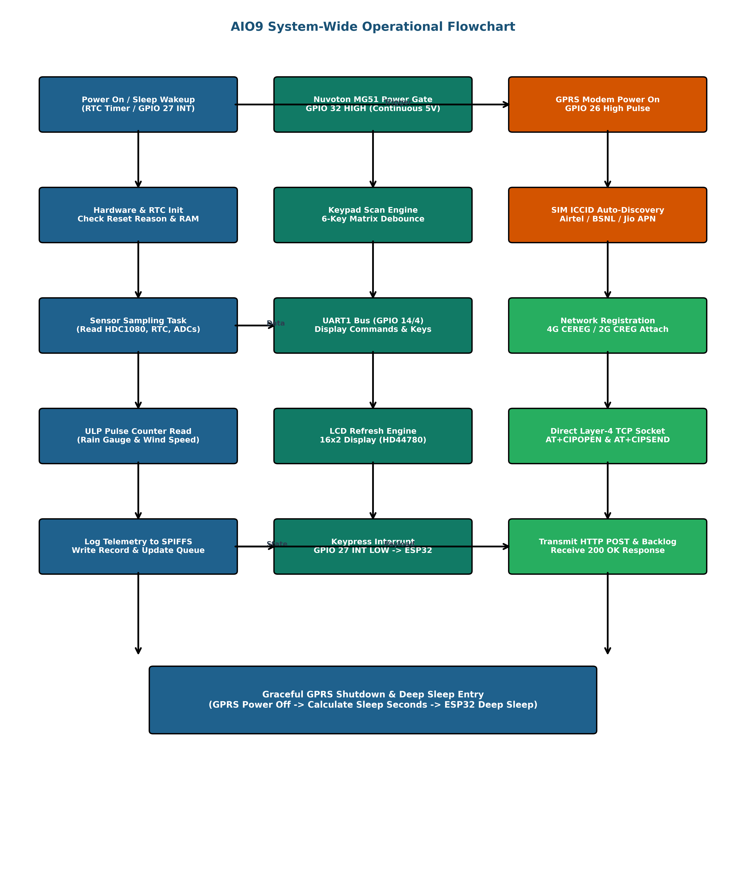

• Phase 1: Boot & Reset Reason Check: ESP32 wakes from Deep Sleep via RTC timer or Nuvoton keypress (GPIO 27 INT LOW). Inspects RTC RAM variables and initializes SPIFFS and I2C sensors.
• Phase 2: Sensor Sampling & ULP Read: Polled readings from HDC1080/2022 (Temp/Hum), DS1307 RTC, and BME280. ULP Coprocessor pulse counts for Rain Gauge and Wind Anemometer are retrieved.
• Phase 3: Inter-Board UI Interface: Nuvoton MG51 MCU scans tactile keypad continuously. Display updates and menu screens are transmitted over UART1 (115200 baud).
• Phase 4: Cellular & Direct TCP Socket: Modem powered via GPIO 26. SIM ICCID auto-discovery selects APN (airteliot.com / bsnlnet). Direct Layer-4 TCP engine connects and posts HTTP raw payload.
• Phase 5: Backlog Flush & Deep Sleep: Transmits up to 15 queued backlog records from SPIFFS. Performs graceful GPRS shutdown (AT+CPOWD), blanks UI display, and enters ESP32 Deep Sleep.

2. ESP32 Core Controller Board Flowchart & Architecture
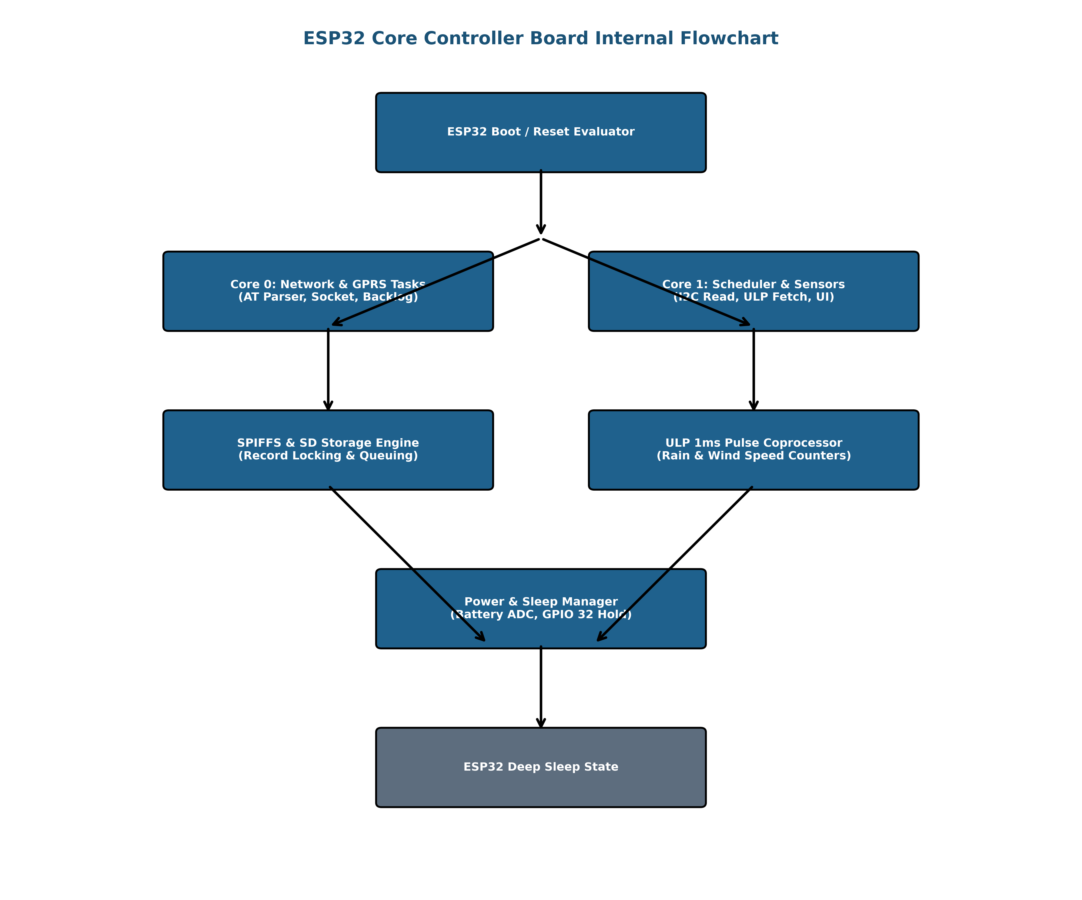
The ESP32 Board operates as the central system master with the following hardware blocks:
■ Dual-Core Processor: Xtensa LX6 @ 240MHz. Core 0 manages GPRS UART, Layer-4 TCP sockets, and AT commands. Core 1 manages system scheduling, sensors, and UI rendering.
■ ULP Coprocessor: Runs 1ms sampling loop during Deep Sleep. Counts tipping bucket rain pulses and wind anemometer pulses without waking the main CPU.
■ RTC Slow Memory: 512-byte reserved RTC RAM preserving pulse accumulators, APN settings, unsent backlog indices, and carrier states across deep sleep.
■ Flash & SPIFFS Storage: 16MB Flash with SPIFFS filesystem storing telemetry logs (cur_file, unsent.txt) and station settings. Includes SPI SD card slot for backups.
■ I2C Bus (GPIO 21/22): Hardware I2C bus communicating with DS1307 RTC (0x68), HDC1080/2022 (0x40), and BME280 barometric pressure sensor.
■ Power Management & ADCs: Battery voltage divider sense via ADC. GPIO 32 controls Nuvoton 5V power gate; GPIO 26 controls GPRS modem power MOSFET gate.

3. GPRS Modem Board Flowchart & Architecture
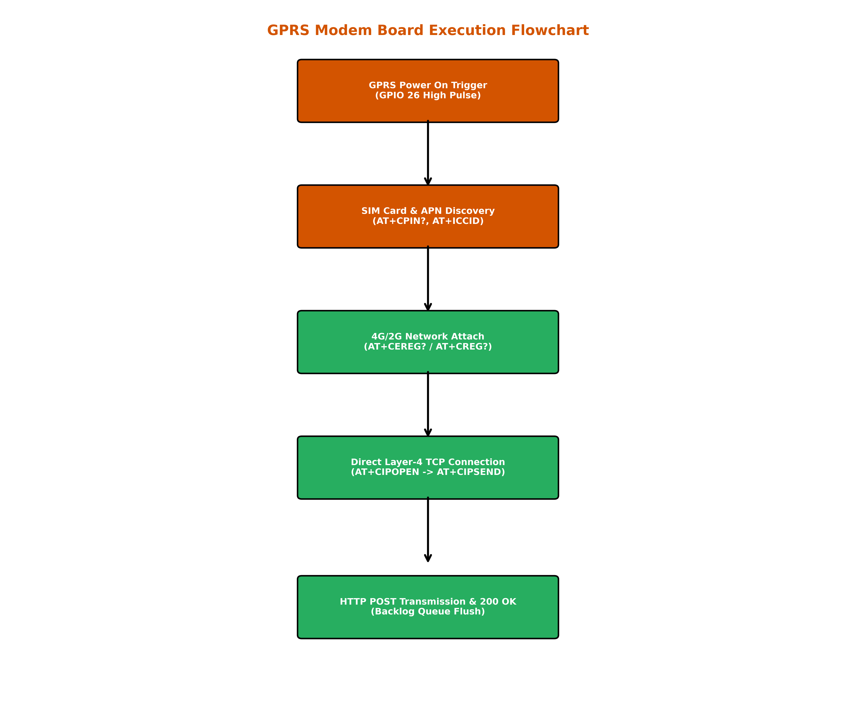
■ SIMCom A7672 Core: LTE Cat-1 4G cellular engine with 2G GSM fallback. Controlled over UART2 (GPIO 16/17 @ 115200 baud).
■ Direct Layer-4 TCP Engine: Hardware transport layer sockets (AT+CIPOPEN, AT+CIPSEND). Bypasses internal modem HTTP stack bugs and provides instant '>' prompt in < 5ms.
■ SIM Interface & Discovery: Supports Airtel M2M, Airtel Commercial, BSNL, and Jio. Auto-discovers carrier via ICCID prefix and configures matching APN (airteliot.com / bsnlnet).
■ Power & RF Front-End: Dedicated 4.0V voltage regulator rail backed by 2000µF bulk capacitors to support 2A peak current bursts during GPRS/LTE transmissions.

4. Nuvoton UI Board Flowchart & Architecture
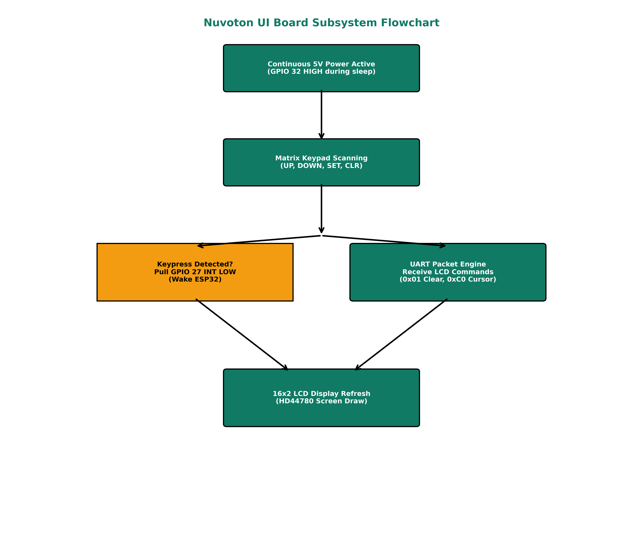
■ Nuvoton MG51 MCU: 8051-core microcontroller running dedicated HMI firmware. Communicates with ESP32 via UART1 (GPIO 14/4 @ 115200 baud).
■ 16x2 LCD Display Engine: HD44780 character LCD module. Parses screen clear (0x01), cursor positioning (0xC0), and display backlight control commands.
■ Tactile Keypad Scanner: 6-button matrix scanner (UP, DOWN, LEFT, RIGHT, SET, CLR) with hardware debouncing and automatic key code remapping.
■ Continuous Power & Wakeup: Powered on continuous 5V rail (GPIO 32 HIGH). Pulls INT line LOW (GPIO 27 ext0) on any keypress to wake ESP32 from Deep Sleep instantly.

5. Signal & Interconnection Pinout Reference Matrix
Subsystem | Signal Name | ESP32 Pin | Target Board Pin | Protocol | Signal Function
Nuvoton UI | UI_TX | GPIO 4 | Nuvoton RX | UART Out (115200 Baud) | Transmits screen drawing & cursor commands from ESP32 to Nuvoton.
Nuvoton UI | UI_RX | GPIO 14 | Nuvoton TX | UART In (115200 Baud) | Receives remapped keypress byte stream from Nuvoton keypad.
Nuvoton UI | UI_INT | GPIO 27 | Nuvoton INT | Digital Input (ext0 LOW) | Keypress trigger line that wakes ESP32 from Deep Sleep mode.
Nuvoton UI | UI_PWR | GPIO 32 | Nuvoton 5V Gate | Digital Output (MOSFET) | Kept HIGH in sleep mode so Nuvoton remains powered for keypress wakeup.
GPRS Modem | GPRS_TX | GPIO 17 | SIMCom RXD | UART Out (115200 Baud) | Sends AT commands and raw Layer-4 TCP socket HTTP POST payloads.
GPRS Modem | GPRS_RX | GPIO 16 | SIMCom TXD | UART In (115200 Baud) | Receives modem responses, TCP connection status, and HTTP 200 OK.
GPRS Modem | GPRS_PWR | GPIO 26 / 5 | SIMCom PWRKEY | Digital Output | Power pulse control line to turn SIMCom modem ON/OFF.
GPRS Modem | GPRS_RST | GPIO 33 / 4 | SIMCom RESET | Digital Output | Hardware emergency reset trigger for modem recovery.
Sensors & RTC | I2C_SDA | GPIO 21 | RTC / Sensors SDA | I2C Data (400kHz) | Shared I2C data bus for DS1307 RTC, HDC1080/2022, and BME280.
Sensors & RTC | I2C_SCL | GPIO 22 | RTC / Sensors SCL | I2C Clock (400kHz) | Shared I2C clock bus for all onboard environmental sensors.

