**TODO Application**

Contents

1 Install and Running 1

2 User Story 1

Scenario 1 1

Scenario 2 2

Scenario 3 3

Scenario 4 5

Scenario 5 6

Scenario 6 6

2 Technologies 6

3 Testing 7

# 1 Install and Running

Step 1: Clone todo-app from GitHUB location and follow instructions.

Step 2: This project is a maven project, please install maven in your local environment. Run below steps from command line or bash

* $ mvn clean install -U

Step 3: Run $mvn jetty:run

* System will open two popup windows for HSQL database. Currently using HSQL DB as a demo database for this application. Please minimize popups and don’t close these popups.

Step 4: Run application

# 2 User Story

This application satisfies following scenarios in a given story.

<https://github.com/michaeldfallen/coding-tests/blob/master/todo-app-frontend.md>

## Scenario 1

As a forgetful person  
I need to record things I need to do  
so that I will never forget them

* Please click on <http://localhost:8080/todo-app/> . This will open TODO Form to record things. Currently there is no active validation for data.

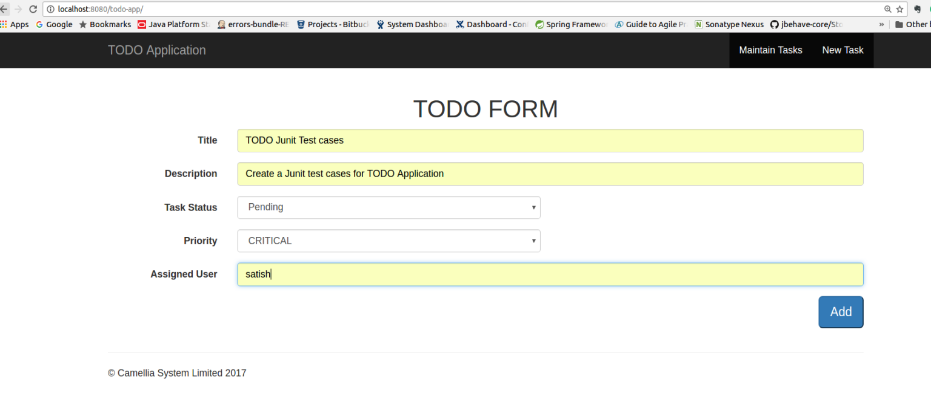

Click on ***Add*** after entering a data will redirect to successful page

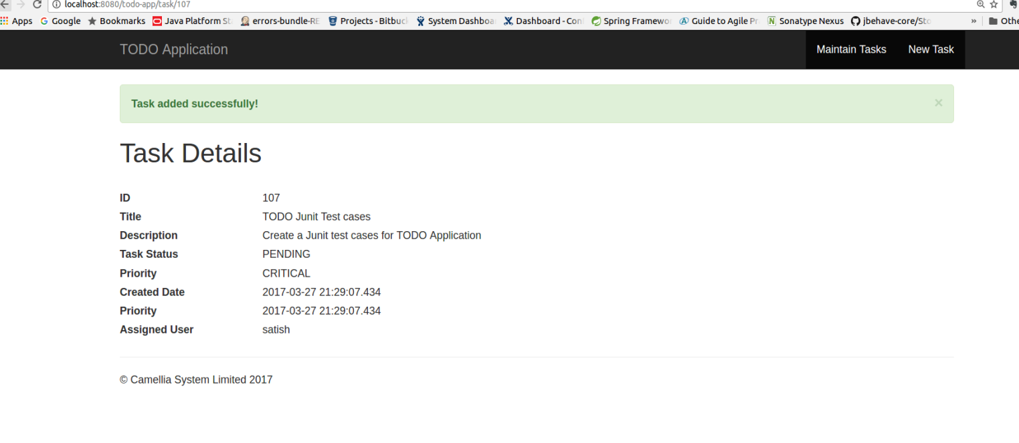

## Scenario 2

As a proactive person  
I need to see the to dos I haven't yet done  
so that I can pick the next one to do

Please click on ‘Maintain tasks’ on Header

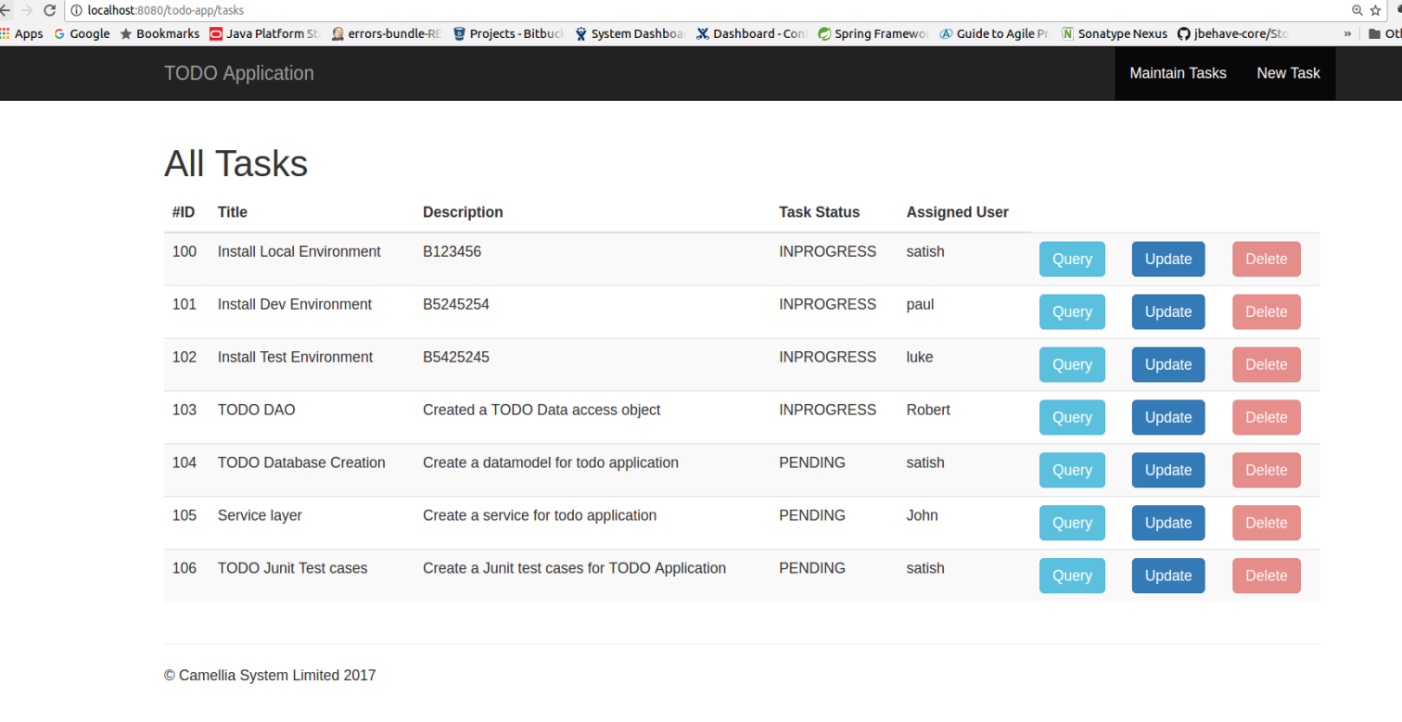

## Scenario 3

As a successful to do doer  
I need to mark a to do as complete  
so that I don't see it on my list of unfinished to dos

Click on update button in Maintain tasks list to change current status to Completed

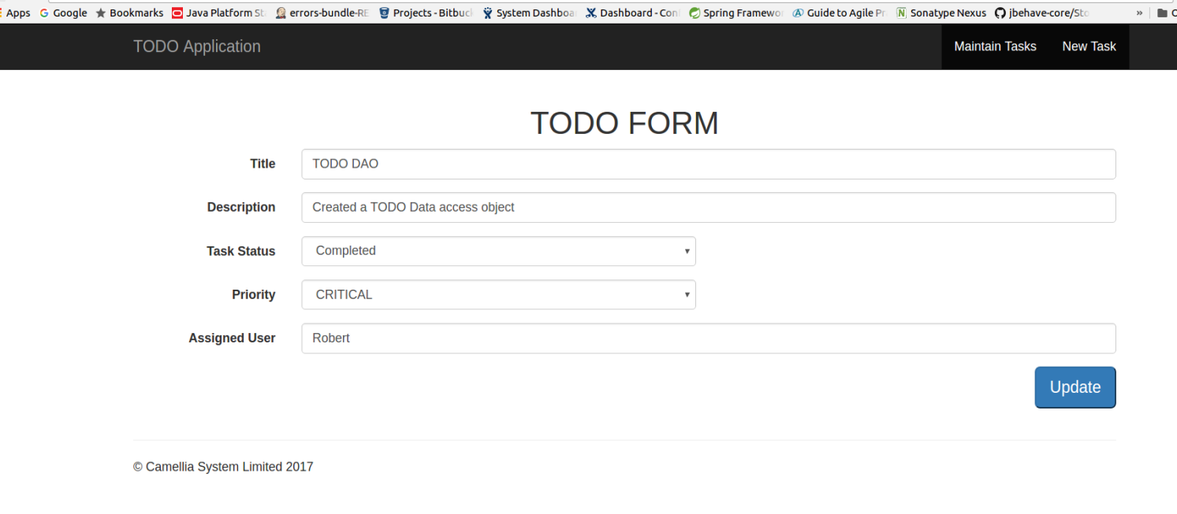

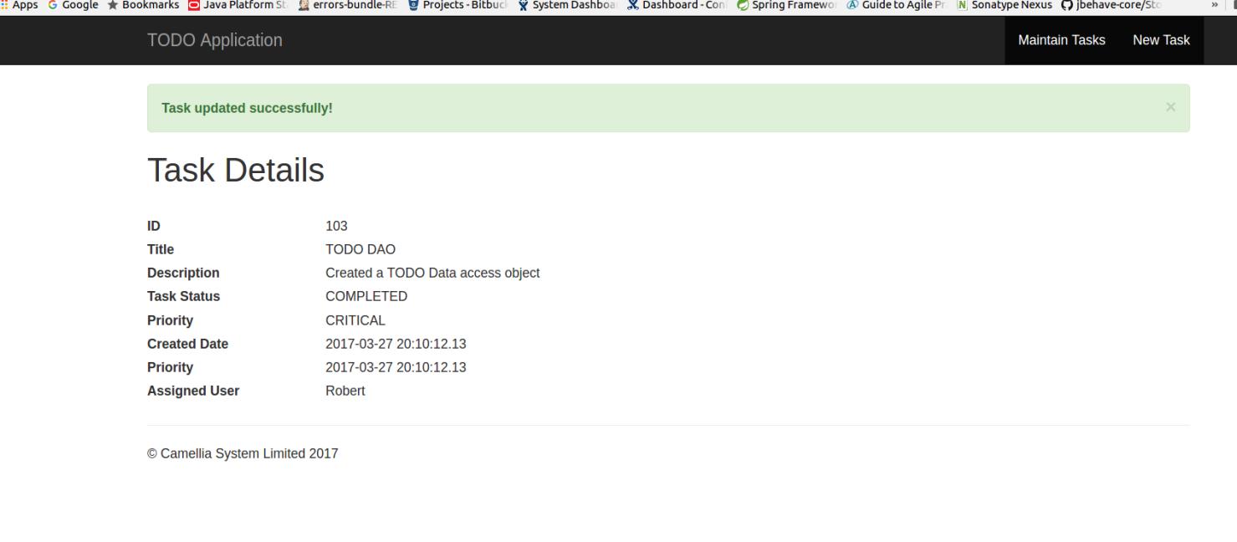

Now System will enable ‘Delete’ button to remove from list. Please check below

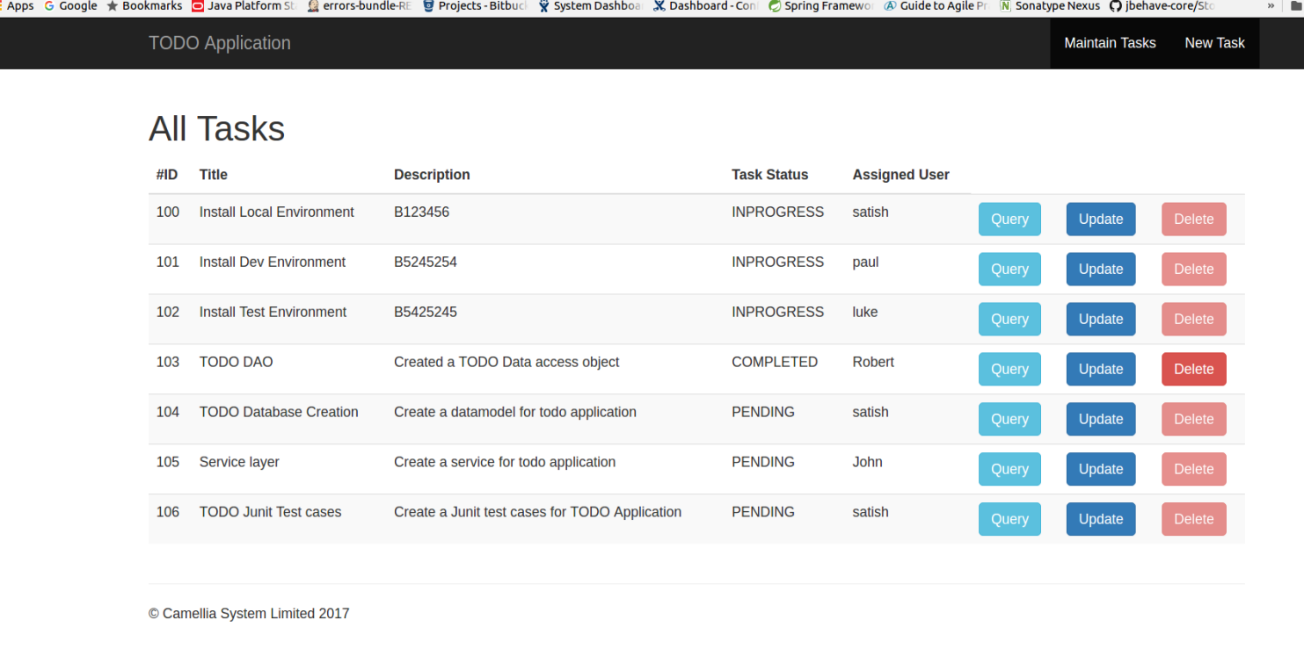

After deletion, it will disappear from above list

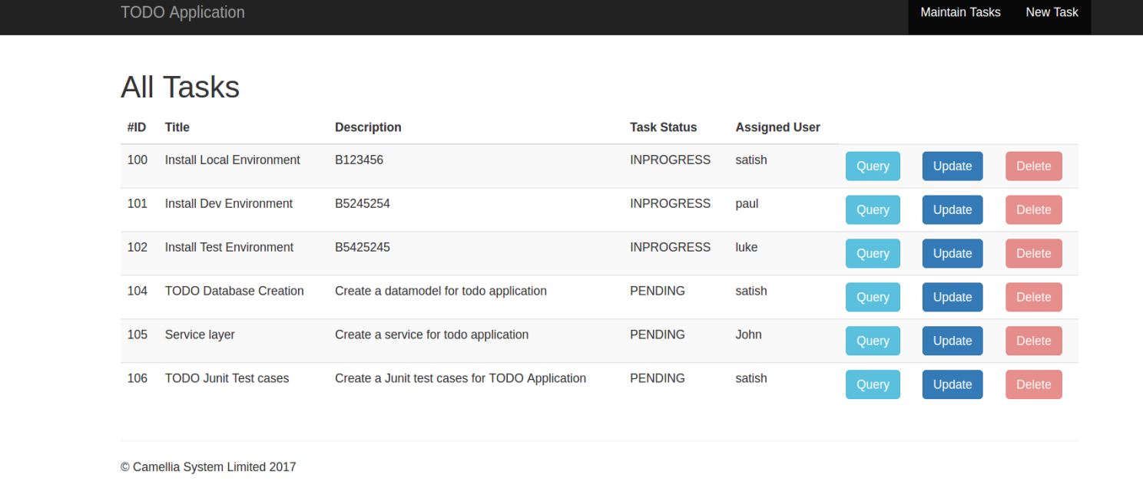

## Scenario 4

As a person with demands on my time  
I need to prioritise my to dos  
so that I don't forget which are most important to do

Please select update button to change priority of the task

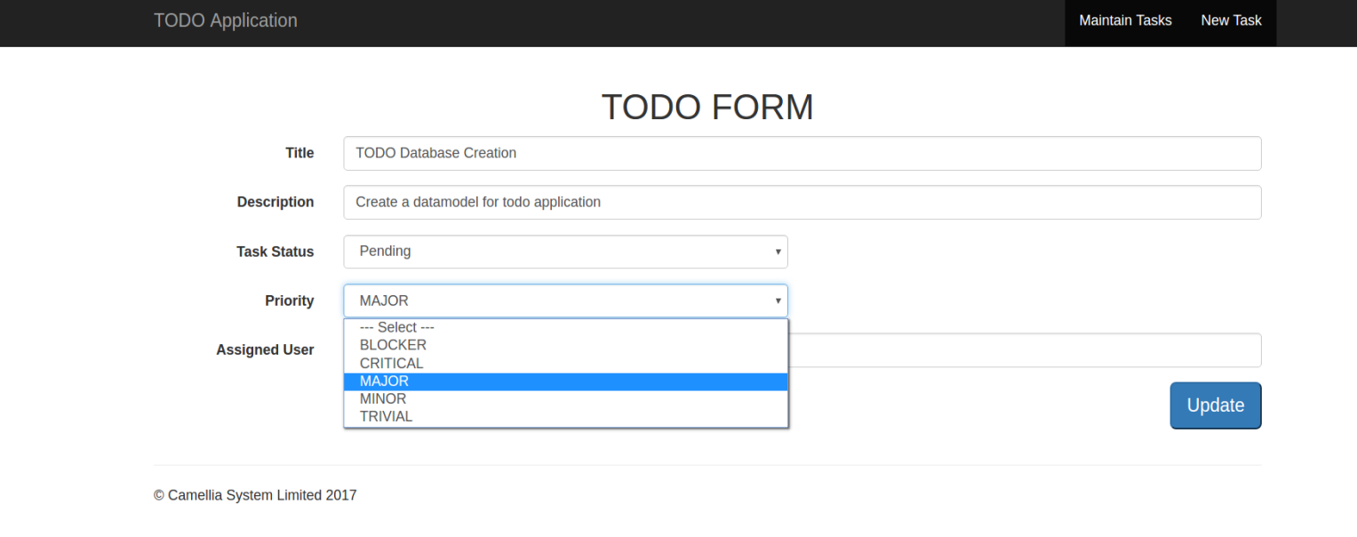

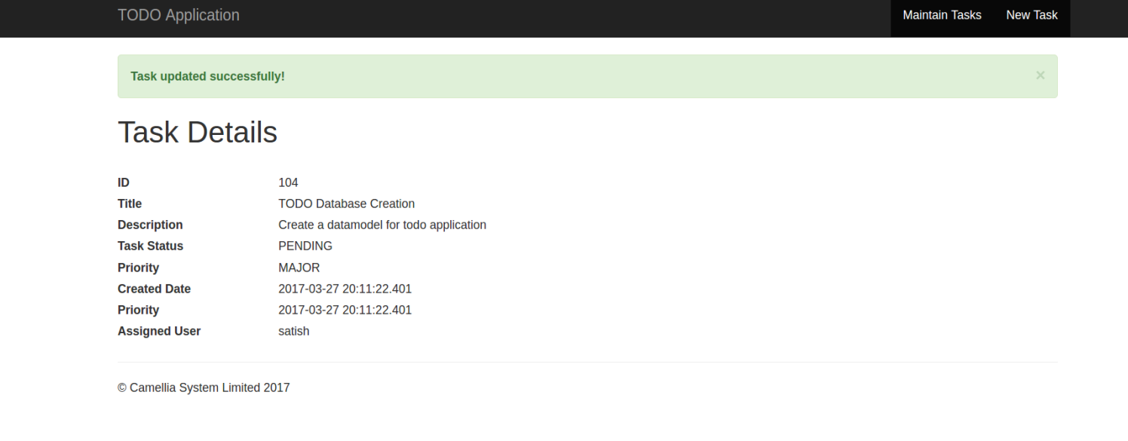

## Scenario 5

As a person with sight impairment  
I need assistive technology to help me interact with web browsers  
so that I can use this to-do service.

Not done

## Scenario 6

So that some users with restricted internet access(e.g. older browser, access via restrictive proxy server) can use the service  
the to-do application user interface  
will need to be designed with this in mind.

* Used bootstrap, CSS and spring components supports all browsers and these components are responsive to all types of browser

# 2 Technologies

* UI used HTML, bootstrap css, JSP core and Spring tags
* Spring MVN
* DAO and Service from backend layer
* Spring JDBC Template for integrating with HSQL and POJO
* HSQL Database for demo purpose
* Maven Project
* Jetty as a light weight web server for demo purpose

# 3 Testing

* No Junit Test cases, created a skeleton for unit test cases
* It is possible to create a E2E testing using selenium web driver to test functionality on cross browsers.