Hibernate First Example - by RAGHU

**JDK:**

**https://www.oracle.com/technetwork/java/javase/downloads/jdk8-downloads-2133151.html**

**STS:**

**(32 bit):-**

**https://download.springsource.com/release/STS/3.9.6.RELEASE/dist/e4.9/spring-tool-suite-3.9.6.RELEASE-e4.9.0-win32.zip**

**(64 bit):-**

**https://download.springsource.com/release/STS/3.9.6.RELEASE/dist/e4.9/spring-tool-suite-3.9.6.RELEASE-e4.9.0-win32-x86_64.zip**

**Hibernate Jars:**

**https://www.mediafire.com/file/cmy5ukdncdc061n/hibernate-release-5.2.17.Final.zip/file**

**Oracle DB (11G):**

**http://www.mediafire.com/file/e0611q3sq87cm6p/Oracle11Gdatabase.rar/file**

**(10G)**

**http://www.mediafire.com/file/roc48z1i6iitpu4/OracleXE.exe/file**

**MYSQL:**

**http://www.mediafire.com/file/98auro9hg2f1fwl/MySQLWithYog.rar/file**

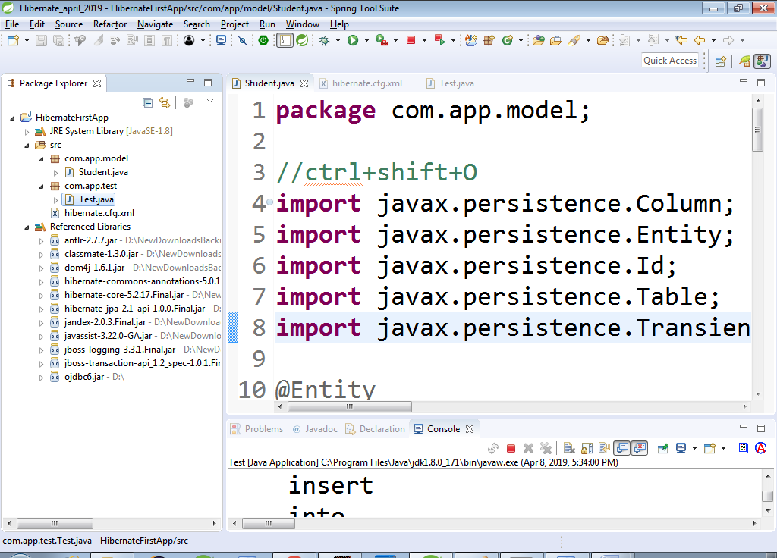

Step#1 Open Eclipse/STS and provide one folder (workspace) name.

Step#2 Create One Java Project

> file > new > Java Project > Enter name : HibernateFirstEx > finish

Step#3 Add Jars to Project (Buildpath)

> Right click on Project > build path > configure build path.. > Library tab > Add External Jars

> choose "required" folder jars > choose DB Jar (ojdbc) > Apply & close

Step#4 Create Model class under src

> Right click on src folder > new >class > enter details:

package : com.app.model

name : Student

Step#5 Create Config file under src

> right click on src > new > other... > search using "XML file" and choose same > next > enter name "hibernate.cfg.xml" > finish

Step#6 Create Test class under src Run after coding (Ctrl+F11) or

Run menu > Run Option

==================================================================

**Model class:-**

**package** com.app.model;

//ctrl+shift+O

**import** javax.persistence.Column;

**import** javax.persistence.Entity;

**import** javax.persistence.Id;

**import** javax.persistence.Table;

**import** javax.persistence.Transient;

@Entity

@Table(name="stdtab")

**public** **class** Student {

@Id

@Column(name="sid")

**private** **int** stdId;

@Column(name="sname")

**private** String stdName;

@Column(name="sfee")

**private** **double** stdFee;

@Transient

**private** String course;

**public** Student() {

**super**();

}

**public** **int** getStdId() {

**return** stdId;

}

**public** **void** setStdId(**int** stdId) {

**this**.stdId = stdId;

}

**public** String getStdName() {

**return** stdName;

}

**public** **void** setStdName(String stdName) {

**this**.stdName = stdName;

}

**public** **double** getStdFee() {

**return** stdFee;

}

**public** **void** setStdFee(**double** stdFee) {

**this**.stdFee = stdFee;

}

**public** String getCourse() {

**return** course;

}

**public** **void** setCourse(String course) {

**this**.course = course;

}

@Override

**public** String toString() {

**return** "Student [stdId=" + stdId + ", stdName=" + stdName + ", stdFee=" + stdFee + ", course=" + course + "]";

}

}

**======================================================**

**hibernate.cfg.xml**

<?xml version=*"1.0"* encoding=*"UTF-8"*?>

**<hibernate-configuration>**

**<session-factory>**

**<property name=*"hibernate.connection.driver_class"*>oracle.jdbc.driver.OracleDriver</property>**

**<property name=*"hibernate.connection.url"*>jdbc:oracle:thin:@localhost:1522:ORCL</property>**

**<property name=*"hibernate.connection.username"*>system</property>**

**<property name=*"hibernate.connection.password"*>admin</property>**

**<property name=*"hibernate.dialect"*>org.hibernate.dialect.OracleDialect</property>**

**<property name=*"hibernate.show_sql"*>true</property>**

**<property name=*"hibernate.format_sql"*>true</property>**

**<property name=*"hibernate.hbm2ddl.auto"*>create</property>**

**<mapping class=*"com.app.model.Student"*/>**

**</session-factory>**

**</hibernate-configuration>**

**===========================================================**

**Test.java**

**package** com.app.test;

**import** org.hibernate.Session;

**import** org.hibernate.SessionFactory;

**import** org.hibernate.Transaction;

**import** org.hibernate.cfg.Configuration;

**import** com.app.model.Student;

**public** **class** Test {

**public** **static** **void** main(String[] args) {

Configuration cfg=**new** Configuration();

cfg.configure();

SessionFactory sf=cfg.buildSessionFactory();

Session ses=sf.openSession();

Transaction tx=ses.beginTransaction();

Student s=**new** Student();

s.setStdId(10);

s.setStdName("AAAA");

s.setStdFee(99.99);

s.setCourse("Hibernate");

ses.save(s);

tx.commit();

ses.close();

}

}

**//ctrl+F11 (Run>Run)**

FB:

**https://www.facebook.com/groups/thejavatemple/**

email:

**javabyraghu@gmail.com**