The Analysis of the Contribution of Anthropogenic and Demographic Factors on CO₂ Emissions

Abstract— In this study, we will conduct a brief analysis on the visual analytic methods used to explore trends on CO2 emissions in literature. We will be comparing these methods and developing a novel method of visual analytics.

Problem statement
Carbon Dioxide Emissions are the single largest driver of global warming, despite methane being 84 times more potent as a greenhouse gas, CO₂ constituted for 81% of all greenhouse gas emissions and lingers for longer in the atmosphere being able to absorb heat in 2018. (EPA, 2018) CO₂ emissions are not only increasing global temperatures and cause polar glaciers to melt, cause a rise in sea levels but has been shown to acidify these oceans ( pH has reduced by 0.1 since 1800 and projected 0.5 units by 2100). (Doney, Fabry, Feely, & Kleypas, 2009) (The Royal Society, 2005)
Being such an important topic of this century, there have been countless studies such as D’Amato & Akdis, 2020 which directly links the effect of anthropogenic factors and global warming to climate change.
There is not much research in literature linking income ewill assess the trend in the Carbon Dioxide emissions in the world, in the past and in the future. Factors such as Employment in agriculture (%), fertility rate, air transport, cereal yield, access to electricity and urban population (%) will be analysed with their relationship with the change in emissions.
By understanding these relationships, the study will aim to answer these research questions:
- How has Carbon Dioxide Emissions changed in regions and in globally between 2010 and 2018?
- Which demographic and anthropogenic factors are greatest attributable to carbon dioxide emissions?
- Could we create a prediction model for future CO₂ Emissions?

state of the art
It is known that the drivers of carbon dioxide emissions are multi-faceted, from supply/ demand to non-quantifiable features such as policies. By analysing of demographic and anthropogenic factors of carbon dioxide emissions, countries can effectively set better targets and policies i.e. Stern result and Kyoto Protocol. (Sinn, 2008)
This study and the papers which will be discussed will be looking at demographics and carbon-dioxide emissions. In particular two papers, (Inekwe, Maharaj, & Bhattacharya, 2020) and (Gallo, Faccilongo, & La Sala, 2018) look into clustering analysis of emissions.
Gallo et al studied how different types of environmental emissions, NO2, CO2, N2O and CH4 from different sources vary in different countries. They used a clustering algorithm on different years (2004, 2007 and 2010) to group the different nations, to identify similar countries. The paper focused on different countries, whether they were or not in the Kyoto Protocol and the effect of it on change in emissions.
The research carried out by Inekwe et al, considered a method which logarithmically processed variables, using different coefficients to sum different attributes to carbon emissions, known as the I=PAT model. This model was also considered in other research papers including (Wang, Liu, Zhou, Hua, & Ou, 2017). These attributes included non-renewable energy intensity, population, and GDP. They also utilised different cluster pairings, with large CO2 emitters such as USA, India and China and without these large emitters. It was determined that keeping these countries did not have an impact on the composition of the clusters. Both these authors use K-means as a method which is based on euclidian distance of data points to cluster the data.
Visualisation Techniques in literally generally included density and heatmaps in a geographical context. Histograms and Boxplots were used for initial data exploratory analysis and for cluster analysis. Wang et al used geospatial heatmaps to distinguish areas or growth in different provinces in China, which was used to analyse carbon emissions. These techniques were also used in Asefi-Najafabady et al. for temporal changes in global carbon emissions and predict future values.
Comparing literature, we plan use demographic data over time and will be clustering the data into different groups and will be analysing the clusters individually.

Properties of the data
The data is obtained from the World Banks’ open data, which is a publicly available collection of global development datasets. The data was taken from a few datasets; Sustainable Development Goals (SDG), World Development Indicators and the Population Estimates and Projects datasets. These datasets include data about carbon dioxide emissions, access to electricity, cereal yield and total population and such demographic data. Since these datasets were from the same website, they had a similar structure and was easy to join on Python using DataFrames.
Missing values in the columns when imported came out as “..”, this was easily replaced in Excel before importing into Python for analysis. Furthermore, a new column was created using geographic data to group the countries into regions and continents, which can be used for aggregative analysis.
There were several columns which would have been particularly useful in the study to see but had too many missing values and was subsequently dropped. These columns included threatened animal, bird and mammal species, the column was only available for one year for each country and would have been difficult to extrapolate.
The access the clean fuels columns had multiple empty rows which were dropped, after that there were few rows which had empty values. These could be grouped by country and imputed using the KNN algorithm to fit their missing values. The imputation did not change the shape of the histograms much, it slightly accentuated the peaks.
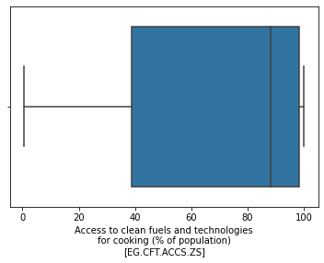
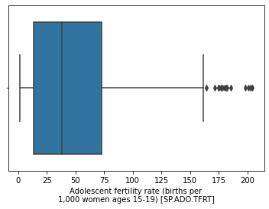
Figure 1- Boxplots of Features

Data distribution was determined using boxplots, many of the variables contained outliers such as Adolescent fertility rate and positive/ negative skews as shown in figure 1.
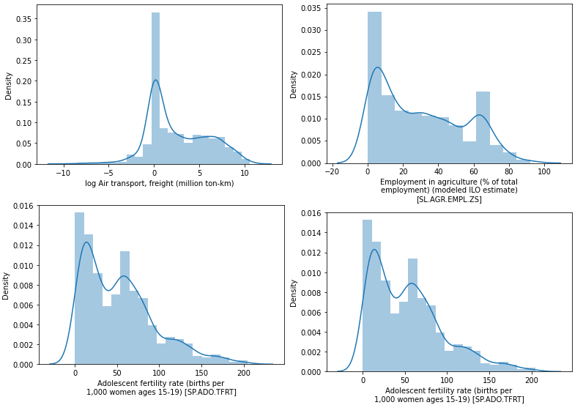
Figure 2- Histograms Evaluation of Features
One value which was logged to reduce the effect of magnitudes was the transport in freight from countries, this initially had peaks/values very far away from each other in the histogram. The distribution of the data could be better seen after the log was applied. Other features were also explored using a histogram, many variables did have a skew or a sort of bi-modal distribution of data. The outliers will be considered as was done by Wang et al. 2017.

Analysis

Approach
In this section, we will be discussing the methodology used to investigate the research questions. We will be explaining the visual analytic techniques and computational methods used to answer the questions.
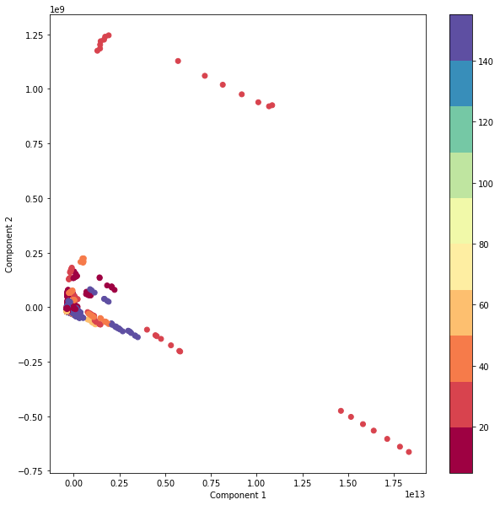
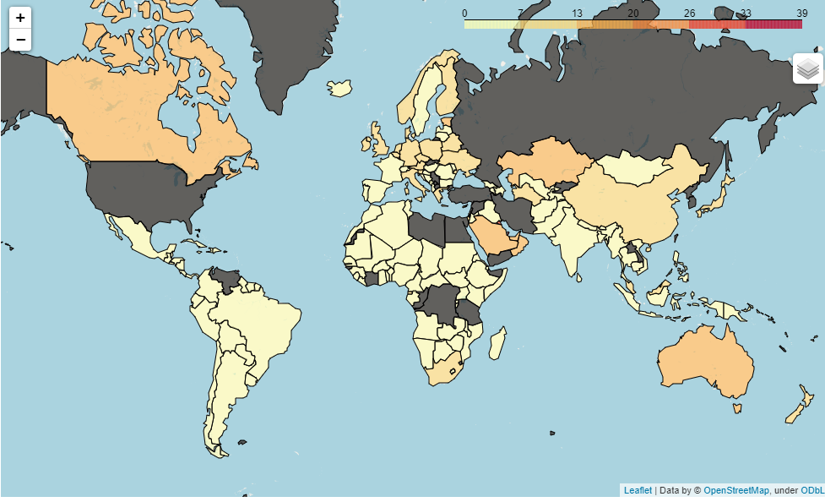

Bibliography
(EPA), U. S. (2018). Overview of Greenhouse Gases. Retrieved from United States Environmental Protection Agency : https://www.epa.gov/ghgemissions/overview-greenhouse-gases
D’Amato, G., & Akdis, A. C. (2020, August 1). Global warming, climate change, air pollution and allergies. Allergy, 75(9), 1. doi:https://doi.org/10.1111/all.14527
Doney, S. C., Fabry, V. J., Feely, R. A., & Kleypas, J. A. (2009, January). Ocean Acidification: The Other CO2 Problem. Annual Review of Marine Science, 1(1), 169-192. doi:https://doi.org/10.1146/annurev.marine.010908.163834
Gallo, C., Faccilongo, N., & La Sala, P. (2018, January 20). Clustering analysis of environmental emissions: A study on Kyoto Protocol's impact on member countries. Journal of Cleaner Production, 172, 3685-3703. doi:https://doi.org/10.1016/j.jclepro.2017.07.194
Inekwe, J., Maharaj, E. A., & Bhattacharya, M. (2020, December 18). Drivers of carbon dioxide emissions: an empirical investigation using hierarchical and non-hierarchical clustering methods. Environmental and Ecological Statistics volume, 27, 1-40. doi:10.1007/s10651-019-00433-4
Lodron Zuin, G., Gonc ̧alves Magalh ̃aes, L., & Corrˆea Loures, T. (2016). MAL-FITT:MyAnimeList Forum Interpreter Through Text. BRACIS 2016- Brazilian Confrence on Intelligent Systems (pp. 205-206). Rio De Janeiro: XIII National Meeting on Artificial and Computational Intelligence - ENIAC'2016.
manami-project. (2020, August 15). anime-offline-database. Retrieved from GitHub: https://github.com/manami-project/anime-offline-database
Orsini, L. (2018, May 30). MyAnimeList Passes Third Day Of Unexpected Downtime. Retrieved from Forbes: https://www.forbes.com/sites/laurenorsini/2018/05/30/myanimelist-passes-third-day-of-unexpected-downtime/?sh=9396b197e9e2#4de588827e9e
Sinn, H.-W. (2008). Public policies against global warming: a supply side. International Tax Public Finance, 15, 360-394. doi:10.1007/s10797-008-9082-z
The Royal Society. (2005, June 12). Ocean acidification due to increasing. Retrieved from The Royal Society: https://oceanrep.geomar.de/7878/1/965_Raven_2005_OceanAcidificationDueToIncreasing_Monogr_pubid13120.pdf
Wang, S., Liu, X., Zhou, C., Hua, J., & Ou, J. (2017, January 1). Examining the impacts of socioeconomic factors, urban form, and transportation networks on CO2 emissions in China’s megacities. Applied Energy, 185(1), 189-200. doi:https://doi.org/10.1016/j.apenergy.2016.10.052
Williams, M. (2019, July 29). variety.com. Retrieved from Variety est 1905.: https://variety.com/2019/tv/news/anime-streaming-netflix-1203278207/
Wit, A. D. (2020, November 27). Anime Industry Grew To Record $24.1 Billion In 2019, Says Trade Body. Retrieved from cartoonbrew: https://www.cartoonbrew.com/business/anime-industry-grew-to-record-24-1-billion-in-2019-says-trade-body-199002.html
Yeung, J. (2020, October 21). Netflix Announces Five New Anime Originals for 2021. Retrieved from HypeBeeast: https://hypebeast.com/2020/10/netflix-anime-festival-2020-announcements

