# SampleCoordinates

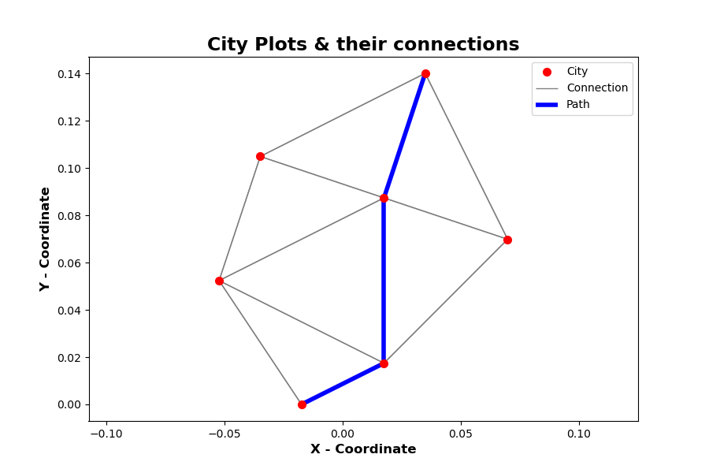Shortest path from 0 to 5 in SampleCoordinates is: [0, 4, 3, 5]

Total distance: 0.16446989717973534

# HungaryCities

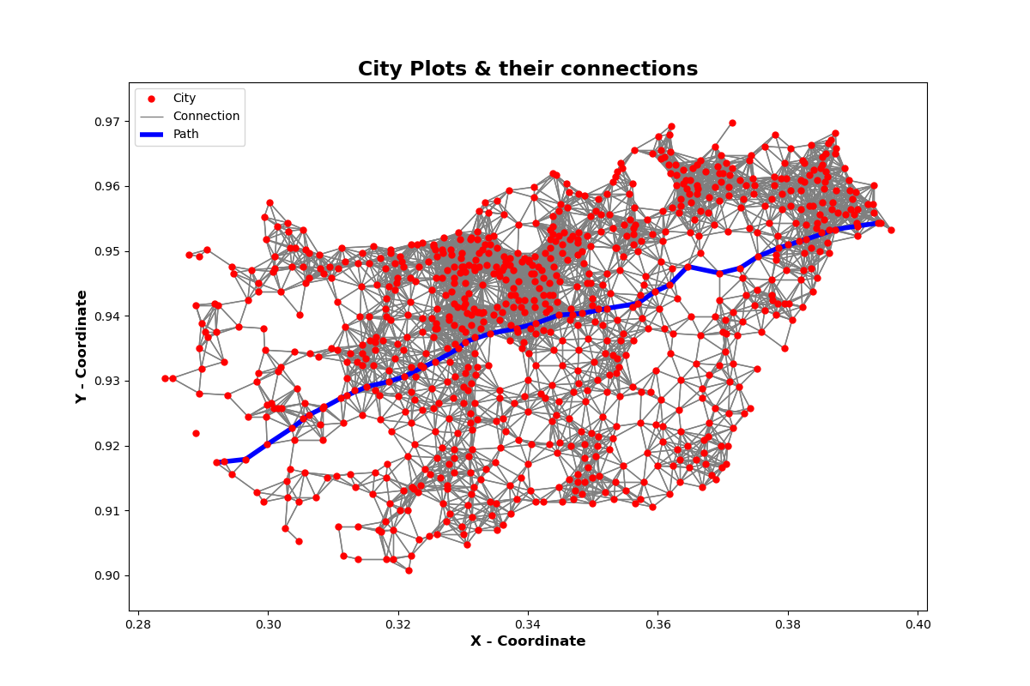

Shortest path from 311 to 702 in HungaryCities is: [311, 19, 460, 629, 269, 236, 781, 50, 193, 571, 624, 402, 370, 153, 262, 554, 126, 251, 368, 221, 827, 300, 648, 253, 836, 73, 35, 219, 503, 789, 200, 702]

Total distance: 0.11144861188215291

# GermanyCities

|  |  |
| --- | --- |
| Function | Time (s) |
| read_coordinate_file | 0.19346976280212402 |
| construct_graph_connections | 42.551297664642334 |
| construct_fast_graph_connections | 1.1902148723602295 |
| construct_graph | 0.010992050170898438 |
| Task 6+7 time | 0.016169071197509766 |
| The entire program excluding plotting (fast version) | 1.4108457565307617 |
| plot_points | 8.113259315490723 |

Shortest path from 1573 to 10584 in GermanyCities is: [1573, 7014, 2499, 3182, 2958, 4197, 4448, 2269, 5634, 3467, 6172, 4656, 4390, 3610, 3776, 4850, 6846, 764, 5614, 7656, 6251, 5004, 5932, 6906, 7571, 4712, 3700, 270, 4160, 2522, 2738, 2376, 4399, 3987, 4890, 2266, 5813, 6473, 6062, 6048, 11572, 8765, 8847, 3995, 9989, 10105, 10232, 4325, 7418, 3122, 7115, 10160, 9311, 4084, 10561, 4135, 4806, 629, 4652, 5762, 6162, 9350, 8352, 1112, 4887, 4699, 6987, 4651, 5513, 9104, 7083, 9513, 9338, 5357, 11054, 10743, 4728, 10971, 10152, 7472, 9467, 11126, 10789, 5970, 7292, 8473, 9856, 11780, 9570, 10476, 10078, 9956, 9998, 738, 10403, 9172, 11716, 6329, 7826, 8148, 6807, 9578, 7733, 7197, 7863, 9346, 10784, 8538, 11378, 10872, 5444, 4289, 6980, 6434, 7064, 7841, 9729, 10362, 7958, 10584]

Total distance: 0.22311918536607628