# SKILL-WORM – LEARNING MANAGEMENT SYSTEM

**A Project Report**

***Submitted by***

## SATNAM SINGH PAHWA

## SANKET RATHI

***Under the Guidance of***

**Prof. Vijayetha Thoday**

***in partial fulfillment for the award of the degree of***

## BACHELORS OF TECHNOLOGY

**IN COMPUTER ENGINEERING**

At



**MUKESH PATEL SCHOOL OF TECHNOLOGY, MANAGEMENT AND ENGINEERING,**

**MUMBAI**

**APRIL 2020**

## DECLARATION

I, Satnam Singh Pahwa, Roll No. E008 BTech (Computer Engineering), VI semester understand that plagiarism is defined as anyone or combination of the following:

1. Un-credited verbatim copying of individual sentences, paragraphs or illustration (such as graphs, diagrams, etc.) from any source, published or unpublished, including the internet.
2. Un-credited improper paraphrasing of pages paragraphs (changing a few words phrases, or rearranging the original sentence order)
3. Credited verbatim copying of a major portion of a paper (or thesis chapter) without clear delineation of who did wrote what. ( Source: IEEE, The institute, Dec. 2004)
4. I have made sure that all the ideas, expressions, graphs, diagrams, etc., that are not a result of my work, are properly credited. Long phrases or sentences that had to be used verbatim from published literature have been clearly identified using quotation marks.
5. I affirm that no portion of my work can be considered as plagiarism and I take full responsibility if such a complaint occurs. I understand fully well that the guide of the seminar/ project report may not be in a position to check for the possibility of such incidences of plagiarism in this body of work.

Signature of the Students: __________, _____________, ____________, ______________

Names: Satnam Singh Pahwa, Sanket Rathi

Roll Nos.: E008, E018

Place: Mumbai

Date: 02/04/2020

## CERTIFICATE

This is to certify that the project entitled “SKILL-WORM, Learning Management System” is the bonafide work carried out by Satnam Singh Pahwa and Sanket Rathi of BTech, MPSTME (NMIMS), Mumbai, during the VI semester of the academic year 2020, in partial fulfillment of the requirements for the Course Programming Language.

___________________

Prof. Vijayetha Thoday

Internal Mentor

_______________________ ________________________

Examiner 1 Examiner 2

## Table of contents

**CHAPTER NO. TITLE PAGE NO.**

1. INTRODUCTION 5
2. SOFTWARES AND API USED 6

WITH DESCRIPTION

1. METHODS IMPLEMENTED 9
2. SCREENSHOTS 12
3. CONCLUSION & FUTURE SCOPE 17
4. SOCIETAL APPLICATION 18

**INTRODUCTION**

Our project has been developed to provide convenient solutions to anyone wanting to learn a new skill. We are providing courses for professional skills as well as courses for hobbies. Our project is using the Django framework. Django is an open source web application frame work which is written in Python.

Unemployment is a very serious issue not only in India but in the whole world. There are hundreds and thousands of people out there who do not have employment. Besides, the problems of unemployment are very severe in India because of the growing population and demand for jobs. We aim to design a system to provide tutors for developing new skills and make people

employable.

Targeted Audience for our project:

* Students at school who need help in studies or wish to develop a hobby.
* Employers wanting to train new or old employees.
* Adults who wish to explore different domains other than their professional skills.
* Tutors looking to approach people to teach.
* Someone who is an expert in their skill background to share their wisdom.

SOFTWARES AND API USED WITH DESCRIPTION

1. Django framework

Django is an open source web application frame work written in Python. The primary goal of Django is to make the development of complex, data-based websites easier. Thus Django emphasizes the reusability and pluggability of components to ensure rapid developments. Django consists of three major parts: model, view and template.

* Model :

Model is a single, definitive data source which contains the essential field and behavior of the data. Usually one model is one table in the database. Each attribute in the model represents a field of a table in the database. Django provides a set of automatically-generated database application programming interfaces (APIs) for the convenience of users.

* View :

View is short form of view file. It is a file containing Python function which takes web requests and returns web responses. A response can be HTML content or XML documents or a “404 error” and so on. The logic inside the view function can be arbitrary as long as it returns the desired response. To link the view function with a particular URL we need to use a structure called URLconf which maps URLs to view functions.

* Template:

Django’s template is a simple text file which can generate a text-based format like HTML and XML. The template contains variables and tags. Variables will be replaced by the result when the template is evaluated. Tags control the logic of the template. We also can modify the variables by using filters. For example, a lowercase filter can convert the variable from uppercase into lowercase.

1. Bootstrap

* Bootstrap is a sleek, intuitive, and powerful front-end framework for faster and easier web development. Bootstrap comes equipped with HTML, CSS, and JavaScript for various web and user interface components.
* Mark Otto and Jacob Thornton at Twitter developed bootstrap, originally named "Twitter Blueprint" as a framework to encourage consistency across internal tools. Bootstrap is a free and open-source collection of tools for creating websites and web applications. It contains HTML and CSS based design templates for typography, forms, buttons, navigation, and other interface components, as well as optional Java Script extensions. It makes development of dynamic websites and web applications easy.
* Bootstrap is a front-end framework, An interface for the user, unlike the server side code, which resides on the back end.
* Bootstrap is compatible with the latest versions of the Google Chrome, Firefox, Internet Explorer, Opera, and Safari browsers.
* Bootstrap gives you ability to create responsive layout with much less efforts. Starting with version 2.0 it supports responsive web design. In version 3.0, Bootstrap adopted a mobile first design philosophy. The version 4.0 alpha release added Sass and Flex box support.
* The biggest advantage of using Bootstrap is that it comes with free set of tools for creating flexible and responsive web layouts as well as common interface components. Additionally, using the Bootstrap data APIs you can create advanced interface components like Scrollspy and Type aheads without writing a single line of JavaScript.

1. PostgreSQL

* PostgreSQL is a powerful, open source object-relational database system. It has more than 15 years of active development phase and a proven architecture that has earned it a strong reputation for reliability, data integrity, and correctness.
* PostgreSQL (pronounced as **post-gress-Q-L**) is an open source relational database management system (DBMS) developed by a worldwide team of volunteers. PostgreSQL is not controlled by any corporation or other private entity and the source code is available free of charge.
* PostgreSQL runs on all major operating systems, including Linux, UNIX (AIX, BSD, HP-UX, SGI IRIX, Mac OS X, Solaris, Tru64), and Windows. It supports text, images, sounds, and video, and includes programming interfaces for C / C++, Java, Perl, Python, Ruby, Tcl and Open Database Connectivity (ODBC).
* PostgreSQL supports a large part of the SQL standard and offers many modern features including the following −
  + Complex SQL queries
  + SQL Sub-selects
  + Foreign keys
  + Trigger
  + Views
  + Transactions
  + Multiversion concurrency control (MVCC)
  + Streaming Replication (as of 9.0)
  + Hot Standby (as of 9.0)

1. WEBRTC

**WebRTC** (Web Real-Time Communication) is a technology which enables Web applications and sites to capture and optionally stream audio and/or video media, as well as to exchange arbitrary data between browsers without requiring an intermediary. The set of standards that comprise WebRTC makes it possible to share data and perform teleconferencing peer-to-peer, without requiring that the user installs plug-ins or any other third-party software.

WebRTC consists of several interrelated APIs and protocols which work together to achieve this. The documentation you'll find here will help you understand the fundamentals of WebRTC, how to set up and use both data and media connections, and more.

WebRTC concepts and usage

* WebRTC serves multiple purposes; together with the [Media Capture and Streams API](https://developer.mozilla.org/en-US/docs/Web/API/Media_Streams_API), they provide powerful multimedia capabilities to the Web, including support for audio and video conferencing, file exchange, screen sharing, identity management, and interfacing with legacy telephone systems including support for sending [DTMF](https://developer.mozilla.org/en-US/docs/Glossary/DTMF) (touch-tone dialing) signals. Connections between peers can be made without requiring any special drivers or plug-ins, and can often be made without any intermediary servers.
* Connections between two peers are represented by the [RTCPeerConnection](https://developer.mozilla.org/en-US/docs/Web/API/RTCPeerConnection) interface. Once a connection has been established and opened using RTCPeerConnection, media streams ([MediaStream](https://developer.mozilla.org/en-US/docs/Web/API/MediaStream)s) and/or data channels ([RTCDataChannel](https://developer.mozilla.org/en-US/docs/Web/API/RTCDataChannel)s) can be added to the connection.
* Media streams can consist of any number of tracks of media information; tracks, which are represented by objects based on the [MediaStreamTrack](https://developer.mozilla.org/en-US/docs/Web/API/MediaStreamTrack) interface, may contain one of a number of types of media data, including audio, video, and text (such as subtitles or even chapter names). Most streams consist of at least one audio track and likely also a video track, and can be used to send and receive both live media or stored media information (such as a streamed movie).

METHODS IMPLEMENTED

1. User Authentication and registration:

This module contains the user base where we register new users and allow them to login and save their information. This modules also consists of all the user data which usercan change when necessary.

Methods implemented:

Registration:

* The user for our platform can be of two types either a student or a professional. The professional users can further be categorised into two sub types tutor and organisation. Based on their type data is collected for registration
* All the user have a common basic data set. Tutors can add their skills on registration where as an organisation has to give its name and registration proof as well.
* We have all the system validations placed such as two users can not have same email id, password must have 1 of each uppercase, lowercase, special character and number and needs to be at least 8 characters long.
* Few of the validations such as password are done using regex module which is available with python.

Login :

* It is a common knowledge that a user must be registered in order to login and access full features.
* Email id and password are the necessary field for logins
* The data on login is verified from the database and valid user are allowed to access all features such as selecting a user.

1. Courses

In this module we have all available course that the tutors have opted for. All available courses are linked within the database to the tutors. The courses consists of following methods:

Courses:

* This consists of tutor and course related data.
* All this data is made available to the user while finding there perfect tutors.
* Tutors can add their course details to this model through their profile.

Categories:

* Every course is split across different category. For example football comes under sports category.
* This helps the user freely navigate through the courses and its related course that my interest you. It also makes it easier find the desired course quickly.

Links:

* The logged in user can select a user and pay for their trial.
* Once the payment has been completed and verified, the tutor is notified and database is updated.
* The job of link is to hold the relation between students and tutors for every course and whether they have been completed or not.

1. Profile:

Once the user has registered, a profile is created for him based on their type. They can display their database there.

The common profile methods are:

Profile:

* This module contains the users profile data where all his personal information is shown.
* Here the user can update their data only is necessary

Reviews:

* Users can check how they have been rated by others.
* Reviews are also available to justify the given ratings.
* The reviews and ratings are in accordance with the course for that specific user.

Video Conferencing:

* This is made available only for the online courses.
* The tutor may start the online video and invite only registered students.
* Similarly only the register students can avail this feature.

The module specific to tutor:

Students:

* Here all the registered students whose trail has not yet been completed are show so that the tutor knows how to handle all this students.

Add course:

* The tutor has the authority to add courses for himself.
* In this manner they can register themselves to courses for which they have necessary skills.
* For educational and some required course their necessary qualifications are checked before approving them to become tutor for that course.

The module specific to student:

My Courses:

* All the courses that the students has registered for and their trails have not been completed are shown.
* This helps the user keep track of their trials easily.

1. Search

Any student can search for a specific course using the search module. The tutors offering that course will be displayed in the search results.

The methods implemented were:

Search Results:

* It will show all the tutors offering that course.
* Along with that the details of the course like location, trial fees, days per week, etc will be shown.

1. Category

This page will contain the names of all categories for which the courses are available.

The methods implemented were:

Category Page:

* Here, all the courses are categorized into their respective categories.
* Along with that the number of tutors offering that course is displayed.

## SCREENSHOTS

## 1)HOMEPAGE

## 

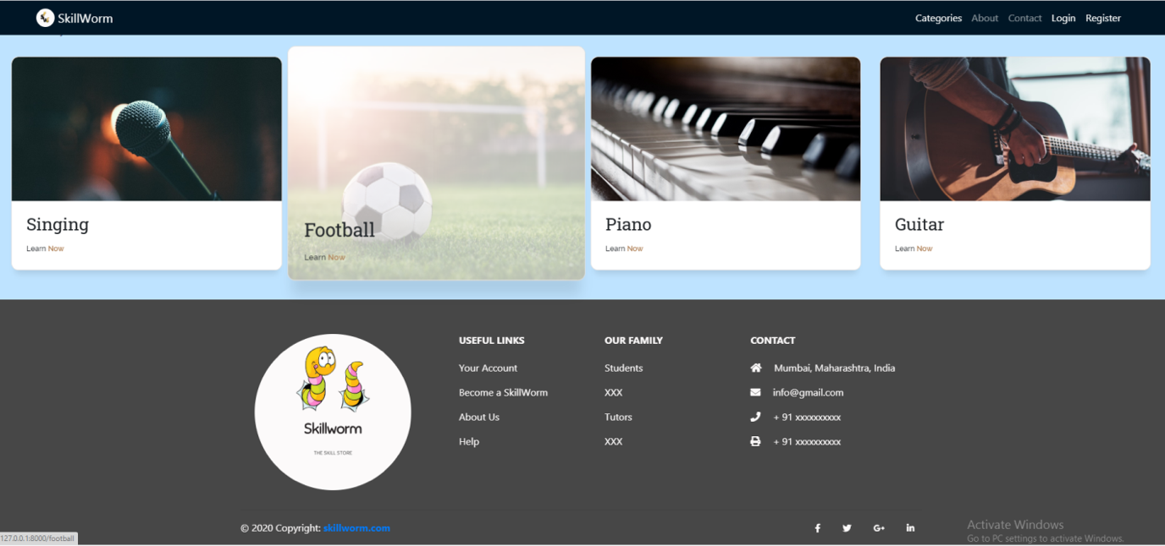

2) CATEGORY PAGE

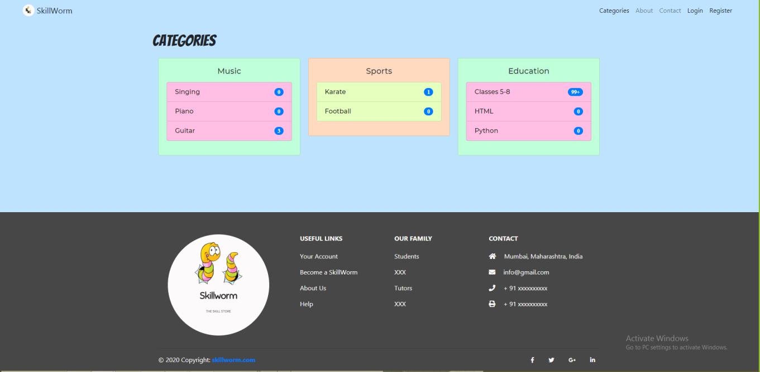

‘

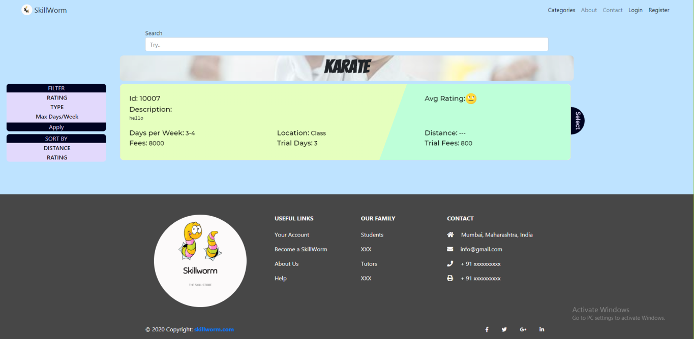3) SEARCH RESULT

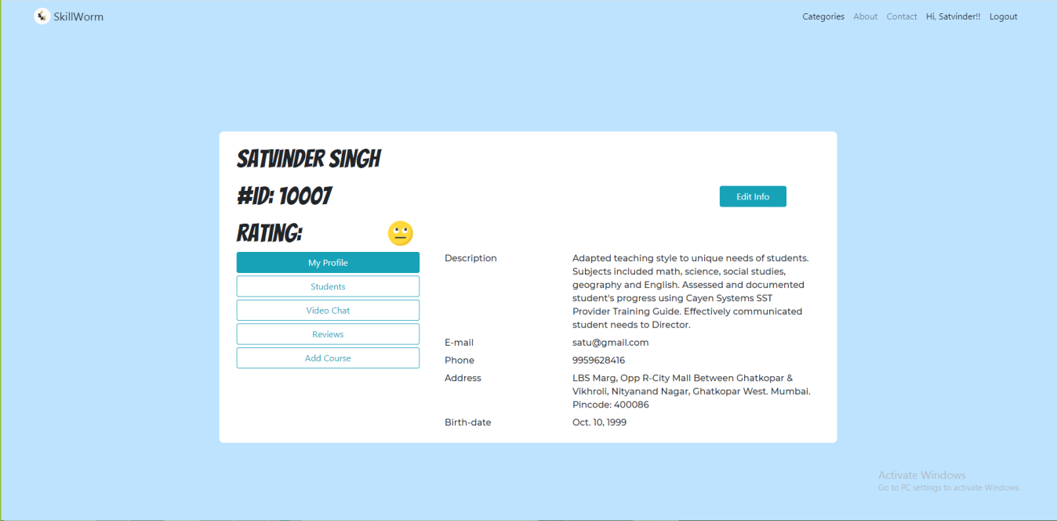4) TUTOR MY PROFILE PAGE

## 5) TUTOR – ENROLLED STUDENTS PAGE

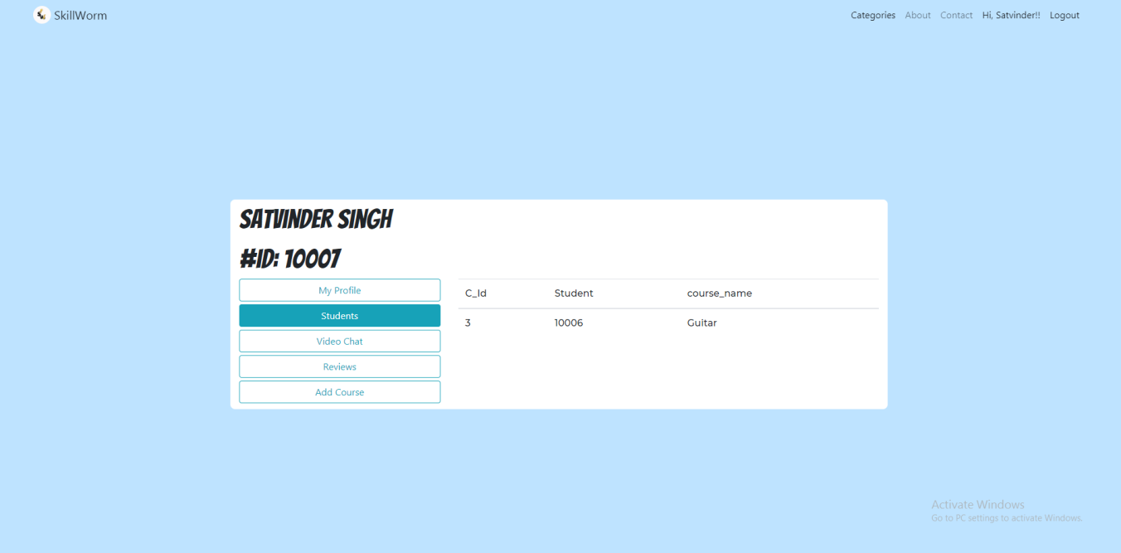

## 6) STUDENT MY PROFILE PAGE

## 

## 7) STUDENT MY COURSES PAGE

## 

## 8) REVIEWS PAGE

## 

## 9) TUTOR – ADD COURSE PAGE

## 

CONCLUSION & FUTURE SCOPE

* Our project Skill-worm, which is a web based application has been developed using Django Framework . jQuery, JavaScript, HTML,HTML5 ,CSS is used for implementing UI .
* It has been a great pleasure for us to work on this challenging project. This project provided us a good practical knowledge of various things like programming in Django web based application and also about database queries.
* It also provided us a good knowledge about the latest technologies like HTML 5,bootstrap for front end in web based applications.
* In future, we might add more functionalities like chatbot for support, video conferencing with multiple students.

SOCIETAL APPLICATION

With an aim to shift from being known as developing country to developed country came the concept of e-learning in India. It is indeed a promising reform with a positive outlook and no specified boundaries. e-learning refers to learning supported by electronic media. e-learning is a means of education that incorporates self-motivation, communication, efficiency, and technology. It is effective as it eliminates distances and subsequent commutes. It is the acquisition of knowledge and skill through electronic technologies such as computer and Internet-based courseware and local and wide area networks. e-learning refers to utilizing e- resources in the e-world. With the vast development of various technologies, learning today is no longer confined to classrooms with lecture delivery as the only method of conveying knowledge, rather, an electronic means of learning has continued to evolve. e-learning facilitates education using communications networks, and has made learning possible from anywhere at anytime using the Internet, wide area networks or local area networks. The students who used to spend their time in library searching for information in books and journals can now a days, use search engines and figure out the web sites for the information needed, thus making information sharing a very easy task.

E- learning probably is one of the means by which education and training can reach greater to the number of people. Its significance can be understood in times like a pandemic or emergency.

The broadest e-learning utilization nowadays is the *Learning Management System* (LMS), which is considered, in the view of the International Forum of Educational Technology & Society (IFETS), as “a collection of e-learning tools available through a shared administrative interface”. A Learning Management System can be thought of as the platform in which online courses or online components of courses are assembled and used. Learning Management System (or LMS) is a software solution that enables the management and delivery of online content to learners. LMSs are web-based to make possible "anytime, anywhere, any pace" access to learning content and management.

Our project skill-worms combines the aspects of e-learning and LMS. We are also providing offline option, especially for children’s who shouldn’t be exposed to digital screens.