IT APPDEV 4
Game Development
Activity 2: Case Study

- Chosen Game
Until Then
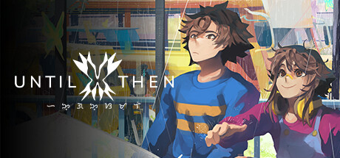

Developer: Polychroma Games (Philippines-based indie studio)
Release Date: June 25, 2024
Platforms: PC (Steam/Windows), PlayStation 5, and Nintendo Switch (2025)
Genre: 2.5D Narrative Adventure / Interactive Visual Novel
- Research and Gather Information
Gameplay Mechanics & Controls
- Interactivity: Beyond simple dialogue choices, the game features smartphone and social media simulation. You scroll through feeds, like posts, and read news articles that change based on your progress.
- The "Type to Talk" Mechanic: In chat sequences, you physically hit keys to "type" Mark’s responses. This adds a tactile layer to digital communication.
- Minigames: Everyday tasks (like eating fishballs, taking a jeepney, or doing a school presentation) are turned into rhythmic or precision-based minigames to ground the fantasy in reality.
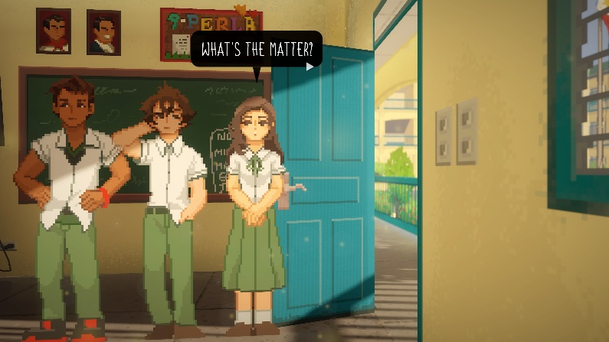
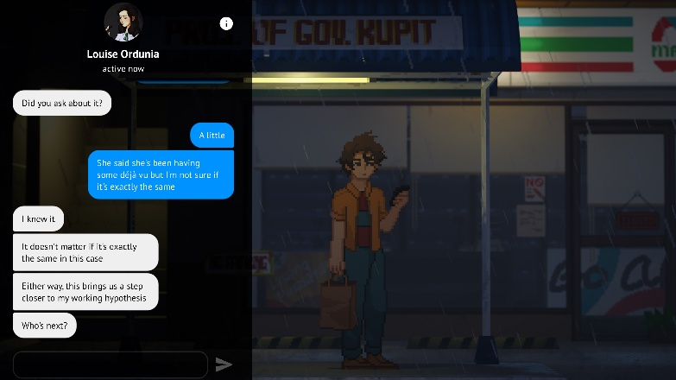

Story & Narrative
- Setting: A fictionalized version of the contemporary Philippines, dealing with the aftermath of a global catastrophe known as "The Ruling."
- Protagonist: Mark Borja, a relatable "slacker" student living alone while his parents work abroad as OFWs (Overseas Filipino Workers).
- Themes: Grief, the reliability of memory, the "Bahala na" (come what may) attitude, and the struggle to move on from trauma.
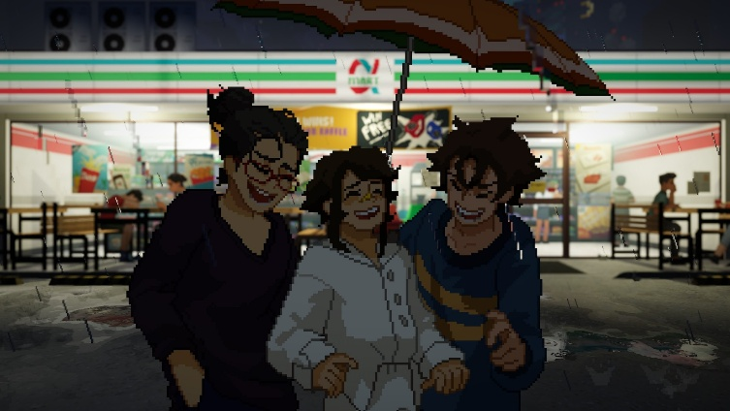
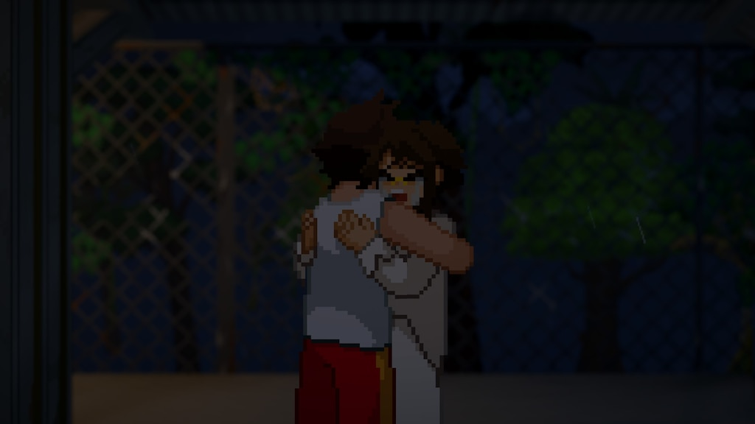
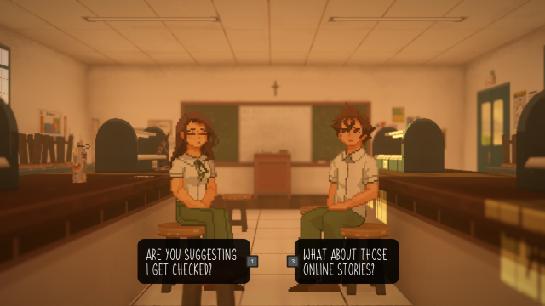
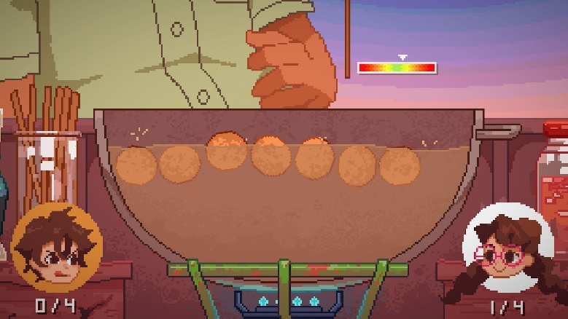
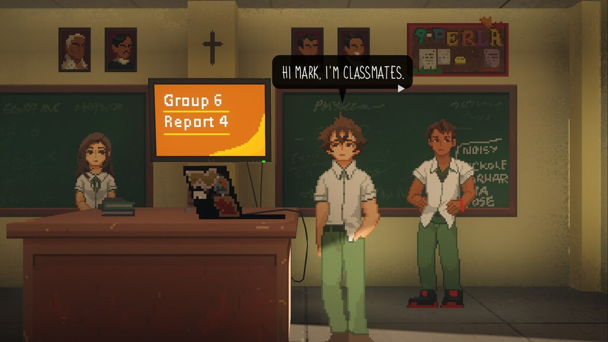
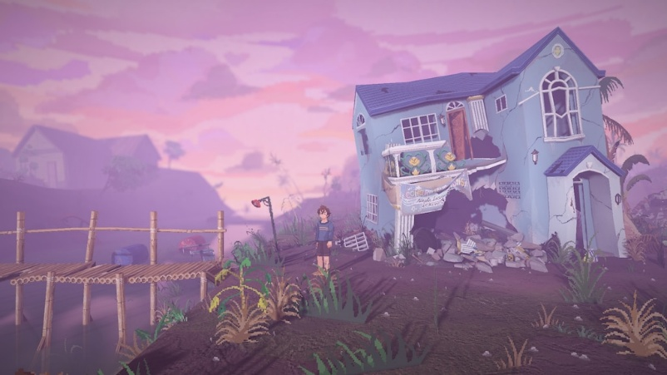

Engagement & UX Analysis
- Engagement: Players are hooked by relatability. By making the player "type" messages and "scroll" feeds, the game blurs the line between the player's real-world habits and the protagonist's life.
- User Experience: The UI is diegetic (the menus are Mark's phone), which keeps the immersion high and prevents the screen from looking "gamey."
- Feedback: The game is critically acclaimed for its authentic representation of Filipino life and its emotional depth, though some players find the initial "slow-burn" pace a challenge.

- Analyzing Strengths and Weaknesses
Feature | Strengths | Weaknesses
Authenticity | Captures real Filipino culture (jeepneys, slang, OFW family dynamics) without feeling like a caricature. | Some international players might feel "lost" with specific cultural references or Taglish terms.
Pacing | Excellent "slow-burn" build-up that makes the eventual supernatural twists hit harder. | The early chapters are very dialogue-heavy; some may find the initial pace too slow.
Narrative Design | Uses a "loop" or multi-playthrough system that reveals new truths, making the second run feel like a completely new game. | The single autosave system can be punishing if you want to experiment with different choices.

What Could Be Improved:

- Technical Inconsistency in Minigames
While the minigames are charming, the "User Experience" (UX) during these segments can be clunky.

Example: The Piano Audition minigame is a significant story beat, but players have reported that the rhythm controls (using arrow keys or buttons) can feel unresponsive or "buggy" compared to dedicated rhythm games. A failure here can feel frustrating because it’s a technical hurdle rather than a narrative choice.

- Visual Clarity in "Crowded" Scenes
The 2.5D pixel art style is beautiful but can sometimes sacrifice gameplay clarity for aesthetics.
Example: In scenes with heavy lighting effects or crowded backgrounds (like the Carnival level), it can be difficult to tell which NPCs are interactable and which are just background decoration. This leads to "pixel hunting," where a player has to walk Mark back and forth just to find the prompt to continue the story.

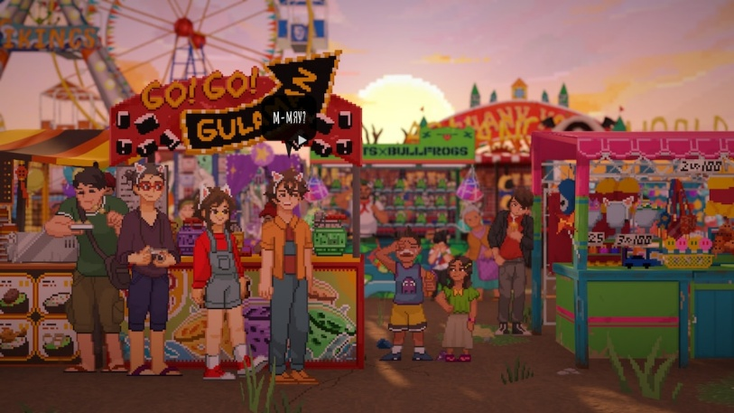


- Summary of Findings

Finding: The game successfully balances a hyper-local setting with universal themes of grief and trauma.

Mini-games as Pacing: Mundane tasks (jeepney rides, school presentations) are turned into minigames that ground the high-concept sci-fi plot in a relatable, everyday reality.

Diegetic UI: The UX is highly immersive because the menus are integrated into the world (Mark’s phone). This reduces "player-character" distance.

Reception: Feedback is overwhelmingly positive (97% on Steam), with players specifically praising the "emotional damage" caused by the authentic writing.

Personal Reflection
It’s been a long time since a game like this had a huge impact to me considering that it is developed by Filipinos. The story telling was excellent, the gameplay was fascinating, and the development is very smart. It brings players on experiencing Filipino culture while highlighting important lessons in life.
Refferences
Steam Community :: Until Then
https://www.eurogamer.net/until-then-review-a-breathtaking-narrative-adventure
Until Then Review (PS5) | Push Square
Until Then Review | GameGrin
How long is Until Then? | HowLongToBeat
Award-winning game developers push video games as storytelling medium | The Varsitarian

