

Functional Safety Concept Lane Assistance

**Document Version: 1.0**



# Document history

|  |  |  |  |
| --- | --- | --- | --- |
| Date | Version | Editor | Description |
| 2018-10-20 | 1.0 | Rodrigo Vasconcelos | Initial version of the document |
|  |  |  |  |
|  |  |  |  |
|  |  |  |  |
|  |  |  |  |

# Table of Contents

Document history

Table of Contents

Purpose of the Functional Safety Concept

Inputs to the Functional Safety Concept

Safety goals from the Hazard Analysis and Risk Assessment

Preliminary Architecture

Functional Safety Concept

Functional Safety Analysis

Functional Safety Requirements

Refinement of the System Architecture

Allocation of Functional Safety Requirements to Architecture Elements

Warning and Degradation Concept

# Purpose of the Functional Safety Concept

The purpose of this document is to allocate the Lane Assisting item’s safety requirements to an element of the system’s architecture in order to refine the system’s architecture and identify technical requirements.

# Inputs to the Functional Safety Concept

## Safety goals from the Hazard Analysis and Risk Assessment

|  |  |
| --- | --- |
| **ID** | **Safety Goal** |
| Safety_Goal_01 | The oscillating steering torque from the lane departure warning function shall be limited. |
| Safety_Goal_02 | The lane keeping assistance function shall be time limited and the additional steering torque shall end after a given time interval so that the driver cannot misuse the system for autonomous driving. |
| Safety_Goal_03 | The lane keeping assistance function shall apply the minimum torque necessary to return the car to the center of the lane. |

## Preliminary Architecture

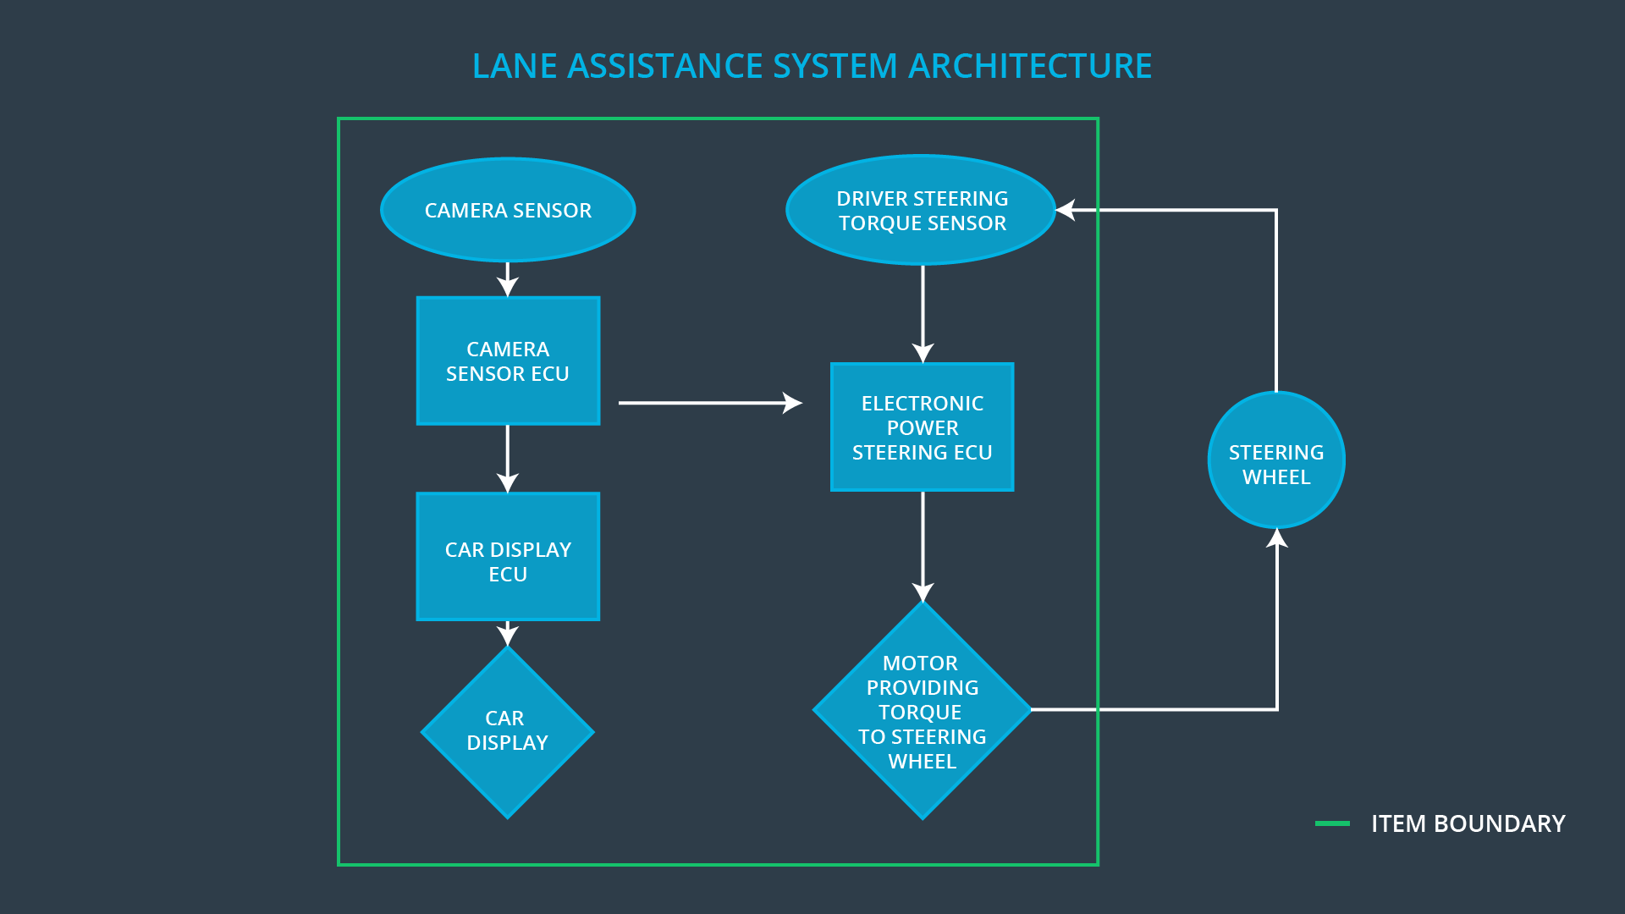

|  |  |
| --- | --- |
| **Element** | **Description** |
| Camera Sensor | Capture the scene in front of the car. |
| Camera Sensor ECU | Identify lane boundaries and the car’s position relative to the center of the lane.  Calculate the torque needed to return the car to the center of the lane. |
| Car Display | Display a light when the Lane Keeping function is on.  Display a light when the Lane Assistance system is on.  Display a light when the Lane Assistance system experiences a malfunction. |
| Car Display ECU | Interpret the Lane Assistance system state to enable the appropriate lights.  Identify when the driver activates a turn signal.  Identify when the driver disengages the Lane Assistance system. |
| Driver Steering Torque Sensor | Read the steering torque applied by the driver. |
| Electronic Power Steering ECU | Oscillate the steering wheel when the Lane Departure Warning is on.  Apply the required torque to the steering wheel as indicated by the Camera Sensor ECU when the Lane Keeping function is on.  Subtract the torque already applied by the driver to the total required to keep the car in the lane. |
| Motor | Apply the required torque to the steering wheel. |

# Functional Safety Concept

The functional safety concept consists of:

* Functional safety analysis
* Functional safety requirements
* Functional safety architecture
* Warning and degradation concept

## Functional Safety Analysis

|  |  |  |  |
| --- | --- | --- | --- |
| **Malfunction ID** | **Main Function of the Item Related to Safety Goal Violations** | **Guidewords (NO, WRONG, EARLY, LATE, MORE, LESS)** | **Resulting Malfunction** |
| Malfunction_01 | Lane Departure Warning (LDW) function shall apply an oscillating steering torque to provide the driver a haptic feedback | MORE | The lane departure warning oscillating torque amplitude is too high. |
| Malfunction_02 | Lane Departure Warning (LDW) function shall apply an oscillating steering torque to provide the driver a haptic feedback | MORE | The lane departure warning oscillating torque frequency is too high. |
| Malfunction_03 | Lane Keeping Assistance (LKA) function shall apply the steering torque when active in order to stay in ego lane | NO | The lane keeping assistance function has no time limit. |
| Malfunction_04 | Lane Keeping Assistance (LKA) function shall apply the steering torque when active in order to stay in ego lane | MORE | The lane keeping assistance function applies a torque that is too high. |

## Functional Safety Requirements

Lane Departure Warning (LDW) Requirements:

|  |  |  |  |  |
| --- | --- | --- | --- | --- |
| **ID** | **Functional Safety Requirement** | **ASIL** | **Fault Tolerant Time Interval** | **Safe State** |
| Functional  Safety  Requirement  01-01 | The lane assistance item shall ensure that the lane departure warning oscillating torque amplitude is below Max_Torque_Amplitude | C | 50ms | Lane Assistance item off |
| Functional  Safety  Requirement  01-02 | The lane assistance item shall ensure that the lane departure warning oscillating torque frequency is below Max_Torque_Frequency | C | 50ms | Lane Assistance item off |

Lane Departure Warning (LDW) Verification and Validation Acceptance Criteria:

|  |  |  |
| --- | --- | --- |
| **ID** | **Validation Acceptance**  **Criteria and Method** | **Verification Acceptance**  **Criteria and Method** |
| Functional  Safety  Requirement  01-01 | Test how drivers react to different torque amplitudes to prove that we chose an appropriate value. | Test using a value over Max_Torque_Amplitude and verify that the system is turned off within 50 ms. |
| Functional  Safety  Requirement  01-02 | Test how drivers react to different torque frequencies to prove that we chose an appropriate value. | Test using a value over Max_Torque_Frequency and verify that the system is turned off within 50 ms. |

Lane Keeping Assistance (LKA) Requirements:

|  |  |  |  |  |
| --- | --- | --- | --- | --- |
| **ID** | **Functional Safety Requirement** | **ASIL** | **Fault Tolerant Time Interval** | **Safe State** |
| Functional  Safety  Requirement  02-01 | The electronic power steering ECU shall ensure that the lane keeping assistance torque is applied for only Max_Duration. | B | 500ms | Lane Assistance item off |
| Functional  Safety  Requirement  02-02 | The electronic power steering ECU shall ensure that the lane keeping assistance torque applied is not higher than Max_Torque_Amount | C | 50ms | Lane Assistance item off |

Lane Keeping Assistance (LKA) Verification and Validation Acceptance Criteria:

|  |  |  |
| --- | --- | --- |
| **ID** | **Validation Acceptance**  **Criteria and Method** | **Verification Acceptance**  **Criteria and Method** |
| Functional  Safety  Requirement  02-01 | Test times required to re-center the car under different conditions to prove that we chose an appropriate value. | Verify that the drivers are dissuaded from taking their hands off the steering wheel with the selected max duration. |
| Functional  Safety  Requirement  02-02 | Test how drivers react to different torque magnitudes to prove that we chose an appropriate value. | Test using a value over Max_Torque_Magnitude and verify that the system is turned off within 50 ms. |

## Refinement of the System Architecture

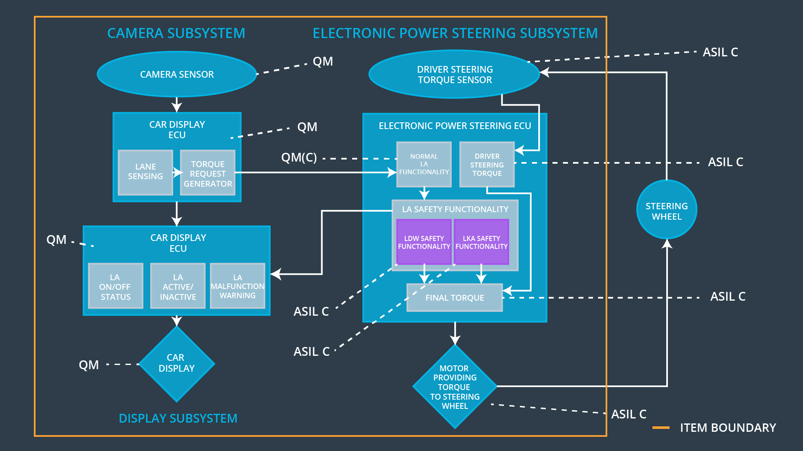

## Allocation of Functional Safety Requirements to Architecture Elements

|  |  |  |  |  |
| --- | --- | --- | --- | --- |
| **ID** | **Functional Safety Requirement** | **Electronic Power Steering ECU** | **Camera ECU** | **Car Display ECU** |
| Functional  Safety  Requirement  01-01 | The lane assistance item shall ensure that the lane departure warning oscillating torque amplitude is below Max_Torque_Amplitude | **X** |  |  |
| Functional  Safety  Requirement  01-02 | The lane assistance item shall ensure that the lane departure warning oscillating torque frequency is below Max_Torque_Frequency | **X** |  |  |
| Functional  Safety  Requirement  02-01 | The electronic power steering ECU shall ensure that the lane keeping assistance torque is applied for only Max_Duration. | **X** |  |  |
| Functional  Safety  Requirement  02-02 | The electronic power steering ECU shall ensure that the lane keeping assistance torque applied is not higher than Max_Torque_Amount | **X** |  |  |

## Warning and Degradation Concept

|  |  |  |  |  |
| --- | --- | --- | --- | --- |
| **ID** | **Degradation Mode** | **Trigger for Degradation Mode** | **Safe State invoked?** | **Driver Warning** |
| WDC-01 | Turn off the Lane Assistance item. | Steering oscillating amplitude is too high. | Yes | Display light on dashboard. |
| WDC-02 | Turn off the Lane Assistance item. | Steering oscillating frequency is too high. | Yes | Display light on dashboard. |
| WDC-03 | Turn off the Lane Assistance item. | The lane keeping assistance function is active for more than Max_Duration. | Yes | Display light on dashboard. |
| WDC-04 | Turn off the Lane Assistance item. | The lane keeping assistance function applies a torque that is too high. | Yes | Display light on dashboard. |