**HOW TO RUN**

-Load mexicantrain.lsp into LISP interpreter and then execute s-expression (mexicanTrain)

-Menus are operated almost entirely numerically except for filenames to load serialization files. Simply enter the appropriate number corresponding to the menu choice you wish to select in playing the game.

**BUG REPORT**

**FEATURE REPORT**

Serialization/deserialization

Main Menu

Start of new game

Start of new Round

Computer/Human drawing 16 tiles from boneyard

Correctly displaying all round information

**DATA STRUCTURES/MODULES**

-The client module contains only client code to load additional files and start the game

-The game module manages new games, resuming games, and victory when the player is done playing

-The round module manages new round, current rounds, ending rounds, alternating turns, and determining victory of round

-The utilities module contains a variety of helpful bottom level functions to aid in design by providing all the tools to design in a purely abstract functional way. Functions include list shuffling/reversal, getNth, setNth, remove, element checking if a list contains element, getting last element, and validating console input

-The boneyard module maintains the boneyard and handles drawing of tiles

-The human module handles the humans turn

-the computer moduel handles the computers turn

-There may one day be a Player module but might call it AI module instead

**DAILY LOG**

**09/28/21**

-Created game client and util modules, established a way to get valid numbers from client input, established intro menu, and began working on concept of round.

**09/29/21**

-Created round module to begin starting of round. Am passing around all 10 major elements of the game list around to each function. Want to find a way to create getters/setters on this as soon as possible, so I can just pass around the entire game between recursive calls of things like (playRound game) instead of (playRound roundNumber computerScore computerHand…and so on.

-Create serialize and deserialize modules, populate with get and sets for all 10 dimensions.

They are implemented with some very long combinatins of first and rest but I would like a better way. I would like a getNth and setNth that can work on any list.

-I experiment with formatting. The LISP IDE I use formats stuff weird so its best to output lists with ~d in the end.

-Setup recursive startRound to handle, one by one, the establishment of boneyard (if its null) (still not shuffled), the drawing of all tiles to be drawn, and the flipping of the coin (if nextPlayer is null)

-getNth, setNth, and many more utility functions added. At this point I am pretty sure I have every single util function I need to perform all the game actions, with the exception of a recursive add all. One that can add together the 2 pipcounts in the list that is each tile, while summing up all the times. This is the job for at least 2 functions, with one calling the other.

**09/30**

-I have completed a game loop and a playRound loop. playRound is not tail recursive, but endRound returns list of both players score, which are returned back through every round, back to playGame which uses those scores to start fresh new round with 1 higher round number. This way I am going much easier on the stack, only 1 level deeper per round of game played.

-I have tacked on an 11th field to the game list that gets passed around. This field is a list of predicates representing whether each player had passed in last turn. I anticipate needing this as I cannot conceive of any functional way to calculate this. It is one of the few state variables that must be created and maintained throughout a round. I believe that if my plan for player modules goes as planned, then I will need no other state variables.

-I have created player class and given it the function tallyHand and the skeleton of one called endturn. A players turn will be initiated from round, and the rest of it will be handled in the respective player classes, but the recommendation system must come from player class and be available to both.

**10/01/21**

-I have been forced to refactor everything now that I understand functional programming a bit better. I have setup some very long chains of returns that kick all the way back to playRound. This final return is the new game state after all modifications have been complete. Another innovation was to return more than just the game state from the function that plays tiles. Now, by returning a list of the game state, and some informationa bout the play, the necessary steps can be taken based on that info, and can be done in a more appropriate part of the program.

I am rapidly creating many empty functions, aiming downward, only occasionally stopping to implement any terminal nodes that shoot off to the side. The great thing about LISP is that I don’t even have to change files to test a function. I can make all sorts of test calls just underneath of it in order to test it. The convenience of that and power is truly exceptional.

**01/30/21**

-I have established the major of what it takes for a player to make a move, but with many stubs along the way. Markers aren’t correctly handled, no passing recording is occurring. I am finding, however, that in order to add these things is usually no more than 1-2 levels of function scope from each other, and just as Professor said, it does not impact any other part of the program.

**10/02/21**

-I have implemented canPlayTileToTrain and playTileToTrain, as well as finalizePlayTile.

**02-01-21**

-

**02-02-21**

-

**02-04-21**

-

**02-06-21**

-

**02-07-21**

-

**SCREENSHOTS**

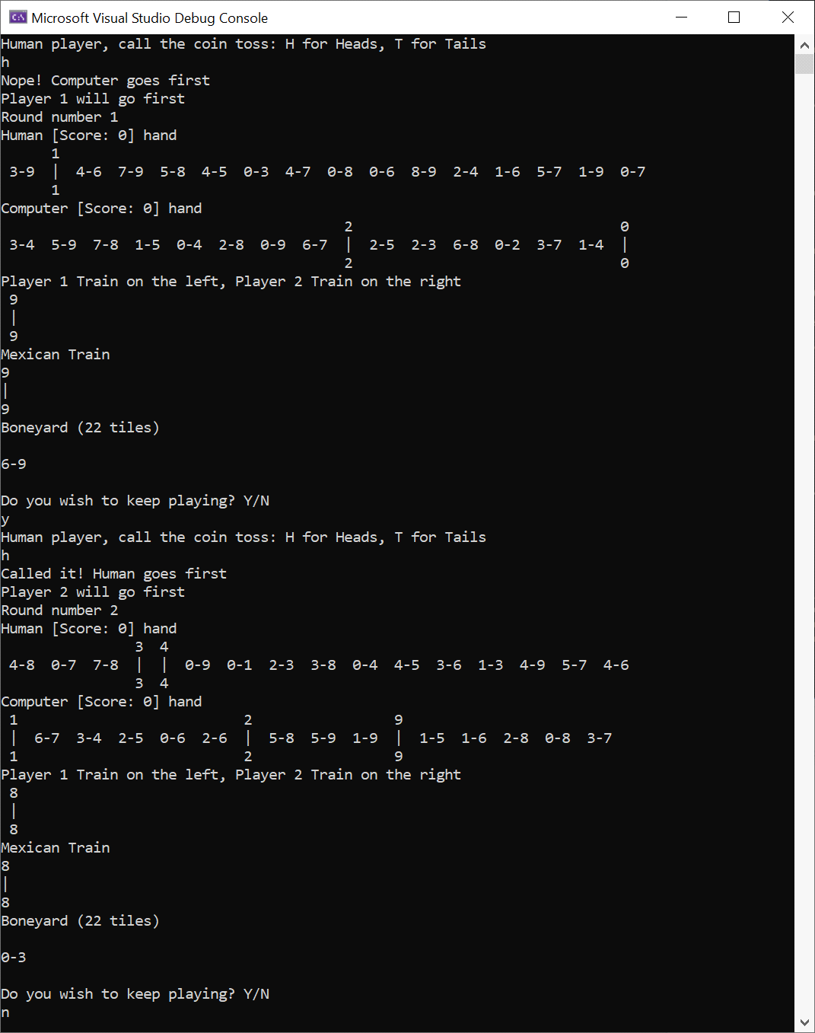

Figure 1Early tests of turn cycling

Figure Case 1

Figure Case 2 Computer plays a double then a non double, justifying reason

Figure 4Case 3, where no player gets to play

Figure Player gets advice

Figure Game is saved then exited

Figure Menus require input validation