Forecasting feature on AppExchange
Created By | Satoshi Haga
First Creation | 9/1/2013
Last Update | 9/1/2013

Purpose of this document
This document describes the review of forecasting feature on AppExchange..

1. Marketo Revenue Cycle Analytics - Marketing Reporting, Marketing Forecasts + ROI
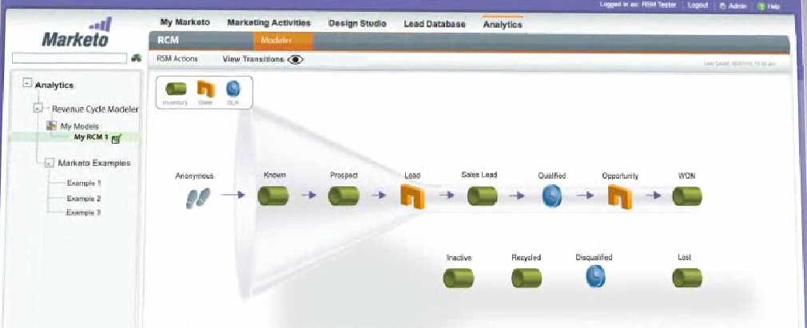
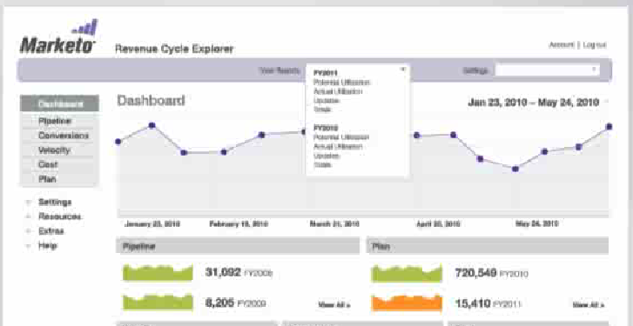

2. Pipeline Manager
Opportunityの分類

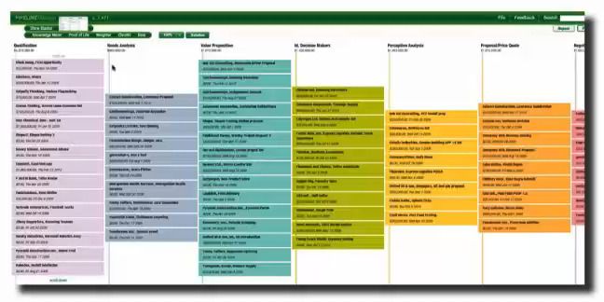

2. SureCast | Maximize Sales & Forecast With Confidence
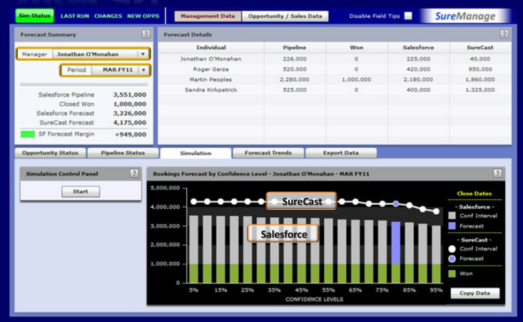
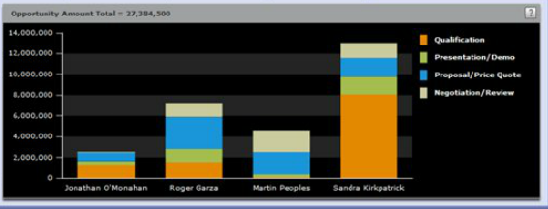
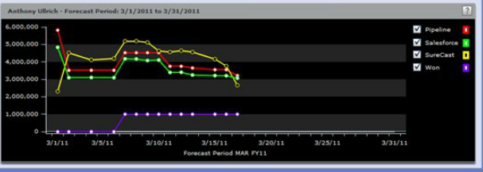

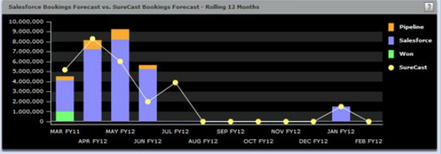

3. Adaptive Planning
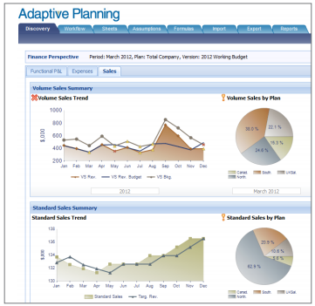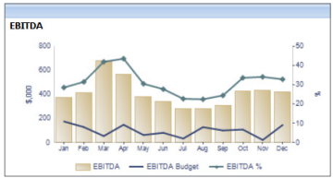
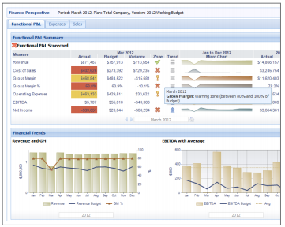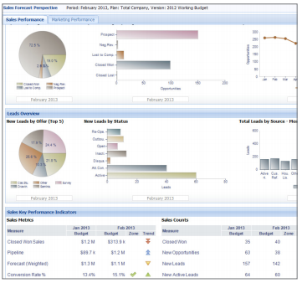

4. Foretuit
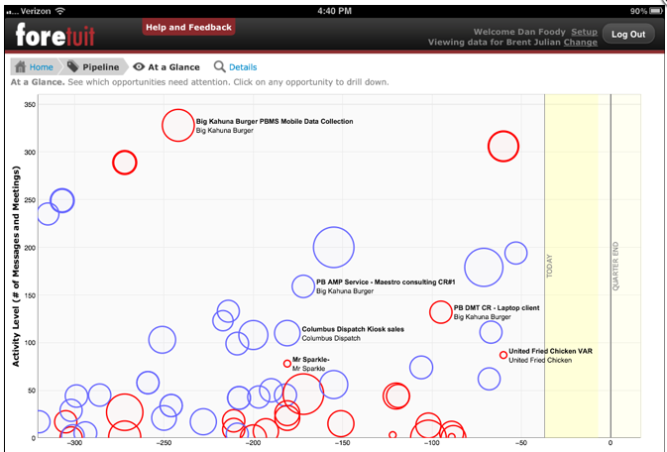

5. USとJPにおけるカテゴリ別のアプリ数の比較
