Install package
- composer require pusher/pusher-php-server
- npm install --save laravel-echo pusher-js
- Open config/app.php and uncomment the following line in the providers array
// App\Providers\BroadcastServiceProvider

We need to tell Laravel that we are using the Pusher driver in the .env file:
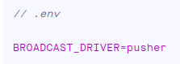
Get key pusher
- Create channels pusher
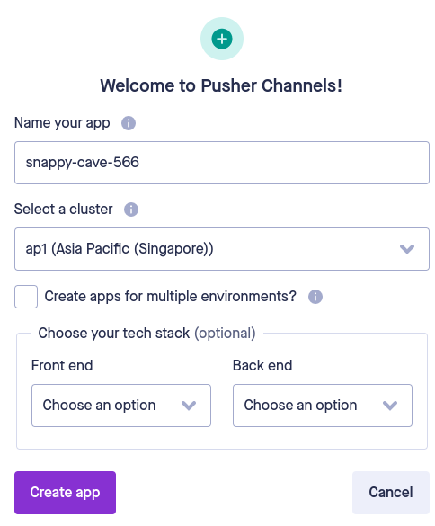

- Get pusher key in page App Keys inside Channels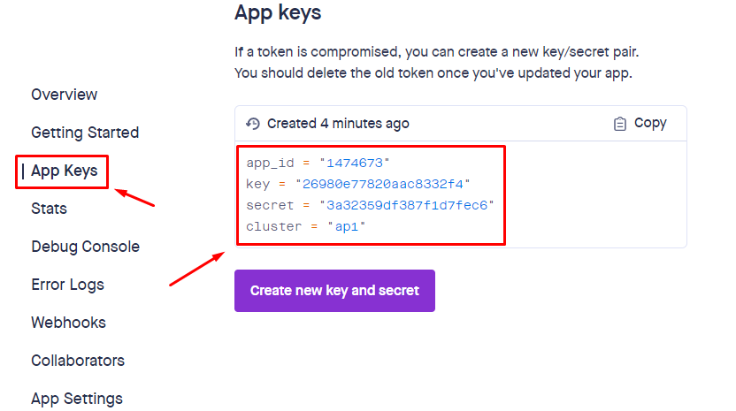

- Next, we need to set the APP_ID, KEY, SECRET and CLUSTER in the environment file

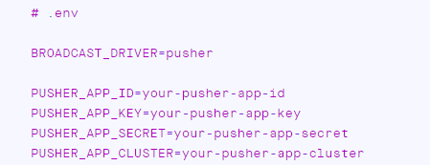
and create a fresh Echo instance in our application’s JavaScript.
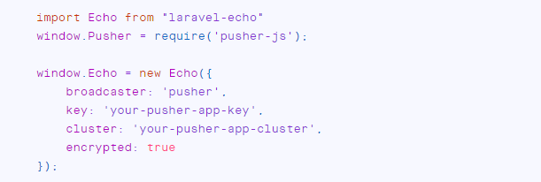

- Testing
The Channels Debug Console can be found within the Channels dashboard and can be used to help you understand what’s happening within your Channels application.
