Install package
- composer require twilio/sdk
Get key twilio
- TWILIO_AUTH_SID
- TWILIO_AUTH_TOKEN
- TWILIO_SERVICE_SID
- TWILIO_API_SECRET
- TWILIO_API_SID
Login to your Twilio dashboard and copy both your ACCOUNT SID and AUTH TOKEN.
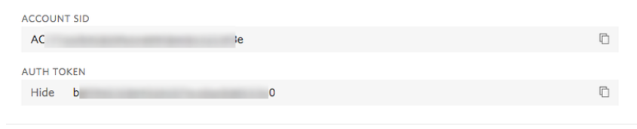
Before you can start using the Twilio Programmable Chat API, you need to first create a chat service:
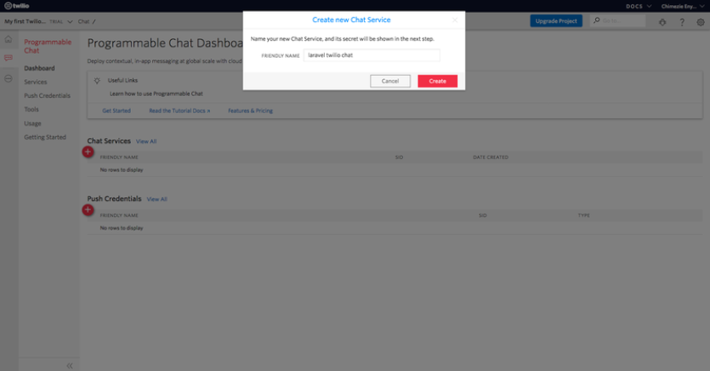
Take note of your SERVICE SID.
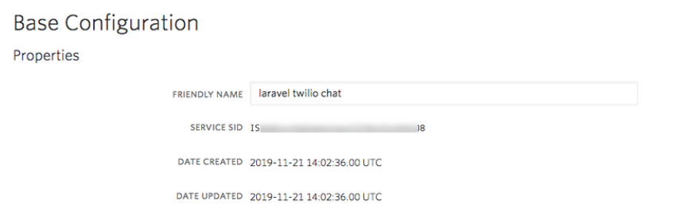
Lastly, you need to create an API key:
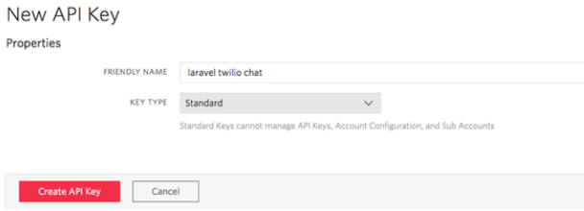
Also, take note of both your API SECRET and API SID.
Setup information PAYPAY to env
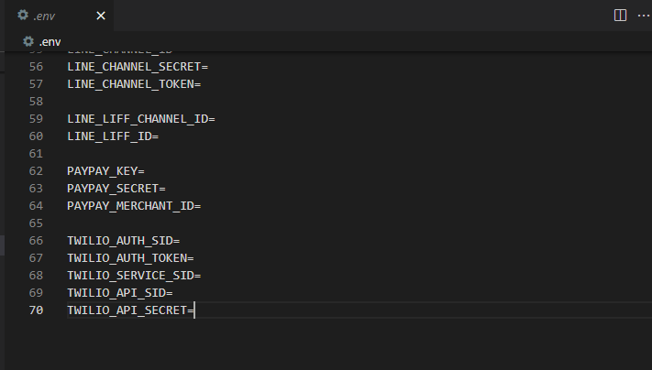
Setup Webhook Twilio
At menu , access Services of Conversation product :
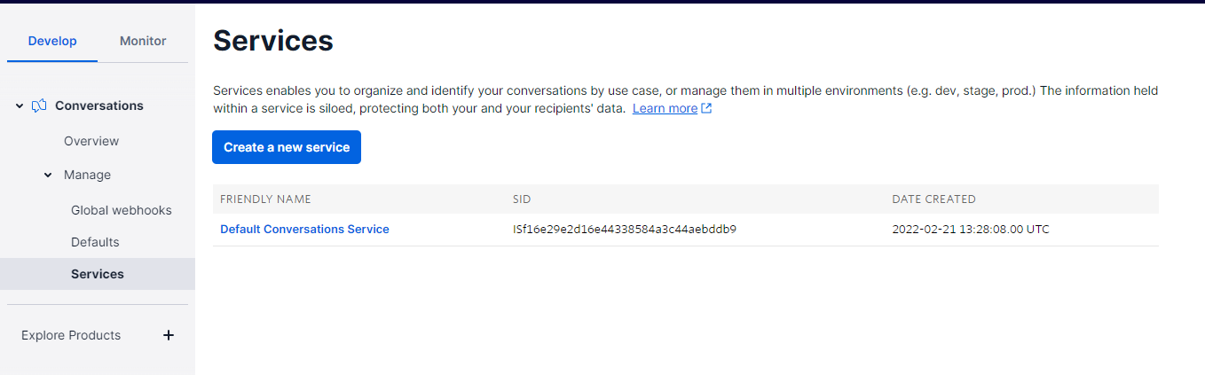
And access webhook of twilio :
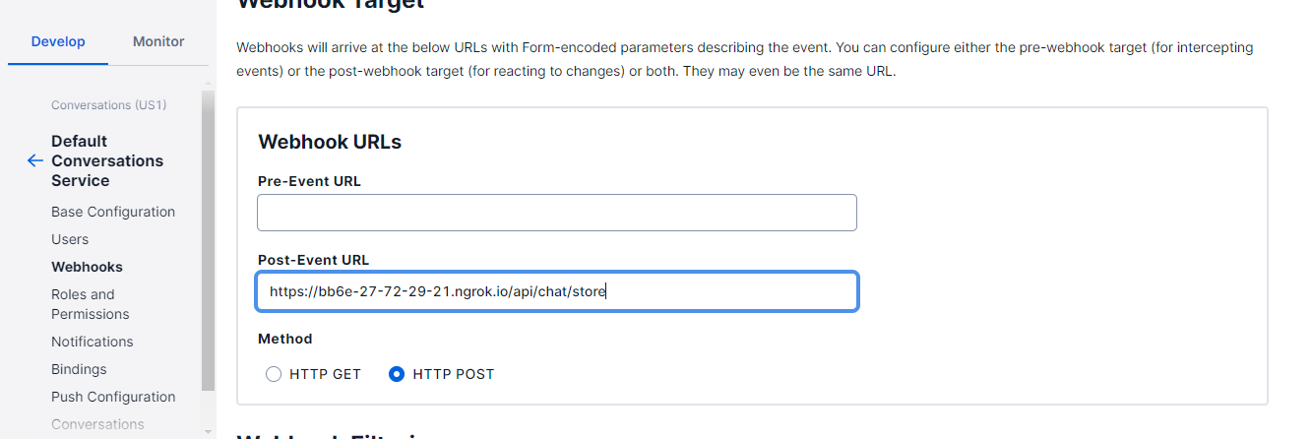

Fill API in Post-Event URL and click the onMessageAdd checkbox . Then , please click to Save button

