Get key line
- LINE_CHANNEL_ID = Line Messaging API Channel ID
- LINE_CHANNEL_SECRET = Line Messaging API Channel Secret
- LINE_CHANNEL_TOKEN = Line Messaging API Channel Token
- LINE_LIFF_CHANNEL_ID = Line Login Channel ID
- LINE_LIFF_ID = Line Login Liff ID (in tab LIFF - LINE LOGIN)
Login to your Line Developer console and creat LINE LOGIN + Message API channel
- In Line Login channel , copy channel ID (Line Login Channel ID)
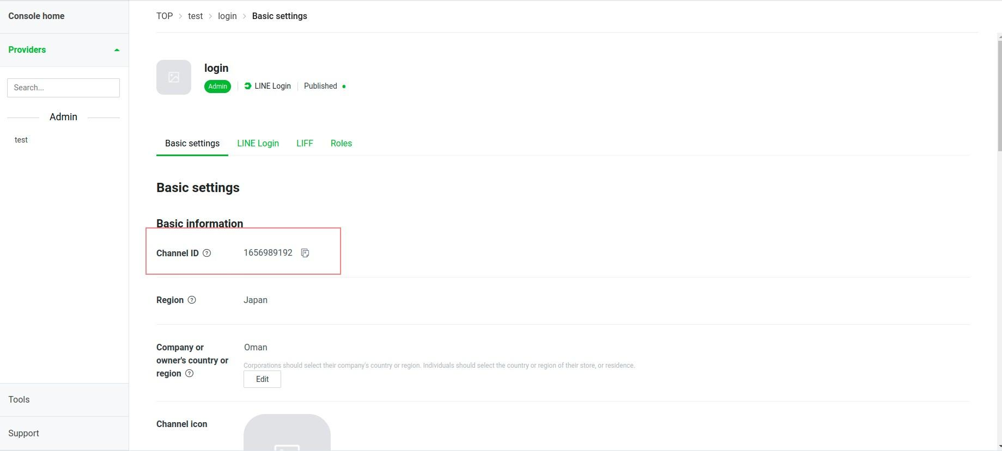
Before that, you need to create Liff app and copy LIFF ID (Line Login Liff ID (in tab LIFF - LINE LOGIN))

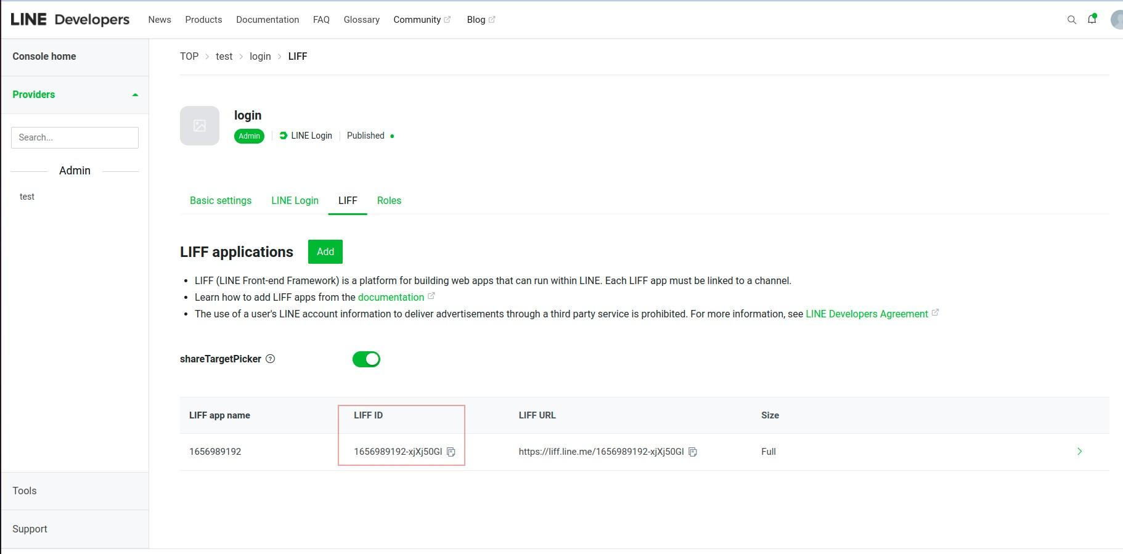

In Message API channel
Take note of your channel id (Line Messaging API Channel ID)
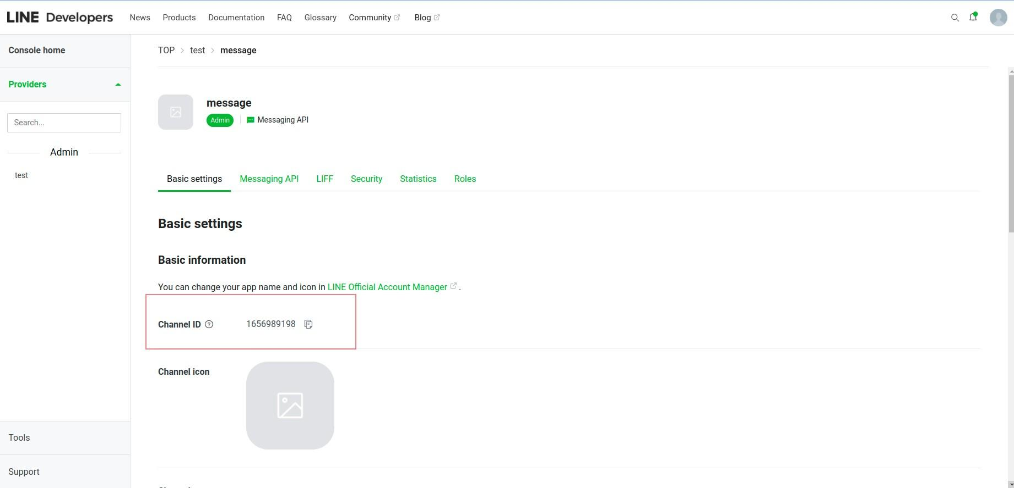
and channel secret (Line Messaging API Channel Secret)
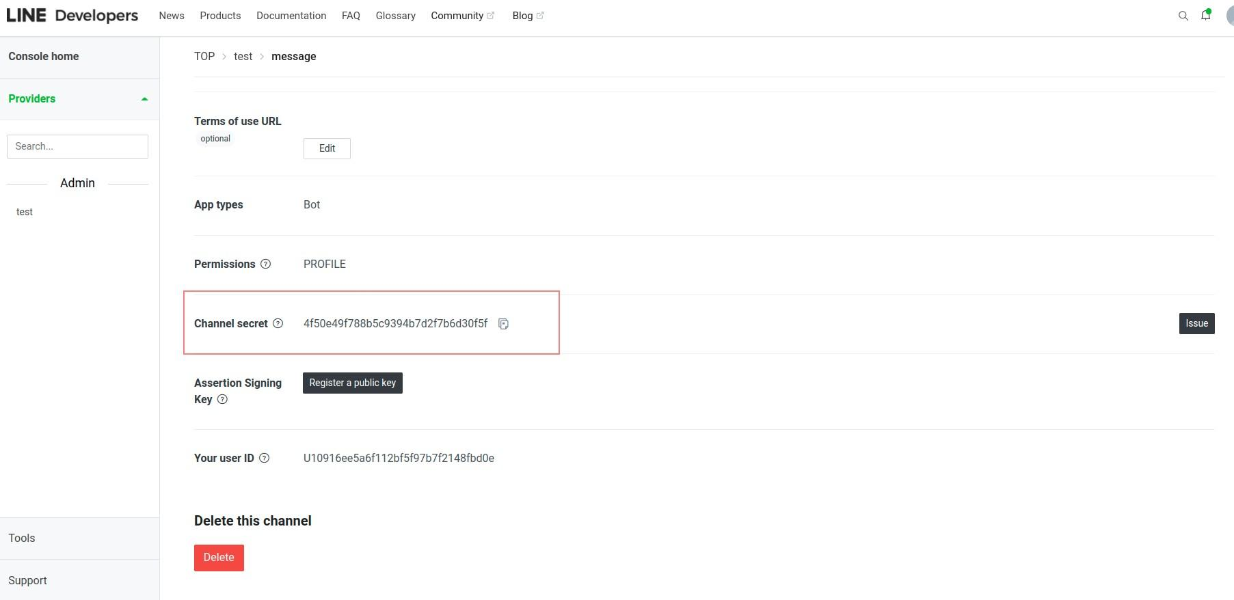

and channel access token (Line Messaging API Channel Token)
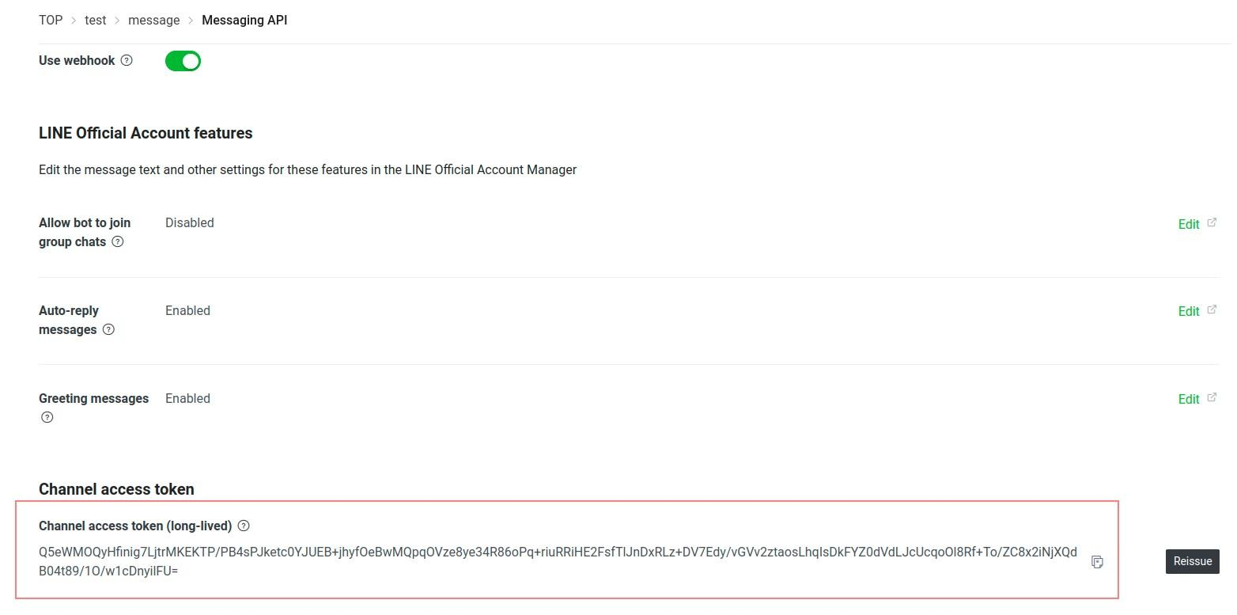

Setup Line information to env
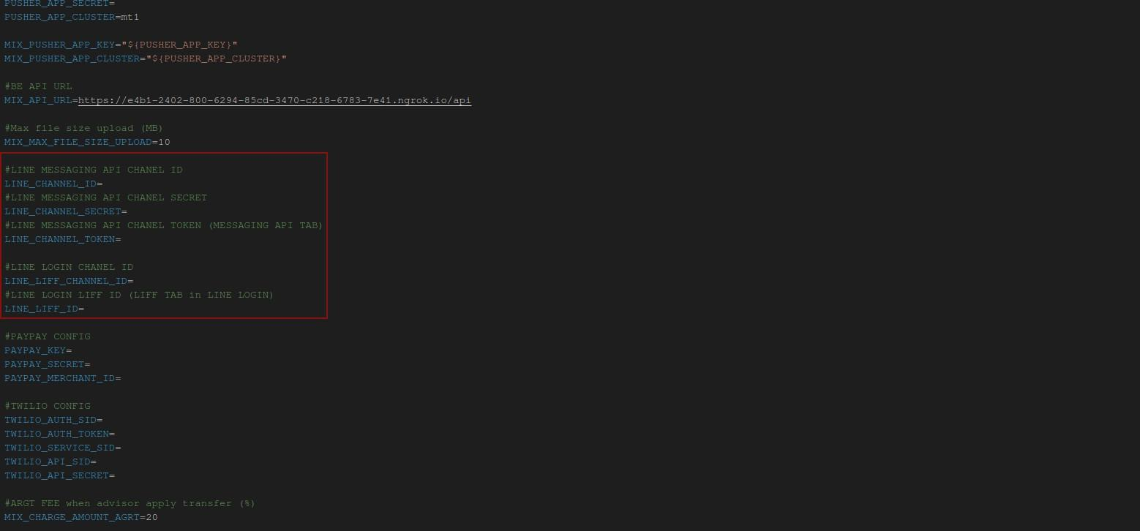

Setup Webhook Line
At menu Messaging API in Messaging API channel,

Fill API in Webhook URL and click the Update button. Then, please verify this webhook
