Install package
- composer require paypayopa/php-sdk

Get information merchant PAYPAY
- Merchant ID
- Key ID
- Key Secret
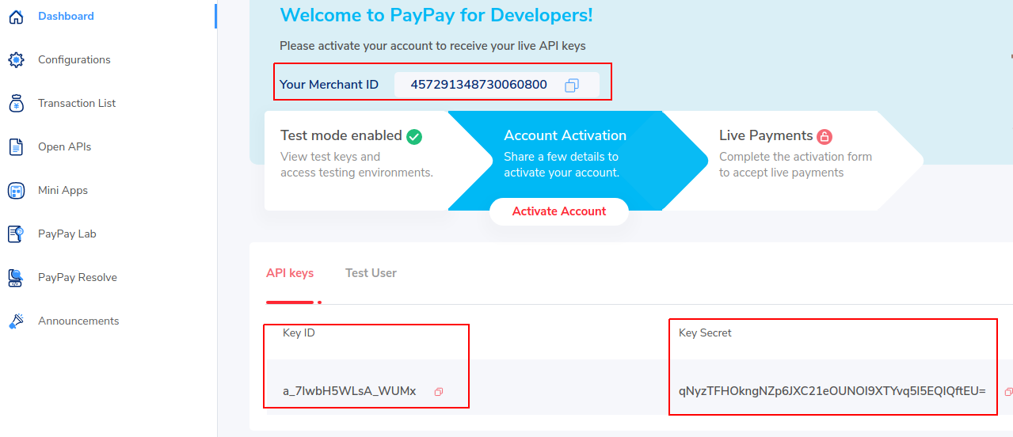- Get Test User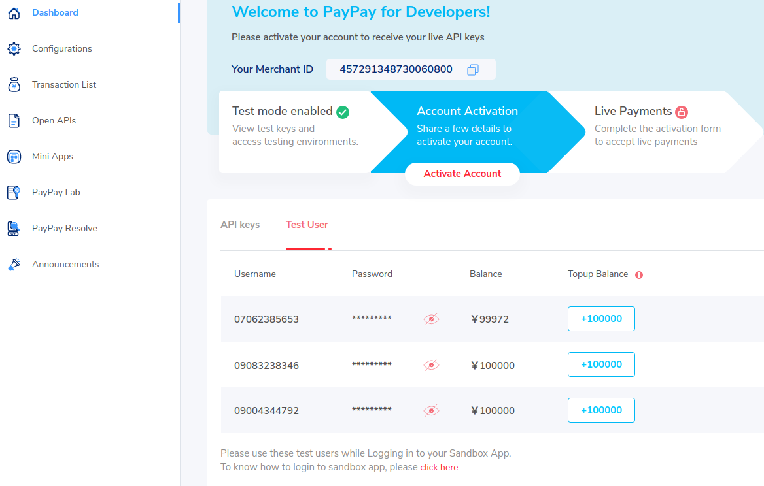
Setup PAYPAY information to env
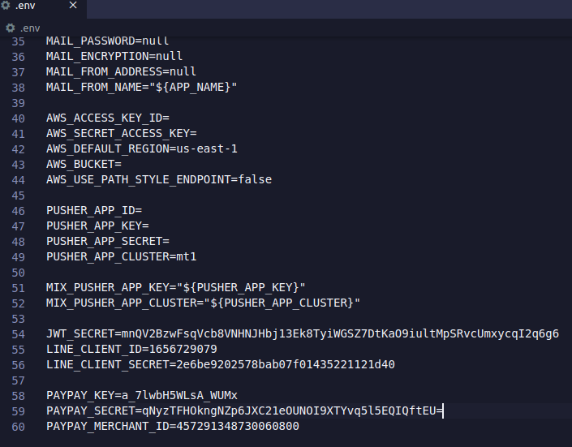
See more about paypay web payment
https://developer.paypay.ne.jp/products/docs/webpayment#dynamic-qr-codeid

Setup webhook PayPay
At menu Notifications WebHook & Payment Status WebHook, please add a url so that paypay can return transaction data when there is a payment event on the website.
